​
​
​
UNITED STATES
SECURITIES AND EXCHANGE COMMISSION
WASHINGTON, D.C. 20549
FORM 8-K
CURRENT REPORT
Pursuant to Section 13 or 15(d)
of The Securities Exchange Act of 1934
Date of Report (Date of earliest event reported): June 30, 2026
UGI Corporation
(Exact Name of Registrant as Specified in Its Charter)
​ | ​ | ​
Pennsylvania  (State or Other Jurisdiction  of Incorporation) | 1-11071  (Commission  File Number) | 23-2668356  (IRS Employer  Identification No.)
​
500 North Gulph Road, King of Prussia, PA 19406
(Address of Principal Executive Offices) (Zip Code)
Registrant’s Telephone Number, Including Area Code: 610 337-1000
Not Applicable
Former Name or Former Address, if Changed Since Last Report
Check the appropriate box below if the Form 8-K filing is intended to simultaneously satisfy the filing obligation of the registrant under any of the following provisions:
☐ | Written communications pursuant to Rule 425 under the Securities Act (17 CFR 230.425)
☐ | Soliciting material pursuant to Rule 14a-12 under the Exchange Act (17 CFR 240.14a-12)
☐ | Pre-commencement communications pursuant to Rule 14d-2(b) under the Exchange Act (17 CFR 240.14d-2(b))
☐ | Pre-commencement communications pursuant to Rule 13e-4(c) under the Exchange Act (17 CFR 240.13e-4(c))
Securities registered pursuant to Section 12(b) of the Act:

​ | ​ | ​ | ​ | ​
Title of each class | ​ ​ ​ | Trading  Symbol(s) | ​ ​ ​ | Name of each exchange  on which registered
Common Stock, without par value | ​ | UGI | ​ | New York Stock Exchange
​
Indicate by check mark whether the registrant is an emerging growth company as defined in Rule 405 of the Securities Act of 1933 (§230.405 of this chapter) or Rule 12b-2 of the Securities Exchange Act of 1934 (§240.12b-2 of this chapter).
Emerging growth company ☐
If an emerging growth company, indicate by check mark if the registrant has elected not to use the extended transition period for complying with any new or revised financial accounting standards provided pursuant to Section 13(a) of the Exchange Act. ☐
​
​
​
​
​
Item 1.01. Entry into a Material Definitive Agreement.
On June 30, 2026, UGI Energy Services, LLC (“UGI Energy Services”), a wholly owned subsidiary of UGI Corporation (the “Company”), entered into that certain Fourth Amendment to Credit Agreement (the “Amendment”), by and among UGI Energy Services, the guarantors party thereto, HSBC Bank USA, N.A., as administrative agent, and HSBC Bank USA, N.A. as the 2026 Refinancing Term Lender (as defined in the Amendment) and the lenders party thereto, which amended UGI Energy Services’ Credit Agreement, dated as of August 13, 2019 (as amended, the “Term Loan Credit Agreement”).
The Amendment provides, among other items, that the Applicable Rate (as defined in the Term Loan Credit Agreement) shall be 2.00% per annum for SOFR Loans (as defined in the Term Loan Credit Agreement) and 1.00% per annum for base rate loans.
The foregoing description of the Amendment does not purport to be complete and is qualified in its entirety by reference to the full text of the Amendment, which is filed as Exhibit 10.1 to this Current Report on Form 8-K and is incorporated herein by reference.
Item 2.03. Creation of a Direct Financial Obligation or an Obligation under an Off-Balance Sheet Arrangement of a Registrant.
The information set forth above in Item 1.01 regarding the Amendment is hereby incorporated into this Item 2.03 by reference, insofar as it relates to the creation of a direct financial obligation. This description is qualified in its entirety by reference to the full text of the Amendment, which is filed as Exhibit 10.1 to this Current Report on Form 8-K and is incorporated herein by reference.
Item 9.01. Financial Statements and Exhibits.
(d) Exhibits.
​
​ | ​ | ​
Exhibit  Number: | ​ ​ ​ | Description
10.1 | ​ | Fourth Amendment to Credit Agreement, dated June 30, 2026, by and among UGI Energy Services, LLC, the guarantors party thereto, the lenders party thereto, HSBC Bank USA, N.A., as administrative agent, and HSBC Bank USA, N.A. as the 2026 Refinancing Term Lender.
​ | ​ | ​
104 | ​ | Cover Page Interactive Data File (formatted as inline XBRL).
​
​
​
​
SIGNATURES
Pursuant to the requirements of the Securities Exchange Act of 1934, the registrant has duly caused this report to be signed on its behalf by the undersigned hereunto duly authorized.
​ | ​ | UGI Corporation
​ | ​ | ​
July 7, 2026 | ​ | By: | /s/ Jessica A. Milner
​ | ​ | Name: | Jessica A. Milner
​ | ​ | Title: | Secretary
​ | ​ | ​
​
​
​
​

 | 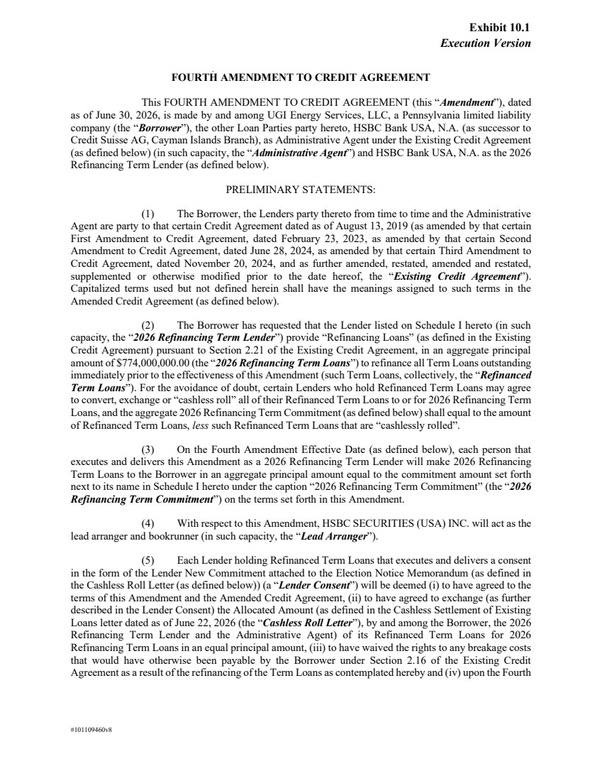 | Execution Version #101109460v8 FOURTH AMENDMENT TO CREDIT AGREEMENT This FOURTH AMENDMENT TO CREDIT AGREEMENT (this “Amendment”), dated as of June 30, 2026, is made by and among UGI Energy Services, LLC, a Pennsylvania limited liability company (the “Borrower”), the other Loan Parties party hereto, HSBC Bank USA, N.A. (as successor to Credit Suisse AG, Cayman Islands Branch), as Administrative Agent under the Existing Credit Agreement (as defined below) (in such capacity, the “Administrative Agent”) and HSBC Bank USA, N.A. as the 2026 Refinancing Term Lender (as defined below). PRELIMINARY STATEMENTS: (1) The Borrower, the Lenders party thereto from time to time and the Administrative Agent are party to that certain Credit Agreement dated as of August 13, 2019 (as amended by that certain First Amendment to Credit Agreement, dated February 23, 2023, as amended by that certain Second Amendment to Credit Agreement, dated June 28, 2024, as amended by that certain Third Amendment to Credit Agreement, dated November 20, 2024, and as further amended, restated, amended and restated, supplemented or otherwise modified prior to the date hereof, the “Existing Credit Agreement”). Capitalized terms used but not defined herein shall have the meanings assigned to such terms in the Amended Credit Agreement (as defined below). (2) The Borrower has requested that the Lender listed on Schedule I hereto (in such capacity, the “2026 Refinancing Term Lender”) provide “Refinancing Loans” (as defined in the Existing Credit Agreement) pursuant to Section 2.21 of the Existing Credit Agreement, in an aggregate principal amount of $774,000,000.00 (the “2026 Refinancing Term Loans”) to refinance all Term Loans outstanding immediately prior to the effectiveness of this Amendment (such Term Loans, collectively, the “Refinanced Term Loans”). For the avoidance of doubt, certain Lenders who hold Refinanced Term Loans may agree to convert, exchange or “cashless roll” all of their Refinanced Term Loans to or for 2026 Refinancing Term Loans, and the aggregate 2026 Refinancing Term Commitment (as defined below) shall equal to the amount of Refinanced Term Loans, less such Refinanced Term Loans that are “cashlessly rolled”. (3) On the Fourth Amendment Effective Date (as defined below), each person that executes and delivers this Amendment as a 2026 Refinancing Term Lender will make 2026 Refinancing Term Loans to the Borrower in an aggregate principal amount equal to the commitment amount set forth next to its name in Schedule I hereto under the caption “2026 Refinancing Term Commitment” (the “2026 Refinancing Term Commitment”) on the terms set forth in this Amendment. (4) With respect to this Amendment, HSBC SECURITIES (USA) INC. will act as the lead arranger and bookrunner (in such capacity, the “Lead Arranger”). (5) Each Lender holding Refinanced Term Loans that executes and delivers a consent in the form of the Lender New Commitment attached to the Election Notice Memorandum (as defined in the Cashless Roll Letter (as defined below)) (a “Lender Consent”) will be deemed (i) to have agreed to the terms of this Amendment and the Amended Credit Agreement, (ii) to have agreed to exchange (as further described in the Lender Consent) the Allocated Amount (as defined in the Cashless Settlement of Existing Loans letter dated as of June 22, 2026 (the “Cashless Roll Letter”), by and among the Borrower, the 2026 Refinancing Term Lender and the Administrative Agent) of its Refinanced Term Loans for 2026 Refinancing Term Loans in an equal principal amount, (iii) to have waived the rights to any breakage costs that would have otherwise been payable by the Borrower under Section 2.16 of the Existing Credit Agreement as a result of the refinancing of the Term Loans as contemplated hereby and (iv) upon the Fourth Exhibit 10.1
 | 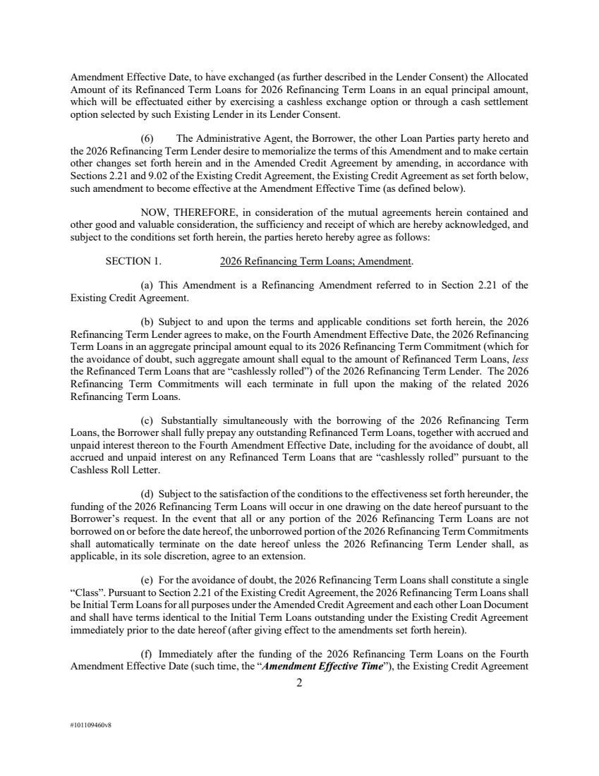 | 2 #101109460v8 Amendment Effective Date, to have exchanged (as further described in the Lender Consent) the Allocated Amount of its Refinanced Term Loans for 2026 Refinancing Term Loans in an equal principal amount, which will be effectuated either by exercising a cashless exchange option or through a cash settlement option selected by such Existing Lender in its Lender Consent. (6) The Administrative Agent, the Borrower, the other Loan Parties party hereto and the 2026 Refinancing Term Lender desire to memorialize the terms of this Amendment and to make certain other changes set forth herein and in the Amended Credit Agreement by amending, in accordance with Sections 2.21 and 9.02 of the Existing Credit Agreement, the Existing Credit Agreement as set forth below, such amendment to become effective at the Amendment Effective Time (as defined below). NOW, THEREFORE, in consideration of the mutual agreements herein contained and other good and valuable consideration, the sufficiency and receipt of which are hereby acknowledged, and subject to the conditions set forth herein, the parties hereto hereby agree as follows: SECTION 1. 2026 Refinancing Term Loans; Amendment. (a) This Amendment is a Refinancing Amendment referred to in Section 2.21 of the Existing Credit Agreement. (b) Subject to and upon the terms and applicable conditions set forth herein, the 2026 Refinancing Term Lender agrees to make, on the Fourth Amendment Effective Date, the 2026 Refinancing Term Loans in an aggregate principal amount equal to its 2026 Refinancing Term Commitment (which for the avoidance of doubt, such aggregate amount shall equal to the amount of Refinanced Term Loans, less the Refinanced Term Loans that are “cashlessly rolled”) of the 2026 Refinancing Term Lender. The 2026 Refinancing Term Commitments will each terminate in full upon the making of the related 2026 Refinancing Term Loans. (c) Substantially simultaneously with the borrowing of the 2026 Refinancing Term Loans, the Borrower shall fully prepay any outstanding Refinanced Term Loans, together with accrued and unpaid interest thereon to the Fourth Amendment Effective Date, including for the avoidance of doubt, all accrued and unpaid interest on any Refinanced Term Loans that are “cashlessly rolled” pursuant to the Cashless Roll Letter. (d) Subject to the satisfaction of the conditions to the effectiveness set forth hereunder, the funding of the 2026 Refinancing Term Loans will occur in one drawing on the date hereof pursuant to the Borrower’s request. In the event that all or any portion of the 2026 Refinancing Term Loans are not borrowed on or before the date hereof, the unborrowed portion of the 2026 Refinancing Term Commitments shall automatically terminate on the date hereof unless the 2026 Refinancing Term Lender shall, as applicable, in its sole discretion, agree to an extension. (e) For the avoidance of doubt, the 2026 Refinancing Term Loans shall constitute a single “Class”. Pursuant to Section 2.21 of the Existing Credit Agreement, the 2026 Refinancing Term Loans shall be Initial Term Loans for all purposes under the Amended Credit Agreement and each other Loan Document and shall have terms identical to the Initial Term Loans outstanding under the Existing Credit Agreement immediately prior to the date hereof (after giving effect to the amendments set forth herein). (f) Immediately after the funding of the 2026 Refinancing Term Loans on the Fourth Amendment Effective Date (such time, the “Amendment Effective Time”), the Existing Credit Agreement
 | 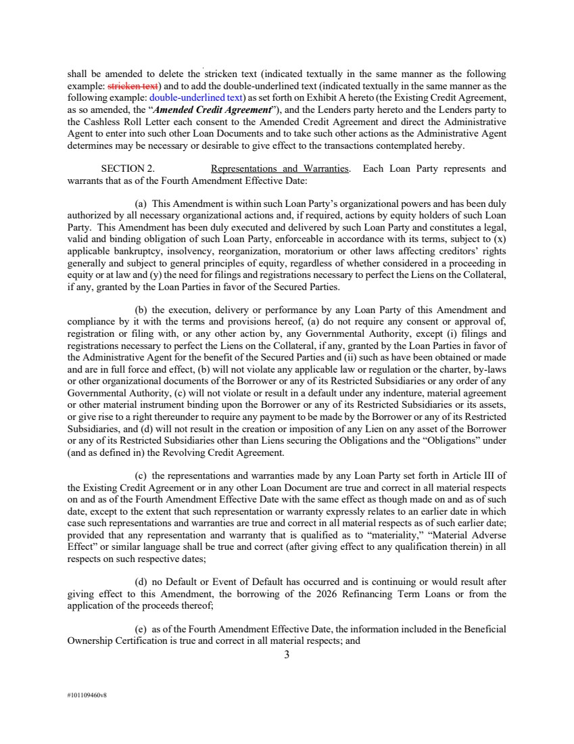 | 3 #101109460v8 shall be amended to delete the stricken text (indicated textually in the same manner as the following example: stricken text) and to add the double-underlined text (indicated textually in the same manner as the following example: double-underlined text) as set forth on Exhibit A hereto (the Existing Credit Agreement, as so amended, the “Amended Credit Agreement”), and the Lenders party hereto and the Lenders party to the Cashless Roll Letter each consent to the Amended Credit Agreement and direct the Administrative Agent to enter into such other Loan Documents and to take such other actions as the Administrative Agent determines may be necessary or desirable to give effect to the transactions contemplated hereby. SECTION 2. Representations and Warranties. Each Loan Party represents and warrants that as of the Fourth Amendment Effective Date: (a) This Amendment is within such Loan Party’s organizational powers and has been duly authorized by all necessary organizational actions and, if required, actions by equity holders of such Loan Party. This Amendment has been duly executed and delivered by such Loan Party and constitutes a legal, valid and binding obligation of such Loan Party, enforceable in accordance with its terms, subject to (x) applicable bankruptcy, insolvency, reorganization, moratorium or other laws affecting creditors’ rights generally and subject to general principles of equity, regardless of whether considered in a proceeding in equity or at law and (y) the need for filings and registrations necessary to perfect the Liens on the Collateral, if any, granted by the Loan Parties in favor of the Secured Parties. (b) the execution, delivery or performance by any Loan Party of this Amendment and compliance by it with the terms and provisions hereof, (a) do not require any consent or approval of, registration or filing with, or any other action by, any Governmental Authority, except (i) filings and registrations necessary to perfect the Liens on the Collateral, if any, granted by the Loan Parties in favor of the Administrative Agent for the benefit of the Secured Parties and (ii) such as have been obtained or made and are in full force and effect, (b) will not violate any applicable law or regulation or the charter, by-laws or other organizational documents of the Borrower or any of its Restricted Subsidiaries or any order of any Governmental Authority, (c) will not violate or result in a default under any indenture, material agreement or other material instrument binding upon the Borrower or any of its Restricted Subsidiaries or its assets, or give rise to a right thereunder to require any payment to be made by the Borrower or any of its Restricted Subsidiaries, and (d) will not result in the creation or imposition of any Lien on any asset of the Borrower or any of its Restricted Subsidiaries other than Liens securing the Obligations and the “Obligations” under (and as defined in) the Revolving Credit Agreement. (c) the representations and warranties made by any Loan Party set forth in Article III of the Existing Credit Agreement or in any other Loan Document are true and correct in all material respects on and as of the Fourth Amendment Effective Date with the same effect as though made on and as of such date, except to the extent that such representation or warranty expressly relates to an earlier date in which case such representations and warranties are true and correct in all material respects as of such earlier date; provided that any representation and warranty that is qualified as to “materiality,” “Material Adverse Effect” or similar language shall be true and correct (after giving effect to any qualification therein) in all respects on such respective dates; (d) no Default or Event of Default has occurred and is continuing or would result after giving effect to this Amendment, the borrowing of the 2026 Refinancing Term Loans or from the application of the proceeds thereof; (e) as of the Fourth Amendment Effective Date, the information included in the Beneficial Ownership Certification is true and correct in all material respects; and
 | 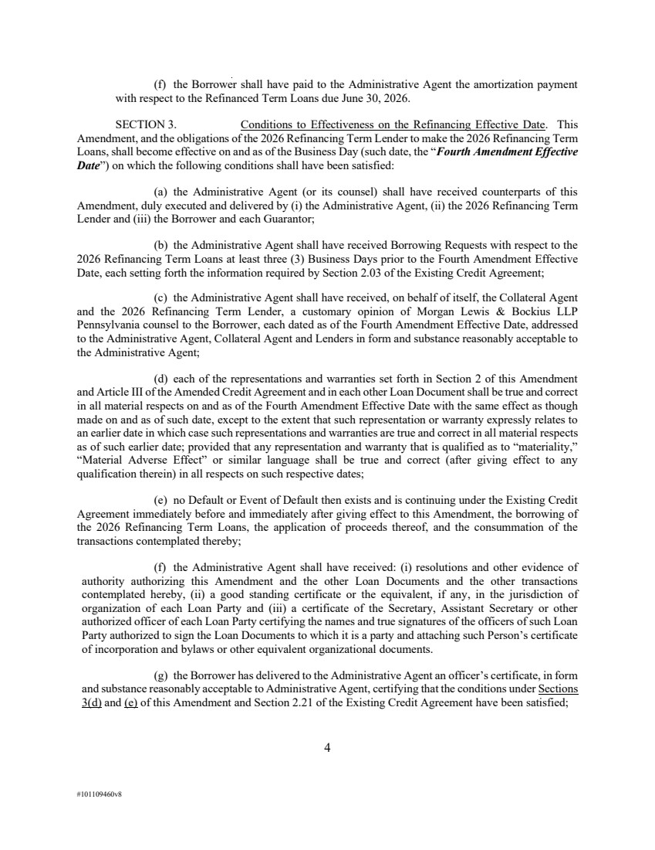 | 4 #101109460v8 (f) the Borrower shall have paid to the Administrative Agent the amortization payment with respect to the Refinanced Term Loans due June 30, 2026. SECTION 3. Conditions to Effectiveness on the Refinancing Effective Date. This Amendment, and the obligations of the 2026 Refinancing Term Lender to make the 2026 Refinancing Term Loans, shall become effective on and as of the Business Day (such date, the “Fourth Amendment Effective Date”) on which the following conditions shall have been satisfied: (a) the Administrative Agent (or its counsel) shall have received counterparts of this Amendment, duly executed and delivered by (i) the Administrative Agent, (ii) the 2026 Refinancing Term Lender and (iii) the Borrower and each Guarantor; (b) the Administrative Agent shall have received Borrowing Requests with respect to the 2026 Refinancing Term Loans at least three (3) Business Days prior to the Fourth Amendment Effective Date, each setting forth the information required by Section 2.03 of the Existing Credit Agreement; (c) the Administrative Agent shall have received, on behalf of itself, the Collateral Agent and the 2026 Refinancing Term Lender, a customary opinion of Morgan Lewis & Bockius LLP Pennsylvania counsel to the Borrower, each dated as of the Fourth Amendment Effective Date, addressed to the Administrative Agent, Collateral Agent and Lenders in form and substance reasonably acceptable to the Administrative Agent; (d) each of the representations and warranties set forth in Section 2 of this Amendment and Article III of the Amended Credit Agreement and in each other Loan Document shall be true and correct in all material respects on and as of the Fourth Amendment Effective Date with the same effect as though made on and as of such date, except to the extent that such representation or warranty expressly relates to an earlier date in which case such representations and warranties are true and correct in all material respects as of such earlier date; provided that any representation and warranty that is qualified as to “materiality,” “Material Adverse Effect” or similar language shall be true and correct (after giving effect to any qualification therein) in all respects on such respective dates; (e) no Default or Event of Default then exists and is continuing under the Existing Credit Agreement immediately before and immediately after giving effect to this Amendment, the borrowing of the 2026 Refinancing Term Loans, the application of proceeds thereof, and the consummation of the transactions contemplated thereby; (f) the Administrative Agent shall have received: (i) resolutions and other evidence of authority authorizing this Amendment and the other Loan Documents and the other transactions contemplated hereby, (ii) a good standing certificate or the equivalent, if any, in the jurisdiction of organization of each Loan Party and (iii) a certificate of the Secretary, Assistant Secretary or other authorized officer of each Loan Party certifying the names and true signatures of the officers of such Loan Party authorized to sign the Loan Documents to which it is a party and attaching such Person’s certificate of incorporation and bylaws or other equivalent organizational documents. (g) the Borrower has delivered to the Administrative Agent an officer’s certificate, in form and substance reasonably acceptable to Administrative Agent, certifying that the conditions under Sections 3(d) and (e) of this Amendment and Section 2.21 of the Existing Credit Agreement have been satisfied;
 |  | 5 #101109460v8 (h) the 2026 Refinancing Term Lender, the Lead Arranger and the Administrative Agent shall have received all fees and other amounts due and payable to them on or prior to the Fourth Amendment Effective Date, including, to the extent invoiced, reimbursement for all reasonable out-of-pocket costs and expenses, including the reasonable fees and disbursements of counsel, incurred by the Lead Arranger and the Administrative Agent in connection with this Amendment, for which invoices have been received at least two (2) Business Days in advance; (i) the Administrative Agent shall have received a solvency certificate in substantially the form attached as Exhibit G to the Existing Credit Agreement, dated as of the Fourth Amendment Effective Date and signed by the chief financial officer (or other officer with reasonably equivalent duties) of Borrower; (j) the Administrative Agent shall have received a notice of prepayment with respect to the Refinanced Term Loans at least three (3) Business Days prior to the Fourth Amendment Effective Date; (k) the Borrower shall have paid to the Administrative Agent, for the ratable account of each Lender holding Refinanced Term Loans immediately prior to the Fourth Amendment Effective Date, simultaneously with the making of the 2026 Refinancing Term Loans, all accrued and unpaid interest and, to the extent required to be paid by the Loan Parties under the Loan Documents, fees and other amounts accrued and unpaid on the Refinanced Term Loans to, but not including, the Fourth Amendment Effective Date, and substantially simultaneously with the borrowing of the 2026 Refinancing Term Loans, the Refinanced Term Loans shall be paid in full; and (l) at least three (3) days prior to the Fourth Amendment Effective Date, (i) all documentation and other information regarding the Borrower requested in connection with applicable “know your customer” and anti-money laundering rules and regulations, including the Patriot Act, to the extent requested in writing of the Borrower at least ten (10) days prior to the Refinancing Effective Date and (ii) to the extent the Borrower qualifies as a “legal entity customer” under the Beneficial Ownership Regulation, at least five days prior to the Refinancing Effective Date, any Lender that has requested, in a written notice to the Borrower at least ten (10) days prior to the Effective Date, a Beneficial Ownership Certification in relation to the Borrower shall have received such Beneficial Ownership Certification. (m) the Administrative Agent shall have received (i) a completed “life of the loan” Federal Emergency Management Agency Standard Flood Hazard Determination with respect to each Mortgaged Property on which any “building” (as defined in the Flood Insurance Laws) is located, and if such property is in a special flood hazard area, duly executed and acknowledged by the appropriate Loan Party, together with evidence of flood insurance as and to the extent required under Section 5.05 of the Amended Credit Agreement. SECTION 4. Treatment of Amortization Payment Due. Immediately after giving effect to the making of the 2026 Refinancing Term Loans on the Fourth Amendment Effective Date, upon the Administrative Agent’s receipt of the Borrower’s amortization payment due June 30, 2026 pursuant to Section 2.10(a) of the Existing Credit Agreement, such amortization payment shall be applied to repay the 2026 Refinancing Term Loans (and not, for the avoidance of doubt, applied to repay the Refinanced Term Loans). SECTION 5. Reaffirmation. Each of the Loan Parties as debtor, grantor, mortgagor, pledgor, guarantor, assignor, or in other any other similar capacity in which such Loan Party grants liens
 | 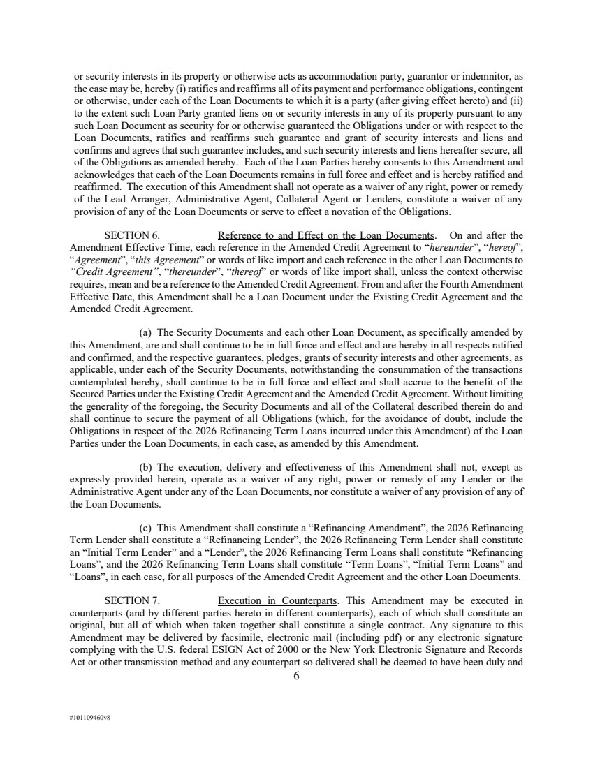 | 6 #101109460v8 or security interests in its property or otherwise acts as accommodation party, guarantor or indemnitor, as the case may be, hereby (i) ratifies and reaffirms all of its payment and performance obligations, contingent or otherwise, under each of the Loan Documents to which it is a party (after giving effect hereto) and (ii) to the extent such Loan Party granted liens on or security interests in any of its property pursuant to any such Loan Document as security for or otherwise guaranteed the Obligations under or with respect to the Loan Documents, ratifies and reaffirms such guarantee and grant of security interests and liens and confirms and agrees that such guarantee includes, and such security interests and liens hereafter secure, all of the Obligations as amended hereby. Each of the Loan Parties hereby consents to this Amendment and acknowledges that each of the Loan Documents remains in full force and effect and is hereby ratified and reaffirmed. The execution of this Amendment shall not operate as a waiver of any right, power or remedy of the Lead Arranger, Administrative Agent, Collateral Agent or Lenders, constitute a waiver of any provision of any of the Loan Documents or serve to effect a novation of the Obligations. SECTION 6. Reference to and Effect on the Loan Documents. On and after the Amendment Effective Time, each reference in the Amended Credit Agreement to “hereunder”, “hereof”, “Agreement”, “this Agreement” or words of like import and each reference in the other Loan Documents to “Credit Agreement”, “thereunder”, “thereof” or words of like import shall, unless the context otherwise requires, mean and be a reference to the Amended Credit Agreement. From and after the Fourth Amendment Effective Date, this Amendment shall be a Loan Document under the Existing Credit Agreement and the Amended Credit Agreement. (a) The Security Documents and each other Loan Document, as specifically amended by this Amendment, are and shall continue to be in full force and effect and are hereby in all respects ratified and confirmed, and the respective guarantees, pledges, grants of security interests and other agreements, as applicable, under each of the Security Documents, notwithstanding the consummation of the transactions contemplated hereby, shall continue to be in full force and effect and shall accrue to the benefit of the Secured Parties under the Existing Credit Agreement and the Amended Credit Agreement. Without limiting the generality of the foregoing, the Security Documents and all of the Collateral described therein do and shall continue to secure the payment of all Obligations (which, for the avoidance of doubt, include the Obligations in respect of the 2026 Refinancing Term Loans incurred under this Amendment) of the Loan Parties under the Loan Documents, in each case, as amended by this Amendment. (b) The execution, delivery and effectiveness of this Amendment shall not, except as expressly provided herein, operate as a waiver of any right, power or remedy of any Lender or the Administrative Agent under any of the Loan Documents, nor constitute a waiver of any provision of any of the Loan Documents. (c) This Amendment shall constitute a “Refinancing Amendment”, the 2026 Refinancing Term Lender shall constitute a “Refinancing Lender”, the 2026 Refinancing Term Lender shall constitute an “Initial Term Lender” and a “Lender”, the 2026 Refinancing Term Loans shall constitute “Refinancing Loans”, and the 2026 Refinancing Term Loans shall constitute “Term Loans”, “Initial Term Loans” and “Loans”, in each case, for all purposes of the Amended Credit Agreement and the other Loan Documents. SECTION 7. Execution in Counterparts. This Amendment may be executed in counterparts (and by different parties hereto in different counterparts), each of which shall constitute an original, but all of which when taken together shall constitute a single contract. Any signature to this Amendment may be delivered by facsimile, electronic mail (including pdf) or any electronic signature complying with the U.S. federal ESIGN Act of 2000 or the New York Electronic Signature and Records Act or other transmission method and any counterpart so delivered shall be deemed to have been duly and
 | 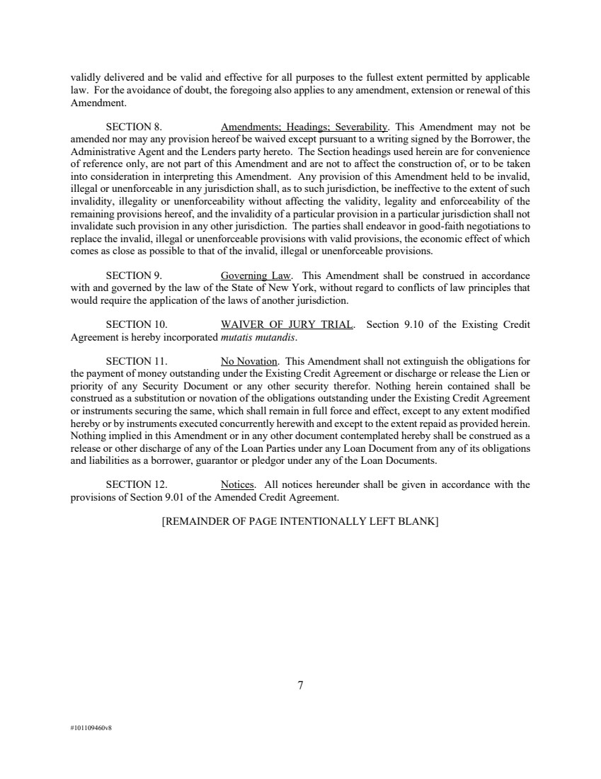 | 7 #101109460v8 validly delivered and be valid and effective for all purposes to the fullest extent permitted by applicable law. For the avoidance of doubt, the foregoing also applies to any amendment, extension or renewal of this Amendment. SECTION 8. Amendments; Headings; Severability. This Amendment may not be amended nor may any provision hereof be waived except pursuant to a writing signed by the Borrower, the Administrative Agent and the Lenders party hereto. The Section headings used herein are for convenience of reference only, are not part of this Amendment and are not to affect the construction of, or to be taken into consideration in interpreting this Amendment. Any provision of this Amendment held to be invalid, illegal or unenforceable in any jurisdiction shall, as to such jurisdiction, be ineffective to the extent of such invalidity, illegality or unenforceability without affecting the validity, legality and enforceability of the remaining provisions hereof, and the invalidity of a particular provision in a particular jurisdiction shall not invalidate such provision in any other jurisdiction. The parties shall endeavor in good-faith negotiations to replace the invalid, illegal or unenforceable provisions with valid provisions, the economic effect of which comes as close as possible to that of the invalid, illegal or unenforceable provisions. SECTION 9. Governing Law. This Amendment shall be construed in accordance with and governed by the law of the State of New York, without regard to conflicts of law principles that would require the application of the laws of another jurisdiction. SECTION 10. WAIVER OF JURY TRIAL. Section 9.10 of the Existing Credit Agreement is hereby incorporated mutatis mutandis. SECTION 11. No Novation. This Amendment shall not extinguish the obligations for the payment of money outstanding under the Existing Credit Agreement or discharge or release the Lien or priority of any Security Document or any other security therefor. Nothing herein contained shall be construed as a substitution or novation of the obligations outstanding under the Existing Credit Agreement or instruments securing the same, which shall remain in full force and effect, except to any extent modified hereby or by instruments executed concurrently herewith and except to the extent repaid as provided herein. Nothing implied in this Amendment or in any other document contemplated hereby shall be construed as a release or other discharge of any of the Loan Parties under any Loan Document from any of its obligations and liabilities as a borrower, guarantor or pledgor under any of the Loan Documents. SECTION 12. Notices. All notices hereunder shall be given in accordance with the provisions of Section 9.01 of the Amended Credit Agreement. [REMAINDER OF PAGE INTENTIONALLY LEFT BLANK]
 |  | [Signature Page to Fourth Amendment to Credit Agreement] #101109460v7 IN WITNESS WHEREOF, the parties hereto have caused this Amendment to be executed by their respective officers thereunto duly authorized, as of the date first above written. UGI ENERGY SERVICES, LLC By: ______________________________________ Name: Joseph L. Hartz Title: President GHI ENERGY, LLC HOMESTEAD HOLDING COMPANY PENNANT MIDSTREAM, LLC UGI AG-GRID, LLC UGI APPALACHIA, LLC UGI AUBURN GATHERING, LLC UGI BETHLEHEM LNG, LLC UGI BIOFUELS, LLC UGI CARLISLE LNG, LLC UGI DAKOTA, LLC UGI GATHERING, LLC UGI GIBRALTAR GATHERING, LLC UGI HAMILTON, LLC UGI LNG, INC. UGI MANNING LNG, LLC UGI MARCELLUS, LLC UGI MORAINE EAST GATHERING, LLC UGI MT. BETHEL PIPELINE COMPANY, LLC UGI NEO, LLC UGI PEAKING, LLC UGI PINE RUN, LLC UGI PONDEROSA, LLC UGI PROPANE AIR, LLC UGI STEELTON LNG, LLC UGI STORAGE COMPANY UGI SUNBURY, LLC UGI TRANSMISSION, LLC UGID SOLAR, LLC By: Name: Joseph L. Hartz Title: President Docusign Envelope ID: 8070F36A-513B-8FFE-8088-27885D2DF897
 | 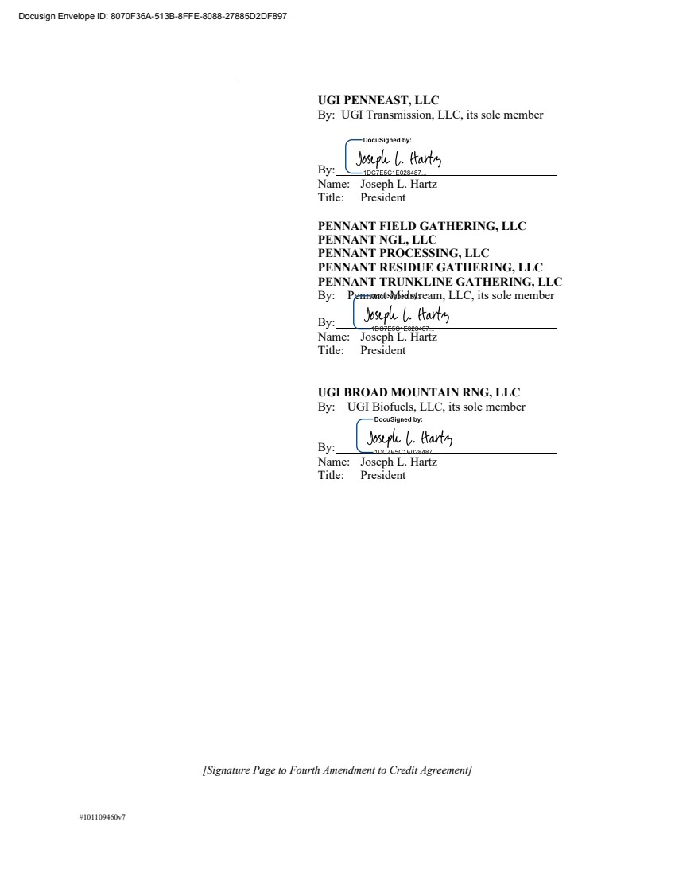 | [Signature Page to Fourth Amendment to Credit Agreement] #101109460v7 UGI PENNEAST, LLC By: UGI Transmission, LLC, its sole member By: Name: Joseph L. Hartz Title: President PENNANT FIELD GATHERING, LLC PENNANT NGL, LLC PENNANT PROCESSING, LLC PENNANT RESIDUE GATHERING, LLC PENNANT TRUNKLINE GATHERING, LLC By: Pennant Midstream, LLC, its sole member By: Name: Joseph L. Hartz Title: President UGI BROAD MOUNTAIN RNG, LLC By: UGI Biofuels, LLC, its sole member By: Name: Joseph L. Hartz Title: President Docusign Envelope ID: 8070F36A-513B-8FFE-8088-27885D2DF897
 | 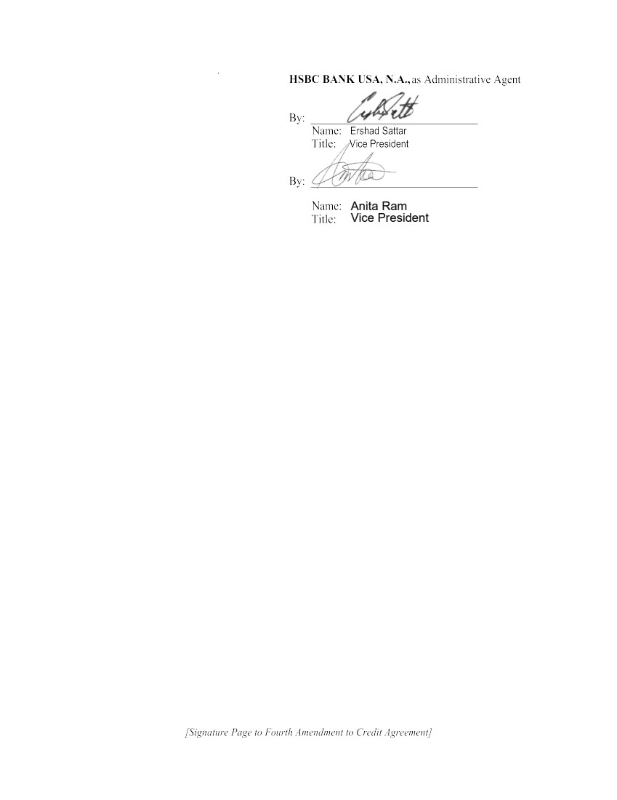 | Anita Ram Vice President
 | 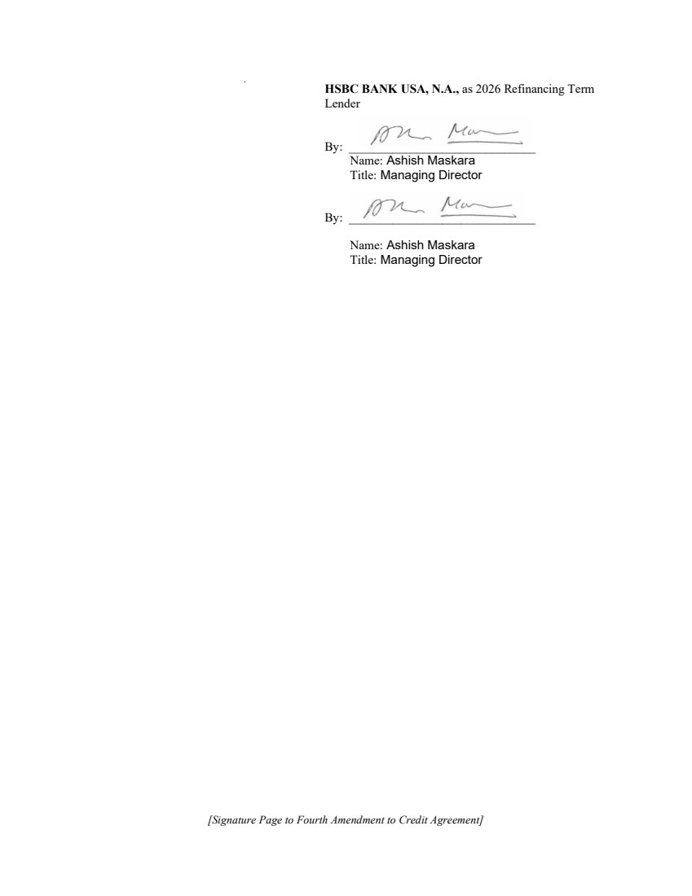 | [Signature Page to Fourth Amendment to Credit Agreement] HSBC BANK USA, N.A., as 2026 Refinancing Term Lender By: ______________________________ Name: Ashish Maskara Title: Managing Director By: ______________________________ Name: Ashish Maskara Title: Managing Director
 |  | #101109460v8 SCHEDULE I 2026 Refinancing Term Commitments 2026 Refinancing Term Lender 2026 Refinancing Term Commitment HSBC Bank USA, N.A. $ 27,453,140.35 Total: $ 27,453,140.35
 |  | #101109460v8 EXHIBIT A Amended Credit Agreement [See attached.]
 | 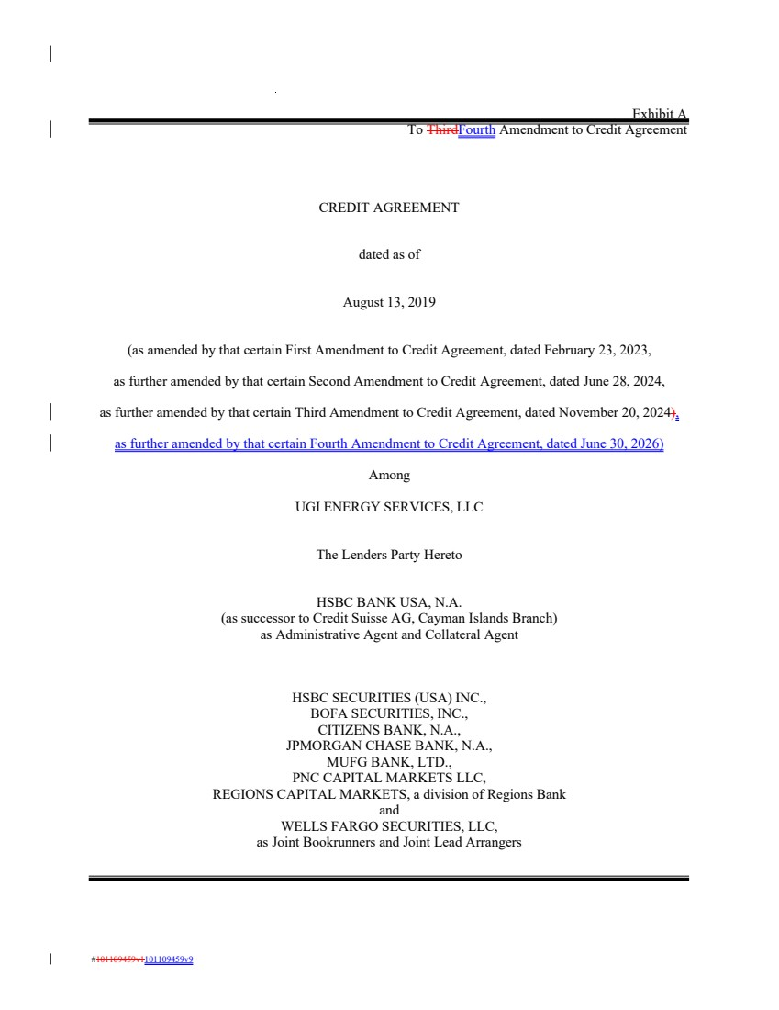 | #101109459v1101109459v9 Exhibit A To ThirdFourth Amendment to Credit Agreement CREDIT AGREEMENT dated as of August 13, 2019 (as amended by that certain First Amendment to Credit Agreement, dated February 23, 2023, as further amended by that certain Second Amendment to Credit Agreement, dated June 28, 2024, as further amended by that certain Third Amendment to Credit Agreement, dated November 20, 2024), as further amended by that certain Fourth Amendment to Credit Agreement, dated June 30, 2026) Among UGI ENERGY SERVICES, LLC The Lenders Party Hereto HSBC BANK USA, N.A. (as successor to Credit Suisse AG, Cayman Islands Branch) as Administrative Agent and Collateral Agent HSBC SECURITIES (USA) INC., BOFA SECURITIES, INC., CITIZENS BANK, N.A., JPMORGAN CHASE BANK, N.A., MUFG BANK, LTD., PNC CAPITAL MARKETS LLC, REGIONS CAPITAL MARKETS, a division of Regions Bank and WELLS FARGO SECURITIES, LLC, as Joint Bookrunners and Joint Lead Arrangers
 | 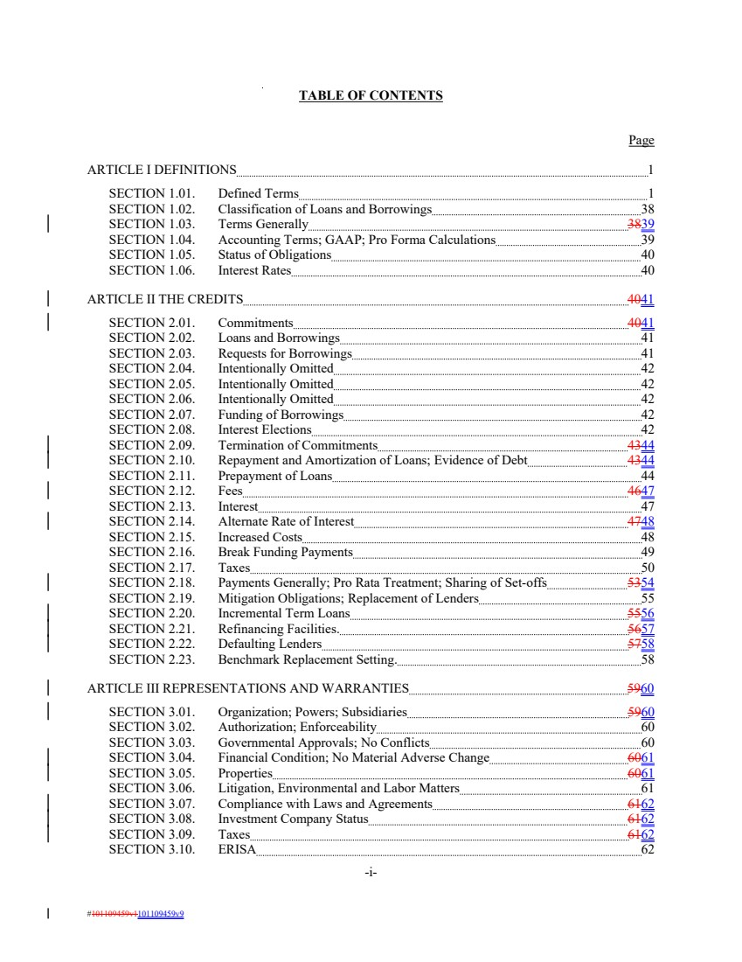 | TABLE OF CONTENTS Page ARTICLE I DEFINITIONS 1 SECTION 1.01. Defined Terms 1 SECTION 1.02. Classification of Loans and Borrowings 38 SECTION 1.03. Terms Generally 3839 SECTION 1.04. Accounting Terms; GAAP; Pro Forma Calculations 39 SECTION 1.05. Status of Obligations 40 SECTION 1.06. Interest Rates 40 ARTICLE II THE CREDITS 4041 SECTION 2.01. Commitments 4041 SECTION 2.02. Loans and Borrowings 41 SECTION 2.03. Requests for Borrowings 41 SECTION 2.04. Intentionally Omitted 42 SECTION 2.05. Intentionally Omitted 42 SECTION 2.06. Intentionally Omitted 42 SECTION 2.07. Funding of Borrowings 42 SECTION 2.08. Interest Elections 42 SECTION 2.09. Termination of Commitments 4344 SECTION 2.10. Repayment and Amortization of Loans; Evidence of Debt 4344 SECTION 2.11. Prepayment of Loans 44 SECTION 2.12. Fees 4647 SECTION 2.13. Interest 47 SECTION 2.14. Alternate Rate of Interest 4748 SECTION 2.15. Increased Costs 48 SECTION 2.16. Break Funding Payments 49 SECTION 2.17. Taxes 50 SECTION 2.18. Payments Generally; Pro Rata Treatment; Sharing of Set-offs 5354 SECTION 2.19. Mitigation Obligations; Replacement of Lenders 55 SECTION 2.20. Incremental Term Loans 5556 SECTION 2.21. Refinancing Facilities. 5657 SECTION 2.22. Defaulting Lenders 5758 SECTION 2.23. Benchmark Replacement Setting. 58 ARTICLE III REPRESENTATIONS AND WARRANTIES 5960 SECTION 3.01. Organization; Powers; Subsidiaries 5960 SECTION 3.02. Authorization; Enforceability 60 SECTION 3.03. Governmental Approvals; No Conflicts 60 SECTION 3.04. Financial Condition; No Material Adverse Change 6061 SECTION 3.05. Properties 6061 SECTION 3.06. Litigation, Environmental and Labor Matters 61 SECTION 3.07. Compliance with Laws and Agreements 6162 SECTION 3.08. Investment Company Status 6162 SECTION 3.09. Taxes 6162 SECTION 3.10. ERISA 62 -i- #101109459v1101109459v9
 | 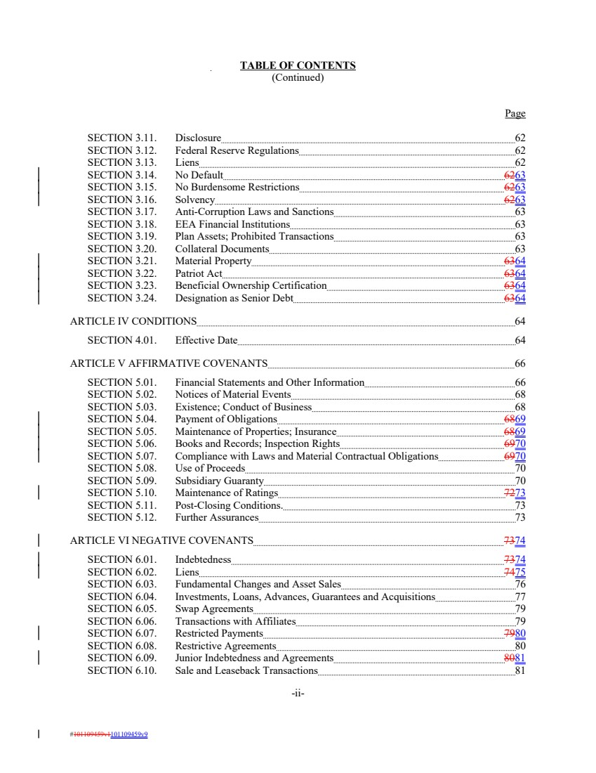 | TABLE OF CONTENTS (Continued) Page SECTION 3.11. Disclosure 62 SECTION 3.12. Federal Reserve Regulations 62 SECTION 3.13. Liens 62 SECTION 3.14. No Default 6263 SECTION 3.15. No Burdensome Restrictions 6263 SECTION 3.16. Solvency 6263 SECTION 3.17. Anti-Corruption Laws and Sanctions 63 SECTION 3.18. EEA Financial Institutions 63 SECTION 3.19. Plan Assets; Prohibited Transactions 63 SECTION 3.20. Collateral Documents 63 SECTION 3.21. Material Property 6364 SECTION 3.22. Patriot Act 6364 SECTION 3.23. Beneficial Ownership Certification 6364 SECTION 3.24. Designation as Senior Debt 6364 ARTICLE IV CONDITIONS 64 SECTION 4.01. Effective Date 64 ARTICLE V AFFIRMATIVE COVENANTS 66 SECTION 5.01. Financial Statements and Other Information 66 SECTION 5.02. Notices of Material Events 68 SECTION 5.03. Existence; Conduct of Business 68 SECTION 5.04. Payment of Obligations 6869 SECTION 5.05. Maintenance of Properties; Insurance 6869 SECTION 5.06. Books and Records; Inspection Rights 6970 SECTION 5.07. Compliance with Laws and Material Contractual Obligations 6970 SECTION 5.08. Use of Proceeds 70 SECTION 5.09. Subsidiary Guaranty 70 SECTION 5.10. Maintenance of Ratings 7273 SECTION 5.11. Post-Closing Conditions. 73 SECTION 5.12. Further Assurances 73 ARTICLE VI NEGATIVE COVENANTS 7374 SECTION 6.01. Indebtedness 7374 SECTION 6.02. Liens 7475 SECTION 6.03. Fundamental Changes and Asset Sales 76 SECTION 6.04. Investments, Loans, Advances, Guarantees and Acquisitions 77 SECTION 6.05. Swap Agreements 79 SECTION 6.06. Transactions with Affiliates 79 SECTION 6.07. Restricted Payments 7980 SECTION 6.08. Restrictive Agreements 80 SECTION 6.09. Junior Indebtedness and Agreements 8081 SECTION 6.10. Sale and Leaseback Transactions 81 -ii- #101109459v1101109459v9
 | 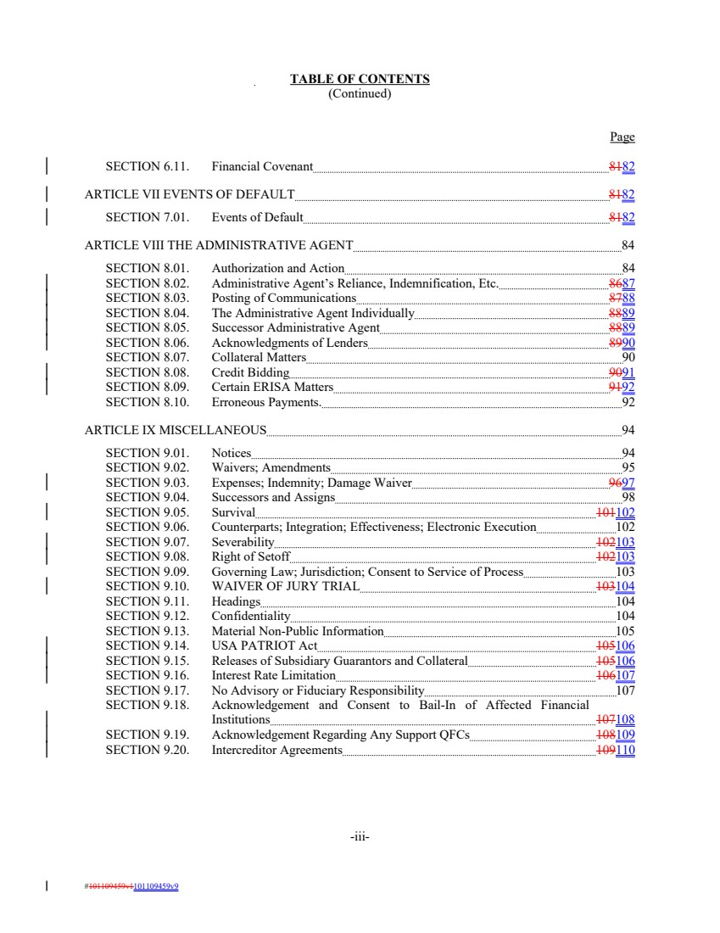 | TABLE OF CONTENTS (Continued) Page SECTION 6.11. Financial Covenant 8182 ARTICLE VII EVENTS OF DEFAULT 8182 SECTION 7.01. Events of Default 8182 ARTICLE VIII THE ADMINISTRATIVE AGENT 84 SECTION 8.01. Authorization and Action 84 SECTION 8.02. Administrative Agent’s Reliance, Indemnification, Etc. 8687 SECTION 8.03. Posting of Communications 8788 SECTION 8.04. The Administrative Agent Individually 8889 SECTION 8.05. Successor Administrative Agent 8889 SECTION 8.06. Acknowledgments of Lenders 8990 SECTION 8.07. Collateral Matters 90 SECTION 8.08. Credit Bidding 9091 SECTION 8.09. Certain ERISA Matters 9192 SECTION 8.10. Erroneous Payments. 92 ARTICLE IX MISCELLANEOUS 94 SECTION 9.01. Notices 94 SECTION 9.02. Waivers; Amendments 95 SECTION 9.03. Expenses; Indemnity; Damage Waiver 9697 SECTION 9.04. Successors and Assigns 98 SECTION 9.05. Survival 101102 SECTION 9.06. Counterparts; Integration; Effectiveness; Electronic Execution 102 SECTION 9.07. Severability 102103 SECTION 9.08. Right of Setoff 102103 SECTION 9.09. Governing Law; Jurisdiction; Consent to Service of Process 103 SECTION 9.10. WAIVER OF JURY TRIAL 103104 SECTION 9.11. Headings 104 SECTION 9.12. Confidentiality 104 SECTION 9.13. Material Non-Public Information 105 SECTION 9.14. USA PATRIOT Act 105106 SECTION 9.15. Releases of Subsidiary Guarantors and Collateral 105106 SECTION 9.16. Interest Rate Limitation 106107 SECTION 9.17. No Advisory or Fiduciary Responsibility 107 SECTION 9.18. Acknowledgement and Consent to Bail-In of Affected Financial Institutions 107108 SECTION 9.19. Acknowledgement Regarding Any Support QFCs 108109 SECTION 9.20. Intercreditor Agreements 109110 -iii- #101109459v1101109459v9
 |  | TABLE OF CONTENTS (Continued) SCHEDULES: Schedule 2.01 – Commitments Schedule 3.01 – Subsidiaries Schedule 5.09 – Certain Mortgaged Properties Schedule 6.01 – Existing Indebtedness Schedule 6.02 – Existing Liens Schedule 6.04 – Existing Investments Schedule 6.06 – Existing Affiliate Transactions EXHIBITS: Exhibit A – Form of Assignment and Assumption Exhibit B – Subordination Terms Exhibit C-1 – Form of U.S. Tax Compliance Certificate (Foreign Lenders That Are Not Partnerships) Exhibit C-2 – Form of U.S. Tax Compliance Certificate (Foreign Participants That Are Not Partnerships) Exhibit C-3 – Form of U.S. Tax Compliance Certificate (Foreign Participants That Are Partnerships) Exhibit C-4 – Form of U.S. Tax Compliance Certificate (Foreign Lenders That Are Partnerships) Exhibit D – Form of Borrowing Request Exhibit E – Form of Interest Election Request Exhibit F – [Reserved] Exhibit G – Form of Solvency Certificate Exhibit H – Form of First Lien/First Lien Intercreditor Agreement Exhibit I – Form of First Lien/Second Lien Intercreditor Agreement Exhibit J – Form of Subsidiary Guaranty Exhibit K – Form of Security Agreement Exhibit L – Form of Perfection Certificate Exhibit M – Form of Perfection Certificate Supplement -i- #101109459v1101109459v9
 | 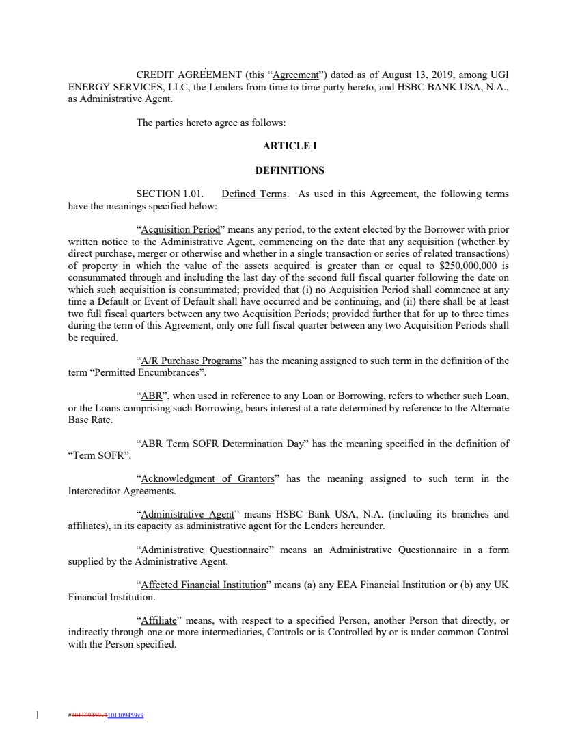 | CREDIT AGREEMENT (this “Agreement”) dated as of August 13, 2019, among UGI ENERGY SERVICES, LLC, the Lenders from time to time party hereto, and HSBC BANK USA, N.A., as Administrative Agent. The parties hereto agree as follows: ARTICLE I DEFINITIONS SECTION 1.01. Defined Terms. As used in this Agreement, the following terms have the meanings specified below: “Acquisition Period” means any period, to the extent elected by the Borrower with prior written notice to the Administrative Agent, commencing on the date that any acquisition (whether by direct purchase, merger or otherwise and whether in a single transaction or series of related transactions) of property in which the value of the assets acquired is greater than or equal to $250,000,000 is consummated through and including the last day of the second full fiscal quarter following the date on which such acquisition is consummated; provided that (i) no Acquisition Period shall commence at any time a Default or Event of Default shall have occurred and be continuing, and (ii) there shall be at least two full fiscal quarters between any two Acquisition Periods; provided further that for up to three times during the term of this Agreement, only one full fiscal quarter between any two Acquisition Periods shall be required. “A/R Purchase Programs” has the meaning assigned to such term in the definition of the term “Permitted Encumbrances”. “ABR”, when used in reference to any Loan or Borrowing, refers to whether such Loan, or the Loans comprising such Borrowing, bears interest at a rate determined by reference to the Alternate Base Rate. “ABR Term SOFR Determination Day” has the meaning specified in the definition of “Term SOFR”. “Acknowledgment of Grantors” has the meaning assigned to such term in the Intercreditor Agreements. “Administrative Agent” means HSBC Bank USA, N.A. (including its branches and affiliates), in its capacity as administrative agent for the Lenders hereunder. “Administrative Questionnaire” means an Administrative Questionnaire in a form supplied by the Administrative Agent. “Affected Financial Institution” means (a) any EEA Financial Institution or (b) any UK Financial Institution. “Affiliate” means, with respect to a specified Person, another Person that directly, or indirectly through one or more intermediaries, Controls or is Controlled by or is under common Control with the Person specified. #101109459v1101109459v9
 | 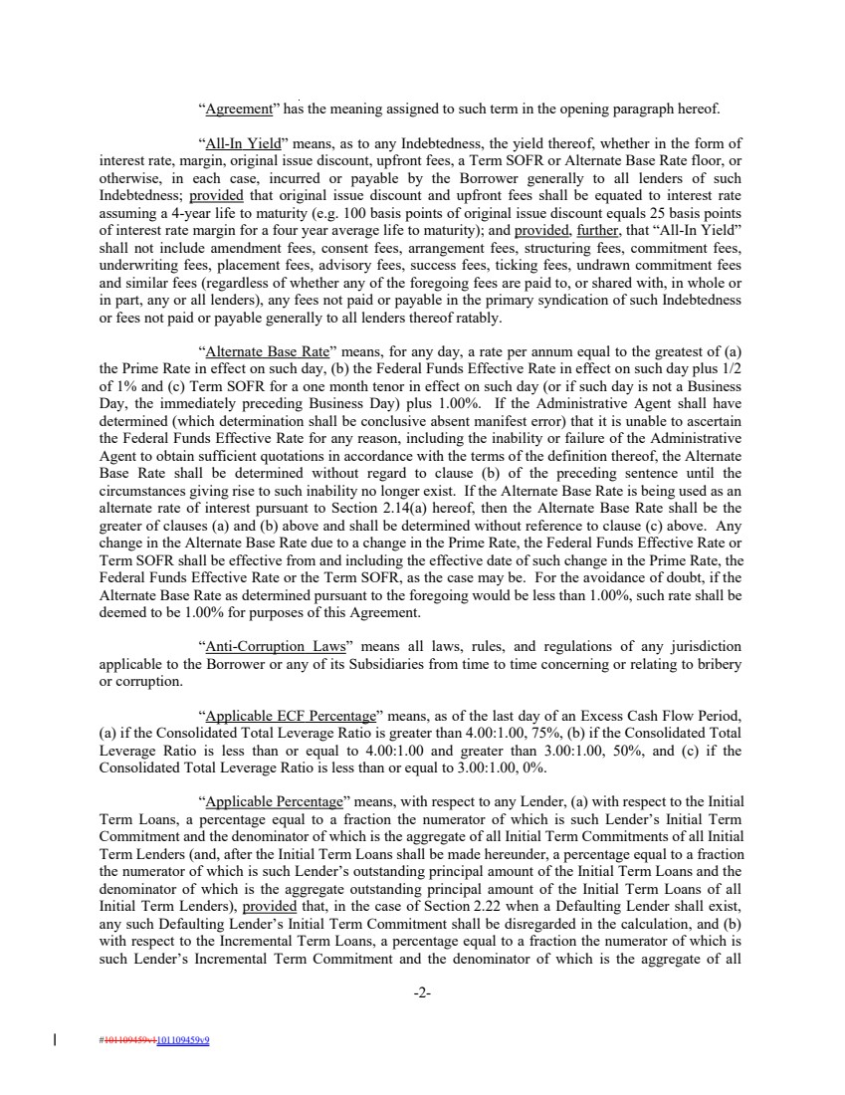 | “Agreement” has the meaning assigned to such term in the opening paragraph hereof. “All-In Yield” means, as to any Indebtedness, the yield thereof, whether in the form of interest rate, margin, original issue discount, upfront fees, a Term SOFR or Alternate Base Rate floor, or otherwise, in each case, incurred or payable by the Borrower generally to all lenders of such Indebtedness; provided that original issue discount and upfront fees shall be equated to interest rate assuming a 4-year life to maturity (e.g. 100 basis points of original issue discount equals 25 basis points of interest rate margin for a four year average life to maturity); and provided, further, that “All-In Yield” shall not include amendment fees, consent fees, arrangement fees, structuring fees, commitment fees, underwriting fees, placement fees, advisory fees, success fees, ticking fees, undrawn commitment fees and similar fees (regardless of whether any of the foregoing fees are paid to, or shared with, in whole or in part, any or all lenders), any fees not paid or payable in the primary syndication of such Indebtedness or fees not paid or payable generally to all lenders thereof ratably. “Alternate Base Rate” means, for any day, a rate per annum equal to the greatest of (a) the Prime Rate in effect on such day, (b) the Federal Funds Effective Rate in effect on such day plus 1/2 of 1% and (c) Term SOFR for a one month tenor in effect on such day (or if such day is not a Business Day, the immediately preceding Business Day) plus 1.00%. If the Administrative Agent shall have determined (which determination shall be conclusive absent manifest error) that it is unable to ascertain the Federal Funds Effective Rate for any reason, including the inability or failure of the Administrative Agent to obtain sufficient quotations in accordance with the terms of the definition thereof, the Alternate Base Rate shall be determined without regard to clause (b) of the preceding sentence until the circumstances giving rise to such inability no longer exist. If the Alternate Base Rate is being used as an alternate rate of interest pursuant to Section 2.14(a) hereof, then the Alternate Base Rate shall be the greater of clauses (a) and (b) above and shall be determined without reference to clause (c) above. Any change in the Alternate Base Rate due to a change in the Prime Rate, the Federal Funds Effective Rate or Term SOFR shall be effective from and including the effective date of such change in the Prime Rate, the Federal Funds Effective Rate or the Term SOFR, as the case may be. For the avoidance of doubt, if the Alternate Base Rate as determined pursuant to the foregoing would be less than 1.00%, such rate shall be deemed to be 1.00% for purposes of this Agreement. “Anti-Corruption Laws” means all laws, rules, and regulations of any jurisdiction applicable to the Borrower or any of its Subsidiaries from time to time concerning or relating to bribery or corruption. “Applicable ECF Percentage” means, as of the last day of an Excess Cash Flow Period, (a) if the Consolidated Total Leverage Ratio is greater than 4.00:1.00, 75%, (b) if the Consolidated Total Leverage Ratio is less than or equal to 4.00:1.00 and greater than 3.00:1.00, 50%, and (c) if the Consolidated Total Leverage Ratio is less than or equal to 3.00:1.00, 0%. “Applicable Percentage” means, with respect to any Lender, (a) with respect to the Initial Term Loans, a percentage equal to a fraction the numerator of which is such Lender’s Initial Term Commitment and the denominator of which is the aggregate of all Initial Term Commitments of all Initial Term Lenders (and, after the Initial Term Loans shall be made hereunder, a percentage equal to a fraction the numerator of which is such Lender’s outstanding principal amount of the Initial Term Loans and the denominator of which is the aggregate outstanding principal amount of the Initial Term Loans of all Initial Term Lenders), provided that, in the case of Section 2.22 when a Defaulting Lender shall exist, any such Defaulting Lender’s Initial Term Commitment shall be disregarded in the calculation, and (b) with respect to the Incremental Term Loans, a percentage equal to a fraction the numerator of which is such Lender’s Incremental Term Commitment and the denominator of which is the aggregate of all -2- #101109459v1101109459v9
 | 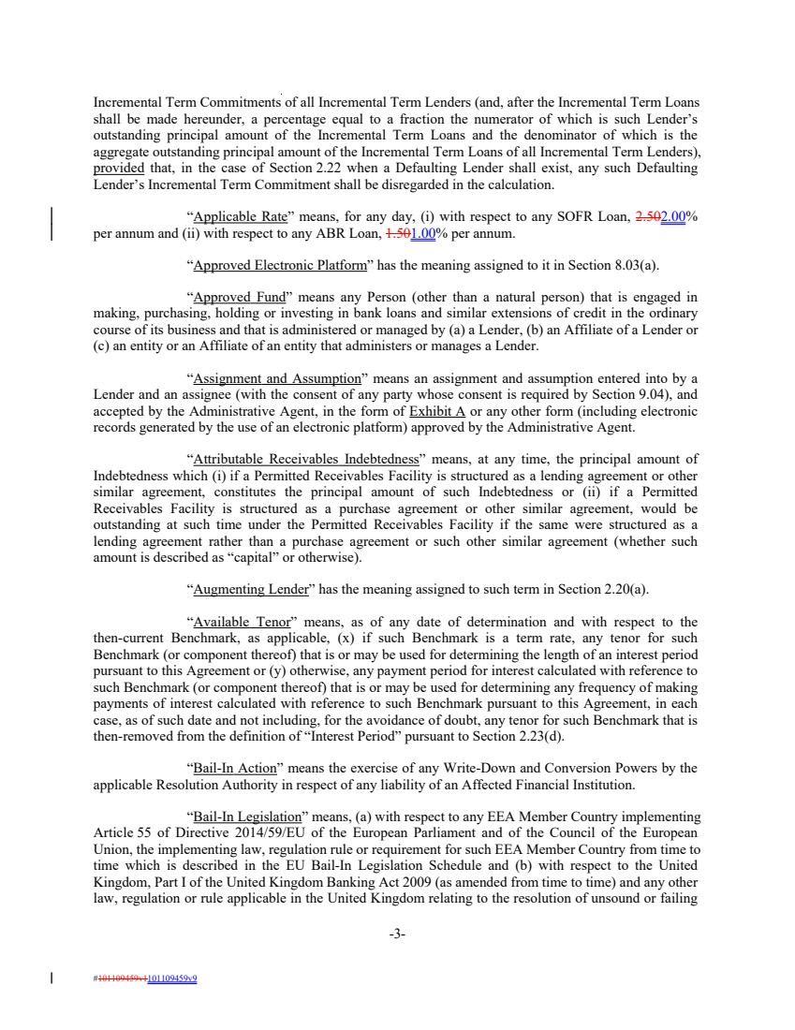 | Incremental Term Commitments of all Incremental Term Lenders (and, after the Incremental Term Loans shall be made hereunder, a percentage equal to a fraction the numerator of which is such Lender’s outstanding principal amount of the Incremental Term Loans and the denominator of which is the aggregate outstanding principal amount of the Incremental Term Loans of all Incremental Term Lenders), provided that, in the case of Section 2.22 when a Defaulting Lender shall exist, any such Defaulting Lender’s Incremental Term Commitment shall be disregarded in the calculation. “Applicable Rate” means, for any day, (i) with respect to any SOFR Loan, 2.502.00% per annum and (ii) with respect to any ABR Loan, 1.501.00% per annum. “Approved Electronic Platform” has the meaning assigned to it in Section 8.03(a). “Approved Fund” means any Person (other than a natural person) that is engaged in making, purchasing, holding or investing in bank loans and similar extensions of credit in the ordinary course of its business and that is administered or managed by (a) a Lender, (b) an Affiliate of a Lender or (c) an entity or an Affiliate of an entity that administers or manages a Lender. “Assignment and Assumption” means an assignment and assumption entered into by a Lender and an assignee (with the consent of any party whose consent is required by Section 9.04), and accepted by the Administrative Agent, in the form of Exhibit A or any other form (including electronic records generated by the use of an electronic platform) approved by the Administrative Agent. “Attributable Receivables Indebtedness” means, at any time, the principal amount of Indebtedness which (i) if a Permitted Receivables Facility is structured as a lending agreement or other similar agreement, constitutes the principal amount of such Indebtedness or (ii) if a Permitted Receivables Facility is structured as a purchase agreement or other similar agreement, would be outstanding at such time under the Permitted Receivables Facility if the same were structured as a lending agreement rather than a purchase agreement or such other similar agreement (whether such amount is described as “capital” or otherwise). “Augmenting Lender” has the meaning assigned to such term in Section 2.20(a). “Available Tenor” means, as of any date of determination and with respect to the then-current Benchmark, as applicable, (x) if such Benchmark is a term rate, any tenor for such Benchmark (or component thereof) that is or may be used for determining the length of an interest period pursuant to this Agreement or (y) otherwise, any payment period for interest calculated with reference to such Benchmark (or component thereof) that is or may be used for determining any frequency of making payments of interest calculated with reference to such Benchmark pursuant to this Agreement, in each case, as of such date and not including, for the avoidance of doubt, any tenor for such Benchmark that is then-removed from the definition of “Interest Period” pursuant to Section 2.23(d). “Bail-In Action” means the exercise of any Write-Down and Conversion Powers by the applicable Resolution Authority in respect of any liability of an Affected Financial Institution. “Bail-In Legislation” means, (a) with respect to any EEA Member Country implementing Article 55 of Directive 2014/59/EU of the European Parliament and of the Council of the European Union, the implementing law, regulation rule or requirement for such EEA Member Country from time to time which is described in the EU Bail-In Legislation Schedule and (b) with respect to the United Kingdom, Part I of the United Kingdom Banking Act 2009 (as amended from time to time) and any other law, regulation or rule applicable in the United Kingdom relating to the resolution of unsound or failing -3- #101109459v1101109459v9
 | 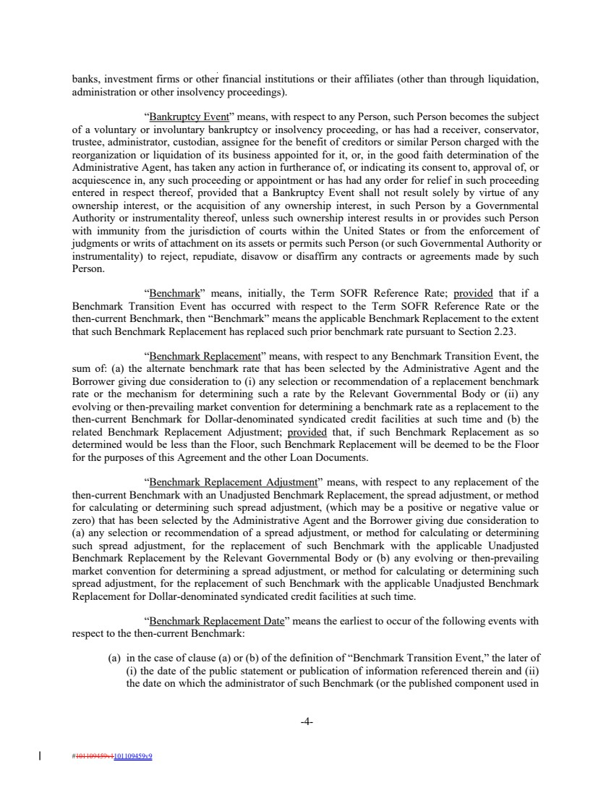 | banks, investment firms or other financial institutions or their affiliates (other than through liquidation, administration or other insolvency proceedings). “Bankruptcy Event” means, with respect to any Person, such Person becomes the subject of a voluntary or involuntary bankruptcy or insolvency proceeding, or has had a receiver, conservator, trustee, administrator, custodian, assignee for the benefit of creditors or similar Person charged with the reorganization or liquidation of its business appointed for it, or, in the good faith determination of the Administrative Agent, has taken any action in furtherance of, or indicating its consent to, approval of, or acquiescence in, any such proceeding or appointment or has had any order for relief in such proceeding entered in respect thereof, provided that a Bankruptcy Event shall not result solely by virtue of any ownership interest, or the acquisition of any ownership interest, in such Person by a Governmental Authority or instrumentality thereof, unless such ownership interest results in or provides such Person with immunity from the jurisdiction of courts within the United States or from the enforcement of judgments or writs of attachment on its assets or permits such Person (or such Governmental Authority or instrumentality) to reject, repudiate, disavow or disaffirm any contracts or agreements made by such Person. “Benchmark” means, initially, the Term SOFR Reference Rate; provided that if a Benchmark Transition Event has occurred with respect to the Term SOFR Reference Rate or the then-current Benchmark, then “Benchmark” means the applicable Benchmark Replacement to the extent that such Benchmark Replacement has replaced such prior benchmark rate pursuant to Section 2.23. “Benchmark Replacement” means, with respect to any Benchmark Transition Event, the sum of: (a) the alternate benchmark rate that has been selected by the Administrative Agent and the Borrower giving due consideration to (i) any selection or recommendation of a replacement benchmark rate or the mechanism for determining such a rate by the Relevant Governmental Body or (ii) any evolving or then-prevailing market convention for determining a benchmark rate as a replacement to the then-current Benchmark for Dollar-denominated syndicated credit facilities at such time and (b) the related Benchmark Replacement Adjustment; provided that, if such Benchmark Replacement as so determined would be less than the Floor, such Benchmark Replacement will be deemed to be the Floor for the purposes of this Agreement and the other Loan Documents. “Benchmark Replacement Adjustment” means, with respect to any replacement of the then-current Benchmark with an Unadjusted Benchmark Replacement, the spread adjustment, or method for calculating or determining such spread adjustment, (which may be a positive or negative value or zero) that has been selected by the Administrative Agent and the Borrower giving due consideration to (a) any selection or recommendation of a spread adjustment, or method for calculating or determining such spread adjustment, for the replacement of such Benchmark with the applicable Unadjusted Benchmark Replacement by the Relevant Governmental Body or (b) any evolving or then-prevailing market convention for determining a spread adjustment, or method for calculating or determining such spread adjustment, for the replacement of such Benchmark with the applicable Unadjusted Benchmark Replacement for Dollar-denominated syndicated credit facilities at such time. “Benchmark Replacement Date” means the earliest to occur of the following events with respect to the then-current Benchmark: (a) in the case of clause (a) or (b) of the definition of “Benchmark Transition Event,” the later of (i) the date of the public statement or publication of information referenced therein and (ii) the date on which the administrator of such Benchmark (or the published component used in -4- #101109459v1101109459v9
 | 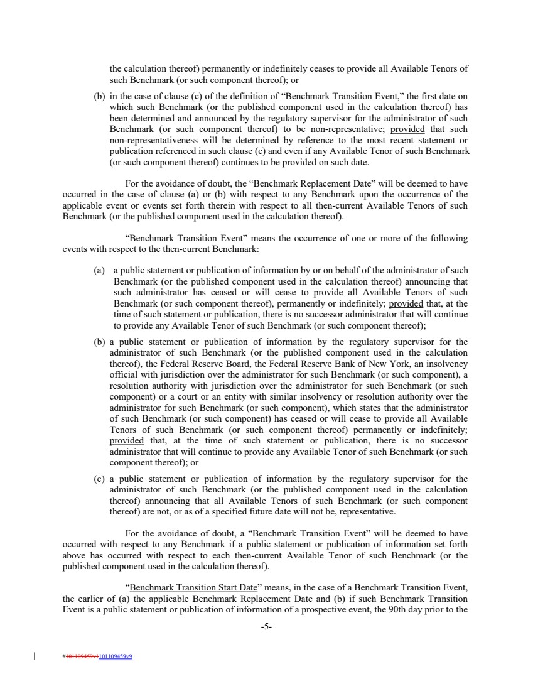 | the calculation thereof) permanently or indefinitely ceases to provide all Available Tenors of such Benchmark (or such component thereof); or (b) in the case of clause (c) of the definition of “Benchmark Transition Event,” the first date on which such Benchmark (or the published component used in the calculation thereof) has been determined and announced by the regulatory supervisor for the administrator of such Benchmark (or such component thereof) to be non-representative; provided that such non-representativeness will be determined by reference to the most recent statement or publication referenced in such clause (c) and even if any Available Tenor of such Benchmark (or such component thereof) continues to be provided on such date. For the avoidance of doubt, the “Benchmark Replacement Date” will be deemed to have occurred in the case of clause (a) or (b) with respect to any Benchmark upon the occurrence of the applicable event or events set forth therein with respect to all then-current Available Tenors of such Benchmark (or the published component used in the calculation thereof). “Benchmark Transition Event” means the occurrence of one or more of the following events with respect to the then-current Benchmark: (a) a public statement or publication of information by or on behalf of the administrator of such Benchmark (or the published component used in the calculation thereof) announcing that such administrator has ceased or will cease to provide all Available Tenors of such Benchmark (or such component thereof), permanently or indefinitely; provided that, at the time of such statement or publication, there is no successor administrator that will continue to provide any Available Tenor of such Benchmark (or such component thereof); (b) a public statement or publication of information by the regulatory supervisor for the administrator of such Benchmark (or the published component used in the calculation thereof), the Federal Reserve Board, the Federal Reserve Bank of New York, an insolvency official with jurisdiction over the administrator for such Benchmark (or such component), a resolution authority with jurisdiction over the administrator for such Benchmark (or such component) or a court or an entity with similar insolvency or resolution authority over the administrator for such Benchmark (or such component), which states that the administrator of such Benchmark (or such component) has ceased or will cease to provide all Available Tenors of such Benchmark (or such component thereof) permanently or indefinitely; provided that, at the time of such statement or publication, there is no successor administrator that will continue to provide any Available Tenor of such Benchmark (or such component thereof); or (c) a public statement or publication of information by the regulatory supervisor for the administrator of such Benchmark (or the published component used in the calculation thereof) announcing that all Available Tenors of such Benchmark (or such component thereof) are not, or as of a specified future date will not be, representative. For the avoidance of doubt, a “Benchmark Transition Event” will be deemed to have occurred with respect to any Benchmark if a public statement or publication of information set forth above has occurred with respect to each then-current Available Tenor of such Benchmark (or the published component used in the calculation thereof). “Benchmark Transition Start Date” means, in the case of a Benchmark Transition Event, the earlier of (a) the applicable Benchmark Replacement Date and (b) if such Benchmark Transition Event is a public statement or publication of information of a prospective event, the 90th day prior to the -5- #101109459v1101109459v9
 | 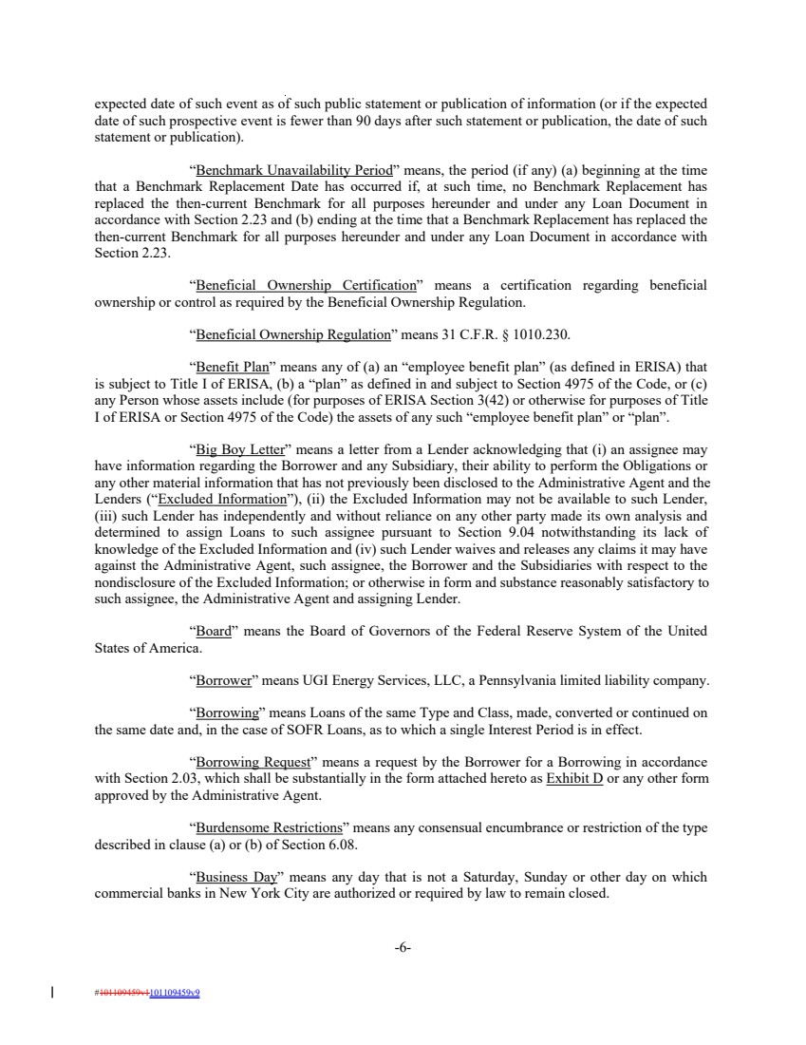 | expected date of such event as of such public statement or publication of information (or if the expected date of such prospective event is fewer than 90 days after such statement or publication, the date of such statement or publication). “Benchmark Unavailability Period” means, the period (if any) (a) beginning at the time that a Benchmark Replacement Date has occurred if, at such time, no Benchmark Replacement has replaced the then-current Benchmark for all purposes hereunder and under any Loan Document in accordance with Section 2.23 and (b) ending at the time that a Benchmark Replacement has replaced the then-current Benchmark for all purposes hereunder and under any Loan Document in accordance with Section 2.23. “Beneficial Ownership Certification” means a certification regarding beneficial ownership or control as required by the Beneficial Ownership Regulation. “Beneficial Ownership Regulation” means 31 C.F.R. § 1010.230. “Benefit Plan” means any of (a) an “employee benefit plan” (as defined in ERISA) that is subject to Title I of ERISA, (b) a “plan” as defined in and subject to Section 4975 of the Code, or (c) any Person whose assets include (for purposes of ERISA Section 3(42) or otherwise for purposes of Title I of ERISA or Section 4975 of the Code) the assets of any such “employee benefit plan” or “plan”. “Big Boy Letter” means a letter from a Lender acknowledging that (i) an assignee may have information regarding the Borrower and any Subsidiary, their ability to perform the Obligations or any other material information that has not previously been disclosed to the Administrative Agent and the Lenders (“Excluded Information”), (ii) the Excluded Information may not be available to such Lender, (iii) such Lender has independently and without reliance on any other party made its own analysis and determined to assign Loans to such assignee pursuant to Section 9.04 notwithstanding its lack of knowledge of the Excluded Information and (iv) such Lender waives and releases any claims it may have against the Administrative Agent, such assignee, the Borrower and the Subsidiaries with respect to the nondisclosure of the Excluded Information; or otherwise in form and substance reasonably satisfactory to such assignee, the Administrative Agent and assigning Lender. “Board” means the Board of Governors of the Federal Reserve System of the United States of America. “Borrower” means UGI Energy Services, LLC, a Pennsylvania limited liability company. “Borrowing” means Loans of the same Type and Class, made, converted or continued on the same date and, in the case of SOFR Loans, as to which a single Interest Period is in effect. “Borrowing Request” means a request by the Borrower for a Borrowing in accordance with Section 2.03, which shall be substantially in the form attached hereto as Exhibit D or any other form approved by the Administrative Agent. “Burdensome Restrictions” means any consensual encumbrance or restriction of the type described in clause (a) or (b) of Section 6.08. “Business Day” means any day that is not a Saturday, Sunday or other day on which commercial banks in New York City are authorized or required by law to remain closed. -6- #101109459v1101109459v9
 | 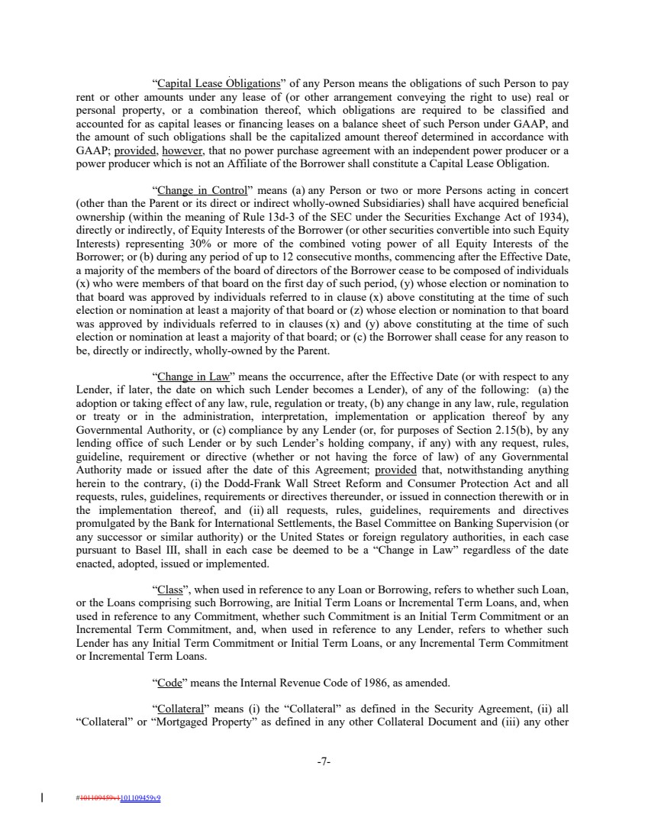 | “Capital Lease Obligations” of any Person means the obligations of such Person to pay rent or other amounts under any lease of (or other arrangement conveying the right to use) real or personal property, or a combination thereof, which obligations are required to be classified and accounted for as capital leases or financing leases on a balance sheet of such Person under GAAP, and the amount of such obligations shall be the capitalized amount thereof determined in accordance with GAAP; provided, however, that no power purchase agreement with an independent power producer or a power producer which is not an Affiliate of the Borrower shall constitute a Capital Lease Obligation. “Change in Control” means (a) any Person or two or more Persons acting in concert (other than the Parent or its direct or indirect wholly-owned Subsidiaries) shall have acquired beneficial ownership (within the meaning of Rule 13d-3 of the SEC under the Securities Exchange Act of 1934), directly or indirectly, of Equity Interests of the Borrower (or other securities convertible into such Equity Interests) representing 30% or more of the combined voting power of all Equity Interests of the Borrower; or (b) during any period of up to 12 consecutive months, commencing after the Effective Date, a majority of the members of the board of directors of the Borrower cease to be composed of individuals (x) who were members of that board on the first day of such period, (y) whose election or nomination to that board was approved by individuals referred to in clause (x) above constituting at the time of such election or nomination at least a majority of that board or (z) whose election or nomination to that board was approved by individuals referred to in clauses (x) and (y) above constituting at the time of such election or nomination at least a majority of that board; or (c) the Borrower shall cease for any reason to be, directly or indirectly, wholly-owned by the Parent. “Change in Law” means the occurrence, after the Effective Date (or with respect to any Lender, if later, the date on which such Lender becomes a Lender), of any of the following: (a) the adoption or taking effect of any law, rule, regulation or treaty, (b) any change in any law, rule, regulation or treaty or in the administration, interpretation, implementation or application thereof by any Governmental Authority, or (c) compliance by any Lender (or, for purposes of Section 2.15(b), by any lending office of such Lender or by such Lender’s holding company, if any) with any request, rules, guideline, requirement or directive (whether or not having the force of law) of any Governmental Authority made or issued after the date of this Agreement; provided that, notwithstanding anything herein to the contrary, (i) the Dodd-Frank Wall Street Reform and Consumer Protection Act and all requests, rules, guidelines, requirements or directives thereunder, or issued in connection therewith or in the implementation thereof, and (ii) all requests, rules, guidelines, requirements and directives promulgated by the Bank for International Settlements, the Basel Committee on Banking Supervision (or any successor or similar authority) or the United States or foreign regulatory authorities, in each case pursuant to Basel III, shall in each case be deemed to be a “Change in Law” regardless of the date enacted, adopted, issued or implemented. “Class”, when used in reference to any Loan or Borrowing, refers to whether such Loan, or the Loans comprising such Borrowing, are Initial Term Loans or Incremental Term Loans, and, when used in reference to any Commitment, whether such Commitment is an Initial Term Commitment or an Incremental Term Commitment, and, when used in reference to any Lender, refers to whether such Lender has any Initial Term Commitment or Initial Term Loans, or any Incremental Term Commitment or Incremental Term Loans. “Code” means the Internal Revenue Code of 1986, as amended. “Collateral” means (i) the “Collateral” as defined in the Security Agreement, (ii) all “Collateral” or “Mortgaged Property” as defined in any other Collateral Document and (iii) any other -7- #101109459v1101109459v9
 | 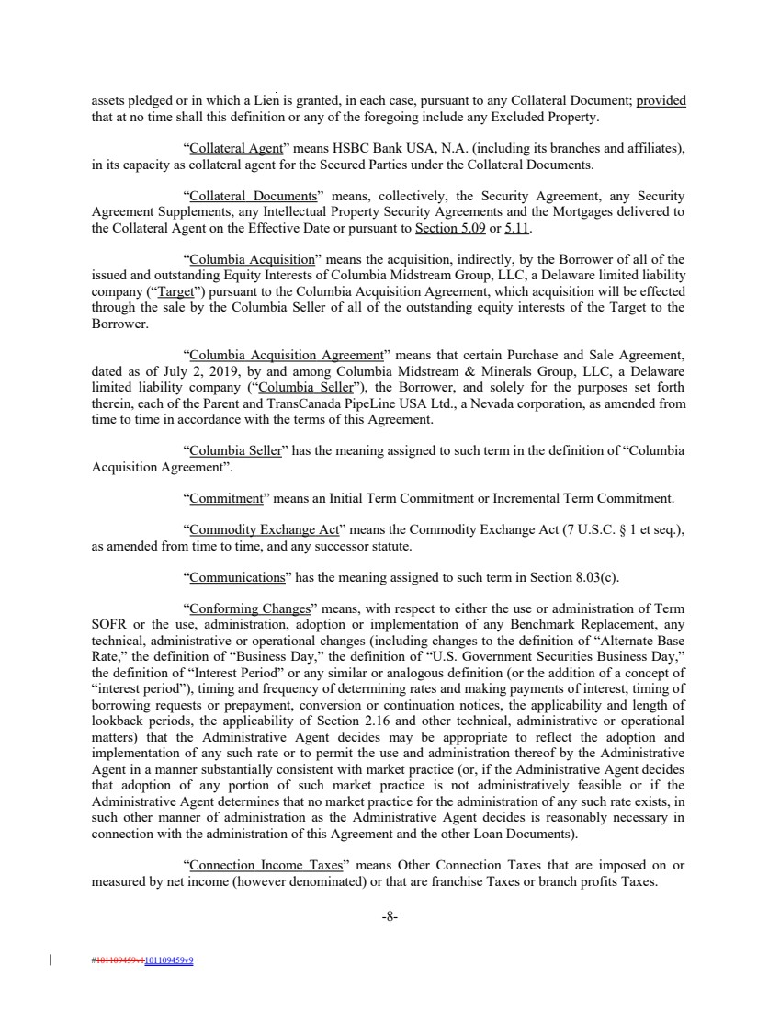 | assets pledged or in which a Lien is granted, in each case, pursuant to any Collateral Document; provided that at no time shall this definition or any of the foregoing include any Excluded Property. “Collateral Agent” means HSBC Bank USA, N.A. (including its branches and affiliates), in its capacity as collateral agent for the Secured Parties under the Collateral Documents. “Collateral Documents” means, collectively, the Security Agreement, any Security Agreement Supplements, any Intellectual Property Security Agreements and the Mortgages delivered to the Collateral Agent on the Effective Date or pursuant to Section 5.09 or 5.11. “Columbia Acquisition” means the acquisition, indirectly, by the Borrower of all of the issued and outstanding Equity Interests of Columbia Midstream Group, LLC, a Delaware limited liability company (“Target”) pursuant to the Columbia Acquisition Agreement, which acquisition will be effected through the sale by the Columbia Seller of all of the outstanding equity interests of the Target to the Borrower. “Columbia Acquisition Agreement” means that certain Purchase and Sale Agreement, dated as of July 2, 2019, by and among Columbia Midstream & Minerals Group, LLC, a Delaware limited liability company (“Columbia Seller”), the Borrower, and solely for the purposes set forth therein, each of the Parent and TransCanada PipeLine USA Ltd., a Nevada corporation, as amended from time to time in accordance with the terms of this Agreement. “Columbia Seller” has the meaning assigned to such term in the definition of “Columbia Acquisition Agreement”. “Commitment” means an Initial Term Commitment or Incremental Term Commitment. “Commodity Exchange Act” means the Commodity Exchange Act (7 U.S.C. § 1 et seq.), as amended from time to time, and any successor statute. “Communications” has the meaning assigned to such term in Section 8.03(c). “Conforming Changes” means, with respect to either the use or administration of Term SOFR or the use, administration, adoption or implementation of any Benchmark Replacement, any technical, administrative or operational changes (including changes to the definition of “Alternate Base Rate,” the definition of “Business Day,” the definition of “U.S. Government Securities Business Day,” the definition of “Interest Period” or any similar or analogous definition (or the addition of a concept of “interest period”), timing and frequency of determining rates and making payments of interest, timing of borrowing requests or prepayment, conversion or continuation notices, the applicability and length of lookback periods, the applicability of Section 2.16 and other technical, administrative or operational matters) that the Administrative Agent decides may be appropriate to reflect the adoption and implementation of any such rate or to permit the use and administration thereof by the Administrative Agent in a manner substantially consistent with market practice (or, if the Administrative Agent decides that adoption of any portion of such market practice is not administratively feasible or if the Administrative Agent determines that no market practice for the administration of any such rate exists, in such other manner of administration as the Administrative Agent decides is reasonably necessary in connection with the administration of this Agreement and the other Loan Documents). “Connection Income Taxes” means Other Connection Taxes that are imposed on or measured by net income (however denominated) or that are franchise Taxes or branch profits Taxes. -8- #101109459v1101109459v9
 | 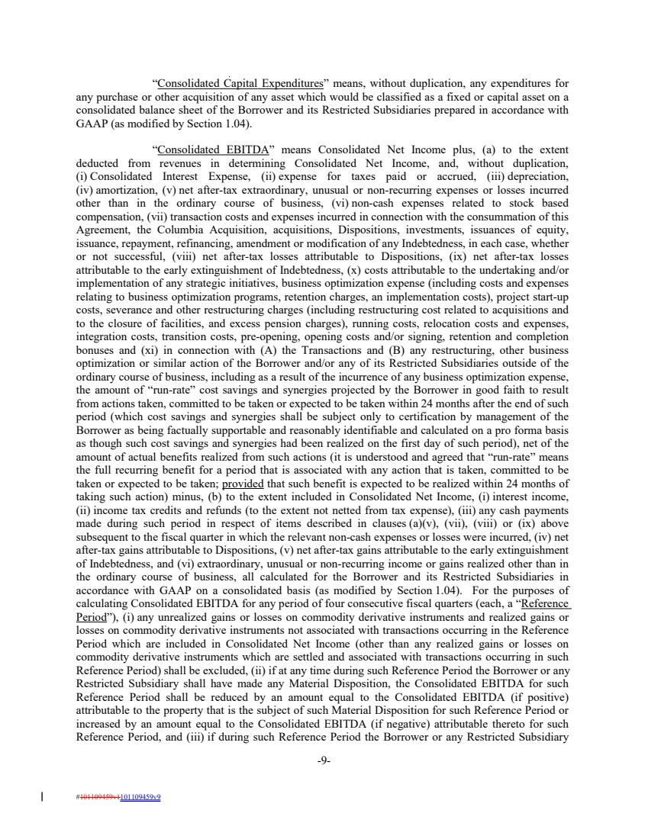 | “Consolidated Capital Expenditures” means, without duplication, any expenditures for any purchase or other acquisition of any asset which would be classified as a fixed or capital asset on a consolidated balance sheet of the Borrower and its Restricted Subsidiaries prepared in accordance with GAAP (as modified by Section 1.04). “Consolidated EBITDA” means Consolidated Net Income plus, (a) to the extent deducted from revenues in determining Consolidated Net Income, and, without duplication, (i) Consolidated Interest Expense, (ii) expense for taxes paid or accrued, (iii) depreciation, (iv) amortization, (v) net after-tax extraordinary, unusual or non-recurring expenses or losses incurred other than in the ordinary course of business, (vi) non-cash expenses related to stock based compensation, (vii) transaction costs and expenses incurred in connection with the consummation of this Agreement, the Columbia Acquisition, acquisitions, Dispositions, investments, issuances of equity, issuance, repayment, refinancing, amendment or modification of any Indebtedness, in each case, whether or not successful, (viii) net after-tax losses attributable to Dispositions, (ix) net after-tax losses attributable to the early extinguishment of Indebtedness, (x) costs attributable to the undertaking and/or implementation of any strategic initiatives, business optimization expense (including costs and expenses relating to business optimization programs, retention charges, an implementation costs), project start-up costs, severance and other restructuring charges (including restructuring cost related to acquisitions and to the closure of facilities, and excess pension charges), running costs, relocation costs and expenses, integration costs, transition costs, pre-opening, opening costs and/or signing, retention and completion bonuses and (xi) in connection with (A) the Transactions and (B) any restructuring, other business optimization or similar action of the Borrower and/or any of its Restricted Subsidiaries outside of the ordinary course of business, including as a result of the incurrence of any business optimization expense, the amount of “run-rate” cost savings and synergies projected by the Borrower in good faith to result from actions taken, committed to be taken or expected to be taken within 24 months after the end of such period (which cost savings and synergies shall be subject only to certification by management of the Borrower as being factually supportable and reasonably identifiable and calculated on a pro forma basis as though such cost savings and synergies had been realized on the first day of such period), net of the amount of actual benefits realized from such actions (it is understood and agreed that “run-rate” means the full recurring benefit for a period that is associated with any action that is taken, committed to be taken or expected to be taken; provided that such benefit is expected to be realized within 24 months of taking such action) minus, (b) to the extent included in Consolidated Net Income, (i) interest income, (ii) income tax credits and refunds (to the extent not netted from tax expense), (iii) any cash payments made during such period in respect of items described in clauses (a)(v), (vii), (viii) or (ix) above subsequent to the fiscal quarter in which the relevant non-cash expenses or losses were incurred, (iv) net after-tax gains attributable to Dispositions, (v) net after-tax gains attributable to the early extinguishment of Indebtedness, and (vi) extraordinary, unusual or non-recurring income or gains realized other than in the ordinary course of business, all calculated for the Borrower and its Restricted Subsidiaries in accordance with GAAP on a consolidated basis (as modified by Section 1.04). For the purposes of calculating Consolidated EBITDA for any period of four consecutive fiscal quarters (each, a “Reference Period”), (i) any unrealized gains or losses on commodity derivative instruments and realized gains or losses on commodity derivative instruments not associated with transactions occurring in the Reference Period which are included in Consolidated Net Income (other than any realized gains or losses on commodity derivative instruments which are settled and associated with transactions occurring in such Reference Period) shall be excluded, (ii) if at any time during such Reference Period the Borrower or any Restricted Subsidiary shall have made any Material Disposition, the Consolidated EBITDA for such Reference Period shall be reduced by an amount equal to the Consolidated EBITDA (if positive) attributable to the property that is the subject of such Material Disposition for such Reference Period or increased by an amount equal to the Consolidated EBITDA (if negative) attributable thereto for such Reference Period, and (iii) if during such Reference Period the Borrower or any Restricted Subsidiary -9- #101109459v1101109459v9
 | 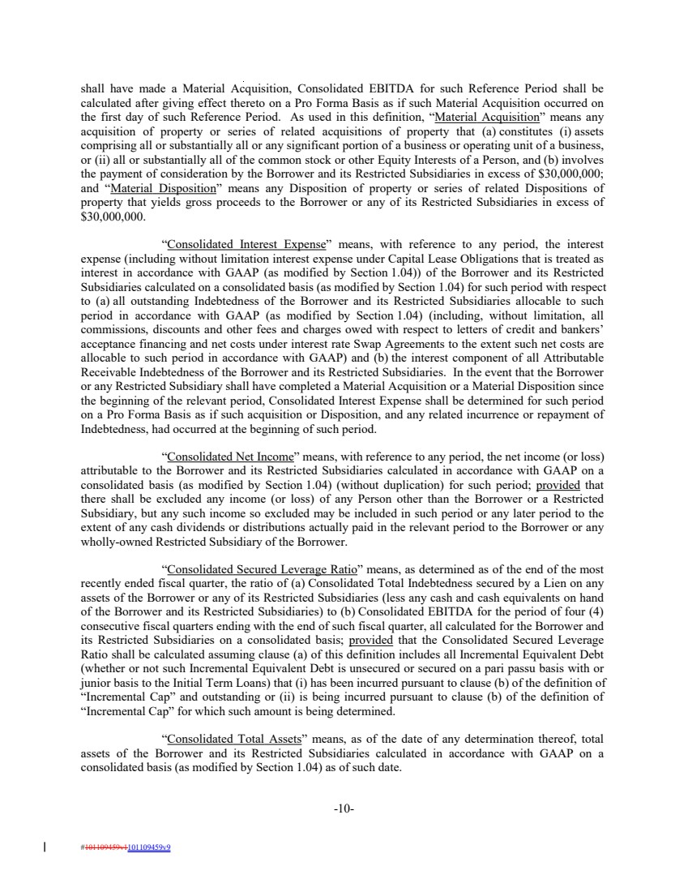 | shall have made a Material Acquisition, Consolidated EBITDA for such Reference Period shall be calculated after giving effect thereto on a Pro Forma Basis as if such Material Acquisition occurred on the first day of such Reference Period. As used in this definition, “Material Acquisition” means any acquisition of property or series of related acquisitions of property that (a) constitutes (i) assets comprising all or substantially all or any significant portion of a business or operating unit of a business, or (ii) all or substantially all of the common stock or other Equity Interests of a Person, and (b) involves the payment of consideration by the Borrower and its Restricted Subsidiaries in excess of $30,000,000; and “Material Disposition” means any Disposition of property or series of related Dispositions of property that yields gross proceeds to the Borrower or any of its Restricted Subsidiaries in excess of $30,000,000. “Consolidated Interest Expense” means, with reference to any period, the interest expense (including without limitation interest expense under Capital Lease Obligations that is treated as interest in accordance with GAAP (as modified by Section 1.04)) of the Borrower and its Restricted Subsidiaries calculated on a consolidated basis (as modified by Section 1.04) for such period with respect to (a) all outstanding Indebtedness of the Borrower and its Restricted Subsidiaries allocable to such period in accordance with GAAP (as modified by Section 1.04) (including, without limitation, all commissions, discounts and other fees and charges owed with respect to letters of credit and bankers’ acceptance financing and net costs under interest rate Swap Agreements to the extent such net costs are allocable to such period in accordance with GAAP) and (b) the interest component of all Attributable Receivable Indebtedness of the Borrower and its Restricted Subsidiaries. In the event that the Borrower or any Restricted Subsidiary shall have completed a Material Acquisition or a Material Disposition since the beginning of the relevant period, Consolidated Interest Expense shall be determined for such period on a Pro Forma Basis as if such acquisition or Disposition, and any related incurrence or repayment of Indebtedness, had occurred at the beginning of such period. “Consolidated Net Income” means, with reference to any period, the net income (or loss) attributable to the Borrower and its Restricted Subsidiaries calculated in accordance with GAAP on a consolidated basis (as modified by Section 1.04) (without duplication) for such period; provided that there shall be excluded any income (or loss) of any Person other than the Borrower or a Restricted Subsidiary, but any such income so excluded may be included in such period or any later period to the extent of any cash dividends or distributions actually paid in the relevant period to the Borrower or any wholly-owned Restricted Subsidiary of the Borrower. “Consolidated Secured Leverage Ratio” means, as determined as of the end of the most recently ended fiscal quarter, the ratio of (a) Consolidated Total Indebtedness secured by a Lien on any assets of the Borrower or any of its Restricted Subsidiaries (less any cash and cash equivalents on hand of the Borrower and its Restricted Subsidiaries) to (b) Consolidated EBITDA for the period of four (4) consecutive fiscal quarters ending with the end of such fiscal quarter, all calculated for the Borrower and its Restricted Subsidiaries on a consolidated basis; provided that the Consolidated Secured Leverage Ratio shall be calculated assuming clause (a) of this definition includes all Incremental Equivalent Debt (whether or not such Incremental Equivalent Debt is unsecured or secured on a pari passu basis with or junior basis to the Initial Term Loans) that (i) has been incurred pursuant to clause (b) of the definition of “Incremental Cap” and outstanding or (ii) is being incurred pursuant to clause (b) of the definition of “Incremental Cap” for which such amount is being determined. “Consolidated Total Assets” means, as of the date of any determination thereof, total assets of the Borrower and its Restricted Subsidiaries calculated in accordance with GAAP on a consolidated basis (as modified by Section 1.04) as of such date. -10- #101109459v1101109459v9
 | 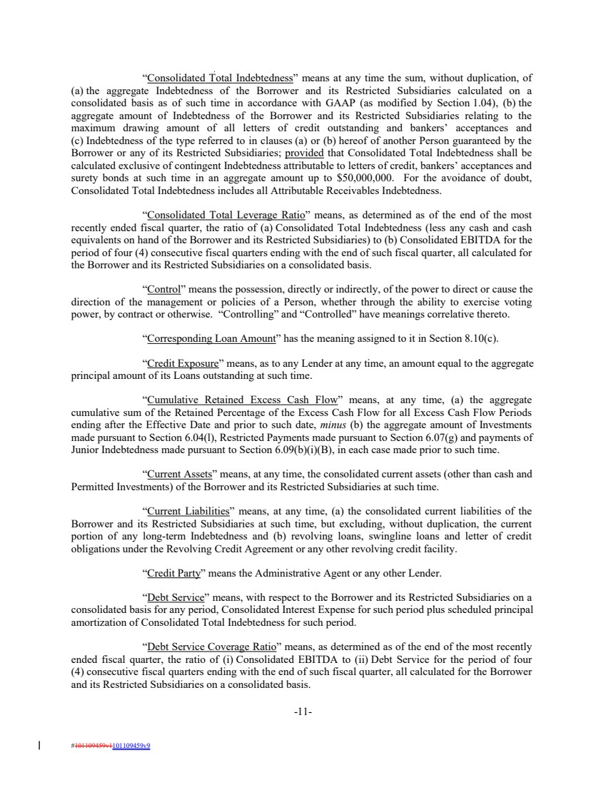 | “Consolidated Total Indebtedness” means at any time the sum, without duplication, of (a) the aggregate Indebtedness of the Borrower and its Restricted Subsidiaries calculated on a consolidated basis as of such time in accordance with GAAP (as modified by Section 1.04), (b) the aggregate amount of Indebtedness of the Borrower and its Restricted Subsidiaries relating to the maximum drawing amount of all letters of credit outstanding and bankers’ acceptances and (c) Indebtedness of the type referred to in clauses (a) or (b) hereof of another Person guaranteed by the Borrower or any of its Restricted Subsidiaries; provided that Consolidated Total Indebtedness shall be calculated exclusive of contingent Indebtedness attributable to letters of credit, bankers’ acceptances and surety bonds at such time in an aggregate amount up to $50,000,000. For the avoidance of doubt, Consolidated Total Indebtedness includes all Attributable Receivables Indebtedness. “Consolidated Total Leverage Ratio” means, as determined as of the end of the most recently ended fiscal quarter, the ratio of (a) Consolidated Total Indebtedness (less any cash and cash equivalents on hand of the Borrower and its Restricted Subsidiaries) to (b) Consolidated EBITDA for the period of four (4) consecutive fiscal quarters ending with the end of such fiscal quarter, all calculated for the Borrower and its Restricted Subsidiaries on a consolidated basis. “Control” means the possession, directly or indirectly, of the power to direct or cause the direction of the management or policies of a Person, whether through the ability to exercise voting power, by contract or otherwise. “Controlling” and “Controlled” have meanings correlative thereto. “Corresponding Loan Amount” has the meaning assigned to it in Section 8.10(c). “Credit Exposure” means, as to any Lender at any time, an amount equal to the aggregate principal amount of its Loans outstanding at such time. “Cumulative Retained Excess Cash Flow” means, at any time, (a) the aggregate cumulative sum of the Retained Percentage of the Excess Cash Flow for all Excess Cash Flow Periods ending after the Effective Date and prior to such date, minus (b) the aggregate amount of Investments made pursuant to Section 6.04(l), Restricted Payments made pursuant to Section 6.07(g) and payments of Junior Indebtedness made pursuant to Section 6.09(b)(i)(B), in each case made prior to such time. “Current Assets” means, at any time, the consolidated current assets (other than cash and Permitted Investments) of the Borrower and its Restricted Subsidiaries at such time. “Current Liabilities” means, at any time, (a) the consolidated current liabilities of the Borrower and its Restricted Subsidiaries at such time, but excluding, without duplication, the current portion of any long-term Indebtedness and (b) revolving loans, swingline loans and letter of credit obligations under the Revolving Credit Agreement or any other revolving credit facility. “Credit Party” means the Administrative Agent or any other Lender. “Debt Service” means, with respect to the Borrower and its Restricted Subsidiaries on a consolidated basis for any period, Consolidated Interest Expense for such period plus scheduled principal amortization of Consolidated Total Indebtedness for such period. “Debt Service Coverage Ratio” means, as determined as of the end of the most recently ended fiscal quarter, the ratio of (i) Consolidated EBITDA to (ii) Debt Service for the period of four (4) consecutive fiscal quarters ending with the end of such fiscal quarter, all calculated for the Borrower and its Restricted Subsidiaries on a consolidated basis. -11- #101109459v1101109459v9
 | 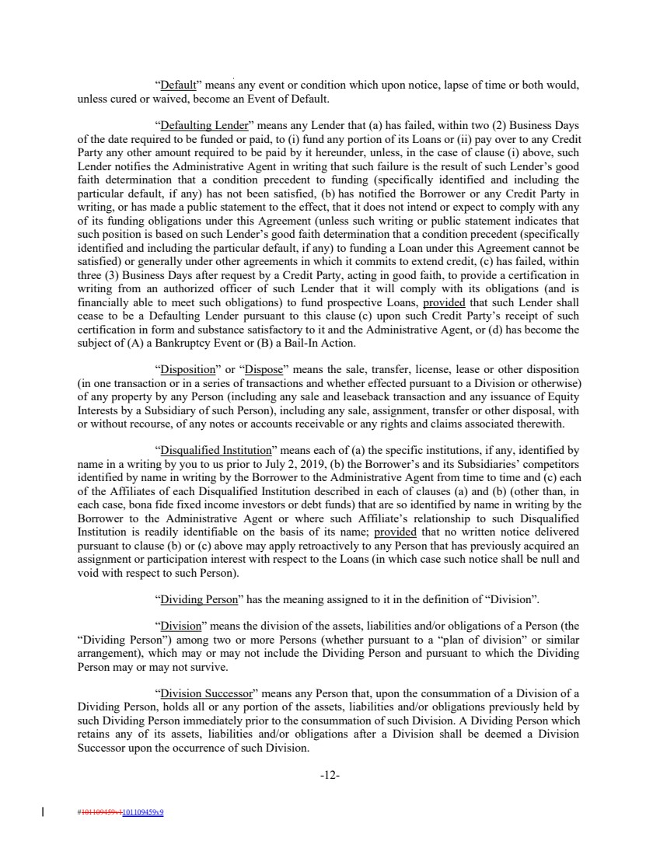 | “Default” means any event or condition which upon notice, lapse of time or both would, unless cured or waived, become an Event of Default. “Defaulting Lender” means any Lender that (a) has failed, within two (2) Business Days of the date required to be funded or paid, to (i) fund any portion of its Loans or (ii) pay over to any Credit Party any other amount required to be paid by it hereunder, unless, in the case of clause (i) above, such Lender notifies the Administrative Agent in writing that such failure is the result of such Lender’s good faith determination that a condition precedent to funding (specifically identified and including the particular default, if any) has not been satisfied, (b) has notified the Borrower or any Credit Party in writing, or has made a public statement to the effect, that it does not intend or expect to comply with any of its funding obligations under this Agreement (unless such writing or public statement indicates that such position is based on such Lender’s good faith determination that a condition precedent (specifically identified and including the particular default, if any) to funding a Loan under this Agreement cannot be satisfied) or generally under other agreements in which it commits to extend credit, (c) has failed, within three (3) Business Days after request by a Credit Party, acting in good faith, to provide a certification in writing from an authorized officer of such Lender that it will comply with its obligations (and is financially able to meet such obligations) to fund prospective Loans, provided that such Lender shall cease to be a Defaulting Lender pursuant to this clause (c) upon such Credit Party’s receipt of such certification in form and substance satisfactory to it and the Administrative Agent, or (d) has become the subject of (A) a Bankruptcy Event or (B) a Bail-In Action. “Disposition” or “Dispose” means the sale, transfer, license, lease or other disposition (in one transaction or in a series of transactions and whether effected pursuant to a Division or otherwise) of any property by any Person (including any sale and leaseback transaction and any issuance of Equity Interests by a Subsidiary of such Person), including any sale, assignment, transfer or other disposal, with or without recourse, of any notes or accounts receivable or any rights and claims associated therewith. “Disqualified Institution” means each of (a) the specific institutions, if any, identified by name in a writing by you to us prior to July 2, 2019, (b) the Borrower’s and its Subsidiaries’ competitors identified by name in writing by the Borrower to the Administrative Agent from time to time and (c) each of the Affiliates of each Disqualified Institution described in each of clauses (a) and (b) (other than, in each case, bona fide fixed income investors or debt funds) that are so identified by name in writing by the Borrower to the Administrative Agent or where such Affiliate’s relationship to such Disqualified Institution is readily identifiable on the basis of its name; provided that no written notice delivered pursuant to clause (b) or (c) above may apply retroactively to any Person that has previously acquired an assignment or participation interest with respect to the Loans (in which case such notice shall be null and void with respect to such Person). “Dividing Person” has the meaning assigned to it in the definition of “Division”. “Division” means the division of the assets, liabilities and/or obligations of a Person (the “Dividing Person”) among two or more Persons (whether pursuant to a “plan of division” or similar arrangement), which may or may not include the Dividing Person and pursuant to which the Dividing Person may or may not survive. “Division Successor” means any Person that, upon the consummation of a Division of a Dividing Person, holds all or any portion of the assets, liabilities and/or obligations previously held by such Dividing Person immediately prior to the consummation of such Division. A Dividing Person which retains any of its assets, liabilities and/or obligations after a Division shall be deemed a Division Successor upon the occurrence of such Division. -12- #101109459v1101109459v9
 | 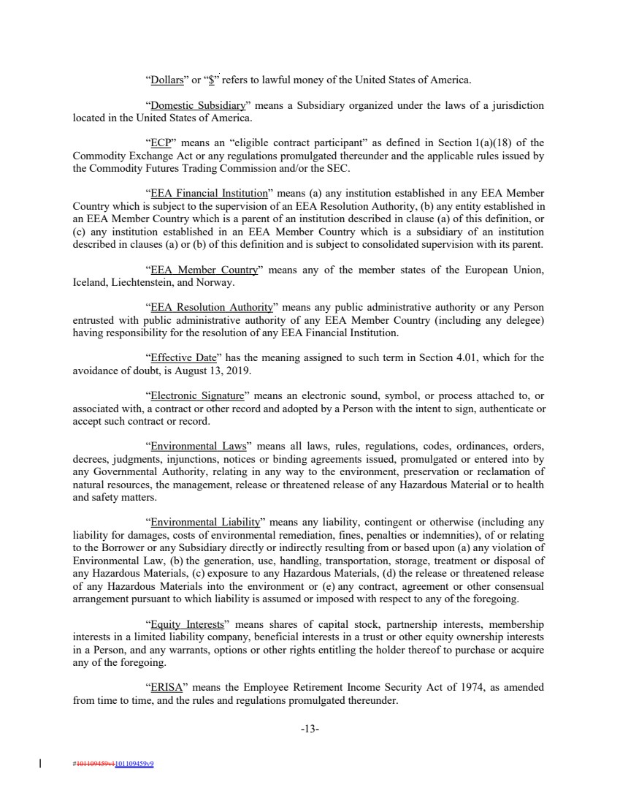 | “Dollars” or “$” refers to lawful money of the United States of America. “Domestic Subsidiary” means a Subsidiary organized under the laws of a jurisdiction located in the United States of America. “ECP” means an “eligible contract participant” as defined in Section 1(a)(18) of the Commodity Exchange Act or any regulations promulgated thereunder and the applicable rules issued by the Commodity Futures Trading Commission and/or the SEC. “EEA Financial Institution” means (a) any institution established in any EEA Member Country which is subject to the supervision of an EEA Resolution Authority, (b) any entity established in an EEA Member Country which is a parent of an institution described in clause (a) of this definition, or (c) any institution established in an EEA Member Country which is a subsidiary of an institution described in clauses (a) or (b) of this definition and is subject to consolidated supervision with its parent. “EEA Member Country” means any of the member states of the European Union, Iceland, Liechtenstein, and Norway. “EEA Resolution Authority” means any public administrative authority or any Person entrusted with public administrative authority of any EEA Member Country (including any delegee) having responsibility for the resolution of any EEA Financial Institution. “Effective Date” has the meaning assigned to such term in Section 4.01, which for the avoidance of doubt, is August 13, 2019. “Electronic Signature” means an electronic sound, symbol, or process attached to, or associated with, a contract or other record and adopted by a Person with the intent to sign, authenticate or accept such contract or record. “Environmental Laws” means all laws, rules, regulations, codes, ordinances, orders, decrees, judgments, injunctions, notices or binding agreements issued, promulgated or entered into by any Governmental Authority, relating in any way to the environment, preservation or reclamation of natural resources, the management, release or threatened release of any Hazardous Material or to health and safety matters. “Environmental Liability” means any liability, contingent or otherwise (including any liability for damages, costs of environmental remediation, fines, penalties or indemnities), of or relating to the Borrower or any Subsidiary directly or indirectly resulting from or based upon (a) any violation of Environmental Law, (b) the generation, use, handling, transportation, storage, treatment or disposal of any Hazardous Materials, (c) exposure to any Hazardous Materials, (d) the release or threatened release of any Hazardous Materials into the environment or (e) any contract, agreement or other consensual arrangement pursuant to which liability is assumed or imposed with respect to any of the foregoing. “Equity Interests” means shares of capital stock, partnership interests, membership interests in a limited liability company, beneficial interests in a trust or other equity ownership interests in a Person, and any warrants, options or other rights entitling the holder thereof to purchase or acquire any of the foregoing. “ERISA” means the Employee Retirement Income Security Act of 1974, as amended from time to time, and the rules and regulations promulgated thereunder. -13- #101109459v1101109459v9
 | 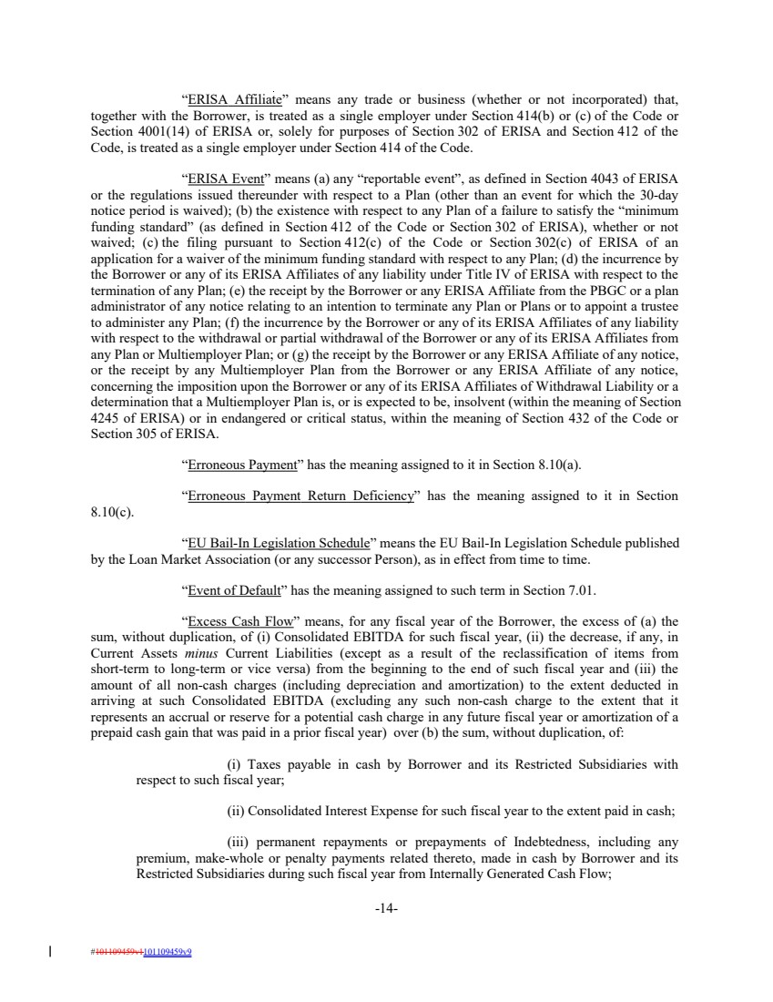 | “ERISA Affiliate” means any trade or business (whether or not incorporated) that, together with the Borrower, is treated as a single employer under Section 414(b) or (c) of the Code or Section 4001(14) of ERISA or, solely for purposes of Section 302 of ERISA and Section 412 of the Code, is treated as a single employer under Section 414 of the Code. “ERISA Event” means (a) any “reportable event”, as defined in Section 4043 of ERISA or the regulations issued thereunder with respect to a Plan (other than an event for which the 30-day notice period is waived); (b) the existence with respect to any Plan of a failure to satisfy the “minimum funding standard” (as defined in Section 412 of the Code or Section 302 of ERISA), whether or not waived; (c) the filing pursuant to Section 412(c) of the Code or Section 302(c) of ERISA of an application for a waiver of the minimum funding standard with respect to any Plan; (d) the incurrence by the Borrower or any of its ERISA Affiliates of any liability under Title IV of ERISA with respect to the termination of any Plan; (e) the receipt by the Borrower or any ERISA Affiliate from the PBGC or a plan administrator of any notice relating to an intention to terminate any Plan or Plans or to appoint a trustee to administer any Plan; (f) the incurrence by the Borrower or any of its ERISA Affiliates of any liability with respect to the withdrawal or partial withdrawal of the Borrower or any of its ERISA Affiliates from any Plan or Multiemployer Plan; or (g) the receipt by the Borrower or any ERISA Affiliate of any notice, or the receipt by any Multiemployer Plan from the Borrower or any ERISA Affiliate of any notice, concerning the imposition upon the Borrower or any of its ERISA Affiliates of Withdrawal Liability or a determination that a Multiemployer Plan is, or is expected to be, insolvent (within the meaning of Section 4245 of ERISA) or in endangered or critical status, within the meaning of Section 432 of the Code or Section 305 of ERISA. “Erroneous Payment” has the meaning assigned to it in Section 8.10(a). “Erroneous Payment Return Deficiency” has the meaning assigned to it in Section 8.10(c). “EU Bail-In Legislation Schedule” means the EU Bail-In Legislation Schedule published by the Loan Market Association (or any successor Person), as in effect from time to time. “Event of Default” has the meaning assigned to such term in Section 7.01. “Excess Cash Flow” means, for any fiscal year of the Borrower, the excess of (a) the sum, without duplication, of (i) Consolidated EBITDA for such fiscal year, (ii) the decrease, if any, in Current Assets minus Current Liabilities (except as a result of the reclassification of items from short-term to long-term or vice versa) from the beginning to the end of such fiscal year and (iii) the amount of all non-cash charges (including depreciation and amortization) to the extent deducted in arriving at such Consolidated EBITDA (excluding any such non-cash charge to the extent that it represents an accrual or reserve for a potential cash charge in any future fiscal year or amortization of a prepaid cash gain that was paid in a prior fiscal year) over (b) the sum, without duplication, of: (i) Taxes payable in cash by Borrower and its Restricted Subsidiaries with respect to such fiscal year; (ii) Consolidated Interest Expense for such fiscal year to the extent paid in cash; (iii) permanent repayments or prepayments of Indebtedness, including any premium, make-whole or penalty payments related thereto, made in cash by Borrower and its Restricted Subsidiaries during such fiscal year from Internally Generated Cash Flow; -14- #101109459v1101109459v9
 | 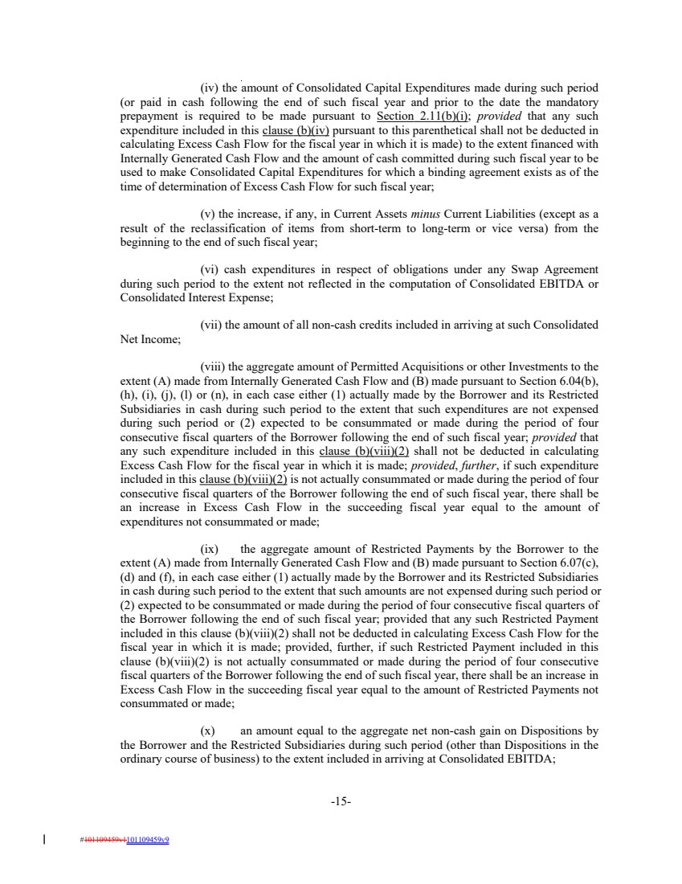 | (iv) the amount of Consolidated Capital Expenditures made during such period (or paid in cash following the end of such fiscal year and prior to the date the mandatory prepayment is required to be made pursuant to Section 2.11(b)(i); provided that any such expenditure included in this clause (b)(iv) pursuant to this parenthetical shall not be deducted in calculating Excess Cash Flow for the fiscal year in which it is made) to the extent financed with Internally Generated Cash Flow and the amount of cash committed during such fiscal year to be used to make Consolidated Capital Expenditures for which a binding agreement exists as of the time of determination of Excess Cash Flow for such fiscal year; (v) the increase, if any, in Current Assets minus Current Liabilities (except as a result of the reclassification of items from short-term to long-term or vice versa) from the beginning to the end of such fiscal year; (vi) cash expenditures in respect of obligations under any Swap Agreement during such period to the extent not reflected in the computation of Consolidated EBITDA or Consolidated Interest Expense; (vii) the amount of all non-cash credits included in arriving at such Consolidated Net Income; (viii) the aggregate amount of Permitted Acquisitions or other Investments to the extent (A) made from Internally Generated Cash Flow and (B) made pursuant to Section 6.04(b), (h), (i), (j), (l) or (n), in each case either (1) actually made by the Borrower and its Restricted Subsidiaries in cash during such period to the extent that such expenditures are not expensed during such period or (2) expected to be consummated or made during the period of four consecutive fiscal quarters of the Borrower following the end of such fiscal year; provided that any such expenditure included in this clause (b)(viii)(2) shall not be deducted in calculating Excess Cash Flow for the fiscal year in which it is made; provided, further, if such expenditure included in this clause (b)(viii)(2) is not actually consummated or made during the period of four consecutive fiscal quarters of the Borrower following the end of such fiscal year, there shall be an increase in Excess Cash Flow in the succeeding fiscal year equal to the amount of expenditures not consummated or made; (ix) the aggregate amount of Restricted Payments by the Borrower to the extent (A) made from Internally Generated Cash Flow and (B) made pursuant to Section 6.07(c), (d) and (f), in each case either (1) actually made by the Borrower and its Restricted Subsidiaries in cash during such period to the extent that such amounts are not expensed during such period or (2) expected to be consummated or made during the period of four consecutive fiscal quarters of the Borrower following the end of such fiscal year; provided that any such Restricted Payment included in this clause (b)(viii)(2) shall not be deducted in calculating Excess Cash Flow for the fiscal year in which it is made; provided, further, if such Restricted Payment included in this clause (b)(viii)(2) is not actually consummated or made during the period of four consecutive fiscal quarters of the Borrower following the end of such fiscal year, there shall be an increase in Excess Cash Flow in the succeeding fiscal year equal to the amount of Restricted Payments not consummated or made; (x) an amount equal to the aggregate net non-cash gain on Dispositions by the Borrower and the Restricted Subsidiaries during such period (other than Dispositions in the ordinary course of business) to the extent included in arriving at Consolidated EBITDA; -15- #101109459v1101109459v9
 | 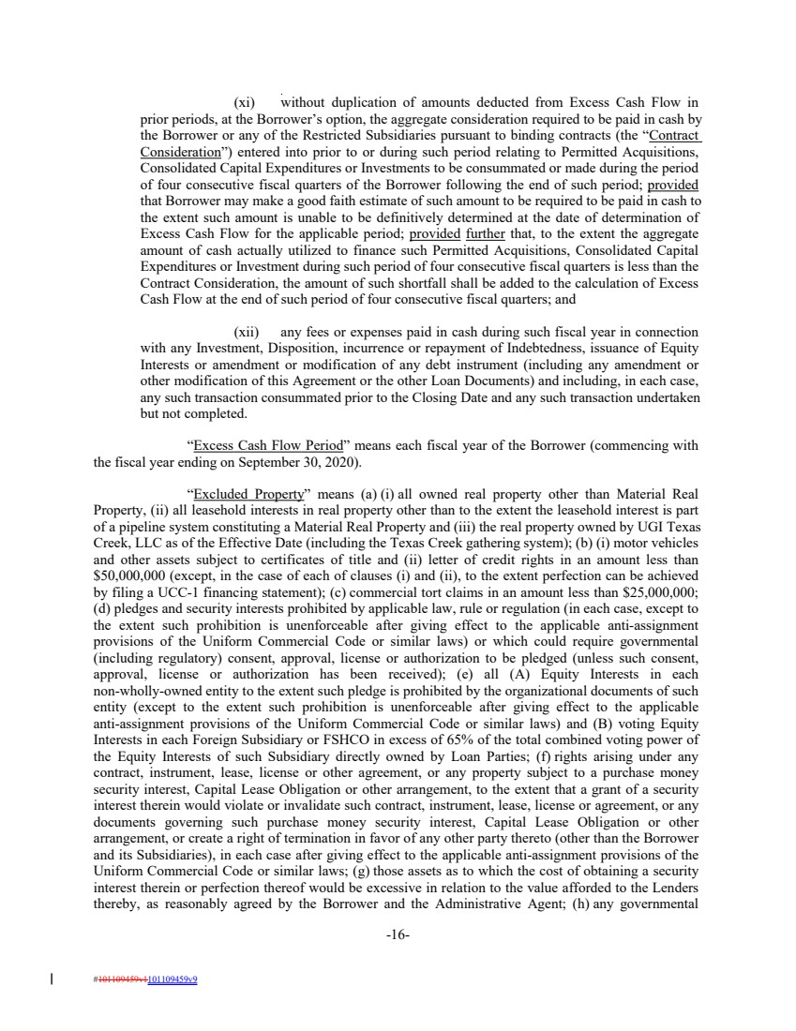 | (xi) without duplication of amounts deducted from Excess Cash Flow in prior periods, at the Borrower’s option, the aggregate consideration required to be paid in cash by the Borrower or any of the Restricted Subsidiaries pursuant to binding contracts (the “Contract Consideration”) entered into prior to or during such period relating to Permitted Acquisitions, Consolidated Capital Expenditures or Investments to be consummated or made during the period of four consecutive fiscal quarters of the Borrower following the end of such period; provided that Borrower may make a good faith estimate of such amount to be required to be paid in cash to the extent such amount is unable to be definitively determined at the date of determination of Excess Cash Flow for the applicable period; provided further that, to the extent the aggregate amount of cash actually utilized to finance such Permitted Acquisitions, Consolidated Capital Expenditures or Investment during such period of four consecutive fiscal quarters is less than the Contract Consideration, the amount of such shortfall shall be added to the calculation of Excess Cash Flow at the end of such period of four consecutive fiscal quarters; and (xii) any fees or expenses paid in cash during such fiscal year in connection with any Investment, Disposition, incurrence or repayment of Indebtedness, issuance of Equity Interests or amendment or modification of any debt instrument (including any amendment or other modification of this Agreement or the other Loan Documents) and including, in each case, any such transaction consummated prior to the Closing Date and any such transaction undertaken but not completed. “Excess Cash Flow Period” means each fiscal year of the Borrower (commencing with the fiscal year ending on September 30, 2020). “Excluded Property” means (a) (i) all owned real property other than Material Real Property, (ii) all leasehold interests in real property other than to the extent the leasehold interest is part of a pipeline system constituting a Material Real Property and (iii) the real property owned by UGI Texas Creek, LLC as of the Effective Date (including the Texas Creek gathering system); (b) (i) motor vehicles and other assets subject to certificates of title and (ii) letter of credit rights in an amount less than $50,000,000 (except, in the case of each of clauses (i) and (ii), to the extent perfection can be achieved by filing a UCC-1 financing statement); (c) commercial tort claims in an amount less than $25,000,000; (d) pledges and security interests prohibited by applicable law, rule or regulation (in each case, except to the extent such prohibition is unenforceable after giving effect to the applicable anti-assignment provisions of the Uniform Commercial Code or similar laws) or which could require governmental (including regulatory) consent, approval, license or authorization to be pledged (unless such consent, approval, license or authorization has been received); (e) all (A) Equity Interests in each non-wholly-owned entity to the extent such pledge is prohibited by the organizational documents of such entity (except to the extent such prohibition is unenforceable after giving effect to the applicable anti-assignment provisions of the Uniform Commercial Code or similar laws) and (B) voting Equity Interests in each Foreign Subsidiary or FSHCO in excess of 65% of the total combined voting power of the Equity Interests of such Subsidiary directly owned by Loan Parties; (f) rights arising under any contract, instrument, lease, license or other agreement, or any property subject to a purchase money security interest, Capital Lease Obligation or other arrangement, to the extent that a grant of a security interest therein would violate or invalidate such contract, instrument, lease, license or agreement, or any documents governing such purchase money security interest, Capital Lease Obligation or other arrangement, or create a right of termination in favor of any other party thereto (other than the Borrower and its Subsidiaries), in each case after giving effect to the applicable anti-assignment provisions of the Uniform Commercial Code or similar laws; (g) those assets as to which the cost of obtaining a security interest therein or perfection thereof would be excessive in relation to the value afforded to the Lenders thereby, as reasonably agreed by the Borrower and the Administrative Agent; (h) any governmental -16- #101109459v1101109459v9
 | 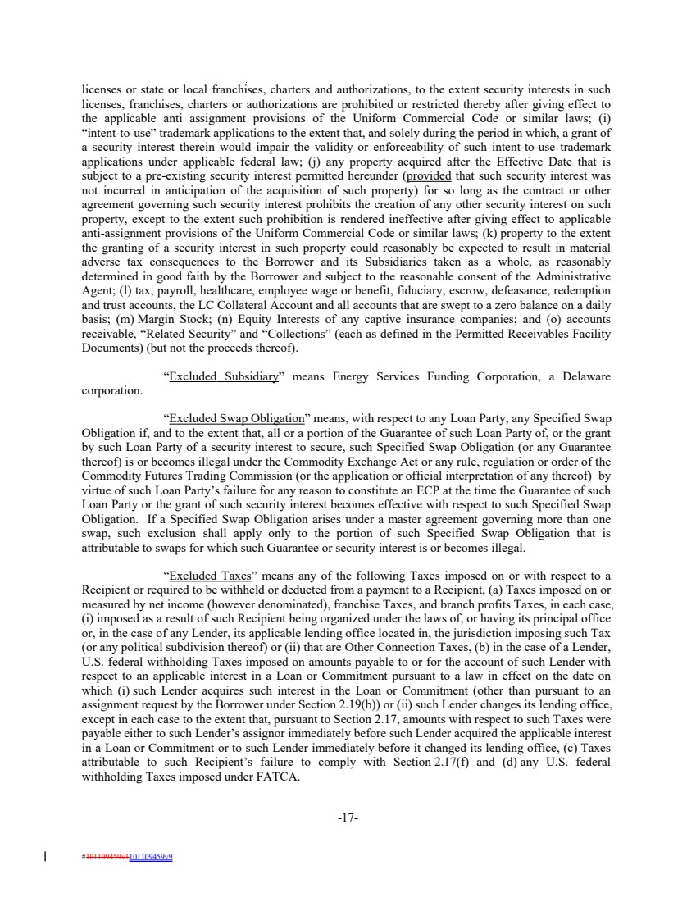 | licenses or state or local franchises, charters and authorizations, to the extent security interests in such licenses, franchises, charters or authorizations are prohibited or restricted thereby after giving effect to the applicable anti assignment provisions of the Uniform Commercial Code or similar laws; (i) “intent-to-use” trademark applications to the extent that, and solely during the period in which, a grant of a security interest therein would impair the validity or enforceability of such intent-to-use trademark applications under applicable federal law; (j) any property acquired after the Effective Date that is subject to a pre-existing security interest permitted hereunder (provided that such security interest was not incurred in anticipation of the acquisition of such property) for so long as the contract or other agreement governing such security interest prohibits the creation of any other security interest on such property, except to the extent such prohibition is rendered ineffective after giving effect to applicable anti-assignment provisions of the Uniform Commercial Code or similar laws; (k) property to the extent the granting of a security interest in such property could reasonably be expected to result in material adverse tax consequences to the Borrower and its Subsidiaries taken as a whole, as reasonably determined in good faith by the Borrower and subject to the reasonable consent of the Administrative Agent; (l) tax, payroll, healthcare, employee wage or benefit, fiduciary, escrow, defeasance, redemption and trust accounts, the LC Collateral Account and all accounts that are swept to a zero balance on a daily basis; (m) Margin Stock; (n) Equity Interests of any captive insurance companies; and (o) accounts receivable, “Related Security” and “Collections” (each as defined in the Permitted Receivables Facility Documents) (but not the proceeds thereof). “Excluded Subsidiary” means Energy Services Funding Corporation, a Delaware corporation. “Excluded Swap Obligation” means, with respect to any Loan Party, any Specified Swap Obligation if, and to the extent that, all or a portion of the Guarantee of such Loan Party of, or the grant by such Loan Party of a security interest to secure, such Specified Swap Obligation (or any Guarantee thereof) is or becomes illegal under the Commodity Exchange Act or any rule, regulation or order of the Commodity Futures Trading Commission (or the application or official interpretation of any thereof) by virtue of such Loan Party’s failure for any reason to constitute an ECP at the time the Guarantee of such Loan Party or the grant of such security interest becomes effective with respect to such Specified Swap Obligation. If a Specified Swap Obligation arises under a master agreement governing more than one swap, such exclusion shall apply only to the portion of such Specified Swap Obligation that is attributable to swaps for which such Guarantee or security interest is or becomes illegal. “Excluded Taxes” means any of the following Taxes imposed on or with respect to a Recipient or required to be withheld or deducted from a payment to a Recipient, (a) Taxes imposed on or measured by net income (however denominated), franchise Taxes, and branch profits Taxes, in each case, (i) imposed as a result of such Recipient being organized under the laws of, or having its principal office or, in the case of any Lender, its applicable lending office located in, the jurisdiction imposing such Tax (or any political subdivision thereof) or (ii) that are Other Connection Taxes, (b) in the case of a Lender, U.S. federal withholding Taxes imposed on amounts payable to or for the account of such Lender with respect to an applicable interest in a Loan or Commitment pursuant to a law in effect on the date on which (i) such Lender acquires such interest in the Loan or Commitment (other than pursuant to an assignment request by the Borrower under Section 2.19(b)) or (ii) such Lender changes its lending office, except in each case to the extent that, pursuant to Section 2.17, amounts with respect to such Taxes were payable either to such Lender’s assignor immediately before such Lender acquired the applicable interest in a Loan or Commitment or to such Lender immediately before it changed its lending office, (c) Taxes attributable to such Recipient’s failure to comply with Section 2.17(f) and (d) any U.S. federal withholding Taxes imposed under FATCA. -17- #101109459v1101109459v9
 | 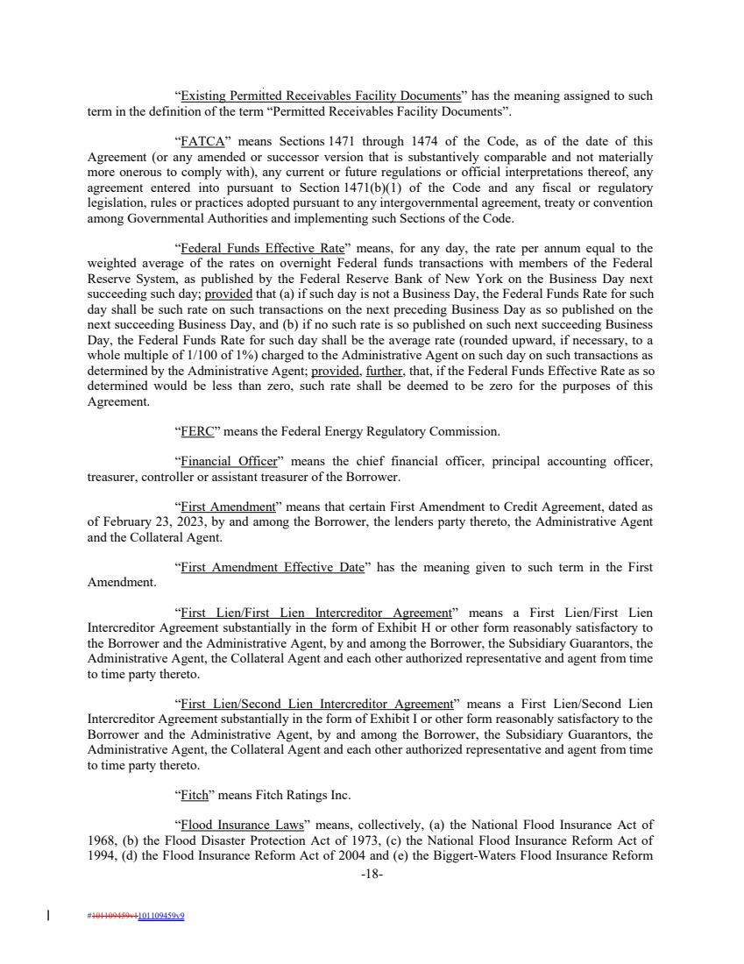 | “Existing Permitted Receivables Facility Documents” has the meaning assigned to such term in the definition of the term “Permitted Receivables Facility Documents”. “FATCA” means Sections 1471 through 1474 of the Code, as of the date of this Agreement (or any amended or successor version that is substantively comparable and not materially more onerous to comply with), any current or future regulations or official interpretations thereof, any agreement entered into pursuant to Section 1471(b)(1) of the Code and any fiscal or regulatory legislation, rules or practices adopted pursuant to any intergovernmental agreement, treaty or convention among Governmental Authorities and implementing such Sections of the Code. “Federal Funds Effective Rate” means, for any day, the rate per annum equal to the weighted average of the rates on overnight Federal funds transactions with members of the Federal Reserve System, as published by the Federal Reserve Bank of New York on the Business Day next succeeding such day; provided that (a) if such day is not a Business Day, the Federal Funds Rate for such day shall be such rate on such transactions on the next preceding Business Day as so published on the next succeeding Business Day, and (b) if no such rate is so published on such next succeeding Business Day, the Federal Funds Rate for such day shall be the average rate (rounded upward, if necessary, to a whole multiple of 1/100 of 1%) charged to the Administrative Agent on such day on such transactions as determined by the Administrative Agent; provided, further, that, if the Federal Funds Effective Rate as so determined would be less than zero, such rate shall be deemed to be zero for the purposes of this Agreement. “FERC” means the Federal Energy Regulatory Commission. “Financial Officer” means the chief financial officer, principal accounting officer, treasurer, controller or assistant treasurer of the Borrower. “First Amendment” means that certain First Amendment to Credit Agreement, dated as of February 23, 2023, by and among the Borrower, the lenders party thereto, the Administrative Agent and the Collateral Agent. “First Amendment Effective Date” has the meaning given to such term in the First Amendment. “First Lien/First Lien Intercreditor Agreement” means a First Lien/First Lien Intercreditor Agreement substantially in the form of Exhibit H or other form reasonably satisfactory to the Borrower and the Administrative Agent, by and among the Borrower, the Subsidiary Guarantors, the Administrative Agent, the Collateral Agent and each other authorized representative and agent from time to time party thereto. “First Lien/Second Lien Intercreditor Agreement” means a First Lien/Second Lien Intercreditor Agreement substantially in the form of Exhibit I or other form reasonably satisfactory to the Borrower and the Administrative Agent, by and among the Borrower, the Subsidiary Guarantors, the Administrative Agent, the Collateral Agent and each other authorized representative and agent from time to time party thereto. “Fitch” means Fitch Ratings Inc. “Flood Insurance Laws” means, collectively, (a) the National Flood Insurance Act of 1968, (b) the Flood Disaster Protection Act of 1973, (c) the National Flood Insurance Reform Act of 1994, (d) the Flood Insurance Reform Act of 2004 and (e) the Biggert-Waters Flood Insurance Reform -18- #101109459v1101109459v9
 | 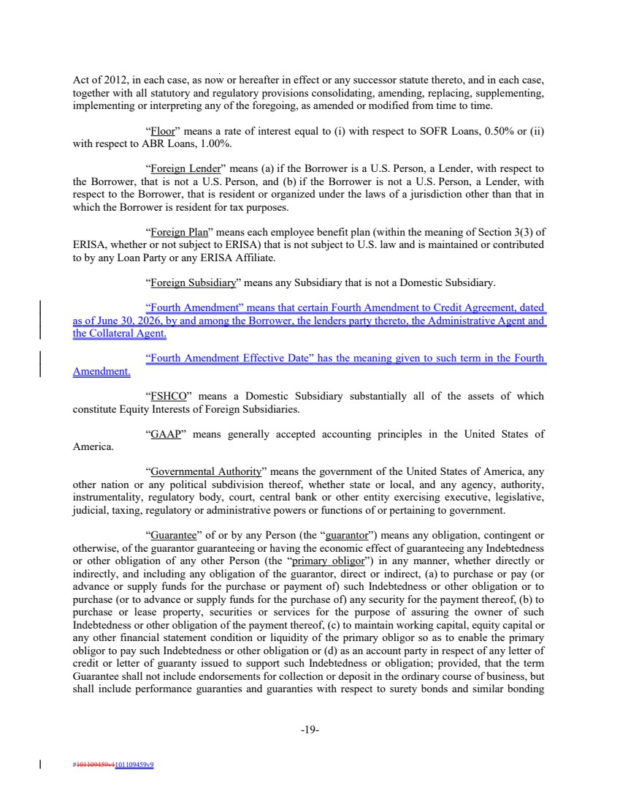 | Act of 2012, in each case, as now or hereafter in effect or any successor statute thereto, and in each case, together with all statutory and regulatory provisions consolidating, amending, replacing, supplementing, implementing or interpreting any of the foregoing, as amended or modified from time to time. “Floor” means a rate of interest equal to (i) with respect to SOFR Loans, 0.50% or (ii) with respect to ABR Loans, 1.00%. “Foreign Lender” means (a) if the Borrower is a U.S. Person, a Lender, with respect to the Borrower, that is not a U.S. Person, and (b) if the Borrower is not a U.S. Person, a Lender, with respect to the Borrower, that is resident or organized under the laws of a jurisdiction other than that in which the Borrower is resident for tax purposes. “Foreign Plan” means each employee benefit plan (within the meaning of Section 3(3) of ERISA, whether or not subject to ERISA) that is not subject to U.S. law and is maintained or contributed to by any Loan Party or any ERISA Affiliate. “Foreign Subsidiary” means any Subsidiary that is not a Domestic Subsidiary. “Fourth Amendment” means that certain Fourth Amendment to Credit Agreement, dated as of June 30, 2026, by and among the Borrower, the lenders party thereto, the Administrative Agent and the Collateral Agent. “Fourth Amendment Effective Date” has the meaning given to such term in the Fourth Amendment. “FSHCO” means a Domestic Subsidiary substantially all of the assets of which constitute Equity Interests of Foreign Subsidiaries. “GAAP” means generally accepted accounting principles in the United States of America. “Governmental Authority” means the government of the United States of America, any other nation or any political subdivision thereof, whether state or local, and any agency, authority, instrumentality, regulatory body, court, central bank or other entity exercising executive, legislative, judicial, taxing, regulatory or administrative powers or functions of or pertaining to government. “Guarantee” of or by any Person (the “guarantor”) means any obligation, contingent or otherwise, of the guarantor guaranteeing or having the economic effect of guaranteeing any Indebtedness or other obligation of any other Person (the “primary obligor”) in any manner, whether directly or indirectly, and including any obligation of the guarantor, direct or indirect, (a) to purchase or pay (or advance or supply funds for the purchase or payment of) such Indebtedness or other obligation or to purchase (or to advance or supply funds for the purchase of) any security for the payment thereof, (b) to purchase or lease property, securities or services for the purpose of assuring the owner of such Indebtedness or other obligation of the payment thereof, (c) to maintain working capital, equity capital or any other financial statement condition or liquidity of the primary obligor so as to enable the primary obligor to pay such Indebtedness or other obligation or (d) as an account party in respect of any letter of credit or letter of guaranty issued to support such Indebtedness or obligation; provided, that the term Guarantee shall not include endorsements for collection or deposit in the ordinary course of business, but shall include performance guaranties and guaranties with respect to surety bonds and similar bonding -19- #101109459v1101109459v9
 | 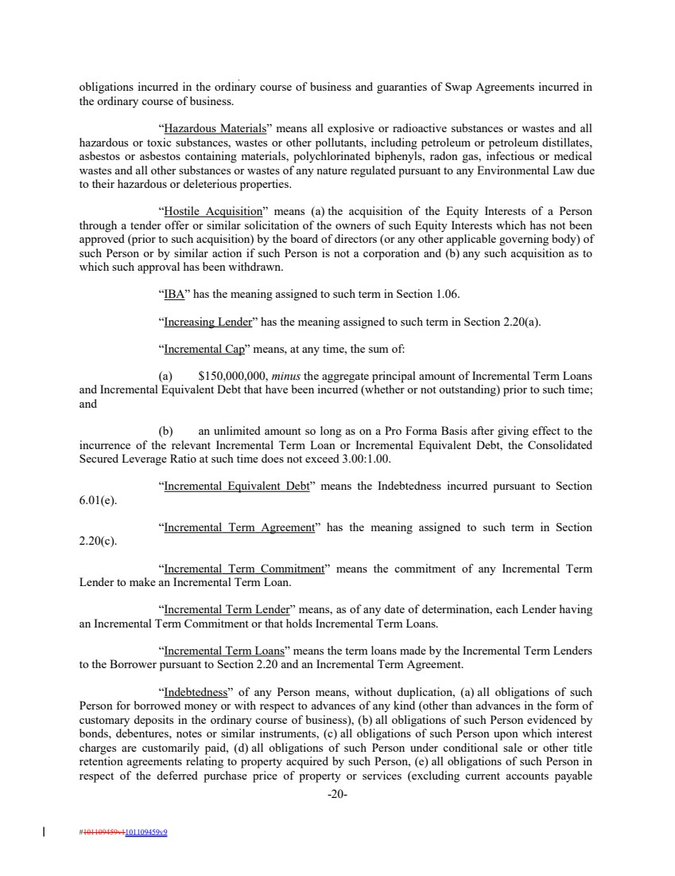 | obligations incurred in the ordinary course of business and guaranties of Swap Agreements incurred in the ordinary course of business. “Hazardous Materials” means all explosive or radioactive substances or wastes and all hazardous or toxic substances, wastes or other pollutants, including petroleum or petroleum distillates, asbestos or asbestos containing materials, polychlorinated biphenyls, radon gas, infectious or medical wastes and all other substances or wastes of any nature regulated pursuant to any Environmental Law due to their hazardous or deleterious properties. “Hostile Acquisition” means (a) the acquisition of the Equity Interests of a Person through a tender offer or similar solicitation of the owners of such Equity Interests which has not been approved (prior to such acquisition) by the board of directors (or any other applicable governing body) of such Person or by similar action if such Person is not a corporation and (b) any such acquisition as to which such approval has been withdrawn. “IBA” has the meaning assigned to such term in Section 1.06. “Increasing Lender” has the meaning assigned to such term in Section 2.20(a). “Incremental Cap” means, at any time, the sum of: (a) $150,000,000, minus the aggregate principal amount of Incremental Term Loans and Incremental Equivalent Debt that have been incurred (whether or not outstanding) prior to such time; and (b) an unlimited amount so long as on a Pro Forma Basis after giving effect to the incurrence of the relevant Incremental Term Loan or Incremental Equivalent Debt, the Consolidated Secured Leverage Ratio at such time does not exceed 3.00:1.00. “Incremental Equivalent Debt” means the Indebtedness incurred pursuant to Section 6.01(e). “Incremental Term Agreement” has the meaning assigned to such term in Section 2.20(c). “Incremental Term Commitment” means the commitment of any Incremental Term Lender to make an Incremental Term Loan. “Incremental Term Lender” means, as of any date of determination, each Lender having an Incremental Term Commitment or that holds Incremental Term Loans. “Incremental Term Loans” means the term loans made by the Incremental Term Lenders to the Borrower pursuant to Section 2.20 and an Incremental Term Agreement. “Indebtedness” of any Person means, without duplication, (a) all obligations of such Person for borrowed money or with respect to advances of any kind (other than advances in the form of customary deposits in the ordinary course of business), (b) all obligations of such Person evidenced by bonds, debentures, notes or similar instruments, (c) all obligations of such Person upon which interest charges are customarily paid, (d) all obligations of such Person under conditional sale or other title retention agreements relating to property acquired by such Person, (e) all obligations of such Person in respect of the deferred purchase price of property or services (excluding current accounts payable -20- #101109459v1101109459v9
 | 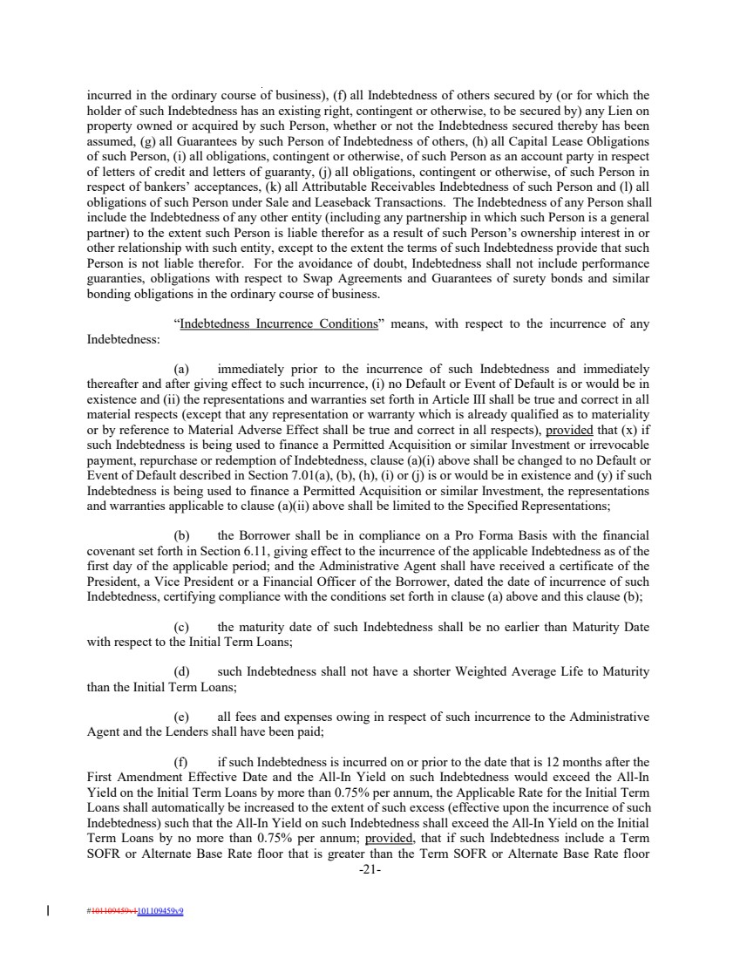 | incurred in the ordinary course of business), (f) all Indebtedness of others secured by (or for which the holder of such Indebtedness has an existing right, contingent or otherwise, to be secured by) any Lien on property owned or acquired by such Person, whether or not the Indebtedness secured thereby has been assumed, (g) all Guarantees by such Person of Indebtedness of others, (h) all Capital Lease Obligations of such Person, (i) all obligations, contingent or otherwise, of such Person as an account party in respect of letters of credit and letters of guaranty, (j) all obligations, contingent or otherwise, of such Person in respect of bankers’ acceptances, (k) all Attributable Receivables Indebtedness of such Person and (l) all obligations of such Person under Sale and Leaseback Transactions. The Indebtedness of any Person shall include the Indebtedness of any other entity (including any partnership in which such Person is a general partner) to the extent such Person is liable therefor as a result of such Person’s ownership interest in or other relationship with such entity, except to the extent the terms of such Indebtedness provide that such Person is not liable therefor. For the avoidance of doubt, Indebtedness shall not include performance guaranties, obligations with respect to Swap Agreements and Guarantees of surety bonds and similar bonding obligations in the ordinary course of business. “Indebtedness Incurrence Conditions” means, with respect to the incurrence of any Indebtedness: (a) immediately prior to the incurrence of such Indebtedness and immediately thereafter and after giving effect to such incurrence, (i) no Default or Event of Default is or would be in existence and (ii) the representations and warranties set forth in Article III shall be true and correct in all material respects (except that any representation or warranty which is already qualified as to materiality or by reference to Material Adverse Effect shall be true and correct in all respects), provided that (x) if such Indebtedness is being used to finance a Permitted Acquisition or similar Investment or irrevocable payment, repurchase or redemption of Indebtedness, clause (a)(i) above shall be changed to no Default or Event of Default described in Section 7.01(a), (b), (h), (i) or (j) is or would be in existence and (y) if such Indebtedness is being used to finance a Permitted Acquisition or similar Investment, the representations and warranties applicable to clause (a)(ii) above shall be limited to the Specified Representations; (b) the Borrower shall be in compliance on a Pro Forma Basis with the financial covenant set forth in Section 6.11, giving effect to the incurrence of the applicable Indebtedness as of the first day of the applicable period; and the Administrative Agent shall have received a certificate of the President, a Vice President or a Financial Officer of the Borrower, dated the date of incurrence of such Indebtedness, certifying compliance with the conditions set forth in clause (a) above and this clause (b); (c) the maturity date of such Indebtedness shall be no earlier than Maturity Date with respect to the Initial Term Loans; (d) such Indebtedness shall not have a shorter Weighted Average Life to Maturity than the Initial Term Loans; (e) all fees and expenses owing in respect of such incurrence to the Administrative Agent and the Lenders shall have been paid; (f) if such Indebtedness is incurred on or prior to the date that is 12 months after the First Amendment Effective Date and the All-In Yield on such Indebtedness would exceed the All-In Yield on the Initial Term Loans by more than 0.75% per annum, the Applicable Rate for the Initial Term Loans shall automatically be increased to the extent of such excess (effective upon the incurrence of such Indebtedness) such that the All-In Yield on such Indebtedness shall exceed the All-In Yield on the Initial Term Loans by no more than 0.75% per annum; provided, that if such Indebtedness include a Term SOFR or Alternate Base Rate floor that is greater than the Term SOFR or Alternate Base Rate floor -21- #101109459v1101109459v9
 | 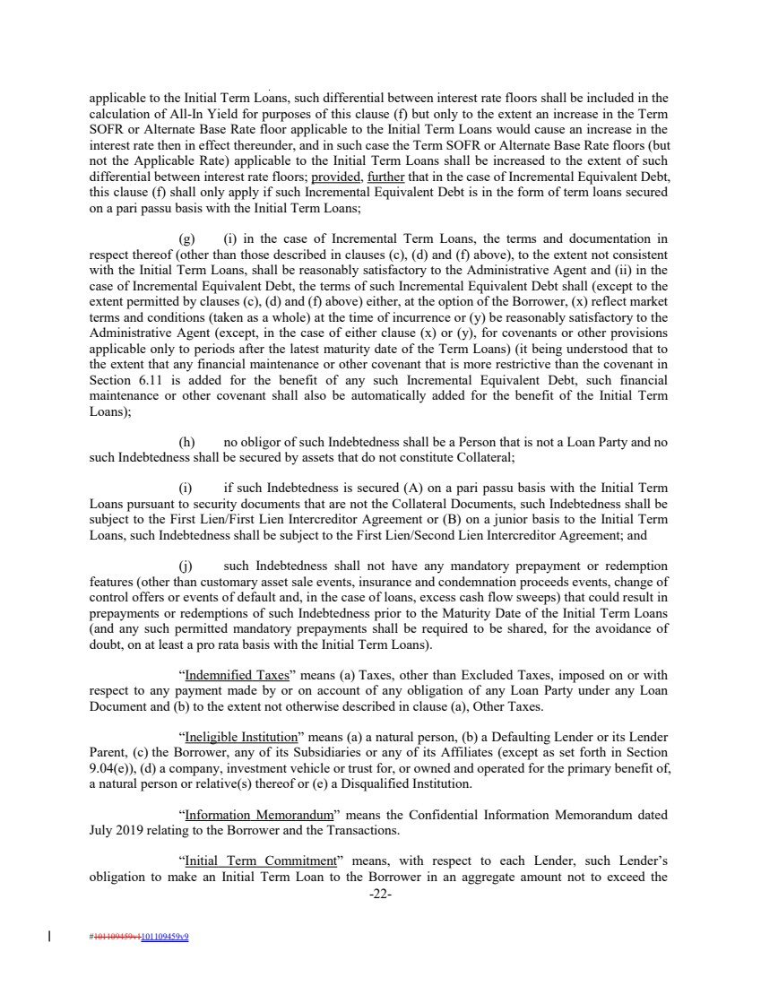 | applicable to the Initial Term Loans, such differential between interest rate floors shall be included in the calculation of All-In Yield for purposes of this clause (f) but only to the extent an increase in the Term SOFR or Alternate Base Rate floor applicable to the Initial Term Loans would cause an increase in the interest rate then in effect thereunder, and in such case the Term SOFR or Alternate Base Rate floors (but not the Applicable Rate) applicable to the Initial Term Loans shall be increased to the extent of such differential between interest rate floors; provided, further that in the case of Incremental Equivalent Debt, this clause (f) shall only apply if such Incremental Equivalent Debt is in the form of term loans secured on a pari passu basis with the Initial Term Loans; (g) (i) in the case of Incremental Term Loans, the terms and documentation in respect thereof (other than those described in clauses (c), (d) and (f) above), to the extent not consistent with the Initial Term Loans, shall be reasonably satisfactory to the Administrative Agent and (ii) in the case of Incremental Equivalent Debt, the terms of such Incremental Equivalent Debt shall (except to the extent permitted by clauses (c), (d) and (f) above) either, at the option of the Borrower, (x) reflect market terms and conditions (taken as a whole) at the time of incurrence or (y) be reasonably satisfactory to the Administrative Agent (except, in the case of either clause (x) or (y), for covenants or other provisions applicable only to periods after the latest maturity date of the Term Loans) (it being understood that to the extent that any financial maintenance or other covenant that is more restrictive than the covenant in Section 6.11 is added for the benefit of any such Incremental Equivalent Debt, such financial maintenance or other covenant shall also be automatically added for the benefit of the Initial Term Loans); (h) no obligor of such Indebtedness shall be a Person that is not a Loan Party and no such Indebtedness shall be secured by assets that do not constitute Collateral; (i) if such Indebtedness is secured (A) on a pari passu basis with the Initial Term Loans pursuant to security documents that are not the Collateral Documents, such Indebtedness shall be subject to the First Lien/First Lien Intercreditor Agreement or (B) on a junior basis to the Initial Term Loans, such Indebtedness shall be subject to the First Lien/Second Lien Intercreditor Agreement; and (j) such Indebtedness shall not have any mandatory prepayment or redemption features (other than customary asset sale events, insurance and condemnation proceeds events, change of control offers or events of default and, in the case of loans, excess cash flow sweeps) that could result in prepayments or redemptions of such Indebtedness prior to the Maturity Date of the Initial Term Loans (and any such permitted mandatory prepayments shall be required to be shared, for the avoidance of doubt, on at least a pro rata basis with the Initial Term Loans). “Indemnified Taxes” means (a) Taxes, other than Excluded Taxes, imposed on or with respect to any payment made by or on account of any obligation of any Loan Party under any Loan Document and (b) to the extent not otherwise described in clause (a), Other Taxes. “Ineligible Institution” means (a) a natural person, (b) a Defaulting Lender or its Lender Parent, (c) the Borrower, any of its Subsidiaries or any of its Affiliates (except as set forth in Section 9.04(e)), (d) a company, investment vehicle or trust for, or owned and operated for the primary benefit of, a natural person or relative(s) thereof or (e) a Disqualified Institution. “Information Memorandum” means the Confidential Information Memorandum dated July 2019 relating to the Borrower and the Transactions. “Initial Term Commitment” means, with respect to each Lender, such Lender’s obligation to make an Initial Term Loan to the Borrower in an aggregate amount not to exceed the -22- #101109459v1101109459v9
 | 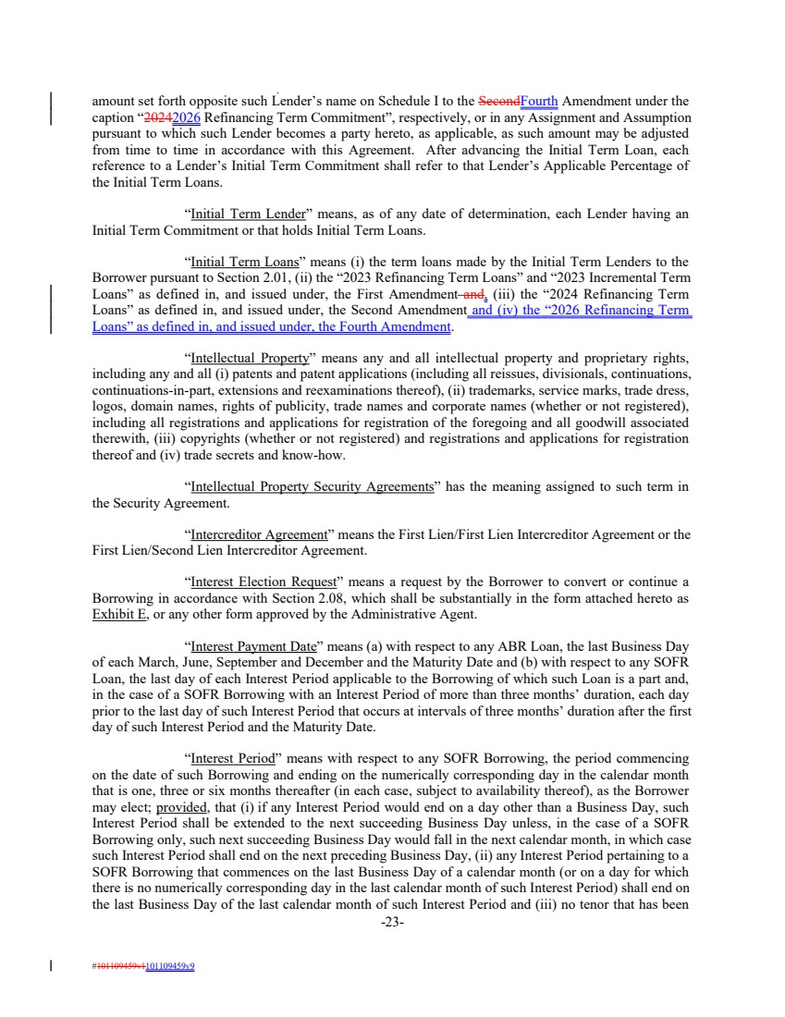 | amount set forth opposite such Lender’s name on Schedule I to the SecondFourth Amendment under the caption “20242026 Refinancing Term Commitment”, respectively, or in any Assignment and Assumption pursuant to which such Lender becomes a party hereto, as applicable, as such amount may be adjusted from time to time in accordance with this Agreement. After advancing the Initial Term Loan, each reference to a Lender’s Initial Term Commitment shall refer to that Lender’s Applicable Percentage of the Initial Term Loans. “Initial Term Lender” means, as of any date of determination, each Lender having an Initial Term Commitment or that holds Initial Term Loans. “Initial Term Loans” means (i) the term loans made by the Initial Term Lenders to the Borrower pursuant to Section 2.01, (ii) the “2023 Refinancing Term Loans” and “2023 Incremental Term Loans” as defined in, and issued under, the First Amendment and, (iii) the “2024 Refinancing Term Loans” as defined in, and issued under, the Second Amendment and (iv) the “2026 Refinancing Term Loans” as defined in, and issued under, the Fourth Amendment. “Intellectual Property” means any and all intellectual property and proprietary rights, including any and all (i) patents and patent applications (including all reissues, divisionals, continuations, continuations-in-part, extensions and reexaminations thereof), (ii) trademarks, service marks, trade dress, logos, domain names, rights of publicity, trade names and corporate names (whether or not registered), including all registrations and applications for registration of the foregoing and all goodwill associated therewith, (iii) copyrights (whether or not registered) and registrations and applications for registration thereof and (iv) trade secrets and know-how. “Intellectual Property Security Agreements” has the meaning assigned to such term in the Security Agreement. “Intercreditor Agreement” means the First Lien/First Lien Intercreditor Agreement or the First Lien/Second Lien Intercreditor Agreement. “Interest Election Request” means a request by the Borrower to convert or continue a Borrowing in accordance with Section 2.08, which shall be substantially in the form attached hereto as Exhibit E, or any other form approved by the Administrative Agent. “Interest Payment Date” means (a) with respect to any ABR Loan, the last Business Day of each March, June, September and December and the Maturity Date and (b) with respect to any SOFR Loan, the last day of each Interest Period applicable to the Borrowing of which such Loan is a part and, in the case of a SOFR Borrowing with an Interest Period of more than three months’ duration, each day prior to the last day of such Interest Period that occurs at intervals of three months’ duration after the first day of such Interest Period and the Maturity Date. “Interest Period” means with respect to any SOFR Borrowing, the period commencing on the date of such Borrowing and ending on the numerically corresponding day in the calendar month that is one, three or six months thereafter (in each case, subject to availability thereof), as the Borrower may elect; provided, that (i) if any Interest Period would end on a day other than a Business Day, such Interest Period shall be extended to the next succeeding Business Day unless, in the case of a SOFR Borrowing only, such next succeeding Business Day would fall in the next calendar month, in which case such Interest Period shall end on the next preceding Business Day, (ii) any Interest Period pertaining to a SOFR Borrowing that commences on the last Business Day of a calendar month (or on a day for which there is no numerically corresponding day in the last calendar month of such Interest Period) shall end on the last Business Day of the last calendar month of such Interest Period and (iii) no tenor that has been -23- #101109459v1101109459v9
 | 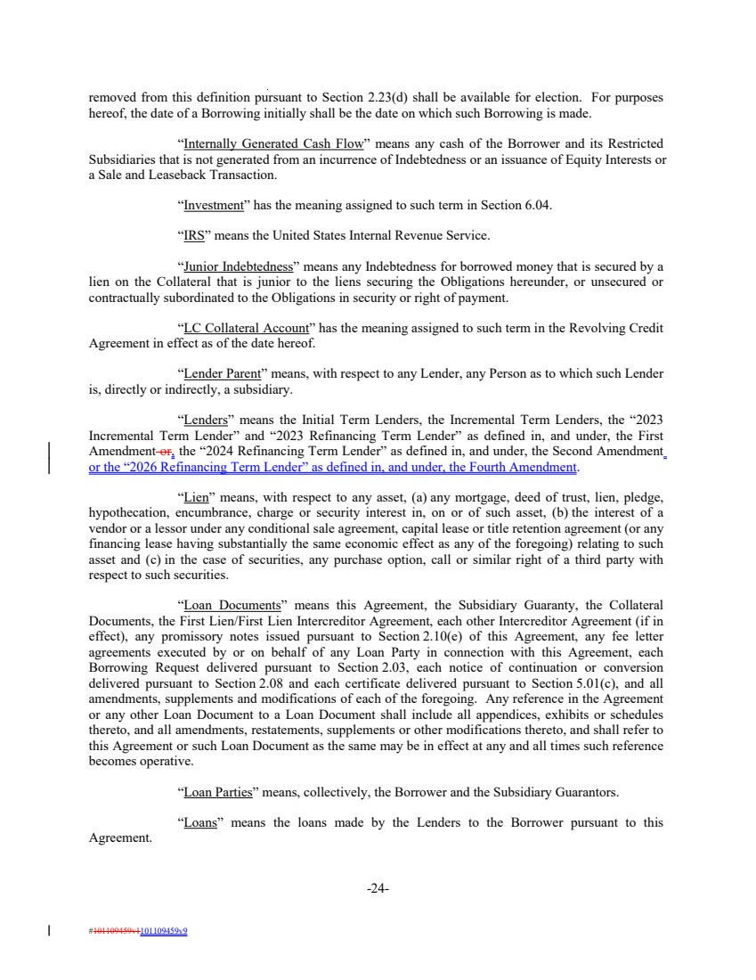 | removed from this definition pursuant to Section 2.23(d) shall be available for election. For purposes hereof, the date of a Borrowing initially shall be the date on which such Borrowing is made. “Internally Generated Cash Flow” means any cash of the Borrower and its Restricted Subsidiaries that is not generated from an incurrence of Indebtedness or an issuance of Equity Interests or a Sale and Leaseback Transaction. “Investment” has the meaning assigned to such term in Section 6.04. “IRS” means the United States Internal Revenue Service. “Junior Indebtedness” means any Indebtedness for borrowed money that is secured by a lien on the Collateral that is junior to the liens securing the Obligations hereunder, or unsecured or contractually subordinated to the Obligations in security or right of payment. “LC Collateral Account” has the meaning assigned to such term in the Revolving Credit Agreement in effect as of the date hereof. “Lender Parent” means, with respect to any Lender, any Person as to which such Lender is, directly or indirectly, a subsidiary. “Lenders” means the Initial Term Lenders, the Incremental Term Lenders, the “2023 Incremental Term Lender” and “2023 Refinancing Term Lender” as defined in, and under, the First Amendment or, the “2024 Refinancing Term Lender” as defined in, and under, the Second Amendment or the “2026 Refinancing Term Lender” as defined in, and under, the Fourth Amendment. “Lien” means, with respect to any asset, (a) any mortgage, deed of trust, lien, pledge, hypothecation, encumbrance, charge or security interest in, on or of such asset, (b) the interest of a vendor or a lessor under any conditional sale agreement, capital lease or title retention agreement (or any financing lease having substantially the same economic effect as any of the foregoing) relating to such asset and (c) in the case of securities, any purchase option, call or similar right of a third party with respect to such securities. “Loan Documents” means this Agreement, the Subsidiary Guaranty, the Collateral Documents, the First Lien/First Lien Intercreditor Agreement, each other Intercreditor Agreement (if in effect), any promissory notes issued pursuant to Section 2.10(e) of this Agreement, any fee letter agreements executed by or on behalf of any Loan Party in connection with this Agreement, each Borrowing Request delivered pursuant to Section 2.03, each notice of continuation or conversion delivered pursuant to Section 2.08 and each certificate delivered pursuant to Section 5.01(c), and all amendments, supplements and modifications of each of the foregoing. Any reference in the Agreement or any other Loan Document to a Loan Document shall include all appendices, exhibits or schedules thereto, and all amendments, restatements, supplements or other modifications thereto, and shall refer to this Agreement or such Loan Document as the same may be in effect at any and all times such reference becomes operative. “Loan Parties” means, collectively, the Borrower and the Subsidiary Guarantors. “Loans” means the loans made by the Lenders to the Borrower pursuant to this Agreement. -24- #101109459v1101109459v9
 | 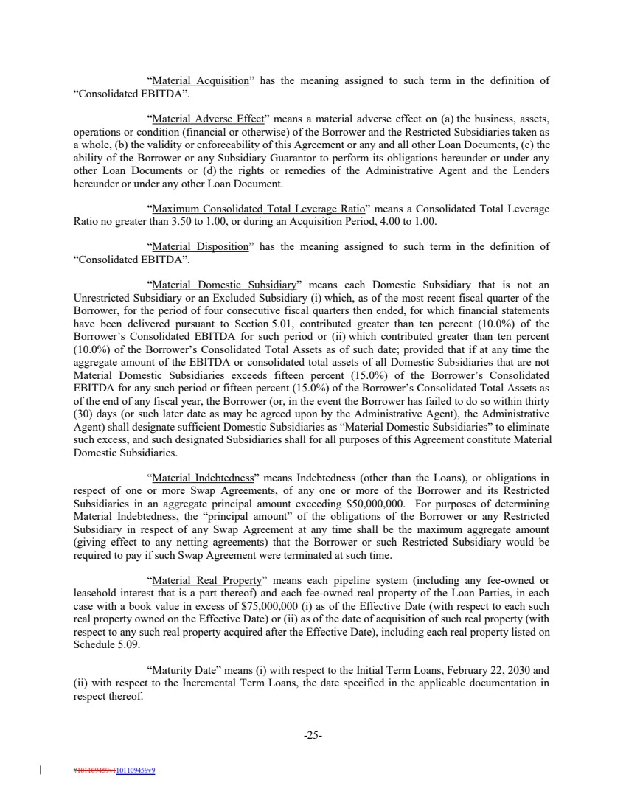 | “Material Acquisition” has the meaning assigned to such term in the definition of “Consolidated EBITDA”. “Material Adverse Effect” means a material adverse effect on (a) the business, assets, operations or condition (financial or otherwise) of the Borrower and the Restricted Subsidiaries taken as a whole, (b) the validity or enforceability of this Agreement or any and all other Loan Documents, (c) the ability of the Borrower or any Subsidiary Guarantor to perform its obligations hereunder or under any other Loan Documents or (d) the rights or remedies of the Administrative Agent and the Lenders hereunder or under any other Loan Document. “Maximum Consolidated Total Leverage Ratio” means a Consolidated Total Leverage Ratio no greater than 3.50 to 1.00, or during an Acquisition Period, 4.00 to 1.00. “Material Disposition” has the meaning assigned to such term in the definition of “Consolidated EBITDA”. “Material Domestic Subsidiary” means each Domestic Subsidiary that is not an Unrestricted Subsidiary or an Excluded Subsidiary (i) which, as of the most recent fiscal quarter of the Borrower, for the period of four consecutive fiscal quarters then ended, for which financial statements have been delivered pursuant to Section 5.01, contributed greater than ten percent (10.0%) of the Borrower’s Consolidated EBITDA for such period or (ii) which contributed greater than ten percent (10.0%) of the Borrower’s Consolidated Total Assets as of such date; provided that if at any time the aggregate amount of the EBITDA or consolidated total assets of all Domestic Subsidiaries that are not Material Domestic Subsidiaries exceeds fifteen percent (15.0%) of the Borrower’s Consolidated EBITDA for any such period or fifteen percent (15.0%) of the Borrower’s Consolidated Total Assets as of the end of any fiscal year, the Borrower (or, in the event the Borrower has failed to do so within thirty (30) days (or such later date as may be agreed upon by the Administrative Agent), the Administrative Agent) shall designate sufficient Domestic Subsidiaries as “Material Domestic Subsidiaries” to eliminate such excess, and such designated Subsidiaries shall for all purposes of this Agreement constitute Material Domestic Subsidiaries. “Material Indebtedness” means Indebtedness (other than the Loans), or obligations in respect of one or more Swap Agreements, of any one or more of the Borrower and its Restricted Subsidiaries in an aggregate principal amount exceeding $50,000,000. For purposes of determining Material Indebtedness, the “principal amount” of the obligations of the Borrower or any Restricted Subsidiary in respect of any Swap Agreement at any time shall be the maximum aggregate amount (giving effect to any netting agreements) that the Borrower or such Restricted Subsidiary would be required to pay if such Swap Agreement were terminated at such time. “Material Real Property” means each pipeline system (including any fee-owned or leasehold interest that is a part thereof) and each fee-owned real property of the Loan Parties, in each case with a book value in excess of $75,000,000 (i) as of the Effective Date (with respect to each such real property owned on the Effective Date) or (ii) as of the date of acquisition of such real property (with respect to any such real property acquired after the Effective Date), including each real property listed on Schedule 5.09. “Maturity Date” means (i) with respect to the Initial Term Loans, February 22, 2030 and (ii) with respect to the Incremental Term Loans, the date specified in the applicable documentation in respect thereof. -25- #101109459v1101109459v9
 | 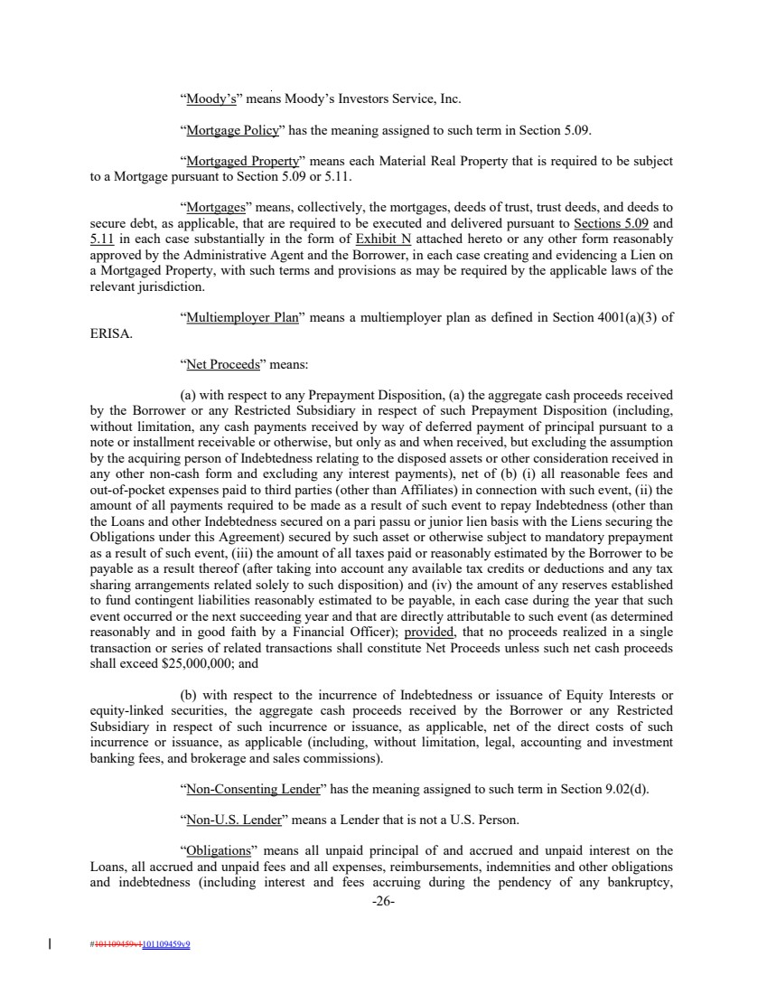 | “Moody’s” means Moody’s Investors Service, Inc. “Mortgage Policy” has the meaning assigned to such term in Section 5.09. “Mortgaged Property” means each Material Real Property that is required to be subject to a Mortgage pursuant to Section 5.09 or 5.11. “Mortgages” means, collectively, the mortgages, deeds of trust, trust deeds, and deeds to secure debt, as applicable, that are required to be executed and delivered pursuant to Sections 5.09 and 5.11 in each case substantially in the form of Exhibit N attached hereto or any other form reasonably approved by the Administrative Agent and the Borrower, in each case creating and evidencing a Lien on a Mortgaged Property, with such terms and provisions as may be required by the applicable laws of the relevant jurisdiction. “Multiemployer Plan” means a multiemployer plan as defined in Section 4001(a)(3) of ERISA. “Net Proceeds” means: (a) with respect to any Prepayment Disposition, (a) the aggregate cash proceeds received by the Borrower or any Restricted Subsidiary in respect of such Prepayment Disposition (including, without limitation, any cash payments received by way of deferred payment of principal pursuant to a note or installment receivable or otherwise, but only as and when received, but excluding the assumption by the acquiring person of Indebtedness relating to the disposed assets or other consideration received in any other non-cash form and excluding any interest payments), net of (b) (i) all reasonable fees and out-of-pocket expenses paid to third parties (other than Affiliates) in connection with such event, (ii) the amount of all payments required to be made as a result of such event to repay Indebtedness (other than the Loans and other Indebtedness secured on a pari passu or junior lien basis with the Liens securing the Obligations under this Agreement) secured by such asset or otherwise subject to mandatory prepayment as a result of such event, (iii) the amount of all taxes paid or reasonably estimated by the Borrower to be payable as a result thereof (after taking into account any available tax credits or deductions and any tax sharing arrangements related solely to such disposition) and (iv) the amount of any reserves established to fund contingent liabilities reasonably estimated to be payable, in each case during the year that such event occurred or the next succeeding year and that are directly attributable to such event (as determined reasonably and in good faith by a Financial Officer); provided, that no proceeds realized in a single transaction or series of related transactions shall constitute Net Proceeds unless such net cash proceeds shall exceed $25,000,000; and (b) with respect to the incurrence of Indebtedness or issuance of Equity Interests or equity-linked securities, the aggregate cash proceeds received by the Borrower or any Restricted Subsidiary in respect of such incurrence or issuance, as applicable, net of the direct costs of such incurrence or issuance, as applicable (including, without limitation, legal, accounting and investment banking fees, and brokerage and sales commissions). “Non-Consenting Lender” has the meaning assigned to such term in Section 9.02(d). “Non-U.S. Lender” means a Lender that is not a U.S. Person. “Obligations” means all unpaid principal of and accrued and unpaid interest on the Loans, all accrued and unpaid fees and all expenses, reimbursements, indemnities and other obligations and indebtedness (including interest and fees accruing during the pendency of any bankruptcy, -26- #101109459v1101109459v9
 | 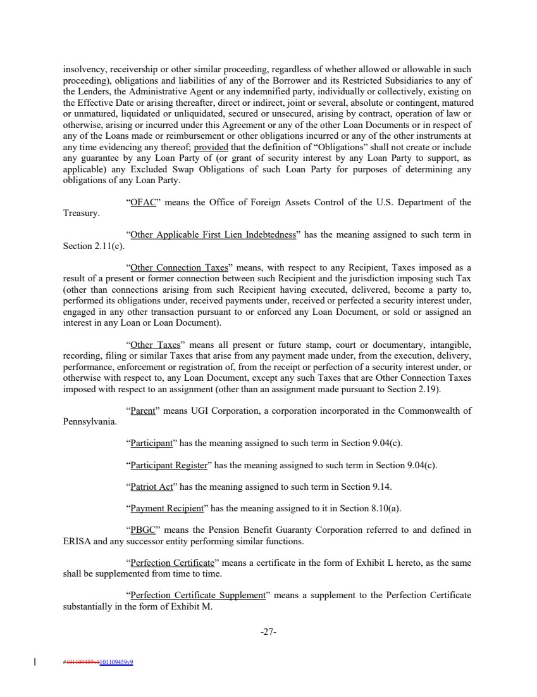 | insolvency, receivership or other similar proceeding, regardless of whether allowed or allowable in such proceeding), obligations and liabilities of any of the Borrower and its Restricted Subsidiaries to any of the Lenders, the Administrative Agent or any indemnified party, individually or collectively, existing on the Effective Date or arising thereafter, direct or indirect, joint or several, absolute or contingent, matured or unmatured, liquidated or unliquidated, secured or unsecured, arising by contract, operation of law or otherwise, arising or incurred under this Agreement or any of the other Loan Documents or in respect of any of the Loans made or reimbursement or other obligations incurred or any of the other instruments at any time evidencing any thereof; provided that the definition of “Obligations” shall not create or include any guarantee by any Loan Party of (or grant of security interest by any Loan Party to support, as applicable) any Excluded Swap Obligations of such Loan Party for purposes of determining any obligations of any Loan Party. “OFAC” means the Office of Foreign Assets Control of the U.S. Department of the Treasury. “Other Applicable First Lien Indebtedness” has the meaning assigned to such term in Section 2.11(c). “Other Connection Taxes” means, with respect to any Recipient, Taxes imposed as a result of a present or former connection between such Recipient and the jurisdiction imposing such Tax (other than connections arising from such Recipient having executed, delivered, become a party to, performed its obligations under, received payments under, received or perfected a security interest under, engaged in any other transaction pursuant to or enforced any Loan Document, or sold or assigned an interest in any Loan or Loan Document). “Other Taxes” means all present or future stamp, court or documentary, intangible, recording, filing or similar Taxes that arise from any payment made under, from the execution, delivery, performance, enforcement or registration of, from the receipt or perfection of a security interest under, or otherwise with respect to, any Loan Document, except any such Taxes that are Other Connection Taxes imposed with respect to an assignment (other than an assignment made pursuant to Section 2.19). “Parent” means UGI Corporation, a corporation incorporated in the Commonwealth of Pennsylvania. “Participant” has the meaning assigned to such term in Section 9.04(c). “Participant Register” has the meaning assigned to such term in Section 9.04(c). “Patriot Act” has the meaning assigned to such term in Section 9.14. “Payment Recipient” has the meaning assigned to it in Section 8.10(a). “PBGC” means the Pension Benefit Guaranty Corporation referred to and defined in ERISA and any successor entity performing similar functions. “Perfection Certificate” means a certificate in the form of Exhibit L hereto, as the same shall be supplemented from time to time. “Perfection Certificate Supplement” means a supplement to the Perfection Certificate substantially in the form of Exhibit M. -27- #101109459v1101109459v9
 | 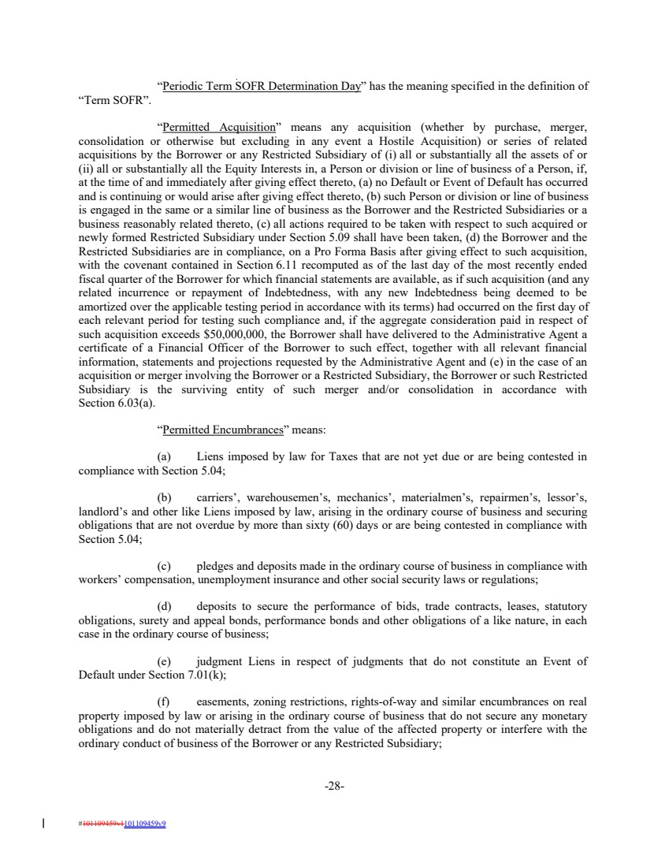 | “Periodic Term SOFR Determination Day” has the meaning specified in the definition of “Term SOFR”. “Permitted Acquisition” means any acquisition (whether by purchase, merger, consolidation or otherwise but excluding in any event a Hostile Acquisition) or series of related acquisitions by the Borrower or any Restricted Subsidiary of (i) all or substantially all the assets of or (ii) all or substantially all the Equity Interests in, a Person or division or line of business of a Person, if, at the time of and immediately after giving effect thereto, (a) no Default or Event of Default has occurred and is continuing or would arise after giving effect thereto, (b) such Person or division or line of business is engaged in the same or a similar line of business as the Borrower and the Restricted Subsidiaries or a business reasonably related thereto, (c) all actions required to be taken with respect to such acquired or newly formed Restricted Subsidiary under Section 5.09 shall have been taken, (d) the Borrower and the Restricted Subsidiaries are in compliance, on a Pro Forma Basis after giving effect to such acquisition, with the covenant contained in Section 6.11 recomputed as of the last day of the most recently ended fiscal quarter of the Borrower for which financial statements are available, as if such acquisition (and any related incurrence or repayment of Indebtedness, with any new Indebtedness being deemed to be amortized over the applicable testing period in accordance with its terms) had occurred on the first day of each relevant period for testing such compliance and, if the aggregate consideration paid in respect of such acquisition exceeds $50,000,000, the Borrower shall have delivered to the Administrative Agent a certificate of a Financial Officer of the Borrower to such effect, together with all relevant financial information, statements and projections requested by the Administrative Agent and (e) in the case of an acquisition or merger involving the Borrower or a Restricted Subsidiary, the Borrower or such Restricted Subsidiary is the surviving entity of such merger and/or consolidation in accordance with Section 6.03(a). “Permitted Encumbrances” means: (a) Liens imposed by law for Taxes that are not yet due or are being contested in compliance with Section 5.04; (b) carriers’, warehousemen’s, mechanics’, materialmen’s, repairmen’s, lessor’s, landlord’s and other like Liens imposed by law, arising in the ordinary course of business and securing obligations that are not overdue by more than sixty (60) days or are being contested in compliance with Section 5.04; (c) pledges and deposits made in the ordinary course of business in compliance with workers’ compensation, unemployment insurance and other social security laws or regulations; (d) deposits to secure the performance of bids, trade contracts, leases, statutory obligations, surety and appeal bonds, performance bonds and other obligations of a like nature, in each case in the ordinary course of business; (e) judgment Liens in respect of judgments that do not constitute an Event of Default under Section 7.01(k); (f) easements, zoning restrictions, rights-of-way and similar encumbrances on real property imposed by law or arising in the ordinary course of business that do not secure any monetary obligations and do not materially detract from the value of the affected property or interfere with the ordinary conduct of business of the Borrower or any Restricted Subsidiary; -28- #101109459v1101109459v9
 | 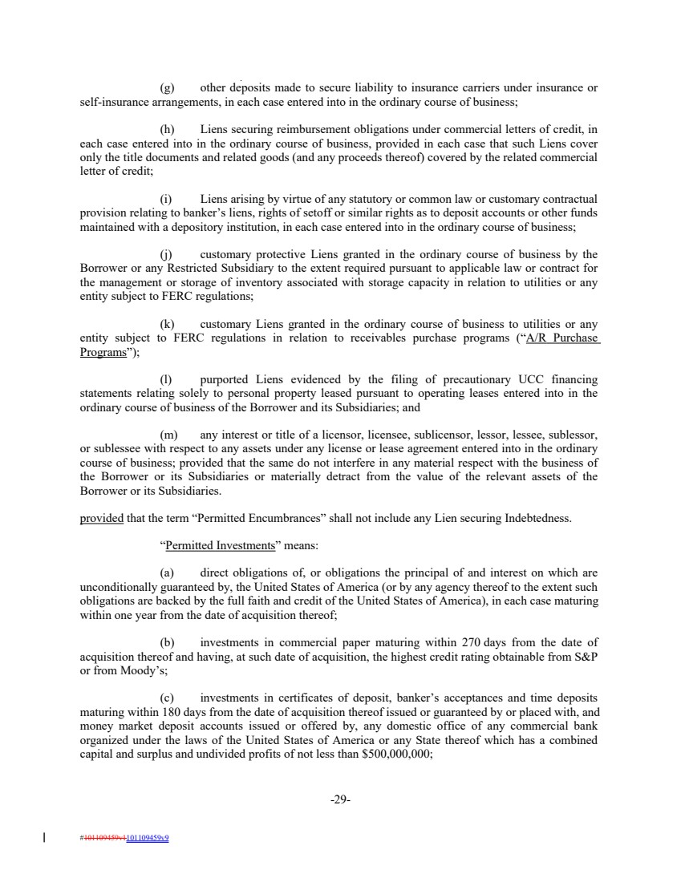 | (g) other deposits made to secure liability to insurance carriers under insurance or self-insurance arrangements, in each case entered into in the ordinary course of business; (h) Liens securing reimbursement obligations under commercial letters of credit, in each case entered into in the ordinary course of business, provided in each case that such Liens cover only the title documents and related goods (and any proceeds thereof) covered by the related commercial letter of credit; (i) Liens arising by virtue of any statutory or common law or customary contractual provision relating to banker’s liens, rights of setoff or similar rights as to deposit accounts or other funds maintained with a depository institution, in each case entered into in the ordinary course of business; (j) customary protective Liens granted in the ordinary course of business by the Borrower or any Restricted Subsidiary to the extent required pursuant to applicable law or contract for the management or storage of inventory associated with storage capacity in relation to utilities or any entity subject to FERC regulations; (k) customary Liens granted in the ordinary course of business to utilities or any entity subject to FERC regulations in relation to receivables purchase programs (“A/R Purchase Programs”); (l) purported Liens evidenced by the filing of precautionary UCC financing statements relating solely to personal property leased pursuant to operating leases entered into in the ordinary course of business of the Borrower and its Subsidiaries; and (m) any interest or title of a licensor, licensee, sublicensor, lessor, lessee, sublessor, or sublessee with respect to any assets under any license or lease agreement entered into in the ordinary course of business; provided that the same do not interfere in any material respect with the business of the Borrower or its Subsidiaries or materially detract from the value of the relevant assets of the Borrower or its Subsidiaries. provided that the term “Permitted Encumbrances” shall not include any Lien securing Indebtedness. “Permitted Investments” means: (a) direct obligations of, or obligations the principal of and interest on which are unconditionally guaranteed by, the United States of America (or by any agency thereof to the extent such obligations are backed by the full faith and credit of the United States of America), in each case maturing within one year from the date of acquisition thereof; (b) investments in commercial paper maturing within 270 days from the date of acquisition thereof and having, at such date of acquisition, the highest credit rating obtainable from S&P or from Moody’s; (c) investments in certificates of deposit, banker’s acceptances and time deposits maturing within 180 days from the date of acquisition thereof issued or guaranteed by or placed with, and money market deposit accounts issued or offered by, any domestic office of any commercial bank organized under the laws of the United States of America or any State thereof which has a combined capital and surplus and undivided profits of not less than $500,000,000; -29- #101109459v1101109459v9
 | 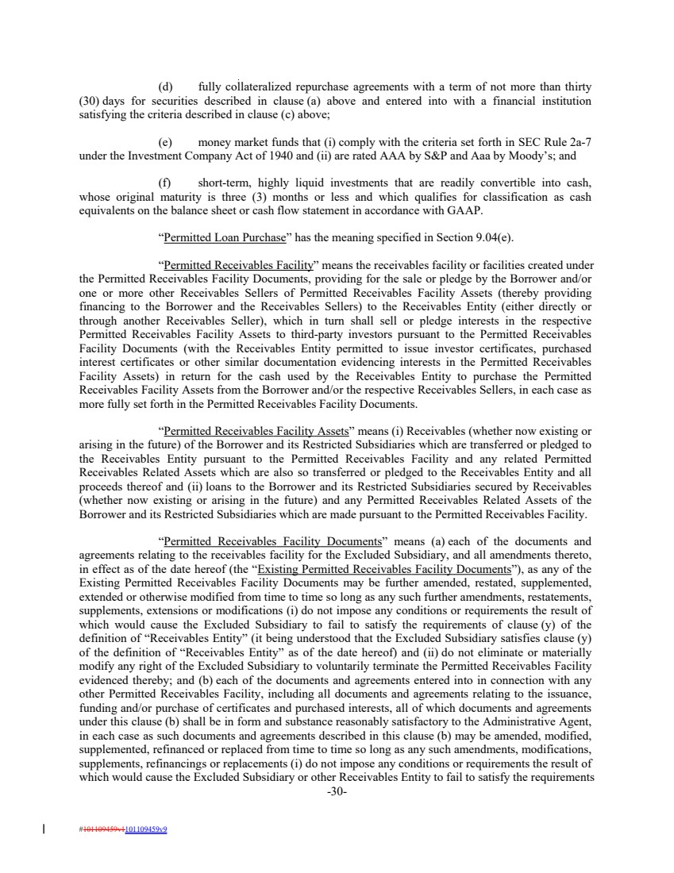 | (d) fully collateralized repurchase agreements with a term of not more than thirty (30) days for securities described in clause (a) above and entered into with a financial institution satisfying the criteria described in clause (c) above; (e) money market funds that (i) comply with the criteria set forth in SEC Rule 2a-7 under the Investment Company Act of 1940 and (ii) are rated AAA by S&P and Aaa by Moody’s; and (f) short-term, highly liquid investments that are readily convertible into cash, whose original maturity is three (3) months or less and which qualifies for classification as cash equivalents on the balance sheet or cash flow statement in accordance with GAAP. “Permitted Loan Purchase” has the meaning specified in Section 9.04(e). “Permitted Receivables Facility” means the receivables facility or facilities created under the Permitted Receivables Facility Documents, providing for the sale or pledge by the Borrower and/or one or more other Receivables Sellers of Permitted Receivables Facility Assets (thereby providing financing to the Borrower and the Receivables Sellers) to the Receivables Entity (either directly or through another Receivables Seller), which in turn shall sell or pledge interests in the respective Permitted Receivables Facility Assets to third-party investors pursuant to the Permitted Receivables Facility Documents (with the Receivables Entity permitted to issue investor certificates, purchased interest certificates or other similar documentation evidencing interests in the Permitted Receivables Facility Assets) in return for the cash used by the Receivables Entity to purchase the Permitted Receivables Facility Assets from the Borrower and/or the respective Receivables Sellers, in each case as more fully set forth in the Permitted Receivables Facility Documents. “Permitted Receivables Facility Assets” means (i) Receivables (whether now existing or arising in the future) of the Borrower and its Restricted Subsidiaries which are transferred or pledged to the Receivables Entity pursuant to the Permitted Receivables Facility and any related Permitted Receivables Related Assets which are also so transferred or pledged to the Receivables Entity and all proceeds thereof and (ii) loans to the Borrower and its Restricted Subsidiaries secured by Receivables (whether now existing or arising in the future) and any Permitted Receivables Related Assets of the Borrower and its Restricted Subsidiaries which are made pursuant to the Permitted Receivables Facility. “Permitted Receivables Facility Documents” means (a) each of the documents and agreements relating to the receivables facility for the Excluded Subsidiary, and all amendments thereto, in effect as of the date hereof (the “Existing Permitted Receivables Facility Documents”), as any of the Existing Permitted Receivables Facility Documents may be further amended, restated, supplemented, extended or otherwise modified from time to time so long as any such further amendments, restatements, supplements, extensions or modifications (i) do not impose any conditions or requirements the result of which would cause the Excluded Subsidiary to fail to satisfy the requirements of clause (y) of the definition of “Receivables Entity” (it being understood that the Excluded Subsidiary satisfies clause (y) of the definition of “Receivables Entity” as of the date hereof) and (ii) do not eliminate or materially modify any right of the Excluded Subsidiary to voluntarily terminate the Permitted Receivables Facility evidenced thereby; and (b) each of the documents and agreements entered into in connection with any other Permitted Receivables Facility, including all documents and agreements relating to the issuance, funding and/or purchase of certificates and purchased interests, all of which documents and agreements under this clause (b) shall be in form and substance reasonably satisfactory to the Administrative Agent, in each case as such documents and agreements described in this clause (b) may be amended, modified, supplemented, refinanced or replaced from time to time so long as any such amendments, modifications, supplements, refinancings or replacements (i) do not impose any conditions or requirements the result of which would cause the Excluded Subsidiary or other Receivables Entity to fail to satisfy the requirements -30- #101109459v1101109459v9
 | 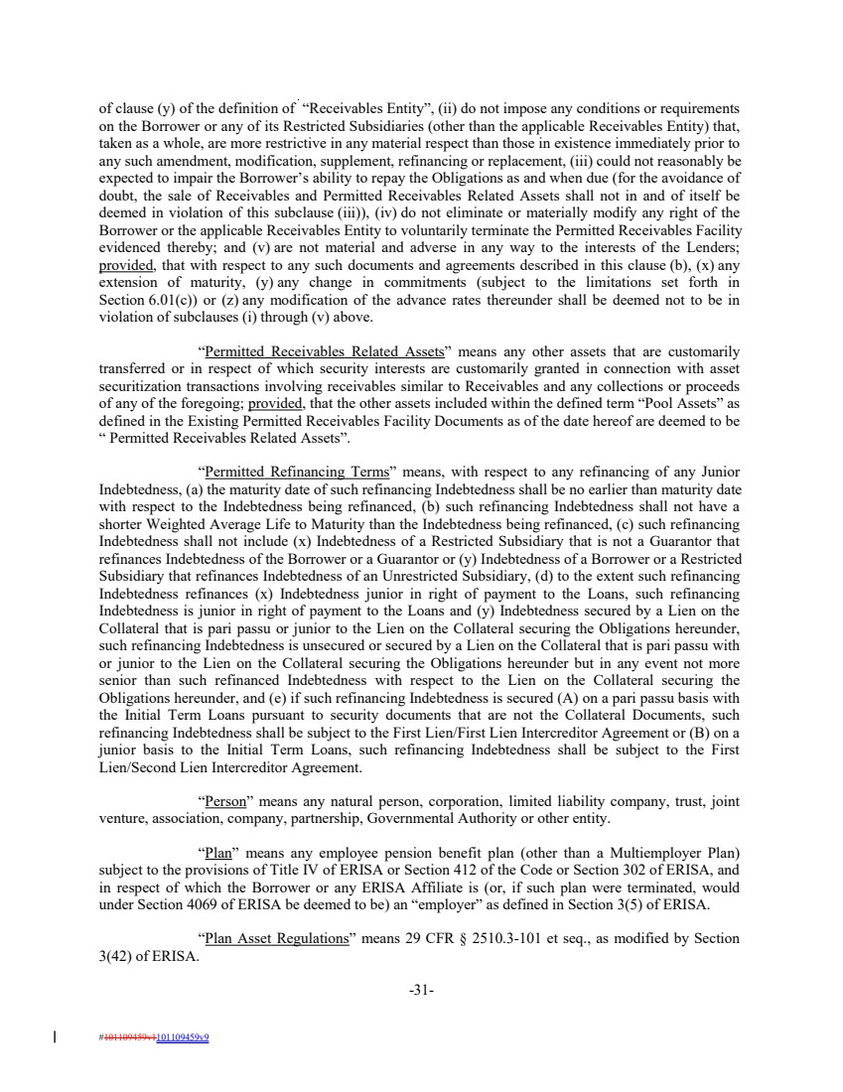 | of clause (y) of the definition of “Receivables Entity”, (ii) do not impose any conditions or requirements on the Borrower or any of its Restricted Subsidiaries (other than the applicable Receivables Entity) that, taken as a whole, are more restrictive in any material respect than those in existence immediately prior to any such amendment, modification, supplement, refinancing or replacement, (iii) could not reasonably be expected to impair the Borrower’s ability to repay the Obligations as and when due (for the avoidance of doubt, the sale of Receivables and Permitted Receivables Related Assets shall not in and of itself be deemed in violation of this subclause (iii)), (iv) do not eliminate or materially modify any right of the Borrower or the applicable Receivables Entity to voluntarily terminate the Permitted Receivables Facility evidenced thereby; and (v) are not material and adverse in any way to the interests of the Lenders; provided, that with respect to any such documents and agreements described in this clause (b), (x) any extension of maturity, (y) any change in commitments (subject to the limitations set forth in Section 6.01(c)) or (z) any modification of the advance rates thereunder shall be deemed not to be in violation of subclauses (i) through (v) above. “Permitted Receivables Related Assets” means any other assets that are customarily transferred or in respect of which security interests are customarily granted in connection with asset securitization transactions involving receivables similar to Receivables and any collections or proceeds of any of the foregoing; provided, that the other assets included within the defined term “Pool Assets” as defined in the Existing Permitted Receivables Facility Documents as of the date hereof are deemed to be “ Permitted Receivables Related Assets”. “Permitted Refinancing Terms” means, with respect to any refinancing of any Junior Indebtedness, (a) the maturity date of such refinancing Indebtedness shall be no earlier than maturity date with respect to the Indebtedness being refinanced, (b) such refinancing Indebtedness shall not have a shorter Weighted Average Life to Maturity than the Indebtedness being refinanced, (c) such refinancing Indebtedness shall not include (x) Indebtedness of a Restricted Subsidiary that is not a Guarantor that refinances Indebtedness of the Borrower or a Guarantor or (y) Indebtedness of a Borrower or a Restricted Subsidiary that refinances Indebtedness of an Unrestricted Subsidiary, (d) to the extent such refinancing Indebtedness refinances (x) Indebtedness junior in right of payment to the Loans, such refinancing Indebtedness is junior in right of payment to the Loans and (y) Indebtedness secured by a Lien on the Collateral that is pari passu or junior to the Lien on the Collateral securing the Obligations hereunder, such refinancing Indebtedness is unsecured or secured by a Lien on the Collateral that is pari passu with or junior to the Lien on the Collateral securing the Obligations hereunder but in any event not more senior than such refinanced Indebtedness with respect to the Lien on the Collateral securing the Obligations hereunder, and (e) if such refinancing Indebtedness is secured (A) on a pari passu basis with the Initial Term Loans pursuant to security documents that are not the Collateral Documents, such refinancing Indebtedness shall be subject to the First Lien/First Lien Intercreditor Agreement or (B) on a junior basis to the Initial Term Loans, such refinancing Indebtedness shall be subject to the First Lien/Second Lien Intercreditor Agreement. “Person” means any natural person, corporation, limited liability company, trust, joint venture, association, company, partnership, Governmental Authority or other entity. “Plan” means any employee pension benefit plan (other than a Multiemployer Plan) subject to the provisions of Title IV of ERISA or Section 412 of the Code or Section 302 of ERISA, and in respect of which the Borrower or any ERISA Affiliate is (or, if such plan were terminated, would under Section 4069 of ERISA be deemed to be) an “employer” as defined in Section 3(5) of ERISA. “Plan Asset Regulations” means 29 CFR § 2510.3-101 et seq., as modified by Section 3(42) of ERISA. -31- #101109459v1101109459v9
 | 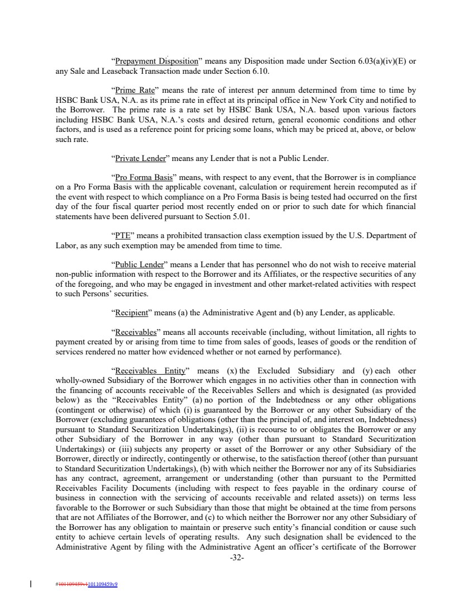 | “Prepayment Disposition” means any Disposition made under Section 6.03(a)(iv)(E) or any Sale and Leaseback Transaction made under Section 6.10. “Prime Rate” means the rate of interest per annum determined from time to time by HSBC Bank USA, N.A. as its prime rate in effect at its principal office in New York City and notified to the Borrower. The prime rate is a rate set by HSBC Bank USA, N.A. based upon various factors including HSBC Bank USA, N.A.’s costs and desired return, general economic conditions and other factors, and is used as a reference point for pricing some loans, which may be priced at, above, or below such rate. “Private Lender” means any Lender that is not a Public Lender. “Pro Forma Basis” means, with respect to any event, that the Borrower is in compliance on a Pro Forma Basis with the applicable covenant, calculation or requirement herein recomputed as if the event with respect to which compliance on a Pro Forma Basis is being tested had occurred on the first day of the four fiscal quarter period most recently ended on or prior to such date for which financial statements have been delivered pursuant to Section 5.01. “PTE” means a prohibited transaction class exemption issued by the U.S. Department of Labor, as any such exemption may be amended from time to time. “Public Lender” means a Lender that has personnel who do not wish to receive material non-public information with respect to the Borrower and its Affiliates, or the respective securities of any of the foregoing, and who may be engaged in investment and other market-related activities with respect to such Persons’ securities. “Recipient” means (a) the Administrative Agent and (b) any Lender, as applicable. “Receivables” means all accounts receivable (including, without limitation, all rights to payment created by or arising from time to time from sales of goods, leases of goods or the rendition of services rendered no matter how evidenced whether or not earned by performance). “Receivables Entity” means (x) the Excluded Subsidiary and (y) each other wholly-owned Subsidiary of the Borrower which engages in no activities other than in connection with the financing of accounts receivable of the Receivables Sellers and which is designated (as provided below) as the “Receivables Entity” (a) no portion of the Indebtedness or any other obligations (contingent or otherwise) of which (i) is guaranteed by the Borrower or any other Subsidiary of the Borrower (excluding guarantees of obligations (other than the principal of, and interest on, Indebtedness) pursuant to Standard Securitization Undertakings), (ii) is recourse to or obligates the Borrower or any other Subsidiary of the Borrower in any way (other than pursuant to Standard Securitization Undertakings) or (iii) subjects any property or asset of the Borrower or any other Subsidiary of the Borrower, directly or indirectly, contingently or otherwise, to the satisfaction thereof (other than pursuant to Standard Securitization Undertakings), (b) with which neither the Borrower nor any of its Subsidiaries has any contract, agreement, arrangement or understanding (other than pursuant to the Permitted Receivables Facility Documents (including with respect to fees payable in the ordinary course of business in connection with the servicing of accounts receivable and related assets)) on terms less favorable to the Borrower or such Subsidiary than those that might be obtained at the time from persons that are not Affiliates of the Borrower, and (c) to which neither the Borrower nor any other Subsidiary of the Borrower has any obligation to maintain or preserve such entity’s financial condition or cause such entity to achieve certain levels of operating results. Any such designation shall be evidenced to the Administrative Agent by filing with the Administrative Agent an officer’s certificate of the Borrower -32- #101109459v1101109459v9
 | 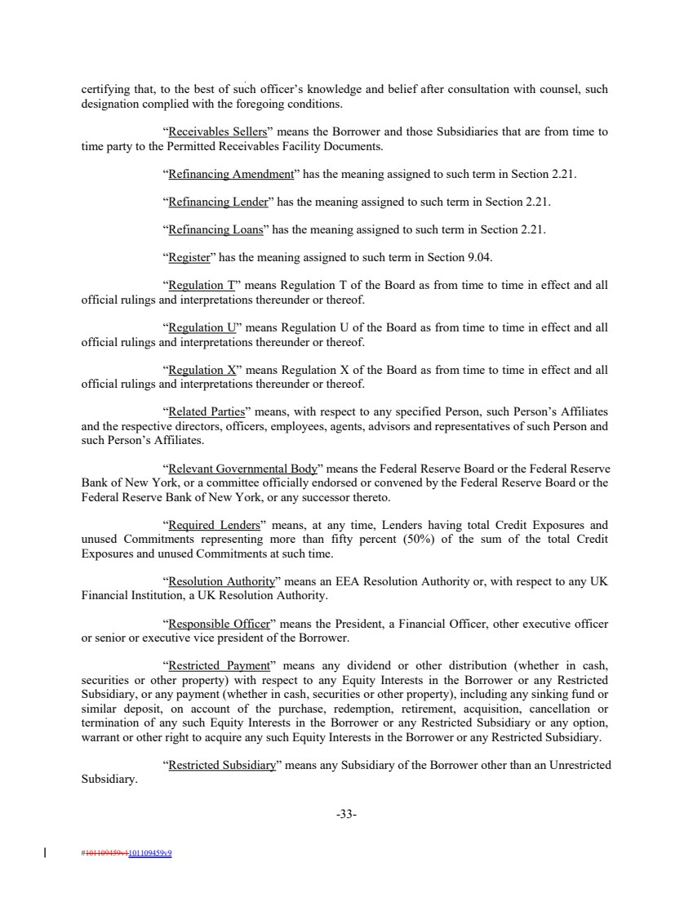 | certifying that, to the best of such officer’s knowledge and belief after consultation with counsel, such designation complied with the foregoing conditions. “Receivables Sellers” means the Borrower and those Subsidiaries that are from time to time party to the Permitted Receivables Facility Documents. “Refinancing Amendment” has the meaning assigned to such term in Section 2.21. “Refinancing Lender” has the meaning assigned to such term in Section 2.21. “Refinancing Loans” has the meaning assigned to such term in Section 2.21. “Register” has the meaning assigned to such term in Section 9.04. “Regulation T” means Regulation T of the Board as from time to time in effect and all official rulings and interpretations thereunder or thereof. “Regulation U” means Regulation U of the Board as from time to time in effect and all official rulings and interpretations thereunder or thereof. “Regulation X” means Regulation X of the Board as from time to time in effect and all official rulings and interpretations thereunder or thereof. “Related Parties” means, with respect to any specified Person, such Person’s Affiliates and the respective directors, officers, employees, agents, advisors and representatives of such Person and such Person’s Affiliates. “Relevant Governmental Body” means the Federal Reserve Board or the Federal Reserve Bank of New York, or a committee officially endorsed or convened by the Federal Reserve Board or the Federal Reserve Bank of New York, or any successor thereto. “Required Lenders” means, at any time, Lenders having total Credit Exposures and unused Commitments representing more than fifty percent (50%) of the sum of the total Credit Exposures and unused Commitments at such time. “Resolution Authority” means an EEA Resolution Authority or, with respect to any UK Financial Institution, a UK Resolution Authority. “Responsible Officer” means the President, a Financial Officer, other executive officer or senior or executive vice president of the Borrower. “Restricted Payment” means any dividend or other distribution (whether in cash, securities or other property) with respect to any Equity Interests in the Borrower or any Restricted Subsidiary, or any payment (whether in cash, securities or other property), including any sinking fund or similar deposit, on account of the purchase, redemption, retirement, acquisition, cancellation or termination of any such Equity Interests in the Borrower or any Restricted Subsidiary or any option, warrant or other right to acquire any such Equity Interests in the Borrower or any Restricted Subsidiary. “Restricted Subsidiary” means any Subsidiary of the Borrower other than an Unrestricted Subsidiary. -33- #101109459v1101109459v9
 | 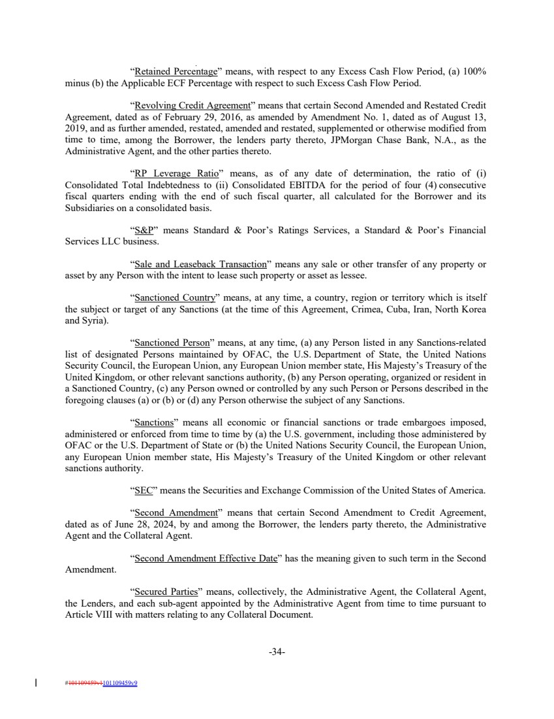 | “Retained Percentage” means, with respect to any Excess Cash Flow Period, (a) 100% minus (b) the Applicable ECF Percentage with respect to such Excess Cash Flow Period. “Revolving Credit Agreement” means that certain Second Amended and Restated Credit Agreement, dated as of February 29, 2016, as amended by Amendment No. 1, dated as of August 13, 2019, and as further amended, restated, amended and restated, supplemented or otherwise modified from time to time, among the Borrower, the lenders party thereto, JPMorgan Chase Bank, N.A., as the Administrative Agent, and the other parties thereto. “RP Leverage Ratio” means, as of any date of determination, the ratio of (i) Consolidated Total Indebtedness to (ii) Consolidated EBITDA for the period of four (4) consecutive fiscal quarters ending with the end of such fiscal quarter, all calculated for the Borrower and its Subsidiaries on a consolidated basis. “S&P” means Standard & Poor’s Ratings Services, a Standard & Poor’s Financial Services LLC business. “Sale and Leaseback Transaction” means any sale or other transfer of any property or asset by any Person with the intent to lease such property or asset as lessee. “Sanctioned Country” means, at any time, a country, region or territory which is itself the subject or target of any Sanctions (at the time of this Agreement, Crimea, Cuba, Iran, North Korea and Syria). “Sanctioned Person” means, at any time, (a) any Person listed in any Sanctions-related list of designated Persons maintained by OFAC, the U.S. Department of State, the United Nations Security Council, the European Union, any European Union member state, His Majesty’s Treasury of the United Kingdom, or other relevant sanctions authority, (b) any Person operating, organized or resident in a Sanctioned Country, (c) any Person owned or controlled by any such Person or Persons described in the foregoing clauses (a) or (b) or (d) any Person otherwise the subject of any Sanctions. “Sanctions” means all economic or financial sanctions or trade embargoes imposed, administered or enforced from time to time by (a) the U.S. government, including those administered by OFAC or the U.S. Department of State or (b) the United Nations Security Council, the European Union, any European Union member state, His Majesty’s Treasury of the United Kingdom or other relevant sanctions authority. “SEC” means the Securities and Exchange Commission of the United States of America. “Second Amendment” means that certain Second Amendment to Credit Agreement, dated as of June 28, 2024, by and among the Borrower, the lenders party thereto, the Administrative Agent and the Collateral Agent. “Second Amendment Effective Date” has the meaning given to such term in the Second Amendment. “Secured Parties” means, collectively, the Administrative Agent, the Collateral Agent, the Lenders, and each sub-agent appointed by the Administrative Agent from time to time pursuant to Article VIII with matters relating to any Collateral Document. -34- #101109459v1101109459v9
 | 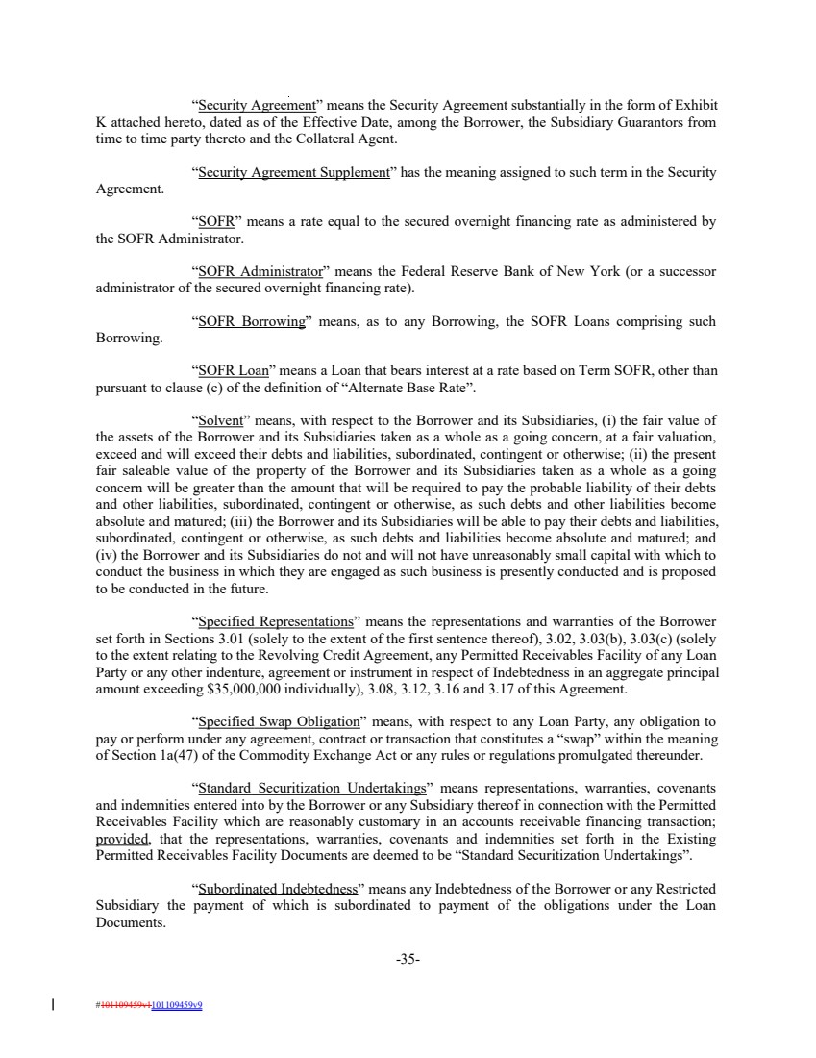 | “Security Agreement” means the Security Agreement substantially in the form of Exhibit K attached hereto, dated as of the Effective Date, among the Borrower, the Subsidiary Guarantors from time to time party thereto and the Collateral Agent. “Security Agreement Supplement” has the meaning assigned to such term in the Security Agreement. “SOFR” means a rate equal to the secured overnight financing rate as administered by the SOFR Administrator. “SOFR Administrator” means the Federal Reserve Bank of New York (or a successor administrator of the secured overnight financing rate). “SOFR Borrowing” means, as to any Borrowing, the SOFR Loans comprising such Borrowing. “SOFR Loan” means a Loan that bears interest at a rate based on Term SOFR, other than pursuant to clause (c) of the definition of “Alternate Base Rate”. “Solvent” means, with respect to the Borrower and its Subsidiaries, (i) the fair value of the assets of the Borrower and its Subsidiaries taken as a whole as a going concern, at a fair valuation, exceed and will exceed their debts and liabilities, subordinated, contingent or otherwise; (ii) the present fair saleable value of the property of the Borrower and its Subsidiaries taken as a whole as a going concern will be greater than the amount that will be required to pay the probable liability of their debts and other liabilities, subordinated, contingent or otherwise, as such debts and other liabilities become absolute and matured; (iii) the Borrower and its Subsidiaries will be able to pay their debts and liabilities, subordinated, contingent or otherwise, as such debts and liabilities become absolute and matured; and (iv) the Borrower and its Subsidiaries do not and will not have unreasonably small capital with which to conduct the business in which they are engaged as such business is presently conducted and is proposed to be conducted in the future. “Specified Representations” means the representations and warranties of the Borrower set forth in Sections 3.01 (solely to the extent of the first sentence thereof), 3.02, 3.03(b), 3.03(c) (solely to the extent relating to the Revolving Credit Agreement, any Permitted Receivables Facility of any Loan Party or any other indenture, agreement or instrument in respect of Indebtedness in an aggregate principal amount exceeding $35,000,000 individually), 3.08, 3.12, 3.16 and 3.17 of this Agreement. “Specified Swap Obligation” means, with respect to any Loan Party, any obligation to pay or perform under any agreement, contract or transaction that constitutes a “swap” within the meaning of Section 1a(47) of the Commodity Exchange Act or any rules or regulations promulgated thereunder. “Standard Securitization Undertakings” means representations, warranties, covenants and indemnities entered into by the Borrower or any Subsidiary thereof in connection with the Permitted Receivables Facility which are reasonably customary in an accounts receivable financing transaction; provided, that the representations, warranties, covenants and indemnities set forth in the Existing Permitted Receivables Facility Documents are deemed to be “Standard Securitization Undertakings”. “Subordinated Indebtedness” means any Indebtedness of the Borrower or any Restricted Subsidiary the payment of which is subordinated to payment of the obligations under the Loan Documents. -35- #101109459v1101109459v9
 | 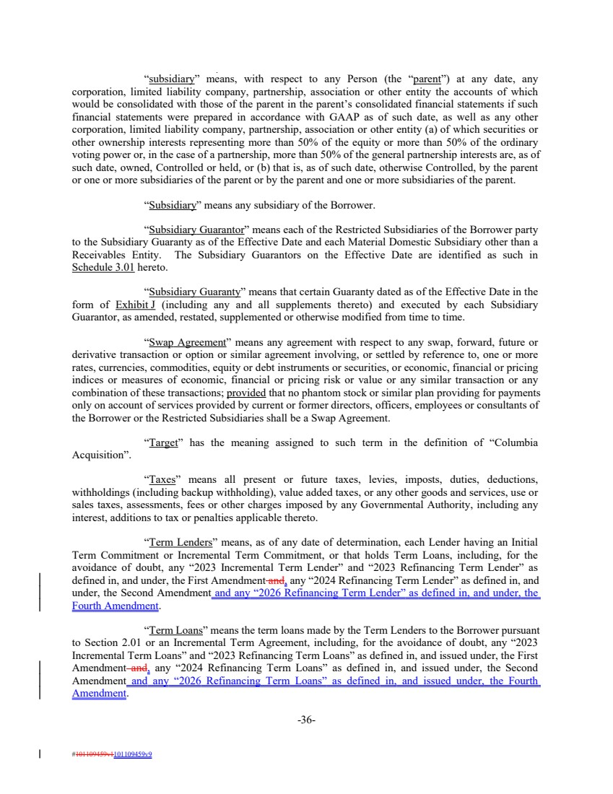 | “subsidiary” means, with respect to any Person (the “parent”) at any date, any corporation, limited liability company, partnership, association or other entity the accounts of which would be consolidated with those of the parent in the parent’s consolidated financial statements if such financial statements were prepared in accordance with GAAP as of such date, as well as any other corporation, limited liability company, partnership, association or other entity (a) of which securities or other ownership interests representing more than 50% of the equity or more than 50% of the ordinary voting power or, in the case of a partnership, more than 50% of the general partnership interests are, as of such date, owned, Controlled or held, or (b) that is, as of such date, otherwise Controlled, by the parent or one or more subsidiaries of the parent or by the parent and one or more subsidiaries of the parent. “Subsidiary” means any subsidiary of the Borrower. “Subsidiary Guarantor” means each of the Restricted Subsidiaries of the Borrower party to the Subsidiary Guaranty as of the Effective Date and each Material Domestic Subsidiary other than a Receivables Entity. The Subsidiary Guarantors on the Effective Date are identified as such in Schedule 3.01 hereto. “Subsidiary Guaranty” means that certain Guaranty dated as of the Effective Date in the form of Exhibit J (including any and all supplements thereto) and executed by each Subsidiary Guarantor, as amended, restated, supplemented or otherwise modified from time to time. “Swap Agreement” means any agreement with respect to any swap, forward, future or derivative transaction or option or similar agreement involving, or settled by reference to, one or more rates, currencies, commodities, equity or debt instruments or securities, or economic, financial or pricing indices or measures of economic, financial or pricing risk or value or any similar transaction or any combination of these transactions; provided that no phantom stock or similar plan providing for payments only on account of services provided by current or former directors, officers, employees or consultants of the Borrower or the Restricted Subsidiaries shall be a Swap Agreement. “Target” has the meaning assigned to such term in the definition of “Columbia Acquisition”. “Taxes” means all present or future taxes, levies, imposts, duties, deductions, withholdings (including backup withholding), value added taxes, or any other goods and services, use or sales taxes, assessments, fees or other charges imposed by any Governmental Authority, including any interest, additions to tax or penalties applicable thereto. “Term Lenders” means, as of any date of determination, each Lender having an Initial Term Commitment or Incremental Term Commitment, or that holds Term Loans, including, for the avoidance of doubt, any “2023 Incremental Term Lender” and “2023 Refinancing Term Lender” as defined in, and under, the First Amendment and, any “2024 Refinancing Term Lender” as defined in, and under, the Second Amendment and any “2026 Refinancing Term Lender” as defined in, and under, the Fourth Amendment. “Term Loans” means the term loans made by the Term Lenders to the Borrower pursuant to Section 2.01 or an Incremental Term Agreement, including, for the avoidance of doubt, any “2023 Incremental Term Loans” and “2023 Refinancing Term Loans” as defined in, and issued under, the First Amendment and, any “2024 Refinancing Term Loans” as defined in, and issued under, the Second Amendment and any “2026 Refinancing Term Loans” as defined in, and issued under, the Fourth Amendment. -36- #101109459v1101109459v9
 | 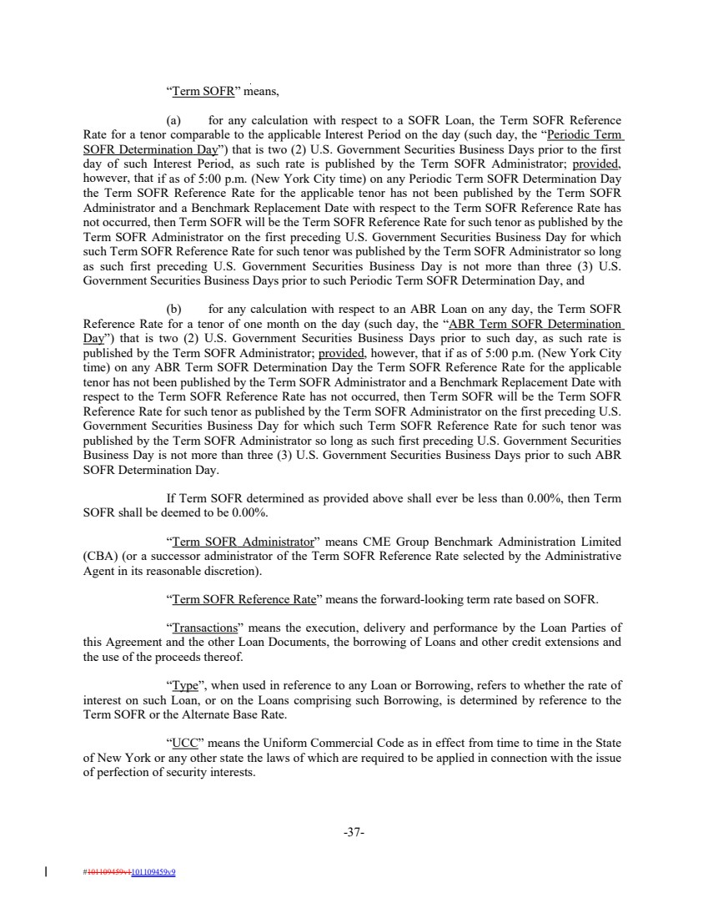 | “Term SOFR” means, (a) for any calculation with respect to a SOFR Loan, the Term SOFR Reference Rate for a tenor comparable to the applicable Interest Period on the day (such day, the “Periodic Term SOFR Determination Day”) that is two (2) U.S. Government Securities Business Days prior to the first day of such Interest Period, as such rate is published by the Term SOFR Administrator; provided, however, that if as of 5:00 p.m. (New York City time) on any Periodic Term SOFR Determination Day the Term SOFR Reference Rate for the applicable tenor has not been published by the Term SOFR Administrator and a Benchmark Replacement Date with respect to the Term SOFR Reference Rate has not occurred, then Term SOFR will be the Term SOFR Reference Rate for such tenor as published by the Term SOFR Administrator on the first preceding U.S. Government Securities Business Day for which such Term SOFR Reference Rate for such tenor was published by the Term SOFR Administrator so long as such first preceding U.S. Government Securities Business Day is not more than three (3) U.S. Government Securities Business Days prior to such Periodic Term SOFR Determination Day, and (b) for any calculation with respect to an ABR Loan on any day, the Term SOFR Reference Rate for a tenor of one month on the day (such day, the “ABR Term SOFR Determination Day”) that is two (2) U.S. Government Securities Business Days prior to such day, as such rate is published by the Term SOFR Administrator; provided, however, that if as of 5:00 p.m. (New York City time) on any ABR Term SOFR Determination Day the Term SOFR Reference Rate for the applicable tenor has not been published by the Term SOFR Administrator and a Benchmark Replacement Date with respect to the Term SOFR Reference Rate has not occurred, then Term SOFR will be the Term SOFR Reference Rate for such tenor as published by the Term SOFR Administrator on the first preceding U.S. Government Securities Business Day for which such Term SOFR Reference Rate for such tenor was published by the Term SOFR Administrator so long as such first preceding U.S. Government Securities Business Day is not more than three (3) U.S. Government Securities Business Days prior to such ABR SOFR Determination Day. If Term SOFR determined as provided above shall ever be less than 0.00%, then Term SOFR shall be deemed to be 0.00%. “Term SOFR Administrator” means CME Group Benchmark Administration Limited (CBA) (or a successor administrator of the Term SOFR Reference Rate selected by the Administrative Agent in its reasonable discretion). “Term SOFR Reference Rate” means the forward-looking term rate based on SOFR. “Transactions” means the execution, delivery and performance by the Loan Parties of this Agreement and the other Loan Documents, the borrowing of Loans and other credit extensions and the use of the proceeds thereof. “Type”, when used in reference to any Loan or Borrowing, refers to whether the rate of interest on such Loan, or on the Loans comprising such Borrowing, is determined by reference to the Term SOFR or the Alternate Base Rate. “UCC” means the Uniform Commercial Code as in effect from time to time in the State of New York or any other state the laws of which are required to be applied in connection with the issue of perfection of security interests. -37- #101109459v1101109459v9
 | 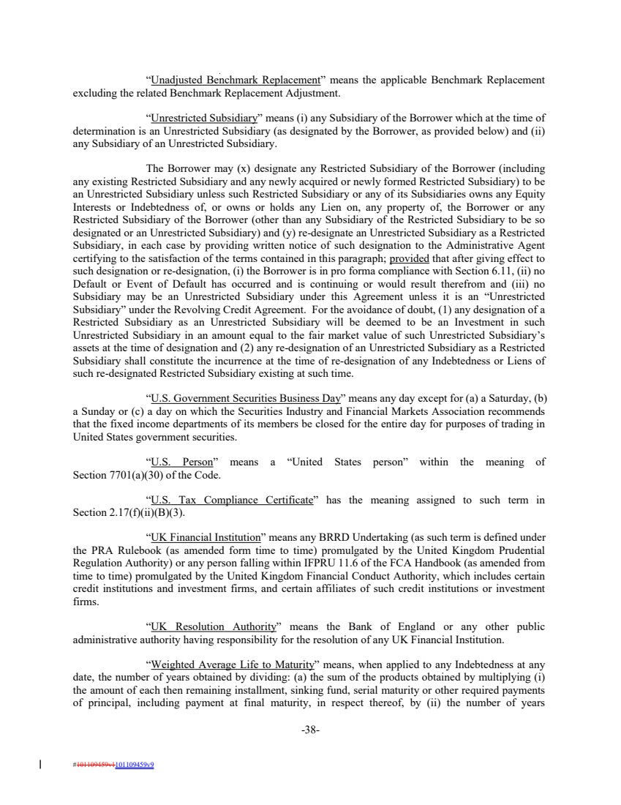 | “Unadjusted Benchmark Replacement” means the applicable Benchmark Replacement excluding the related Benchmark Replacement Adjustment. “Unrestricted Subsidiary” means (i) any Subsidiary of the Borrower which at the time of determination is an Unrestricted Subsidiary (as designated by the Borrower, as provided below) and (ii) any Subsidiary of an Unrestricted Subsidiary. The Borrower may (x) designate any Restricted Subsidiary of the Borrower (including any existing Restricted Subsidiary and any newly acquired or newly formed Restricted Subsidiary) to be an Unrestricted Subsidiary unless such Restricted Subsidiary or any of its Subsidiaries owns any Equity Interests or Indebtedness of, or owns or holds any Lien on, any property of, the Borrower or any Restricted Subsidiary of the Borrower (other than any Subsidiary of the Restricted Subsidiary to be so designated or an Unrestricted Subsidiary) and (y) re-designate an Unrestricted Subsidiary as a Restricted Subsidiary, in each case by providing written notice of such designation to the Administrative Agent certifying to the satisfaction of the terms contained in this paragraph; provided that after giving effect to such designation or re-designation, (i) the Borrower is in pro forma compliance with Section 6.11, (ii) no Default or Event of Default has occurred and is continuing or would result therefrom and (iii) no Subsidiary may be an Unrestricted Subsidiary under this Agreement unless it is an “Unrestricted Subsidiary” under the Revolving Credit Agreement. For the avoidance of doubt, (1) any designation of a Restricted Subsidiary as an Unrestricted Subsidiary will be deemed to be an Investment in such Unrestricted Subsidiary in an amount equal to the fair market value of such Unrestricted Subsidiary’s assets at the time of designation and (2) any re-designation of an Unrestricted Subsidiary as a Restricted Subsidiary shall constitute the incurrence at the time of re-designation of any Indebtedness or Liens of such re-designated Restricted Subsidiary existing at such time. “U.S. Government Securities Business Day” means any day except for (a) a Saturday, (b) a Sunday or (c) a day on which the Securities Industry and Financial Markets Association recommends that the fixed income departments of its members be closed for the entire day for purposes of trading in United States government securities. “U.S. Person” means a “United States person” within the meaning of Section 7701(a)(30) of the Code. “U.S. Tax Compliance Certificate” has the meaning assigned to such term in Section 2.17(f)(ii)(B)(3). “UK Financial Institution” means any BRRD Undertaking (as such term is defined under the PRA Rulebook (as amended form time to time) promulgated by the United Kingdom Prudential Regulation Authority) or any person falling within IFPRU 11.6 of the FCA Handbook (as amended from time to time) promulgated by the United Kingdom Financial Conduct Authority, which includes certain credit institutions and investment firms, and certain affiliates of such credit institutions or investment firms. “UK Resolution Authority” means the Bank of England or any other public administrative authority having responsibility for the resolution of any UK Financial Institution. “Weighted Average Life to Maturity” means, when applied to any Indebtedness at any date, the number of years obtained by dividing: (a) the sum of the products obtained by multiplying (i) the amount of each then remaining installment, sinking fund, serial maturity or other required payments of principal, including payment at final maturity, in respect thereof, by (ii) the number of years -38- #101109459v1101109459v9
 | 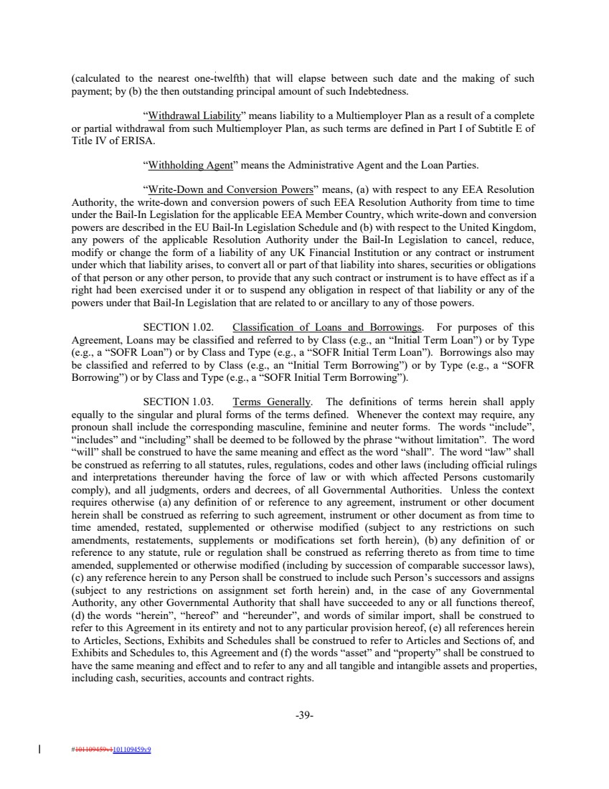 | (calculated to the nearest one-twelfth) that will elapse between such date and the making of such payment; by (b) the then outstanding principal amount of such Indebtedness. “Withdrawal Liability” means liability to a Multiemployer Plan as a result of a complete or partial withdrawal from such Multiemployer Plan, as such terms are defined in Part I of Subtitle E of Title IV of ERISA. “Withholding Agent” means the Administrative Agent and the Loan Parties. “Write-Down and Conversion Powers” means, (a) with respect to any EEA Resolution Authority, the write-down and conversion powers of such EEA Resolution Authority from time to time under the Bail-In Legislation for the applicable EEA Member Country, which write-down and conversion powers are described in the EU Bail-In Legislation Schedule and (b) with respect to the United Kingdom, any powers of the applicable Resolution Authority under the Bail-In Legislation to cancel, reduce, modify or change the form of a liability of any UK Financial Institution or any contract or instrument under which that liability arises, to convert all or part of that liability into shares, securities or obligations of that person or any other person, to provide that any such contract or instrument is to have effect as if a right had been exercised under it or to suspend any obligation in respect of that liability or any of the powers under that Bail-In Legislation that are related to or ancillary to any of those powers. SECTION 1.02. Classification of Loans and Borrowings. For purposes of this Agreement, Loans may be classified and referred to by Class (e.g., an “Initial Term Loan”) or by Type (e.g., a “SOFR Loan”) or by Class and Type (e.g., a “SOFR Initial Term Loan”). Borrowings also may be classified and referred to by Class (e.g., an “Initial Term Borrowing”) or by Type (e.g., a “SOFR Borrowing”) or by Class and Type (e.g., a “SOFR Initial Term Borrowing”). SECTION 1.03. Terms Generally. The definitions of terms herein shall apply equally to the singular and plural forms of the terms defined. Whenever the context may require, any pronoun shall include the corresponding masculine, feminine and neuter forms. The words “include”, “includes” and “including” shall be deemed to be followed by the phrase “without limitation”. The word “will” shall be construed to have the same meaning and effect as the word “shall”. The word “law” shall be construed as referring to all statutes, rules, regulations, codes and other laws (including official rulings and interpretations thereunder having the force of law or with which affected Persons customarily comply), and all judgments, orders and decrees, of all Governmental Authorities. Unless the context requires otherwise (a) any definition of or reference to any agreement, instrument or other document herein shall be construed as referring to such agreement, instrument or other document as from time to time amended, restated, supplemented or otherwise modified (subject to any restrictions on such amendments, restatements, supplements or modifications set forth herein), (b) any definition of or reference to any statute, rule or regulation shall be construed as referring thereto as from time to time amended, supplemented or otherwise modified (including by succession of comparable successor laws), (c) any reference herein to any Person shall be construed to include such Person’s successors and assigns (subject to any restrictions on assignment set forth herein) and, in the case of any Governmental Authority, any other Governmental Authority that shall have succeeded to any or all functions thereof, (d) the words “herein”, “hereof” and “hereunder”, and words of similar import, shall be construed to refer to this Agreement in its entirety and not to any particular provision hereof, (e) all references herein to Articles, Sections, Exhibits and Schedules shall be construed to refer to Articles and Sections of, and Exhibits and Schedules to, this Agreement and (f) the words “asset” and “property” shall be construed to have the same meaning and effect and to refer to any and all tangible and intangible assets and properties, including cash, securities, accounts and contract rights. -39- #101109459v1101109459v9
 | 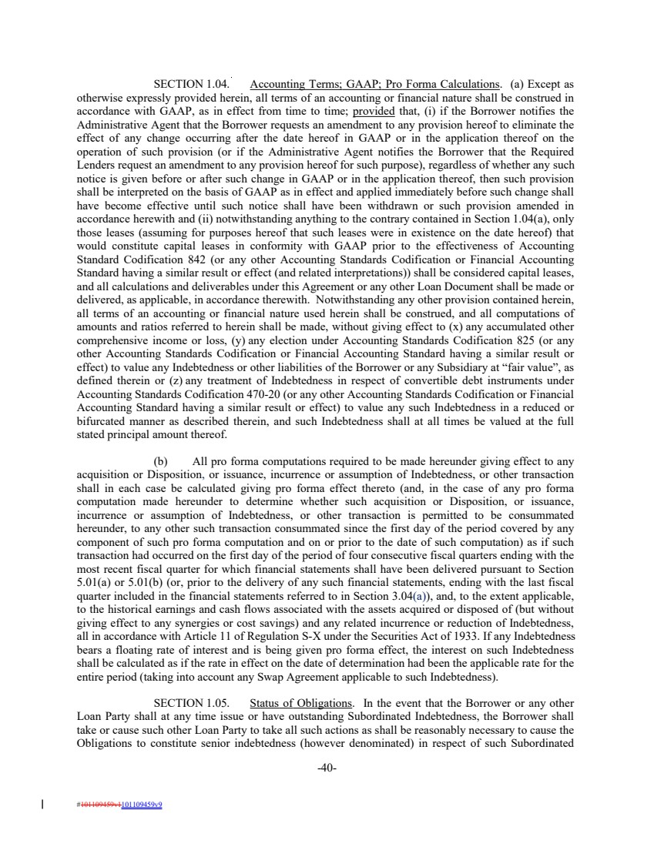 | SECTION 1.04. Accounting Terms; GAAP; Pro Forma Calculations. (a) Except as otherwise expressly provided herein, all terms of an accounting or financial nature shall be construed in accordance with GAAP, as in effect from time to time; provided that, (i) if the Borrower notifies the Administrative Agent that the Borrower requests an amendment to any provision hereof to eliminate the effect of any change occurring after the date hereof in GAAP or in the application thereof on the operation of such provision (or if the Administrative Agent notifies the Borrower that the Required Lenders request an amendment to any provision hereof for such purpose), regardless of whether any such notice is given before or after such change in GAAP or in the application thereof, then such provision shall be interpreted on the basis of GAAP as in effect and applied immediately before such change shall have become effective until such notice shall have been withdrawn or such provision amended in accordance herewith and (ii) notwithstanding anything to the contrary contained in Section 1.04(a), only those leases (assuming for purposes hereof that such leases were in existence on the date hereof) that would constitute capital leases in conformity with GAAP prior to the effectiveness of Accounting Standard Codification 842 (or any other Accounting Standards Codification or Financial Accounting Standard having a similar result or effect (and related interpretations)) shall be considered capital leases, and all calculations and deliverables under this Agreement or any other Loan Document shall be made or delivered, as applicable, in accordance therewith. Notwithstanding any other provision contained herein, all terms of an accounting or financial nature used herein shall be construed, and all computations of amounts and ratios referred to herein shall be made, without giving effect to (x) any accumulated other comprehensive income or loss, (y) any election under Accounting Standards Codification 825 (or any other Accounting Standards Codification or Financial Accounting Standard having a similar result or effect) to value any Indebtedness or other liabilities of the Borrower or any Subsidiary at “fair value”, as defined therein or (z) any treatment of Indebtedness in respect of convertible debt instruments under Accounting Standards Codification 470-20 (or any other Accounting Standards Codification or Financial Accounting Standard having a similar result or effect) to value any such Indebtedness in a reduced or bifurcated manner as described therein, and such Indebtedness shall at all times be valued at the full stated principal amount thereof. (b) All pro forma computations required to be made hereunder giving effect to any acquisition or Disposition, or issuance, incurrence or assumption of Indebtedness, or other transaction shall in each case be calculated giving pro forma effect thereto (and, in the case of any pro forma computation made hereunder to determine whether such acquisition or Disposition, or issuance, incurrence or assumption of Indebtedness, or other transaction is permitted to be consummated hereunder, to any other such transaction consummated since the first day of the period covered by any component of such pro forma computation and on or prior to the date of such computation) as if such transaction had occurred on the first day of the period of four consecutive fiscal quarters ending with the most recent fiscal quarter for which financial statements shall have been delivered pursuant to Section 5.01(a) or 5.01(b) (or, prior to the delivery of any such financial statements, ending with the last fiscal quarter included in the financial statements referred to in Section 3.04(a)), and, to the extent applicable, to the historical earnings and cash flows associated with the assets acquired or disposed of (but without giving effect to any synergies or cost savings) and any related incurrence or reduction of Indebtedness, all in accordance with Article 11 of Regulation S-X under the Securities Act of 1933. If any Indebtedness bears a floating rate of interest and is being given pro forma effect, the interest on such Indebtedness shall be calculated as if the rate in effect on the date of determination had been the applicable rate for the entire period (taking into account any Swap Agreement applicable to such Indebtedness). SECTION 1.05. Status of Obligations. In the event that the Borrower or any other Loan Party shall at any time issue or have outstanding Subordinated Indebtedness, the Borrower shall take or cause such other Loan Party to take all such actions as shall be reasonably necessary to cause the Obligations to constitute senior indebtedness (however denominated) in respect of such Subordinated -40- #101109459v1101109459v9
 | 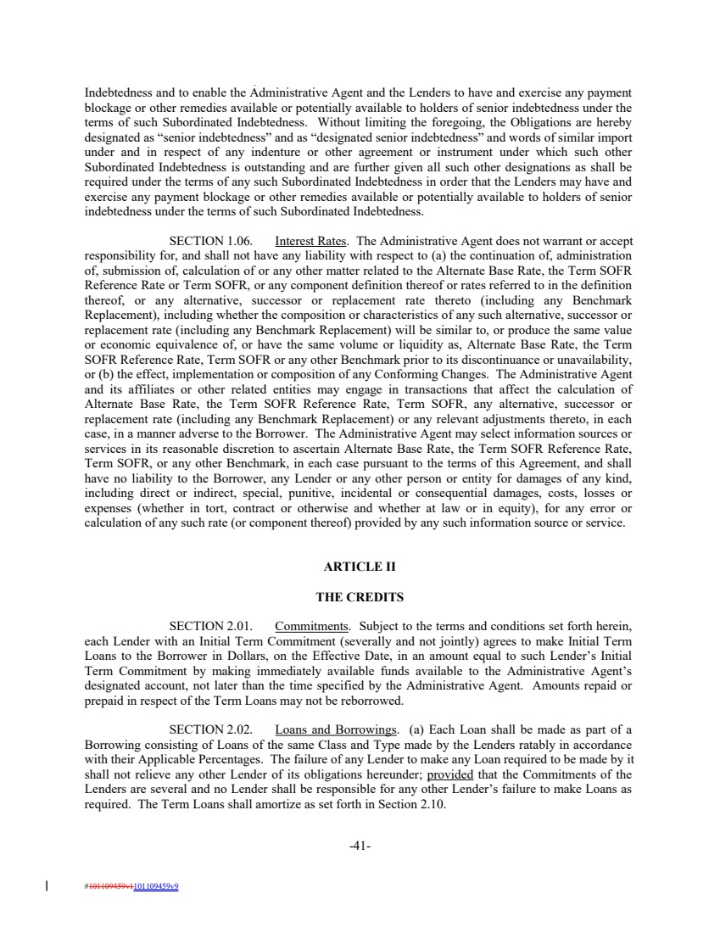 | Indebtedness and to enable the Administrative Agent and the Lenders to have and exercise any payment blockage or other remedies available or potentially available to holders of senior indebtedness under the terms of such Subordinated Indebtedness. Without limiting the foregoing, the Obligations are hereby designated as “senior indebtedness” and as “designated senior indebtedness” and words of similar import under and in respect of any indenture or other agreement or instrument under which such other Subordinated Indebtedness is outstanding and are further given all such other designations as shall be required under the terms of any such Subordinated Indebtedness in order that the Lenders may have and exercise any payment blockage or other remedies available or potentially available to holders of senior indebtedness under the terms of such Subordinated Indebtedness. SECTION 1.06. Interest Rates. The Administrative Agent does not warrant or accept responsibility for, and shall not have any liability with respect to (a) the continuation of, administration of, submission of, calculation of or any other matter related to the Alternate Base Rate, the Term SOFR Reference Rate or Term SOFR, or any component definition thereof or rates referred to in the definition thereof, or any alternative, successor or replacement rate thereto (including any Benchmark Replacement), including whether the composition or characteristics of any such alternative, successor or replacement rate (including any Benchmark Replacement) will be similar to, or produce the same value or economic equivalence of, or have the same volume or liquidity as, Alternate Base Rate, the Term SOFR Reference Rate, Term SOFR or any other Benchmark prior to its discontinuance or unavailability, or (b) the effect, implementation or composition of any Conforming Changes. The Administrative Agent and its affiliates or other related entities may engage in transactions that affect the calculation of Alternate Base Rate, the Term SOFR Reference Rate, Term SOFR, any alternative, successor or replacement rate (including any Benchmark Replacement) or any relevant adjustments thereto, in each case, in a manner adverse to the Borrower. The Administrative Agent may select information sources or services in its reasonable discretion to ascertain Alternate Base Rate, the Term SOFR Reference Rate, Term SOFR, or any other Benchmark, in each case pursuant to the terms of this Agreement, and shall have no liability to the Borrower, any Lender or any other person or entity for damages of any kind, including direct or indirect, special, punitive, incidental or consequential damages, costs, losses or expenses (whether in tort, contract or otherwise and whether at law or in equity), for any error or calculation of any such rate (or component thereof) provided by any such information source or service. ARTICLE II THE CREDITS SECTION 2.01. Commitments. Subject to the terms and conditions set forth herein, each Lender with an Initial Term Commitment (severally and not jointly) agrees to make Initial Term Loans to the Borrower in Dollars, on the Effective Date, in an amount equal to such Lender’s Initial Term Commitment by making immediately available funds available to the Administrative Agent’s designated account, not later than the time specified by the Administrative Agent. Amounts repaid or prepaid in respect of the Term Loans may not be reborrowed. SECTION 2.02. Loans and Borrowings. (a) Each Loan shall be made as part of a Borrowing consisting of Loans of the same Class and Type made by the Lenders ratably in accordance with their Applicable Percentages. The failure of any Lender to make any Loan required to be made by it shall not relieve any other Lender of its obligations hereunder; provided that the Commitments of the Lenders are several and no Lender shall be responsible for any other Lender’s failure to make Loans as required. The Term Loans shall amortize as set forth in Section 2.10. -41- #101109459v1101109459v9
 | 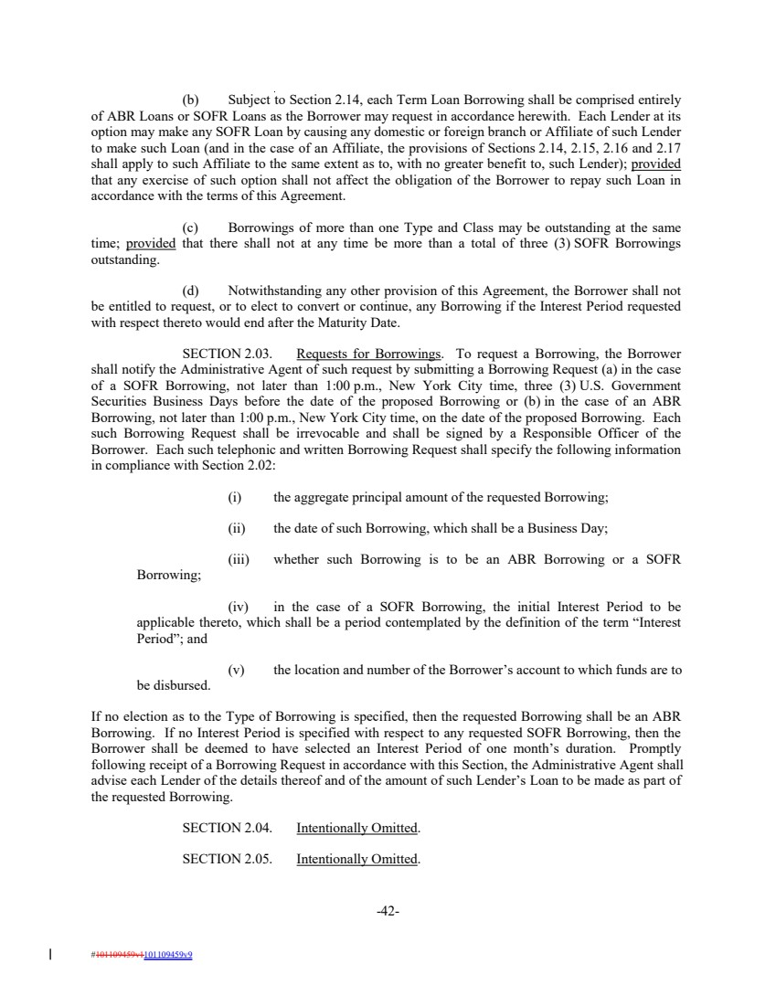 | (b) Subject to Section 2.14, each Term Loan Borrowing shall be comprised entirely of ABR Loans or SOFR Loans as the Borrower may request in accordance herewith. Each Lender at its option may make any SOFR Loan by causing any domestic or foreign branch or Affiliate of such Lender to make such Loan (and in the case of an Affiliate, the provisions of Sections 2.14, 2.15, 2.16 and 2.17 shall apply to such Affiliate to the same extent as to, with no greater benefit to, such Lender); provided that any exercise of such option shall not affect the obligation of the Borrower to repay such Loan in accordance with the terms of this Agreement. (c) Borrowings of more than one Type and Class may be outstanding at the same time; provided that there shall not at any time be more than a total of three (3) SOFR Borrowings outstanding. (d) Notwithstanding any other provision of this Agreement, the Borrower shall not be entitled to request, or to elect to convert or continue, any Borrowing if the Interest Period requested with respect thereto would end after the Maturity Date. SECTION 2.03. Requests for Borrowings. To request a Borrowing, the Borrower shall notify the Administrative Agent of such request by submitting a Borrowing Request (a) in the case of a SOFR Borrowing, not later than 1:00 p.m., New York City time, three (3) U.S. Government Securities Business Days before the date of the proposed Borrowing or (b) in the case of an ABR Borrowing, not later than 1:00 p.m., New York City time, on the date of the proposed Borrowing. Each such Borrowing Request shall be irrevocable and shall be signed by a Responsible Officer of the Borrower. Each such telephonic and written Borrowing Request shall specify the following information in compliance with Section 2.02: (i) the aggregate principal amount of the requested Borrowing; (ii) the date of such Borrowing, which shall be a Business Day; (iii) whether such Borrowing is to be an ABR Borrowing or a SOFR Borrowing; (iv) in the case of a SOFR Borrowing, the initial Interest Period to be applicable thereto, which shall be a period contemplated by the definition of the term “Interest Period”; and (v) the location and number of the Borrower’s account to which funds are to be disbursed. If no election as to the Type of Borrowing is specified, then the requested Borrowing shall be an ABR Borrowing. If no Interest Period is specified with respect to any requested SOFR Borrowing, then the Borrower shall be deemed to have selected an Interest Period of one month’s duration. Promptly following receipt of a Borrowing Request in accordance with this Section, the Administrative Agent shall advise each Lender of the details thereof and of the amount of such Lender’s Loan to be made as part of the requested Borrowing. SECTION 2.04. Intentionally Omitted. SECTION 2.05. Intentionally Omitted. -42- #101109459v1101109459v9
 | 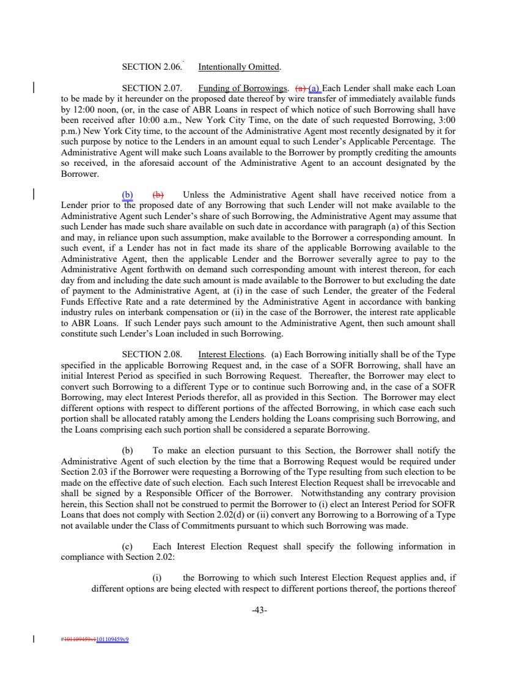 | SECTION 2.06. Intentionally Omitted. SECTION 2.07. Funding of Borrowings. (a) (a) Each Lender shall make each Loan to be made by it hereunder on the proposed date thereof by wire transfer of immediately available funds by 12:00 noon, (or, in the case of ABR Loans in respect of which notice of such Borrowing shall have been received after 10:00 a.m., New York City Time, on the date of such requested Borrowing, 3:00 p.m.) New York City time, to the account of the Administrative Agent most recently designated by it for such purpose by notice to the Lenders in an amount equal to such Lender’s Applicable Percentage. The Administrative Agent will make such Loans available to the Borrower by promptly crediting the amounts so received, in the aforesaid account of the Administrative Agent to an account designated by the Borrower. (b) (b) Unless the Administrative Agent shall have received notice from a Lender prior to the proposed date of any Borrowing that such Lender will not make available to the Administrative Agent such Lender’s share of such Borrowing, the Administrative Agent may assume that such Lender has made such share available on such date in accordance with paragraph (a) of this Section and may, in reliance upon such assumption, make available to the Borrower a corresponding amount. In such event, if a Lender has not in fact made its share of the applicable Borrowing available to the Administrative Agent, then the applicable Lender and the Borrower severally agree to pay to the Administrative Agent forthwith on demand such corresponding amount with interest thereon, for each day from and including the date such amount is made available to the Borrower to but excluding the date of payment to the Administrative Agent, at (i) in the case of such Lender, the greater of the Federal Funds Effective Rate and a rate determined by the Administrative Agent in accordance with banking industry rules on interbank compensation or (ii) in the case of the Borrower, the interest rate applicable to ABR Loans. If such Lender pays such amount to the Administrative Agent, then such amount shall constitute such Lender’s Loan included in such Borrowing. SECTION 2.08. Interest Elections. (a) Each Borrowing initially shall be of the Type specified in the applicable Borrowing Request and, in the case of a SOFR Borrowing, shall have an initial Interest Period as specified in such Borrowing Request. Thereafter, the Borrower may elect to convert such Borrowing to a different Type or to continue such Borrowing and, in the case of a SOFR Borrowing, may elect Interest Periods therefor, all as provided in this Section. The Borrower may elect different options with respect to different portions of the affected Borrowing, in which case each such portion shall be allocated ratably among the Lenders holding the Loans comprising such Borrowing, and the Loans comprising each such portion shall be considered a separate Borrowing. (b) To make an election pursuant to this Section, the Borrower shall notify the Administrative Agent of such election by the time that a Borrowing Request would be required under Section 2.03 if the Borrower were requesting a Borrowing of the Type resulting from such election to be made on the effective date of such election. Each such Interest Election Request shall be irrevocable and shall be signed by a Responsible Officer of the Borrower. Notwithstanding any contrary provision herein, this Section shall not be construed to permit the Borrower to (i) elect an Interest Period for SOFR Loans that does not comply with Section 2.02(d) or (ii) convert any Borrowing to a Borrowing of a Type not available under the Class of Commitments pursuant to which such Borrowing was made. (c) Each Interest Election Request shall specify the following information in compliance with Section 2.02: (i) the Borrowing to which such Interest Election Request applies and, if different options are being elected with respect to different portions thereof, the portions thereof -43- #101109459v1101109459v9
 | 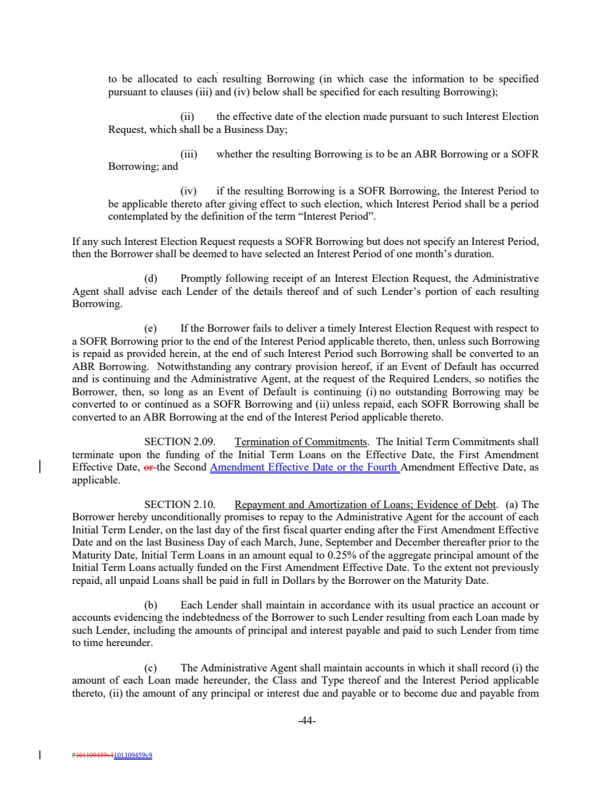 | to be allocated to each resulting Borrowing (in which case the information to be specified pursuant to clauses (iii) and (iv) below shall be specified for each resulting Borrowing); (ii) the effective date of the election made pursuant to such Interest Election Request, which shall be a Business Day; (iii) whether the resulting Borrowing is to be an ABR Borrowing or a SOFR Borrowing; and (iv) if the resulting Borrowing is a SOFR Borrowing, the Interest Period to be applicable thereto after giving effect to such election, which Interest Period shall be a period contemplated by the definition of the term “Interest Period”. If any such Interest Election Request requests a SOFR Borrowing but does not specify an Interest Period, then the Borrower shall be deemed to have selected an Interest Period of one month’s duration. (d) Promptly following receipt of an Interest Election Request, the Administrative Agent shall advise each Lender of the details thereof and of such Lender’s portion of each resulting Borrowing. (e) If the Borrower fails to deliver a timely Interest Election Request with respect to a SOFR Borrowing prior to the end of the Interest Period applicable thereto, then, unless such Borrowing is repaid as provided herein, at the end of such Interest Period such Borrowing shall be converted to an ABR Borrowing. Notwithstanding any contrary provision hereof, if an Event of Default has occurred and is continuing and the Administrative Agent, at the request of the Required Lenders, so notifies the Borrower, then, so long as an Event of Default is continuing (i) no outstanding Borrowing may be converted to or continued as a SOFR Borrowing and (ii) unless repaid, each SOFR Borrowing shall be converted to an ABR Borrowing at the end of the Interest Period applicable thereto. SECTION 2.09. Termination of Commitments. The Initial Term Commitments shall terminate upon the funding of the Initial Term Loans on the Effective Date, the First Amendment Effective Date, or the Second Amendment Effective Date or the Fourth Amendment Effective Date, as applicable. SECTION 2.10. Repayment and Amortization of Loans; Evidence of Debt. (a) The Borrower hereby unconditionally promises to repay to the Administrative Agent for the account of each Initial Term Lender, on the last day of the first fiscal quarter ending after the First Amendment Effective Date and on the last Business Day of each March, June, September and December thereafter prior to the Maturity Date, Initial Term Loans in an amount equal to 0.25% of the aggregate principal amount of the Initial Term Loans actually funded on the First Amendment Effective Date. To the extent not previously repaid, all unpaid Loans shall be paid in full in Dollars by the Borrower on the Maturity Date. (b) Each Lender shall maintain in accordance with its usual practice an account or accounts evidencing the indebtedness of the Borrower to such Lender resulting from each Loan made by such Lender, including the amounts of principal and interest payable and paid to such Lender from time to time hereunder. (c) The Administrative Agent shall maintain accounts in which it shall record (i) the amount of each Loan made hereunder, the Class and Type thereof and the Interest Period applicable thereto, (ii) the amount of any principal or interest due and payable or to become due and payable from -44- #101109459v1101109459v9
 | 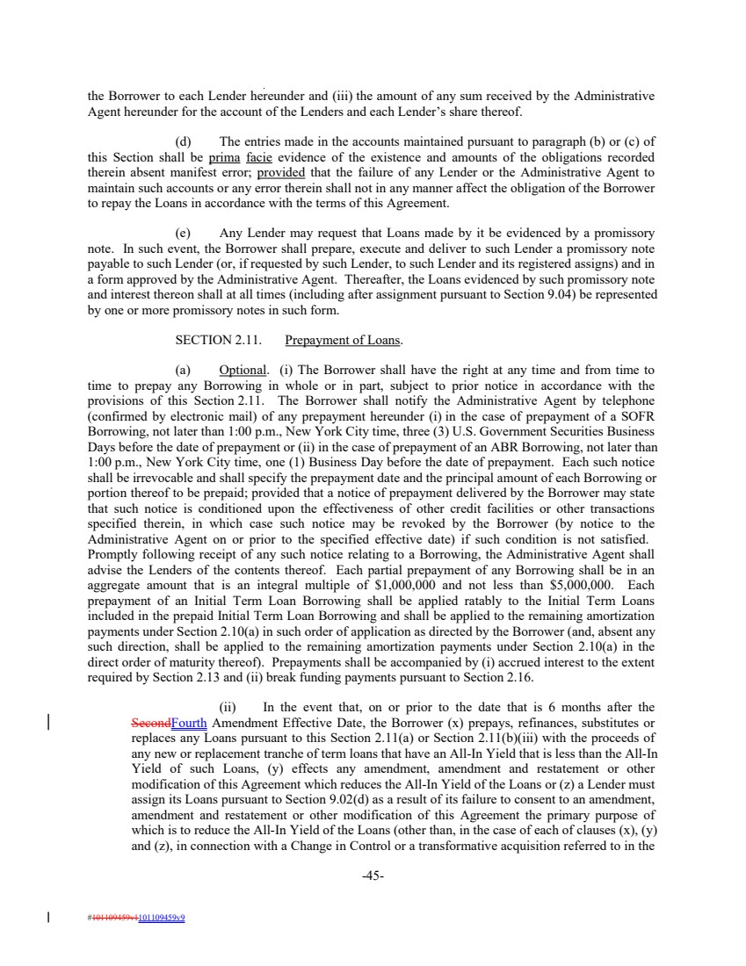 | the Borrower to each Lender hereunder and (iii) the amount of any sum received by the Administrative Agent hereunder for the account of the Lenders and each Lender’s share thereof. (d) The entries made in the accounts maintained pursuant to paragraph (b) or (c) of this Section shall be prima facie evidence of the existence and amounts of the obligations recorded therein absent manifest error; provided that the failure of any Lender or the Administrative Agent to maintain such accounts or any error therein shall not in any manner affect the obligation of the Borrower to repay the Loans in accordance with the terms of this Agreement. (e) Any Lender may request that Loans made by it be evidenced by a promissory note. In such event, the Borrower shall prepare, execute and deliver to such Lender a promissory note payable to such Lender (or, if requested by such Lender, to such Lender and its registered assigns) and in a form approved by the Administrative Agent. Thereafter, the Loans evidenced by such promissory note and interest thereon shall at all times (including after assignment pursuant to Section 9.04) be represented by one or more promissory notes in such form. SECTION 2.11. Prepayment of Loans. (a) Optional. (i) The Borrower shall have the right at any time and from time to time to prepay any Borrowing in whole or in part, subject to prior notice in accordance with the provisions of this Section 2.11. The Borrower shall notify the Administrative Agent by telephone (confirmed by electronic mail) of any prepayment hereunder (i) in the case of prepayment of a SOFR Borrowing, not later than 1:00 p.m., New York City time, three (3) U.S. Government Securities Business Days before the date of prepayment or (ii) in the case of prepayment of an ABR Borrowing, not later than 1:00 p.m., New York City time, one (1) Business Day before the date of prepayment. Each such notice shall be irrevocable and shall specify the prepayment date and the principal amount of each Borrowing or portion thereof to be prepaid; provided that a notice of prepayment delivered by the Borrower may state that such notice is conditioned upon the effectiveness of other credit facilities or other transactions specified therein, in which case such notice may be revoked by the Borrower (by notice to the Administrative Agent on or prior to the specified effective date) if such condition is not satisfied. Promptly following receipt of any such notice relating to a Borrowing, the Administrative Agent shall advise the Lenders of the contents thereof. Each partial prepayment of any Borrowing shall be in an aggregate amount that is an integral multiple of $1,000,000 and not less than $5,000,000. Each prepayment of an Initial Term Loan Borrowing shall be applied ratably to the Initial Term Loans included in the prepaid Initial Term Loan Borrowing and shall be applied to the remaining amortization payments under Section 2.10(a) in such order of application as directed by the Borrower (and, absent any such direction, shall be applied to the remaining amortization payments under Section 2.10(a) in the direct order of maturity thereof). Prepayments shall be accompanied by (i) accrued interest to the extent required by Section 2.13 and (ii) break funding payments pursuant to Section 2.16. (ii) In the event that, on or prior to the date that is 6 months after the SecondFourth Amendment Effective Date, the Borrower (x) prepays, refinances, substitutes or replaces any Loans pursuant to this Section 2.11(a) or Section 2.11(b)(iii) with the proceeds of any new or replacement tranche of term loans that have an All-In Yield that is less than the All-In Yield of such Loans, (y) effects any amendment, amendment and restatement or other modification of this Agreement which reduces the All-In Yield of the Loans or (z) a Lender must assign its Loans pursuant to Section 9.02(d) as a result of its failure to consent to an amendment, amendment and restatement or other modification of this Agreement the primary purpose of which is to reduce the All-In Yield of the Loans (other than, in the case of each of clauses (x), (y) and (z), in connection with a Change in Control or a transformative acquisition referred to in the -45- #101109459v1101109459v9
 | 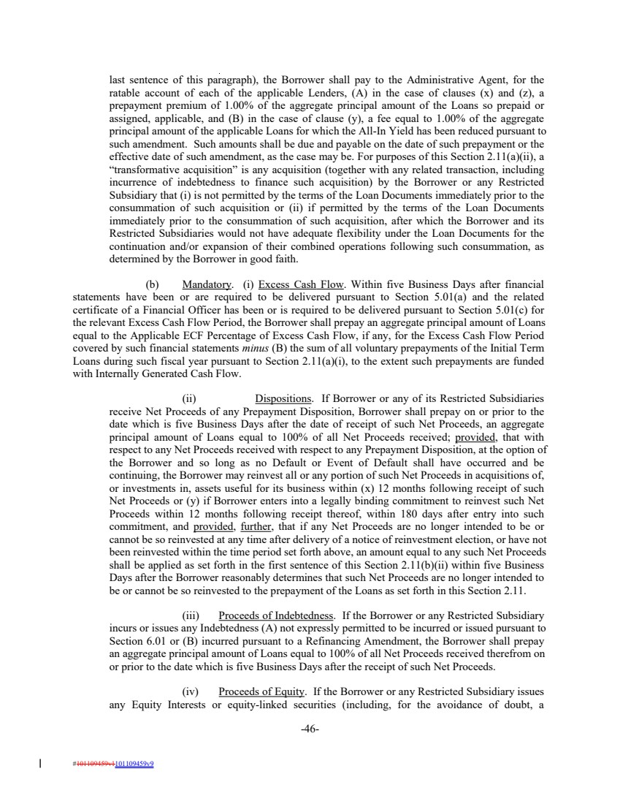 | last sentence of this paragraph), the Borrower shall pay to the Administrative Agent, for the ratable account of each of the applicable Lenders, (A) in the case of clauses (x) and (z), a prepayment premium of 1.00% of the aggregate principal amount of the Loans so prepaid or assigned, applicable, and (B) in the case of clause (y), a fee equal to 1.00% of the aggregate principal amount of the applicable Loans for which the All-In Yield has been reduced pursuant to such amendment. Such amounts shall be due and payable on the date of such prepayment or the effective date of such amendment, as the case may be. For purposes of this Section 2.11(a)(ii), a “transformative acquisition” is any acquisition (together with any related transaction, including incurrence of indebtedness to finance such acquisition) by the Borrower or any Restricted Subsidiary that (i) is not permitted by the terms of the Loan Documents immediately prior to the consummation of such acquisition or (ii) if permitted by the terms of the Loan Documents immediately prior to the consummation of such acquisition, after which the Borrower and its Restricted Subsidiaries would not have adequate flexibility under the Loan Documents for the continuation and/or expansion of their combined operations following such consummation, as determined by the Borrower in good faith. (b) Mandatory. (i) Excess Cash Flow. Within five Business Days after financial statements have been or are required to be delivered pursuant to Section 5.01(a) and the related certificate of a Financial Officer has been or is required to be delivered pursuant to Section 5.01(c) for the relevant Excess Cash Flow Period, the Borrower shall prepay an aggregate principal amount of Loans equal to the Applicable ECF Percentage of Excess Cash Flow, if any, for the Excess Cash Flow Period covered by such financial statements minus (B) the sum of all voluntary prepayments of the Initial Term Loans during such fiscal year pursuant to Section 2.11(a)(i), to the extent such prepayments are funded with Internally Generated Cash Flow. (ii) Dispositions. If Borrower or any of its Restricted Subsidiaries receive Net Proceeds of any Prepayment Disposition, Borrower shall prepay on or prior to the date which is five Business Days after the date of receipt of such Net Proceeds, an aggregate principal amount of Loans equal to 100% of all Net Proceeds received; provided, that with respect to any Net Proceeds received with respect to any Prepayment Disposition, at the option of the Borrower and so long as no Default or Event of Default shall have occurred and be continuing, the Borrower may reinvest all or any portion of such Net Proceeds in acquisitions of, or investments in, assets useful for its business within (x) 12 months following receipt of such Net Proceeds or (y) if Borrower enters into a legally binding commitment to reinvest such Net Proceeds within 12 months following receipt thereof, within 180 days after entry into such commitment, and provided, further, that if any Net Proceeds are no longer intended to be or cannot be so reinvested at any time after delivery of a notice of reinvestment election, or have not been reinvested within the time period set forth above, an amount equal to any such Net Proceeds shall be applied as set forth in the first sentence of this Section 2.11(b)(ii) within five Business Days after the Borrower reasonably determines that such Net Proceeds are no longer intended to be or cannot be so reinvested to the prepayment of the Loans as set forth in this Section 2.11. (iii) Proceeds of Indebtedness. If the Borrower or any Restricted Subsidiary incurs or issues any Indebtedness (A) not expressly permitted to be incurred or issued pursuant to Section 6.01 or (B) incurred pursuant to a Refinancing Amendment, the Borrower shall prepay an aggregate principal amount of Loans equal to 100% of all Net Proceeds received therefrom on or prior to the date which is five Business Days after the receipt of such Net Proceeds. (iv) Proceeds of Equity. If the Borrower or any Restricted Subsidiary issues any Equity Interests or equity-linked securities (including, for the avoidance of doubt, a -46- #101109459v1101109459v9
 | 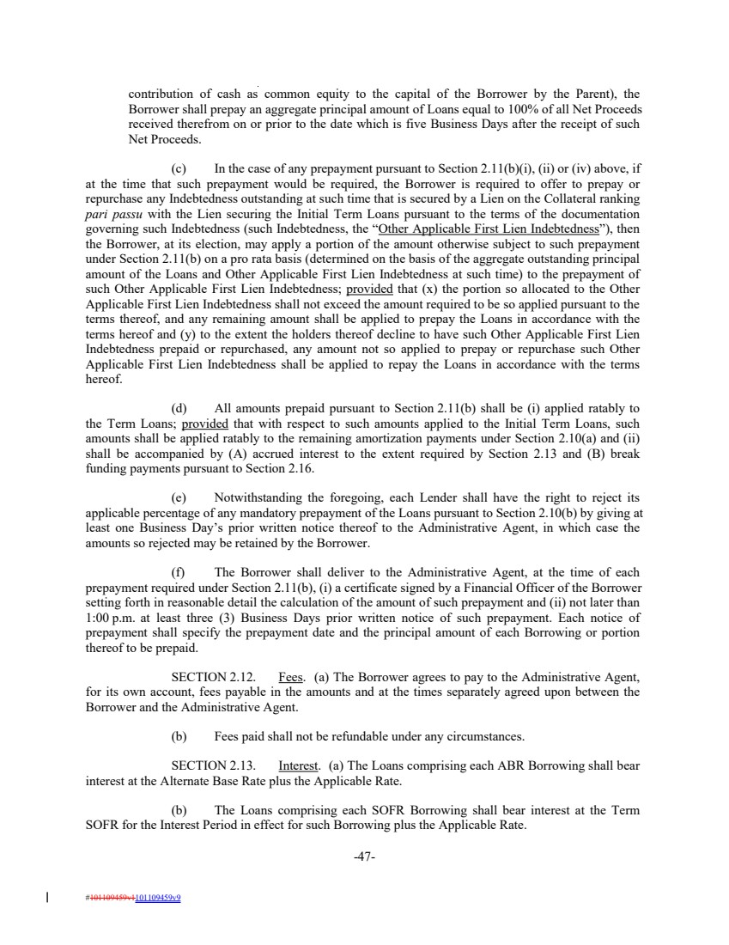 | contribution of cash as common equity to the capital of the Borrower by the Parent), the Borrower shall prepay an aggregate principal amount of Loans equal to 100% of all Net Proceeds received therefrom on or prior to the date which is five Business Days after the receipt of such Net Proceeds. (c) In the case of any prepayment pursuant to Section 2.11(b)(i), (ii) or (iv) above, if at the time that such prepayment would be required, the Borrower is required to offer to prepay or repurchase any Indebtedness outstanding at such time that is secured by a Lien on the Collateral ranking pari passu with the Lien securing the Initial Term Loans pursuant to the terms of the documentation governing such Indebtedness (such Indebtedness, the “Other Applicable First Lien Indebtedness”), then the Borrower, at its election, may apply a portion of the amount otherwise subject to such prepayment under Section 2.11(b) on a pro rata basis (determined on the basis of the aggregate outstanding principal amount of the Loans and Other Applicable First Lien Indebtedness at such time) to the prepayment of such Other Applicable First Lien Indebtedness; provided that (x) the portion so allocated to the Other Applicable First Lien Indebtedness shall not exceed the amount required to be so applied pursuant to the terms thereof, and any remaining amount shall be applied to prepay the Loans in accordance with the terms hereof and (y) to the extent the holders thereof decline to have such Other Applicable First Lien Indebtedness prepaid or repurchased, any amount not so applied to prepay or repurchase such Other Applicable First Lien Indebtedness shall be applied to repay the Loans in accordance with the terms hereof. (d) All amounts prepaid pursuant to Section 2.11(b) shall be (i) applied ratably to the Term Loans; provided that with respect to such amounts applied to the Initial Term Loans, such amounts shall be applied ratably to the remaining amortization payments under Section 2.10(a) and (ii) shall be accompanied by (A) accrued interest to the extent required by Section 2.13 and (B) break funding payments pursuant to Section 2.16. (e) Notwithstanding the foregoing, each Lender shall have the right to reject its applicable percentage of any mandatory prepayment of the Loans pursuant to Section 2.10(b) by giving at least one Business Day’s prior written notice thereof to the Administrative Agent, in which case the amounts so rejected may be retained by the Borrower. (f) The Borrower shall deliver to the Administrative Agent, at the time of each prepayment required under Section 2.11(b), (i) a certificate signed by a Financial Officer of the Borrower setting forth in reasonable detail the calculation of the amount of such prepayment and (ii) not later than 1:00 p.m. at least three (3) Business Days prior written notice of such prepayment. Each notice of prepayment shall specify the prepayment date and the principal amount of each Borrowing or portion thereof to be prepaid. SECTION 2.12. Fees. (a) The Borrower agrees to pay to the Administrative Agent, for its own account, fees payable in the amounts and at the times separately agreed upon between the Borrower and the Administrative Agent. (b) Fees paid shall not be refundable under any circumstances. SECTION 2.13. Interest. (a) The Loans comprising each ABR Borrowing shall bear interest at the Alternate Base Rate plus the Applicable Rate. (b) The Loans comprising each SOFR Borrowing shall bear interest at the Term SOFR for the Interest Period in effect for such Borrowing plus the Applicable Rate. -47- #101109459v1101109459v9
 | 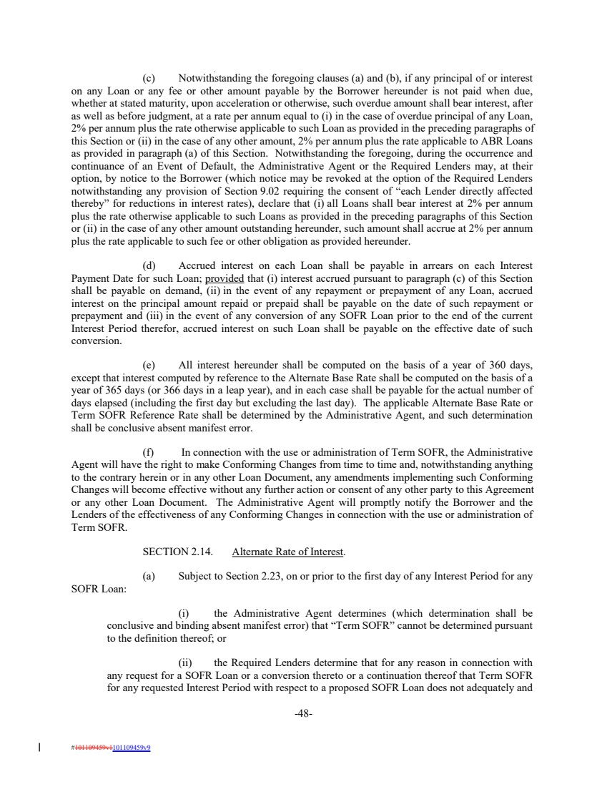 | (c) Notwithstanding the foregoing clauses (a) and (b), if any principal of or interest on any Loan or any fee or other amount payable by the Borrower hereunder is not paid when due, whether at stated maturity, upon acceleration or otherwise, such overdue amount shall bear interest, after as well as before judgment, at a rate per annum equal to (i) in the case of overdue principal of any Loan, 2% per annum plus the rate otherwise applicable to such Loan as provided in the preceding paragraphs of this Section or (ii) in the case of any other amount, 2% per annum plus the rate applicable to ABR Loans as provided in paragraph (a) of this Section. Notwithstanding the foregoing, during the occurrence and continuance of an Event of Default, the Administrative Agent or the Required Lenders may, at their option, by notice to the Borrower (which notice may be revoked at the option of the Required Lenders notwithstanding any provision of Section 9.02 requiring the consent of “each Lender directly affected thereby” for reductions in interest rates), declare that (i) all Loans shall bear interest at 2% per annum plus the rate otherwise applicable to such Loans as provided in the preceding paragraphs of this Section or (ii) in the case of any other amount outstanding hereunder, such amount shall accrue at 2% per annum plus the rate applicable to such fee or other obligation as provided hereunder. (d) Accrued interest on each Loan shall be payable in arrears on each Interest Payment Date for such Loan; provided that (i) interest accrued pursuant to paragraph (c) of this Section shall be payable on demand, (ii) in the event of any repayment or prepayment of any Loan, accrued interest on the principal amount repaid or prepaid shall be payable on the date of such repayment or prepayment and (iii) in the event of any conversion of any SOFR Loan prior to the end of the current Interest Period therefor, accrued interest on such Loan shall be payable on the effective date of such conversion. (e) All interest hereunder shall be computed on the basis of a year of 360 days, except that interest computed by reference to the Alternate Base Rate shall be computed on the basis of a year of 365 days (or 366 days in a leap year), and in each case shall be payable for the actual number of days elapsed (including the first day but excluding the last day). The applicable Alternate Base Rate or Term SOFR Reference Rate shall be determined by the Administrative Agent, and such determination shall be conclusive absent manifest error. (f) In connection with the use or administration of Term SOFR, the Administrative Agent will have the right to make Conforming Changes from time to time and, notwithstanding anything to the contrary herein or in any other Loan Document, any amendments implementing such Conforming Changes will become effective without any further action or consent of any other party to this Agreement or any other Loan Document. The Administrative Agent will promptly notify the Borrower and the Lenders of the effectiveness of any Conforming Changes in connection with the use or administration of Term SOFR. SECTION 2.14. Alternate Rate of Interest. (a) Subject to Section 2.23, on or prior to the first day of any Interest Period for any SOFR Loan: (i) the Administrative Agent determines (which determination shall be conclusive and binding absent manifest error) that “Term SOFR” cannot be determined pursuant to the definition thereof; or (ii) the Required Lenders determine that for any reason in connection with any request for a SOFR Loan or a conversion thereto or a continuation thereof that Term SOFR for any requested Interest Period with respect to a proposed SOFR Loan does not adequately and -48- #101109459v1101109459v9
 | 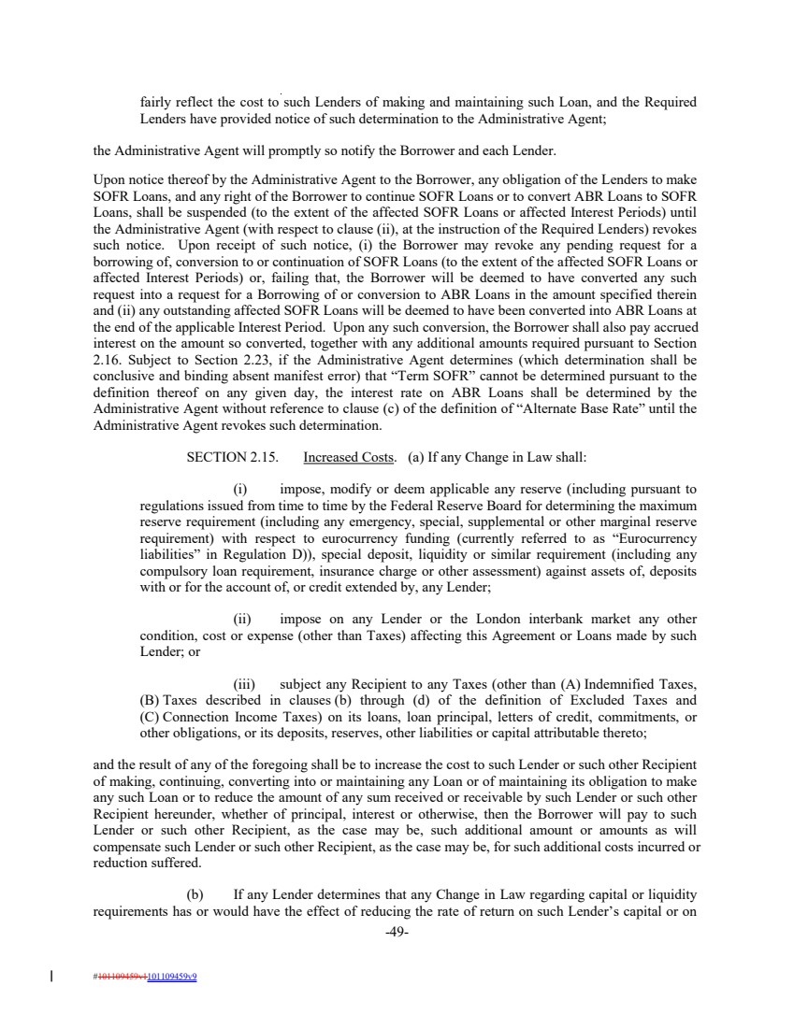 | fairly reflect the cost to such Lenders of making and maintaining such Loan, and the Required Lenders have provided notice of such determination to the Administrative Agent; the Administrative Agent will promptly so notify the Borrower and each Lender. Upon notice thereof by the Administrative Agent to the Borrower, any obligation of the Lenders to make SOFR Loans, and any right of the Borrower to continue SOFR Loans or to convert ABR Loans to SOFR Loans, shall be suspended (to the extent of the affected SOFR Loans or affected Interest Periods) until the Administrative Agent (with respect to clause (ii), at the instruction of the Required Lenders) revokes such notice. Upon receipt of such notice, (i) the Borrower may revoke any pending request for a borrowing of, conversion to or continuation of SOFR Loans (to the extent of the affected SOFR Loans or affected Interest Periods) or, failing that, the Borrower will be deemed to have converted any such request into a request for a Borrowing of or conversion to ABR Loans in the amount specified therein and (ii) any outstanding affected SOFR Loans will be deemed to have been converted into ABR Loans at the end of the applicable Interest Period. Upon any such conversion, the Borrower shall also pay accrued interest on the amount so converted, together with any additional amounts required pursuant to Section 2.16. Subject to Section 2.23, if the Administrative Agent determines (which determination shall be conclusive and binding absent manifest error) that “Term SOFR” cannot be determined pursuant to the definition thereof on any given day, the interest rate on ABR Loans shall be determined by the Administrative Agent without reference to clause (c) of the definition of “Alternate Base Rate” until the Administrative Agent revokes such determination. SECTION 2.15. Increased Costs. (a) If any Change in Law shall: (i) impose, modify or deem applicable any reserve (including pursuant to regulations issued from time to time by the Federal Reserve Board for determining the maximum reserve requirement (including any emergency, special, supplemental or other marginal reserve requirement) with respect to eurocurrency funding (currently referred to as “Eurocurrency liabilities” in Regulation D)), special deposit, liquidity or similar requirement (including any compulsory loan requirement, insurance charge or other assessment) against assets of, deposits with or for the account of, or credit extended by, any Lender; (ii) impose on any Lender or the London interbank market any other condition, cost or expense (other than Taxes) affecting this Agreement or Loans made by such Lender; or (iii) subject any Recipient to any Taxes (other than (A) Indemnified Taxes, (B) Taxes described in clauses (b) through (d) of the definition of Excluded Taxes and (C) Connection Income Taxes) on its loans, loan principal, letters of credit, commitments, or other obligations, or its deposits, reserves, other liabilities or capital attributable thereto; and the result of any of the foregoing shall be to increase the cost to such Lender or such other Recipient of making, continuing, converting into or maintaining any Loan or of maintaining its obligation to make any such Loan or to reduce the amount of any sum received or receivable by such Lender or such other Recipient hereunder, whether of principal, interest or otherwise, then the Borrower will pay to such Lender or such other Recipient, as the case may be, such additional amount or amounts as will compensate such Lender or such other Recipient, as the case may be, for such additional costs incurred or reduction suffered. (b) If any Lender determines that any Change in Law regarding capital or liquidity requirements has or would have the effect of reducing the rate of return on such Lender’s capital or on -49- #101109459v1101109459v9
 | 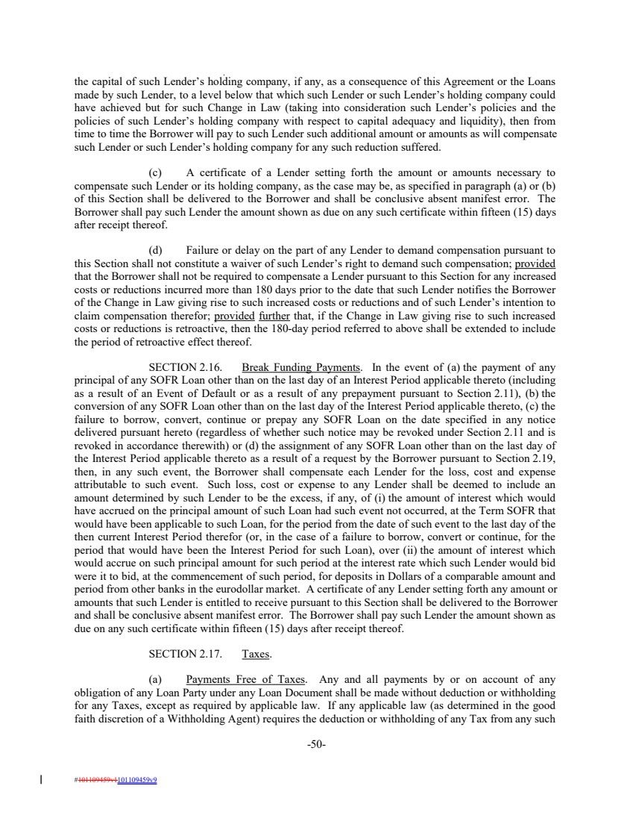 | the capital of such Lender’s holding company, if any, as a consequence of this Agreement or the Loans made by such Lender, to a level below that which such Lender or such Lender’s holding company could have achieved but for such Change in Law (taking into consideration such Lender’s policies and the policies of such Lender’s holding company with respect to capital adequacy and liquidity), then from time to time the Borrower will pay to such Lender such additional amount or amounts as will compensate such Lender or such Lender’s holding company for any such reduction suffered. (c) A certificate of a Lender setting forth the amount or amounts necessary to compensate such Lender or its holding company, as the case may be, as specified in paragraph (a) or (b) of this Section shall be delivered to the Borrower and shall be conclusive absent manifest error. The Borrower shall pay such Lender the amount shown as due on any such certificate within fifteen (15) days after receipt thereof. (d) Failure or delay on the part of any Lender to demand compensation pursuant to this Section shall not constitute a waiver of such Lender’s right to demand such compensation; provided that the Borrower shall not be required to compensate a Lender pursuant to this Section for any increased costs or reductions incurred more than 180 days prior to the date that such Lender notifies the Borrower of the Change in Law giving rise to such increased costs or reductions and of such Lender’s intention to claim compensation therefor; provided further that, if the Change in Law giving rise to such increased costs or reductions is retroactive, then the 180-day period referred to above shall be extended to include the period of retroactive effect thereof. SECTION 2.16. Break Funding Payments. In the event of (a) the payment of any principal of any SOFR Loan other than on the last day of an Interest Period applicable thereto (including as a result of an Event of Default or as a result of any prepayment pursuant to Section 2.11), (b) the conversion of any SOFR Loan other than on the last day of the Interest Period applicable thereto, (c) the failure to borrow, convert, continue or prepay any SOFR Loan on the date specified in any notice delivered pursuant hereto (regardless of whether such notice may be revoked under Section 2.11 and is revoked in accordance therewith) or (d) the assignment of any SOFR Loan other than on the last day of the Interest Period applicable thereto as a result of a request by the Borrower pursuant to Section 2.19, then, in any such event, the Borrower shall compensate each Lender for the loss, cost and expense attributable to such event. Such loss, cost or expense to any Lender shall be deemed to include an amount determined by such Lender to be the excess, if any, of (i) the amount of interest which would have accrued on the principal amount of such Loan had such event not occurred, at the Term SOFR that would have been applicable to such Loan, for the period from the date of such event to the last day of the then current Interest Period therefor (or, in the case of a failure to borrow, convert or continue, for the period that would have been the Interest Period for such Loan), over (ii) the amount of interest which would accrue on such principal amount for such period at the interest rate which such Lender would bid were it to bid, at the commencement of such period, for deposits in Dollars of a comparable amount and period from other banks in the eurodollar market. A certificate of any Lender setting forth any amount or amounts that such Lender is entitled to receive pursuant to this Section shall be delivered to the Borrower and shall be conclusive absent manifest error. The Borrower shall pay such Lender the amount shown as due on any such certificate within fifteen (15) days after receipt thereof. SECTION 2.17. Taxes. (a) Payments Free of Taxes. Any and all payments by or on account of any obligation of any Loan Party under any Loan Document shall be made without deduction or withholding for any Taxes, except as required by applicable law. If any applicable law (as determined in the good faith discretion of a Withholding Agent) requires the deduction or withholding of any Tax from any such -50- #101109459v1101109459v9
 | 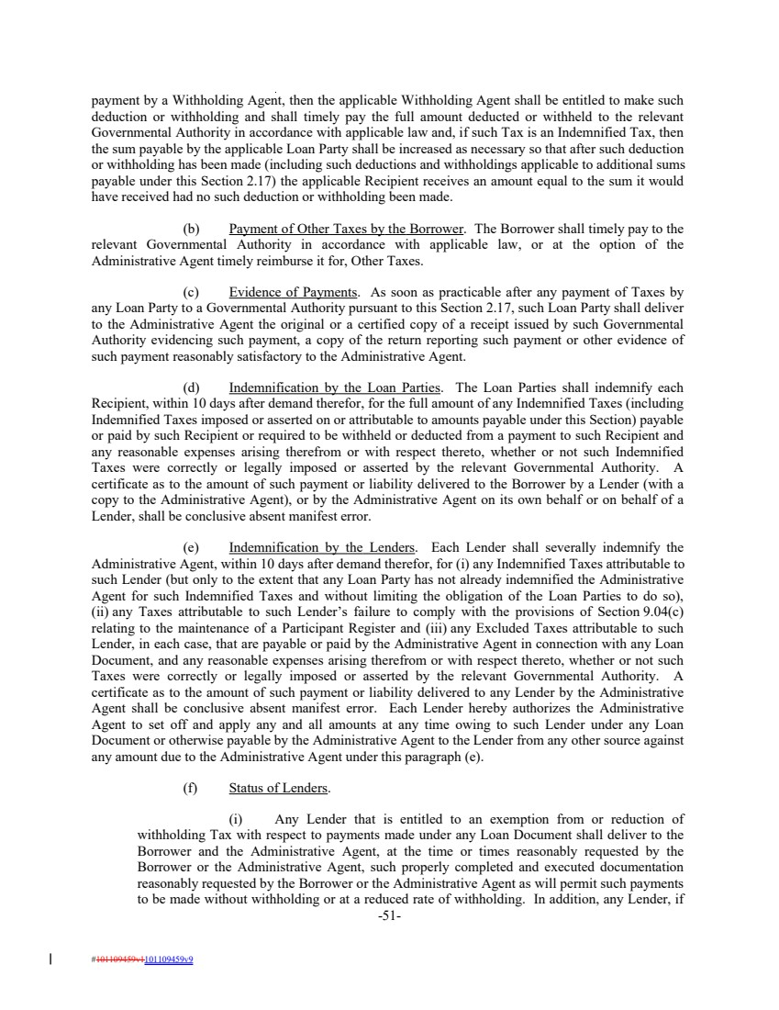 | payment by a Withholding Agent, then the applicable Withholding Agent shall be entitled to make such deduction or withholding and shall timely pay the full amount deducted or withheld to the relevant Governmental Authority in accordance with applicable law and, if such Tax is an Indemnified Tax, then the sum payable by the applicable Loan Party shall be increased as necessary so that after such deduction or withholding has been made (including such deductions and withholdings applicable to additional sums payable under this Section 2.17) the applicable Recipient receives an amount equal to the sum it would have received had no such deduction or withholding been made. (b) Payment of Other Taxes by the Borrower. The Borrower shall timely pay to the relevant Governmental Authority in accordance with applicable law, or at the option of the Administrative Agent timely reimburse it for, Other Taxes. (c) Evidence of Payments. As soon as practicable after any payment of Taxes by any Loan Party to a Governmental Authority pursuant to this Section 2.17, such Loan Party shall deliver to the Administrative Agent the original or a certified copy of a receipt issued by such Governmental Authority evidencing such payment, a copy of the return reporting such payment or other evidence of such payment reasonably satisfactory to the Administrative Agent. (d) Indemnification by the Loan Parties. The Loan Parties shall indemnify each Recipient, within 10 days after demand therefor, for the full amount of any Indemnified Taxes (including Indemnified Taxes imposed or asserted on or attributable to amounts payable under this Section) payable or paid by such Recipient or required to be withheld or deducted from a payment to such Recipient and any reasonable expenses arising therefrom or with respect thereto, whether or not such Indemnified Taxes were correctly or legally imposed or asserted by the relevant Governmental Authority. A certificate as to the amount of such payment or liability delivered to the Borrower by a Lender (with a copy to the Administrative Agent), or by the Administrative Agent on its own behalf or on behalf of a Lender, shall be conclusive absent manifest error. (e) Indemnification by the Lenders. Each Lender shall severally indemnify the Administrative Agent, within 10 days after demand therefor, for (i) any Indemnified Taxes attributable to such Lender (but only to the extent that any Loan Party has not already indemnified the Administrative Agent for such Indemnified Taxes and without limiting the obligation of the Loan Parties to do so), (ii) any Taxes attributable to such Lender’s failure to comply with the provisions of Section 9.04(c) relating to the maintenance of a Participant Register and (iii) any Excluded Taxes attributable to such Lender, in each case, that are payable or paid by the Administrative Agent in connection with any Loan Document, and any reasonable expenses arising therefrom or with respect thereto, whether or not such Taxes were correctly or legally imposed or asserted by the relevant Governmental Authority. A certificate as to the amount of such payment or liability delivered to any Lender by the Administrative Agent shall be conclusive absent manifest error. Each Lender hereby authorizes the Administrative Agent to set off and apply any and all amounts at any time owing to such Lender under any Loan Document or otherwise payable by the Administrative Agent to the Lender from any other source against any amount due to the Administrative Agent under this paragraph (e). (f) Status of Lenders. (i) Any Lender that is entitled to an exemption from or reduction of withholding Tax with respect to payments made under any Loan Document shall deliver to the Borrower and the Administrative Agent, at the time or times reasonably requested by the Borrower or the Administrative Agent, such properly completed and executed documentation reasonably requested by the Borrower or the Administrative Agent as will permit such payments to be made without withholding or at a reduced rate of withholding. In addition, any Lender, if -51- #101109459v1101109459v9
 |  | reasonably requested by the Borrower or the Administrative Agent, shall deliver such other documentation prescribed by applicable law or reasonably requested by the Borrower or the Administrative Agent as will enable the Borrower or the Administrative Agent to determine whether or not such Lender is subject to backup withholding or information reporting requirements. Notwithstanding anything to the contrary in the preceding two sentences, the completion, execution and submission of such documentation (other than such documentation set forth in Section 2.17(f)(ii)(A), (ii)(B) and (ii)(D) below) shall not be required if in the Lender’s reasonable judgment such completion, execution or submission would subject such Lender to any material unreimbursed cost or expense or would materially prejudice the legal or commercial position of such Lender. (ii) Without limiting the generality of the foregoing, in the event that the Borrower is a U.S. Person: (A) any Lender that is a U.S. Person shall deliver to the Borrower and the Administrative Agent on or prior to the date on which such Lender becomes a Lender under this Agreement (and from time to time thereafter upon the reasonable request of the Borrower or the Administrative Agent), an executed copy of IRS Form W-9 certifying that such Lender is exempt from U.S. federal backup withholding tax; (B) any Foreign Lender shall, to the extent it is legally entitled to do so, deliver to the Borrower and the Administrative Agent (in such number of copies as shall be requested by the recipient) on or prior to the date on which such Foreign Lender becomes a Lender under this Agreement (and from time to time thereafter upon the reasonable request of the Borrower or the Administrative Agent), whichever of the following is applicable: (1) in the case of a Foreign Lender claiming the benefits of an income tax treaty to which the United States is a party (x) with respect to payments of interest under any Loan Document, an executed copy of IRS Form W-8BEN-E or IRS Form W-8BEN establishing an exemption from, or reduction of, U.S. federal withholding Tax pursuant to the “interest” article of such tax treaty and (y) with respect to any other applicable payments under any Loan Document, IRS Form W-8BEN-E or IRS Form W-8BEN establishing an exemption from, or reduction of, U.S. federal withholding Tax pursuant to the “business profits” or “other income” article of such tax treaty; (2) in the case of a Foreign Lender claiming that its extension of credit will generate U.S. effectively connected income, an executed copy of IRS Form W-8ECI; (3) in the case of a Foreign Lender claiming the benefits of the exemption for portfolio interest under Section 881(c) of the Code, (x) a certificate substantially in the form of Exhibit C-1 to the effect that such Foreign Lender is not a “bank” within the meaning of Section 881(c)(3)(A) of the Code, a “10 percent shareholder” of the Borrower within the meaning of Section 881(c)(3)(B) of the Code, or a “controlled foreign corporation” described in Section 881(c)(3)(C) of the Code (a “U.S. Tax Compliance Certificate”) and (y) an executed copy of IRS Form W-8BEN-E or IRS Form W-8BEN; or -52- #101109459v1101109459v9
 | 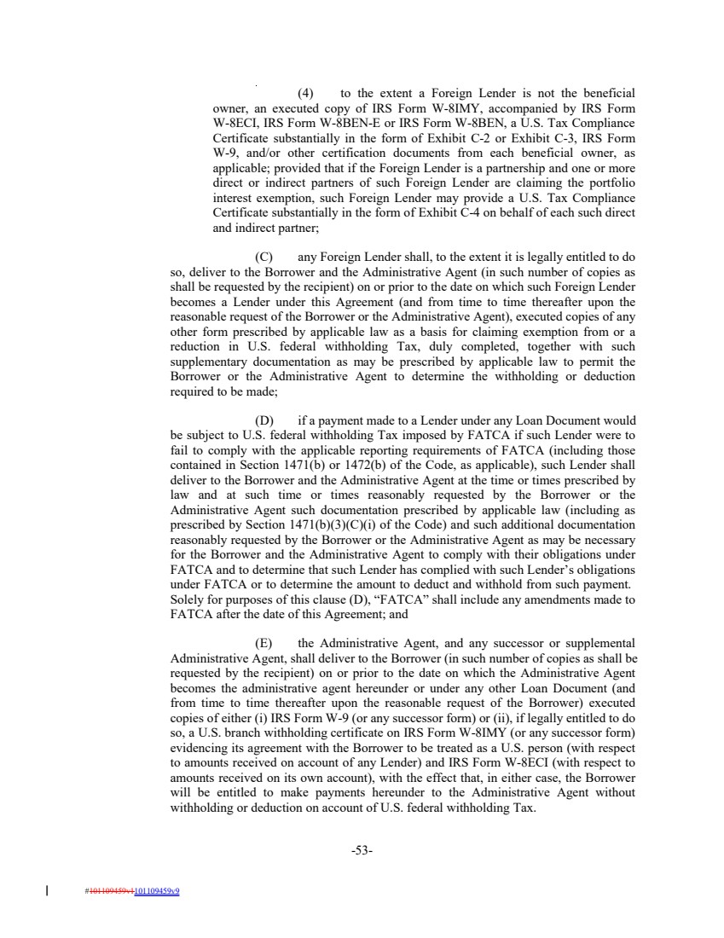 | (4) to the extent a Foreign Lender is not the beneficial owner, an executed copy of IRS Form W-8IMY, accompanied by IRS Form W-8ECI, IRS Form W-8BEN-E or IRS Form W-8BEN, a U.S. Tax Compliance Certificate substantially in the form of Exhibit C-2 or Exhibit C-3, IRS Form W-9, and/or other certification documents from each beneficial owner, as applicable; provided that if the Foreign Lender is a partnership and one or more direct or indirect partners of such Foreign Lender are claiming the portfolio interest exemption, such Foreign Lender may provide a U.S. Tax Compliance Certificate substantially in the form of Exhibit C-4 on behalf of each such direct and indirect partner; (C) any Foreign Lender shall, to the extent it is legally entitled to do so, deliver to the Borrower and the Administrative Agent (in such number of copies as shall be requested by the recipient) on or prior to the date on which such Foreign Lender becomes a Lender under this Agreement (and from time to time thereafter upon the reasonable request of the Borrower or the Administrative Agent), executed copies of any other form prescribed by applicable law as a basis for claiming exemption from or a reduction in U.S. federal withholding Tax, duly completed, together with such supplementary documentation as may be prescribed by applicable law to permit the Borrower or the Administrative Agent to determine the withholding or deduction required to be made; (D) if a payment made to a Lender under any Loan Document would be subject to U.S. federal withholding Tax imposed by FATCA if such Lender were to fail to comply with the applicable reporting requirements of FATCA (including those contained in Section 1471(b) or 1472(b) of the Code, as applicable), such Lender shall deliver to the Borrower and the Administrative Agent at the time or times prescribed by law and at such time or times reasonably requested by the Borrower or the Administrative Agent such documentation prescribed by applicable law (including as prescribed by Section 1471(b)(3)(C)(i) of the Code) and such additional documentation reasonably requested by the Borrower or the Administrative Agent as may be necessary for the Borrower and the Administrative Agent to comply with their obligations under FATCA and to determine that such Lender has complied with such Lender’s obligations under FATCA or to determine the amount to deduct and withhold from such payment. Solely for purposes of this clause (D), “FATCA” shall include any amendments made to FATCA after the date of this Agreement; and (E) the Administrative Agent, and any successor or supplemental Administrative Agent, shall deliver to the Borrower (in such number of copies as shall be requested by the recipient) on or prior to the date on which the Administrative Agent becomes the administrative agent hereunder or under any other Loan Document (and from time to time thereafter upon the reasonable request of the Borrower) executed copies of either (i) IRS Form W-9 (or any successor form) or (ii), if legally entitled to do so, a U.S. branch withholding certificate on IRS Form W-8IMY (or any successor form) evidencing its agreement with the Borrower to be treated as a U.S. person (with respect to amounts received on account of any Lender) and IRS Form W-8ECI (with respect to amounts received on its own account), with the effect that, in either case, the Borrower will be entitled to make payments hereunder to the Administrative Agent without withholding or deduction on account of U.S. federal withholding Tax. -53- #101109459v1101109459v9
 | 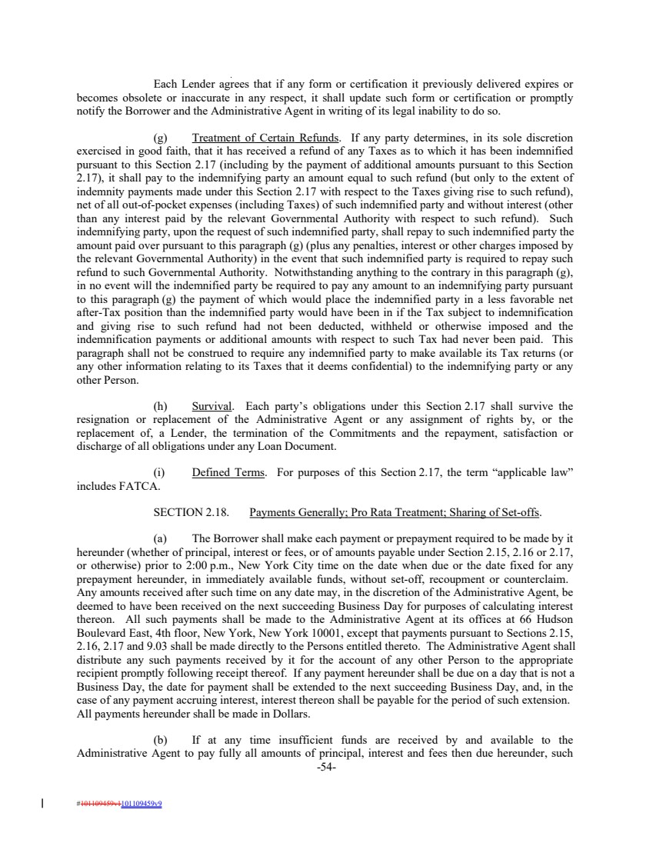 | Each Lender agrees that if any form or certification it previously delivered expires or becomes obsolete or inaccurate in any respect, it shall update such form or certification or promptly notify the Borrower and the Administrative Agent in writing of its legal inability to do so. (g) Treatment of Certain Refunds. If any party determines, in its sole discretion exercised in good faith, that it has received a refund of any Taxes as to which it has been indemnified pursuant to this Section 2.17 (including by the payment of additional amounts pursuant to this Section 2.17), it shall pay to the indemnifying party an amount equal to such refund (but only to the extent of indemnity payments made under this Section 2.17 with respect to the Taxes giving rise to such refund), net of all out-of-pocket expenses (including Taxes) of such indemnified party and without interest (other than any interest paid by the relevant Governmental Authority with respect to such refund). Such indemnifying party, upon the request of such indemnified party, shall repay to such indemnified party the amount paid over pursuant to this paragraph (g) (plus any penalties, interest or other charges imposed by the relevant Governmental Authority) in the event that such indemnified party is required to repay such refund to such Governmental Authority. Notwithstanding anything to the contrary in this paragraph (g), in no event will the indemnified party be required to pay any amount to an indemnifying party pursuant to this paragraph (g) the payment of which would place the indemnified party in a less favorable net after-Tax position than the indemnified party would have been in if the Tax subject to indemnification and giving rise to such refund had not been deducted, withheld or otherwise imposed and the indemnification payments or additional amounts with respect to such Tax had never been paid. This paragraph shall not be construed to require any indemnified party to make available its Tax returns (or any other information relating to its Taxes that it deems confidential) to the indemnifying party or any other Person. (h) Survival. Each party’s obligations under this Section 2.17 shall survive the resignation or replacement of the Administrative Agent or any assignment of rights by, or the replacement of, a Lender, the termination of the Commitments and the repayment, satisfaction or discharge of all obligations under any Loan Document. (i) Defined Terms. For purposes of this Section 2.17, the term “applicable law” includes FATCA. SECTION 2.18. Payments Generally; Pro Rata Treatment; Sharing of Set-offs. (a) The Borrower shall make each payment or prepayment required to be made by it hereunder (whether of principal, interest or fees, or of amounts payable under Section 2.15, 2.16 or 2.17, or otherwise) prior to 2:00 p.m., New York City time on the date when due or the date fixed for any prepayment hereunder, in immediately available funds, without set-off, recoupment or counterclaim. Any amounts received after such time on any date may, in the discretion of the Administrative Agent, be deemed to have been received on the next succeeding Business Day for purposes of calculating interest thereon. All such payments shall be made to the Administrative Agent at its offices at 66 Hudson Boulevard East, 4th floor, New York, New York 10001, except that payments pursuant to Sections 2.15, 2.16, 2.17 and 9.03 shall be made directly to the Persons entitled thereto. The Administrative Agent shall distribute any such payments received by it for the account of any other Person to the appropriate recipient promptly following receipt thereof. If any payment hereunder shall be due on a day that is not a Business Day, the date for payment shall be extended to the next succeeding Business Day, and, in the case of any payment accruing interest, interest thereon shall be payable for the period of such extension. All payments hereunder shall be made in Dollars. (b) If at any time insufficient funds are received by and available to the Administrative Agent to pay fully all amounts of principal, interest and fees then due hereunder, such -54- #101109459v1101109459v9
 | 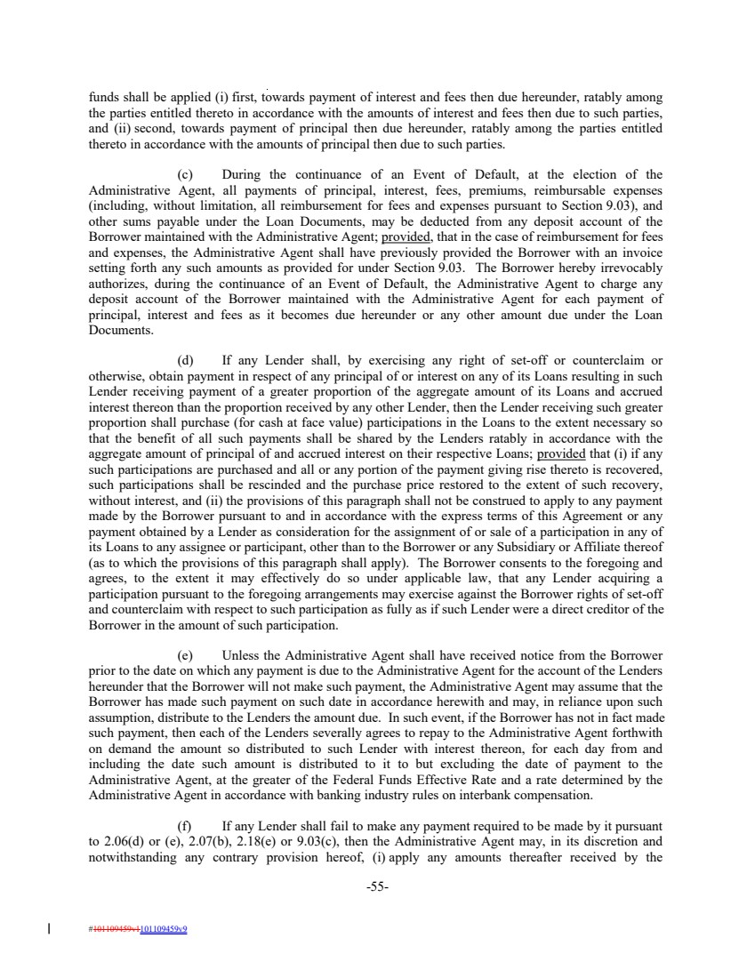 | funds shall be applied (i) first, towards payment of interest and fees then due hereunder, ratably among the parties entitled thereto in accordance with the amounts of interest and fees then due to such parties, and (ii) second, towards payment of principal then due hereunder, ratably among the parties entitled thereto in accordance with the amounts of principal then due to such parties. (c) During the continuance of an Event of Default, at the election of the Administrative Agent, all payments of principal, interest, fees, premiums, reimbursable expenses (including, without limitation, all reimbursement for fees and expenses pursuant to Section 9.03), and other sums payable under the Loan Documents, may be deducted from any deposit account of the Borrower maintained with the Administrative Agent; provided, that in the case of reimbursement for fees and expenses, the Administrative Agent shall have previously provided the Borrower with an invoice setting forth any such amounts as provided for under Section 9.03. The Borrower hereby irrevocably authorizes, during the continuance of an Event of Default, the Administrative Agent to charge any deposit account of the Borrower maintained with the Administrative Agent for each payment of principal, interest and fees as it becomes due hereunder or any other amount due under the Loan Documents. (d) If any Lender shall, by exercising any right of set-off or counterclaim or otherwise, obtain payment in respect of any principal of or interest on any of its Loans resulting in such Lender receiving payment of a greater proportion of the aggregate amount of its Loans and accrued interest thereon than the proportion received by any other Lender, then the Lender receiving such greater proportion shall purchase (for cash at face value) participations in the Loans to the extent necessary so that the benefit of all such payments shall be shared by the Lenders ratably in accordance with the aggregate amount of principal of and accrued interest on their respective Loans; provided that (i) if any such participations are purchased and all or any portion of the payment giving rise thereto is recovered, such participations shall be rescinded and the purchase price restored to the extent of such recovery, without interest, and (ii) the provisions of this paragraph shall not be construed to apply to any payment made by the Borrower pursuant to and in accordance with the express terms of this Agreement or any payment obtained by a Lender as consideration for the assignment of or sale of a participation in any of its Loans to any assignee or participant, other than to the Borrower or any Subsidiary or Affiliate thereof (as to which the provisions of this paragraph shall apply). The Borrower consents to the foregoing and agrees, to the extent it may effectively do so under applicable law, that any Lender acquiring a participation pursuant to the foregoing arrangements may exercise against the Borrower rights of set-off and counterclaim with respect to such participation as fully as if such Lender were a direct creditor of the Borrower in the amount of such participation. (e) Unless the Administrative Agent shall have received notice from the Borrower prior to the date on which any payment is due to the Administrative Agent for the account of the Lenders hereunder that the Borrower will not make such payment, the Administrative Agent may assume that the Borrower has made such payment on such date in accordance herewith and may, in reliance upon such assumption, distribute to the Lenders the amount due. In such event, if the Borrower has not in fact made such payment, then each of the Lenders severally agrees to repay to the Administrative Agent forthwith on demand the amount so distributed to such Lender with interest thereon, for each day from and including the date such amount is distributed to it to but excluding the date of payment to the Administrative Agent, at the greater of the Federal Funds Effective Rate and a rate determined by the Administrative Agent in accordance with banking industry rules on interbank compensation. (f) If any Lender shall fail to make any payment required to be made by it pursuant to 2.06(d) or (e), 2.07(b), 2.18(e) or 9.03(c), then the Administrative Agent may, in its discretion and notwithstanding any contrary provision hereof, (i) apply any amounts thereafter received by the -55- #101109459v1101109459v9
 | 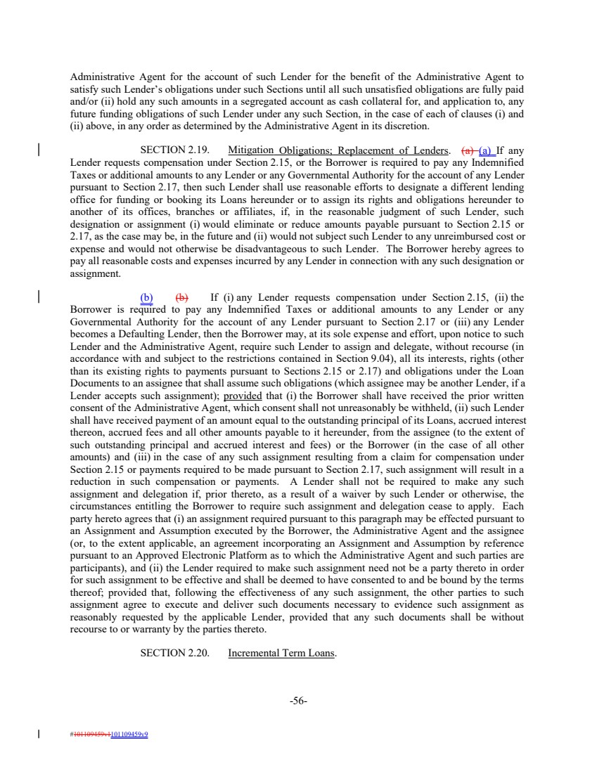 | Administrative Agent for the account of such Lender for the benefit of the Administrative Agent to satisfy such Lender’s obligations under such Sections until all such unsatisfied obligations are fully paid and/or (ii) hold any such amounts in a segregated account as cash collateral for, and application to, any future funding obligations of such Lender under any such Section, in the case of each of clauses (i) and (ii) above, in any order as determined by the Administrative Agent in its discretion. SECTION 2.19. Mitigation Obligations; Replacement of Lenders. (a) (a) If any Lender requests compensation under Section 2.15, or the Borrower is required to pay any Indemnified Taxes or additional amounts to any Lender or any Governmental Authority for the account of any Lender pursuant to Section 2.17, then such Lender shall use reasonable efforts to designate a different lending office for funding or booking its Loans hereunder or to assign its rights and obligations hereunder to another of its offices, branches or affiliates, if, in the reasonable judgment of such Lender, such designation or assignment (i) would eliminate or reduce amounts payable pursuant to Section 2.15 or 2.17, as the case may be, in the future and (ii) would not subject such Lender to any unreimbursed cost or expense and would not otherwise be disadvantageous to such Lender. The Borrower hereby agrees to pay all reasonable costs and expenses incurred by any Lender in connection with any such designation or assignment. (b) (b) If (i) any Lender requests compensation under Section 2.15, (ii) the Borrower is required to pay any Indemnified Taxes or additional amounts to any Lender or any Governmental Authority for the account of any Lender pursuant to Section 2.17 or (iii) any Lender becomes a Defaulting Lender, then the Borrower may, at its sole expense and effort, upon notice to such Lender and the Administrative Agent, require such Lender to assign and delegate, without recourse (in accordance with and subject to the restrictions contained in Section 9.04), all its interests, rights (other than its existing rights to payments pursuant to Sections 2.15 or 2.17) and obligations under the Loan Documents to an assignee that shall assume such obligations (which assignee may be another Lender, if a Lender accepts such assignment); provided that (i) the Borrower shall have received the prior written consent of the Administrative Agent, which consent shall not unreasonably be withheld, (ii) such Lender shall have received payment of an amount equal to the outstanding principal of its Loans, accrued interest thereon, accrued fees and all other amounts payable to it hereunder, from the assignee (to the extent of such outstanding principal and accrued interest and fees) or the Borrower (in the case of all other amounts) and (iii) in the case of any such assignment resulting from a claim for compensation under Section 2.15 or payments required to be made pursuant to Section 2.17, such assignment will result in a reduction in such compensation or payments. A Lender shall not be required to make any such assignment and delegation if, prior thereto, as a result of a waiver by such Lender or otherwise, the circumstances entitling the Borrower to require such assignment and delegation cease to apply. Each party hereto agrees that (i) an assignment required pursuant to this paragraph may be effected pursuant to an Assignment and Assumption executed by the Borrower, the Administrative Agent and the assignee (or, to the extent applicable, an agreement incorporating an Assignment and Assumption by reference pursuant to an Approved Electronic Platform as to which the Administrative Agent and such parties are participants), and (ii) the Lender required to make such assignment need not be a party thereto in order for such assignment to be effective and shall be deemed to have consented to and be bound by the terms thereof; provided that, following the effectiveness of any such assignment, the other parties to such assignment agree to execute and deliver such documents necessary to evidence such assignment as reasonably requested by the applicable Lender, provided that any such documents shall be without recourse to or warranty by the parties thereto. SECTION 2.20. Incremental Term Loans. -56- #101109459v1101109459v9
 | 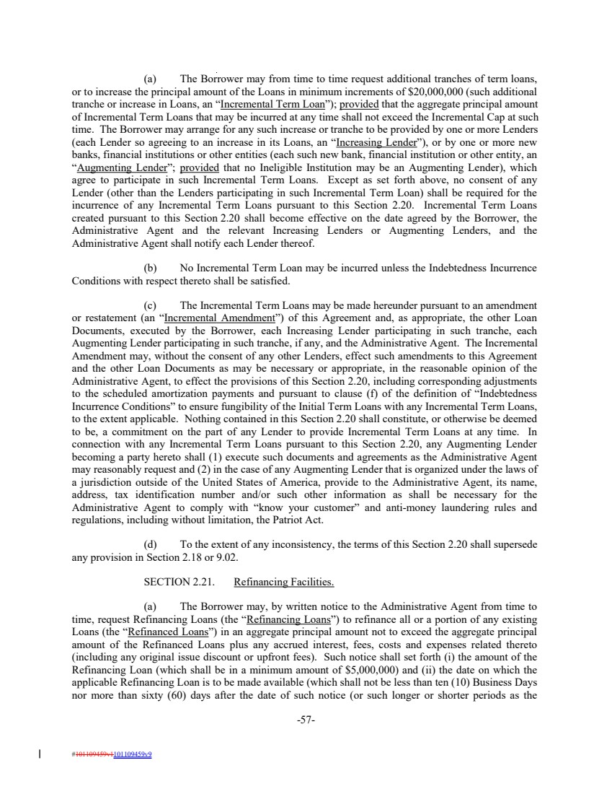 | (a) The Borrower may from time to time request additional tranches of term loans, or to increase the principal amount of the Loans in minimum increments of $20,000,000 (such additional tranche or increase in Loans, an “Incremental Term Loan”); provided that the aggregate principal amount of Incremental Term Loans that may be incurred at any time shall not exceed the Incremental Cap at such time. The Borrower may arrange for any such increase or tranche to be provided by one or more Lenders (each Lender so agreeing to an increase in its Loans, an “Increasing Lender”), or by one or more new banks, financial institutions or other entities (each such new bank, financial institution or other entity, an “Augmenting Lender”; provided that no Ineligible Institution may be an Augmenting Lender), which agree to participate in such Incremental Term Loans. Except as set forth above, no consent of any Lender (other than the Lenders participating in such Incremental Term Loan) shall be required for the incurrence of any Incremental Term Loans pursuant to this Section 2.20. Incremental Term Loans created pursuant to this Section 2.20 shall become effective on the date agreed by the Borrower, the Administrative Agent and the relevant Increasing Lenders or Augmenting Lenders, and the Administrative Agent shall notify each Lender thereof. (b) No Incremental Term Loan may be incurred unless the Indebtedness Incurrence Conditions with respect thereto shall be satisfied. (c) The Incremental Term Loans may be made hereunder pursuant to an amendment or restatement (an “Incremental Amendment”) of this Agreement and, as appropriate, the other Loan Documents, executed by the Borrower, each Increasing Lender participating in such tranche, each Augmenting Lender participating in such tranche, if any, and the Administrative Agent. The Incremental Amendment may, without the consent of any other Lenders, effect such amendments to this Agreement and the other Loan Documents as may be necessary or appropriate, in the reasonable opinion of the Administrative Agent, to effect the provisions of this Section 2.20, including corresponding adjustments to the scheduled amortization payments and pursuant to clause (f) of the definition of “Indebtedness Incurrence Conditions” to ensure fungibility of the Initial Term Loans with any Incremental Term Loans, to the extent applicable. Nothing contained in this Section 2.20 shall constitute, or otherwise be deemed to be, a commitment on the part of any Lender to provide Incremental Term Loans at any time. In connection with any Incremental Term Loans pursuant to this Section 2.20, any Augmenting Lender becoming a party hereto shall (1) execute such documents and agreements as the Administrative Agent may reasonably request and (2) in the case of any Augmenting Lender that is organized under the laws of a jurisdiction outside of the United States of America, provide to the Administrative Agent, its name, address, tax identification number and/or such other information as shall be necessary for the Administrative Agent to comply with “know your customer” and anti-money laundering rules and regulations, including without limitation, the Patriot Act. (d) To the extent of any inconsistency, the terms of this Section 2.20 shall supersede any provision in Section 2.18 or 9.02. SECTION 2.21. Refinancing Facilities. (a) The Borrower may, by written notice to the Administrative Agent from time to time, request Refinancing Loans (the “Refinancing Loans”) to refinance all or a portion of any existing Loans (the “Refinanced Loans”) in an aggregate principal amount not to exceed the aggregate principal amount of the Refinanced Loans plus any accrued interest, fees, costs and expenses related thereto (including any original issue discount or upfront fees). Such notice shall set forth (i) the amount of the Refinancing Loan (which shall be in a minimum amount of $5,000,000) and (ii) the date on which the applicable Refinancing Loan is to be made available (which shall not be less than ten (10) Business Days nor more than sixty (60) days after the date of such notice (or such longer or shorter periods as the -57- #101109459v1101109459v9
 | 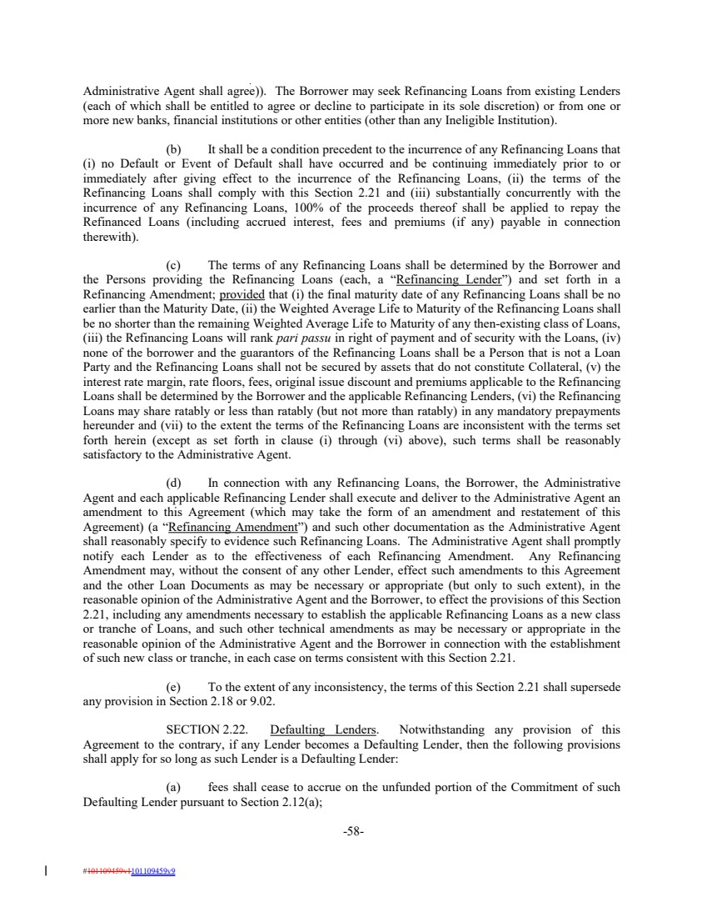 | Administrative Agent shall agree)). The Borrower may seek Refinancing Loans from existing Lenders (each of which shall be entitled to agree or decline to participate in its sole discretion) or from one or more new banks, financial institutions or other entities (other than any Ineligible Institution). (b) It shall be a condition precedent to the incurrence of any Refinancing Loans that (i) no Default or Event of Default shall have occurred and be continuing immediately prior to or immediately after giving effect to the incurrence of the Refinancing Loans, (ii) the terms of the Refinancing Loans shall comply with this Section 2.21 and (iii) substantially concurrently with the incurrence of any Refinancing Loans, 100% of the proceeds thereof shall be applied to repay the Refinanced Loans (including accrued interest, fees and premiums (if any) payable in connection therewith). (c) The terms of any Refinancing Loans shall be determined by the Borrower and the Persons providing the Refinancing Loans (each, a “Refinancing Lender”) and set forth in a Refinancing Amendment; provided that (i) the final maturity date of any Refinancing Loans shall be no earlier than the Maturity Date, (ii) the Weighted Average Life to Maturity of the Refinancing Loans shall be no shorter than the remaining Weighted Average Life to Maturity of any then-existing class of Loans, (iii) the Refinancing Loans will rank pari passu in right of payment and of security with the Loans, (iv) none of the borrower and the guarantors of the Refinancing Loans shall be a Person that is not a Loan Party and the Refinancing Loans shall not be secured by assets that do not constitute Collateral, (v) the interest rate margin, rate floors, fees, original issue discount and premiums applicable to the Refinancing Loans shall be determined by the Borrower and the applicable Refinancing Lenders, (vi) the Refinancing Loans may share ratably or less than ratably (but not more than ratably) in any mandatory prepayments hereunder and (vii) to the extent the terms of the Refinancing Loans are inconsistent with the terms set forth herein (except as set forth in clause (i) through (vi) above), such terms shall be reasonably satisfactory to the Administrative Agent. (d) In connection with any Refinancing Loans, the Borrower, the Administrative Agent and each applicable Refinancing Lender shall execute and deliver to the Administrative Agent an amendment to this Agreement (which may take the form of an amendment and restatement of this Agreement) (a “Refinancing Amendment”) and such other documentation as the Administrative Agent shall reasonably specify to evidence such Refinancing Loans. The Administrative Agent shall promptly notify each Lender as to the effectiveness of each Refinancing Amendment. Any Refinancing Amendment may, without the consent of any other Lender, effect such amendments to this Agreement and the other Loan Documents as may be necessary or appropriate (but only to such extent), in the reasonable opinion of the Administrative Agent and the Borrower, to effect the provisions of this Section 2.21, including any amendments necessary to establish the applicable Refinancing Loans as a new class or tranche of Loans, and such other technical amendments as may be necessary or appropriate in the reasonable opinion of the Administrative Agent and the Borrower in connection with the establishment of such new class or tranche, in each case on terms consistent with this Section 2.21. (e) To the extent of any inconsistency, the terms of this Section 2.21 shall supersede any provision in Section 2.18 or 9.02. SECTION 2.22. Defaulting Lenders. Notwithstanding any provision of this Agreement to the contrary, if any Lender becomes a Defaulting Lender, then the following provisions shall apply for so long as such Lender is a Defaulting Lender: (a) fees shall cease to accrue on the unfunded portion of the Commitment of such Defaulting Lender pursuant to Section 2.12(a); -58- #101109459v1101109459v9
 | 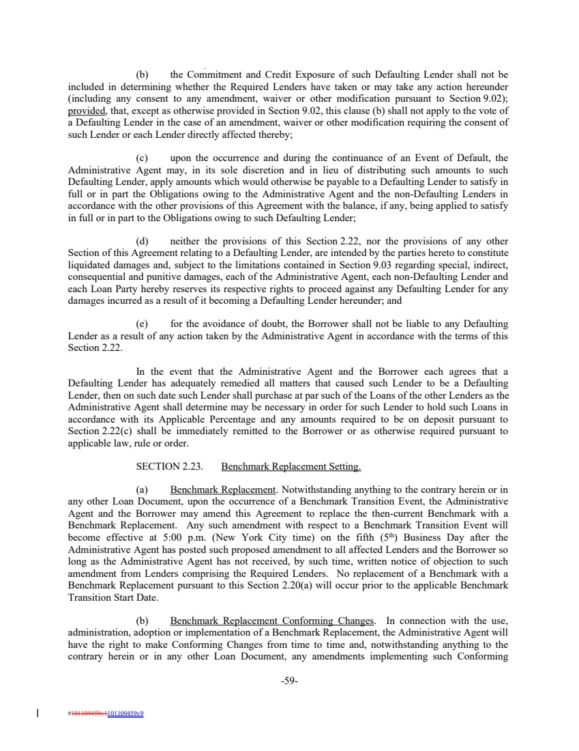 | (b) the Commitment and Credit Exposure of such Defaulting Lender shall not be included in determining whether the Required Lenders have taken or may take any action hereunder (including any consent to any amendment, waiver or other modification pursuant to Section 9.02); provided, that, except as otherwise provided in Section 9.02, this clause (b) shall not apply to the vote of a Defaulting Lender in the case of an amendment, waiver or other modification requiring the consent of such Lender or each Lender directly affected thereby; (c) upon the occurrence and during the continuance of an Event of Default, the Administrative Agent may, in its sole discretion and in lieu of distributing such amounts to such Defaulting Lender, apply amounts which would otherwise be payable to a Defaulting Lender to satisfy in full or in part the Obligations owing to the Administrative Agent and the non-Defaulting Lenders in accordance with the other provisions of this Agreement with the balance, if any, being applied to satisfy in full or in part to the Obligations owing to such Defaulting Lender; (d) neither the provisions of this Section 2.22, nor the provisions of any other Section of this Agreement relating to a Defaulting Lender, are intended by the parties hereto to constitute liquidated damages and, subject to the limitations contained in Section 9.03 regarding special, indirect, consequential and punitive damages, each of the Administrative Agent, each non-Defaulting Lender and each Loan Party hereby reserves its respective rights to proceed against any Defaulting Lender for any damages incurred as a result of it becoming a Defaulting Lender hereunder; and (e) for the avoidance of doubt, the Borrower shall not be liable to any Defaulting Lender as a result of any action taken by the Administrative Agent in accordance with the terms of this Section 2.22. In the event that the Administrative Agent and the Borrower each agrees that a Defaulting Lender has adequately remedied all matters that caused such Lender to be a Defaulting Lender, then on such date such Lender shall purchase at par such of the Loans of the other Lenders as the Administrative Agent shall determine may be necessary in order for such Lender to hold such Loans in accordance with its Applicable Percentage and any amounts required to be on deposit pursuant to Section 2.22(c) shall be immediately remitted to the Borrower or as otherwise required pursuant to applicable law, rule or order. SECTION 2.23. Benchmark Replacement Setting. (a) Benchmark Replacement. Notwithstanding anything to the contrary herein or in any other Loan Document, upon the occurrence of a Benchmark Transition Event, the Administrative Agent and the Borrower may amend this Agreement to replace the then-current Benchmark with a Benchmark Replacement. Any such amendment with respect to a Benchmark Transition Event will become effective at 5:00 p.m. (New York City time) on the fifth (5 th) Business Day after the Administrative Agent has posted such proposed amendment to all affected Lenders and the Borrower so long as the Administrative Agent has not received, by such time, written notice of objection to such amendment from Lenders comprising the Required Lenders. No replacement of a Benchmark with a Benchmark Replacement pursuant to this Section 2.20(a) will occur prior to the applicable Benchmark Transition Start Date. (b) Benchmark Replacement Conforming Changes. In connection with the use, administration, adoption or implementation of a Benchmark Replacement, the Administrative Agent will have the right to make Conforming Changes from time to time and, notwithstanding anything to the contrary herein or in any other Loan Document, any amendments implementing such Conforming -59- #101109459v1101109459v9
 | 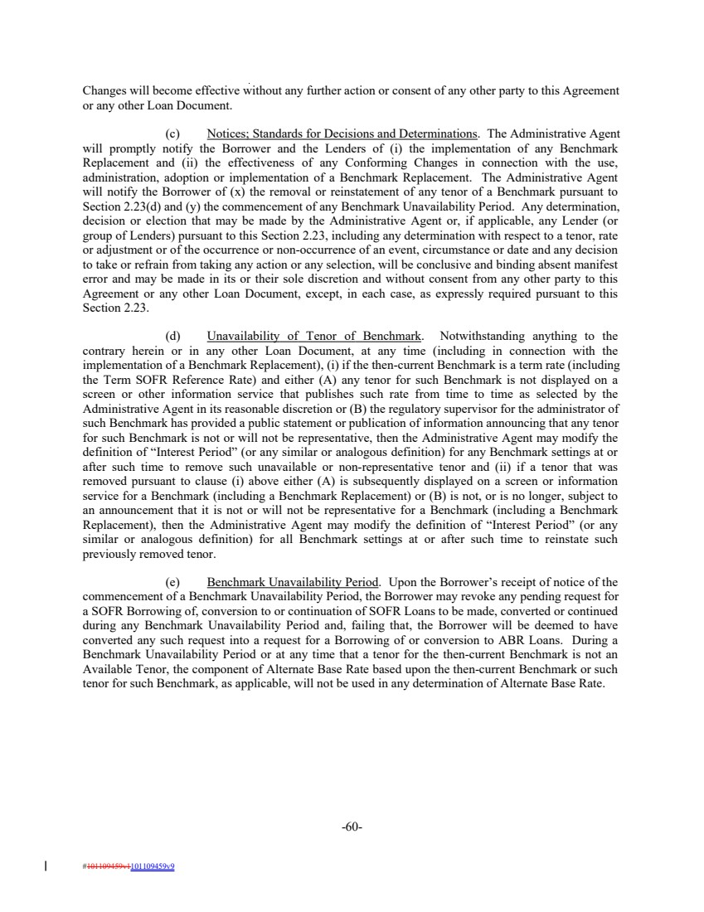 | Changes will become effective without any further action or consent of any other party to this Agreement or any other Loan Document. (c) Notices; Standards for Decisions and Determinations. The Administrative Agent will promptly notify the Borrower and the Lenders of (i) the implementation of any Benchmark Replacement and (ii) the effectiveness of any Conforming Changes in connection with the use, administration, adoption or implementation of a Benchmark Replacement. The Administrative Agent will notify the Borrower of (x) the removal or reinstatement of any tenor of a Benchmark pursuant to Section 2.23(d) and (y) the commencement of any Benchmark Unavailability Period. Any determination, decision or election that may be made by the Administrative Agent or, if applicable, any Lender (or group of Lenders) pursuant to this Section 2.23, including any determination with respect to a tenor, rate or adjustment or of the occurrence or non-occurrence of an event, circumstance or date and any decision to take or refrain from taking any action or any selection, will be conclusive and binding absent manifest error and may be made in its or their sole discretion and without consent from any other party to this Agreement or any other Loan Document, except, in each case, as expressly required pursuant to this Section 2.23. (d) Unavailability of Tenor of Benchmark. Notwithstanding anything to the contrary herein or in any other Loan Document, at any time (including in connection with the implementation of a Benchmark Replacement), (i) if the then-current Benchmark is a term rate (including the Term SOFR Reference Rate) and either (A) any tenor for such Benchmark is not displayed on a screen or other information service that publishes such rate from time to time as selected by the Administrative Agent in its reasonable discretion or (B) the regulatory supervisor for the administrator of such Benchmark has provided a public statement or publication of information announcing that any tenor for such Benchmark is not or will not be representative, then the Administrative Agent may modify the definition of “Interest Period” (or any similar or analogous definition) for any Benchmark settings at or after such time to remove such unavailable or non-representative tenor and (ii) if a tenor that was removed pursuant to clause (i) above either (A) is subsequently displayed on a screen or information service for a Benchmark (including a Benchmark Replacement) or (B) is not, or is no longer, subject to an announcement that it is not or will not be representative for a Benchmark (including a Benchmark Replacement), then the Administrative Agent may modify the definition of “Interest Period” (or any similar or analogous definition) for all Benchmark settings at or after such time to reinstate such previously removed tenor. (e) Benchmark Unavailability Period. Upon the Borrower’s receipt of notice of the commencement of a Benchmark Unavailability Period, the Borrower may revoke any pending request for a SOFR Borrowing of, conversion to or continuation of SOFR Loans to be made, converted or continued during any Benchmark Unavailability Period and, failing that, the Borrower will be deemed to have converted any such request into a request for a Borrowing of or conversion to ABR Loans. During a Benchmark Unavailability Period or at any time that a tenor for the then-current Benchmark is not an Available Tenor, the component of Alternate Base Rate based upon the then-current Benchmark or such tenor for such Benchmark, as applicable, will not be used in any determination of Alternate Base Rate. -60- #101109459v1101109459v9
 | 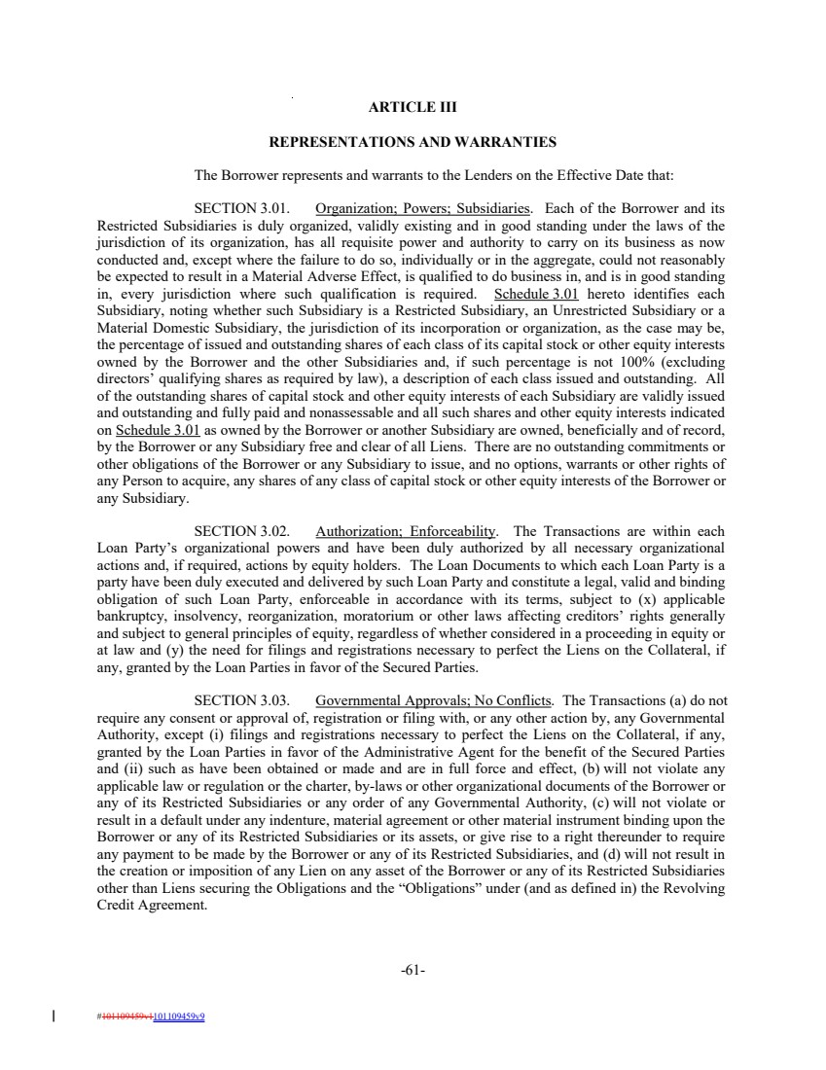 | ARTICLE III REPRESENTATIONS AND WARRANTIES The Borrower represents and warrants to the Lenders on the Effective Date that: SECTION 3.01. Organization; Powers; Subsidiaries. Each of the Borrower and its Restricted Subsidiaries is duly organized, validly existing and in good standing under the laws of the jurisdiction of its organization, has all requisite power and authority to carry on its business as now conducted and, except where the failure to do so, individually or in the aggregate, could not reasonably be expected to result in a Material Adverse Effect, is qualified to do business in, and is in good standing in, every jurisdiction where such qualification is required. Schedule 3.01 hereto identifies each Subsidiary, noting whether such Subsidiary is a Restricted Subsidiary, an Unrestricted Subsidiary or a Material Domestic Subsidiary, the jurisdiction of its incorporation or organization, as the case may be, the percentage of issued and outstanding shares of each class of its capital stock or other equity interests owned by the Borrower and the other Subsidiaries and, if such percentage is not 100% (excluding directors’ qualifying shares as required by law), a description of each class issued and outstanding. All of the outstanding shares of capital stock and other equity interests of each Subsidiary are validly issued and outstanding and fully paid and nonassessable and all such shares and other equity interests indicated on Schedule 3.01 as owned by the Borrower or another Subsidiary are owned, beneficially and of record, by the Borrower or any Subsidiary free and clear of all Liens. There are no outstanding commitments or other obligations of the Borrower or any Subsidiary to issue, and no options, warrants or other rights of any Person to acquire, any shares of any class of capital stock or other equity interests of the Borrower or any Subsidiary. SECTION 3.02. Authorization; Enforceability. The Transactions are within each Loan Party’s organizational powers and have been duly authorized by all necessary organizational actions and, if required, actions by equity holders. The Loan Documents to which each Loan Party is a party have been duly executed and delivered by such Loan Party and constitute a legal, valid and binding obligation of such Loan Party, enforceable in accordance with its terms, subject to (x) applicable bankruptcy, insolvency, reorganization, moratorium or other laws affecting creditors’ rights generally and subject to general principles of equity, regardless of whether considered in a proceeding in equity or at law and (y) the need for filings and registrations necessary to perfect the Liens on the Collateral, if any, granted by the Loan Parties in favor of the Secured Parties. SECTION 3.03. Governmental Approvals; No Conflicts. The Transactions (a) do not require any consent or approval of, registration or filing with, or any other action by, any Governmental Authority, except (i) filings and registrations necessary to perfect the Liens on the Collateral, if any, granted by the Loan Parties in favor of the Administrative Agent for the benefit of the Secured Parties and (ii) such as have been obtained or made and are in full force and effect, (b) will not violate any applicable law or regulation or the charter, by-laws or other organizational documents of the Borrower or any of its Restricted Subsidiaries or any order of any Governmental Authority, (c) will not violate or result in a default under any indenture, material agreement or other material instrument binding upon the Borrower or any of its Restricted Subsidiaries or its assets, or give rise to a right thereunder to require any payment to be made by the Borrower or any of its Restricted Subsidiaries, and (d) will not result in the creation or imposition of any Lien on any asset of the Borrower or any of its Restricted Subsidiaries other than Liens securing the Obligations and the “Obligations” under (and as defined in) the Revolving Credit Agreement. -61- #101109459v1101109459v9
 | 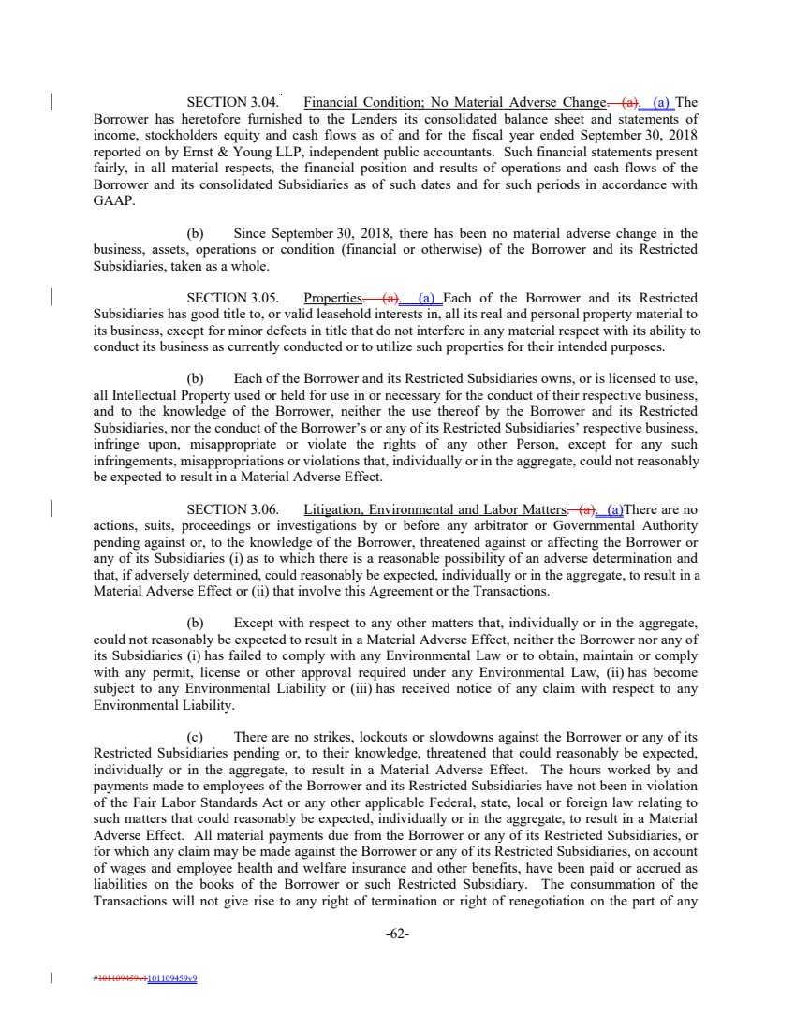 | SECTION 3.04. Financial Condition; No Material Adverse Change. (a). (a) The Borrower has heretofore furnished to the Lenders its consolidated balance sheet and statements of income, stockholders equity and cash flows as of and for the fiscal year ended September 30, 2018 reported on by Ernst & Young LLP, independent public accountants. Such financial statements present fairly, in all material respects, the financial position and results of operations and cash flows of the Borrower and its consolidated Subsidiaries as of such dates and for such periods in accordance with GAAP. (b) Since September 30, 2018, there has been no material adverse change in the business, assets, operations or condition (financial or otherwise) of the Borrower and its Restricted Subsidiaries, taken as a whole. SECTION 3.05. Properties. (a). (a) Each of the Borrower and its Restricted Subsidiaries has good title to, or valid leasehold interests in, all its real and personal property material to its business, except for minor defects in title that do not interfere in any material respect with its ability to conduct its business as currently conducted or to utilize such properties for their intended purposes. (b) Each of the Borrower and its Restricted Subsidiaries owns, or is licensed to use, all Intellectual Property used or held for use in or necessary for the conduct of their respective business, and to the knowledge of the Borrower, neither the use thereof by the Borrower and its Restricted Subsidiaries, nor the conduct of the Borrower’s or any of its Restricted Subsidiaries’ respective business, infringe upon, misappropriate or violate the rights of any other Person, except for any such infringements, misappropriations or violations that, individually or in the aggregate, could not reasonably be expected to result in a Material Adverse Effect. SECTION 3.06. Litigation, Environmental and Labor Matters. (a). (a)There are no actions, suits, proceedings or investigations by or before any arbitrator or Governmental Authority pending against or, to the knowledge of the Borrower, threatened against or affecting the Borrower or any of its Subsidiaries (i) as to which there is a reasonable possibility of an adverse determination and that, if adversely determined, could reasonably be expected, individually or in the aggregate, to result in a Material Adverse Effect or (ii) that involve this Agreement or the Transactions. (b) Except with respect to any other matters that, individually or in the aggregate, could not reasonably be expected to result in a Material Adverse Effect, neither the Borrower nor any of its Subsidiaries (i) has failed to comply with any Environmental Law or to obtain, maintain or comply with any permit, license or other approval required under any Environmental Law, (ii) has become subject to any Environmental Liability or (iii) has received notice of any claim with respect to any Environmental Liability. (c) There are no strikes, lockouts or slowdowns against the Borrower or any of its Restricted Subsidiaries pending or, to their knowledge, threatened that could reasonably be expected, individually or in the aggregate, to result in a Material Adverse Effect. The hours worked by and payments made to employees of the Borrower and its Restricted Subsidiaries have not been in violation of the Fair Labor Standards Act or any other applicable Federal, state, local or foreign law relating to such matters that could reasonably be expected, individually or in the aggregate, to result in a Material Adverse Effect. All material payments due from the Borrower or any of its Restricted Subsidiaries, or for which any claim may be made against the Borrower or any of its Restricted Subsidiaries, on account of wages and employee health and welfare insurance and other benefits, have been paid or accrued as liabilities on the books of the Borrower or such Restricted Subsidiary. The consummation of the Transactions will not give rise to any right of termination or right of renegotiation on the part of any -62- #101109459v1101109459v9
 | 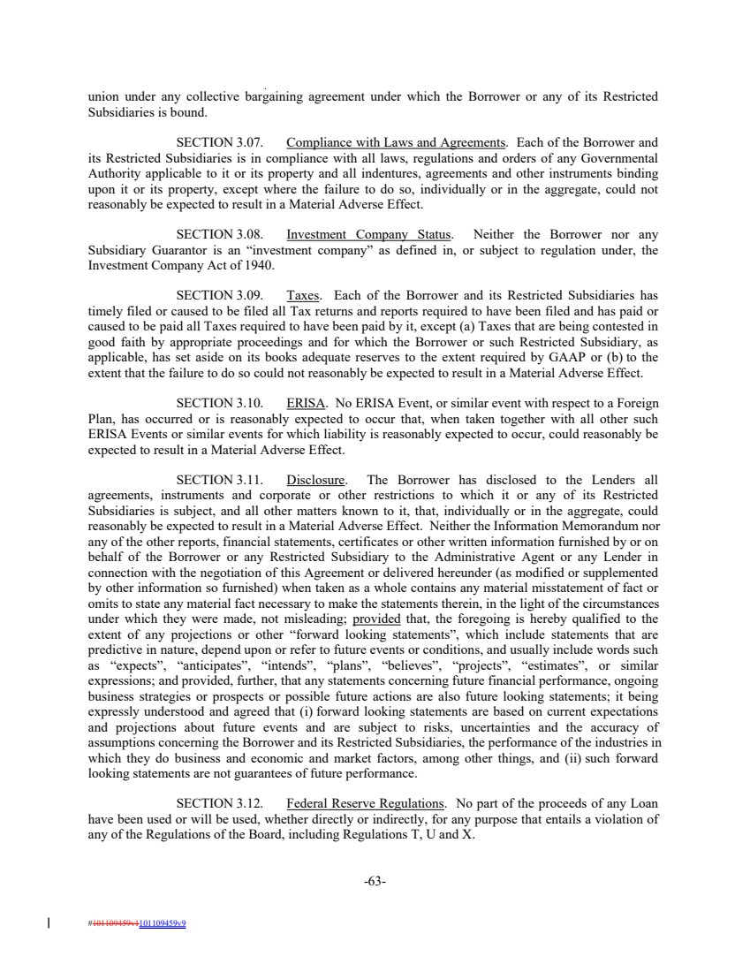 | union under any collective bargaining agreement under which the Borrower or any of its Restricted Subsidiaries is bound. SECTION 3.07. Compliance with Laws and Agreements. Each of the Borrower and its Restricted Subsidiaries is in compliance with all laws, regulations and orders of any Governmental Authority applicable to it or its property and all indentures, agreements and other instruments binding upon it or its property, except where the failure to do so, individually or in the aggregate, could not reasonably be expected to result in a Material Adverse Effect. SECTION 3.08. Investment Company Status. Neither the Borrower nor any Subsidiary Guarantor is an “investment company” as defined in, or subject to regulation under, the Investment Company Act of 1940. SECTION 3.09. Taxes. Each of the Borrower and its Restricted Subsidiaries has timely filed or caused to be filed all Tax returns and reports required to have been filed and has paid or caused to be paid all Taxes required to have been paid by it, except (a) Taxes that are being contested in good faith by appropriate proceedings and for which the Borrower or such Restricted Subsidiary, as applicable, has set aside on its books adequate reserves to the extent required by GAAP or (b) to the extent that the failure to do so could not reasonably be expected to result in a Material Adverse Effect. SECTION 3.10. ERISA. No ERISA Event, or similar event with respect to a Foreign Plan, has occurred or is reasonably expected to occur that, when taken together with all other such ERISA Events or similar events for which liability is reasonably expected to occur, could reasonably be expected to result in a Material Adverse Effect. SECTION 3.11. Disclosure. The Borrower has disclosed to the Lenders all agreements, instruments and corporate or other restrictions to which it or any of its Restricted Subsidiaries is subject, and all other matters known to it, that, individually or in the aggregate, could reasonably be expected to result in a Material Adverse Effect. Neither the Information Memorandum nor any of the other reports, financial statements, certificates or other written information furnished by or on behalf of the Borrower or any Restricted Subsidiary to the Administrative Agent or any Lender in connection with the negotiation of this Agreement or delivered hereunder (as modified or supplemented by other information so furnished) when taken as a whole contains any material misstatement of fact or omits to state any material fact necessary to make the statements therein, in the light of the circumstances under which they were made, not misleading; provided that, the foregoing is hereby qualified to the extent of any projections or other “forward looking statements”, which include statements that are predictive in nature, depend upon or refer to future events or conditions, and usually include words such as “expects”, “anticipates”, “intends”, “plans”, “believes”, “projects”, “estimates”, or similar expressions; and provided, further, that any statements concerning future financial performance, ongoing business strategies or prospects or possible future actions are also future looking statements; it being expressly understood and agreed that (i) forward looking statements are based on current expectations and projections about future events and are subject to risks, uncertainties and the accuracy of assumptions concerning the Borrower and its Restricted Subsidiaries, the performance of the industries in which they do business and economic and market factors, among other things, and (ii) such forward looking statements are not guarantees of future performance. SECTION 3.12. Federal Reserve Regulations. No part of the proceeds of any Loan have been used or will be used, whether directly or indirectly, for any purpose that entails a violation of any of the Regulations of the Board, including Regulations T, U and X. -63- #101109459v1101109459v9
 | 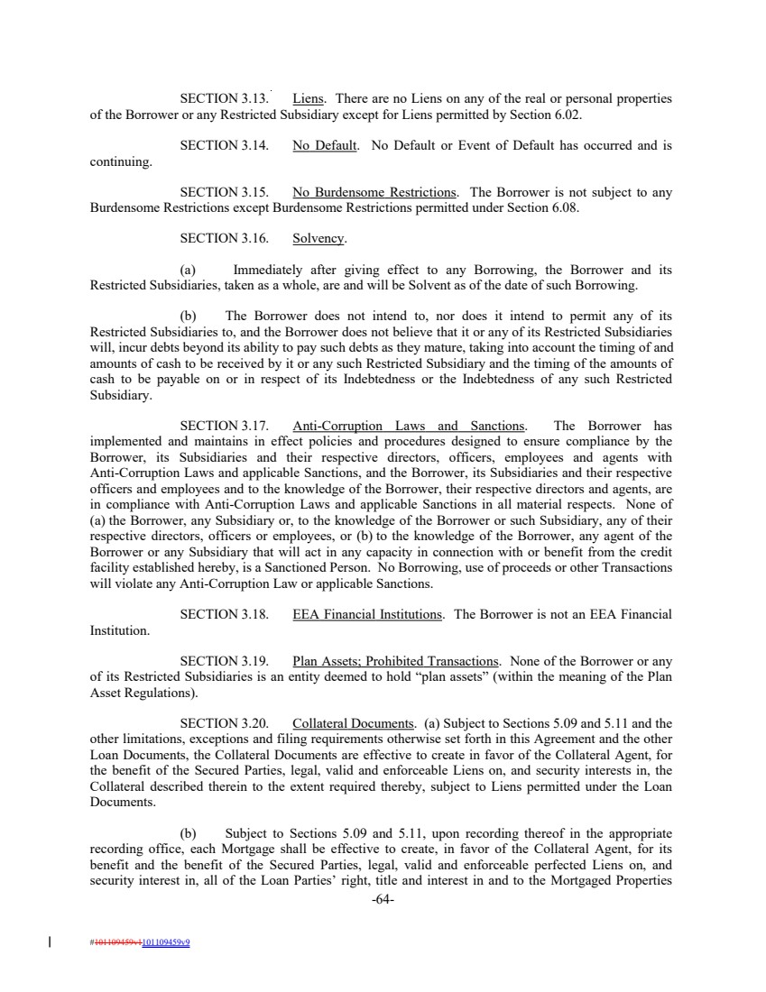 | SECTION 3.13. Liens. There are no Liens on any of the real or personal properties of the Borrower or any Restricted Subsidiary except for Liens permitted by Section 6.02. SECTION 3.14. No Default. No Default or Event of Default has occurred and is continuing. SECTION 3.15. No Burdensome Restrictions. The Borrower is not subject to any Burdensome Restrictions except Burdensome Restrictions permitted under Section 6.08. SECTION 3.16. Solvency. (a) Immediately after giving effect to any Borrowing, the Borrower and its Restricted Subsidiaries, taken as a whole, are and will be Solvent as of the date of such Borrowing. (b) The Borrower does not intend to, nor does it intend to permit any of its Restricted Subsidiaries to, and the Borrower does not believe that it or any of its Restricted Subsidiaries will, incur debts beyond its ability to pay such debts as they mature, taking into account the timing of and amounts of cash to be received by it or any such Restricted Subsidiary and the timing of the amounts of cash to be payable on or in respect of its Indebtedness or the Indebtedness of any such Restricted Subsidiary. SECTION 3.17. Anti-Corruption Laws and Sanctions. The Borrower has implemented and maintains in effect policies and procedures designed to ensure compliance by the Borrower, its Subsidiaries and their respective directors, officers, employees and agents with Anti-Corruption Laws and applicable Sanctions, and the Borrower, its Subsidiaries and their respective officers and employees and to the knowledge of the Borrower, their respective directors and agents, are in compliance with Anti-Corruption Laws and applicable Sanctions in all material respects. None of (a) the Borrower, any Subsidiary or, to the knowledge of the Borrower or such Subsidiary, any of their respective directors, officers or employees, or (b) to the knowledge of the Borrower, any agent of the Borrower or any Subsidiary that will act in any capacity in connection with or benefit from the credit facility established hereby, is a Sanctioned Person. No Borrowing, use of proceeds or other Transactions will violate any Anti-Corruption Law or applicable Sanctions. SECTION 3.18. EEA Financial Institutions. The Borrower is not an EEA Financial Institution. SECTION 3.19. Plan Assets; Prohibited Transactions. None of the Borrower or any of its Restricted Subsidiaries is an entity deemed to hold “plan assets” (within the meaning of the Plan Asset Regulations). SECTION 3.20. Collateral Documents. (a) Subject to Sections 5.09 and 5.11 and the other limitations, exceptions and filing requirements otherwise set forth in this Agreement and the other Loan Documents, the Collateral Documents are effective to create in favor of the Collateral Agent, for the benefit of the Secured Parties, legal, valid and enforceable Liens on, and security interests in, the Collateral described therein to the extent required thereby, subject to Liens permitted under the Loan Documents. (b) Subject to Sections 5.09 and 5.11, upon recording thereof in the appropriate recording office, each Mortgage shall be effective to create, in favor of the Collateral Agent, for its benefit and the benefit of the Secured Parties, legal, valid and enforceable perfected Liens on, and security interest in, all of the Loan Parties’ right, title and interest in and to the Mortgaged Properties -64- #101109459v1101109459v9
 | 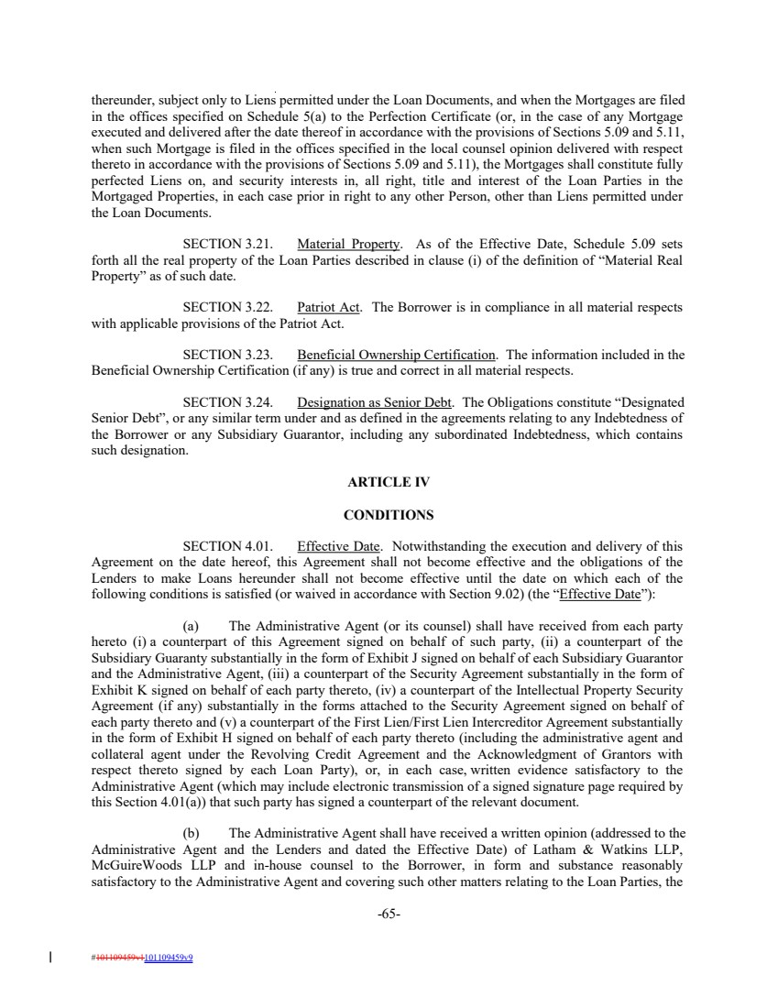 | thereunder, subject only to Liens permitted under the Loan Documents, and when the Mortgages are filed in the offices specified on Schedule 5(a) to the Perfection Certificate (or, in the case of any Mortgage executed and delivered after the date thereof in accordance with the provisions of Sections 5.09 and 5.11, when such Mortgage is filed in the offices specified in the local counsel opinion delivered with respect thereto in accordance with the provisions of Sections 5.09 and 5.11), the Mortgages shall constitute fully perfected Liens on, and security interests in, all right, title and interest of the Loan Parties in the Mortgaged Properties, in each case prior in right to any other Person, other than Liens permitted under the Loan Documents. SECTION 3.21. Material Property. As of the Effective Date, Schedule 5.09 sets forth all the real property of the Loan Parties described in clause (i) of the definition of “Material Real Property” as of such date. SECTION 3.22. Patriot Act. The Borrower is in compliance in all material respects with applicable provisions of the Patriot Act. SECTION 3.23. Beneficial Ownership Certification. The information included in the Beneficial Ownership Certification (if any) is true and correct in all material respects. SECTION 3.24. Designation as Senior Debt. The Obligations constitute “Designated Senior Debt”, or any similar term under and as defined in the agreements relating to any Indebtedness of the Borrower or any Subsidiary Guarantor, including any subordinated Indebtedness, which contains such designation. ARTICLE IV CONDITIONS SECTION 4.01. Effective Date. Notwithstanding the execution and delivery of this Agreement on the date hereof, this Agreement shall not become effective and the obligations of the Lenders to make Loans hereunder shall not become effective until the date on which each of the following conditions is satisfied (or waived in accordance with Section 9.02) (the “Effective Date”): (a) The Administrative Agent (or its counsel) shall have received from each party hereto (i) a counterpart of this Agreement signed on behalf of such party, (ii) a counterpart of the Subsidiary Guaranty substantially in the form of Exhibit J signed on behalf of each Subsidiary Guarantor and the Administrative Agent, (iii) a counterpart of the Security Agreement substantially in the form of Exhibit K signed on behalf of each party thereto, (iv) a counterpart of the Intellectual Property Security Agreement (if any) substantially in the forms attached to the Security Agreement signed on behalf of each party thereto and (v) a counterpart of the First Lien/First Lien Intercreditor Agreement substantially in the form of Exhibit H signed on behalf of each party thereto (including the administrative agent and collateral agent under the Revolving Credit Agreement and the Acknowledgment of Grantors with respect thereto signed by each Loan Party), or, in each case, written evidence satisfactory to the Administrative Agent (which may include electronic transmission of a signed signature page required by this Section 4.01(a)) that such party has signed a counterpart of the relevant document. (b) The Administrative Agent shall have received a written opinion (addressed to the Administrative Agent and the Lenders and dated the Effective Date) of Latham & Watkins LLP, McGuireWoods LLP and in-house counsel to the Borrower, in form and substance reasonably satisfactory to the Administrative Agent and covering such other matters relating to the Loan Parties, the -65- #101109459v1101109459v9
 | 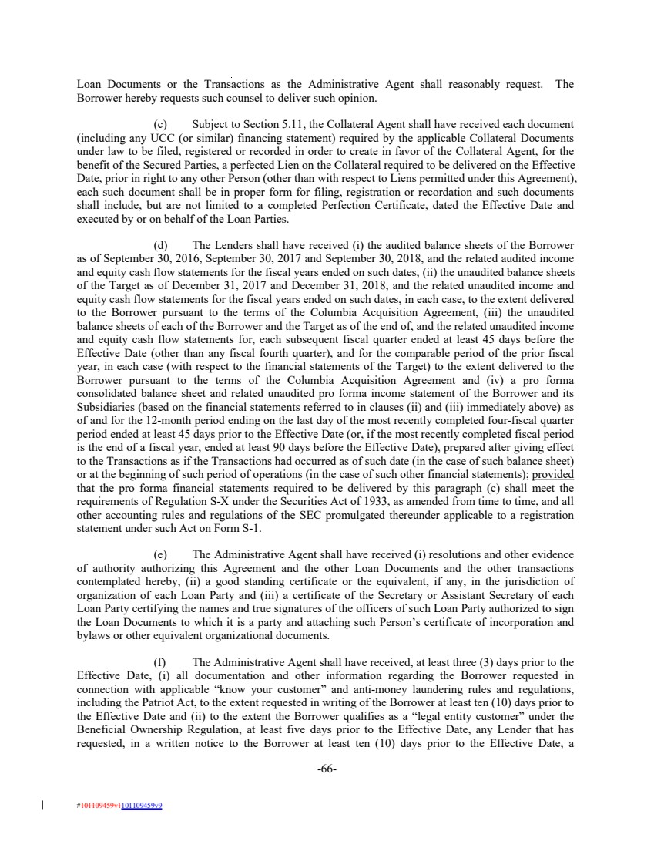 | Loan Documents or the Transactions as the Administrative Agent shall reasonably request. The Borrower hereby requests such counsel to deliver such opinion. (c) Subject to Section 5.11, the Collateral Agent shall have received each document (including any UCC (or similar) financing statement) required by the applicable Collateral Documents under law to be filed, registered or recorded in order to create in favor of the Collateral Agent, for the benefit of the Secured Parties, a perfected Lien on the Collateral required to be delivered on the Effective Date, prior in right to any other Person (other than with respect to Liens permitted under this Agreement), each such document shall be in proper form for filing, registration or recordation and such documents shall include, but are not limited to a completed Perfection Certificate, dated the Effective Date and executed by or on behalf of the Loan Parties. (d) The Lenders shall have received (i) the audited balance sheets of the Borrower as of September 30, 2016, September 30, 2017 and September 30, 2018, and the related audited income and equity cash flow statements for the fiscal years ended on such dates, (ii) the unaudited balance sheets of the Target as of December 31, 2017 and December 31, 2018, and the related unaudited income and equity cash flow statements for the fiscal years ended on such dates, in each case, to the extent delivered to the Borrower pursuant to the terms of the Columbia Acquisition Agreement, (iii) the unaudited balance sheets of each of the Borrower and the Target as of the end of, and the related unaudited income and equity cash flow statements for, each subsequent fiscal quarter ended at least 45 days before the Effective Date (other than any fiscal fourth quarter), and for the comparable period of the prior fiscal year, in each case (with respect to the financial statements of the Target) to the extent delivered to the Borrower pursuant to the terms of the Columbia Acquisition Agreement and (iv) a pro forma consolidated balance sheet and related unaudited pro forma income statement of the Borrower and its Subsidiaries (based on the financial statements referred to in clauses (ii) and (iii) immediately above) as of and for the 12-month period ending on the last day of the most recently completed four-fiscal quarter period ended at least 45 days prior to the Effective Date (or, if the most recently completed fiscal period is the end of a fiscal year, ended at least 90 days before the Effective Date), prepared after giving effect to the Transactions as if the Transactions had occurred as of such date (in the case of such balance sheet) or at the beginning of such period of operations (in the case of such other financial statements); provided that the pro forma financial statements required to be delivered by this paragraph (c) shall meet the requirements of Regulation S-X under the Securities Act of 1933, as amended from time to time, and all other accounting rules and regulations of the SEC promulgated thereunder applicable to a registration statement under such Act on Form S-1. (e) The Administrative Agent shall have received (i) resolutions and other evidence of authority authorizing this Agreement and the other Loan Documents and the other transactions contemplated hereby, (ii) a good standing certificate or the equivalent, if any, in the jurisdiction of organization of each Loan Party and (iii) a certificate of the Secretary or Assistant Secretary of each Loan Party certifying the names and true signatures of the officers of such Loan Party authorized to sign the Loan Documents to which it is a party and attaching such Person’s certificate of incorporation and bylaws or other equivalent organizational documents. (f) The Administrative Agent shall have received, at least three (3) days prior to the Effective Date, (i) all documentation and other information regarding the Borrower requested in connection with applicable “know your customer” and anti-money laundering rules and regulations, including the Patriot Act, to the extent requested in writing of the Borrower at least ten (10) days prior to the Effective Date and (ii) to the extent the Borrower qualifies as a “legal entity customer” under the Beneficial Ownership Regulation, at least five days prior to the Effective Date, any Lender that has requested, in a written notice to the Borrower at least ten (10) days prior to the Effective Date, a -66- #101109459v1101109459v9
 | 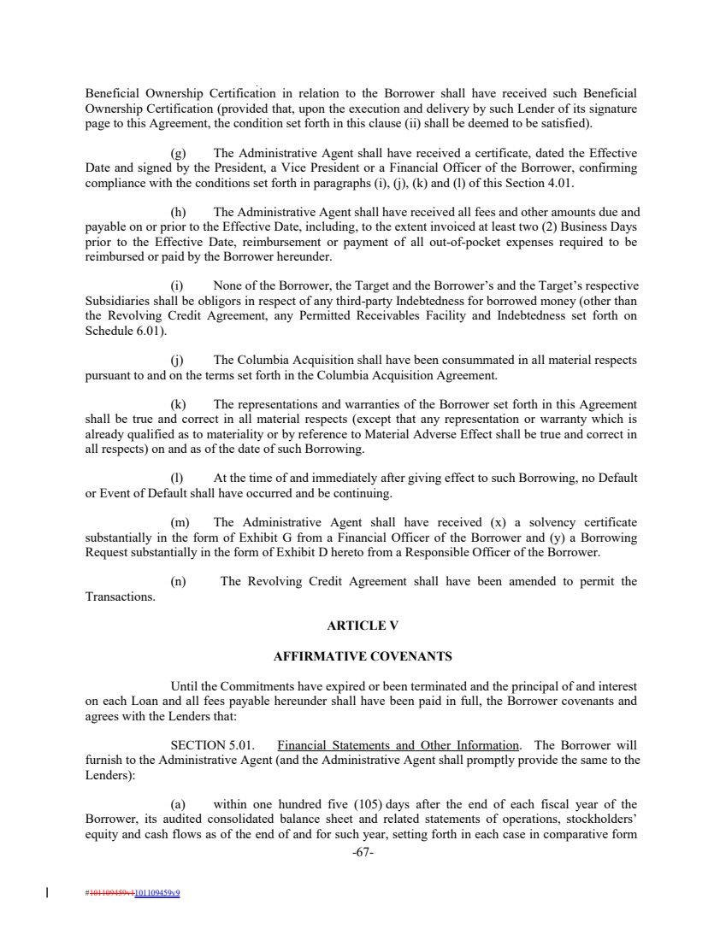 | Beneficial Ownership Certification in relation to the Borrower shall have received such Beneficial Ownership Certification (provided that, upon the execution and delivery by such Lender of its signature page to this Agreement, the condition set forth in this clause (ii) shall be deemed to be satisfied). (g) The Administrative Agent shall have received a certificate, dated the Effective Date and signed by the President, a Vice President or a Financial Officer of the Borrower, confirming compliance with the conditions set forth in paragraphs (i), (j), (k) and (l) of this Section 4.01. (h) The Administrative Agent shall have received all fees and other amounts due and payable on or prior to the Effective Date, including, to the extent invoiced at least two (2) Business Days prior to the Effective Date, reimbursement or payment of all out-of-pocket expenses required to be reimbursed or paid by the Borrower hereunder. (i) None of the Borrower, the Target and the Borrower’s and the Target’s respective Subsidiaries shall be obligors in respect of any third-party Indebtedness for borrowed money (other than the Revolving Credit Agreement, any Permitted Receivables Facility and Indebtedness set forth on Schedule 6.01). (j) The Columbia Acquisition shall have been consummated in all material respects pursuant to and on the terms set forth in the Columbia Acquisition Agreement. (k) The representations and warranties of the Borrower set forth in this Agreement shall be true and correct in all material respects (except that any representation or warranty which is already qualified as to materiality or by reference to Material Adverse Effect shall be true and correct in all respects) on and as of the date of such Borrowing. (l) At the time of and immediately after giving effect to such Borrowing, no Default or Event of Default shall have occurred and be continuing. (m) The Administrative Agent shall have received (x) a solvency certificate substantially in the form of Exhibit G from a Financial Officer of the Borrower and (y) a Borrowing Request substantially in the form of Exhibit D hereto from a Responsible Officer of the Borrower. (n) The Revolving Credit Agreement shall have been amended to permit the Transactions. ARTICLE V AFFIRMATIVE COVENANTS Until the Commitments have expired or been terminated and the principal of and interest on each Loan and all fees payable hereunder shall have been paid in full, the Borrower covenants and agrees with the Lenders that: SECTION 5.01. Financial Statements and Other Information. The Borrower will furnish to the Administrative Agent (and the Administrative Agent shall promptly provide the same to the Lenders): (a) within one hundred five (105) days after the end of each fiscal year of the Borrower, its audited consolidated balance sheet and related statements of operations, stockholders’ equity and cash flows as of the end of and for such year, setting forth in each case in comparative form -67- #101109459v1101109459v9
 | 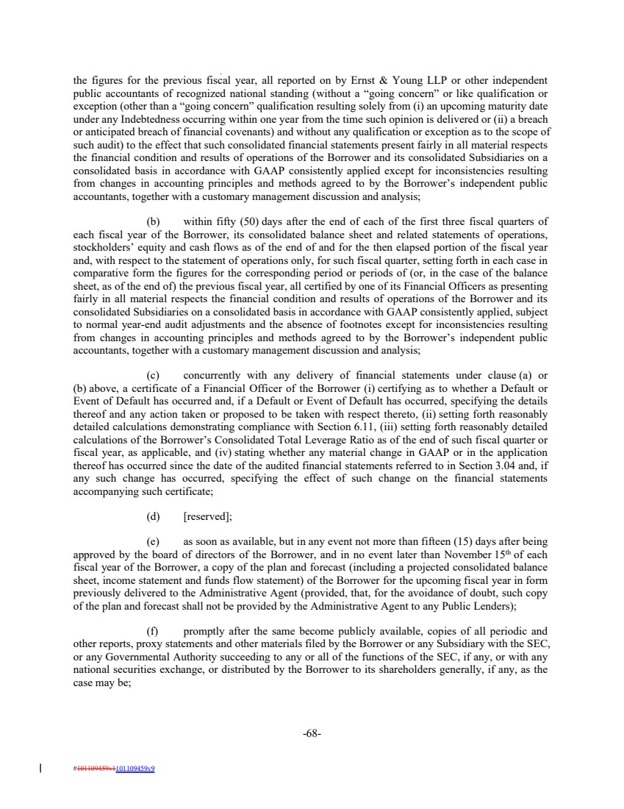 | the figures for the previous fiscal year, all reported on by Ernst & Young LLP or other independent public accountants of recognized national standing (without a “going concern” or like qualification or exception (other than a “going concern” qualification resulting solely from (i) an upcoming maturity date under any Indebtedness occurring within one year from the time such opinion is delivered or (ii) a breach or anticipated breach of financial covenants) and without any qualification or exception as to the scope of such audit) to the effect that such consolidated financial statements present fairly in all material respects the financial condition and results of operations of the Borrower and its consolidated Subsidiaries on a consolidated basis in accordance with GAAP consistently applied except for inconsistencies resulting from changes in accounting principles and methods agreed to by the Borrower’s independent public accountants, together with a customary management discussion and analysis; (b) within fifty (50) days after the end of each of the first three fiscal quarters of each fiscal year of the Borrower, its consolidated balance sheet and related statements of operations, stockholders’ equity and cash flows as of the end of and for the then elapsed portion of the fiscal year and, with respect to the statement of operations only, for such fiscal quarter, setting forth in each case in comparative form the figures for the corresponding period or periods of (or, in the case of the balance sheet, as of the end of) the previous fiscal year, all certified by one of its Financial Officers as presenting fairly in all material respects the financial condition and results of operations of the Borrower and its consolidated Subsidiaries on a consolidated basis in accordance with GAAP consistently applied, subject to normal year-end audit adjustments and the absence of footnotes except for inconsistencies resulting from changes in accounting principles and methods agreed to by the Borrower’s independent public accountants, together with a customary management discussion and analysis; (c) concurrently with any delivery of financial statements under clause (a) or (b) above, a certificate of a Financial Officer of the Borrower (i) certifying as to whether a Default or Event of Default has occurred and, if a Default or Event of Default has occurred, specifying the details thereof and any action taken or proposed to be taken with respect thereto, (ii) setting forth reasonably detailed calculations demonstrating compliance with Section 6.11, (iii) setting forth reasonably detailed calculations of the Borrower’s Consolidated Total Leverage Ratio as of the end of such fiscal quarter or fiscal year, as applicable, and (iv) stating whether any material change in GAAP or in the application thereof has occurred since the date of the audited financial statements referred to in Section 3.04 and, if any such change has occurred, specifying the effect of such change on the financial statements accompanying such certificate; (d) [reserved]; (e) as soon as available, but in any event not more than fifteen (15) days after being approved by the board of directors of the Borrower, and in no event later than November 15th of each fiscal year of the Borrower, a copy of the plan and forecast (including a projected consolidated balance sheet, income statement and funds flow statement) of the Borrower for the upcoming fiscal year in form previously delivered to the Administrative Agent (provided, that, for the avoidance of doubt, such copy of the plan and forecast shall not be provided by the Administrative Agent to any Public Lenders); (f) promptly after the same become publicly available, copies of all periodic and other reports, proxy statements and other materials filed by the Borrower or any Subsidiary with the SEC, or any Governmental Authority succeeding to any or all of the functions of the SEC, if any, or with any national securities exchange, or distributed by the Borrower to its shareholders generally, if any, as the case may be; -68- #101109459v1101109459v9
 | 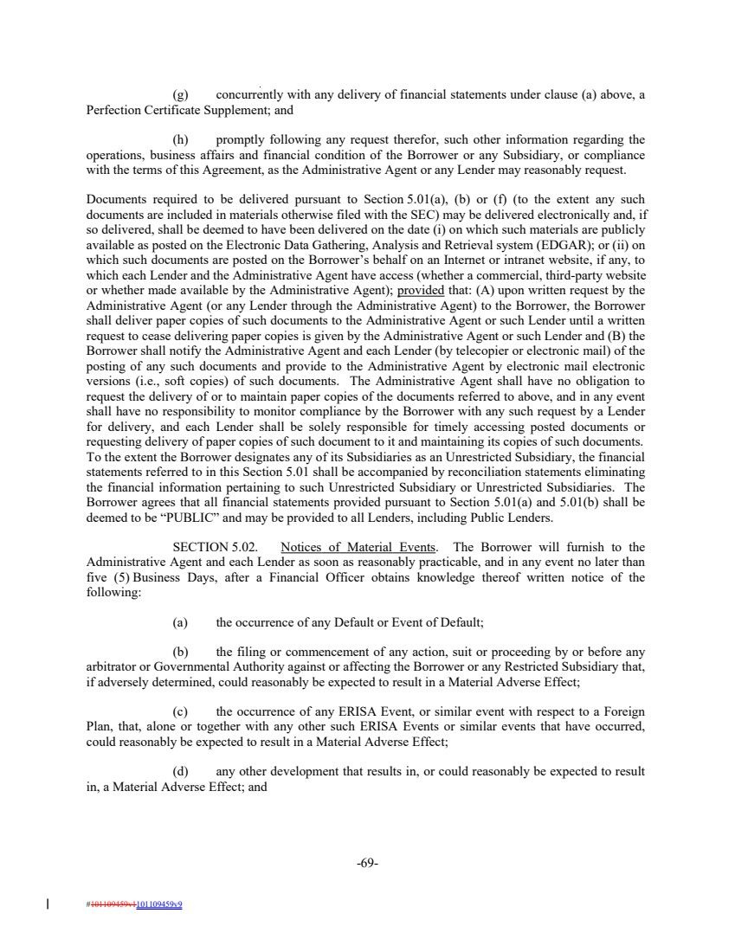 | (g) concurrently with any delivery of financial statements under clause (a) above, a Perfection Certificate Supplement; and (h) promptly following any request therefor, such other information regarding the operations, business affairs and financial condition of the Borrower or any Subsidiary, or compliance with the terms of this Agreement, as the Administrative Agent or any Lender may reasonably request. Documents required to be delivered pursuant to Section 5.01(a), (b) or (f) (to the extent any such documents are included in materials otherwise filed with the SEC) may be delivered electronically and, if so delivered, shall be deemed to have been delivered on the date (i) on which such materials are publicly available as posted on the Electronic Data Gathering, Analysis and Retrieval system (EDGAR); or (ii) on which such documents are posted on the Borrower’s behalf on an Internet or intranet website, if any, to which each Lender and the Administrative Agent have access (whether a commercial, third-party website or whether made available by the Administrative Agent); provided that: (A) upon written request by the Administrative Agent (or any Lender through the Administrative Agent) to the Borrower, the Borrower shall deliver paper copies of such documents to the Administrative Agent or such Lender until a written request to cease delivering paper copies is given by the Administrative Agent or such Lender and (B) the Borrower shall notify the Administrative Agent and each Lender (by telecopier or electronic mail) of the posting of any such documents and provide to the Administrative Agent by electronic mail electronic versions (i.e., soft copies) of such documents. The Administrative Agent shall have no obligation to request the delivery of or to maintain paper copies of the documents referred to above, and in any event shall have no responsibility to monitor compliance by the Borrower with any such request by a Lender for delivery, and each Lender shall be solely responsible for timely accessing posted documents or requesting delivery of paper copies of such document to it and maintaining its copies of such documents. To the extent the Borrower designates any of its Subsidiaries as an Unrestricted Subsidiary, the financial statements referred to in this Section 5.01 shall be accompanied by reconciliation statements eliminating the financial information pertaining to such Unrestricted Subsidiary or Unrestricted Subsidiaries. The Borrower agrees that all financial statements provided pursuant to Section 5.01(a) and 5.01(b) shall be deemed to be “PUBLIC” and may be provided to all Lenders, including Public Lenders. SECTION 5.02. Notices of Material Events. The Borrower will furnish to the Administrative Agent and each Lender as soon as reasonably practicable, and in any event no later than five (5) Business Days, after a Financial Officer obtains knowledge thereof written notice of the following: (a) the occurrence of any Default or Event of Default; (b) the filing or commencement of any action, suit or proceeding by or before any arbitrator or Governmental Authority against or affecting the Borrower or any Restricted Subsidiary that, if adversely determined, could reasonably be expected to result in a Material Adverse Effect; (c) the occurrence of any ERISA Event, or similar event with respect to a Foreign Plan, that, alone or together with any other such ERISA Events or similar events that have occurred, could reasonably be expected to result in a Material Adverse Effect; (d) any other development that results in, or could reasonably be expected to result in, a Material Adverse Effect; and -69- #101109459v1101109459v9
 | 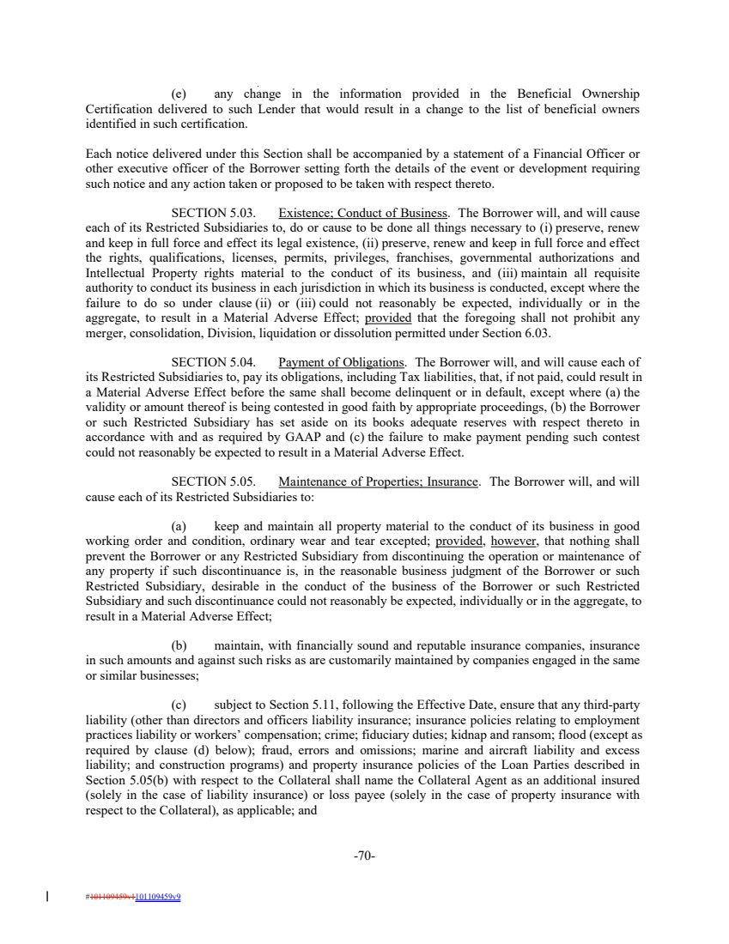 | (e) any change in the information provided in the Beneficial Ownership Certification delivered to such Lender that would result in a change to the list of beneficial owners identified in such certification. Each notice delivered under this Section shall be accompanied by a statement of a Financial Officer or other executive officer of the Borrower setting forth the details of the event or development requiring such notice and any action taken or proposed to be taken with respect thereto. SECTION 5.03. Existence; Conduct of Business. The Borrower will, and will cause each of its Restricted Subsidiaries to, do or cause to be done all things necessary to (i) preserve, renew and keep in full force and effect its legal existence, (ii) preserve, renew and keep in full force and effect the rights, qualifications, licenses, permits, privileges, franchises, governmental authorizations and Intellectual Property rights material to the conduct of its business, and (iii) maintain all requisite authority to conduct its business in each jurisdiction in which its business is conducted, except where the failure to do so under clause (ii) or (iii) could not reasonably be expected, individually or in the aggregate, to result in a Material Adverse Effect; provided that the foregoing shall not prohibit any merger, consolidation, Division, liquidation or dissolution permitted under Section 6.03. SECTION 5.04. Payment of Obligations. The Borrower will, and will cause each of its Restricted Subsidiaries to, pay its obligations, including Tax liabilities, that, if not paid, could result in a Material Adverse Effect before the same shall become delinquent or in default, except where (a) the validity or amount thereof is being contested in good faith by appropriate proceedings, (b) the Borrower or such Restricted Subsidiary has set aside on its books adequate reserves with respect thereto in accordance with and as required by GAAP and (c) the failure to make payment pending such contest could not reasonably be expected to result in a Material Adverse Effect. SECTION 5.05. Maintenance of Properties; Insurance. The Borrower will, and will cause each of its Restricted Subsidiaries to: (a) keep and maintain all property material to the conduct of its business in good working order and condition, ordinary wear and tear excepted; provided, however, that nothing shall prevent the Borrower or any Restricted Subsidiary from discontinuing the operation or maintenance of any property if such discontinuance is, in the reasonable business judgment of the Borrower or such Restricted Subsidiary, desirable in the conduct of the business of the Borrower or such Restricted Subsidiary and such discontinuance could not reasonably be expected, individually or in the aggregate, to result in a Material Adverse Effect; (b) maintain, with financially sound and reputable insurance companies, insurance in such amounts and against such risks as are customarily maintained by companies engaged in the same or similar businesses; (c) subject to Section 5.11, following the Effective Date, ensure that any third-party liability (other than directors and officers liability insurance; insurance policies relating to employment practices liability or workers’ compensation; crime; fiduciary duties; kidnap and ransom; flood (except as required by clause (d) below); fraud, errors and omissions; marine and aircraft liability and excess liability; and construction programs) and property insurance policies of the Loan Parties described in Section 5.05(b) with respect to the Collateral shall name the Collateral Agent as an additional insured (solely in the case of liability insurance) or loss payee (solely in the case of property insurance with respect to the Collateral), as applicable; and -70- #101109459v1101109459v9
 | 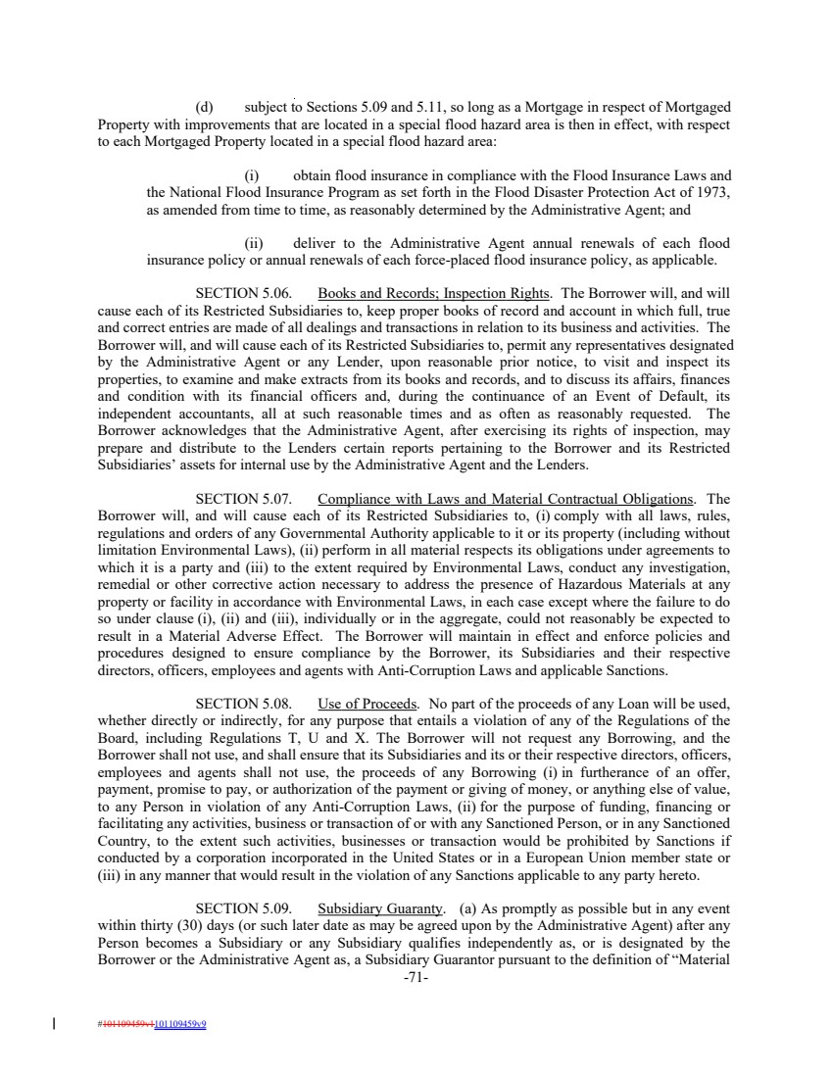 | (d) subject to Sections 5.09 and 5.11, so long as a Mortgage in respect of Mortgaged Property with improvements that are located in a special flood hazard area is then in effect, with respect to each Mortgaged Property located in a special flood hazard area: (i) obtain flood insurance in compliance with the Flood Insurance Laws and the National Flood Insurance Program as set forth in the Flood Disaster Protection Act of 1973, as amended from time to time, as reasonably determined by the Administrative Agent; and (ii) deliver to the Administrative Agent annual renewals of each flood insurance policy or annual renewals of each force-placed flood insurance policy, as applicable. SECTION 5.06. Books and Records; Inspection Rights. The Borrower will, and will cause each of its Restricted Subsidiaries to, keep proper books of record and account in which full, true and correct entries are made of all dealings and transactions in relation to its business and activities. The Borrower will, and will cause each of its Restricted Subsidiaries to, permit any representatives designated by the Administrative Agent or any Lender, upon reasonable prior notice, to visit and inspect its properties, to examine and make extracts from its books and records, and to discuss its affairs, finances and condition with its financial officers and, during the continuance of an Event of Default, its independent accountants, all at such reasonable times and as often as reasonably requested. The Borrower acknowledges that the Administrative Agent, after exercising its rights of inspection, may prepare and distribute to the Lenders certain reports pertaining to the Borrower and its Restricted Subsidiaries’ assets for internal use by the Administrative Agent and the Lenders. SECTION 5.07. Compliance with Laws and Material Contractual Obligations. The Borrower will, and will cause each of its Restricted Subsidiaries to, (i) comply with all laws, rules, regulations and orders of any Governmental Authority applicable to it or its property (including without limitation Environmental Laws), (ii) perform in all material respects its obligations under agreements to which it is a party and (iii) to the extent required by Environmental Laws, conduct any investigation, remedial or other corrective action necessary to address the presence of Hazardous Materials at any property or facility in accordance with Environmental Laws, in each case except where the failure to do so under clause (i), (ii) and (iii), individually or in the aggregate, could not reasonably be expected to result in a Material Adverse Effect. The Borrower will maintain in effect and enforce policies and procedures designed to ensure compliance by the Borrower, its Subsidiaries and their respective directors, officers, employees and agents with Anti-Corruption Laws and applicable Sanctions. SECTION 5.08. Use of Proceeds. No part of the proceeds of any Loan will be used, whether directly or indirectly, for any purpose that entails a violation of any of the Regulations of the Board, including Regulations T, U and X. The Borrower will not request any Borrowing, and the Borrower shall not use, and shall ensure that its Subsidiaries and its or their respective directors, officers, employees and agents shall not use, the proceeds of any Borrowing (i) in furtherance of an offer, payment, promise to pay, or authorization of the payment or giving of money, or anything else of value, to any Person in violation of any Anti-Corruption Laws, (ii) for the purpose of funding, financing or facilitating any activities, business or transaction of or with any Sanctioned Person, or in any Sanctioned Country, to the extent such activities, businesses or transaction would be prohibited by Sanctions if conducted by a corporation incorporated in the United States or in a European Union member state or (iii) in any manner that would result in the violation of any Sanctions applicable to any party hereto. SECTION 5.09. Subsidiary Guaranty. (a) As promptly as possible but in any event within thirty (30) days (or such later date as may be agreed upon by the Administrative Agent) after any Person becomes a Subsidiary or any Subsidiary qualifies independently as, or is designated by the Borrower or the Administrative Agent as, a Subsidiary Guarantor pursuant to the definition of “Material -71- #101109459v1101109459v9
 | 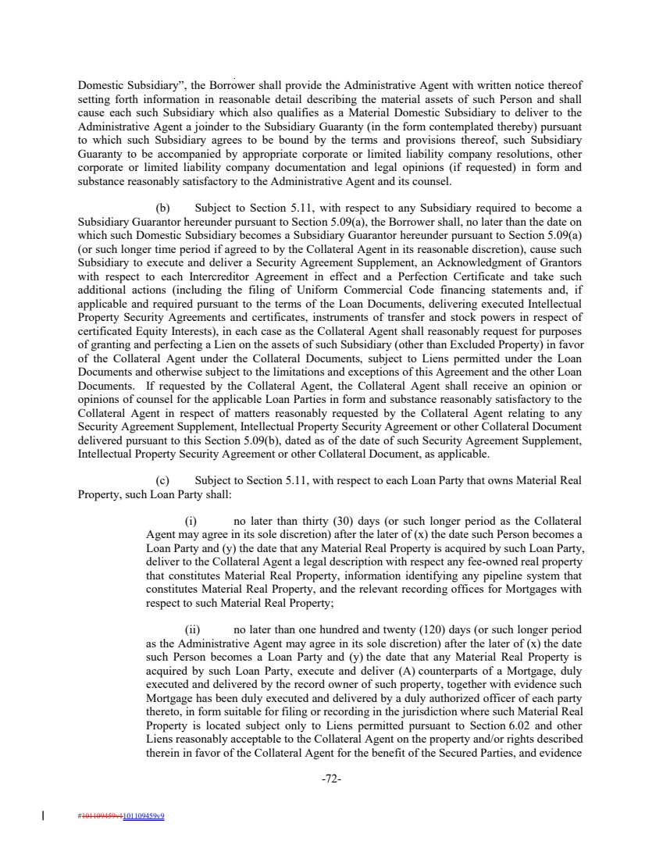 | Domestic Subsidiary”, the Borrower shall provide the Administrative Agent with written notice thereof setting forth information in reasonable detail describing the material assets of such Person and shall cause each such Subsidiary which also qualifies as a Material Domestic Subsidiary to deliver to the Administrative Agent a joinder to the Subsidiary Guaranty (in the form contemplated thereby) pursuant to which such Subsidiary agrees to be bound by the terms and provisions thereof, such Subsidiary Guaranty to be accompanied by appropriate corporate or limited liability company resolutions, other corporate or limited liability company documentation and legal opinions (if requested) in form and substance reasonably satisfactory to the Administrative Agent and its counsel. (b) Subject to Section 5.11, with respect to any Subsidiary required to become a Subsidiary Guarantor hereunder pursuant to Section 5.09(a), the Borrower shall, no later than the date on which such Domestic Subsidiary becomes a Subsidiary Guarantor hereunder pursuant to Section 5.09(a) (or such longer time period if agreed to by the Collateral Agent in its reasonable discretion), cause such Subsidiary to execute and deliver a Security Agreement Supplement, an Acknowledgment of Grantors with respect to each Intercreditor Agreement in effect and a Perfection Certificate and take such additional actions (including the filing of Uniform Commercial Code financing statements and, if applicable and required pursuant to the terms of the Loan Documents, delivering executed Intellectual Property Security Agreements and certificates, instruments of transfer and stock powers in respect of certificated Equity Interests), in each case as the Collateral Agent shall reasonably request for purposes of granting and perfecting a Lien on the assets of such Subsidiary (other than Excluded Property) in favor of the Collateral Agent under the Collateral Documents, subject to Liens permitted under the Loan Documents and otherwise subject to the limitations and exceptions of this Agreement and the other Loan Documents. If requested by the Collateral Agent, the Collateral Agent shall receive an opinion or opinions of counsel for the applicable Loan Parties in form and substance reasonably satisfactory to the Collateral Agent in respect of matters reasonably requested by the Collateral Agent relating to any Security Agreement Supplement, Intellectual Property Security Agreement or other Collateral Document delivered pursuant to this Section 5.09(b), dated as of the date of such Security Agreement Supplement, Intellectual Property Security Agreement or other Collateral Document, as applicable. (c) Subject to Section 5.11, with respect to each Loan Party that owns Material Real Property, such Loan Party shall: (i) no later than thirty (30) days (or such longer period as the Collateral Agent may agree in its sole discretion) after the later of (x) the date such Person becomes a Loan Party and (y) the date that any Material Real Property is acquired by such Loan Party, deliver to the Collateral Agent a legal description with respect any fee-owned real property that constitutes Material Real Property, information identifying any pipeline system that constitutes Material Real Property, and the relevant recording offices for Mortgages with respect to such Material Real Property; (ii) no later than one hundred and twenty (120) days (or such longer period as the Administrative Agent may agree in its sole discretion) after the later of (x) the date such Person becomes a Loan Party and (y) the date that any Material Real Property is acquired by such Loan Party, execute and deliver (A) counterparts of a Mortgage, duly executed and delivered by the record owner of such property, together with evidence such Mortgage has been duly executed and delivered by a duly authorized officer of each party thereto, in form suitable for filing or recording in the jurisdiction where such Material Real Property is located subject only to Liens permitted pursuant to Section 6.02 and other Liens reasonably acceptable to the Collateral Agent on the property and/or rights described therein in favor of the Collateral Agent for the benefit of the Secured Parties, and evidence -72- #101109459v1101109459v9
 | 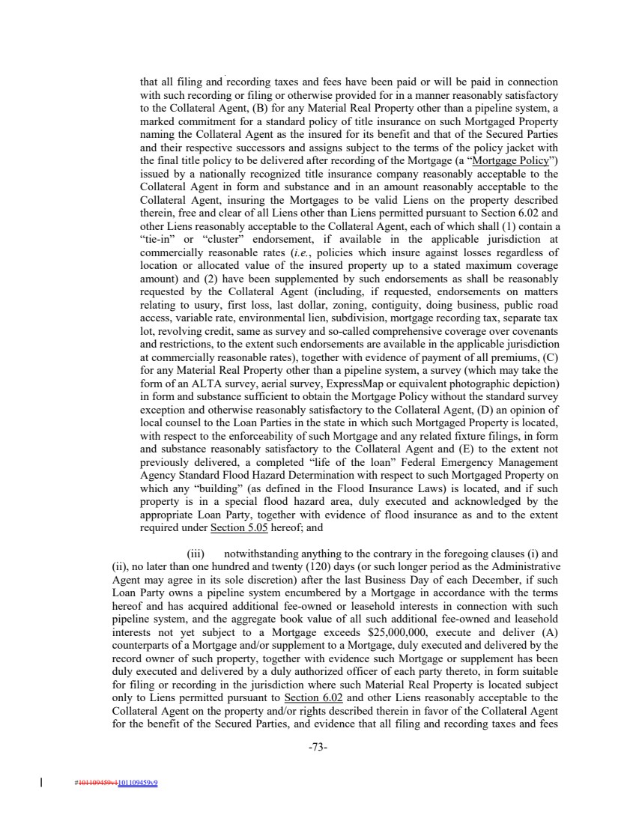 | that all filing and recording taxes and fees have been paid or will be paid in connection with such recording or filing or otherwise provided for in a manner reasonably satisfactory to the Collateral Agent, (B) for any Material Real Property other than a pipeline system, a marked commitment for a standard policy of title insurance on such Mortgaged Property naming the Collateral Agent as the insured for its benefit and that of the Secured Parties and their respective successors and assigns subject to the terms of the policy jacket with the final title policy to be delivered after recording of the Mortgage (a “Mortgage Policy”) issued by a nationally recognized title insurance company reasonably acceptable to the Collateral Agent in form and substance and in an amount reasonably acceptable to the Collateral Agent, insuring the Mortgages to be valid Liens on the property described therein, free and clear of all Liens other than Liens permitted pursuant to Section 6.02 and other Liens reasonably acceptable to the Collateral Agent, each of which shall (1) contain a “tie-in” or “cluster” endorsement, if available in the applicable jurisdiction at commercially reasonable rates (i.e., policies which insure against losses regardless of location or allocated value of the insured property up to a stated maximum coverage amount) and (2) have been supplemented by such endorsements as shall be reasonably requested by the Collateral Agent (including, if requested, endorsements on matters relating to usury, first loss, last dollar, zoning, contiguity, doing business, public road access, variable rate, environmental lien, subdivision, mortgage recording tax, separate tax lot, revolving credit, same as survey and so-called comprehensive coverage over covenants and restrictions, to the extent such endorsements are available in the applicable jurisdiction at commercially reasonable rates), together with evidence of payment of all premiums, (C) for any Material Real Property other than a pipeline system, a survey (which may take the form of an ALTA survey, aerial survey, ExpressMap or equivalent photographic depiction) in form and substance sufficient to obtain the Mortgage Policy without the standard survey exception and otherwise reasonably satisfactory to the Collateral Agent, (D) an opinion of local counsel to the Loan Parties in the state in which such Mortgaged Property is located, with respect to the enforceability of such Mortgage and any related fixture filings, in form and substance reasonably satisfactory to the Collateral Agent and (E) to the extent not previously delivered, a completed “life of the loan” Federal Emergency Management Agency Standard Flood Hazard Determination with respect to such Mortgaged Property on which any “building” (as defined in the Flood Insurance Laws) is located, and if such property is in a special flood hazard area, duly executed and acknowledged by the appropriate Loan Party, together with evidence of flood insurance as and to the extent required under Section 5.05 hereof; and (iii) notwithstanding anything to the contrary in the foregoing clauses (i) and (ii), no later than one hundred and twenty (120) days (or such longer period as the Administrative Agent may agree in its sole discretion) after the last Business Day of each December, if such Loan Party owns a pipeline system encumbered by a Mortgage in accordance with the terms hereof and has acquired additional fee-owned or leasehold interests in connection with such pipeline system, and the aggregate book value of all such additional fee-owned and leasehold interests not yet subject to a Mortgage exceeds $25,000,000, execute and deliver (A) counterparts of a Mortgage and/or supplement to a Mortgage, duly executed and delivered by the record owner of such property, together with evidence such Mortgage or supplement has been duly executed and delivered by a duly authorized officer of each party thereto, in form suitable for filing or recording in the jurisdiction where such Material Real Property is located subject only to Liens permitted pursuant to Section 6.02 and other Liens reasonably acceptable to the Collateral Agent on the property and/or rights described therein in favor of the Collateral Agent for the benefit of the Secured Parties, and evidence that all filing and recording taxes and fees -73- #101109459v1101109459v9
 | 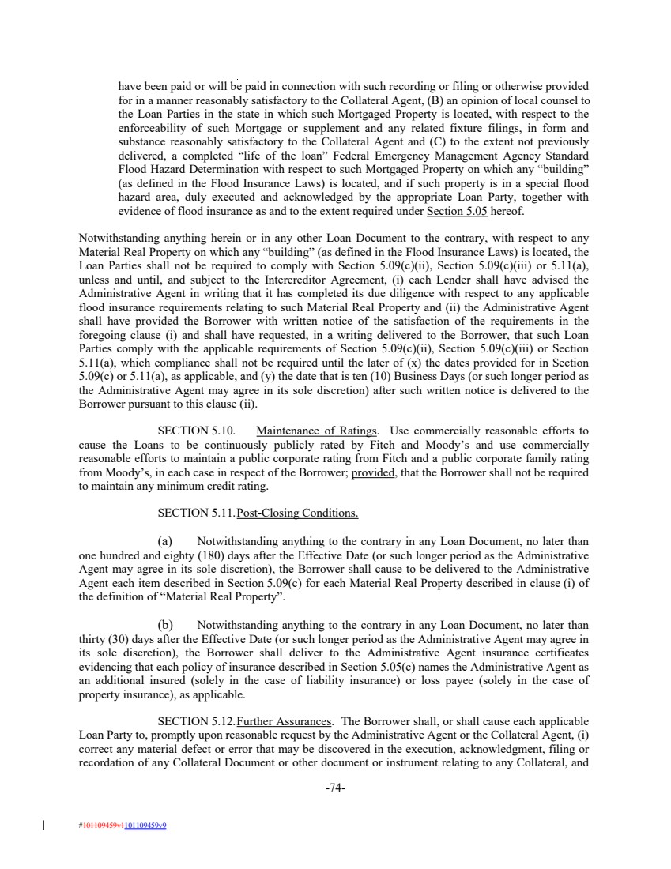 | have been paid or will be paid in connection with such recording or filing or otherwise provided for in a manner reasonably satisfactory to the Collateral Agent, (B) an opinion of local counsel to the Loan Parties in the state in which such Mortgaged Property is located, with respect to the enforceability of such Mortgage or supplement and any related fixture filings, in form and substance reasonably satisfactory to the Collateral Agent and (C) to the extent not previously delivered, a completed “life of the loan” Federal Emergency Management Agency Standard Flood Hazard Determination with respect to such Mortgaged Property on which any “building” (as defined in the Flood Insurance Laws) is located, and if such property is in a special flood hazard area, duly executed and acknowledged by the appropriate Loan Party, together with evidence of flood insurance as and to the extent required under Section 5.05 hereof. Notwithstanding anything herein or in any other Loan Document to the contrary, with respect to any Material Real Property on which any “building” (as defined in the Flood Insurance Laws) is located, the Loan Parties shall not be required to comply with Section 5.09(c)(ii), Section 5.09(c)(iii) or 5.11(a), unless and until, and subject to the Intercreditor Agreement, (i) each Lender shall have advised the Administrative Agent in writing that it has completed its due diligence with respect to any applicable flood insurance requirements relating to such Material Real Property and (ii) the Administrative Agent shall have provided the Borrower with written notice of the satisfaction of the requirements in the foregoing clause (i) and shall have requested, in a writing delivered to the Borrower, that such Loan Parties comply with the applicable requirements of Section 5.09(c)(ii), Section 5.09(c)(iii) or Section 5.11(a), which compliance shall not be required until the later of (x) the dates provided for in Section 5.09(c) or 5.11(a), as applicable, and (y) the date that is ten (10) Business Days (or such longer period as the Administrative Agent may agree in its sole discretion) after such written notice is delivered to the Borrower pursuant to this clause (ii). SECTION 5.10. Maintenance of Ratings. Use commercially reasonable efforts to cause the Loans to be continuously publicly rated by Fitch and Moody’s and use commercially reasonable efforts to maintain a public corporate rating from Fitch and a public corporate family rating from Moody’s, in each case in respect of the Borrower; provided, that the Borrower shall not be required to maintain any minimum credit rating. SECTION 5.11.Post-Closing Conditions. (a) Notwithstanding anything to the contrary in any Loan Document, no later than one hundred and eighty (180) days after the Effective Date (or such longer period as the Administrative Agent may agree in its sole discretion), the Borrower shall cause to be delivered to the Administrative Agent each item described in Section 5.09(c) for each Material Real Property described in clause (i) of the definition of “Material Real Property”. (b) Notwithstanding anything to the contrary in any Loan Document, no later than thirty (30) days after the Effective Date (or such longer period as the Administrative Agent may agree in its sole discretion), the Borrower shall deliver to the Administrative Agent insurance certificates evidencing that each policy of insurance described in Section 5.05(c) names the Administrative Agent as an additional insured (solely in the case of liability insurance) or loss payee (solely in the case of property insurance), as applicable. SECTION 5.12.Further Assurances. The Borrower shall, or shall cause each applicable Loan Party to, promptly upon reasonable request by the Administrative Agent or the Collateral Agent, (i) correct any material defect or error that may be discovered in the execution, acknowledgment, filing or recordation of any Collateral Document or other document or instrument relating to any Collateral, and -74- #101109459v1101109459v9
 | 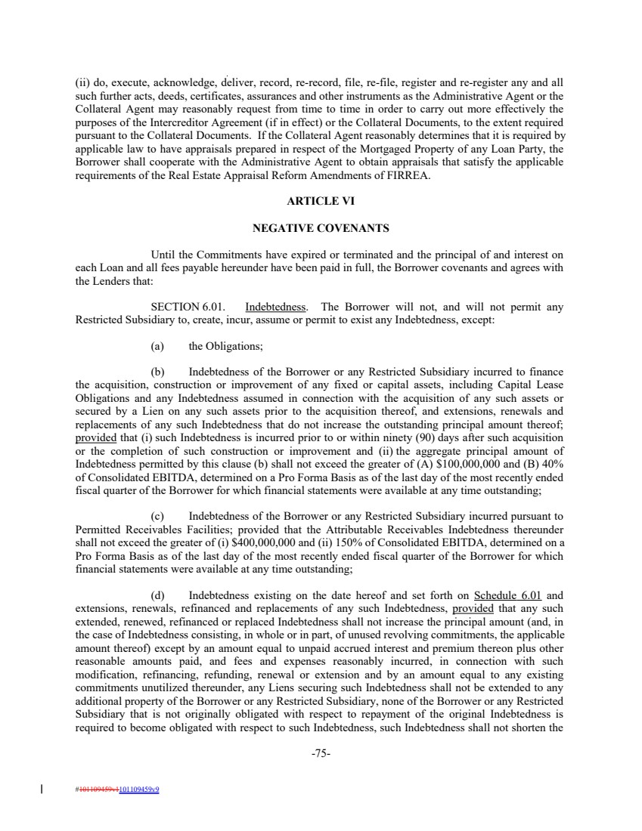 | (ii) do, execute, acknowledge, deliver, record, re-record, file, re-file, register and re-register any and all such further acts, deeds, certificates, assurances and other instruments as the Administrative Agent or the Collateral Agent may reasonably request from time to time in order to carry out more effectively the purposes of the Intercreditor Agreement (if in effect) or the Collateral Documents, to the extent required pursuant to the Collateral Documents. If the Collateral Agent reasonably determines that it is required by applicable law to have appraisals prepared in respect of the Mortgaged Property of any Loan Party, the Borrower shall cooperate with the Administrative Agent to obtain appraisals that satisfy the applicable requirements of the Real Estate Appraisal Reform Amendments of FIRREA. ARTICLE VI NEGATIVE COVENANTS Until the Commitments have expired or terminated and the principal of and interest on each Loan and all fees payable hereunder have been paid in full, the Borrower covenants and agrees with the Lenders that: SECTION 6.01. Indebtedness. The Borrower will not, and will not permit any Restricted Subsidiary to, create, incur, assume or permit to exist any Indebtedness, except: (a) the Obligations; (b) Indebtedness of the Borrower or any Restricted Subsidiary incurred to finance the acquisition, construction or improvement of any fixed or capital assets, including Capital Lease Obligations and any Indebtedness assumed in connection with the acquisition of any such assets or secured by a Lien on any such assets prior to the acquisition thereof, and extensions, renewals and replacements of any such Indebtedness that do not increase the outstanding principal amount thereof; provided that (i) such Indebtedness is incurred prior to or within ninety (90) days after such acquisition or the completion of such construction or improvement and (ii) the aggregate principal amount of Indebtedness permitted by this clause (b) shall not exceed the greater of (A) $100,000,000 and (B) 40% of Consolidated EBITDA, determined on a Pro Forma Basis as of the last day of the most recently ended fiscal quarter of the Borrower for which financial statements were available at any time outstanding; (c) Indebtedness of the Borrower or any Restricted Subsidiary incurred pursuant to Permitted Receivables Facilities; provided that the Attributable Receivables Indebtedness thereunder shall not exceed the greater of (i) $400,000,000 and (ii) 150% of Consolidated EBITDA, determined on a Pro Forma Basis as of the last day of the most recently ended fiscal quarter of the Borrower for which financial statements were available at any time outstanding; (d) Indebtedness existing on the date hereof and set forth on Schedule 6.01 and extensions, renewals, refinanced and replacements of any such Indebtedness, provided that any such extended, renewed, refinanced or replaced Indebtedness shall not increase the principal amount (and, in the case of Indebtedness consisting, in whole or in part, of unused revolving commitments, the applicable amount thereof) except by an amount equal to unpaid accrued interest and premium thereon plus other reasonable amounts paid, and fees and expenses reasonably incurred, in connection with such modification, refinancing, refunding, renewal or extension and by an amount equal to any existing commitments unutilized thereunder, any Liens securing such Indebtedness shall not be extended to any additional property of the Borrower or any Restricted Subsidiary, none of the Borrower or any Restricted Subsidiary that is not originally obligated with respect to repayment of the original Indebtedness is required to become obligated with respect to such Indebtedness, such Indebtedness shall not shorten the -75- #101109459v1101109459v9
 | 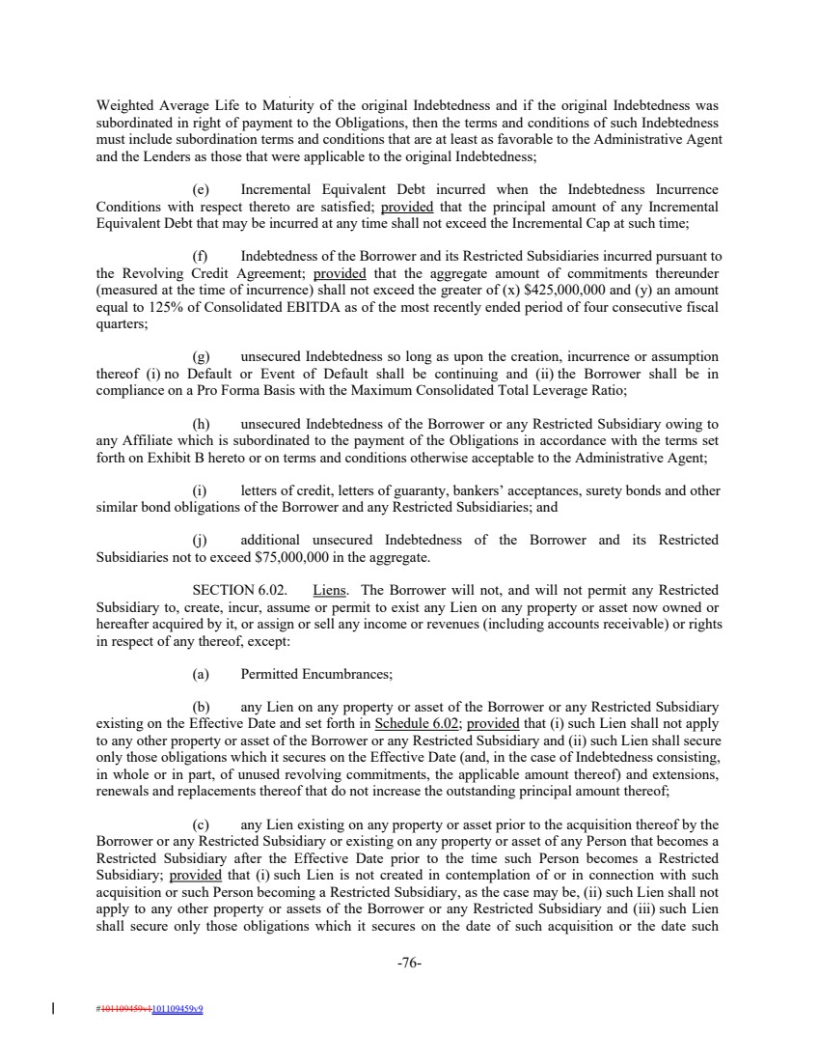 | Weighted Average Life to Maturity of the original Indebtedness and if the original Indebtedness was subordinated in right of payment to the Obligations, then the terms and conditions of such Indebtedness must include subordination terms and conditions that are at least as favorable to the Administrative Agent and the Lenders as those that were applicable to the original Indebtedness; (e) Incremental Equivalent Debt incurred when the Indebtedness Incurrence Conditions with respect thereto are satisfied; provided that the principal amount of any Incremental Equivalent Debt that may be incurred at any time shall not exceed the Incremental Cap at such time; (f) Indebtedness of the Borrower and its Restricted Subsidiaries incurred pursuant to the Revolving Credit Agreement; provided that the aggregate amount of commitments thereunder (measured at the time of incurrence) shall not exceed the greater of (x) $425,000,000 and (y) an amount equal to 125% of Consolidated EBITDA as of the most recently ended period of four consecutive fiscal quarters; (g) unsecured Indebtedness so long as upon the creation, incurrence or assumption thereof (i) no Default or Event of Default shall be continuing and (ii) the Borrower shall be in compliance on a Pro Forma Basis with the Maximum Consolidated Total Leverage Ratio; (h) unsecured Indebtedness of the Borrower or any Restricted Subsidiary owing to any Affiliate which is subordinated to the payment of the Obligations in accordance with the terms set forth on Exhibit B hereto or on terms and conditions otherwise acceptable to the Administrative Agent; (i) letters of credit, letters of guaranty, bankers’ acceptances, surety bonds and other similar bond obligations of the Borrower and any Restricted Subsidiaries; and (j) additional unsecured Indebtedness of the Borrower and its Restricted Subsidiaries not to exceed $75,000,000 in the aggregate. SECTION 6.02. Liens. The Borrower will not, and will not permit any Restricted Subsidiary to, create, incur, assume or permit to exist any Lien on any property or asset now owned or hereafter acquired by it, or assign or sell any income or revenues (including accounts receivable) or rights in respect of any thereof, except: (a) Permitted Encumbrances; (b) any Lien on any property or asset of the Borrower or any Restricted Subsidiary existing on the Effective Date and set forth in Schedule 6.02; provided that (i) such Lien shall not apply to any other property or asset of the Borrower or any Restricted Subsidiary and (ii) such Lien shall secure only those obligations which it secures on the Effective Date (and, in the case of Indebtedness consisting, in whole or in part, of unused revolving commitments, the applicable amount thereof) and extensions, renewals and replacements thereof that do not increase the outstanding principal amount thereof; (c) any Lien existing on any property or asset prior to the acquisition thereof by the Borrower or any Restricted Subsidiary or existing on any property or asset of any Person that becomes a Restricted Subsidiary after the Effective Date prior to the time such Person becomes a Restricted Subsidiary; provided that (i) such Lien is not created in contemplation of or in connection with such acquisition or such Person becoming a Restricted Subsidiary, as the case may be, (ii) such Lien shall not apply to any other property or assets of the Borrower or any Restricted Subsidiary and (iii) such Lien shall secure only those obligations which it secures on the date of such acquisition or the date such -76- #101109459v1101109459v9
 | 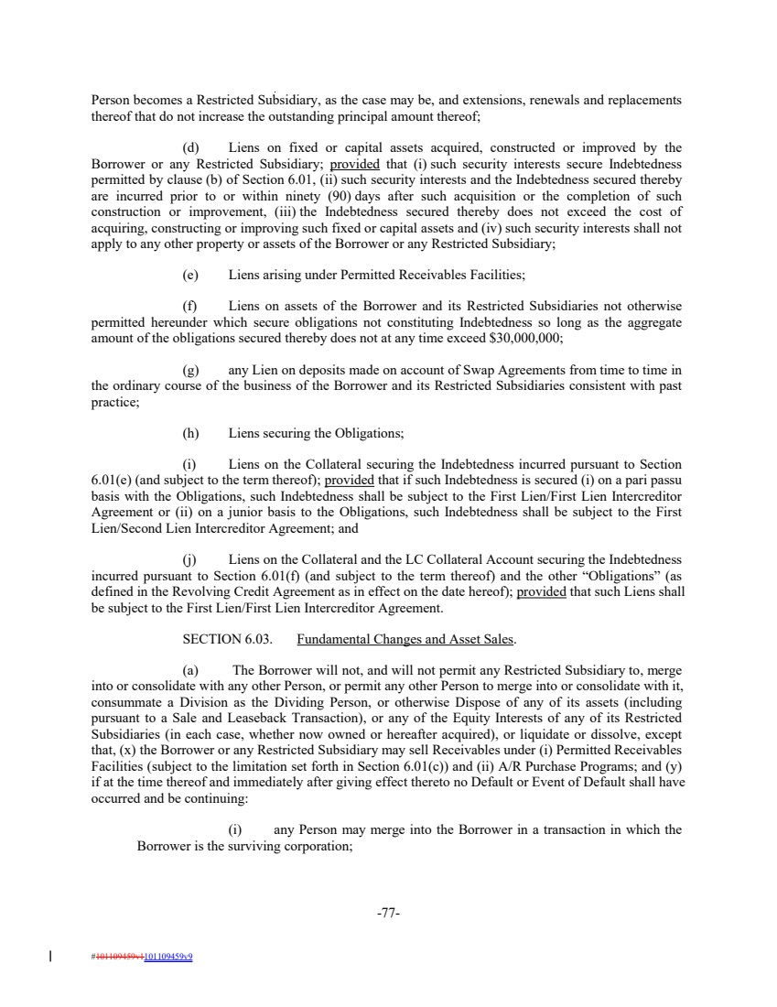 | Person becomes a Restricted Subsidiary, as the case may be, and extensions, renewals and replacements thereof that do not increase the outstanding principal amount thereof; (d) Liens on fixed or capital assets acquired, constructed or improved by the Borrower or any Restricted Subsidiary; provided that (i) such security interests secure Indebtedness permitted by clause (b) of Section 6.01, (ii) such security interests and the Indebtedness secured thereby are incurred prior to or within ninety (90) days after such acquisition or the completion of such construction or improvement, (iii) the Indebtedness secured thereby does not exceed the cost of acquiring, constructing or improving such fixed or capital assets and (iv) such security interests shall not apply to any other property or assets of the Borrower or any Restricted Subsidiary; (e) Liens arising under Permitted Receivables Facilities; (f) Liens on assets of the Borrower and its Restricted Subsidiaries not otherwise permitted hereunder which secure obligations not constituting Indebtedness so long as the aggregate amount of the obligations secured thereby does not at any time exceed $30,000,000; (g) any Lien on deposits made on account of Swap Agreements from time to time in the ordinary course of the business of the Borrower and its Restricted Subsidiaries consistent with past practice; (h) Liens securing the Obligations; (i) Liens on the Collateral securing the Indebtedness incurred pursuant to Section 6.01(e) (and subject to the term thereof); provided that if such Indebtedness is secured (i) on a pari passu basis with the Obligations, such Indebtedness shall be subject to the First Lien/First Lien Intercreditor Agreement or (ii) on a junior basis to the Obligations, such Indebtedness shall be subject to the First Lien/Second Lien Intercreditor Agreement; and (j) Liens on the Collateral and the LC Collateral Account securing the Indebtedness incurred pursuant to Section 6.01(f) (and subject to the term thereof) and the other “Obligations” (as defined in the Revolving Credit Agreement as in effect on the date hereof); provided that such Liens shall be subject to the First Lien/First Lien Intercreditor Agreement. SECTION 6.03. Fundamental Changes and Asset Sales. (a) The Borrower will not, and will not permit any Restricted Subsidiary to, merge into or consolidate with any other Person, or permit any other Person to merge into or consolidate with it, consummate a Division as the Dividing Person, or otherwise Dispose of any of its assets (including pursuant to a Sale and Leaseback Transaction), or any of the Equity Interests of any of its Restricted Subsidiaries (in each case, whether now owned or hereafter acquired), or liquidate or dissolve, except that, (x) the Borrower or any Restricted Subsidiary may sell Receivables under (i) Permitted Receivables Facilities (subject to the limitation set forth in Section 6.01(c)) and (ii) A/R Purchase Programs; and (y) if at the time thereof and immediately after giving effect thereto no Default or Event of Default shall have occurred and be continuing: (i) any Person may merge into the Borrower in a transaction in which the Borrower is the surviving corporation; -77- #101109459v1101109459v9
 | 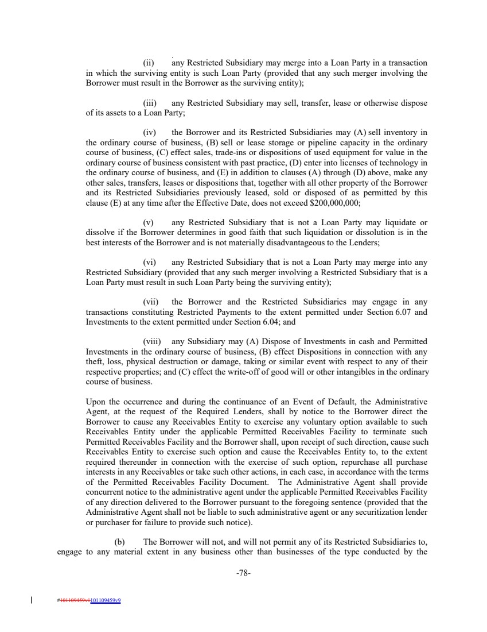 | (ii) any Restricted Subsidiary may merge into a Loan Party in a transaction in which the surviving entity is such Loan Party (provided that any such merger involving the Borrower must result in the Borrower as the surviving entity); (iii) any Restricted Subsidiary may sell, transfer, lease or otherwise dispose of its assets to a Loan Party; (iv) the Borrower and its Restricted Subsidiaries may (A) sell inventory in the ordinary course of business, (B) sell or lease storage or pipeline capacity in the ordinary course of business, (C) effect sales, trade-ins or dispositions of used equipment for value in the ordinary course of business consistent with past practice, (D) enter into licenses of technology in the ordinary course of business, and (E) in addition to clauses (A) through (D) above, make any other sales, transfers, leases or dispositions that, together with all other property of the Borrower and its Restricted Subsidiaries previously leased, sold or disposed of as permitted by this clause (E) at any time after the Effective Date, does not exceed $200,000,000; (v) any Restricted Subsidiary that is not a Loan Party may liquidate or dissolve if the Borrower determines in good faith that such liquidation or dissolution is in the best interests of the Borrower and is not materially disadvantageous to the Lenders; (vi) any Restricted Subsidiary that is not a Loan Party may merge into any Restricted Subsidiary (provided that any such merger involving a Restricted Subsidiary that is a Loan Party must result in such Loan Party being the surviving entity); (vii) the Borrower and the Restricted Subsidiaries may engage in any transactions constituting Restricted Payments to the extent permitted under Section 6.07 and Investments to the extent permitted under Section 6.04; and (viii) any Subsidiary may (A) Dispose of Investments in cash and Permitted Investments in the ordinary course of business, (B) effect Dispositions in connection with any theft, loss, physical destruction or damage, taking or similar event with respect to any of their respective properties; and (C) effect the write-off of good will or other intangibles in the ordinary course of business. Upon the occurrence and during the continuance of an Event of Default, the Administrative Agent, at the request of the Required Lenders, shall by notice to the Borrower direct the Borrower to cause any Receivables Entity to exercise any voluntary option available to such Receivables Entity under the applicable Permitted Receivables Facility to terminate such Permitted Receivables Facility and the Borrower shall, upon receipt of such direction, cause such Receivables Entity to exercise such option and cause the Receivables Entity to, to the extent required thereunder in connection with the exercise of such option, repurchase all purchase interests in any Receivables or take such other actions, in each case, in accordance with the terms of the Permitted Receivables Facility Document. The Administrative Agent shall provide concurrent notice to the administrative agent under the applicable Permitted Receivables Facility of any direction delivered to the Borrower pursuant to the foregoing sentence (provided that the Administrative Agent shall not be liable to such administrative agent or any securitization lender or purchaser for failure to provide such notice). (b) The Borrower will not, and will not permit any of its Restricted Subsidiaries to, engage to any material extent in any business other than businesses of the type conducted by the -78- #101109459v1101109459v9
 | 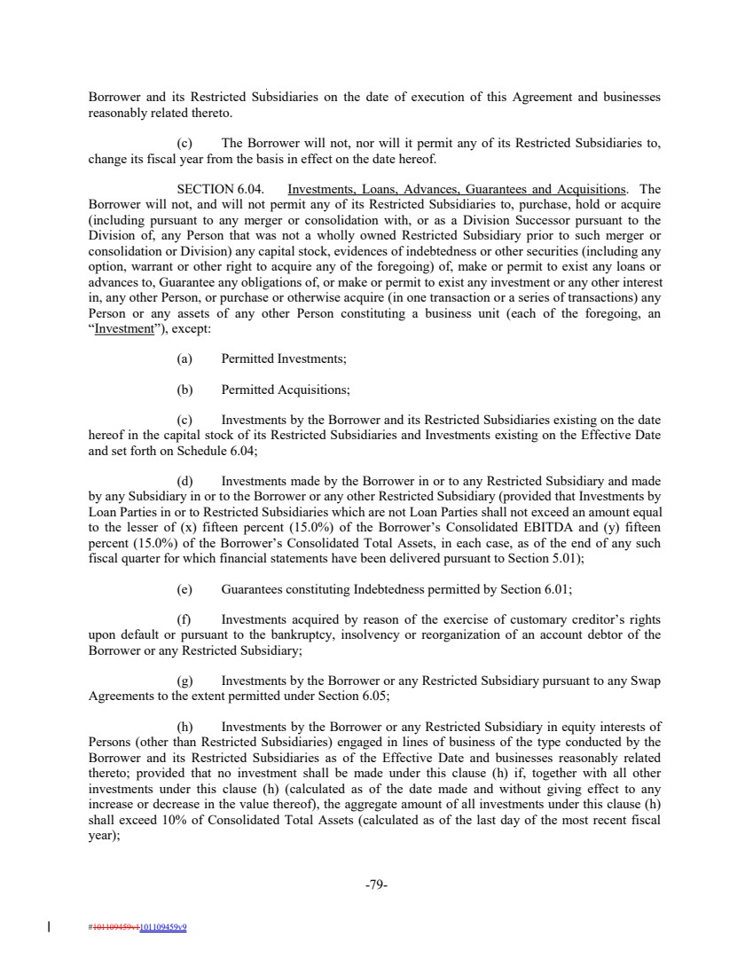 | Borrower and its Restricted Subsidiaries on the date of execution of this Agreement and businesses reasonably related thereto. (c) The Borrower will not, nor will it permit any of its Restricted Subsidiaries to, change its fiscal year from the basis in effect on the date hereof. SECTION 6.04. Investments, Loans, Advances, Guarantees and Acquisitions. The Borrower will not, and will not permit any of its Restricted Subsidiaries to, purchase, hold or acquire (including pursuant to any merger or consolidation with, or as a Division Successor pursuant to the Division of, any Person that was not a wholly owned Restricted Subsidiary prior to such merger or consolidation or Division) any capital stock, evidences of indebtedness or other securities (including any option, warrant or other right to acquire any of the foregoing) of, make or permit to exist any loans or advances to, Guarantee any obligations of, or make or permit to exist any investment or any other interest in, any other Person, or purchase or otherwise acquire (in one transaction or a series of transactions) any Person or any assets of any other Person constituting a business unit (each of the foregoing, an “Investment”), except: (a) Permitted Investments; (b) Permitted Acquisitions; (c) Investments by the Borrower and its Restricted Subsidiaries existing on the date hereof in the capital stock of its Restricted Subsidiaries and Investments existing on the Effective Date and set forth on Schedule 6.04; (d) Investments made by the Borrower in or to any Restricted Subsidiary and made by any Subsidiary in or to the Borrower or any other Restricted Subsidiary (provided that Investments by Loan Parties in or to Restricted Subsidiaries which are not Loan Parties shall not exceed an amount equal to the lesser of (x) fifteen percent (15.0%) of the Borrower’s Consolidated EBITDA and (y) fifteen percent (15.0%) of the Borrower’s Consolidated Total Assets, in each case, as of the end of any such fiscal quarter for which financial statements have been delivered pursuant to Section 5.01); (e) Guarantees constituting Indebtedness permitted by Section 6.01; (f) Investments acquired by reason of the exercise of customary creditor’s rights upon default or pursuant to the bankruptcy, insolvency or reorganization of an account debtor of the Borrower or any Restricted Subsidiary; (g) Investments by the Borrower or any Restricted Subsidiary pursuant to any Swap Agreements to the extent permitted under Section 6.05; (h) Investments by the Borrower or any Restricted Subsidiary in equity interests of Persons (other than Restricted Subsidiaries) engaged in lines of business of the type conducted by the Borrower and its Restricted Subsidiaries as of the Effective Date and businesses reasonably related thereto; provided that no investment shall be made under this clause (h) if, together with all other investments under this clause (h) (calculated as of the date made and without giving effect to any increase or decrease in the value thereof), the aggregate amount of all investments under this clause (h) shall exceed 10% of Consolidated Total Assets (calculated as of the last day of the most recent fiscal year); -79- #101109459v1101109459v9
 | 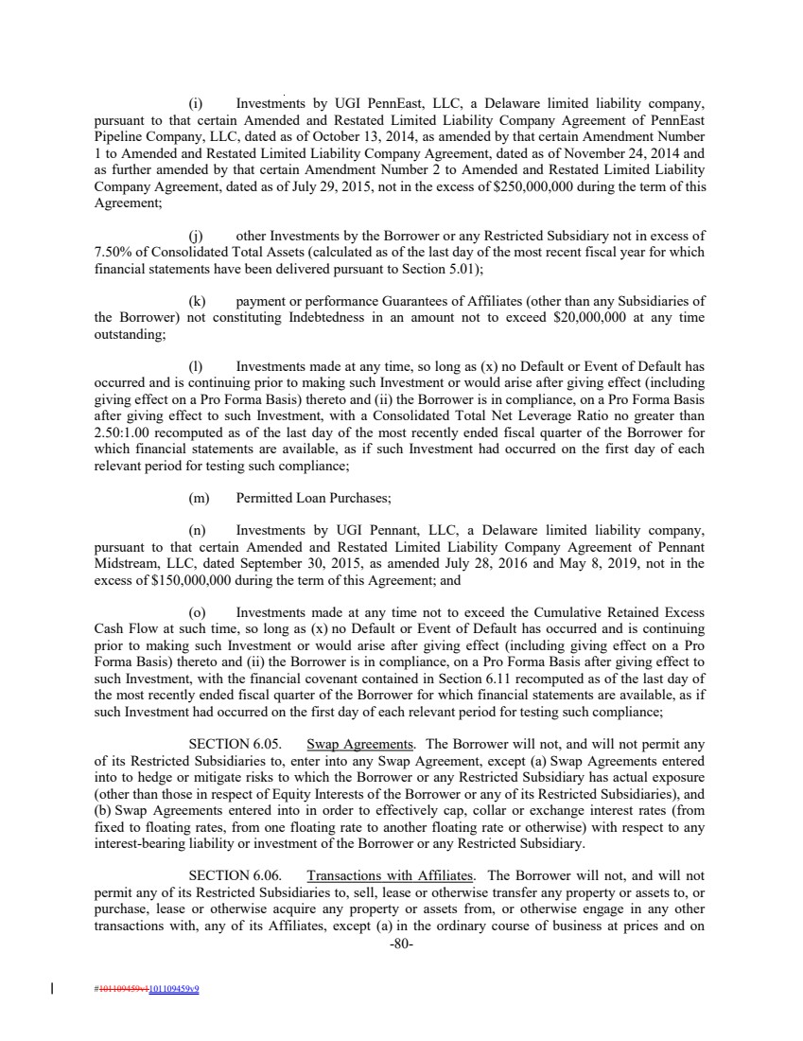 | (i) Investments by UGI PennEast, LLC, a Delaware limited liability company, pursuant to that certain Amended and Restated Limited Liability Company Agreement of PennEast Pipeline Company, LLC, dated as of October 13, 2014, as amended by that certain Amendment Number 1 to Amended and Restated Limited Liability Company Agreement, dated as of November 24, 2014 and as further amended by that certain Amendment Number 2 to Amended and Restated Limited Liability Company Agreement, dated as of July 29, 2015, not in the excess of $250,000,000 during the term of this Agreement; (j) other Investments by the Borrower or any Restricted Subsidiary not in excess of 7.50% of Consolidated Total Assets (calculated as of the last day of the most recent fiscal year for which financial statements have been delivered pursuant to Section 5.01); (k) payment or performance Guarantees of Affiliates (other than any Subsidiaries of the Borrower) not constituting Indebtedness in an amount not to exceed $20,000,000 at any time outstanding; (l) Investments made at any time, so long as (x) no Default or Event of Default has occurred and is continuing prior to making such Investment or would arise after giving effect (including giving effect on a Pro Forma Basis) thereto and (ii) the Borrower is in compliance, on a Pro Forma Basis after giving effect to such Investment, with a Consolidated Total Net Leverage Ratio no greater than 2.50:1.00 recomputed as of the last day of the most recently ended fiscal quarter of the Borrower for which financial statements are available, as if such Investment had occurred on the first day of each relevant period for testing such compliance; (m) Permitted Loan Purchases; (n) Investments by UGI Pennant, LLC, a Delaware limited liability company, pursuant to that certain Amended and Restated Limited Liability Company Agreement of Pennant Midstream, LLC, dated September 30, 2015, as amended July 28, 2016 and May 8, 2019, not in the excess of $150,000,000 during the term of this Agreement; and (o) Investments made at any time not to exceed the Cumulative Retained Excess Cash Flow at such time, so long as (x) no Default or Event of Default has occurred and is continuing prior to making such Investment or would arise after giving effect (including giving effect on a Pro Forma Basis) thereto and (ii) the Borrower is in compliance, on a Pro Forma Basis after giving effect to such Investment, with the financial covenant contained in Section 6.11 recomputed as of the last day of the most recently ended fiscal quarter of the Borrower for which financial statements are available, as if such Investment had occurred on the first day of each relevant period for testing such compliance; SECTION 6.05. Swap Agreements. The Borrower will not, and will not permit any of its Restricted Subsidiaries to, enter into any Swap Agreement, except (a) Swap Agreements entered into to hedge or mitigate risks to which the Borrower or any Restricted Subsidiary has actual exposure (other than those in respect of Equity Interests of the Borrower or any of its Restricted Subsidiaries), and (b) Swap Agreements entered into in order to effectively cap, collar or exchange interest rates (from fixed to floating rates, from one floating rate to another floating rate or otherwise) with respect to any interest-bearing liability or investment of the Borrower or any Restricted Subsidiary. SECTION 6.06. Transactions with Affiliates. The Borrower will not, and will not permit any of its Restricted Subsidiaries to, sell, lease or otherwise transfer any property or assets to, or purchase, lease or otherwise acquire any property or assets from, or otherwise engage in any other transactions with, any of its Affiliates, except (a) in the ordinary course of business at prices and on -80- #101109459v1101109459v9
 | 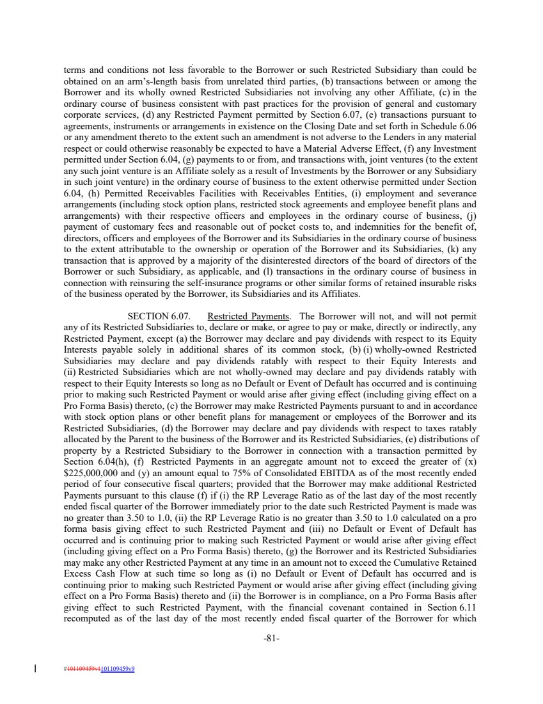 | terms and conditions not less favorable to the Borrower or such Restricted Subsidiary than could be obtained on an arm’s-length basis from unrelated third parties, (b) transactions between or among the Borrower and its wholly owned Restricted Subsidiaries not involving any other Affiliate, (c) in the ordinary course of business consistent with past practices for the provision of general and customary corporate services, (d) any Restricted Payment permitted by Section 6.07, (e) transactions pursuant to agreements, instruments or arrangements in existence on the Closing Date and set forth in Schedule 6.06 or any amendment thereto to the extent such an amendment is not adverse to the Lenders in any material respect or could otherwise reasonably be expected to have a Material Adverse Effect, (f) any Investment permitted under Section 6.04, (g) payments to or from, and transactions with, joint ventures (to the extent any such joint venture is an Affiliate solely as a result of Investments by the Borrower or any Subsidiary in such joint venture) in the ordinary course of business to the extent otherwise permitted under Section 6.04, (h) Permitted Receivables Facilities with Receivables Entities, (i) employment and severance arrangements (including stock option plans, restricted stock agreements and employee benefit plans and arrangements) with their respective officers and employees in the ordinary course of business, (j) payment of customary fees and reasonable out of pocket costs to, and indemnities for the benefit of, directors, officers and employees of the Borrower and its Subsidiaries in the ordinary course of business to the extent attributable to the ownership or operation of the Borrower and its Subsidiaries, (k) any transaction that is approved by a majority of the disinterested directors of the board of directors of the Borrower or such Subsidiary, as applicable, and (l) transactions in the ordinary course of business in connection with reinsuring the self-insurance programs or other similar forms of retained insurable risks of the business operated by the Borrower, its Subsidiaries and its Affiliates. SECTION 6.07. Restricted Payments. The Borrower will not, and will not permit any of its Restricted Subsidiaries to, declare or make, or agree to pay or make, directly or indirectly, any Restricted Payment, except (a) the Borrower may declare and pay dividends with respect to its Equity Interests payable solely in additional shares of its common stock, (b) (i) wholly-owned Restricted Subsidiaries may declare and pay dividends ratably with respect to their Equity Interests and (ii) Restricted Subsidiaries which are not wholly-owned may declare and pay dividends ratably with respect to their Equity Interests so long as no Default or Event of Default has occurred and is continuing prior to making such Restricted Payment or would arise after giving effect (including giving effect on a Pro Forma Basis) thereto, (c) the Borrower may make Restricted Payments pursuant to and in accordance with stock option plans or other benefit plans for management or employees of the Borrower and its Restricted Subsidiaries, (d) the Borrower may declare and pay dividends with respect to taxes ratably allocated by the Parent to the business of the Borrower and its Restricted Subsidiaries, (e) distributions of property by a Restricted Subsidiary to the Borrower in connection with a transaction permitted by Section 6.04(h), (f) Restricted Payments in an aggregate amount not to exceed the greater of (x) $225,000,000 and (y) an amount equal to 75% of Consolidated EBITDA as of the most recently ended period of four consecutive fiscal quarters; provided that the Borrower may make additional Restricted Payments pursuant to this clause (f) if (i) the RP Leverage Ratio as of the last day of the most recently ended fiscal quarter of the Borrower immediately prior to the date such Restricted Payment is made was no greater than 3.50 to 1.0, (ii) the RP Leverage Ratio is no greater than 3.50 to 1.0 calculated on a pro forma basis giving effect to such Restricted Payment and (iii) no Default or Event of Default has occurred and is continuing prior to making such Restricted Payment or would arise after giving effect (including giving effect on a Pro Forma Basis) thereto, (g) the Borrower and its Restricted Subsidiaries may make any other Restricted Payment at any time in an amount not to exceed the Cumulative Retained Excess Cash Flow at such time so long as (i) no Default or Event of Default has occurred and is continuing prior to making such Restricted Payment or would arise after giving effect (including giving effect on a Pro Forma Basis) thereto and (ii) the Borrower is in compliance, on a Pro Forma Basis after giving effect to such Restricted Payment, with the financial covenant contained in Section 6.11 recomputed as of the last day of the most recently ended fiscal quarter of the Borrower for which -81- #101109459v1101109459v9
 | 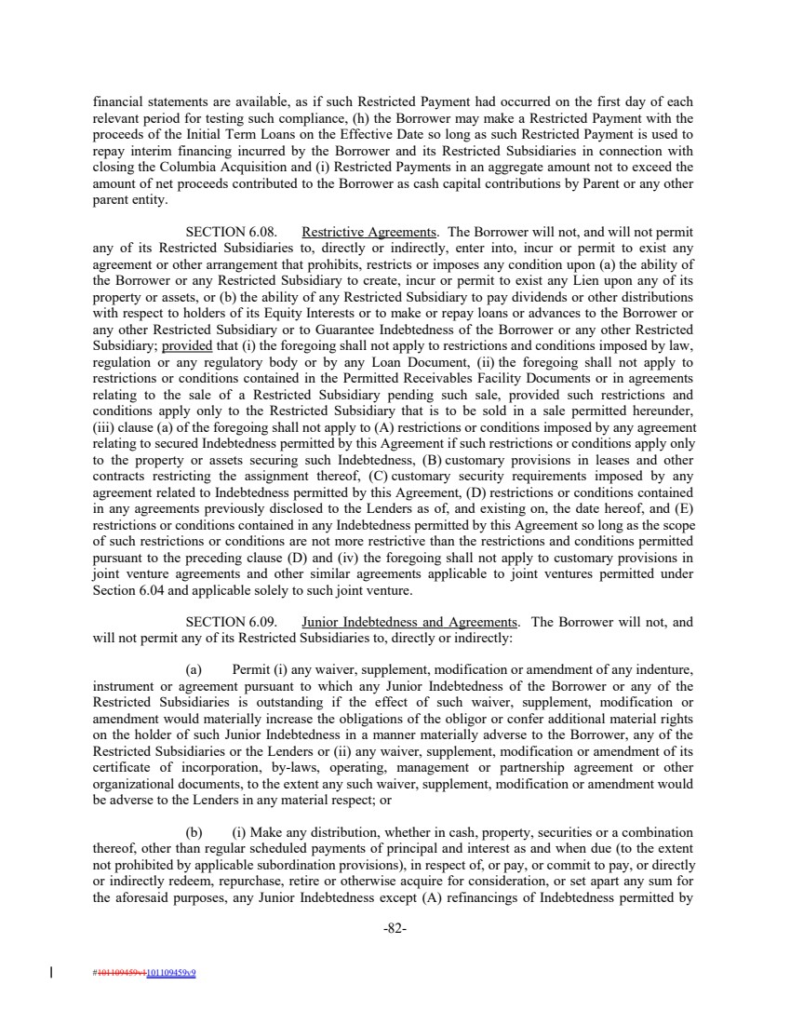 | financial statements are available, as if such Restricted Payment had occurred on the first day of each relevant period for testing such compliance, (h) the Borrower may make a Restricted Payment with the proceeds of the Initial Term Loans on the Effective Date so long as such Restricted Payment is used to repay interim financing incurred by the Borrower and its Restricted Subsidiaries in connection with closing the Columbia Acquisition and (i) Restricted Payments in an aggregate amount not to exceed the amount of net proceeds contributed to the Borrower as cash capital contributions by Parent or any other parent entity. SECTION 6.08. Restrictive Agreements. The Borrower will not, and will not permit any of its Restricted Subsidiaries to, directly or indirectly, enter into, incur or permit to exist any agreement or other arrangement that prohibits, restricts or imposes any condition upon (a) the ability of the Borrower or any Restricted Subsidiary to create, incur or permit to exist any Lien upon any of its property or assets, or (b) the ability of any Restricted Subsidiary to pay dividends or other distributions with respect to holders of its Equity Interests or to make or repay loans or advances to the Borrower or any other Restricted Subsidiary or to Guarantee Indebtedness of the Borrower or any other Restricted Subsidiary; provided that (i) the foregoing shall not apply to restrictions and conditions imposed by law, regulation or any regulatory body or by any Loan Document, (ii) the foregoing shall not apply to restrictions or conditions contained in the Permitted Receivables Facility Documents or in agreements relating to the sale of a Restricted Subsidiary pending such sale, provided such restrictions and conditions apply only to the Restricted Subsidiary that is to be sold in a sale permitted hereunder, (iii) clause (a) of the foregoing shall not apply to (A) restrictions or conditions imposed by any agreement relating to secured Indebtedness permitted by this Agreement if such restrictions or conditions apply only to the property or assets securing such Indebtedness, (B) customary provisions in leases and other contracts restricting the assignment thereof, (C) customary security requirements imposed by any agreement related to Indebtedness permitted by this Agreement, (D) restrictions or conditions contained in any agreements previously disclosed to the Lenders as of, and existing on, the date hereof, and (E) restrictions or conditions contained in any Indebtedness permitted by this Agreement so long as the scope of such restrictions or conditions are not more restrictive than the restrictions and conditions permitted pursuant to the preceding clause (D) and (iv) the foregoing shall not apply to customary provisions in joint venture agreements and other similar agreements applicable to joint ventures permitted under Section 6.04 and applicable solely to such joint venture. SECTION 6.09. Junior Indebtedness and Agreements. The Borrower will not, and will not permit any of its Restricted Subsidiaries to, directly or indirectly: (a) Permit (i) any waiver, supplement, modification or amendment of any indenture, instrument or agreement pursuant to which any Junior Indebtedness of the Borrower or any of the Restricted Subsidiaries is outstanding if the effect of such waiver, supplement, modification or amendment would materially increase the obligations of the obligor or confer additional material rights on the holder of such Junior Indebtedness in a manner materially adverse to the Borrower, any of the Restricted Subsidiaries or the Lenders or (ii) any waiver, supplement, modification or amendment of its certificate of incorporation, by-laws, operating, management or partnership agreement or other organizational documents, to the extent any such waiver, supplement, modification or amendment would be adverse to the Lenders in any material respect; or (b) (i) Make any distribution, whether in cash, property, securities or a combination thereof, other than regular scheduled payments of principal and interest as and when due (to the extent not prohibited by applicable subordination provisions), in respect of, or pay, or commit to pay, or directly or indirectly redeem, repurchase, retire or otherwise acquire for consideration, or set apart any sum for the aforesaid purposes, any Junior Indebtedness except (A) refinancings of Indebtedness permitted by -82- #101109459v1101109459v9
 | 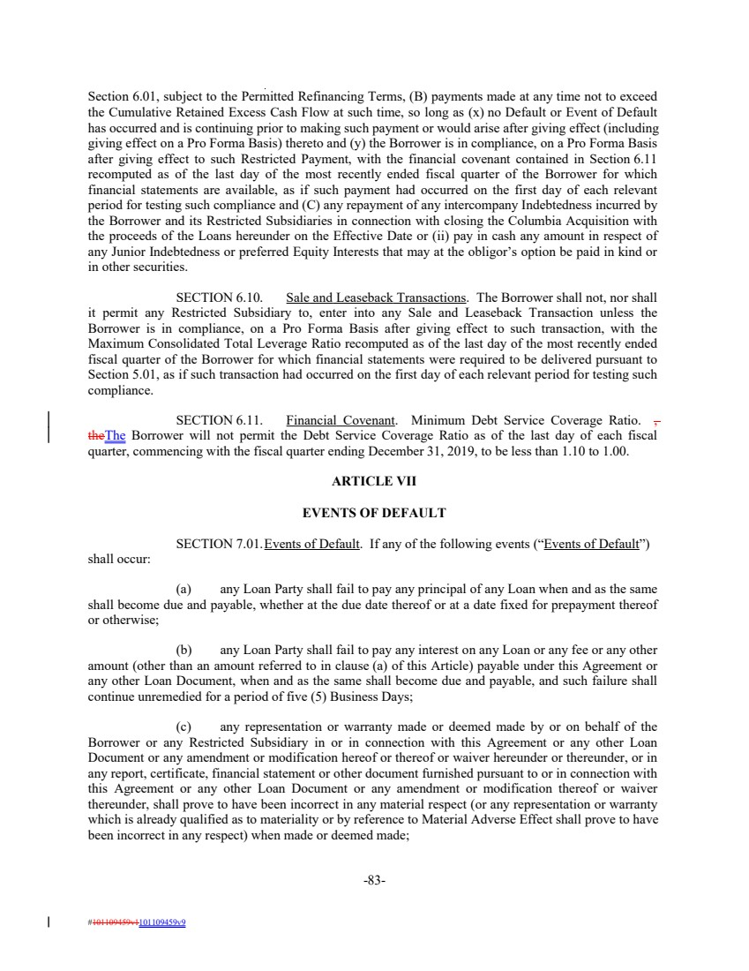 | Section 6.01, subject to the Permitted Refinancing Terms, (B) payments made at any time not to exceed the Cumulative Retained Excess Cash Flow at such time, so long as (x) no Default or Event of Default has occurred and is continuing prior to making such payment or would arise after giving effect (including giving effect on a Pro Forma Basis) thereto and (y) the Borrower is in compliance, on a Pro Forma Basis after giving effect to such Restricted Payment, with the financial covenant contained in Section 6.11 recomputed as of the last day of the most recently ended fiscal quarter of the Borrower for which financial statements are available, as if such payment had occurred on the first day of each relevant period for testing such compliance and (C) any repayment of any intercompany Indebtedness incurred by the Borrower and its Restricted Subsidiaries in connection with closing the Columbia Acquisition with the proceeds of the Loans hereunder on the Effective Date or (ii) pay in cash any amount in respect of any Junior Indebtedness or preferred Equity Interests that may at the obligor’s option be paid in kind or in other securities. SECTION 6.10. Sale and Leaseback Transactions. The Borrower shall not, nor shall it permit any Restricted Subsidiary to, enter into any Sale and Leaseback Transaction unless the Borrower is in compliance, on a Pro Forma Basis after giving effect to such transaction, with the Maximum Consolidated Total Leverage Ratio recomputed as of the last day of the most recently ended fiscal quarter of the Borrower for which financial statements were required to be delivered pursuant to Section 5.01, as if such transaction had occurred on the first day of each relevant period for testing such compliance. SECTION 6.11. Financial Covenant. Minimum Debt Service Coverage Ratio. , theThe Borrower will not permit the Debt Service Coverage Ratio as of the last day of each fiscal quarter, commencing with the fiscal quarter ending December 31, 2019, to be less than 1.10 to 1.00. ARTICLE VII EVENTS OF DEFAULT SECTION 7.01.Events of Default. If any of the following events (“Events of Default”) shall occur: (a) any Loan Party shall fail to pay any principal of any Loan when and as the same shall become due and payable, whether at the due date thereof or at a date fixed for prepayment thereof or otherwise; (b) any Loan Party shall fail to pay any interest on any Loan or any fee or any other amount (other than an amount referred to in clause (a) of this Article) payable under this Agreement or any other Loan Document, when and as the same shall become due and payable, and such failure shall continue unremedied for a period of five (5) Business Days; (c) any representation or warranty made or deemed made by or on behalf of the Borrower or any Restricted Subsidiary in or in connection with this Agreement or any other Loan Document or any amendment or modification hereof or thereof or waiver hereunder or thereunder, or in any report, certificate, financial statement or other document furnished pursuant to or in connection with this Agreement or any other Loan Document or any amendment or modification thereof or waiver thereunder, shall prove to have been incorrect in any material respect (or any representation or warranty which is already qualified as to materiality or by reference to Material Adverse Effect shall prove to have been incorrect in any respect) when made or deemed made; -83- #101109459v1101109459v9
 | 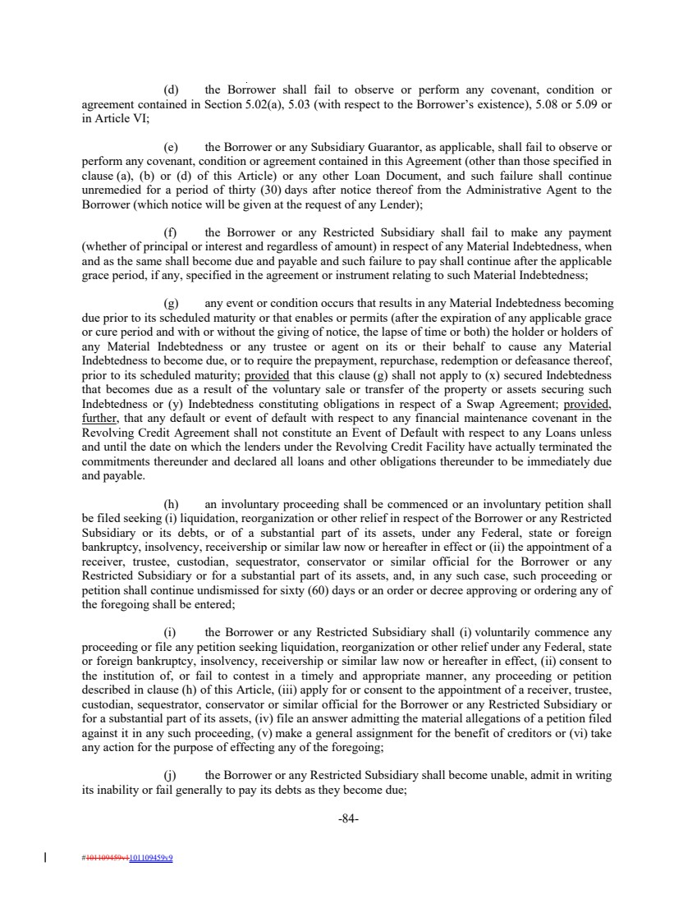 | (d) the Borrower shall fail to observe or perform any covenant, condition or agreement contained in Section 5.02(a), 5.03 (with respect to the Borrower’s existence), 5.08 or 5.09 or in Article VI; (e) the Borrower or any Subsidiary Guarantor, as applicable, shall fail to observe or perform any covenant, condition or agreement contained in this Agreement (other than those specified in clause (a), (b) or (d) of this Article) or any other Loan Document, and such failure shall continue unremedied for a period of thirty (30) days after notice thereof from the Administrative Agent to the Borrower (which notice will be given at the request of any Lender); (f) the Borrower or any Restricted Subsidiary shall fail to make any payment (whether of principal or interest and regardless of amount) in respect of any Material Indebtedness, when and as the same shall become due and payable and such failure to pay shall continue after the applicable grace period, if any, specified in the agreement or instrument relating to such Material Indebtedness; (g) any event or condition occurs that results in any Material Indebtedness becoming due prior to its scheduled maturity or that enables or permits (after the expiration of any applicable grace or cure period and with or without the giving of notice, the lapse of time or both) the holder or holders of any Material Indebtedness or any trustee or agent on its or their behalf to cause any Material Indebtedness to become due, or to require the prepayment, repurchase, redemption or defeasance thereof, prior to its scheduled maturity; provided that this clause (g) shall not apply to (x) secured Indebtedness that becomes due as a result of the voluntary sale or transfer of the property or assets securing such Indebtedness or (y) Indebtedness constituting obligations in respect of a Swap Agreement; provided, further, that any default or event of default with respect to any financial maintenance covenant in the Revolving Credit Agreement shall not constitute an Event of Default with respect to any Loans unless and until the date on which the lenders under the Revolving Credit Facility have actually terminated the commitments thereunder and declared all loans and other obligations thereunder to be immediately due and payable. (h) an involuntary proceeding shall be commenced or an involuntary petition shall be filed seeking (i) liquidation, reorganization or other relief in respect of the Borrower or any Restricted Subsidiary or its debts, or of a substantial part of its assets, under any Federal, state or foreign bankruptcy, insolvency, receivership or similar law now or hereafter in effect or (ii) the appointment of a receiver, trustee, custodian, sequestrator, conservator or similar official for the Borrower or any Restricted Subsidiary or for a substantial part of its assets, and, in any such case, such proceeding or petition shall continue undismissed for sixty (60) days or an order or decree approving or ordering any of the foregoing shall be entered; (i) the Borrower or any Restricted Subsidiary shall (i) voluntarily commence any proceeding or file any petition seeking liquidation, reorganization or other relief under any Federal, state or foreign bankruptcy, insolvency, receivership or similar law now or hereafter in effect, (ii) consent to the institution of, or fail to contest in a timely and appropriate manner, any proceeding or petition described in clause (h) of this Article, (iii) apply for or consent to the appointment of a receiver, trustee, custodian, sequestrator, conservator or similar official for the Borrower or any Restricted Subsidiary or for a substantial part of its assets, (iv) file an answer admitting the material allegations of a petition filed against it in any such proceeding, (v) make a general assignment for the benefit of creditors or (vi) take any action for the purpose of effecting any of the foregoing; (j) the Borrower or any Restricted Subsidiary shall become unable, admit in writing its inability or fail generally to pay its debts as they become due; -84- #101109459v1101109459v9
 | 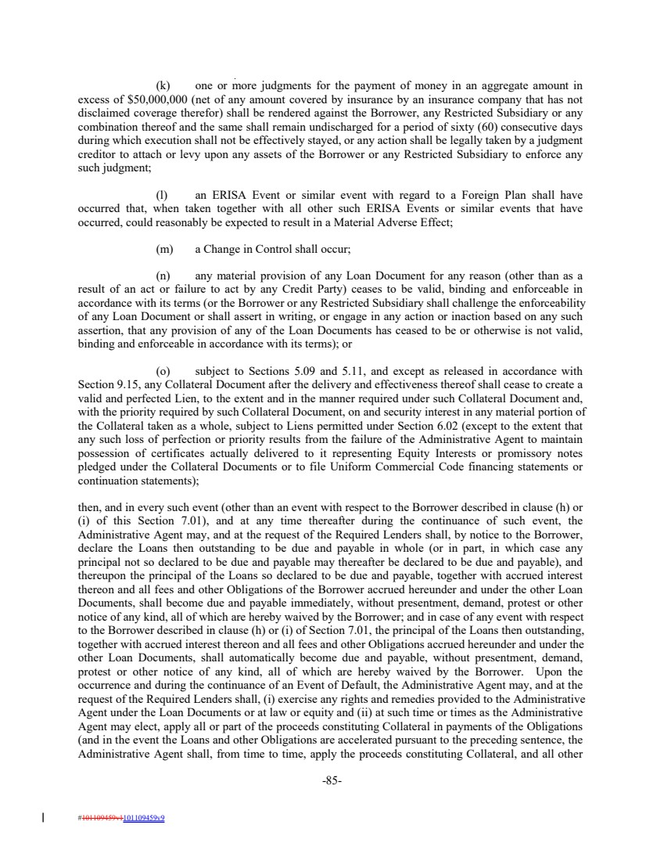 | (k) one or more judgments for the payment of money in an aggregate amount in excess of $50,000,000 (net of any amount covered by insurance by an insurance company that has not disclaimed coverage therefor) shall be rendered against the Borrower, any Restricted Subsidiary or any combination thereof and the same shall remain undischarged for a period of sixty (60) consecutive days during which execution shall not be effectively stayed, or any action shall be legally taken by a judgment creditor to attach or levy upon any assets of the Borrower or any Restricted Subsidiary to enforce any such judgment; (l) an ERISA Event or similar event with regard to a Foreign Plan shall have occurred that, when taken together with all other such ERISA Events or similar events that have occurred, could reasonably be expected to result in a Material Adverse Effect; (m) a Change in Control shall occur; (n) any material provision of any Loan Document for any reason (other than as a result of an act or failure to act by any Credit Party) ceases to be valid, binding and enforceable in accordance with its terms (or the Borrower or any Restricted Subsidiary shall challenge the enforceability of any Loan Document or shall assert in writing, or engage in any action or inaction based on any such assertion, that any provision of any of the Loan Documents has ceased to be or otherwise is not valid, binding and enforceable in accordance with its terms); or (o) subject to Sections 5.09 and 5.11, and except as released in accordance with Section 9.15, any Collateral Document after the delivery and effectiveness thereof shall cease to create a valid and perfected Lien, to the extent and in the manner required under such Collateral Document and, with the priority required by such Collateral Document, on and security interest in any material portion of the Collateral taken as a whole, subject to Liens permitted under Section 6.02 (except to the extent that any such loss of perfection or priority results from the failure of the Administrative Agent to maintain possession of certificates actually delivered to it representing Equity Interests or promissory notes pledged under the Collateral Documents or to file Uniform Commercial Code financing statements or continuation statements); then, and in every such event (other than an event with respect to the Borrower described in clause (h) or (i) of this Section 7.01), and at any time thereafter during the continuance of such event, the Administrative Agent may, and at the request of the Required Lenders shall, by notice to the Borrower, declare the Loans then outstanding to be due and payable in whole (or in part, in which case any principal not so declared to be due and payable may thereafter be declared to be due and payable), and thereupon the principal of the Loans so declared to be due and payable, together with accrued interest thereon and all fees and other Obligations of the Borrower accrued hereunder and under the other Loan Documents, shall become due and payable immediately, without presentment, demand, protest or other notice of any kind, all of which are hereby waived by the Borrower; and in case of any event with respect to the Borrower described in clause (h) or (i) of Section 7.01, the principal of the Loans then outstanding, together with accrued interest thereon and all fees and other Obligations accrued hereunder and under the other Loan Documents, shall automatically become due and payable, without presentment, demand, protest or other notice of any kind, all of which are hereby waived by the Borrower. Upon the occurrence and during the continuance of an Event of Default, the Administrative Agent may, and at the request of the Required Lenders shall, (i) exercise any rights and remedies provided to the Administrative Agent under the Loan Documents or at law or equity and (ii) at such time or times as the Administrative Agent may elect, apply all or part of the proceeds constituting Collateral in payments of the Obligations (and in the event the Loans and other Obligations are accelerated pursuant to the preceding sentence, the Administrative Agent shall, from time to time, apply the proceeds constituting Collateral, and all other -85- #101109459v1101109459v9
 | 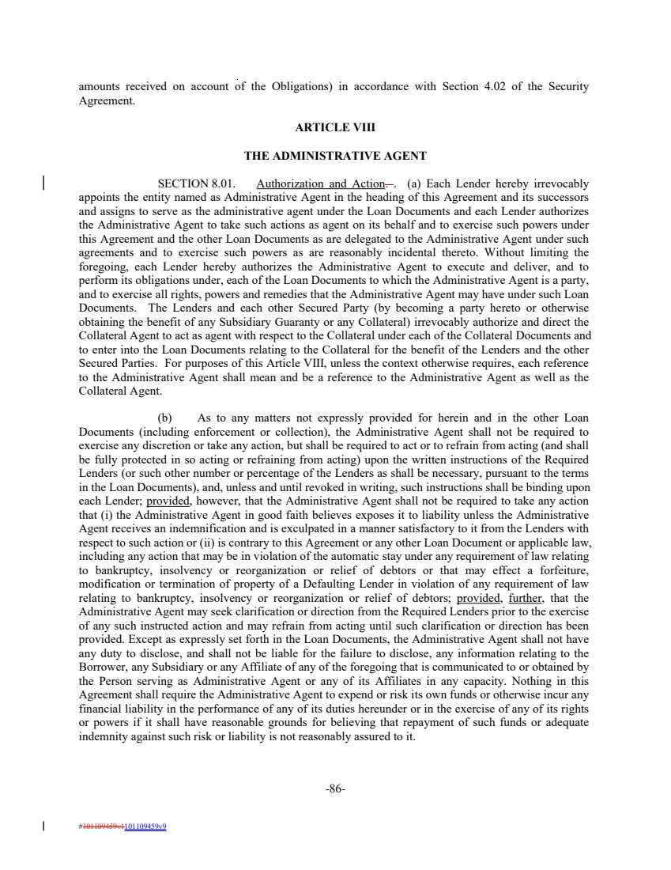 | amounts received on account of the Obligations) in accordance with Section 4.02 of the Security Agreement. ARTICLE VIII THE ADMINISTRATIVE AGENT SECTION 8.01. Authorization and Action. . (a) Each Lender hereby irrevocably appoints the entity named as Administrative Agent in the heading of this Agreement and its successors and assigns to serve as the administrative agent under the Loan Documents and each Lender authorizes the Administrative Agent to take such actions as agent on its behalf and to exercise such powers under this Agreement and the other Loan Documents as are delegated to the Administrative Agent under such agreements and to exercise such powers as are reasonably incidental thereto. Without limiting the foregoing, each Lender hereby authorizes the Administrative Agent to execute and deliver, and to perform its obligations under, each of the Loan Documents to which the Administrative Agent is a party, and to exercise all rights, powers and remedies that the Administrative Agent may have under such Loan Documents. The Lenders and each other Secured Party (by becoming a party hereto or otherwise obtaining the benefit of any Subsidiary Guaranty or any Collateral) irrevocably authorize and direct the Collateral Agent to act as agent with respect to the Collateral under each of the Collateral Documents and to enter into the Loan Documents relating to the Collateral for the benefit of the Lenders and the other Secured Parties. For purposes of this Article VIII, unless the context otherwise requires, each reference to the Administrative Agent shall mean and be a reference to the Administrative Agent as well as the Collateral Agent. (b) As to any matters not expressly provided for herein and in the other Loan Documents (including enforcement or collection), the Administrative Agent shall not be required to exercise any discretion or take any action, but shall be required to act or to refrain from acting (and shall be fully protected in so acting or refraining from acting) upon the written instructions of the Required Lenders (or such other number or percentage of the Lenders as shall be necessary, pursuant to the terms in the Loan Documents), and, unless and until revoked in writing, such instructions shall be binding upon each Lender; provided, however, that the Administrative Agent shall not be required to take any action that (i) the Administrative Agent in good faith believes exposes it to liability unless the Administrative Agent receives an indemnification and is exculpated in a manner satisfactory to it from the Lenders with respect to such action or (ii) is contrary to this Agreement or any other Loan Document or applicable law, including any action that may be in violation of the automatic stay under any requirement of law relating to bankruptcy, insolvency or reorganization or relief of debtors or that may effect a forfeiture, modification or termination of property of a Defaulting Lender in violation of any requirement of law relating to bankruptcy, insolvency or reorganization or relief of debtors; provided, further, that the Administrative Agent may seek clarification or direction from the Required Lenders prior to the exercise of any such instructed action and may refrain from acting until such clarification or direction has been provided. Except as expressly set forth in the Loan Documents, the Administrative Agent shall not have any duty to disclose, and shall not be liable for the failure to disclose, any information relating to the Borrower, any Subsidiary or any Affiliate of any of the foregoing that is communicated to or obtained by the Person serving as Administrative Agent or any of its Affiliates in any capacity. Nothing in this Agreement shall require the Administrative Agent to expend or risk its own funds or otherwise incur any financial liability in the performance of any of its duties hereunder or in the exercise of any of its rights or powers if it shall have reasonable grounds for believing that repayment of such funds or adequate indemnity against such risk or liability is not reasonably assured to it. -86- #101109459v1101109459v9
 | 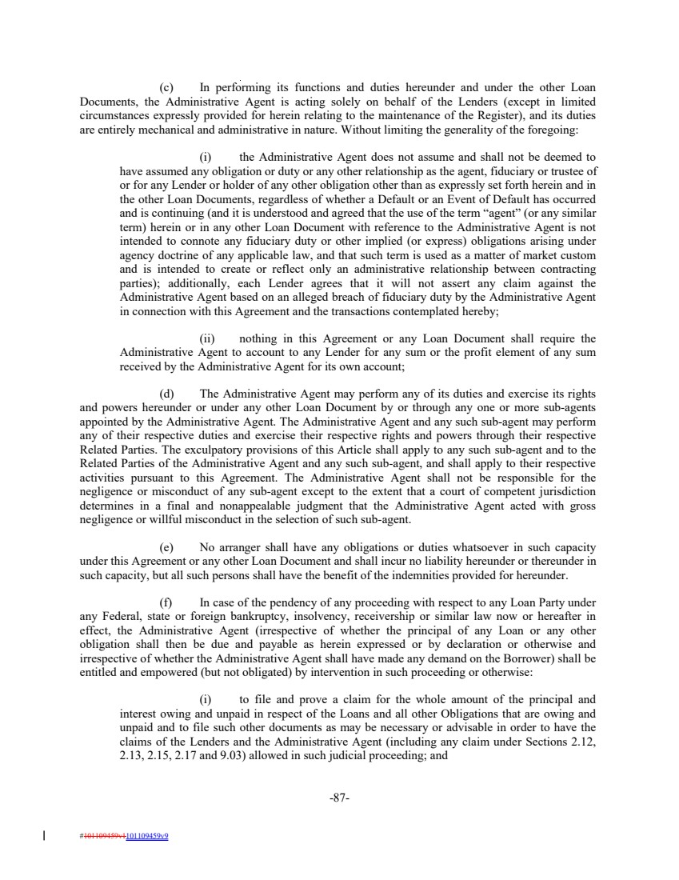 | (c) In performing its functions and duties hereunder and under the other Loan Documents, the Administrative Agent is acting solely on behalf of the Lenders (except in limited circumstances expressly provided for herein relating to the maintenance of the Register), and its duties are entirely mechanical and administrative in nature. Without limiting the generality of the foregoing: (i) the Administrative Agent does not assume and shall not be deemed to have assumed any obligation or duty or any other relationship as the agent, fiduciary or trustee of or for any Lender or holder of any other obligation other than as expressly set forth herein and in the other Loan Documents, regardless of whether a Default or an Event of Default has occurred and is continuing (and it is understood and agreed that the use of the term “agent” (or any similar term) herein or in any other Loan Document with reference to the Administrative Agent is not intended to connote any fiduciary duty or other implied (or express) obligations arising under agency doctrine of any applicable law, and that such term is used as a matter of market custom and is intended to create or reflect only an administrative relationship between contracting parties); additionally, each Lender agrees that it will not assert any claim against the Administrative Agent based on an alleged breach of fiduciary duty by the Administrative Agent in connection with this Agreement and the transactions contemplated hereby; (ii) nothing in this Agreement or any Loan Document shall require the Administrative Agent to account to any Lender for any sum or the profit element of any sum received by the Administrative Agent for its own account; (d) The Administrative Agent may perform any of its duties and exercise its rights and powers hereunder or under any other Loan Document by or through any one or more sub-agents appointed by the Administrative Agent. The Administrative Agent and any such sub-agent may perform any of their respective duties and exercise their respective rights and powers through their respective Related Parties. The exculpatory provisions of this Article shall apply to any such sub-agent and to the Related Parties of the Administrative Agent and any such sub-agent, and shall apply to their respective activities pursuant to this Agreement. The Administrative Agent shall not be responsible for the negligence or misconduct of any sub-agent except to the extent that a court of competent jurisdiction determines in a final and nonappealable judgment that the Administrative Agent acted with gross negligence or willful misconduct in the selection of such sub-agent. (e) No arranger shall have any obligations or duties whatsoever in such capacity under this Agreement or any other Loan Document and shall incur no liability hereunder or thereunder in such capacity, but all such persons shall have the benefit of the indemnities provided for hereunder. (f) In case of the pendency of any proceeding with respect to any Loan Party under any Federal, state or foreign bankruptcy, insolvency, receivership or similar law now or hereafter in effect, the Administrative Agent (irrespective of whether the principal of any Loan or any other obligation shall then be due and payable as herein expressed or by declaration or otherwise and irrespective of whether the Administrative Agent shall have made any demand on the Borrower) shall be entitled and empowered (but not obligated) by intervention in such proceeding or otherwise: (i) to file and prove a claim for the whole amount of the principal and interest owing and unpaid in respect of the Loans and all other Obligations that are owing and unpaid and to file such other documents as may be necessary or advisable in order to have the claims of the Lenders and the Administrative Agent (including any claim under Sections 2.12, 2.13, 2.15, 2.17 and 9.03) allowed in such judicial proceeding; and -87- #101109459v1101109459v9
 | 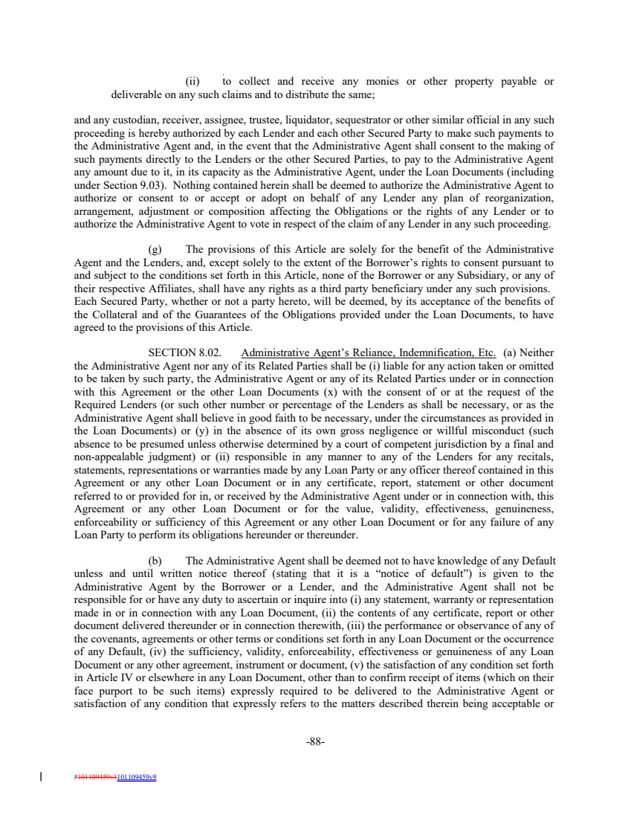 | (ii) to collect and receive any monies or other property payable or deliverable on any such claims and to distribute the same; and any custodian, receiver, assignee, trustee, liquidator, sequestrator or other similar official in any such proceeding is hereby authorized by each Lender and each other Secured Party to make such payments to the Administrative Agent and, in the event that the Administrative Agent shall consent to the making of such payments directly to the Lenders or the other Secured Parties, to pay to the Administrative Agent any amount due to it, in its capacity as the Administrative Agent, under the Loan Documents (including under Section 9.03). Nothing contained herein shall be deemed to authorize the Administrative Agent to authorize or consent to or accept or adopt on behalf of any Lender any plan of reorganization, arrangement, adjustment or composition affecting the Obligations or the rights of any Lender or to authorize the Administrative Agent to vote in respect of the claim of any Lender in any such proceeding. (g) The provisions of this Article are solely for the benefit of the Administrative Agent and the Lenders, and, except solely to the extent of the Borrower’s rights to consent pursuant to and subject to the conditions set forth in this Article, none of the Borrower or any Subsidiary, or any of their respective Affiliates, shall have any rights as a third party beneficiary under any such provisions. Each Secured Party, whether or not a party hereto, will be deemed, by its acceptance of the benefits of the Collateral and of the Guarantees of the Obligations provided under the Loan Documents, to have agreed to the provisions of this Article. SECTION 8.02. Administrative Agent’s Reliance, Indemnification, Etc. (a) Neither the Administrative Agent nor any of its Related Parties shall be (i) liable for any action taken or omitted to be taken by such party, the Administrative Agent or any of its Related Parties under or in connection with this Agreement or the other Loan Documents (x) with the consent of or at the request of the Required Lenders (or such other number or percentage of the Lenders as shall be necessary, or as the Administrative Agent shall believe in good faith to be necessary, under the circumstances as provided in the Loan Documents) or (y) in the absence of its own gross negligence or willful misconduct (such absence to be presumed unless otherwise determined by a court of competent jurisdiction by a final and non-appealable judgment) or (ii) responsible in any manner to any of the Lenders for any recitals, statements, representations or warranties made by any Loan Party or any officer thereof contained in this Agreement or any other Loan Document or in any certificate, report, statement or other document referred to or provided for in, or received by the Administrative Agent under or in connection with, this Agreement or any other Loan Document or for the value, validity, effectiveness, genuineness, enforceability or sufficiency of this Agreement or any other Loan Document or for any failure of any Loan Party to perform its obligations hereunder or thereunder. (b) The Administrative Agent shall be deemed not to have knowledge of any Default unless and until written notice thereof (stating that it is a “notice of default”) is given to the Administrative Agent by the Borrower or a Lender, and the Administrative Agent shall not be responsible for or have any duty to ascertain or inquire into (i) any statement, warranty or representation made in or in connection with any Loan Document, (ii) the contents of any certificate, report or other document delivered thereunder or in connection therewith, (iii) the performance or observance of any of the covenants, agreements or other terms or conditions set forth in any Loan Document or the occurrence of any Default, (iv) the sufficiency, validity, enforceability, effectiveness or genuineness of any Loan Document or any other agreement, instrument or document, (v) the satisfaction of any condition set forth in Article IV or elsewhere in any Loan Document, other than to confirm receipt of items (which on their face purport to be such items) expressly required to be delivered to the Administrative Agent or satisfaction of any condition that expressly refers to the matters described therein being acceptable or -88- #101109459v1101109459v9
 | 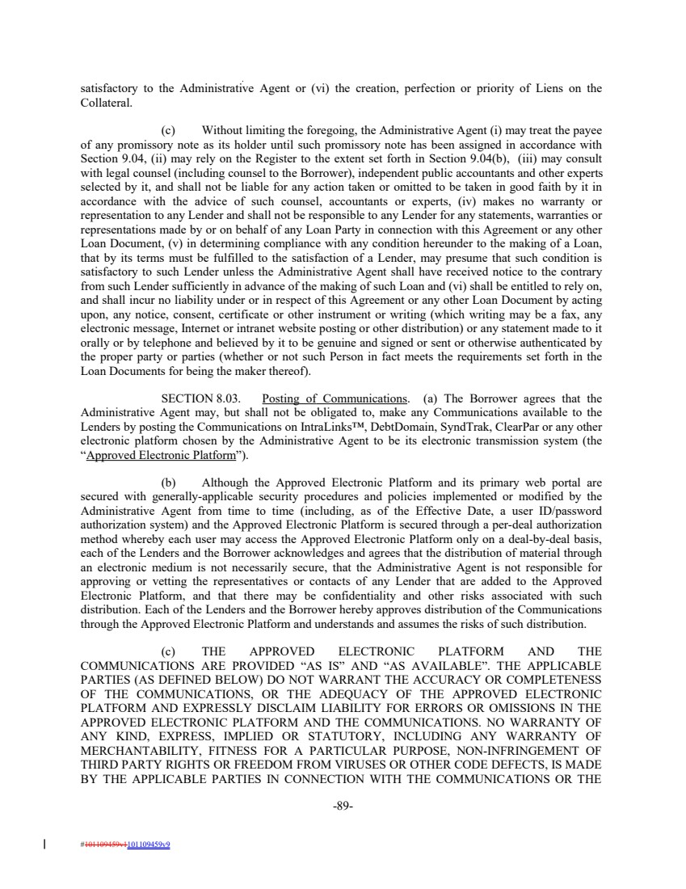 | satisfactory to the Administrative Agent or (vi) the creation, perfection or priority of Liens on the Collateral. (c) Without limiting the foregoing, the Administrative Agent (i) may treat the payee of any promissory note as its holder until such promissory note has been assigned in accordance with Section 9.04, (ii) may rely on the Register to the extent set forth in Section 9.04(b), (iii) may consult with legal counsel (including counsel to the Borrower), independent public accountants and other experts selected by it, and shall not be liable for any action taken or omitted to be taken in good faith by it in accordance with the advice of such counsel, accountants or experts, (iv) makes no warranty or representation to any Lender and shall not be responsible to any Lender for any statements, warranties or representations made by or on behalf of any Loan Party in connection with this Agreement or any other Loan Document, (v) in determining compliance with any condition hereunder to the making of a Loan, that by its terms must be fulfilled to the satisfaction of a Lender, may presume that such condition is satisfactory to such Lender unless the Administrative Agent shall have received notice to the contrary from such Lender sufficiently in advance of the making of such Loan and (vi) shall be entitled to rely on, and shall incur no liability under or in respect of this Agreement or any other Loan Document by acting upon, any notice, consent, certificate or other instrument or writing (which writing may be a fax, any electronic message, Internet or intranet website posting or other distribution) or any statement made to it orally or by telephone and believed by it to be genuine and signed or sent or otherwise authenticated by the proper party or parties (whether or not such Person in fact meets the requirements set forth in the Loan Documents for being the maker thereof). SECTION 8.03. Posting of Communications. (a) The Borrower agrees that the Administrative Agent may, but shall not be obligated to, make any Communications available to the Lenders by posting the Communications on IntraLinks™, DebtDomain, SyndTrak, ClearPar or any other electronic platform chosen by the Administrative Agent to be its electronic transmission system (the “Approved Electronic Platform”). (b) Although the Approved Electronic Platform and its primary web portal are secured with generally-applicable security procedures and policies implemented or modified by the Administrative Agent from time to time (including, as of the Effective Date, a user ID/password authorization system) and the Approved Electronic Platform is secured through a per-deal authorization method whereby each user may access the Approved Electronic Platform only on a deal-by-deal basis, each of the Lenders and the Borrower acknowledges and agrees that the distribution of material through an electronic medium is not necessarily secure, that the Administrative Agent is not responsible for approving or vetting the representatives or contacts of any Lender that are added to the Approved Electronic Platform, and that there may be confidentiality and other risks associated with such distribution. Each of the Lenders and the Borrower hereby approves distribution of the Communications through the Approved Electronic Platform and understands and assumes the risks of such distribution. (c) THE APPROVED ELECTRONIC PLATFORM AND THE COMMUNICATIONS ARE PROVIDED “AS IS” AND “AS AVAILABLE”. THE APPLICABLE PARTIES (AS DEFINED BELOW) DO NOT WARRANT THE ACCURACY OR COMPLETENESS OF THE COMMUNICATIONS, OR THE ADEQUACY OF THE APPROVED ELECTRONIC PLATFORM AND EXPRESSLY DISCLAIM LIABILITY FOR ERRORS OR OMISSIONS IN THE APPROVED ELECTRONIC PLATFORM AND THE COMMUNICATIONS. NO WARRANTY OF ANY KIND, EXPRESS, IMPLIED OR STATUTORY, INCLUDING ANY WARRANTY OF MERCHANTABILITY, FITNESS FOR A PARTICULAR PURPOSE, NON-INFRINGEMENT OF THIRD PARTY RIGHTS OR FREEDOM FROM VIRUSES OR OTHER CODE DEFECTS, IS MADE BY THE APPLICABLE PARTIES IN CONNECTION WITH THE COMMUNICATIONS OR THE -89- #101109459v1101109459v9
 | 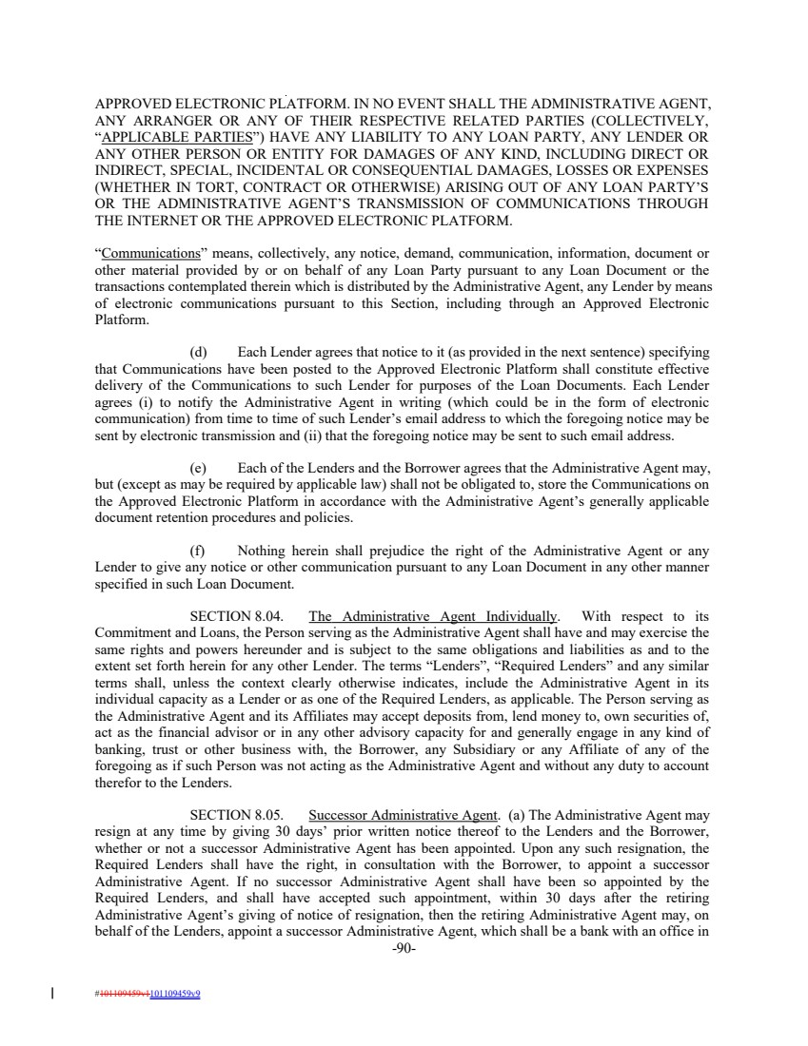 | APPROVED ELECTRONIC PLATFORM. IN NO EVENT SHALL THE ADMINISTRATIVE AGENT, ANY ARRANGER OR ANY OF THEIR RESPECTIVE RELATED PARTIES (COLLECTIVELY, “APPLICABLE PARTIES”) HAVE ANY LIABILITY TO ANY LOAN PARTY, ANY LENDER OR ANY OTHER PERSON OR ENTITY FOR DAMAGES OF ANY KIND, INCLUDING DIRECT OR INDIRECT, SPECIAL, INCIDENTAL OR CONSEQUENTIAL DAMAGES, LOSSES OR EXPENSES (WHETHER IN TORT, CONTRACT OR OTHERWISE) ARISING OUT OF ANY LOAN PARTY’S OR THE ADMINISTRATIVE AGENT’S TRANSMISSION OF COMMUNICATIONS THROUGH THE INTERNET OR THE APPROVED ELECTRONIC PLATFORM. “Communications” means, collectively, any notice, demand, communication, information, document or other material provided by or on behalf of any Loan Party pursuant to any Loan Document or the transactions contemplated therein which is distributed by the Administrative Agent, any Lender by means of electronic communications pursuant to this Section, including through an Approved Electronic Platform. (d) Each Lender agrees that notice to it (as provided in the next sentence) specifying that Communications have been posted to the Approved Electronic Platform shall constitute effective delivery of the Communications to such Lender for purposes of the Loan Documents. Each Lender agrees (i) to notify the Administrative Agent in writing (which could be in the form of electronic communication) from time to time of such Lender’s email address to which the foregoing notice may be sent by electronic transmission and (ii) that the foregoing notice may be sent to such email address. (e) Each of the Lenders and the Borrower agrees that the Administrative Agent may, but (except as may be required by applicable law) shall not be obligated to, store the Communications on the Approved Electronic Platform in accordance with the Administrative Agent’s generally applicable document retention procedures and policies. (f) Nothing herein shall prejudice the right of the Administrative Agent or any Lender to give any notice or other communication pursuant to any Loan Document in any other manner specified in such Loan Document. SECTION 8.04. The Administrative Agent Individually. With respect to its Commitment and Loans, the Person serving as the Administrative Agent shall have and may exercise the same rights and powers hereunder and is subject to the same obligations and liabilities as and to the extent set forth herein for any other Lender. The terms “Lenders”, “Required Lenders” and any similar terms shall, unless the context clearly otherwise indicates, include the Administrative Agent in its individual capacity as a Lender or as one of the Required Lenders, as applicable. The Person serving as the Administrative Agent and its Affiliates may accept deposits from, lend money to, own securities of, act as the financial advisor or in any other advisory capacity for and generally engage in any kind of banking, trust or other business with, the Borrower, any Subsidiary or any Affiliate of any of the foregoing as if such Person was not acting as the Administrative Agent and without any duty to account therefor to the Lenders. SECTION 8.05. Successor Administrative Agent. (a) The Administrative Agent may resign at any time by giving 30 days’ prior written notice thereof to the Lenders and the Borrower, whether or not a successor Administrative Agent has been appointed. Upon any such resignation, the Required Lenders shall have the right, in consultation with the Borrower, to appoint a successor Administrative Agent. If no successor Administrative Agent shall have been so appointed by the Required Lenders, and shall have accepted such appointment, within 30 days after the retiring Administrative Agent’s giving of notice of resignation, then the retiring Administrative Agent may, on behalf of the Lenders, appoint a successor Administrative Agent, which shall be a bank with an office in -90- #101109459v1101109459v9
 | 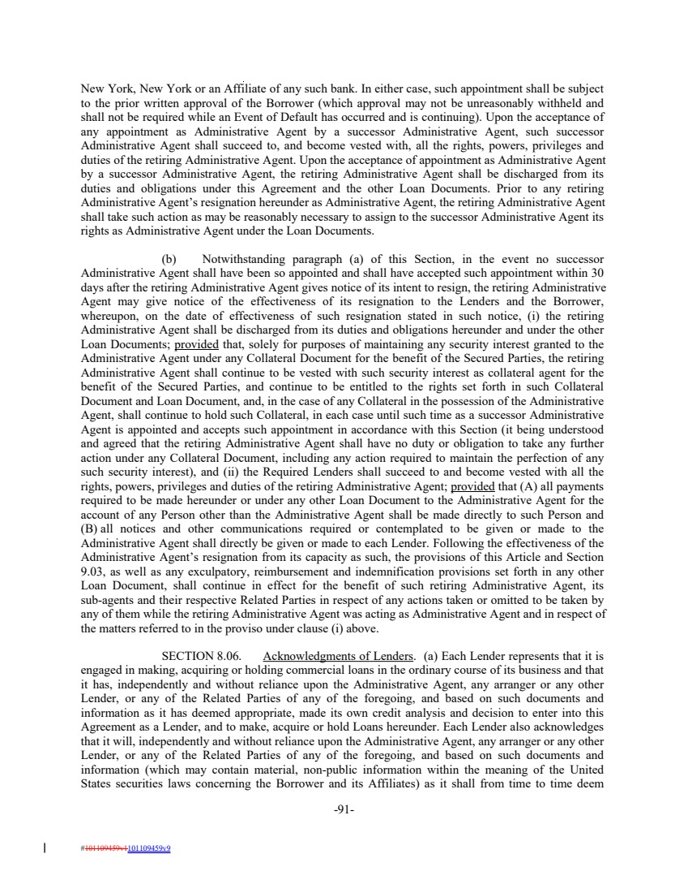 | New York, New York or an Affiliate of any such bank. In either case, such appointment shall be subject to the prior written approval of the Borrower (which approval may not be unreasonably withheld and shall not be required while an Event of Default has occurred and is continuing). Upon the acceptance of any appointment as Administrative Agent by a successor Administrative Agent, such successor Administrative Agent shall succeed to, and become vested with, all the rights, powers, privileges and duties of the retiring Administrative Agent. Upon the acceptance of appointment as Administrative Agent by a successor Administrative Agent, the retiring Administrative Agent shall be discharged from its duties and obligations under this Agreement and the other Loan Documents. Prior to any retiring Administrative Agent’s resignation hereunder as Administrative Agent, the retiring Administrative Agent shall take such action as may be reasonably necessary to assign to the successor Administrative Agent its rights as Administrative Agent under the Loan Documents. (b) Notwithstanding paragraph (a) of this Section, in the event no successor Administrative Agent shall have been so appointed and shall have accepted such appointment within 30 days after the retiring Administrative Agent gives notice of its intent to resign, the retiring Administrative Agent may give notice of the effectiveness of its resignation to the Lenders and the Borrower, whereupon, on the date of effectiveness of such resignation stated in such notice, (i) the retiring Administrative Agent shall be discharged from its duties and obligations hereunder and under the other Loan Documents; provided that, solely for purposes of maintaining any security interest granted to the Administrative Agent under any Collateral Document for the benefit of the Secured Parties, the retiring Administrative Agent shall continue to be vested with such security interest as collateral agent for the benefit of the Secured Parties, and continue to be entitled to the rights set forth in such Collateral Document and Loan Document, and, in the case of any Collateral in the possession of the Administrative Agent, shall continue to hold such Collateral, in each case until such time as a successor Administrative Agent is appointed and accepts such appointment in accordance with this Section (it being understood and agreed that the retiring Administrative Agent shall have no duty or obligation to take any further action under any Collateral Document, including any action required to maintain the perfection of any such security interest), and (ii) the Required Lenders shall succeed to and become vested with all the rights, powers, privileges and duties of the retiring Administrative Agent; provided that (A) all payments required to be made hereunder or under any other Loan Document to the Administrative Agent for the account of any Person other than the Administrative Agent shall be made directly to such Person and (B) all notices and other communications required or contemplated to be given or made to the Administrative Agent shall directly be given or made to each Lender. Following the effectiveness of the Administrative Agent’s resignation from its capacity as such, the provisions of this Article and Section 9.03, as well as any exculpatory, reimbursement and indemnification provisions set forth in any other Loan Document, shall continue in effect for the benefit of such retiring Administrative Agent, its sub-agents and their respective Related Parties in respect of any actions taken or omitted to be taken by any of them while the retiring Administrative Agent was acting as Administrative Agent and in respect of the matters referred to in the proviso under clause (i) above. SECTION 8.06. Acknowledgments of Lenders. (a) Each Lender represents that it is engaged in making, acquiring or holding commercial loans in the ordinary course of its business and that it has, independently and without reliance upon the Administrative Agent, any arranger or any other Lender, or any of the Related Parties of any of the foregoing, and based on such documents and information as it has deemed appropriate, made its own credit analysis and decision to enter into this Agreement as a Lender, and to make, acquire or hold Loans hereunder. Each Lender also acknowledges that it will, independently and without reliance upon the Administrative Agent, any arranger or any other Lender, or any of the Related Parties of any of the foregoing, and based on such documents and information (which may contain material, non-public information within the meaning of the United States securities laws concerning the Borrower and its Affiliates) as it shall from time to time deem -91- #101109459v1101109459v9
 | 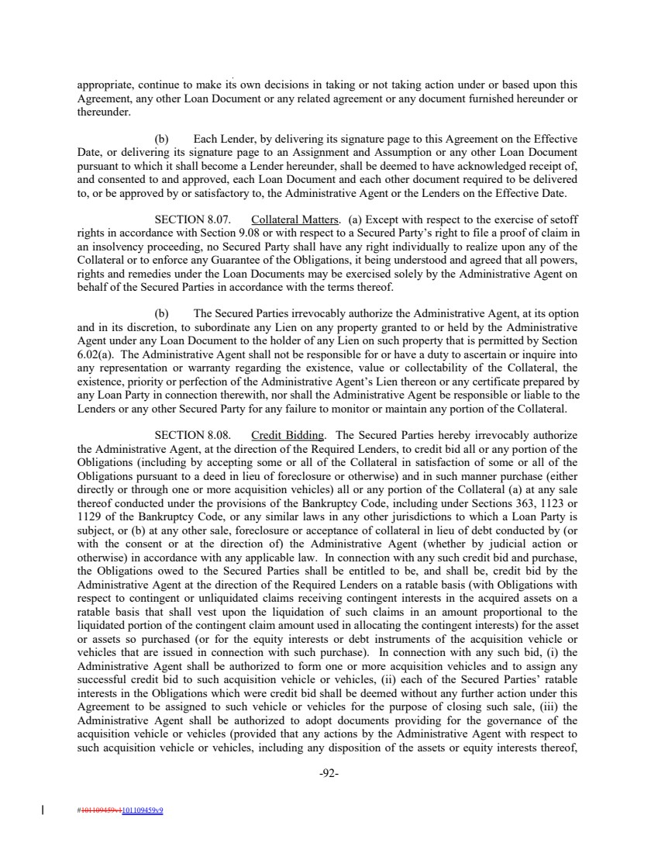 | appropriate, continue to make its own decisions in taking or not taking action under or based upon this Agreement, any other Loan Document or any related agreement or any document furnished hereunder or thereunder. (b) Each Lender, by delivering its signature page to this Agreement on the Effective Date, or delivering its signature page to an Assignment and Assumption or any other Loan Document pursuant to which it shall become a Lender hereunder, shall be deemed to have acknowledged receipt of, and consented to and approved, each Loan Document and each other document required to be delivered to, or be approved by or satisfactory to, the Administrative Agent or the Lenders on the Effective Date. SECTION 8.07. Collateral Matters. (a) Except with respect to the exercise of setoff rights in accordance with Section 9.08 or with respect to a Secured Party’s right to file a proof of claim in an insolvency proceeding, no Secured Party shall have any right individually to realize upon any of the Collateral or to enforce any Guarantee of the Obligations, it being understood and agreed that all powers, rights and remedies under the Loan Documents may be exercised solely by the Administrative Agent on behalf of the Secured Parties in accordance with the terms thereof. (b) The Secured Parties irrevocably authorize the Administrative Agent, at its option and in its discretion, to subordinate any Lien on any property granted to or held by the Administrative Agent under any Loan Document to the holder of any Lien on such property that is permitted by Section 6.02(a). The Administrative Agent shall not be responsible for or have a duty to ascertain or inquire into any representation or warranty regarding the existence, value or collectability of the Collateral, the existence, priority or perfection of the Administrative Agent’s Lien thereon or any certificate prepared by any Loan Party in connection therewith, nor shall the Administrative Agent be responsible or liable to the Lenders or any other Secured Party for any failure to monitor or maintain any portion of the Collateral. SECTION 8.08. Credit Bidding. The Secured Parties hereby irrevocably authorize the Administrative Agent, at the direction of the Required Lenders, to credit bid all or any portion of the Obligations (including by accepting some or all of the Collateral in satisfaction of some or all of the Obligations pursuant to a deed in lieu of foreclosure or otherwise) and in such manner purchase (either directly or through one or more acquisition vehicles) all or any portion of the Collateral (a) at any sale thereof conducted under the provisions of the Bankruptcy Code, including under Sections 363, 1123 or 1129 of the Bankruptcy Code, or any similar laws in any other jurisdictions to which a Loan Party is subject, or (b) at any other sale, foreclosure or acceptance of collateral in lieu of debt conducted by (or with the consent or at the direction of) the Administrative Agent (whether by judicial action or otherwise) in accordance with any applicable law. In connection with any such credit bid and purchase, the Obligations owed to the Secured Parties shall be entitled to be, and shall be, credit bid by the Administrative Agent at the direction of the Required Lenders on a ratable basis (with Obligations with respect to contingent or unliquidated claims receiving contingent interests in the acquired assets on a ratable basis that shall vest upon the liquidation of such claims in an amount proportional to the liquidated portion of the contingent claim amount used in allocating the contingent interests) for the asset or assets so purchased (or for the equity interests or debt instruments of the acquisition vehicle or vehicles that are issued in connection with such purchase). In connection with any such bid, (i) the Administrative Agent shall be authorized to form one or more acquisition vehicles and to assign any successful credit bid to such acquisition vehicle or vehicles, (ii) each of the Secured Parties’ ratable interests in the Obligations which were credit bid shall be deemed without any further action under this Agreement to be assigned to such vehicle or vehicles for the purpose of closing such sale, (iii) the Administrative Agent shall be authorized to adopt documents providing for the governance of the acquisition vehicle or vehicles (provided that any actions by the Administrative Agent with respect to such acquisition vehicle or vehicles, including any disposition of the assets or equity interests thereof, -92- #101109459v1101109459v9
 | 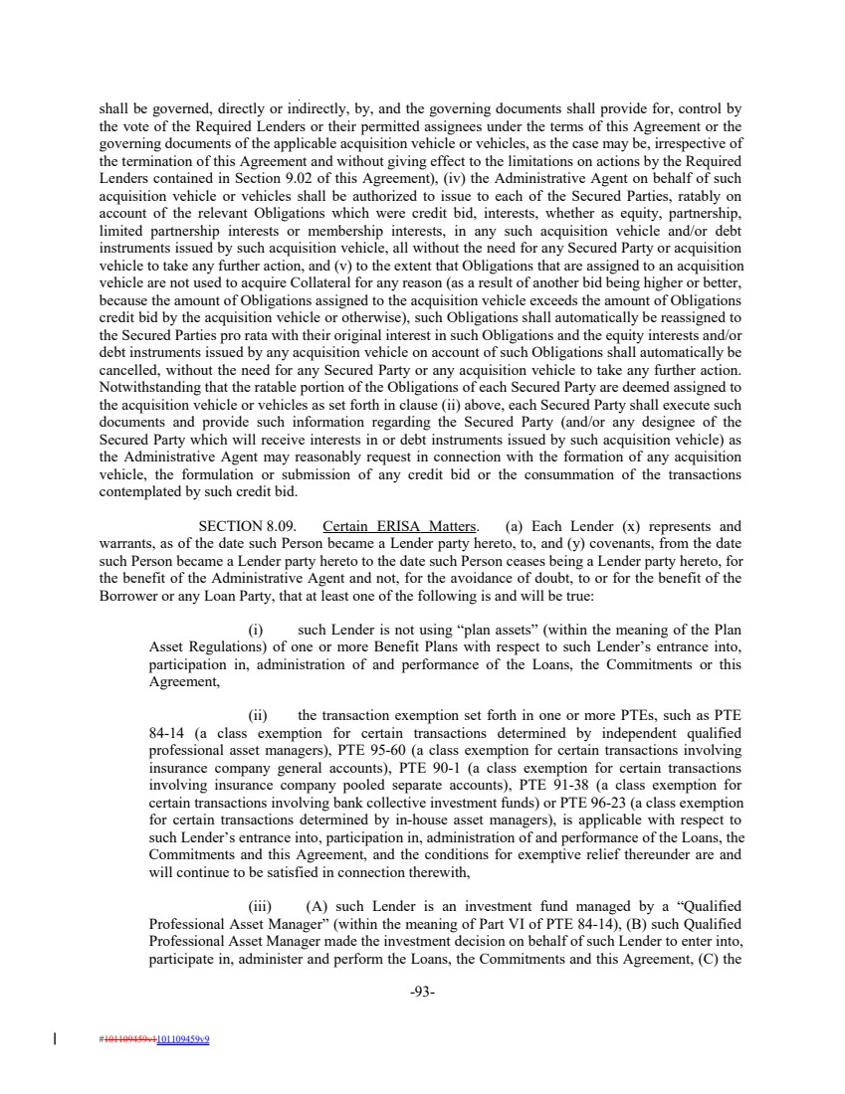 | shall be governed, directly or indirectly, by, and the governing documents shall provide for, control by the vote of the Required Lenders or their permitted assignees under the terms of this Agreement or the governing documents of the applicable acquisition vehicle or vehicles, as the case may be, irrespective of the termination of this Agreement and without giving effect to the limitations on actions by the Required Lenders contained in Section 9.02 of this Agreement), (iv) the Administrative Agent on behalf of such acquisition vehicle or vehicles shall be authorized to issue to each of the Secured Parties, ratably on account of the relevant Obligations which were credit bid, interests, whether as equity, partnership, limited partnership interests or membership interests, in any such acquisition vehicle and/or debt instruments issued by such acquisition vehicle, all without the need for any Secured Party or acquisition vehicle to take any further action, and (v) to the extent that Obligations that are assigned to an acquisition vehicle are not used to acquire Collateral for any reason (as a result of another bid being higher or better, because the amount of Obligations assigned to the acquisition vehicle exceeds the amount of Obligations credit bid by the acquisition vehicle or otherwise), such Obligations shall automatically be reassigned to the Secured Parties pro rata with their original interest in such Obligations and the equity interests and/or debt instruments issued by any acquisition vehicle on account of such Obligations shall automatically be cancelled, without the need for any Secured Party or any acquisition vehicle to take any further action. Notwithstanding that the ratable portion of the Obligations of each Secured Party are deemed assigned to the acquisition vehicle or vehicles as set forth in clause (ii) above, each Secured Party shall execute such documents and provide such information regarding the Secured Party (and/or any designee of the Secured Party which will receive interests in or debt instruments issued by such acquisition vehicle) as the Administrative Agent may reasonably request in connection with the formation of any acquisition vehicle, the formulation or submission of any credit bid or the consummation of the transactions contemplated by such credit bid. SECTION 8.09. Certain ERISA Matters. (a) Each Lender (x) represents and warrants, as of the date such Person became a Lender party hereto, to, and (y) covenants, from the date such Person became a Lender party hereto to the date such Person ceases being a Lender party hereto, for the benefit of the Administrative Agent and not, for the avoidance of doubt, to or for the benefit of the Borrower or any Loan Party, that at least one of the following is and will be true: (i) such Lender is not using “plan assets” (within the meaning of the Plan Asset Regulations) of one or more Benefit Plans with respect to such Lender’s entrance into, participation in, administration of and performance of the Loans, the Commitments or this Agreement, (ii) the transaction exemption set forth in one or more PTEs, such as PTE 84-14 (a class exemption for certain transactions determined by independent qualified professional asset managers), PTE 95-60 (a class exemption for certain transactions involving insurance company general accounts), PTE 90-1 (a class exemption for certain transactions involving insurance company pooled separate accounts), PTE 91-38 (a class exemption for certain transactions involving bank collective investment funds) or PTE 96-23 (a class exemption for certain transactions determined by in-house asset managers), is applicable with respect to such Lender’s entrance into, participation in, administration of and performance of the Loans, the Commitments and this Agreement, and the conditions for exemptive relief thereunder are and will continue to be satisfied in connection therewith, (iii) (A) such Lender is an investment fund managed by a “Qualified Professional Asset Manager” (within the meaning of Part VI of PTE 84-14), (B) such Qualified Professional Asset Manager made the investment decision on behalf of such Lender to enter into, participate in, administer and perform the Loans, the Commitments and this Agreement, (C) the -93- #101109459v1101109459v9
 | 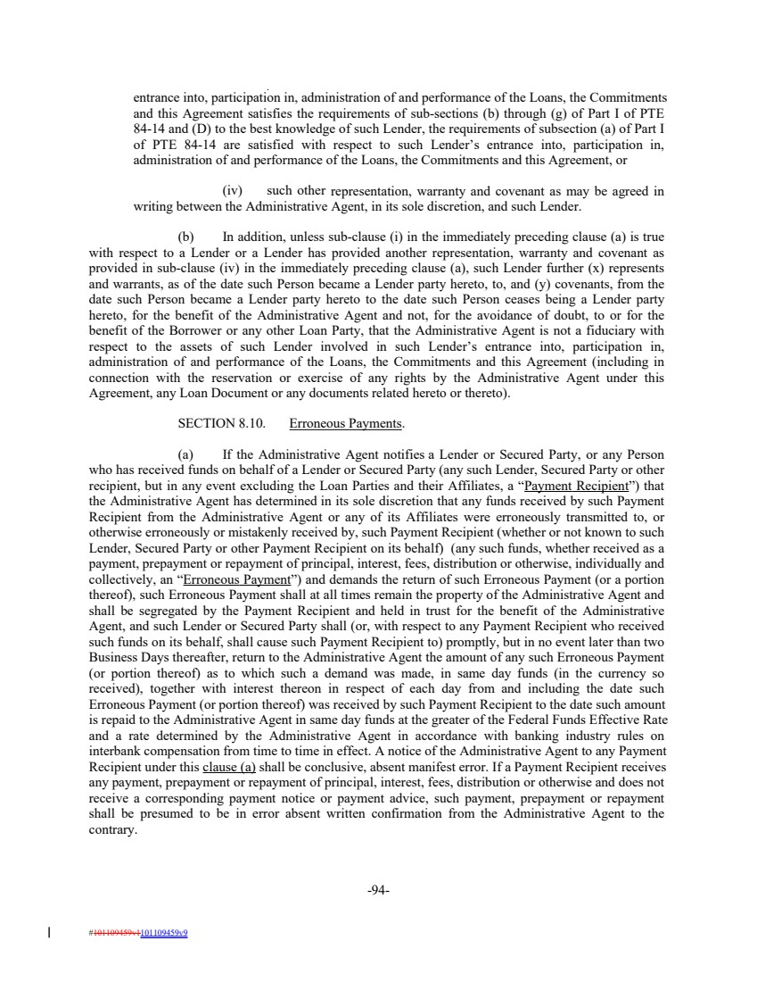 | entrance into, participation in, administration of and performance of the Loans, the Commitments and this Agreement satisfies the requirements of sub-sections (b) through (g) of Part I of PTE 84-14 and (D) to the best knowledge of such Lender, the requirements of subsection (a) of Part I of PTE 84-14 are satisfied with respect to such Lender’s entrance into, participation in, administration of and performance of the Loans, the Commitments and this Agreement, or (iv) such other representation, warranty and covenant as may be agreed in writing between the Administrative Agent, in its sole discretion, and such Lender. (b) In addition, unless sub-clause (i) in the immediately preceding clause (a) is true with respect to a Lender or a Lender has provided another representation, warranty and covenant as provided in sub-clause (iv) in the immediately preceding clause (a), such Lender further (x) represents and warrants, as of the date such Person became a Lender party hereto, to, and (y) covenants, from the date such Person became a Lender party hereto to the date such Person ceases being a Lender party hereto, for the benefit of the Administrative Agent and not, for the avoidance of doubt, to or for the benefit of the Borrower or any other Loan Party, that the Administrative Agent is not a fiduciary with respect to the assets of such Lender involved in such Lender’s entrance into, participation in, administration of and performance of the Loans, the Commitments and this Agreement (including in connection with the reservation or exercise of any rights by the Administrative Agent under this Agreement, any Loan Document or any documents related hereto or thereto). SECTION 8.10. Erroneous Payments. (a) If the Administrative Agent notifies a Lender or Secured Party, or any Person who has received funds on behalf of a Lender or Secured Party (any such Lender, Secured Party or other recipient, but in any event excluding the Loan Parties and their Affiliates, a “Payment Recipient”) that the Administrative Agent has determined in its sole discretion that any funds received by such Payment Recipient from the Administrative Agent or any of its Affiliates were erroneously transmitted to, or otherwise erroneously or mistakenly received by, such Payment Recipient (whether or not known to such Lender, Secured Party or other Payment Recipient on its behalf) (any such funds, whether received as a payment, prepayment or repayment of principal, interest, fees, distribution or otherwise, individually and collectively, an “Erroneous Payment”) and demands the return of such Erroneous Payment (or a portion thereof), such Erroneous Payment shall at all times remain the property of the Administrative Agent and shall be segregated by the Payment Recipient and held in trust for the benefit of the Administrative Agent, and such Lender or Secured Party shall (or, with respect to any Payment Recipient who received such funds on its behalf, shall cause such Payment Recipient to) promptly, but in no event later than two Business Days thereafter, return to the Administrative Agent the amount of any such Erroneous Payment (or portion thereof) as to which such a demand was made, in same day funds (in the currency so received), together with interest thereon in respect of each day from and including the date such Erroneous Payment (or portion thereof) was received by such Payment Recipient to the date such amount is repaid to the Administrative Agent in same day funds at the greater of the Federal Funds Effective Rate and a rate determined by the Administrative Agent in accordance with banking industry rules on interbank compensation from time to time in effect. A notice of the Administrative Agent to any Payment Recipient under this clause (a) shall be conclusive, absent manifest error. If a Payment Recipient receives any payment, prepayment or repayment of principal, interest, fees, distribution or otherwise and does not receive a corresponding payment notice or payment advice, such payment, prepayment or repayment shall be presumed to be in error absent written confirmation from the Administrative Agent to the contrary. -94- #101109459v1101109459v9
 | 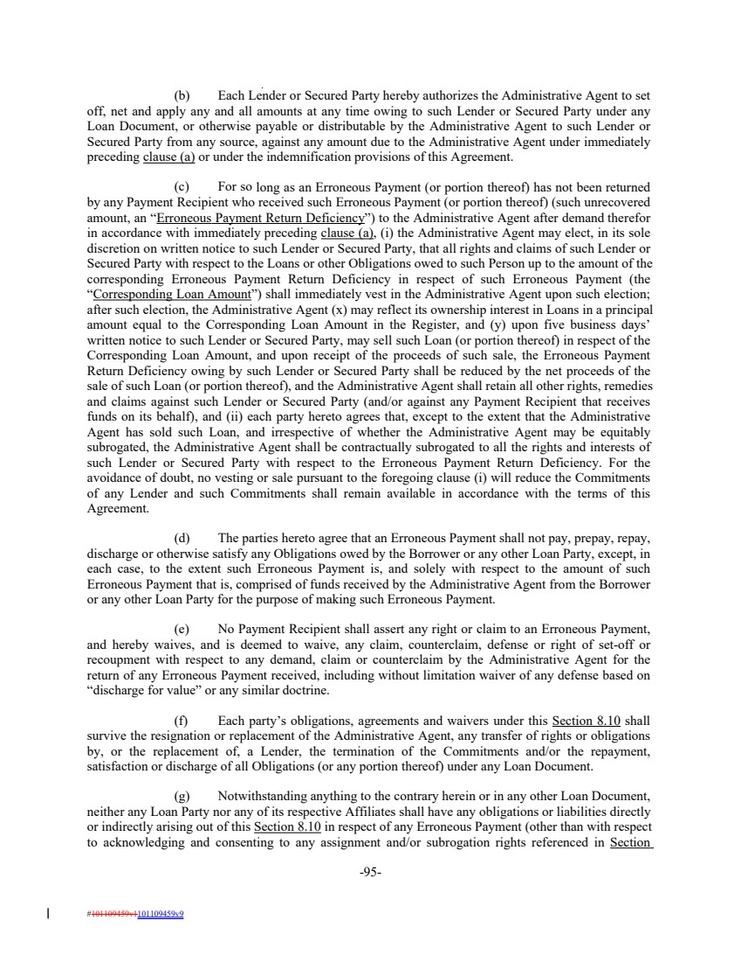 | (b) Each Lender or Secured Party hereby authorizes the Administrative Agent to set off, net and apply any and all amounts at any time owing to such Lender or Secured Party under any Loan Document, or otherwise payable or distributable by the Administrative Agent to such Lender or Secured Party from any source, against any amount due to the Administrative Agent under immediately preceding clause (a) or under the indemnification provisions of this Agreement. (c) For so long as an Erroneous Payment (or portion thereof) has not been returned by any Payment Recipient who received such Erroneous Payment (or portion thereof) (such unrecovered amount, an “Erroneous Payment Return Deficiency”) to the Administrative Agent after demand therefor in accordance with immediately preceding clause (a), (i) the Administrative Agent may elect, in its sole discretion on written notice to such Lender or Secured Party, that all rights and claims of such Lender or Secured Party with respect to the Loans or other Obligations owed to such Person up to the amount of the corresponding Erroneous Payment Return Deficiency in respect of such Erroneous Payment (the “Corresponding Loan Amount”) shall immediately vest in the Administrative Agent upon such election; after such election, the Administrative Agent (x) may reflect its ownership interest in Loans in a principal amount equal to the Corresponding Loan Amount in the Register, and (y) upon five business days’ written notice to such Lender or Secured Party, may sell such Loan (or portion thereof) in respect of the Corresponding Loan Amount, and upon receipt of the proceeds of such sale, the Erroneous Payment Return Deficiency owing by such Lender or Secured Party shall be reduced by the net proceeds of the sale of such Loan (or portion thereof), and the Administrative Agent shall retain all other rights, remedies and claims against such Lender or Secured Party (and/or against any Payment Recipient that receives funds on its behalf), and (ii) each party hereto agrees that, except to the extent that the Administrative Agent has sold such Loan, and irrespective of whether the Administrative Agent may be equitably subrogated, the Administrative Agent shall be contractually subrogated to all the rights and interests of such Lender or Secured Party with respect to the Erroneous Payment Return Deficiency. For the avoidance of doubt, no vesting or sale pursuant to the foregoing clause (i) will reduce the Commitments of any Lender and such Commitments shall remain available in accordance with the terms of this Agreement. (d) The parties hereto agree that an Erroneous Payment shall not pay, prepay, repay, discharge or otherwise satisfy any Obligations owed by the Borrower or any other Loan Party, except, in each case, to the extent such Erroneous Payment is, and solely with respect to the amount of such Erroneous Payment that is, comprised of funds received by the Administrative Agent from the Borrower or any other Loan Party for the purpose of making such Erroneous Payment. (e) No Payment Recipient shall assert any right or claim to an Erroneous Payment, and hereby waives, and is deemed to waive, any claim, counterclaim, defense or right of set-off or recoupment with respect to any demand, claim or counterclaim by the Administrative Agent for the return of any Erroneous Payment received, including without limitation waiver of any defense based on “discharge for value” or any similar doctrine. (f) Each party’s obligations, agreements and waivers under this Section 8.10 shall survive the resignation or replacement of the Administrative Agent, any transfer of rights or obligations by, or the replacement of, a Lender, the termination of the Commitments and/or the repayment, satisfaction or discharge of all Obligations (or any portion thereof) under any Loan Document. (g) Notwithstanding anything to the contrary herein or in any other Loan Document, neither any Loan Party nor any of its respective Affiliates shall have any obligations or liabilities directly or indirectly arising out of this Section 8.10 in respect of any Erroneous Payment (other than with respect to acknowledging and consenting to any assignment and/or subrogation rights referenced in Section -95- #101109459v1101109459v9
 | 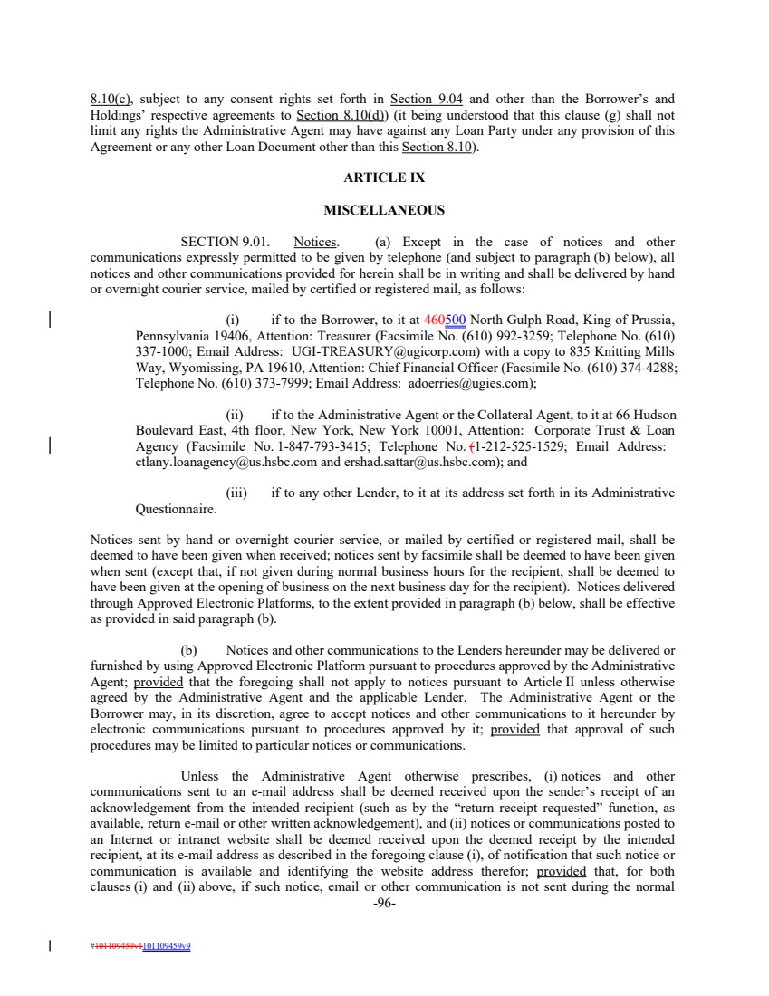 | 8.10(c), subject to any consent rights set forth in Section 9.04 and other than the Borrower’s and Holdings’ respective agreements to Section 8.10(d)) (it being understood that this clause (g) shall not limit any rights the Administrative Agent may have against any Loan Party under any provision of this Agreement or any other Loan Document other than this Section 8.10). ARTICLE IX MISCELLANEOUS SECTION 9.01. Notices. (a) Except in the case of notices and other communications expressly permitted to be given by telephone (and subject to paragraph (b) below), all notices and other communications provided for herein shall be in writing and shall be delivered by hand or overnight courier service, mailed by certified or registered mail, as follows: (i) if to the Borrower, to it at 460500 North Gulph Road, King of Prussia, Pennsylvania 19406, Attention: Treasurer (Facsimile No. (610) 992-3259; Telephone No. (610) 337-1000; Email Address: UGI-TREASURY@ugicorp.com) with a copy to 835 Knitting Mills Way, Wyomissing, PA 19610, Attention: Chief Financial Officer (Facsimile No. (610) 374-4288; Telephone No. (610) 373-7999; Email Address: adoerries@ugies.com); (ii) if to the Administrative Agent or the Collateral Agent, to it at 66 Hudson Boulevard East, 4th floor, New York, New York 10001, Attention: Corporate Trust & Loan Agency (Facsimile No. 1-847-793-3415; Telephone No. (1-212-525-1529; Email Address: ctlany.loanagency@us.hsbc.com and ershad.sattar@us.hsbc.com); and (iii) if to any other Lender, to it at its address set forth in its Administrative Questionnaire. Notices sent by hand or overnight courier service, or mailed by certified or registered mail, shall be deemed to have been given when received; notices sent by facsimile shall be deemed to have been given when sent (except that, if not given during normal business hours for the recipient, shall be deemed to have been given at the opening of business on the next business day for the recipient). Notices delivered through Approved Electronic Platforms, to the extent provided in paragraph (b) below, shall be effective as provided in said paragraph (b). (b) Notices and other communications to the Lenders hereunder may be delivered or furnished by using Approved Electronic Platform pursuant to procedures approved by the Administrative Agent; provided that the foregoing shall not apply to notices pursuant to Article II unless otherwise agreed by the Administrative Agent and the applicable Lender. The Administrative Agent or the Borrower may, in its discretion, agree to accept notices and other communications to it hereunder by electronic communications pursuant to procedures approved by it; provided that approval of such procedures may be limited to particular notices or communications. Unless the Administrative Agent otherwise prescribes, (i) notices and other communications sent to an e-mail address shall be deemed received upon the sender’s receipt of an acknowledgement from the intended recipient (such as by the “return receipt requested” function, as available, return e-mail or other written acknowledgement), and (ii) notices or communications posted to an Internet or intranet website shall be deemed received upon the deemed receipt by the intended recipient, at its e-mail address as described in the foregoing clause (i), of notification that such notice or communication is available and identifying the website address therefor; provided that, for both clauses (i) and (ii) above, if such notice, email or other communication is not sent during the normal -96- #101109459v1101109459v9
 | 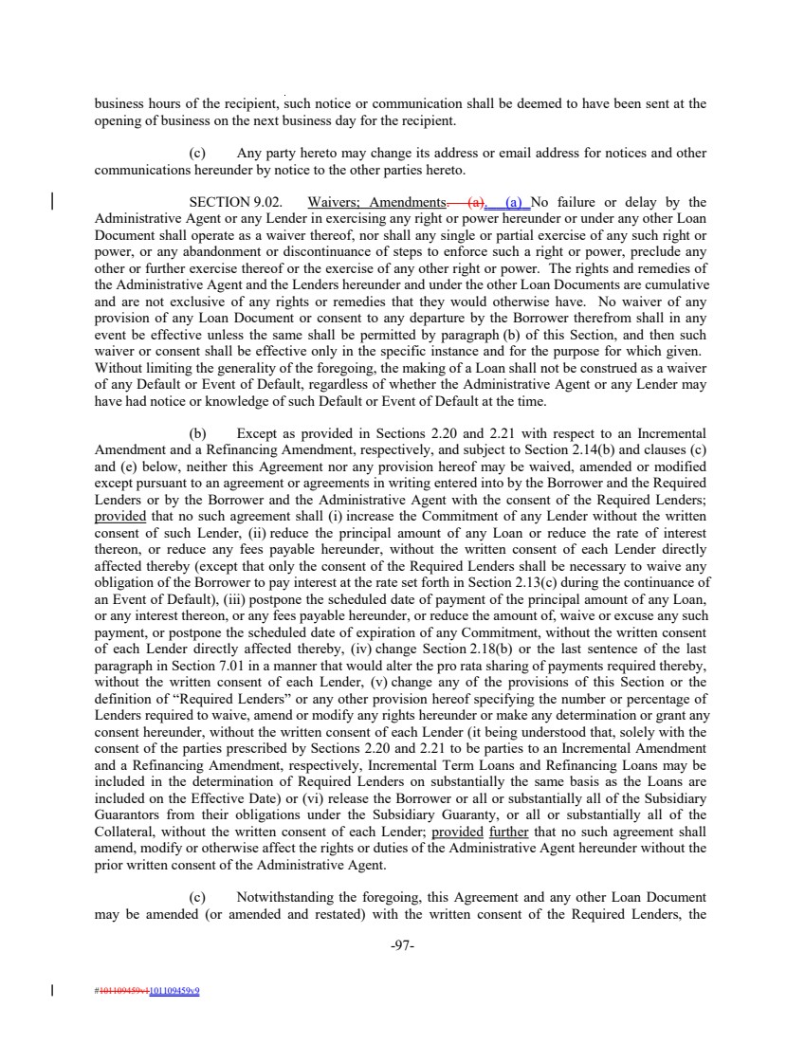 | business hours of the recipient, such notice or communication shall be deemed to have been sent at the opening of business on the next business day for the recipient. (c) Any party hereto may change its address or email address for notices and other communications hereunder by notice to the other parties hereto. SECTION 9.02. Waivers; Amendments. (a). (a) No failure or delay by the Administrative Agent or any Lender in exercising any right or power hereunder or under any other Loan Document shall operate as a waiver thereof, nor shall any single or partial exercise of any such right or power, or any abandonment or discontinuance of steps to enforce such a right or power, preclude any other or further exercise thereof or the exercise of any other right or power. The rights and remedies of the Administrative Agent and the Lenders hereunder and under the other Loan Documents are cumulative and are not exclusive of any rights or remedies that they would otherwise have. No waiver of any provision of any Loan Document or consent to any departure by the Borrower therefrom shall in any event be effective unless the same shall be permitted by paragraph (b) of this Section, and then such waiver or consent shall be effective only in the specific instance and for the purpose for which given. Without limiting the generality of the foregoing, the making of a Loan shall not be construed as a waiver of any Default or Event of Default, regardless of whether the Administrative Agent or any Lender may have had notice or knowledge of such Default or Event of Default at the time. (b) Except as provided in Sections 2.20 and 2.21 with respect to an Incremental Amendment and a Refinancing Amendment, respectively, and subject to Section 2.14(b) and clauses (c) and (e) below, neither this Agreement nor any provision hereof may be waived, amended or modified except pursuant to an agreement or agreements in writing entered into by the Borrower and the Required Lenders or by the Borrower and the Administrative Agent with the consent of the Required Lenders; provided that no such agreement shall (i) increase the Commitment of any Lender without the written consent of such Lender, (ii) reduce the principal amount of any Loan or reduce the rate of interest thereon, or reduce any fees payable hereunder, without the written consent of each Lender directly affected thereby (except that only the consent of the Required Lenders shall be necessary to waive any obligation of the Borrower to pay interest at the rate set forth in Section 2.13(c) during the continuance of an Event of Default), (iii) postpone the scheduled date of payment of the principal amount of any Loan, or any interest thereon, or any fees payable hereunder, or reduce the amount of, waive or excuse any such payment, or postpone the scheduled date of expiration of any Commitment, without the written consent of each Lender directly affected thereby, (iv) change Section 2.18(b) or the last sentence of the last paragraph in Section 7.01 in a manner that would alter the pro rata sharing of payments required thereby, without the written consent of each Lender, (v) change any of the provisions of this Section or the definition of “Required Lenders” or any other provision hereof specifying the number or percentage of Lenders required to waive, amend or modify any rights hereunder or make any determination or grant any consent hereunder, without the written consent of each Lender (it being understood that, solely with the consent of the parties prescribed by Sections 2.20 and 2.21 to be parties to an Incremental Amendment and a Refinancing Amendment, respectively, Incremental Term Loans and Refinancing Loans may be included in the determination of Required Lenders on substantially the same basis as the Loans are included on the Effective Date) or (vi) release the Borrower or all or substantially all of the Subsidiary Guarantors from their obligations under the Subsidiary Guaranty, or all or substantially all of the Collateral, without the written consent of each Lender; provided further that no such agreement shall amend, modify or otherwise affect the rights or duties of the Administrative Agent hereunder without the prior written consent of the Administrative Agent. (c) Notwithstanding the foregoing, this Agreement and any other Loan Document may be amended (or amended and restated) with the written consent of the Required Lenders, the -97- #101109459v1101109459v9
 | 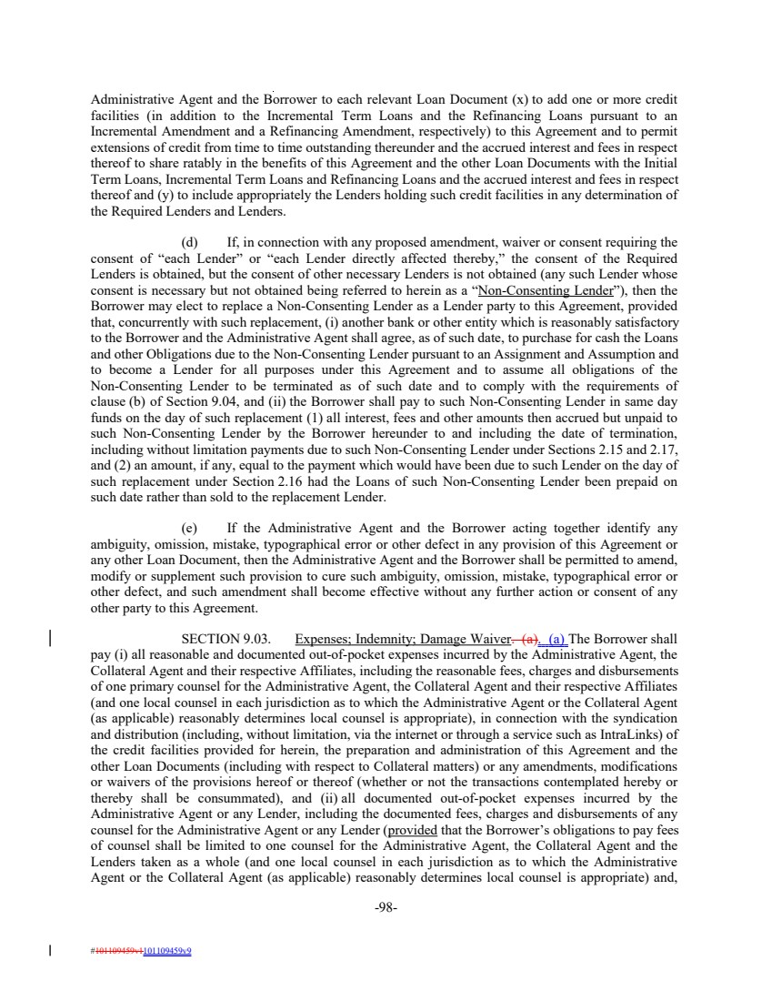 | Administrative Agent and the Borrower to each relevant Loan Document (x) to add one or more credit facilities (in addition to the Incremental Term Loans and the Refinancing Loans pursuant to an Incremental Amendment and a Refinancing Amendment, respectively) to this Agreement and to permit extensions of credit from time to time outstanding thereunder and the accrued interest and fees in respect thereof to share ratably in the benefits of this Agreement and the other Loan Documents with the Initial Term Loans, Incremental Term Loans and Refinancing Loans and the accrued interest and fees in respect thereof and (y) to include appropriately the Lenders holding such credit facilities in any determination of the Required Lenders and Lenders. (d) If, in connection with any proposed amendment, waiver or consent requiring the consent of “each Lender” or “each Lender directly affected thereby,” the consent of the Required Lenders is obtained, but the consent of other necessary Lenders is not obtained (any such Lender whose consent is necessary but not obtained being referred to herein as a “Non-Consenting Lender”), then the Borrower may elect to replace a Non-Consenting Lender as a Lender party to this Agreement, provided that, concurrently with such replacement, (i) another bank or other entity which is reasonably satisfactory to the Borrower and the Administrative Agent shall agree, as of such date, to purchase for cash the Loans and other Obligations due to the Non-Consenting Lender pursuant to an Assignment and Assumption and to become a Lender for all purposes under this Agreement and to assume all obligations of the Non-Consenting Lender to be terminated as of such date and to comply with the requirements of clause (b) of Section 9.04, and (ii) the Borrower shall pay to such Non-Consenting Lender in same day funds on the day of such replacement (1) all interest, fees and other amounts then accrued but unpaid to such Non-Consenting Lender by the Borrower hereunder to and including the date of termination, including without limitation payments due to such Non-Consenting Lender under Sections 2.15 and 2.17, and (2) an amount, if any, equal to the payment which would have been due to such Lender on the day of such replacement under Section 2.16 had the Loans of such Non-Consenting Lender been prepaid on such date rather than sold to the replacement Lender. (e) If the Administrative Agent and the Borrower acting together identify any ambiguity, omission, mistake, typographical error or other defect in any provision of this Agreement or any other Loan Document, then the Administrative Agent and the Borrower shall be permitted to amend, modify or supplement such provision to cure such ambiguity, omission, mistake, typographical error or other defect, and such amendment shall become effective without any further action or consent of any other party to this Agreement. SECTION 9.03. Expenses; Indemnity; Damage Waiver. (a). (a) The Borrower shall pay (i) all reasonable and documented out-of-pocket expenses incurred by the Administrative Agent, the Collateral Agent and their respective Affiliates, including the reasonable fees, charges and disbursements of one primary counsel for the Administrative Agent, the Collateral Agent and their respective Affiliates (and one local counsel in each jurisdiction as to which the Administrative Agent or the Collateral Agent (as applicable) reasonably determines local counsel is appropriate), in connection with the syndication and distribution (including, without limitation, via the internet or through a service such as IntraLinks) of the credit facilities provided for herein, the preparation and administration of this Agreement and the other Loan Documents (including with respect to Collateral matters) or any amendments, modifications or waivers of the provisions hereof or thereof (whether or not the transactions contemplated hereby or thereby shall be consummated), and (ii) all documented out-of-pocket expenses incurred by the Administrative Agent or any Lender, including the documented fees, charges and disbursements of any counsel for the Administrative Agent or any Lender (provided that the Borrower’s obligations to pay fees of counsel shall be limited to one counsel for the Administrative Agent, the Collateral Agent and the Lenders taken as a whole (and one local counsel in each jurisdiction as to which the Administrative Agent or the Collateral Agent (as applicable) reasonably determines local counsel is appropriate) and, -98- #101109459v1101109459v9
 | 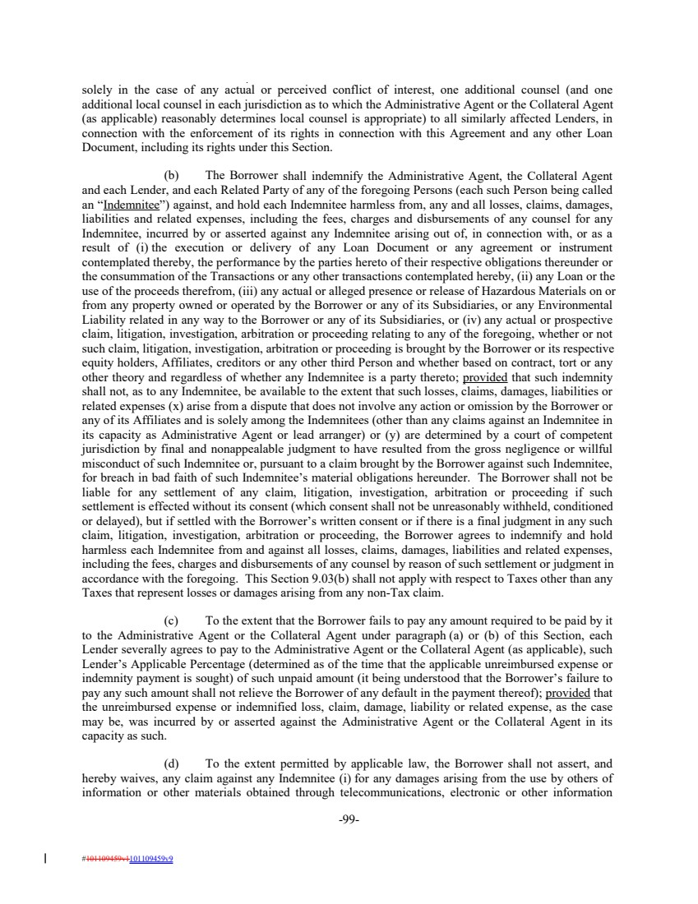 | solely in the case of any actual or perceived conflict of interest, one additional counsel (and one additional local counsel in each jurisdiction as to which the Administrative Agent or the Collateral Agent (as applicable) reasonably determines local counsel is appropriate) to all similarly affected Lenders, in connection with the enforcement of its rights in connection with this Agreement and any other Loan Document, including its rights under this Section. (b) The Borrower shall indemnify the Administrative Agent, the Collateral Agent and each Lender, and each Related Party of any of the foregoing Persons (each such Person being called an “Indemnitee”) against, and hold each Indemnitee harmless from, any and all losses, claims, damages, liabilities and related expenses, including the fees, charges and disbursements of any counsel for any Indemnitee, incurred by or asserted against any Indemnitee arising out of, in connection with, or as a result of (i) the execution or delivery of any Loan Document or any agreement or instrument contemplated thereby, the performance by the parties hereto of their respective obligations thereunder or the consummation of the Transactions or any other transactions contemplated hereby, (ii) any Loan or the use of the proceeds therefrom, (iii) any actual or alleged presence or release of Hazardous Materials on or from any property owned or operated by the Borrower or any of its Subsidiaries, or any Environmental Liability related in any way to the Borrower or any of its Subsidiaries, or (iv) any actual or prospective claim, litigation, investigation, arbitration or proceeding relating to any of the foregoing, whether or not such claim, litigation, investigation, arbitration or proceeding is brought by the Borrower or its respective equity holders, Affiliates, creditors or any other third Person and whether based on contract, tort or any other theory and regardless of whether any Indemnitee is a party thereto; provided that such indemnity shall not, as to any Indemnitee, be available to the extent that such losses, claims, damages, liabilities or related expenses (x) arise from a dispute that does not involve any action or omission by the Borrower or any of its Affiliates and is solely among the Indemnitees (other than any claims against an Indemnitee in its capacity as Administrative Agent or lead arranger) or (y) are determined by a court of competent jurisdiction by final and nonappealable judgment to have resulted from the gross negligence or willful misconduct of such Indemnitee or, pursuant to a claim brought by the Borrower against such Indemnitee, for breach in bad faith of such Indemnitee’s material obligations hereunder. The Borrower shall not be liable for any settlement of any claim, litigation, investigation, arbitration or proceeding if such settlement is effected without its consent (which consent shall not be unreasonably withheld, conditioned or delayed), but if settled with the Borrower’s written consent or if there is a final judgment in any such claim, litigation, investigation, arbitration or proceeding, the Borrower agrees to indemnify and hold harmless each Indemnitee from and against all losses, claims, damages, liabilities and related expenses, including the fees, charges and disbursements of any counsel by reason of such settlement or judgment in accordance with the foregoing. This Section 9.03(b) shall not apply with respect to Taxes other than any Taxes that represent losses or damages arising from any non-Tax claim. (c) To the extent that the Borrower fails to pay any amount required to be paid by it to the Administrative Agent or the Collateral Agent under paragraph (a) or (b) of this Section, each Lender severally agrees to pay to the Administrative Agent or the Collateral Agent (as applicable), such Lender’s Applicable Percentage (determined as of the time that the applicable unreimbursed expense or indemnity payment is sought) of such unpaid amount (it being understood that the Borrower’s failure to pay any such amount shall not relieve the Borrower of any default in the payment thereof); provided that the unreimbursed expense or indemnified loss, claim, damage, liability or related expense, as the case may be, was incurred by or asserted against the Administrative Agent or the Collateral Agent in its capacity as such. (d) To the extent permitted by applicable law, the Borrower shall not assert, and hereby waives, any claim against any Indemnitee (i) for any damages arising from the use by others of information or other materials obtained through telecommunications, electronic or other information -99- #101109459v1101109459v9
 | 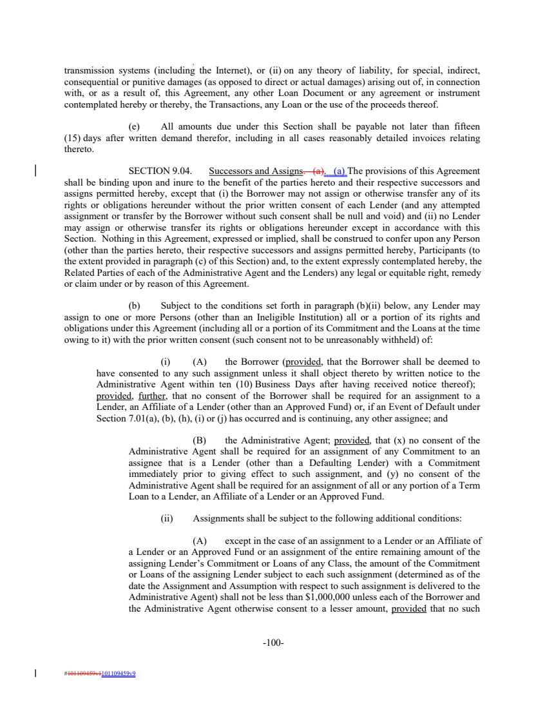 | transmission systems (including the Internet), or (ii) on any theory of liability, for special, indirect, consequential or punitive damages (as opposed to direct or actual damages) arising out of, in connection with, or as a result of, this Agreement, any other Loan Document or any agreement or instrument contemplated hereby or thereby, the Transactions, any Loan or the use of the proceeds thereof. (e) All amounts due under this Section shall be payable not later than fifteen (15) days after written demand therefor, including in all cases reasonably detailed invoices relating thereto. SECTION 9.04. Successors and Assigns. (a). (a) The provisions of this Agreement shall be binding upon and inure to the benefit of the parties hereto and their respective successors and assigns permitted hereby, except that (i) the Borrower may not assign or otherwise transfer any of its rights or obligations hereunder without the prior written consent of each Lender (and any attempted assignment or transfer by the Borrower without such consent shall be null and void) and (ii) no Lender may assign or otherwise transfer its rights or obligations hereunder except in accordance with this Section. Nothing in this Agreement, expressed or implied, shall be construed to confer upon any Person (other than the parties hereto, their respective successors and assigns permitted hereby, Participants (to the extent provided in paragraph (c) of this Section) and, to the extent expressly contemplated hereby, the Related Parties of each of the Administrative Agent and the Lenders) any legal or equitable right, remedy or claim under or by reason of this Agreement. (b) Subject to the conditions set forth in paragraph (b)(ii) below, any Lender may assign to one or more Persons (other than an Ineligible Institution) all or a portion of its rights and obligations under this Agreement (including all or a portion of its Commitment and the Loans at the time owing to it) with the prior written consent (such consent not to be unreasonably withheld) of: (i) (A) the Borrower (provided, that the Borrower shall be deemed to have consented to any such assignment unless it shall object thereto by written notice to the Administrative Agent within ten (10) Business Days after having received notice thereof); provided, further, that no consent of the Borrower shall be required for an assignment to a Lender, an Affiliate of a Lender (other than an Approved Fund) or, if an Event of Default under Section 7.01(a), (b), (h), (i) or (j) has occurred and is continuing, any other assignee; and (B) the Administrative Agent; provided, that (x) no consent of the Administrative Agent shall be required for an assignment of any Commitment to an assignee that is a Lender (other than a Defaulting Lender) with a Commitment immediately prior to giving effect to such assignment, and (y) no consent of the Administrative Agent shall be required for an assignment of all or any portion of a Term Loan to a Lender, an Affiliate of a Lender or an Approved Fund. (ii) Assignments shall be subject to the following additional conditions: (A) except in the case of an assignment to a Lender or an Affiliate of a Lender or an Approved Fund or an assignment of the entire remaining amount of the assigning Lender’s Commitment or Loans of any Class, the amount of the Commitment or Loans of the assigning Lender subject to each such assignment (determined as of the date the Assignment and Assumption with respect to such assignment is delivered to the Administrative Agent) shall not be less than $1,000,000 unless each of the Borrower and the Administrative Agent otherwise consent to a lesser amount, provided that no such -100- #101109459v1101109459v9
 |  | consent of the Borrower shall be required if an Event of Default has occurred and is continuing; (B) each partial assignment shall be made as an assignment of a proportionate part of all the assigning Lender’s rights and obligations under this Agreement, provided that this clause shall not be construed to prohibit the assignment of a proportionate part of all the assigning Lender’s rights and obligations in respect of one Class of Commitments or Loans; (C) the parties to each assignment shall execute and deliver to the Administrative Agent (x) an Assignment and Assumption or (y) to the extent applicable, an agreement incorporating an Assignment and Assumption by reference pursuant to an Approved Electronic Platform as to which the Administrative Agent and the parties to the Assignment and Assumption are participants, together with a processing and recordation fee of $3,500 (which fee may be waived or reduced in the sole discretion of the Administrative Agent), such fee to be paid by either the assigning Lender or the assignee Lender or shared between such Lenders; (D) the assignee, if it shall not be a Lender, shall deliver to the Administrative Agent an Administrative Questionnaire in which the assignee designates one or more credit contacts to whom all syndicate-level information (which may contain material non-public information about the Borrower and its Affiliates and their Related Parties or their respective securities, subject to Section 9.12) will be made available and who may receive such information in accordance with the assignee’s compliance procedures and applicable laws, including Federal and state securities laws; and (E) without the prior written consent of the Administrative Agent, no assignment shall be made to a prospective assignee that bears a relationship to the Borrower described in Section 108(e)(4) of the Code. (iii) Subject to acceptance and recording thereof pursuant to paragraph (b)(iv) of this Section, from and after the effective date specified in each Assignment and Assumption the assignee thereunder shall be a party hereto and, to the extent of the interest assigned by such Assignment and Assumption, have the rights and obligations of a Lender under this Agreement, and the assigning Lender thereunder shall, to the extent of the interest assigned by such Assignment and Assumption, be released from its obligations under this Agreement (and, in the case of an Assignment and Assumption covering all of the assigning Lender’s rights and obligations under this Agreement, such Lender shall cease to be a party hereto but shall continue to be entitled to the benefits of Sections 2.15, 2.16, 2.17 and 9.03). Any assignment or transfer by a Lender of rights or obligations under this Agreement that does not comply with this Section 9.04 shall be treated for purposes of this Agreement as a sale by such Lender of a participation in such rights and obligations in accordance with paragraph (c) of this Section. (iv) The Administrative Agent, acting for this purpose as a non-fiduciary agent of the Borrower, shall maintain at one of its offices a copy of each Assignment and Assumption delivered to it and a register for the recordation of the names and addresses of the Lenders, and the Commitment of, and principal amount (and stated interest) of the Loans owing to, each Lender pursuant to the terms hereof from time to time (the “Register”). The entries in the Register shall be conclusive, and the Borrower, the Administrative Agent and the Lenders shall treat each Person whose name is recorded in the Register pursuant to the terms hereof as a Lender hereunder for all purposes of this Agreement, notwithstanding notice to the contrary. -101- #101109459v1101109459v9
 | 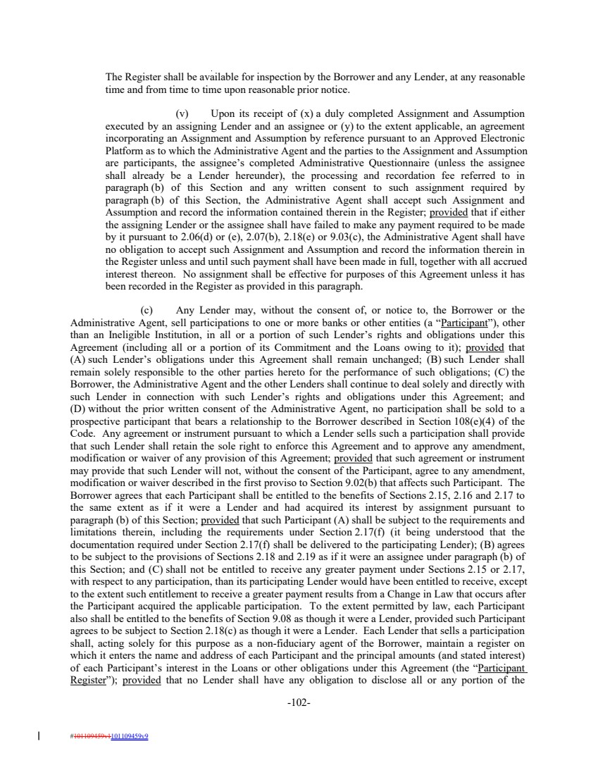 | The Register shall be available for inspection by the Borrower and any Lender, at any reasonable time and from time to time upon reasonable prior notice. (v) Upon its receipt of (x) a duly completed Assignment and Assumption executed by an assigning Lender and an assignee or (y) to the extent applicable, an agreement incorporating an Assignment and Assumption by reference pursuant to an Approved Electronic Platform as to which the Administrative Agent and the parties to the Assignment and Assumption are participants, the assignee’s completed Administrative Questionnaire (unless the assignee shall already be a Lender hereunder), the processing and recordation fee referred to in paragraph (b) of this Section and any written consent to such assignment required by paragraph (b) of this Section, the Administrative Agent shall accept such Assignment and Assumption and record the information contained therein in the Register; provided that if either the assigning Lender or the assignee shall have failed to make any payment required to be made by it pursuant to 2.06(d) or (e), 2.07(b), 2.18(e) or 9.03(c), the Administrative Agent shall have no obligation to accept such Assignment and Assumption and record the information therein in the Register unless and until such payment shall have been made in full, together with all accrued interest thereon. No assignment shall be effective for purposes of this Agreement unless it has been recorded in the Register as provided in this paragraph. (c) Any Lender may, without the consent of, or notice to, the Borrower or the Administrative Agent, sell participations to one or more banks or other entities (a “Participant”), other than an Ineligible Institution, in all or a portion of such Lender’s rights and obligations under this Agreement (including all or a portion of its Commitment and the Loans owing to it); provided that (A) such Lender’s obligations under this Agreement shall remain unchanged; (B) such Lender shall remain solely responsible to the other parties hereto for the performance of such obligations; (C) the Borrower, the Administrative Agent and the other Lenders shall continue to deal solely and directly with such Lender in connection with such Lender’s rights and obligations under this Agreement; and (D) without the prior written consent of the Administrative Agent, no participation shall be sold to a prospective participant that bears a relationship to the Borrower described in Section 108(e)(4) of the Code. Any agreement or instrument pursuant to which a Lender sells such a participation shall provide that such Lender shall retain the sole right to enforce this Agreement and to approve any amendment, modification or waiver of any provision of this Agreement; provided that such agreement or instrument may provide that such Lender will not, without the consent of the Participant, agree to any amendment, modification or waiver described in the first proviso to Section 9.02(b) that affects such Participant. The Borrower agrees that each Participant shall be entitled to the benefits of Sections 2.15, 2.16 and 2.17 to the same extent as if it were a Lender and had acquired its interest by assignment pursuant to paragraph (b) of this Section; provided that such Participant (A) shall be subject to the requirements and limitations therein, including the requirements under Section 2.17(f) (it being understood that the documentation required under Section 2.17(f) shall be delivered to the participating Lender); (B) agrees to be subject to the provisions of Sections 2.18 and 2.19 as if it were an assignee under paragraph (b) of this Section; and (C) shall not be entitled to receive any greater payment under Sections 2.15 or 2.17, with respect to any participation, than its participating Lender would have been entitled to receive, except to the extent such entitlement to receive a greater payment results from a Change in Law that occurs after the Participant acquired the applicable participation. To the extent permitted by law, each Participant also shall be entitled to the benefits of Section 9.08 as though it were a Lender, provided such Participant agrees to be subject to Section 2.18(c) as though it were a Lender. Each Lender that sells a participation shall, acting solely for this purpose as a non-fiduciary agent of the Borrower, maintain a register on which it enters the name and address of each Participant and the principal amounts (and stated interest) of each Participant’s interest in the Loans or other obligations under this Agreement (the “Participant Register”); provided that no Lender shall have any obligation to disclose all or any portion of the -102- #101109459v1101109459v9
 | 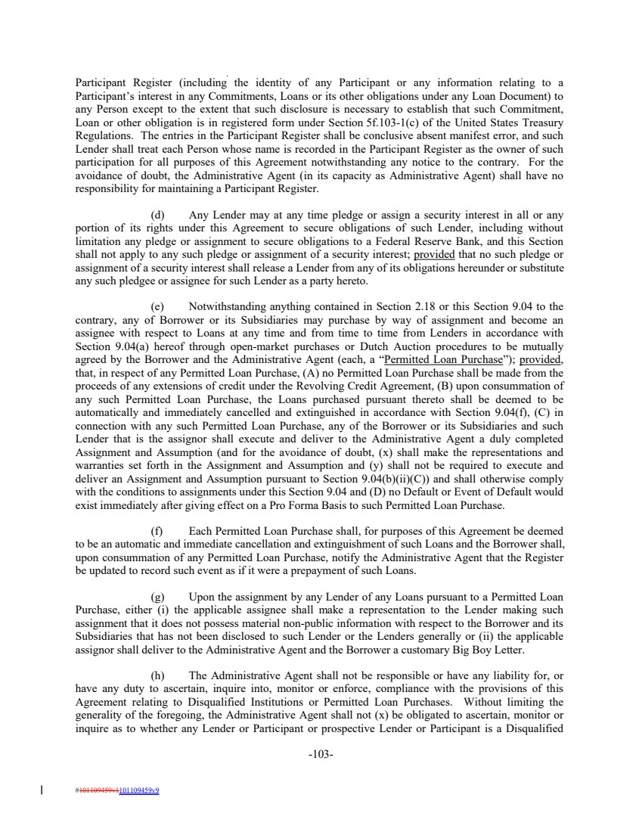 | Participant Register (including the identity of any Participant or any information relating to a Participant’s interest in any Commitments, Loans or its other obligations under any Loan Document) to any Person except to the extent that such disclosure is necessary to establish that such Commitment, Loan or other obligation is in registered form under Section 5f.103-1(c) of the United States Treasury Regulations. The entries in the Participant Register shall be conclusive absent manifest error, and such Lender shall treat each Person whose name is recorded in the Participant Register as the owner of such participation for all purposes of this Agreement notwithstanding any notice to the contrary. For the avoidance of doubt, the Administrative Agent (in its capacity as Administrative Agent) shall have no responsibility for maintaining a Participant Register. (d) Any Lender may at any time pledge or assign a security interest in all or any portion of its rights under this Agreement to secure obligations of such Lender, including without limitation any pledge or assignment to secure obligations to a Federal Reserve Bank, and this Section shall not apply to any such pledge or assignment of a security interest; provided that no such pledge or assignment of a security interest shall release a Lender from any of its obligations hereunder or substitute any such pledgee or assignee for such Lender as a party hereto. (e) Notwithstanding anything contained in Section 2.18 or this Section 9.04 to the contrary, any of Borrower or its Subsidiaries may purchase by way of assignment and become an assignee with respect to Loans at any time and from time to time from Lenders in accordance with Section 9.04(a) hereof through open-market purchases or Dutch Auction procedures to be mutually agreed by the Borrower and the Administrative Agent (each, a “Permitted Loan Purchase”); provided, that, in respect of any Permitted Loan Purchase, (A) no Permitted Loan Purchase shall be made from the proceeds of any extensions of credit under the Revolving Credit Agreement, (B) upon consummation of any such Permitted Loan Purchase, the Loans purchased pursuant thereto shall be deemed to be automatically and immediately cancelled and extinguished in accordance with Section 9.04(f), (C) in connection with any such Permitted Loan Purchase, any of the Borrower or its Subsidiaries and such Lender that is the assignor shall execute and deliver to the Administrative Agent a duly completed Assignment and Assumption (and for the avoidance of doubt, (x) shall make the representations and warranties set forth in the Assignment and Assumption and (y) shall not be required to execute and deliver an Assignment and Assumption pursuant to Section 9.04(b)(ii)(C)) and shall otherwise comply with the conditions to assignments under this Section 9.04 and (D) no Default or Event of Default would exist immediately after giving effect on a Pro Forma Basis to such Permitted Loan Purchase. (f) Each Permitted Loan Purchase shall, for purposes of this Agreement be deemed to be an automatic and immediate cancellation and extinguishment of such Loans and the Borrower shall, upon consummation of any Permitted Loan Purchase, notify the Administrative Agent that the Register be updated to record such event as if it were a prepayment of such Loans. (g) Upon the assignment by any Lender of any Loans pursuant to a Permitted Loan Purchase, either (i) the applicable assignee shall make a representation to the Lender making such assignment that it does not possess material non-public information with respect to the Borrower and its Subsidiaries that has not been disclosed to such Lender or the Lenders generally or (ii) the applicable assignor shall deliver to the Administrative Agent and the Borrower a customary Big Boy Letter. (h) The Administrative Agent shall not be responsible or have any liability for, or have any duty to ascertain, inquire into, monitor or enforce, compliance with the provisions of this Agreement relating to Disqualified Institutions or Permitted Loan Purchases. Without limiting the generality of the foregoing, the Administrative Agent shall not (x) be obligated to ascertain, monitor or inquire as to whether any Lender or Participant or prospective Lender or Participant is a Disqualified -103- #101109459v1101109459v9
 | 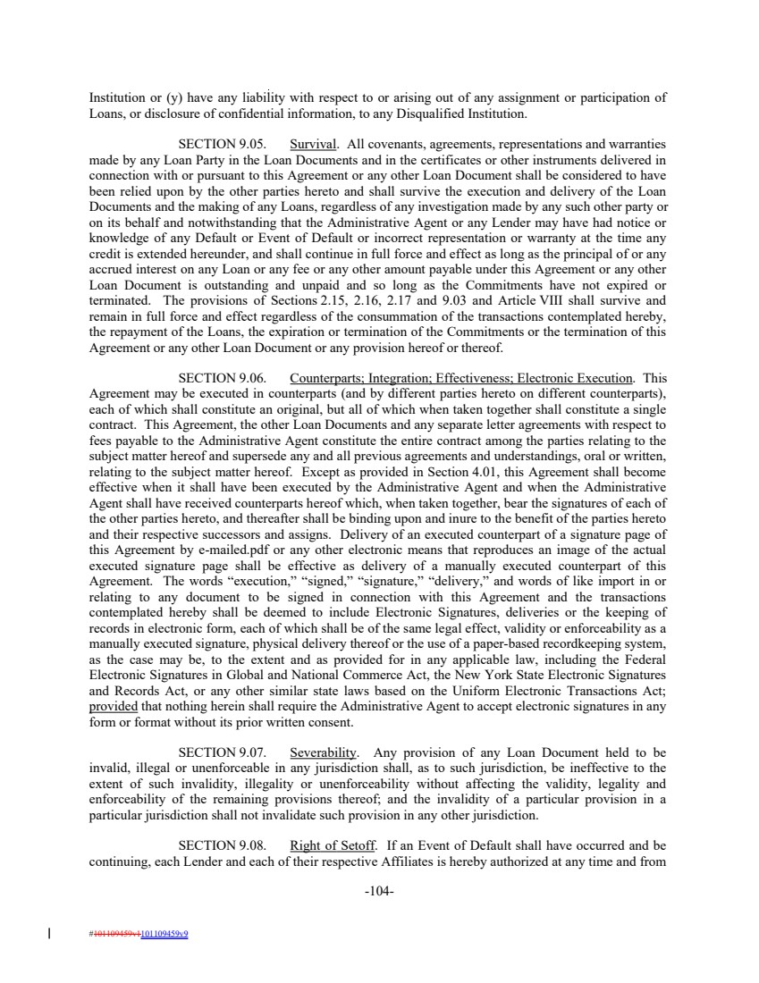 | Institution or (y) have any liability with respect to or arising out of any assignment or participation of Loans, or disclosure of confidential information, to any Disqualified Institution. SECTION 9.05. Survival. All covenants, agreements, representations and warranties made by any Loan Party in the Loan Documents and in the certificates or other instruments delivered in connection with or pursuant to this Agreement or any other Loan Document shall be considered to have been relied upon by the other parties hereto and shall survive the execution and delivery of the Loan Documents and the making of any Loans, regardless of any investigation made by any such other party or on its behalf and notwithstanding that the Administrative Agent or any Lender may have had notice or knowledge of any Default or Event of Default or incorrect representation or warranty at the time any credit is extended hereunder, and shall continue in full force and effect as long as the principal of or any accrued interest on any Loan or any fee or any other amount payable under this Agreement or any other Loan Document is outstanding and unpaid and so long as the Commitments have not expired or terminated. The provisions of Sections 2.15, 2.16, 2.17 and 9.03 and Article VIII shall survive and remain in full force and effect regardless of the consummation of the transactions contemplated hereby, the repayment of the Loans, the expiration or termination of the Commitments or the termination of this Agreement or any other Loan Document or any provision hereof or thereof. SECTION 9.06. Counterparts; Integration; Effectiveness; Electronic Execution. This Agreement may be executed in counterparts (and by different parties hereto on different counterparts), each of which shall constitute an original, but all of which when taken together shall constitute a single contract. This Agreement, the other Loan Documents and any separate letter agreements with respect to fees payable to the Administrative Agent constitute the entire contract among the parties relating to the subject matter hereof and supersede any and all previous agreements and understandings, oral or written, relating to the subject matter hereof. Except as provided in Section 4.01, this Agreement shall become effective when it shall have been executed by the Administrative Agent and when the Administrative Agent shall have received counterparts hereof which, when taken together, bear the signatures of each of the other parties hereto, and thereafter shall be binding upon and inure to the benefit of the parties hereto and their respective successors and assigns. Delivery of an executed counterpart of a signature page of this Agreement by e-mailed.pdf or any other electronic means that reproduces an image of the actual executed signature page shall be effective as delivery of a manually executed counterpart of this Agreement. The words “execution,” “signed,” “signature,” “delivery,” and words of like import in or relating to any document to be signed in connection with this Agreement and the transactions contemplated hereby shall be deemed to include Electronic Signatures, deliveries or the keeping of records in electronic form, each of which shall be of the same legal effect, validity or enforceability as a manually executed signature, physical delivery thereof or the use of a paper-based recordkeeping system, as the case may be, to the extent and as provided for in any applicable law, including the Federal Electronic Signatures in Global and National Commerce Act, the New York State Electronic Signatures and Records Act, or any other similar state laws based on the Uniform Electronic Transactions Act; provided that nothing herein shall require the Administrative Agent to accept electronic signatures in any form or format without its prior written consent. SECTION 9.07. Severability. Any provision of any Loan Document held to be invalid, illegal or unenforceable in any jurisdiction shall, as to such jurisdiction, be ineffective to the extent of such invalidity, illegality or unenforceability without affecting the validity, legality and enforceability of the remaining provisions thereof; and the invalidity of a particular provision in a particular jurisdiction shall not invalidate such provision in any other jurisdiction. SECTION 9.08. Right of Setoff. If an Event of Default shall have occurred and be continuing, each Lender and each of their respective Affiliates is hereby authorized at any time and from -104- #101109459v1101109459v9
 | 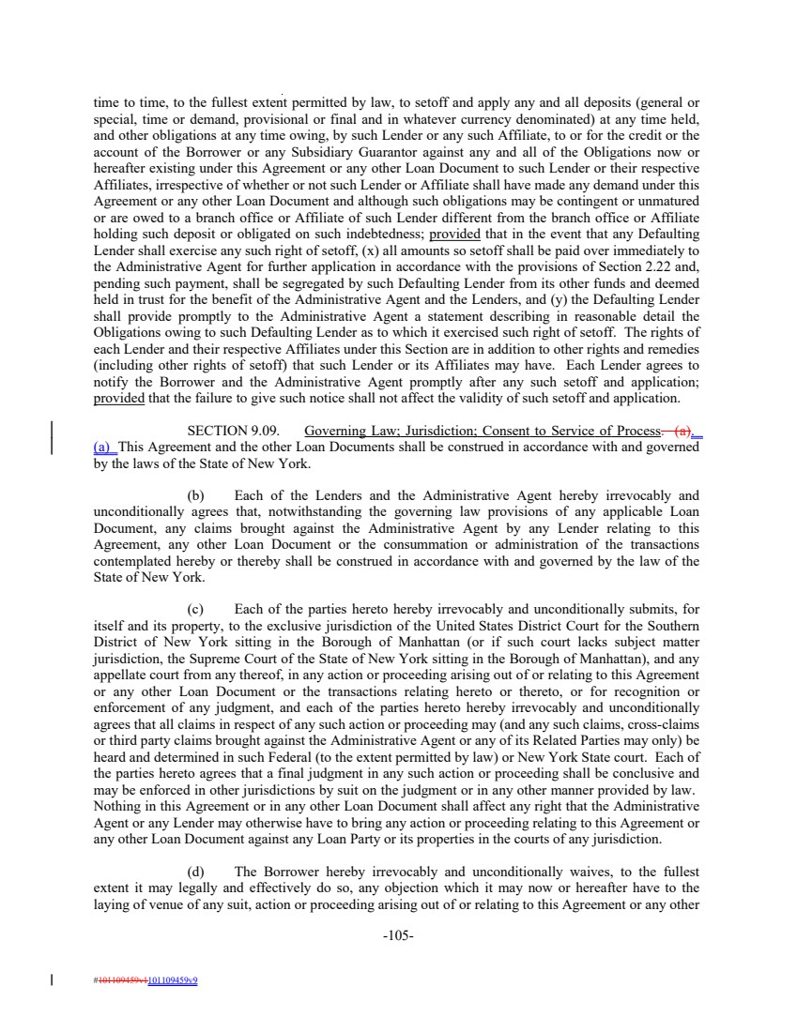 | time to time, to the fullest extent permitted by law, to setoff and apply any and all deposits (general or special, time or demand, provisional or final and in whatever currency denominated) at any time held, and other obligations at any time owing, by such Lender or any such Affiliate, to or for the credit or the account of the Borrower or any Subsidiary Guarantor against any and all of the Obligations now or hereafter existing under this Agreement or any other Loan Document to such Lender or their respective Affiliates, irrespective of whether or not such Lender or Affiliate shall have made any demand under this Agreement or any other Loan Document and although such obligations may be contingent or unmatured or are owed to a branch office or Affiliate of such Lender different from the branch office or Affiliate holding such deposit or obligated on such indebtedness; provided that in the event that any Defaulting Lender shall exercise any such right of setoff, (x) all amounts so setoff shall be paid over immediately to the Administrative Agent for further application in accordance with the provisions of Section 2.22 and, pending such payment, shall be segregated by such Defaulting Lender from its other funds and deemed held in trust for the benefit of the Administrative Agent and the Lenders, and (y) the Defaulting Lender shall provide promptly to the Administrative Agent a statement describing in reasonable detail the Obligations owing to such Defaulting Lender as to which it exercised such right of setoff. The rights of each Lender and their respective Affiliates under this Section are in addition to other rights and remedies (including other rights of setoff) that such Lender or its Affiliates may have. Each Lender agrees to notify the Borrower and the Administrative Agent promptly after any such setoff and application; provided that the failure to give such notice shall not affect the validity of such setoff and application. SECTION 9.09. Governing Law; Jurisdiction; Consent to Service of Process. (a). (a) This Agreement and the other Loan Documents shall be construed in accordance with and governed by the laws of the State of New York. (b) Each of the Lenders and the Administrative Agent hereby irrevocably and unconditionally agrees that, notwithstanding the governing law provisions of any applicable Loan Document, any claims brought against the Administrative Agent by any Lender relating to this Agreement, any other Loan Document or the consummation or administration of the transactions contemplated hereby or thereby shall be construed in accordance with and governed by the law of the State of New York. (c) Each of the parties hereto hereby irrevocably and unconditionally submits, for itself and its property, to the exclusive jurisdiction of the United States District Court for the Southern District of New York sitting in the Borough of Manhattan (or if such court lacks subject matter jurisdiction, the Supreme Court of the State of New York sitting in the Borough of Manhattan), and any appellate court from any thereof, in any action or proceeding arising out of or relating to this Agreement or any other Loan Document or the transactions relating hereto or thereto, or for recognition or enforcement of any judgment, and each of the parties hereto hereby irrevocably and unconditionally agrees that all claims in respect of any such action or proceeding may (and any such claims, cross-claims or third party claims brought against the Administrative Agent or any of its Related Parties may only) be heard and determined in such Federal (to the extent permitted by law) or New York State court. Each of the parties hereto agrees that a final judgment in any such action or proceeding shall be conclusive and may be enforced in other jurisdictions by suit on the judgment or in any other manner provided by law. Nothing in this Agreement or in any other Loan Document shall affect any right that the Administrative Agent or any Lender may otherwise have to bring any action or proceeding relating to this Agreement or any other Loan Document against any Loan Party or its properties in the courts of any jurisdiction. (d) The Borrower hereby irrevocably and unconditionally waives, to the fullest extent it may legally and effectively do so, any objection which it may now or hereafter have to the laying of venue of any suit, action or proceeding arising out of or relating to this Agreement or any other -105- #101109459v1101109459v9
 | 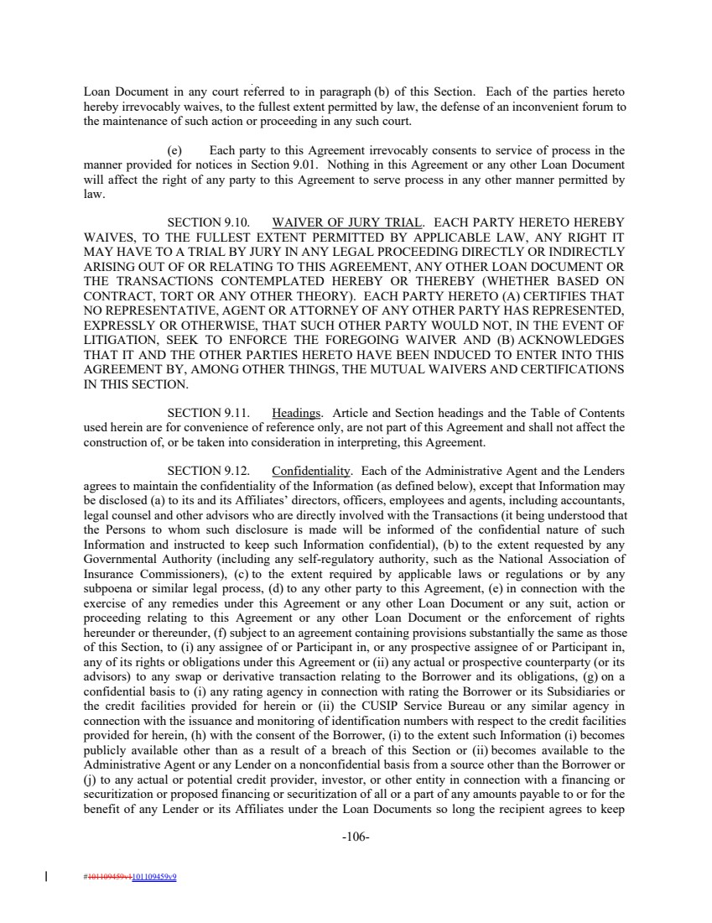 | Loan Document in any court referred to in paragraph (b) of this Section. Each of the parties hereto hereby irrevocably waives, to the fullest extent permitted by law, the defense of an inconvenient forum to the maintenance of such action or proceeding in any such court. (e) Each party to this Agreement irrevocably consents to service of process in the manner provided for notices in Section 9.01. Nothing in this Agreement or any other Loan Document will affect the right of any party to this Agreement to serve process in any other manner permitted by law. SECTION 9.10. WAIVER OF JURY TRIAL. EACH PARTY HERETO HEREBY WAIVES, TO THE FULLEST EXTENT PERMITTED BY APPLICABLE LAW, ANY RIGHT IT MAY HAVE TO A TRIAL BY JURY IN ANY LEGAL PROCEEDING DIRECTLY OR INDIRECTLY ARISING OUT OF OR RELATING TO THIS AGREEMENT, ANY OTHER LOAN DOCUMENT OR THE TRANSACTIONS CONTEMPLATED HEREBY OR THEREBY (WHETHER BASED ON CONTRACT, TORT OR ANY OTHER THEORY). EACH PARTY HERETO (A) CERTIFIES THAT NO REPRESENTATIVE, AGENT OR ATTORNEY OF ANY OTHER PARTY HAS REPRESENTED, EXPRESSLY OR OTHERWISE, THAT SUCH OTHER PARTY WOULD NOT, IN THE EVENT OF LITIGATION, SEEK TO ENFORCE THE FOREGOING WAIVER AND (B) ACKNOWLEDGES THAT IT AND THE OTHER PARTIES HERETO HAVE BEEN INDUCED TO ENTER INTO THIS AGREEMENT BY, AMONG OTHER THINGS, THE MUTUAL WAIVERS AND CERTIFICATIONS IN THIS SECTION. SECTION 9.11. Headings. Article and Section headings and the Table of Contents used herein are for convenience of reference only, are not part of this Agreement and shall not affect the construction of, or be taken into consideration in interpreting, this Agreement. SECTION 9.12. Confidentiality. Each of the Administrative Agent and the Lenders agrees to maintain the confidentiality of the Information (as defined below), except that Information may be disclosed (a) to its and its Affiliates’ directors, officers, employees and agents, including accountants, legal counsel and other advisors who are directly involved with the Transactions (it being understood that the Persons to whom such disclosure is made will be informed of the confidential nature of such Information and instructed to keep such Information confidential), (b) to the extent requested by any Governmental Authority (including any self-regulatory authority, such as the National Association of Insurance Commissioners), (c) to the extent required by applicable laws or regulations or by any subpoena or similar legal process, (d) to any other party to this Agreement, (e) in connection with the exercise of any remedies under this Agreement or any other Loan Document or any suit, action or proceeding relating to this Agreement or any other Loan Document or the enforcement of rights hereunder or thereunder, (f) subject to an agreement containing provisions substantially the same as those of this Section, to (i) any assignee of or Participant in, or any prospective assignee of or Participant in, any of its rights or obligations under this Agreement or (ii) any actual or prospective counterparty (or its advisors) to any swap or derivative transaction relating to the Borrower and its obligations, (g) on a confidential basis to (i) any rating agency in connection with rating the Borrower or its Subsidiaries or the credit facilities provided for herein or (ii) the CUSIP Service Bureau or any similar agency in connection with the issuance and monitoring of identification numbers with respect to the credit facilities provided for herein, (h) with the consent of the Borrower, (i) to the extent such Information (i) becomes publicly available other than as a result of a breach of this Section or (ii) becomes available to the Administrative Agent or any Lender on a nonconfidential basis from a source other than the Borrower or (j) to any actual or potential credit provider, investor, or other entity in connection with a financing or securitization or proposed financing or securitization of all or a part of any amounts payable to or for the benefit of any Lender or its Affiliates under the Loan Documents so long the recipient agrees to keep -106- #101109459v1101109459v9
 | 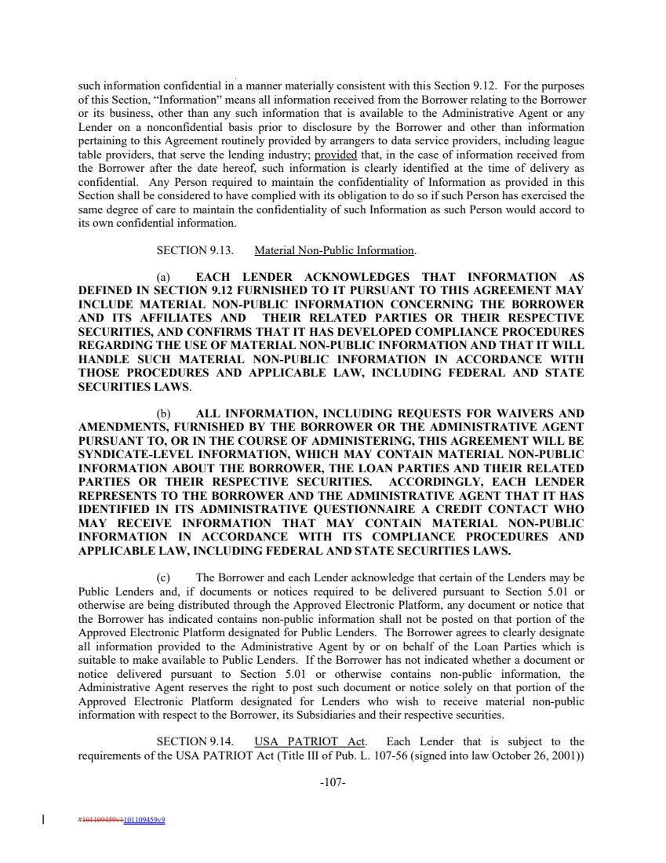 | such information confidential in a manner materially consistent with this Section 9.12. For the purposes of this Section, “Information” means all information received from the Borrower relating to the Borrower or its business, other than any such information that is available to the Administrative Agent or any Lender on a nonconfidential basis prior to disclosure by the Borrower and other than information pertaining to this Agreement routinely provided by arrangers to data service providers, including league table providers, that serve the lending industry; provided that, in the case of information received from the Borrower after the date hereof, such information is clearly identified at the time of delivery as confidential. Any Person required to maintain the confidentiality of Information as provided in this Section shall be considered to have complied with its obligation to do so if such Person has exercised the same degree of care to maintain the confidentiality of such Information as such Person would accord to its own confidential information. SECTION 9.13. Material Non-Public Information. (a) EACH LENDER ACKNOWLEDGES THAT INFORMATION AS DEFINED IN SECTION 9.12 FURNISHED TO IT PURSUANT TO THIS AGREEMENT MAY INCLUDE MATERIAL NON-PUBLIC INFORMATION CONCERNING THE BORROWER AND ITS AFFILIATES AND THEIR RELATED PARTIES OR THEIR RESPECTIVE SECURITIES, AND CONFIRMS THAT IT HAS DEVELOPED COMPLIANCE PROCEDURES REGARDING THE USE OF MATERIAL NON-PUBLIC INFORMATION AND THAT IT WILL HANDLE SUCH MATERIAL NON-PUBLIC INFORMATION IN ACCORDANCE WITH THOSE PROCEDURES AND APPLICABLE LAW, INCLUDING FEDERAL AND STATE SECURITIES LAWS. (b) ALL INFORMATION, INCLUDING REQUESTS FOR WAIVERS AND AMENDMENTS, FURNISHED BY THE BORROWER OR THE ADMINISTRATIVE AGENT PURSUANT TO, OR IN THE COURSE OF ADMINISTERING, THIS AGREEMENT WILL BE SYNDICATE-LEVEL INFORMATION, WHICH MAY CONTAIN MATERIAL NON-PUBLIC INFORMATION ABOUT THE BORROWER, THE LOAN PARTIES AND THEIR RELATED PARTIES OR THEIR RESPECTIVE SECURITIES. ACCORDINGLY, EACH LENDER REPRESENTS TO THE BORROWER AND THE ADMINISTRATIVE AGENT THAT IT HAS IDENTIFIED IN ITS ADMINISTRATIVE QUESTIONNAIRE A CREDIT CONTACT WHO MAY RECEIVE INFORMATION THAT MAY CONTAIN MATERIAL NON-PUBLIC INFORMATION IN ACCORDANCE WITH ITS COMPLIANCE PROCEDURES AND APPLICABLE LAW, INCLUDING FEDERAL AND STATE SECURITIES LAWS. (c) The Borrower and each Lender acknowledge that certain of the Lenders may be Public Lenders and, if documents or notices required to be delivered pursuant to Section 5.01 or otherwise are being distributed through the Approved Electronic Platform, any document or notice that the Borrower has indicated contains non-public information shall not be posted on that portion of the Approved Electronic Platform designated for Public Lenders. The Borrower agrees to clearly designate all information provided to the Administrative Agent by or on behalf of the Loan Parties which is suitable to make available to Public Lenders. If the Borrower has not indicated whether a document or notice delivered pursuant to Section 5.01 or otherwise contains non-public information, the Administrative Agent reserves the right to post such document or notice solely on that portion of the Approved Electronic Platform designated for Lenders who wish to receive material non-public information with respect to the Borrower, its Subsidiaries and their respective securities. SECTION 9.14. USA PATRIOT Act. Each Lender that is subject to the requirements of the USA PATRIOT Act (Title III of Pub. L. 107-56 (signed into law October 26, 2001)) -107- #101109459v1101109459v9
 | 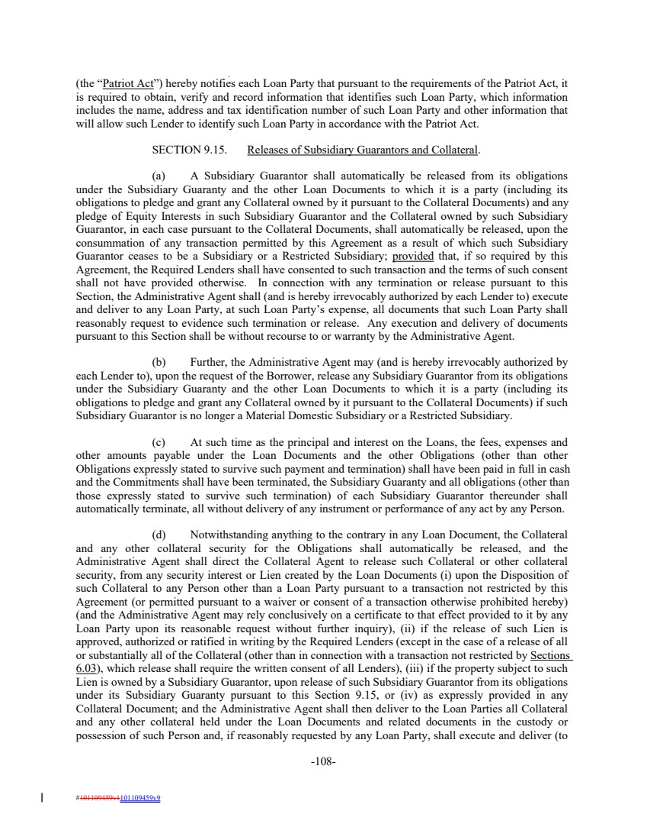 | (the “Patriot Act”) hereby notifies each Loan Party that pursuant to the requirements of the Patriot Act, it is required to obtain, verify and record information that identifies such Loan Party, which information includes the name, address and tax identification number of such Loan Party and other information that will allow such Lender to identify such Loan Party in accordance with the Patriot Act. SECTION 9.15. Releases of Subsidiary Guarantors and Collateral. (a) A Subsidiary Guarantor shall automatically be released from its obligations under the Subsidiary Guaranty and the other Loan Documents to which it is a party (including its obligations to pledge and grant any Collateral owned by it pursuant to the Collateral Documents) and any pledge of Equity Interests in such Subsidiary Guarantor and the Collateral owned by such Subsidiary Guarantor, in each case pursuant to the Collateral Documents, shall automatically be released, upon the consummation of any transaction permitted by this Agreement as a result of which such Subsidiary Guarantor ceases to be a Subsidiary or a Restricted Subsidiary; provided that, if so required by this Agreement, the Required Lenders shall have consented to such transaction and the terms of such consent shall not have provided otherwise. In connection with any termination or release pursuant to this Section, the Administrative Agent shall (and is hereby irrevocably authorized by each Lender to) execute and deliver to any Loan Party, at such Loan Party’s expense, all documents that such Loan Party shall reasonably request to evidence such termination or release. Any execution and delivery of documents pursuant to this Section shall be without recourse to or warranty by the Administrative Agent. (b) Further, the Administrative Agent may (and is hereby irrevocably authorized by each Lender to), upon the request of the Borrower, release any Subsidiary Guarantor from its obligations under the Subsidiary Guaranty and the other Loan Documents to which it is a party (including its obligations to pledge and grant any Collateral owned by it pursuant to the Collateral Documents) if such Subsidiary Guarantor is no longer a Material Domestic Subsidiary or a Restricted Subsidiary. (c) At such time as the principal and interest on the Loans, the fees, expenses and other amounts payable under the Loan Documents and the other Obligations (other than other Obligations expressly stated to survive such payment and termination) shall have been paid in full in cash and the Commitments shall have been terminated, the Subsidiary Guaranty and all obligations (other than those expressly stated to survive such termination) of each Subsidiary Guarantor thereunder shall automatically terminate, all without delivery of any instrument or performance of any act by any Person. (d) Notwithstanding anything to the contrary in any Loan Document, the Collateral and any other collateral security for the Obligations shall automatically be released, and the Administrative Agent shall direct the Collateral Agent to release such Collateral or other collateral security, from any security interest or Lien created by the Loan Documents (i) upon the Disposition of such Collateral to any Person other than a Loan Party pursuant to a transaction not restricted by this Agreement (or permitted pursuant to a waiver or consent of a transaction otherwise prohibited hereby) (and the Administrative Agent may rely conclusively on a certificate to that effect provided to it by any Loan Party upon its reasonable request without further inquiry), (ii) if the release of such Lien is approved, authorized or ratified in writing by the Required Lenders (except in the case of a release of all or substantially all of the Collateral (other than in connection with a transaction not restricted by Sections 6.03), which release shall require the written consent of all Lenders), (iii) if the property subject to such Lien is owned by a Subsidiary Guarantor, upon release of such Subsidiary Guarantor from its obligations under its Subsidiary Guaranty pursuant to this Section 9.15, or (iv) as expressly provided in any Collateral Document; and the Administrative Agent shall then deliver to the Loan Parties all Collateral and any other collateral held under the Loan Documents and related documents in the custody or possession of such Person and, if reasonably requested by any Loan Party, shall execute and deliver (to -108- #101109459v1101109459v9
 | 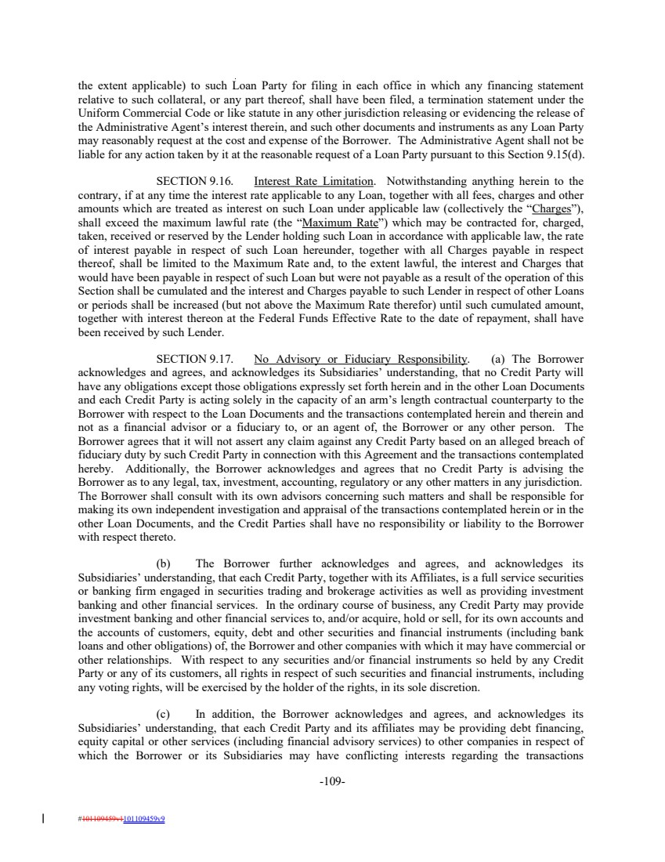 | the extent applicable) to such Loan Party for filing in each office in which any financing statement relative to such collateral, or any part thereof, shall have been filed, a termination statement under the Uniform Commercial Code or like statute in any other jurisdiction releasing or evidencing the release of the Administrative Agent’s interest therein, and such other documents and instruments as any Loan Party may reasonably request at the cost and expense of the Borrower. The Administrative Agent shall not be liable for any action taken by it at the reasonable request of a Loan Party pursuant to this Section 9.15(d). SECTION 9.16. Interest Rate Limitation. Notwithstanding anything herein to the contrary, if at any time the interest rate applicable to any Loan, together with all fees, charges and other amounts which are treated as interest on such Loan under applicable law (collectively the “Charges”), shall exceed the maximum lawful rate (the “Maximum Rate”) which may be contracted for, charged, taken, received or reserved by the Lender holding such Loan in accordance with applicable law, the rate of interest payable in respect of such Loan hereunder, together with all Charges payable in respect thereof, shall be limited to the Maximum Rate and, to the extent lawful, the interest and Charges that would have been payable in respect of such Loan but were not payable as a result of the operation of this Section shall be cumulated and the interest and Charges payable to such Lender in respect of other Loans or periods shall be increased (but not above the Maximum Rate therefor) until such cumulated amount, together with interest thereon at the Federal Funds Effective Rate to the date of repayment, shall have been received by such Lender. SECTION 9.17. No Advisory or Fiduciary Responsibility. (a) The Borrower acknowledges and agrees, and acknowledges its Subsidiaries’ understanding, that no Credit Party will have any obligations except those obligations expressly set forth herein and in the other Loan Documents and each Credit Party is acting solely in the capacity of an arm’s length contractual counterparty to the Borrower with respect to the Loan Documents and the transactions contemplated herein and therein and not as a financial advisor or a fiduciary to, or an agent of, the Borrower or any other person. The Borrower agrees that it will not assert any claim against any Credit Party based on an alleged breach of fiduciary duty by such Credit Party in connection with this Agreement and the transactions contemplated hereby. Additionally, the Borrower acknowledges and agrees that no Credit Party is advising the Borrower as to any legal, tax, investment, accounting, regulatory or any other matters in any jurisdiction. The Borrower shall consult with its own advisors concerning such matters and shall be responsible for making its own independent investigation and appraisal of the transactions contemplated herein or in the other Loan Documents, and the Credit Parties shall have no responsibility or liability to the Borrower with respect thereto. (b) The Borrower further acknowledges and agrees, and acknowledges its Subsidiaries’ understanding, that each Credit Party, together with its Affiliates, is a full service securities or banking firm engaged in securities trading and brokerage activities as well as providing investment banking and other financial services. In the ordinary course of business, any Credit Party may provide investment banking and other financial services to, and/or acquire, hold or sell, for its own accounts and the accounts of customers, equity, debt and other securities and financial instruments (including bank loans and other obligations) of, the Borrower and other companies with which it may have commercial or other relationships. With respect to any securities and/or financial instruments so held by any Credit Party or any of its customers, all rights in respect of such securities and financial instruments, including any voting rights, will be exercised by the holder of the rights, in its sole discretion. (c) In addition, the Borrower acknowledges and agrees, and acknowledges its Subsidiaries’ understanding, that each Credit Party and its affiliates may be providing debt financing, equity capital or other services (including financial advisory services) to other companies in respect of which the Borrower or its Subsidiaries may have conflicting interests regarding the transactions -109- #101109459v1101109459v9
 | 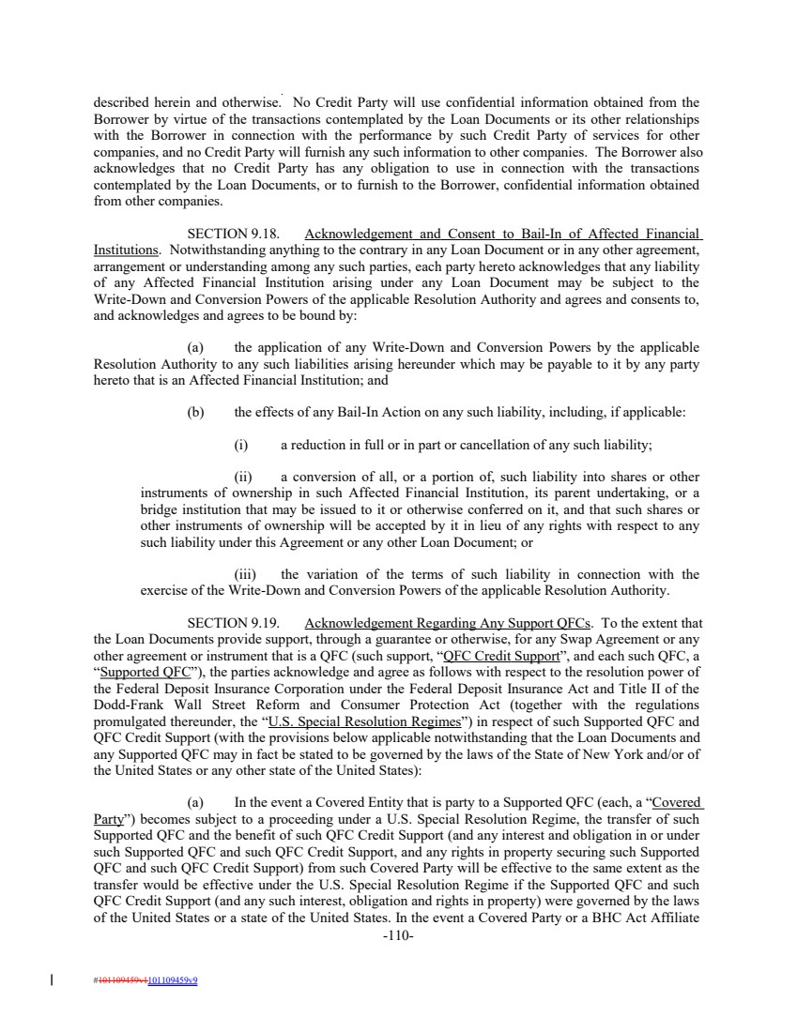 | described herein and otherwise. No Credit Party will use confidential information obtained from the Borrower by virtue of the transactions contemplated by the Loan Documents or its other relationships with the Borrower in connection with the performance by such Credit Party of services for other companies, and no Credit Party will furnish any such information to other companies. The Borrower also acknowledges that no Credit Party has any obligation to use in connection with the transactions contemplated by the Loan Documents, or to furnish to the Borrower, confidential information obtained from other companies. SECTION 9.18. Acknowledgement and Consent to Bail-In of Affected Financial Institutions. Notwithstanding anything to the contrary in any Loan Document or in any other agreement, arrangement or understanding among any such parties, each party hereto acknowledges that any liability of any Affected Financial Institution arising under any Loan Document may be subject to the Write-Down and Conversion Powers of the applicable Resolution Authority and agrees and consents to, and acknowledges and agrees to be bound by: (a) the application of any Write-Down and Conversion Powers by the applicable Resolution Authority to any such liabilities arising hereunder which may be payable to it by any party hereto that is an Affected Financial Institution; and (b) the effects of any Bail-In Action on any such liability, including, if applicable: (i) a reduction in full or in part or cancellation of any such liability; (ii) a conversion of all, or a portion of, such liability into shares or other instruments of ownership in such Affected Financial Institution, its parent undertaking, or a bridge institution that may be issued to it or otherwise conferred on it, and that such shares or other instruments of ownership will be accepted by it in lieu of any rights with respect to any such liability under this Agreement or any other Loan Document; or (iii) the variation of the terms of such liability in connection with the exercise of the Write-Down and Conversion Powers of the applicable Resolution Authority. SECTION 9.19. Acknowledgement Regarding Any Support QFCs. To the extent that the Loan Documents provide support, through a guarantee or otherwise, for any Swap Agreement or any other agreement or instrument that is a QFC (such support, “QFC Credit Support”, and each such QFC, a “Supported QFC”), the parties acknowledge and agree as follows with respect to the resolution power of the Federal Deposit Insurance Corporation under the Federal Deposit Insurance Act and Title II of the Dodd-Frank Wall Street Reform and Consumer Protection Act (together with the regulations promulgated thereunder, the “U.S. Special Resolution Regimes”) in respect of such Supported QFC and QFC Credit Support (with the provisions below applicable notwithstanding that the Loan Documents and any Supported QFC may in fact be stated to be governed by the laws of the State of New York and/or of the United States or any other state of the United States): (a) In the event a Covered Entity that is party to a Supported QFC (each, a “Covered Party”) becomes subject to a proceeding under a U.S. Special Resolution Regime, the transfer of such Supported QFC and the benefit of such QFC Credit Support (and any interest and obligation in or under such Supported QFC and such QFC Credit Support, and any rights in property securing such Supported QFC and such QFC Credit Support) from such Covered Party will be effective to the same extent as the transfer would be effective under the U.S. Special Resolution Regime if the Supported QFC and such QFC Credit Support (and any such interest, obligation and rights in property) were governed by the laws of the United States or a state of the United States. In the event a Covered Party or a BHC Act Affiliate -110- #101109459v1101109459v9
 | 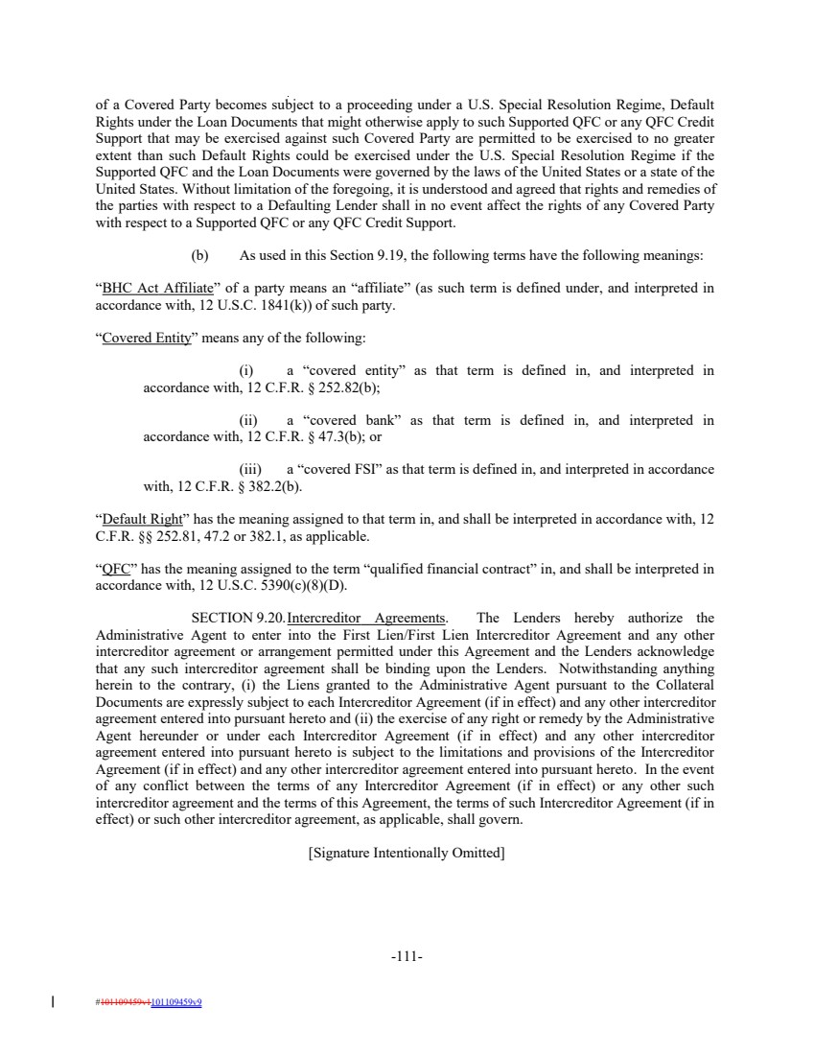 | of a Covered Party becomes subject to a proceeding under a U.S. Special Resolution Regime, Default Rights under the Loan Documents that might otherwise apply to such Supported QFC or any QFC Credit Support that may be exercised against such Covered Party are permitted to be exercised to no greater extent than such Default Rights could be exercised under the U.S. Special Resolution Regime if the Supported QFC and the Loan Documents were governed by the laws of the United States or a state of the United States. Without limitation of the foregoing, it is understood and agreed that rights and remedies of the parties with respect to a Defaulting Lender shall in no event affect the rights of any Covered Party with respect to a Supported QFC or any QFC Credit Support. (b) As used in this Section 9.19, the following terms have the following meanings: “BHC Act Affiliate” of a party means an “affiliate” (as such term is defined under, and interpreted in accordance with, 12 U.S.C. 1841(k)) of such party. “Covered Entity” means any of the following: (i) a “covered entity” as that term is defined in, and interpreted in accordance with, 12 C.F.R. § 252.82(b); (ii) a “covered bank” as that term is defined in, and interpreted in accordance with, 12 C.F.R. § 47.3(b); or (iii) a “covered FSI” as that term is defined in, and interpreted in accordance with, 12 C.F.R. § 382.2(b). “Default Right” has the meaning assigned to that term in, and shall be interpreted in accordance with, 12 C.F.R. §§ 252.81, 47.2 or 382.1, as applicable. “QFC” has the meaning assigned to the term “qualified financial contract” in, and shall be interpreted in accordance with, 12 U.S.C. 5390(c)(8)(D). SECTION 9.20.Intercreditor Agreements. The Lenders hereby authorize the Administrative Agent to enter into the First Lien/First Lien Intercreditor Agreement and any other intercreditor agreement or arrangement permitted under this Agreement and the Lenders acknowledge that any such intercreditor agreement shall be binding upon the Lenders. Notwithstanding anything herein to the contrary, (i) the Liens granted to the Administrative Agent pursuant to the Collateral Documents are expressly subject to each Intercreditor Agreement (if in effect) and any other intercreditor agreement entered into pursuant hereto and (ii) the exercise of any right or remedy by the Administrative Agent hereunder or under each Intercreditor Agreement (if in effect) and any other intercreditor agreement entered into pursuant hereto is subject to the limitations and provisions of the Intercreditor Agreement (if in effect) and any other intercreditor agreement entered into pursuant hereto. In the event of any conflict between the terms of any Intercreditor Agreement (if in effect) or any other such intercreditor agreement and the terms of this Agreement, the terms of such Intercreditor Agreement (if in effect) or such other intercreditor agreement, as applicable, shall govern. [Signature Intentionally Omitted] -111- #101109459v1101109459v9

