​
​
​
UNITED STATES
SECURITIES AND EXCHANGE COMMISSION
WASHINGTON, D.C. 20549
FORM 8-K
CURRENT REPORT
Pursuant to Section 13 or 15(d)
of The Securities Exchange Act of 1934
Date of Report (Date of earliest event reported): September 28, 2026
UGI Corporation
(Exact Name of Registrant as Specified in Its Charter)
​ | ​ | ​
Pennsylvania  (State or Other Jurisdiction  of Incorporation) | 1-11071  (Commission  File Number) | 23-2668356  (IRS Employer  Identification No.)
​
500 North Gulph Road, King of Prussia, PA 19406
(Address of Principal Executive Offices) (Zip Code)
Registrant’s Telephone Number, Including Area Code: 610 337-1000
Not Applicable
Former Name or Former Address, if Changed Since Last Report
Check the appropriate box below if the Form 8-K filing is intended to simultaneously satisfy the filing obligation of the registrant under any of the following provisions:
☐ | Written communications pursuant to Rule 425 under the Securities Act (17 CFR 230.425)
☐ | Soliciting material pursuant to Rule 14a-12 under the Exchange Act (17 CFR 240.14a-12)
☐ | Pre-commencement communications pursuant to Rule 14d-2(b) under the Exchange Act (17 CFR 240.14d-2(b))
☐ | Pre-commencement communications pursuant to Rule 13e-4(c) under the Exchange Act (17 CFR 240.13e-4(c))
Securities registered pursuant to Section 12(b) of the Act:

​ | ​ | ​ | ​ | ​
Title of each class | ​ ​ ​ | Trading  Symbol(s) | ​ ​ ​ | Name of each exchange  on which registered
Common Stock, without par value | ​ | UGI | ​ | New York Stock Exchange
​
Indicate by check mark whether the registrant is an emerging growth company as defined in Rule 405 of the Securities Act of 1933 (§230.405 of this chapter) or Rule 12b-2 of the Securities Exchange Act of 1934 (§240.12b-2 of this chapter).
Emerging growth company ☐
If an emerging growth company, indicate by check mark if the registrant has elected not to use the extended transition period for complying with any new or revised financial accounting standards provided pursuant to Section 13(a) of the Exchange Act. ☐
​
​
​
​
​
Item 1.01. Entry into a Material Definitive Agreement.
On September 28, 2026, Mountaineer Gas Company (“Mountaineer”), a West Virginia corporation and an indirect, wholly owned subsidiary of UGI Corporation (the “Company”), entered into a Note Purchase Agreement (the “Note Purchase Agreement”) with certain persons relating to the private placement of $30 million aggregate principal amount of 5.95% Senior Notes, Series H, with a maturity date of September 28, 2038 (the “Series H Notes”) and $20 million aggregate principal amount of 6.05% Senior Notes, Series I, with a maturity date of September 28, 2041 (the “Series I Notes,” and together with the Series H Notes, the “Notes”). The private placement of the Notes is exempt from registration under the Securities Act of 1933, as amended. Funding of the Notes occurred on September 28, 2026. Interest payments on the Notes will be payable semiannually on March 28th and September 28th of each year. The Notes will be unsecured and unsubordinated obligations of Mountaineer, ranking pari passu in all respects with Mountaineer’s existing and future unsecured and unsubordinated indebtedness. If any subsidiary guarantees or otherwise becomes liable for Mountaineer’s obligations under a material credit facility, the subsidiary will provide a guaranty of payment of the Notes and compliance with the Note Purchase Agreement. Proceeds from the Notes will be used primarily to refinance indebtedness and for general corporate purposes. The pricing of the Notes occurred on June 30, 2026.
The Note Purchase Agreement includes the usual and customary covenants for note purchase agreements of this type, including, among others, covenants relating to the maintenance of existence, payment of taxes when due, compliance with laws, maintenance of properties in good repair, compliance with the Office of Foreign Assets Control of the United States Department of the Treasury, maintenance of insurance, maintenance of books and records, pari passu ranking, merger and consolidation, line of business, antiterrorism and sanctions, and change in control. The Note Purchase Agreement also contains restrictive and financial covenants, specifying, among other things, that the sale of assets is limited to 15% of consolidated total assets in any fiscal year subject to safe harbors for debt prepayment or property reinvestments and specified exclusions, that priority indebtedness (excluding certain indebtedness of subsidiaries) will not at any time exceed 15% of consolidated tangible net worth, that the ratio of total debt to total capitalization will not at any time exceed 0.65 to 1.00, that the ratio of consolidated EBITDA to consolidated interest expense of Mountaineer shall not be less than 2.00 to 1.00 and that Mountaineer’s consolidated tangible net worth will not be less than $70 million at any time.
The Note Purchase Agreement also contains customary events of default, including, without limitation, failure to pay principal and make whole amount when due at maturity or otherwise, failure to pay interest within five business days of the due date, failure to satisfy any financial covenant or negative covenant, failure to comply with the affirmative covenants within a 30-day grace period, default beyond the applicable grace period for payments on other borrowings and cross acceleration for acceleration of other borrowings as a result of non-monetary defaults provided that either of such defaults relates to indebtedness in an aggregate principal amount of $25 million or more, certain events of bankruptcy or insolvency of Mountaineer and its material subsidiaries, judgment defaults provided such judgment relates to the payment of money aggregating in excess of $25 million, and material ERISA defaults.
Each of the Series H and Series I Notes are callable by Mountaineer, in whole or in part, (i) at any time at a price equal to 100% of the principal amount thereof, plus the applicable “make-whole” amount and accrued and unpaid interest thereon to the date of prepayment, and (ii) at any time after June 30, 2038 and June 30, 2041, respectively, at 100% of the principal amount thereof, plus accrued and unpaid interest thereon to the date of prepayment, but without the payment of the “make-whole” amount. Holders of the Notes have a right to require prepayment of the principal amount of the Notes, together with interest accrued thereon, if Mountaineer ceases for any reason to be directly or indirectly majority owned, beneficially and of record, by the Company, including, without limitation, if the Company ceases to own (beneficially and of record), directly or indirectly, voting stock of Mountaineer representing 51% or more of the combined voting power of all voting stock of Mountaineer and 51% or more of the economic interests in Mountaineer, or if Mountaineer or any of its subsidiaries executes any agreement that may reasonably be expected to result in a change of control and if none of Fitch, Moody’s or Standard & Poor’s at such time is providing a debt rating for Mountaineer or at such time Mountaineer’s debt rating is below BBB- by Fitch, below Baa3 by Moody’s or below BBB- by Standard & Poor’s or there is a rating decline within 60 days of such event.
The foregoing description of the Note Purchase Agreement does not purport to be complete and is qualified in its entirety by reference to the Note Purchase Agreement, which is filed as Exhibit 4.1 to this Current Report on Form 8-K and is incorporated herein by reference.
​
​
Item 2.03. Creation of a Direct Financial Obligation or an Obligation under an Off-Balance Sheet Arrangement of a Registrant.
The information set forth above in Item 1.01 regarding the Note Purchase Agreement is hereby incorporated into this Item 2.03 by reference. This description is qualified in its entirety by reference to the full text of the Note Purchase Agreement, which is filed as Exhibit 4.1 to this Current Report on Form 8-K and is incorporated herein by reference.
Item 9.01. Financial Statements and Exhibits.
(d) Exhibits.
​
​ | ​ | ​
Exhibit  Number: | ​ ​ ​ | Description
4.1 | ​ | Note Purchase Agreement, dated September 28, 2026, by and among Mountaineer Gas Company and the purchasers listed as signatories thereto.
​ | ​ | ​
104 | ​ | Cover Page Interactive Data File (formatted as inline XBRL).
​
​
​
​
SIGNATURES
Pursuant to the requirements of the Securities Exchange Act of 1934, the registrant has duly caused this report to be signed on its behalf by the undersigned hereunto duly authorized.
​ | ​ | UGI Corporation
​ | ​ | ​
October 2, 2026 | ​ | By: | /s/ Jessica A. Milner
​ | ​ | Name: | Jessica A. Milner
​ | ​ | Title: | Secretary
​ | ​ | ​
​
​

 | 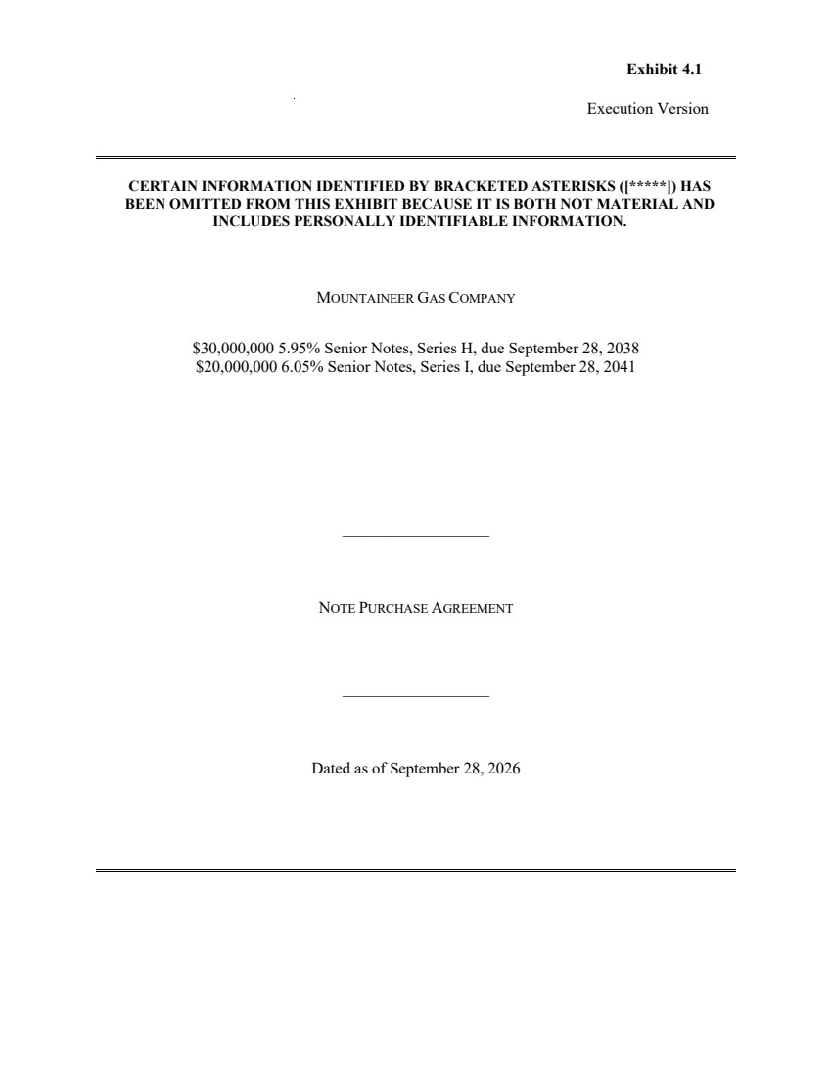 | Execution Version MOUNTAINEER GAS COMPANY $30,000,000 5.95% Senior Notes, Series H, due September 28, 2038 $20,000,000 6.05% Senior Notes, Series I, due September 28, 2041 __________________ NOTE PURCHASE AGREEMENT __________________ Dated as of September 28, 2026 Exhibit 4.1 CERTAIN INFORMATION IDENTIFIED BY BRACKETED ASTERISKS ([*****]) HAS BEEN OMITTED FROM THIS EXHIBIT BECAUSE IT IS BOTH NOT MATERIAL AND INCLUDES PERSONALLY IDENTIFIABLE INFORMATION.
 | 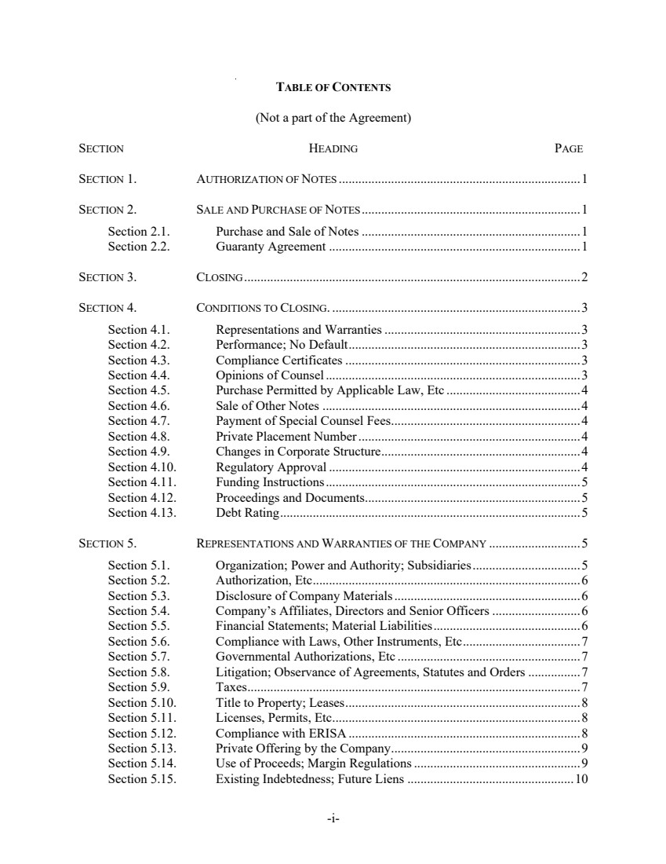 | -i-TABLE OF CONTENTS (Not a part of the Agreement) SECTION HEADING PAGE SECTION 1. AUTHORIZATION OF NOTES ..........................................................................1 SECTION 2. SALE AND PURCHASE OF NOTES...................................................................1 Section 2.1. Purchase and Sale of Notes ...................................................................1 Section 2.2. Guaranty Agreement .............................................................................1 SECTION 3. CLOSING.......................................................................................................2 SECTION 4. CONDITIONS TO CLOSING. ............................................................................3 Section 4.1. Representations and Warranties............................................................3 Section 4.2. Performance; No Default.......................................................................3 Section 4.3. Compliance Certificates ........................................................................3 Section 4.4. Opinions of Counsel..............................................................................3 Section 4.5. Purchase Permitted by Applicable Law, Etc .........................................4 Section 4.6. Sale of Other Notes ...............................................................................4 Section 4.7. Payment of Special Counsel Fees..........................................................4 Section 4.8. Private Placement Number....................................................................4 Section 4.9. Changes in Corporate Structure.............................................................4 Section 4.10. Regulatory Approval .............................................................................4 Section 4.11. Funding Instructions..............................................................................5 Section 4.12. Proceedings and Documents..................................................................5 Section 4.13. Debt Rating............................................................................................5 SECTION 5. REPRESENTATIONS AND WARRANTIES OF THE COMPANY ............................5 Section 5.1. Organization; Power and Authority; Subsidiaries.................................5 Section 5.2. Authorization, Etc..................................................................................6 Section 5.3. Disclosure of Company Materials.........................................................6 Section 5.4. Company’s Affiliates, Directors and Senior Officers ...........................6 Section 5.5. Financial Statements; Material Liabilities.............................................6 Section 5.6. Compliance with Laws, Other Instruments, Etc....................................7 Section 5.7. Governmental Authorizations, Etc ........................................................7 Section 5.8. Litigation; Observance of Agreements, Statutes and Orders ................7 Section 5.9. Taxes......................................................................................................7 Section 5.10. Title to Property; Leases........................................................................8 Section 5.11. Licenses, Permits, Etc............................................................................8 Section 5.12. Compliance with ERISA .......................................................................8 Section 5.13. Private Offering by the Company..........................................................9 Section 5.14. Use of Proceeds; Margin Regulations...................................................9 Section 5.15. Existing Indebtedness; Future Liens ...................................................10
 | 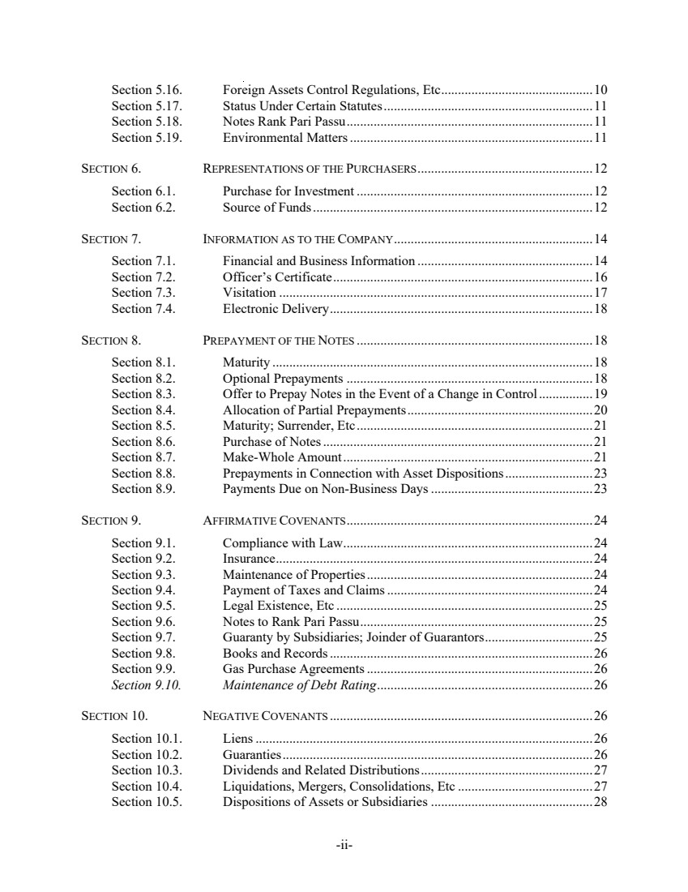 | -ii-Section 5.16. Foreign Assets Control Regulations, Etc.............................................10 Section 5.17. Status Under Certain Statutes..............................................................11 Section 5.18. Notes Rank Pari Passu.........................................................................11 Section 5.19. Environmental Matters........................................................................11 SECTION 6. REPRESENTATIONS OF THE PURCHASERS....................................................12 Section 6.1. Purchase for Investment ......................................................................12 Section 6.2. Source of Funds...................................................................................12 SECTION 7. INFORMATION AS TO THE COMPANY...........................................................14 Section 7.1. Financial and Business Information ....................................................14 Section 7.2. Officer’s Certificate.............................................................................16 Section 7.3. Visitation .............................................................................................17 Section 7.4. Electronic Delivery..............................................................................18 SECTION 8. PREPAYMENT OF THE NOTES ......................................................................18 Section 8.1. Maturity ...............................................................................................18 Section 8.2. Optional Prepayments .........................................................................18 Section 8.3. Offer to Prepay Notes in the Event of a Change in Control................19 Section 8.4. Allocation of Partial Prepayments.......................................................20 Section 8.5. Maturity; Surrender, Etc......................................................................21 Section 8.6. Purchase of Notes................................................................................21 Section 8.7. Make-Whole Amount..........................................................................21 Section 8.8. Prepayments in Connection with Asset Dispositions..........................23 Section 8.9. Payments Due on Non-Business Days................................................23 SECTION 9. AFFIRMATIVE COVENANTS.........................................................................24 Section 9.1. Compliance with Law..........................................................................24 Section 9.2. Insurance..............................................................................................24 Section 9.3. Maintenance of Properties...................................................................24 Section 9.4. Payment of Taxes and Claims.............................................................24 Section 9.5. Legal Existence, Etc ............................................................................25 Section 9.6. Notes to Rank Pari Passu.....................................................................25 Section 9.7. Guaranty by Subsidiaries; Joinder of Guarantors................................25 Section 9.8. Books and Records..............................................................................26 Section 9.9. Gas Purchase Agreements...................................................................26 Section 9.10. Maintenance of Debt Rating................................................................26 SECTION 10. NEGATIVE COVENANTS ..............................................................................26 Section 10.1. Liens....................................................................................................26 Section 10.2. Guaranties............................................................................................26 Section 10.3. Dividends and Related Distributions...................................................27 Section 10.4. Liquidations, Mergers, Consolidations, Etc ........................................27 Section 10.5. Dispositions of Assets or Subsidiaries ................................................28
 | 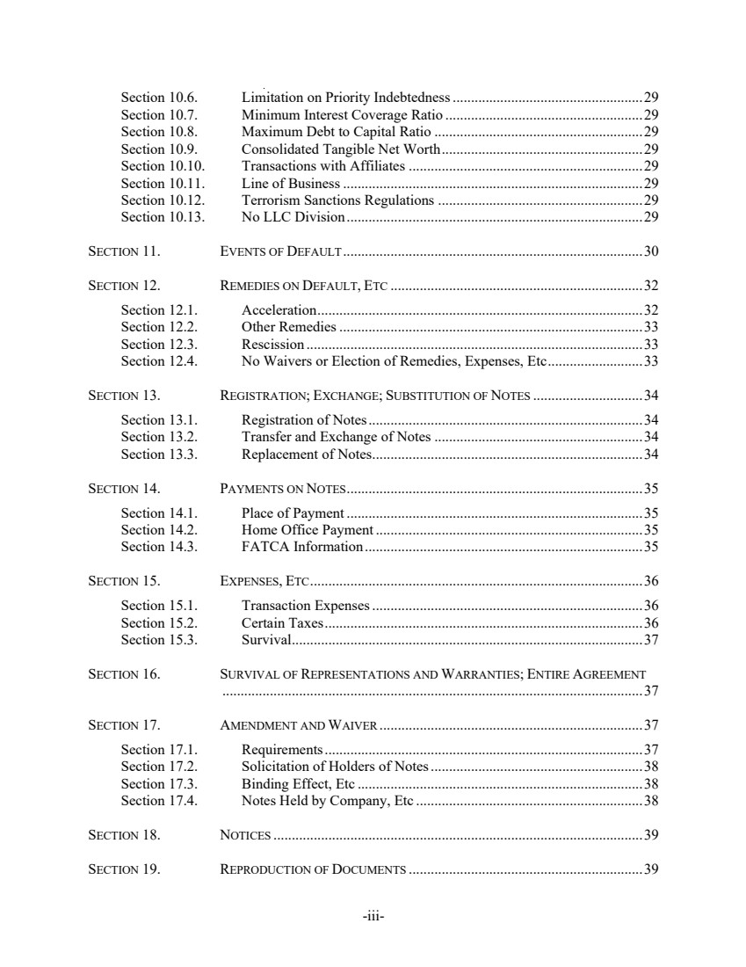 | -iii-Section 10.6. Limitation on Priority Indebtedness....................................................29 Section 10.7. Minimum Interest Coverage Ratio ......................................................29 Section 10.8. Maximum Debt to Capital Ratio .........................................................29 Section 10.9. Consolidated Tangible Net Worth.......................................................29 Section 10.10. Transactions with Affiliates ................................................................29 Section 10.11. Line of Business..................................................................................29 Section 10.12. Terrorism Sanctions Regulations ........................................................29 Section 10.13. No LLC Division.................................................................................29 SECTION 11. EVENTS OF DEFAULT..................................................................................30 SECTION 12. REMEDIES ON DEFAULT, ETC .....................................................................32 Section 12.1. Acceleration.........................................................................................32 Section 12.2. Other Remedies...................................................................................33 Section 12.3. Rescission ............................................................................................33 Section 12.4. No Waivers or Election of Remedies, Expenses, Etc..........................33 SECTION 13. REGISTRATION; EXCHANGE; SUBSTITUTION OF NOTES ..............................34 Section 13.1. Registration of Notes...........................................................................34 Section 13.2. Transfer and Exchange of Notes .........................................................34 Section 13.3. Replacement of Notes..........................................................................34 SECTION 14. PAYMENTS ON NOTES.................................................................................35 Section 14.1. Place of Payment .................................................................................35 Section 14.2. Home Office Payment .........................................................................35 Section 14.3. FATCA Information............................................................................35 SECTION 15. EXPENSES, ETC...........................................................................................36 Section 15.1. Transaction Expenses..........................................................................36 Section 15.2. Certain Taxes.......................................................................................36 Section 15.3. Survival................................................................................................37 SECTION 16. SURVIVAL OF REPRESENTATIONS AND WARRANTIES; ENTIRE AGREEMENT ...................................................................................................................37 SECTION 17. AMENDMENT AND WAIVER ........................................................................37 Section 17.1. Requirements.......................................................................................37 Section 17.2. Solicitation of Holders of Notes..........................................................38 Section 17.3. Binding Effect, Etc ..............................................................................38 Section 17.4. Notes Held by Company, Etc ..............................................................38 SECTION 18. NOTICES .....................................................................................................39 SECTION 19. REPRODUCTION OF DOCUMENTS ................................................................39
 | 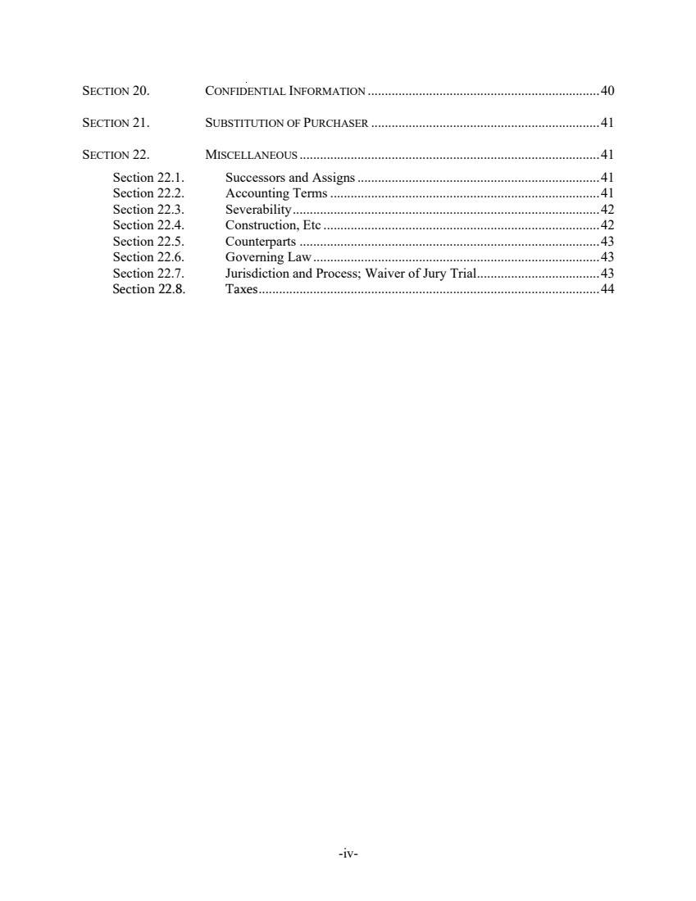 | -iv-SECTION 20. CONFIDENTIAL INFORMATION ....................................................................40 SECTION 21. SUBSTITUTION OF PURCHASER ...................................................................41 SECTION 22. MISCELLANEOUS ........................................................................................41 Section 22.1. Successors and Assigns.......................................................................41 Section 22.2. Accounting Terms...............................................................................41 Section 22.3. Severability..........................................................................................42 Section 22.4. Construction, Etc .................................................................................42 Section 22.5. Counterparts ........................................................................................43 Section 22.6. Governing Law....................................................................................43 Section 22.7. Jurisdiction and Process; Waiver of Jury Trial....................................43 Section 22.8. Taxes....................................................................................................44
 | 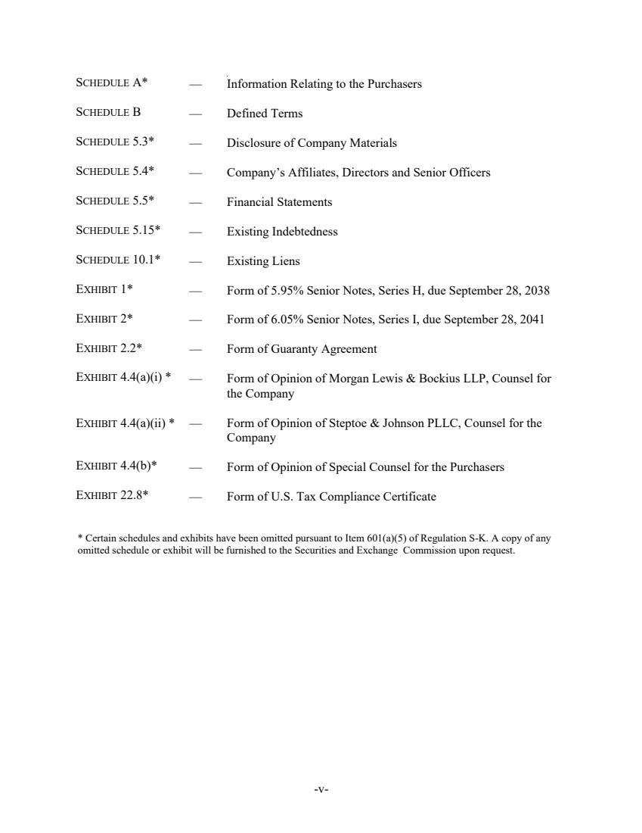 | -v- — Information Relating to the Purchasers — Defined Terms — Disclosure of Company Materials — Company’s Affiliates, Directors and Senior Officers — Financial Statements — Existing Indebtedness — Existing Liens — Form of 5.95% Senior Notes, Series H, due September 28, 2038 — Form of 6.05% Senior Notes, Series I, due September 28, 2041 — Form of Guaranty Agreement SCHEDULE A* SCHEDULE B SCHEDULE 5.3* SCHEDULE 5.4* SCHEDULE 5.5* SCHEDULE 5.15* SCHEDULE 10.1* EXHIBIT 1* EXHIBIT 2* EXHIBIT 2.2* EXHIBIT 4.4(a)(i) * — Form of Opinion of Morgan Lewis & Bockius LLP, Counsel for the Company EXHIBIT 4.4(a)(ii) * — Form of Opinion of Steptoe & Johnson PLLC, Counsel for the Company EXHIBIT 4.4(b)* — Form of Opinion of Special Counsel for the Purchasers EXHIBIT 22.8* — Form of U.S. Tax Compliance Certificate * Certain schedules and exhibits have been omitted pursuant to Item 601(a)(5) of Regulation S-K. A copy of any omitted schedule or exhibit will be furnished to the Securities and Exchange Commission upon request.
 | 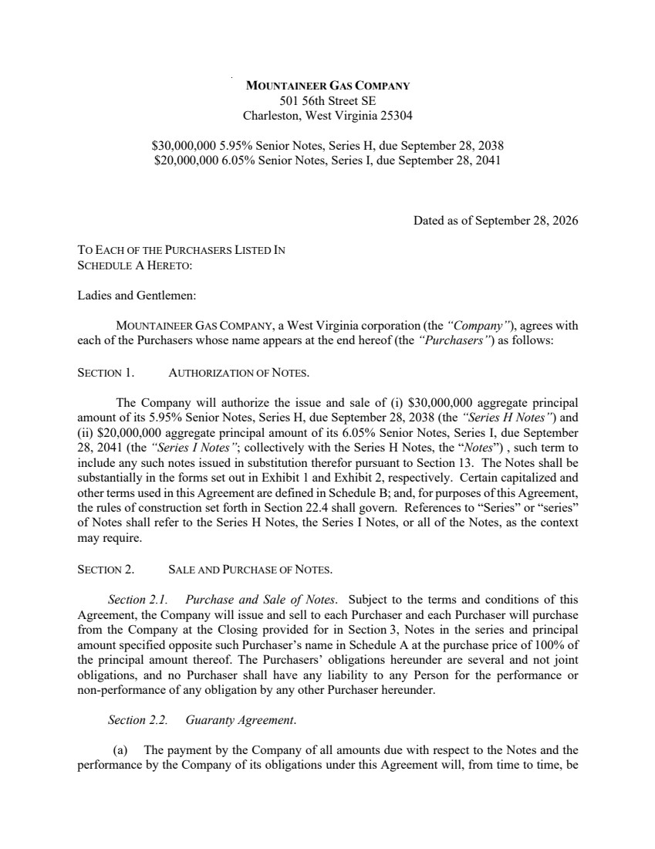 | MOUNTAINEER GAS COMPANY 501 56th Street SE Charleston, West Virginia 25304 $30,000,000 5.95% Senior Notes, Series H, due September 28, 2038 $20,000,000 6.05% Senior Notes, Series I, due September 28, 2041 Dated as of September 28, 2026 TO EACH OF THE PURCHASERS LISTED IN SCHEDULE A HERETO: Ladies and Gentlemen: MOUNTAINEER GAS COMPANY, a West Virginia corporation (the “Company”), agrees with each of the Purchasers whose name appears at the end hereof (the “Purchasers”) as follows: SECTION 1. AUTHORIZATION OF NOTES. The Company will authorize the issue and sale of (i) $30,000,000 aggregate principal amount of its 5.95% Senior Notes, Series H, due September 28, 2038 (the “Series H Notes”) and (ii) $20,000,000 aggregate principal amount of its 6.05% Senior Notes, Series I, due September 28, 2041 (the “Series I Notes”; collectively with the Series H Notes, the “Notes”) , such term to include any such notes issued in substitution therefor pursuant to Section 13. The Notes shall be substantially in the forms set out in Exhibit 1 and Exhibit 2, respectively. Certain capitalized and other terms used in this Agreement are defined in Schedule B; and, for purposes of this Agreement, the rules of construction set forth in Section 22.4 shall govern. References to “Series” or “series” of Notes shall refer to the Series H Notes, the Series I Notes, or all of the Notes, as the context may require. SECTION 2. SALE AND PURCHASE OF NOTES. Section 2.1. Purchase and Sale of Notes. Subject to the terms and conditions of this Agreement, the Company will issue and sell to each Purchaser and each Purchaser will purchase from the Company at the Closing provided for in Section 3, Notes in the series and principal amount specified opposite such Purchaser’s name in Schedule A at the purchase price of 100% of the principal amount thereof. The Purchasers’ obligations hereunder are several and not joint obligations, and no Purchaser shall have any liability to any Person for the performance or non-performance of any obligation by any other Purchaser hereunder. Section 2.2. Guaranty Agreement. (a) The payment by the Company of all amounts due with respect to the Notes and the performance by the Company of its obligations under this Agreement will, from time to time, be
 | 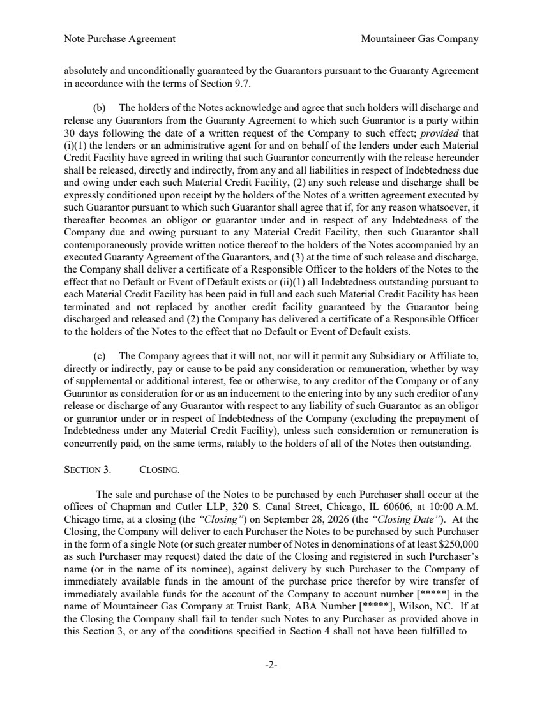 | Note Purchase Agreement Mountaineer Gas Company -2- absolutely and unconditionally guaranteed by the Guarantors pursuant to the Guaranty Agreement in accordance with the terms of Section 9.7. (b) The holders of the Notes acknowledge and agree that such holders will discharge and release any Guarantors from the Guaranty Agreement to which such Guarantor is a party within 30 days following the date of a written request of the Company to such effect; provided that (i)(1) the lenders or an administrative agent for and on behalf of the lenders under each Material Credit Facility have agreed in writing that such Guarantor concurrently with the release hereunder shall be released, directly and indirectly, from any and all liabilities in respect of Indebtedness due and owing under each such Material Credit Facility, (2) any such release and discharge shall be expressly conditioned upon receipt by the holders of the Notes of a written agreement executed by such Guarantor pursuant to which such Guarantor shall agree that if, for any reason whatsoever, it thereafter becomes an obligor or guarantor under and in respect of any Indebtedness of the Company due and owing pursuant to any Material Credit Facility, then such Guarantor shall contemporaneously provide written notice thereof to the holders of the Notes accompanied by an executed Guaranty Agreement of the Guarantors, and (3) at the time of such release and discharge, the Company shall deliver a certificate of a Responsible Officer to the holders of the Notes to the effect that no Default or Event of Default exists or (ii)(1) all Indebtedness outstanding pursuant to each Material Credit Facility has been paid in full and each such Material Credit Facility has been terminated and not replaced by another credit facility guaranteed by the Guarantor being discharged and released and (2) the Company has delivered a certificate of a Responsible Officer to the holders of the Notes to the effect that no Default or Event of Default exists. (c) The Company agrees that it will not, nor will it permit any Subsidiary or Affiliate to, directly or indirectly, pay or cause to be paid any consideration or remuneration, whether by way of supplemental or additional interest, fee or otherwise, to any creditor of the Company or of any Guarantor as consideration for or as an inducement to the entering into by any such creditor of any release or discharge of any Guarantor with respect to any liability of such Guarantor as an obligor or guarantor under or in respect of Indebtedness of the Company (excluding the prepayment of Indebtedness under any Material Credit Facility), unless such consideration or remuneration is concurrently paid, on the same terms, ratably to the holders of all of the Notes then outstanding. SECTION 3. CLOSING. The sale and purchase of the Notes to be purchased by each Purchaser shall occur at the offices of Chapman and Cutler LLP, 320 S. Canal Street, Chicago, IL 60606, at 10:00 A.M. Chicago time, at a closing (the “Closing”) on September 28, 2026 (the “Closing Date”). At the Closing, the Company will deliver to each Purchaser the Notes to be purchased by such Purchaser in the form of a single Note (or such greater number of Notes in denominations of at least $250,000 as such Purchaser may request) dated the date of the Closing and registered in such Purchaser’s name (or in the name of its nominee), against delivery by such Purchaser to the Company of immediately available funds in the amount of the purchase price therefor by wire transfer of immediately available funds for the account of the Company to account number [*****] in the name of Mountaineer Gas Company at Truist Bank, ABA Number [*****], Wilson, NC. If at the Closing the Company shall fail to tender such Notes to any Purchaser as provided above in this Section 3, or any of the conditions specified in Section 4 shall not have been fulfilled to
 | 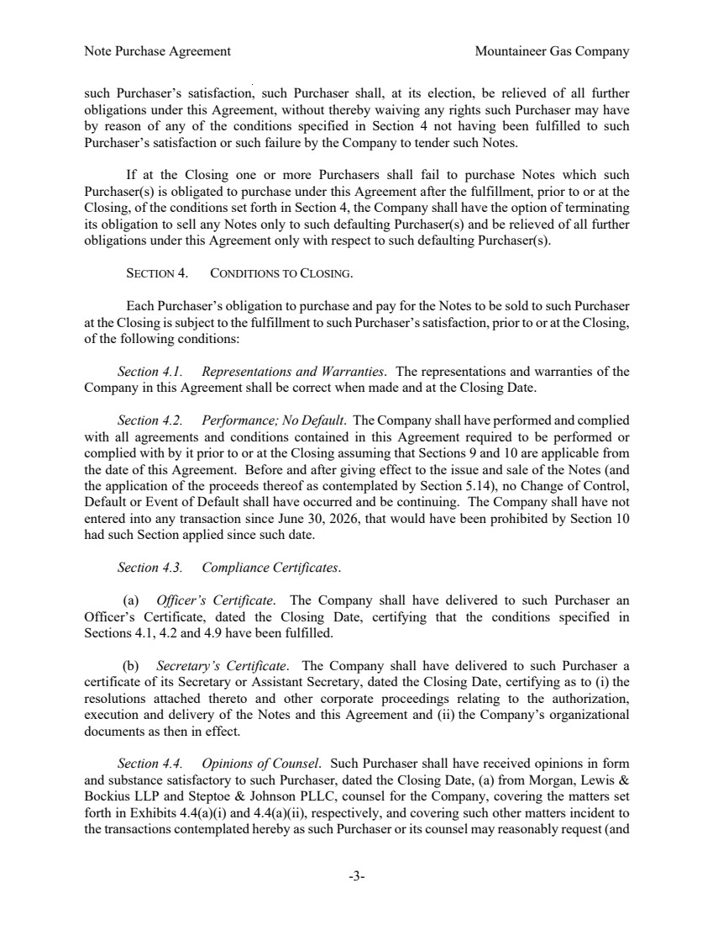 | Note Purchase Agreement Mountaineer Gas Company -3- such Purchaser’s satisfaction, such Purchaser shall, at its election, be relieved of all further obligations under this Agreement, without thereby waiving any rights such Purchaser may have by reason of any of the conditions specified in Section 4 not having been fulfilled to such Purchaser’s satisfaction or such failure by the Company to tender such Notes. If at the Closing one or more Purchasers shall fail to purchase Notes which such Purchaser(s) is obligated to purchase under this Agreement after the fulfillment, prior to or at the Closing, of the conditions set forth in Section 4, the Company shall have the option of terminating its obligation to sell any Notes only to such defaulting Purchaser(s) and be relieved of all further obligations under this Agreement only with respect to such defaulting Purchaser(s). SECTION 4. CONDITIONS TO CLOSING. Each Purchaser’s obligation to purchase and pay for the Notes to be sold to such Purchaser at the Closing is subject to the fulfillment to such Purchaser’s satisfaction, prior to or at the Closing, of the following conditions: Section 4.1. Representations and Warranties. The representations and warranties of the Company in this Agreement shall be correct when made and at the Closing Date. Section 4.2. Performance; No Default. The Company shall have performed and complied with all agreements and conditions contained in this Agreement required to be performed or complied with by it prior to or at the Closing assuming that Sections 9 and 10 are applicable from the date of this Agreement. Before and after giving effect to the issue and sale of the Notes (and the application of the proceeds thereof as contemplated by Section 5.14), no Change of Control, Default or Event of Default shall have occurred and be continuing. The Company shall have not entered into any transaction since June 30, 2026, that would have been prohibited by Section 10 had such Section applied since such date. Section 4.3. Compliance Certificates. (a) Officer’s Certificate. The Company shall have delivered to such Purchaser an Officer’s Certificate, dated the Closing Date, certifying that the conditions specified in Sections 4.1, 4.2 and 4.9 have been fulfilled. (b) Secretary’s Certificate. The Company shall have delivered to such Purchaser a certificate of its Secretary or Assistant Secretary, dated the Closing Date, certifying as to (i) the resolutions attached thereto and other corporate proceedings relating to the authorization, execution and delivery of the Notes and this Agreement and (ii) the Company’s organizational documents as then in effect. Section 4.4. Opinions of Counsel. Such Purchaser shall have received opinions in form and substance satisfactory to such Purchaser, dated the Closing Date, (a) from Morgan, Lewis & Bockius LLP and Steptoe & Johnson PLLC, counsel for the Company, covering the matters set forth in Exhibits 4.4(a)(i) and 4.4(a)(ii), respectively, and covering such other matters incident to the transactions contemplated hereby as such Purchaser or its counsel may reasonably request (and
 | 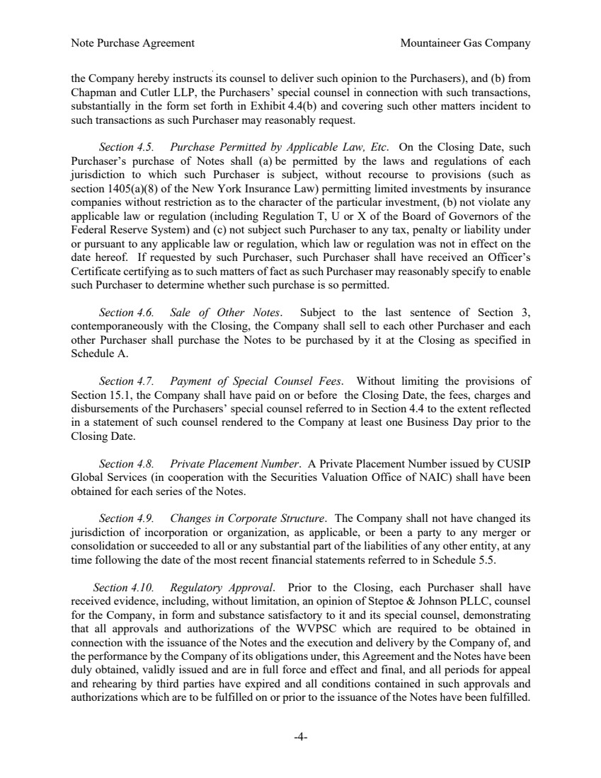 | Note Purchase Agreement Mountaineer Gas Company -4- the Company hereby instructs its counsel to deliver such opinion to the Purchasers), and (b) from Chapman and Cutler LLP, the Purchasers’ special counsel in connection with such transactions, substantially in the form set forth in Exhibit 4.4(b) and covering such other matters incident to such transactions as such Purchaser may reasonably request. Section 4.5. Purchase Permitted by Applicable Law, Etc. On the Closing Date, such Purchaser’s purchase of Notes shall (a) be permitted by the laws and regulations of each jurisdiction to which such Purchaser is subject, without recourse to provisions (such as section 1405(a)(8) of the New York Insurance Law) permitting limited investments by insurance companies without restriction as to the character of the particular investment, (b) not violate any applicable law or regulation (including Regulation T, U or X of the Board of Governors of the Federal Reserve System) and (c) not subject such Purchaser to any tax, penalty or liability under or pursuant to any applicable law or regulation, which law or regulation was not in effect on the date hereof. If requested by such Purchaser, such Purchaser shall have received an Officer’s Certificate certifying as to such matters of fact as such Purchaser may reasonably specify to enable such Purchaser to determine whether such purchase is so permitted. Section 4.6. Sale of Other Notes. Subject to the last sentence of Section 3, contemporaneously with the Closing, the Company shall sell to each other Purchaser and each other Purchaser shall purchase the Notes to be purchased by it at the Closing as specified in Schedule A. Section 4.7. Payment of Special Counsel Fees. Without limiting the provisions of Section 15.1, the Company shall have paid on or before the Closing Date, the fees, charges and disbursements of the Purchasers’ special counsel referred to in Section 4.4 to the extent reflected in a statement of such counsel rendered to the Company at least one Business Day prior to the Closing Date. Section 4.8. Private Placement Number. A Private Placement Number issued by CUSIP Global Services (in cooperation with the Securities Valuation Office of NAIC) shall have been obtained for each series of the Notes. Section 4.9. Changes in Corporate Structure. The Company shall not have changed its jurisdiction of incorporation or organization, as applicable, or been a party to any merger or consolidation or succeeded to all or any substantial part of the liabilities of any other entity, at any time following the date of the most recent financial statements referred to in Schedule 5.5. Section 4.10. Regulatory Approval. Prior to the Closing, each Purchaser shall have received evidence, including, without limitation, an opinion of Steptoe & Johnson PLLC, counsel for the Company, in form and substance satisfactory to it and its special counsel, demonstrating that all approvals and authorizations of the WVPSC which are required to be obtained in connection with the issuance of the Notes and the execution and delivery by the Company of, and the performance by the Company of its obligations under, this Agreement and the Notes have been duly obtained, validly issued and are in full force and effect and final, and all periods for appeal and rehearing by third parties have expired and all conditions contained in such approvals and authorizations which are to be fulfilled on or prior to the issuance of the Notes have been fulfilled.
 | 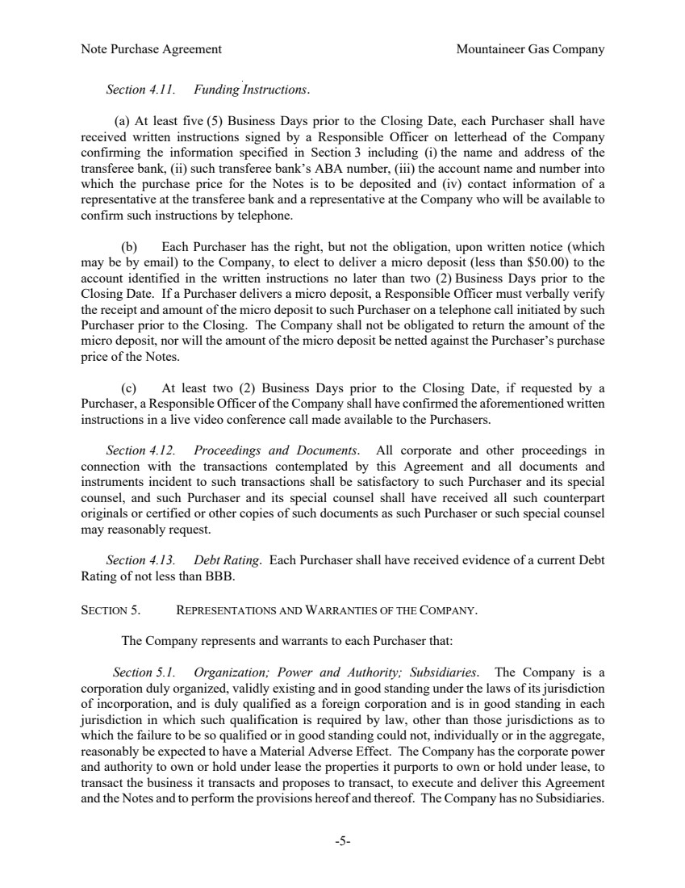 | Note Purchase Agreement Mountaineer Gas Company -5- Section 4.11. Funding Instructions. (a) At least five (5) Business Days prior to the Closing Date, each Purchaser shall have received written instructions signed by a Responsible Officer on letterhead of the Company confirming the information specified in Section 3 including (i) the name and address of the transferee bank, (ii) such transferee bank’s ABA number, (iii) the account name and number into which the purchase price for the Notes is to be deposited and (iv) contact information of a representative at the transferee bank and a representative at the Company who will be available to confirm such instructions by telephone. (b) Each Purchaser has the right, but not the obligation, upon written notice (which may be by email) to the Company, to elect to deliver a micro deposit (less than $50.00) to the account identified in the written instructions no later than two (2) Business Days prior to the Closing Date. If a Purchaser delivers a micro deposit, a Responsible Officer must verbally verify the receipt and amount of the micro deposit to such Purchaser on a telephone call initiated by such Purchaser prior to the Closing. The Company shall not be obligated to return the amount of the micro deposit, nor will the amount of the micro deposit be netted against the Purchaser’s purchase price of the Notes. (c) At least two (2) Business Days prior to the Closing Date, if requested by a Purchaser, a Responsible Officer of the Company shall have confirmed the aforementioned written instructions in a live video conference call made available to the Purchasers. Section 4.12. Proceedings and Documents. All corporate and other proceedings in connection with the transactions contemplated by this Agreement and all documents and instruments incident to such transactions shall be satisfactory to such Purchaser and its special counsel, and such Purchaser and its special counsel shall have received all such counterpart originals or certified or other copies of such documents as such Purchaser or such special counsel may reasonably request. Section 4.13. Debt Rating. Each Purchaser shall have received evidence of a current Debt Rating of not less than BBB. SECTION 5. REPRESENTATIONS AND WARRANTIES OF THE COMPANY. The Company represents and warrants to each Purchaser that: Section 5.1. Organization; Power and Authority; Subsidiaries. The Company is a corporation duly organized, validly existing and in good standing under the laws of its jurisdiction of incorporation, and is duly qualified as a foreign corporation and is in good standing in each jurisdiction in which such qualification is required by law, other than those jurisdictions as to which the failure to be so qualified or in good standing could not, individually or in the aggregate, reasonably be expected to have a Material Adverse Effect. The Company has the corporate power and authority to own or hold under lease the properties it purports to own or hold under lease, to transact the business it transacts and proposes to transact, to execute and deliver this Agreement and the Notes and to perform the provisions hereof and thereof. The Company has no Subsidiaries.
 | 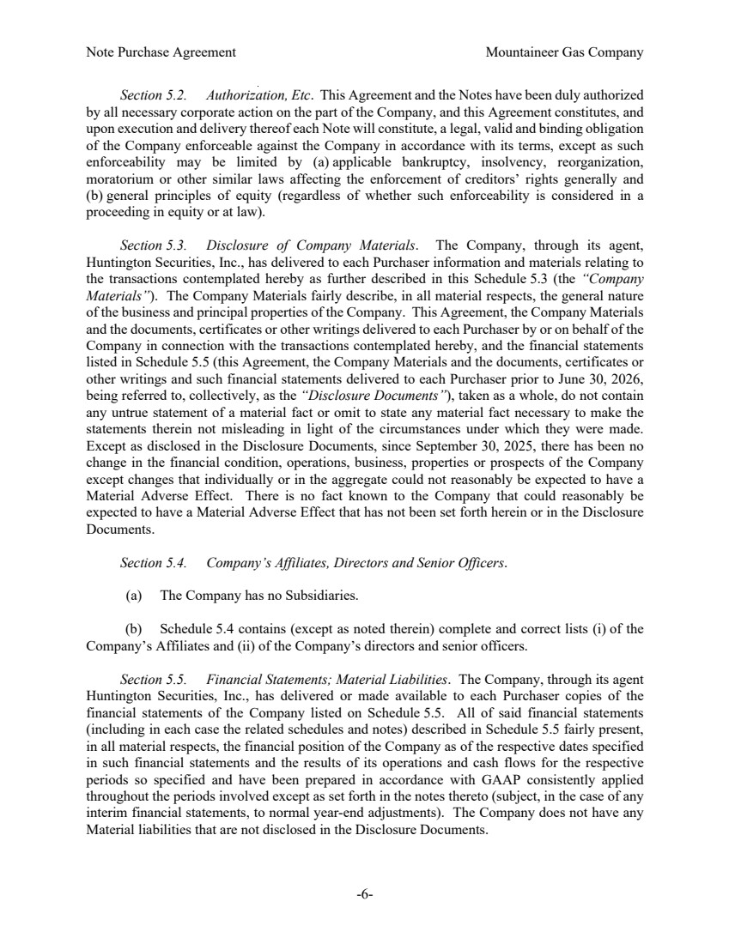 | Note Purchase Agreement Mountaineer Gas Company -6- Section 5.2. Authorization, Etc. This Agreement and the Notes have been duly authorized by all necessary corporate action on the part of the Company, and this Agreement constitutes, and upon execution and delivery thereof each Note will constitute, a legal, valid and binding obligation of the Company enforceable against the Company in accordance with its terms, except as such enforceability may be limited by (a) applicable bankruptcy, insolvency, reorganization, moratorium or other similar laws affecting the enforcement of creditors’ rights generally and (b) general principles of equity (regardless of whether such enforceability is considered in a proceeding in equity or at law). Section 5.3. Disclosure of Company Materials. The Company, through its agent, Huntington Securities, Inc., has delivered to each Purchaser information and materials relating to the transactions contemplated hereby as further described in this Schedule 5.3 (the “Company Materials”). The Company Materials fairly describe, in all material respects, the general nature of the business and principal properties of the Company. This Agreement, the Company Materials and the documents, certificates or other writings delivered to each Purchaser by or on behalf of the Company in connection with the transactions contemplated hereby, and the financial statements listed in Schedule 5.5 (this Agreement, the Company Materials and the documents, certificates or other writings and such financial statements delivered to each Purchaser prior to June 30, 2026, being referred to, collectively, as the “Disclosure Documents”), taken as a whole, do not contain any untrue statement of a material fact or omit to state any material fact necessary to make the statements therein not misleading in light of the circumstances under which they were made. Except as disclosed in the Disclosure Documents, since September 30, 2025, there has been no change in the financial condition, operations, business, properties or prospects of the Company except changes that individually or in the aggregate could not reasonably be expected to have a Material Adverse Effect. There is no fact known to the Company that could reasonably be expected to have a Material Adverse Effect that has not been set forth herein or in the Disclosure Documents. Section 5.4. Company’s Affiliates, Directors and Senior Officers. (a) The Company has no Subsidiaries. (b) Schedule 5.4 contains (except as noted therein) complete and correct lists (i) of the Company’s Affiliates and (ii) of the Company’s directors and senior officers. Section 5.5. Financial Statements; Material Liabilities. The Company, through its agent Huntington Securities, Inc., has delivered or made available to each Purchaser copies of the financial statements of the Company listed on Schedule 5.5. All of said financial statements (including in each case the related schedules and notes) described in Schedule 5.5 fairly present, in all material respects, the financial position of the Company as of the respective dates specified in such financial statements and the results of its operations and cash flows for the respective periods so specified and have been prepared in accordance with GAAP consistently applied throughout the periods involved except as set forth in the notes thereto (subject, in the case of any interim financial statements, to normal year-end adjustments). The Company does not have any Material liabilities that are not disclosed in the Disclosure Documents.
 | 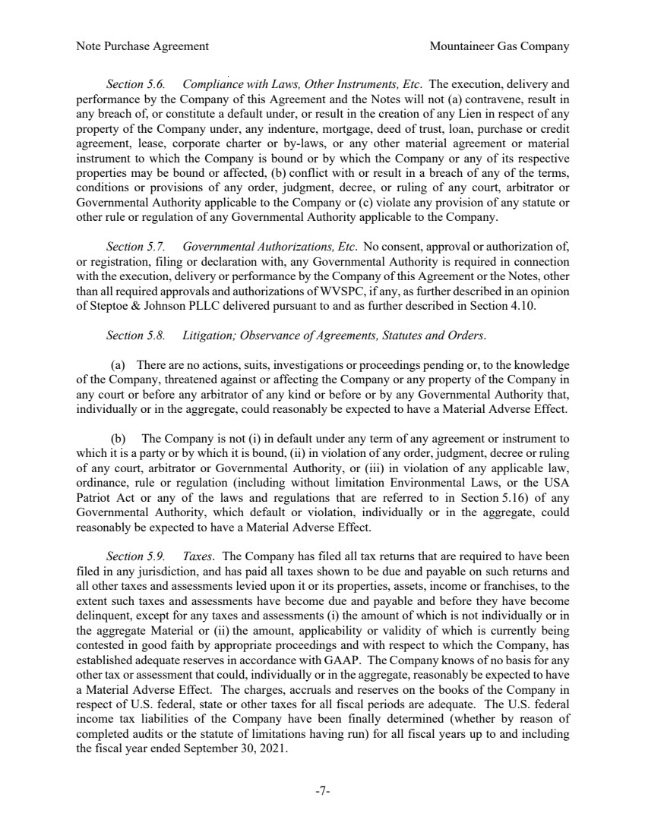 | Note Purchase Agreement Mountaineer Gas Company -7- Section 5.6. Compliance with Laws, Other Instruments, Etc. The execution, delivery and performance by the Company of this Agreement and the Notes will not (a) contravene, result in any breach of, or constitute a default under, or result in the creation of any Lien in respect of any property of the Company under, any indenture, mortgage, deed of trust, loan, purchase or credit agreement, lease, corporate charter or by-laws, or any other material agreement or material instrument to which the Company is bound or by which the Company or any of its respective properties may be bound or affected, (b) conflict with or result in a breach of any of the terms, conditions or provisions of any order, judgment, decree, or ruling of any court, arbitrator or Governmental Authority applicable to the Company or (c) violate any provision of any statute or other rule or regulation of any Governmental Authority applicable to the Company. Section 5.7. Governmental Authorizations, Etc. No consent, approval or authorization of, or registration, filing or declaration with, any Governmental Authority is required in connection with the execution, delivery or performance by the Company of this Agreement or the Notes, other than all required approvals and authorizations of WVSPC, if any, as further described in an opinion of Steptoe & Johnson PLLC delivered pursuant to and as further described in Section 4.10. Section 5.8. Litigation; Observance of Agreements, Statutes and Orders. (a) There are no actions, suits, investigations or proceedings pending or, to the knowledge of the Company, threatened against or affecting the Company or any property of the Company in any court or before any arbitrator of any kind or before or by any Governmental Authority that, individually or in the aggregate, could reasonably be expected to have a Material Adverse Effect. (b) The Company is not (i) in default under any term of any agreement or instrument to which it is a party or by which it is bound, (ii) in violation of any order, judgment, decree or ruling of any court, arbitrator or Governmental Authority, or (iii) in violation of any applicable law, ordinance, rule or regulation (including without limitation Environmental Laws, or the USA Patriot Act or any of the laws and regulations that are referred to in Section 5.16) of any Governmental Authority, which default or violation, individually or in the aggregate, could reasonably be expected to have a Material Adverse Effect. Section 5.9. Taxes. The Company has filed all tax returns that are required to have been filed in any jurisdiction, and has paid all taxes shown to be due and payable on such returns and all other taxes and assessments levied upon it or its properties, assets, income or franchises, to the extent such taxes and assessments have become due and payable and before they have become delinquent, except for any taxes and assessments (i) the amount of which is not individually or in the aggregate Material or (ii) the amount, applicability or validity of which is currently being contested in good faith by appropriate proceedings and with respect to which the Company, has established adequate reserves in accordance with GAAP. The Company knows of no basis for any other tax or assessment that could, individually or in the aggregate, reasonably be expected to have a Material Adverse Effect. The charges, accruals and reserves on the books of the Company in respect of U.S. federal, state or other taxes for all fiscal periods are adequate. The U.S. federal income tax liabilities of the Company have been finally determined (whether by reason of completed audits or the statute of limitations having run) for all fiscal years up to and including the fiscal year ended September 30, 2021.
 | 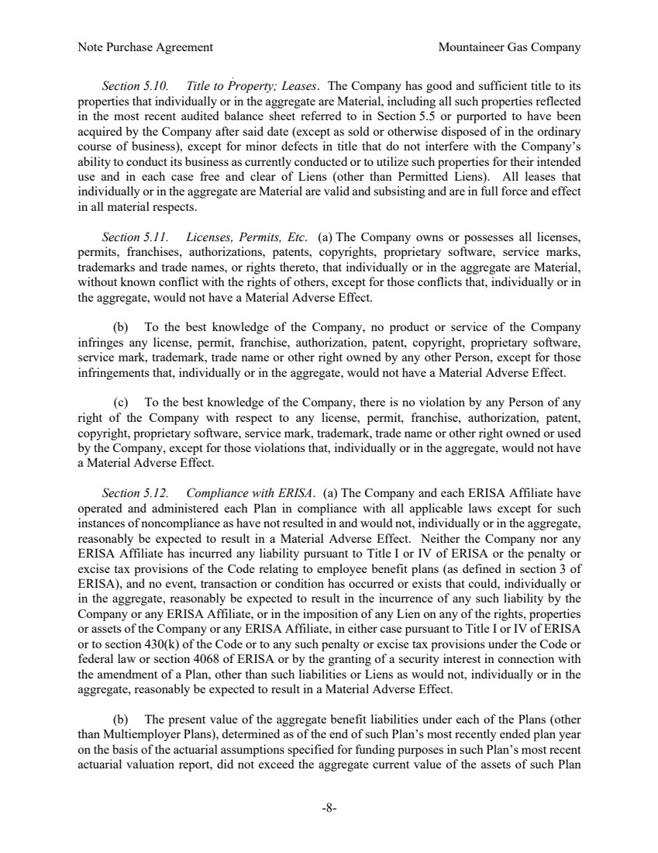 | Note Purchase Agreement Mountaineer Gas Company -8- Section 5.10. Title to Property; Leases. The Company has good and sufficient title to its properties that individually or in the aggregate are Material, including all such properties reflected in the most recent audited balance sheet referred to in Section 5.5 or purported to have been acquired by the Company after said date (except as sold or otherwise disposed of in the ordinary course of business), except for minor defects in title that do not interfere with the Company’s ability to conduct its business as currently conducted or to utilize such properties for their intended use and in each case free and clear of Liens (other than Permitted Liens). All leases that individually or in the aggregate are Material are valid and subsisting and are in full force and effect in all material respects. Section 5.11. Licenses, Permits, Etc. (a) The Company owns or possesses all licenses, permits, franchises, authorizations, patents, copyrights, proprietary software, service marks, trademarks and trade names, or rights thereto, that individually or in the aggregate are Material, without known conflict with the rights of others, except for those conflicts that, individually or in the aggregate, would not have a Material Adverse Effect. (b) To the best knowledge of the Company, no product or service of the Company infringes any license, permit, franchise, authorization, patent, copyright, proprietary software, service mark, trademark, trade name or other right owned by any other Person, except for those infringements that, individually or in the aggregate, would not have a Material Adverse Effect. (c) To the best knowledge of the Company, there is no violation by any Person of any right of the Company with respect to any license, permit, franchise, authorization, patent, copyright, proprietary software, service mark, trademark, trade name or other right owned or used by the Company, except for those violations that, individually or in the aggregate, would not have a Material Adverse Effect. Section 5.12. Compliance with ERISA. (a) The Company and each ERISA Affiliate have operated and administered each Plan in compliance with all applicable laws except for such instances of noncompliance as have not resulted in and would not, individually or in the aggregate, reasonably be expected to result in a Material Adverse Effect. Neither the Company nor any ERISA Affiliate has incurred any liability pursuant to Title I or IV of ERISA or the penalty or excise tax provisions of the Code relating to employee benefit plans (as defined in section 3 of ERISA), and no event, transaction or condition has occurred or exists that could, individually or in the aggregate, reasonably be expected to result in the incurrence of any such liability by the Company or any ERISA Affiliate, or in the imposition of any Lien on any of the rights, properties or assets of the Company or any ERISA Affiliate, in either case pursuant to Title I or IV of ERISA or to section 430(k) of the Code or to any such penalty or excise tax provisions under the Code or federal law or section 4068 of ERISA or by the granting of a security interest in connection with the amendment of a Plan, other than such liabilities or Liens as would not, individually or in the aggregate, reasonably be expected to result in a Material Adverse Effect. (b) The present value of the aggregate benefit liabilities under each of the Plans (other than Multiemployer Plans), determined as of the end of such Plan’s most recently ended plan year on the basis of the actuarial assumptions specified for funding purposes in such Plan’s most recent actuarial valuation report, did not exceed the aggregate current value of the assets of such Plan
 | 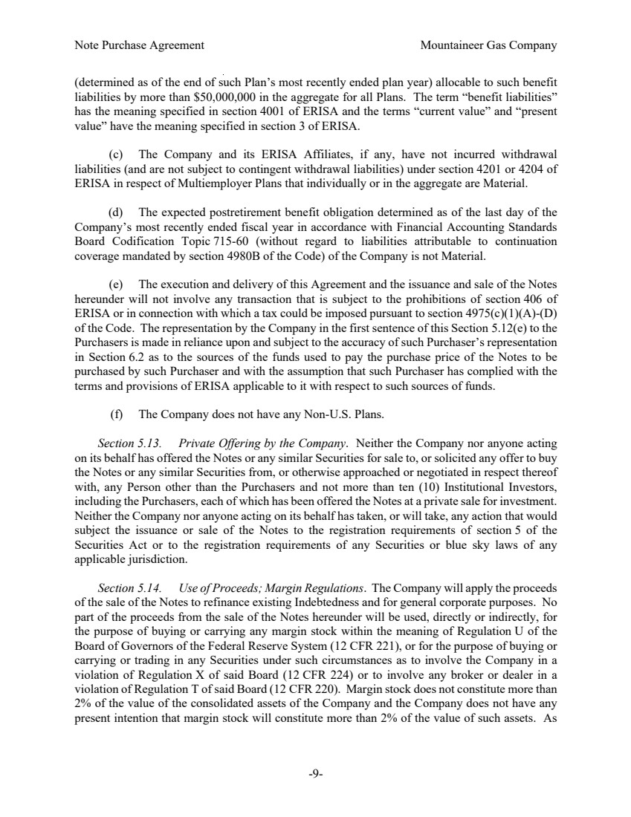 | Note Purchase Agreement Mountaineer Gas Company -9- (determined as of the end of such Plan’s most recently ended plan year) allocable to such benefit liabilities by more than $50,000,000 in the aggregate for all Plans. The term “benefit liabilities” has the meaning specified in section 4001 of ERISA and the terms “current value” and “present value” have the meaning specified in section 3 of ERISA. (c) The Company and its ERISA Affiliates, if any, have not incurred withdrawal liabilities (and are not subject to contingent withdrawal liabilities) under section 4201 or 4204 of ERISA in respect of Multiemployer Plans that individually or in the aggregate are Material. (d) The expected postretirement benefit obligation determined as of the last day of the Company’s most recently ended fiscal year in accordance with Financial Accounting Standards Board Codification Topic 715-60 (without regard to liabilities attributable to continuation coverage mandated by section 4980B of the Code) of the Company is not Material. (e) The execution and delivery of this Agreement and the issuance and sale of the Notes hereunder will not involve any transaction that is subject to the prohibitions of section 406 of ERISA or in connection with which a tax could be imposed pursuant to section 4975(c)(1)(A)-(D) of the Code. The representation by the Company in the first sentence of this Section 5.12(e) to the Purchasers is made in reliance upon and subject to the accuracy of such Purchaser’s representation in Section 6.2 as to the sources of the funds used to pay the purchase price of the Notes to be purchased by such Purchaser and with the assumption that such Purchaser has complied with the terms and provisions of ERISA applicable to it with respect to such sources of funds. (f) The Company does not have any Non-U.S. Plans. Section 5.13. Private Offering by the Company. Neither the Company nor anyone acting on its behalf has offered the Notes or any similar Securities for sale to, or solicited any offer to buy the Notes or any similar Securities from, or otherwise approached or negotiated in respect thereof with, any Person other than the Purchasers and not more than ten (10) Institutional Investors, including the Purchasers, each of which has been offered the Notes at a private sale for investment. Neither the Company nor anyone acting on its behalf has taken, or will take, any action that would subject the issuance or sale of the Notes to the registration requirements of section 5 of the Securities Act or to the registration requirements of any Securities or blue sky laws of any applicable jurisdiction. Section 5.14. Use of Proceeds; Margin Regulations. The Company will apply the proceeds of the sale of the Notes to refinance existing Indebtedness and for general corporate purposes. No part of the proceeds from the sale of the Notes hereunder will be used, directly or indirectly, for the purpose of buying or carrying any margin stock within the meaning of Regulation U of the Board of Governors of the Federal Reserve System (12 CFR 221), or for the purpose of buying or carrying or trading in any Securities under such circumstances as to involve the Company in a violation of Regulation X of said Board (12 CFR 224) or to involve any broker or dealer in a violation of Regulation T of said Board (12 CFR 220). Margin stock does not constitute more than 2% of the value of the consolidated assets of the Company and the Company does not have any present intention that margin stock will constitute more than 2% of the value of such assets. As
 | 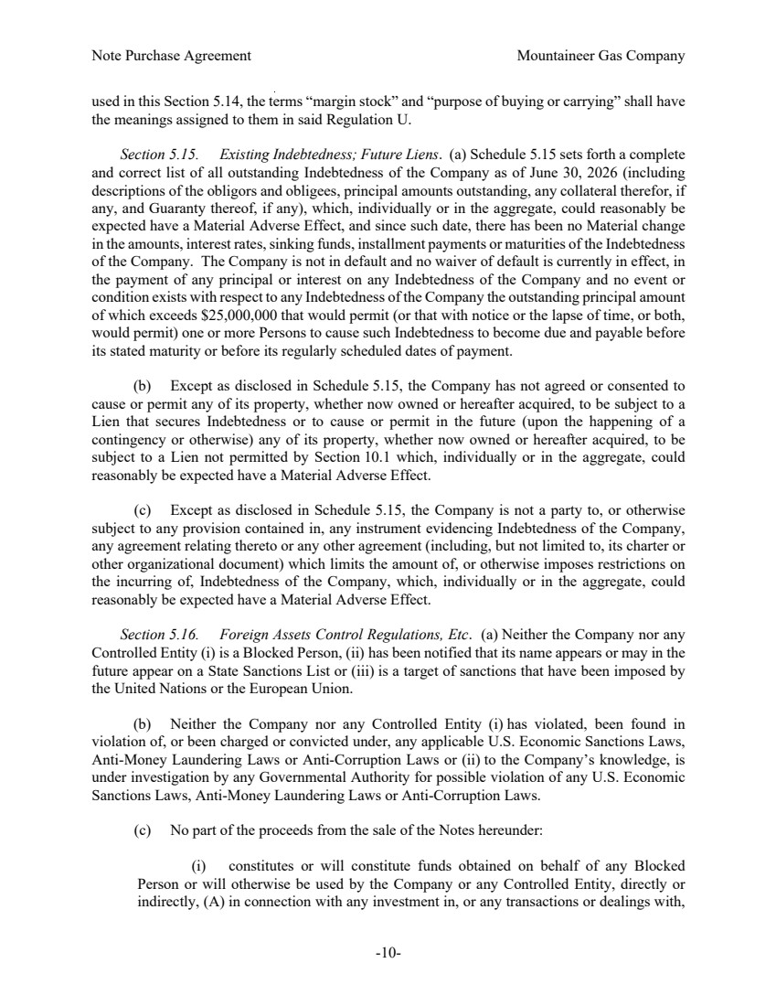 | Note Purchase Agreement Mountaineer Gas Company -10- used in this Section 5.14, the terms “margin stock” and “purpose of buying or carrying” shall have the meanings assigned to them in said Regulation U. Section 5.15. Existing Indebtedness; Future Liens. (a) Schedule 5.15 sets forth a complete and correct list of all outstanding Indebtedness of the Company as of June 30, 2026 (including descriptions of the obligors and obligees, principal amounts outstanding, any collateral therefor, if any, and Guaranty thereof, if any), which, individually or in the aggregate, could reasonably be expected have a Material Adverse Effect, and since such date, there has been no Material change in the amounts, interest rates, sinking funds, installment payments or maturities of the Indebtedness of the Company. The Company is not in default and no waiver of default is currently in effect, in the payment of any principal or interest on any Indebtedness of the Company and no event or condition exists with respect to any Indebtedness of the Company the outstanding principal amount of which exceeds $25,000,000 that would permit (or that with notice or the lapse of time, or both, would permit) one or more Persons to cause such Indebtedness to become due and payable before its stated maturity or before its regularly scheduled dates of payment. (b) Except as disclosed in Schedule 5.15, the Company has not agreed or consented to cause or permit any of its property, whether now owned or hereafter acquired, to be subject to a Lien that secures Indebtedness or to cause or permit in the future (upon the happening of a contingency or otherwise) any of its property, whether now owned or hereafter acquired, to be subject to a Lien not permitted by Section 10.1 which, individually or in the aggregate, could reasonably be expected have a Material Adverse Effect. (c) Except as disclosed in Schedule 5.15, the Company is not a party to, or otherwise subject to any provision contained in, any instrument evidencing Indebtedness of the Company, any agreement relating thereto or any other agreement (including, but not limited to, its charter or other organizational document) which limits the amount of, or otherwise imposes restrictions on the incurring of, Indebtedness of the Company, which, individually or in the aggregate, could reasonably be expected have a Material Adverse Effect. Section 5.16. Foreign Assets Control Regulations, Etc. (a) Neither the Company nor any Controlled Entity (i) is a Blocked Person, (ii) has been notified that its name appears or may in the future appear on a State Sanctions List or (iii) is a target of sanctions that have been imposed by the United Nations or the European Union. (b) Neither the Company nor any Controlled Entity (i) has violated, been found in violation of, or been charged or convicted under, any applicable U.S. Economic Sanctions Laws, Anti-Money Laundering Laws or Anti-Corruption Laws or (ii) to the Company’s knowledge, is under investigation by any Governmental Authority for possible violation of any U.S. Economic Sanctions Laws, Anti-Money Laundering Laws or Anti-Corruption Laws. (c) No part of the proceeds from the sale of the Notes hereunder: (i) constitutes or will constitute funds obtained on behalf of any Blocked Person or will otherwise be used by the Company or any Controlled Entity, directly or indirectly, (A) in connection with any investment in, or any transactions or dealings with,
 | 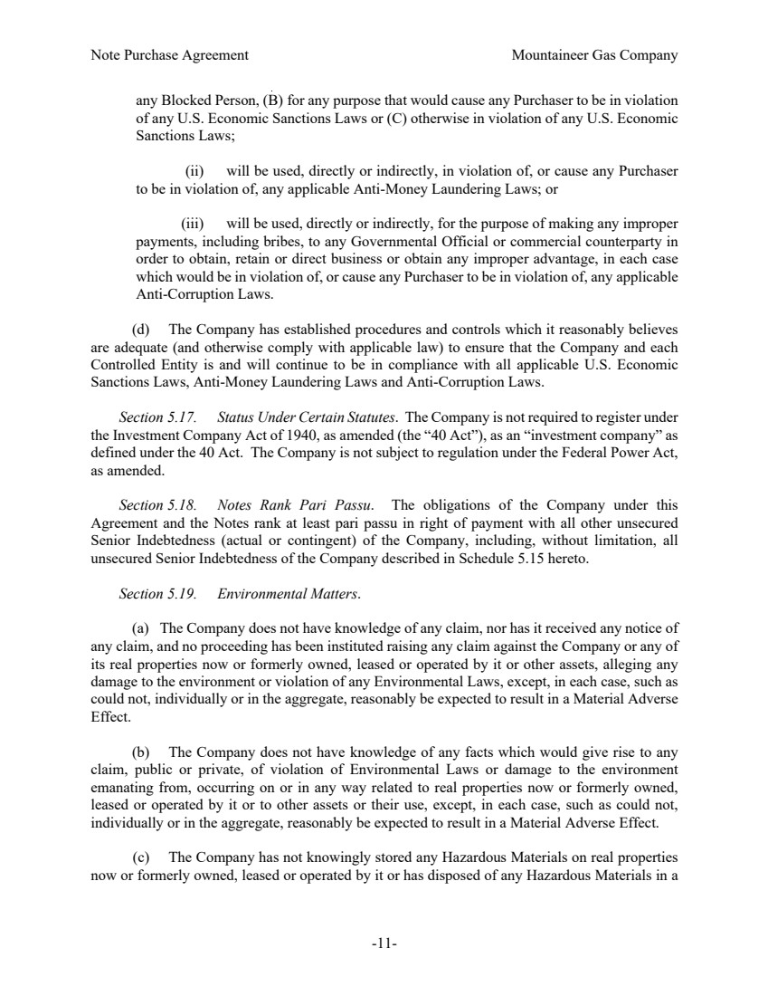 | Note Purchase Agreement Mountaineer Gas Company -11- any Blocked Person, (B) for any purpose that would cause any Purchaser to be in violation of any U.S. Economic Sanctions Laws or (C) otherwise in violation of any U.S. Economic Sanctions Laws; (ii) will be used, directly or indirectly, in violation of, or cause any Purchaser to be in violation of, any applicable Anti-Money Laundering Laws; or (iii) will be used, directly or indirectly, for the purpose of making any improper payments, including bribes, to any Governmental Official or commercial counterparty in order to obtain, retain or direct business or obtain any improper advantage, in each case which would be in violation of, or cause any Purchaser to be in violation of, any applicable Anti-Corruption Laws. (d) The Company has established procedures and controls which it reasonably believes are adequate (and otherwise comply with applicable law) to ensure that the Company and each Controlled Entity is and will continue to be in compliance with all applicable U.S. Economic Sanctions Laws, Anti-Money Laundering Laws and Anti-Corruption Laws. Section 5.17. Status Under Certain Statutes. The Company is not required to register under the Investment Company Act of 1940, as amended (the “40 Act”), as an “investment company” as defined under the 40 Act. The Company is not subject to regulation under the Federal Power Act, as amended. Section 5.18. Notes Rank Pari Passu. The obligations of the Company under this Agreement and the Notes rank at least pari passu in right of payment with all other unsecured Senior Indebtedness (actual or contingent) of the Company, including, without limitation, all unsecured Senior Indebtedness of the Company described in Schedule 5.15 hereto. Section 5.19. Environmental Matters. (a) The Company does not have knowledge of any claim, nor has it received any notice of any claim, and no proceeding has been instituted raising any claim against the Company or any of its real properties now or formerly owned, leased or operated by it or other assets, alleging any damage to the environment or violation of any Environmental Laws, except, in each case, such as could not, individually or in the aggregate, reasonably be expected to result in a Material Adverse Effect. (b) The Company does not have knowledge of any facts which would give rise to any claim, public or private, of violation of Environmental Laws or damage to the environment emanating from, occurring on or in any way related to real properties now or formerly owned, leased or operated by it or to other assets or their use, except, in each case, such as could not, individually or in the aggregate, reasonably be expected to result in a Material Adverse Effect. (c) The Company has not knowingly stored any Hazardous Materials on real properties now or formerly owned, leased or operated by it or has disposed of any Hazardous Materials in a
 | 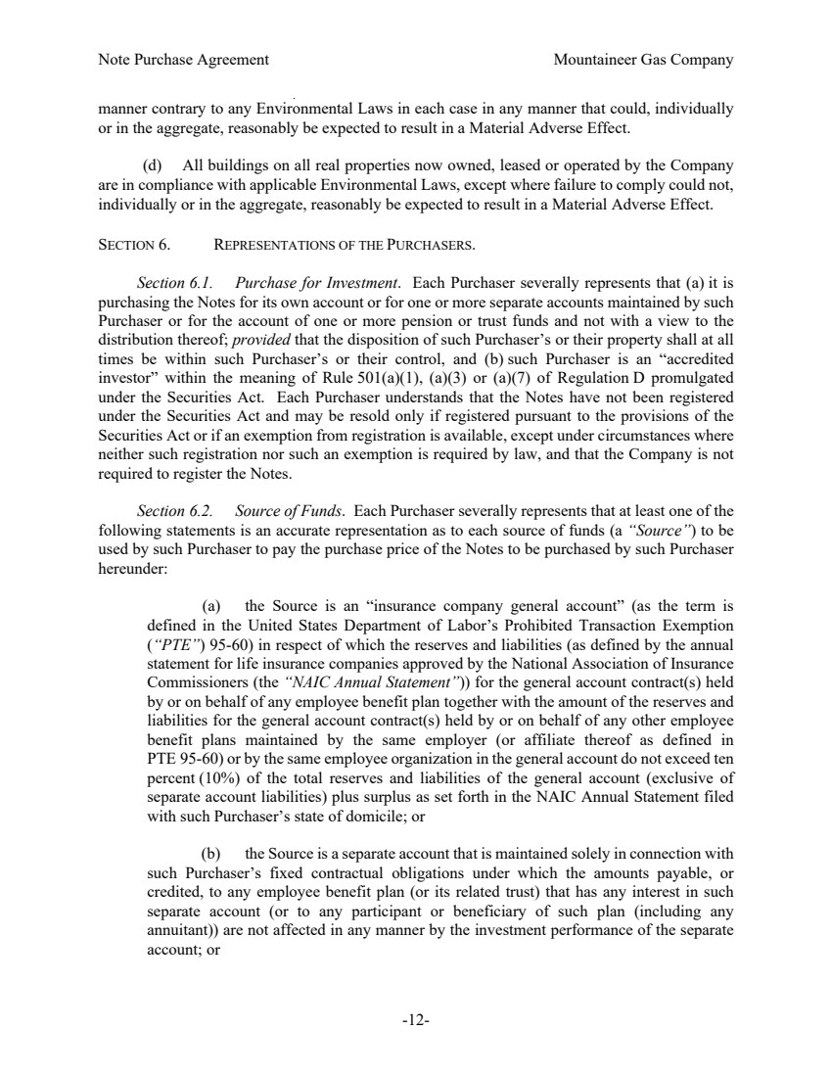 | Note Purchase Agreement Mountaineer Gas Company -12- manner contrary to any Environmental Laws in each case in any manner that could, individually or in the aggregate, reasonably be expected to result in a Material Adverse Effect. (d) All buildings on all real properties now owned, leased or operated by the Company are in compliance with applicable Environmental Laws, except where failure to comply could not, individually or in the aggregate, reasonably be expected to result in a Material Adverse Effect. SECTION 6. REPRESENTATIONS OF THE PURCHASERS. Section 6.1. Purchase for Investment. Each Purchaser severally represents that (a) it is purchasing the Notes for its own account or for one or more separate accounts maintained by such Purchaser or for the account of one or more pension or trust funds and not with a view to the distribution thereof; provided that the disposition of such Purchaser’s or their property shall at all times be within such Purchaser’s or their control, and (b) such Purchaser is an “accredited investor” within the meaning of Rule 501(a)(1), (a)(3) or (a)(7) of Regulation D promulgated under the Securities Act. Each Purchaser understands that the Notes have not been registered under the Securities Act and may be resold only if registered pursuant to the provisions of the Securities Act or if an exemption from registration is available, except under circumstances where neither such registration nor such an exemption is required by law, and that the Company is not required to register the Notes. Section 6.2. Source of Funds. Each Purchaser severally represents that at least one of the following statements is an accurate representation as to each source of funds (a “Source”) to be used by such Purchaser to pay the purchase price of the Notes to be purchased by such Purchaser hereunder: (a) the Source is an “insurance company general account” (as the term is defined in the United States Department of Labor’s Prohibited Transaction Exemption (“PTE”) 95-60) in respect of which the reserves and liabilities (as defined by the annual statement for life insurance companies approved by the National Association of Insurance Commissioners (the “NAIC Annual Statement”)) for the general account contract(s) held by or on behalf of any employee benefit plan together with the amount of the reserves and liabilities for the general account contract(s) held by or on behalf of any other employee benefit plans maintained by the same employer (or affiliate thereof as defined in PTE 95-60) or by the same employee organization in the general account do not exceed ten percent (10%) of the total reserves and liabilities of the general account (exclusive of separate account liabilities) plus surplus as set forth in the NAIC Annual Statement filed with such Purchaser’s state of domicile; or (b) the Source is a separate account that is maintained solely in connection with such Purchaser’s fixed contractual obligations under which the amounts payable, or credited, to any employee benefit plan (or its related trust) that has any interest in such separate account (or to any participant or beneficiary of such plan (including any annuitant)) are not affected in any manner by the investment performance of the separate account; or
 | 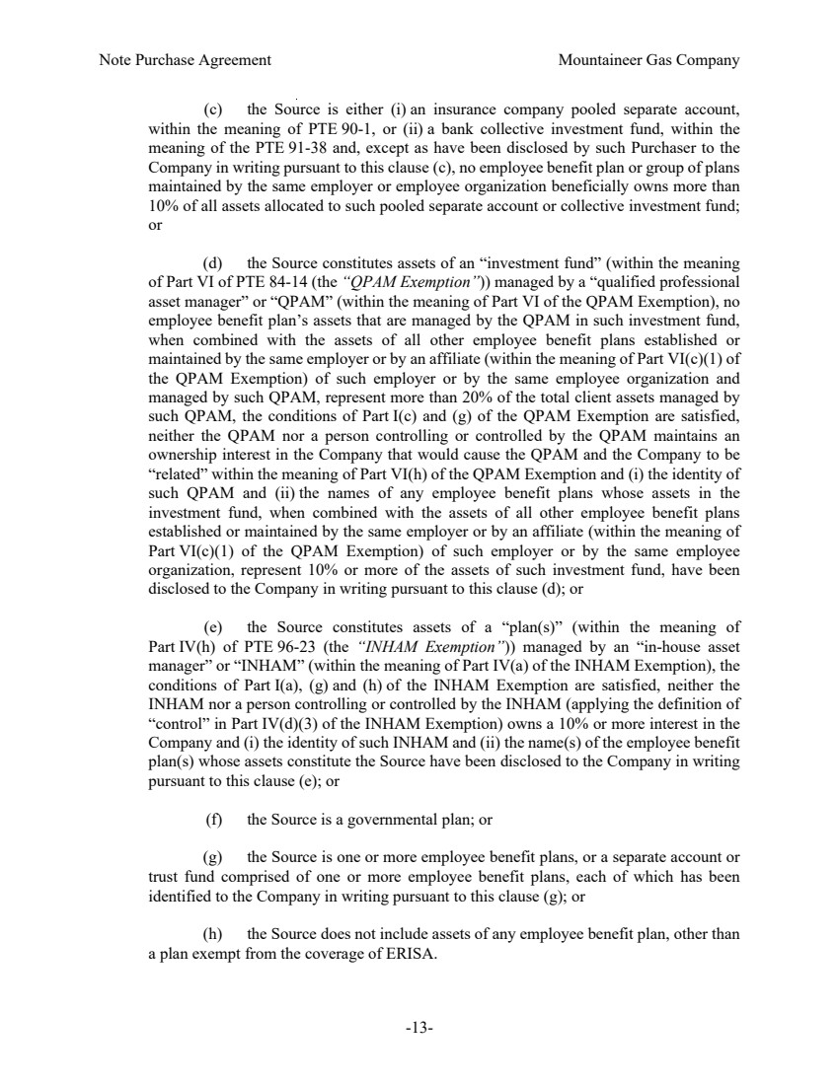 | Note Purchase Agreement Mountaineer Gas Company -13- (c) the Source is either (i) an insurance company pooled separate account, within the meaning of PTE 90-1, or (ii) a bank collective investment fund, within the meaning of the PTE 91-38 and, except as have been disclosed by such Purchaser to the Company in writing pursuant to this clause (c), no employee benefit plan or group of plans maintained by the same employer or employee organization beneficially owns more than 10% of all assets allocated to such pooled separate account or collective investment fund; or (d) the Source constitutes assets of an “investment fund” (within the meaning of Part VI of PTE 84-14 (the “QPAM Exemption”)) managed by a “qualified professional asset manager” or “QPAM” (within the meaning of Part VI of the QPAM Exemption), no employee benefit plan’s assets that are managed by the QPAM in such investment fund, when combined with the assets of all other employee benefit plans established or maintained by the same employer or by an affiliate (within the meaning of Part VI(c)(1) of the QPAM Exemption) of such employer or by the same employee organization and managed by such QPAM, represent more than 20% of the total client assets managed by such QPAM, the conditions of Part I(c) and (g) of the QPAM Exemption are satisfied, neither the QPAM nor a person controlling or controlled by the QPAM maintains an ownership interest in the Company that would cause the QPAM and the Company to be “related” within the meaning of Part VI(h) of the QPAM Exemption and (i) the identity of such QPAM and (ii) the names of any employee benefit plans whose assets in the investment fund, when combined with the assets of all other employee benefit plans established or maintained by the same employer or by an affiliate (within the meaning of Part VI(c)(1) of the QPAM Exemption) of such employer or by the same employee organization, represent 10% or more of the assets of such investment fund, have been disclosed to the Company in writing pursuant to this clause (d); or (e) the Source constitutes assets of a “plan(s)” (within the meaning of Part IV(h) of PTE 96-23 (the “INHAM Exemption”)) managed by an “in-house asset manager” or “INHAM” (within the meaning of Part IV(a) of the INHAM Exemption), the conditions of Part I(a), (g) and (h) of the INHAM Exemption are satisfied, neither the INHAM nor a person controlling or controlled by the INHAM (applying the definition of “control” in Part IV(d)(3) of the INHAM Exemption) owns a 10% or more interest in the Company and (i) the identity of such INHAM and (ii) the name(s) of the employee benefit plan(s) whose assets constitute the Source have been disclosed to the Company in writing pursuant to this clause (e); or (f) the Source is a governmental plan; or (g) the Source is one or more employee benefit plans, or a separate account or trust fund comprised of one or more employee benefit plans, each of which has been identified to the Company in writing pursuant to this clause (g); or (h) the Source does not include assets of any employee benefit plan, other than a plan exempt from the coverage of ERISA.
 | 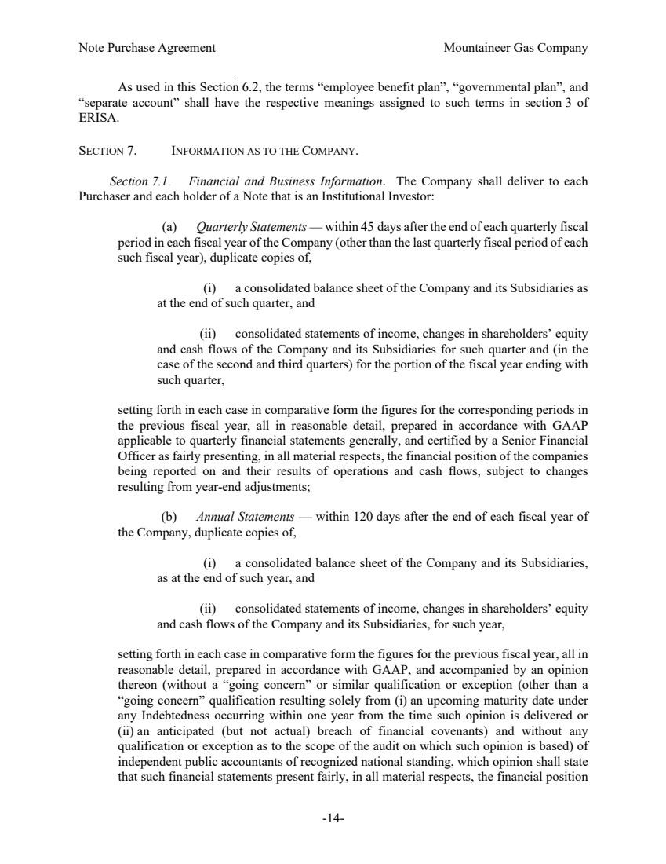 | Note Purchase Agreement Mountaineer Gas Company -14- As used in this Section 6.2, the terms “employee benefit plan”, “governmental plan”, and “separate account” shall have the respective meanings assigned to such terms in section 3 of ERISA. SECTION 7. INFORMATION AS TO THE COMPANY. Section 7.1. Financial and Business Information. The Company shall deliver to each Purchaser and each holder of a Note that is an Institutional Investor: (a) Quarterly Statements — within 45 days after the end of each quarterly fiscal period in each fiscal year of the Company (other than the last quarterly fiscal period of each such fiscal year), duplicate copies of, (i) a consolidated balance sheet of the Company and its Subsidiaries as at the end of such quarter, and (ii) consolidated statements of income, changes in shareholders’ equity and cash flows of the Company and its Subsidiaries for such quarter and (in the case of the second and third quarters) for the portion of the fiscal year ending with such quarter, setting forth in each case in comparative form the figures for the corresponding periods in the previous fiscal year, all in reasonable detail, prepared in accordance with GAAP applicable to quarterly financial statements generally, and certified by a Senior Financial Officer as fairly presenting, in all material respects, the financial position of the companies being reported on and their results of operations and cash flows, subject to changes resulting from year-end adjustments; (b) Annual Statements — within 120 days after the end of each fiscal year of the Company, duplicate copies of, (i) a consolidated balance sheet of the Company and its Subsidiaries, as at the end of such year, and (ii) consolidated statements of income, changes in shareholders’ equity and cash flows of the Company and its Subsidiaries, for such year, setting forth in each case in comparative form the figures for the previous fiscal year, all in reasonable detail, prepared in accordance with GAAP, and accompanied by an opinion thereon (without a “going concern” or similar qualification or exception (other than a “going concern” qualification resulting solely from (i) an upcoming maturity date under any Indebtedness occurring within one year from the time such opinion is delivered or (ii) an anticipated (but not actual) breach of financial covenants) and without any qualification or exception as to the scope of the audit on which such opinion is based) of independent public accountants of recognized national standing, which opinion shall state that such financial statements present fairly, in all material respects, the financial position
 | 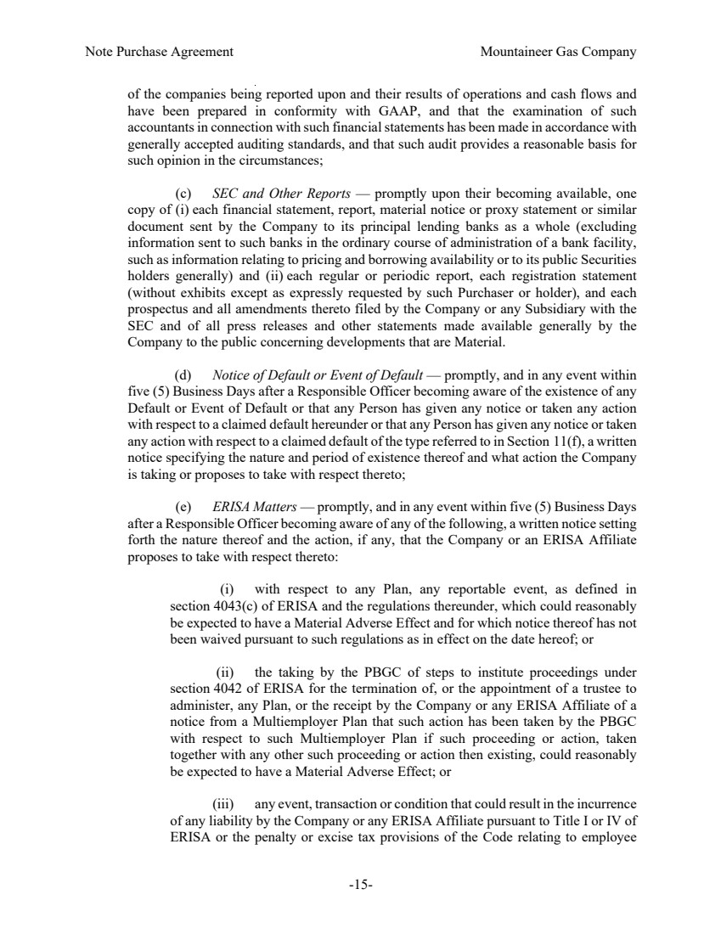 | Note Purchase Agreement Mountaineer Gas Company -15- of the companies being reported upon and their results of operations and cash flows and have been prepared in conformity with GAAP, and that the examination of such accountants in connection with such financial statements has been made in accordance with generally accepted auditing standards, and that such audit provides a reasonable basis for such opinion in the circumstances; (c) SEC and Other Reports — promptly upon their becoming available, one copy of (i) each financial statement, report, material notice or proxy statement or similar document sent by the Company to its principal lending banks as a whole (excluding information sent to such banks in the ordinary course of administration of a bank facility, such as information relating to pricing and borrowing availability or to its public Securities holders generally) and (ii) each regular or periodic report, each registration statement (without exhibits except as expressly requested by such Purchaser or holder), and each prospectus and all amendments thereto filed by the Company or any Subsidiary with the SEC and of all press releases and other statements made available generally by the Company to the public concerning developments that are Material. (d) Notice of Default or Event of Default — promptly, and in any event within five (5) Business Days after a Responsible Officer becoming aware of the existence of any Default or Event of Default or that any Person has given any notice or taken any action with respect to a claimed default hereunder or that any Person has given any notice or taken any action with respect to a claimed default of the type referred to in Section 11(f), a written notice specifying the nature and period of existence thereof and what action the Company is taking or proposes to take with respect thereto; (e) ERISA Matters — promptly, and in any event within five (5) Business Days after a Responsible Officer becoming aware of any of the following, a written notice setting forth the nature thereof and the action, if any, that the Company or an ERISA Affiliate proposes to take with respect thereto: (i) with respect to any Plan, any reportable event, as defined in section 4043(c) of ERISA and the regulations thereunder, which could reasonably be expected to have a Material Adverse Effect and for which notice thereof has not been waived pursuant to such regulations as in effect on the date hereof; or (ii) the taking by the PBGC of steps to institute proceedings under section 4042 of ERISA for the termination of, or the appointment of a trustee to administer, any Plan, or the receipt by the Company or any ERISA Affiliate of a notice from a Multiemployer Plan that such action has been taken by the PBGC with respect to such Multiemployer Plan if such proceeding or action, taken together with any other such proceeding or action then existing, could reasonably be expected to have a Material Adverse Effect; or (iii) any event, transaction or condition that could result in the incurrence of any liability by the Company or any ERISA Affiliate pursuant to Title I or IV of ERISA or the penalty or excise tax provisions of the Code relating to employee
 | 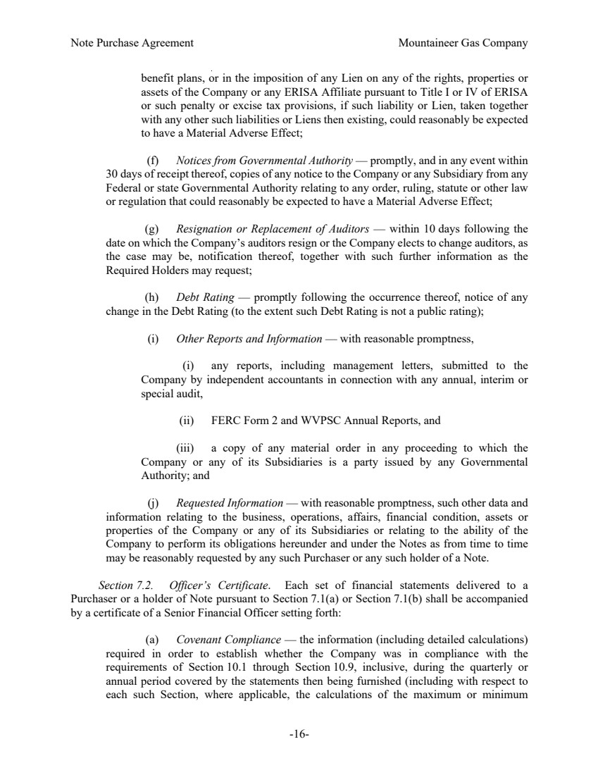 | Note Purchase Agreement Mountaineer Gas Company -16- benefit plans, or in the imposition of any Lien on any of the rights, properties or assets of the Company or any ERISA Affiliate pursuant to Title I or IV of ERISA or such penalty or excise tax provisions, if such liability or Lien, taken together with any other such liabilities or Liens then existing, could reasonably be expected to have a Material Adverse Effect; (f) Notices from Governmental Authority — promptly, and in any event within 30 days of receipt thereof, copies of any notice to the Company or any Subsidiary from any Federal or state Governmental Authority relating to any order, ruling, statute or other law or regulation that could reasonably be expected to have a Material Adverse Effect; (g) Resignation or Replacement of Auditors — within 10 days following the date on which the Company’s auditors resign or the Company elects to change auditors, as the case may be, notification thereof, together with such further information as the Required Holders may request; (h) Debt Rating — promptly following the occurrence thereof, notice of any change in the Debt Rating (to the extent such Debt Rating is not a public rating); (i) Other Reports and Information — with reasonable promptness, (i) any reports, including management letters, submitted to the Company by independent accountants in connection with any annual, interim or special audit, (ii) FERC Form 2 and WVPSC Annual Reports, and (iii) a copy of any material order in any proceeding to which the Company or any of its Subsidiaries is a party issued by any Governmental Authority; and (j) Requested Information — with reasonable promptness, such other data and information relating to the business, operations, affairs, financial condition, assets or properties of the Company or any of its Subsidiaries or relating to the ability of the Company to perform its obligations hereunder and under the Notes as from time to time may be reasonably requested by any such Purchaser or any such holder of a Note. Section 7.2. Officer’s Certificate. Each set of financial statements delivered to a Purchaser or a holder of Note pursuant to Section 7.1(a) or Section 7.1(b) shall be accompanied by a certificate of a Senior Financial Officer setting forth: (a) Covenant Compliance — the information (including detailed calculations) required in order to establish whether the Company was in compliance with the requirements of Section 10.1 through Section 10.9, inclusive, during the quarterly or annual period covered by the statements then being furnished (including with respect to each such Section, where applicable, the calculations of the maximum or minimum
 | 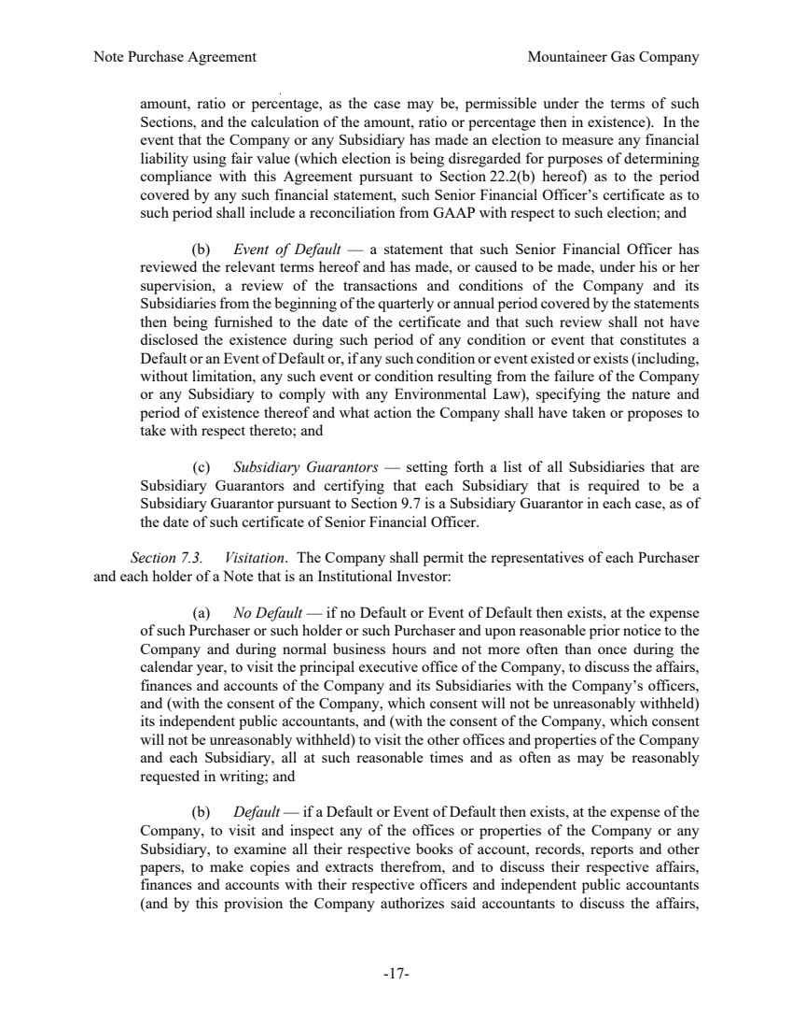 | Note Purchase Agreement Mountaineer Gas Company -17- amount, ratio or percentage, as the case may be, permissible under the terms of such Sections, and the calculation of the amount, ratio or percentage then in existence). In the event that the Company or any Subsidiary has made an election to measure any financial liability using fair value (which election is being disregarded for purposes of determining compliance with this Agreement pursuant to Section 22.2(b) hereof) as to the period covered by any such financial statement, such Senior Financial Officer’s certificate as to such period shall include a reconciliation from GAAP with respect to such election; and (b) Event of Default — a statement that such Senior Financial Officer has reviewed the relevant terms hereof and has made, or caused to be made, under his or her supervision, a review of the transactions and conditions of the Company and its Subsidiaries from the beginning of the quarterly or annual period covered by the statements then being furnished to the date of the certificate and that such review shall not have disclosed the existence during such period of any condition or event that constitutes a Default or an Event of Default or, if any such condition or event existed or exists (including, without limitation, any such event or condition resulting from the failure of the Company or any Subsidiary to comply with any Environmental Law), specifying the nature and period of existence thereof and what action the Company shall have taken or proposes to take with respect thereto; and (c) Subsidiary Guarantors — setting forth a list of all Subsidiaries that are Subsidiary Guarantors and certifying that each Subsidiary that is required to be a Subsidiary Guarantor pursuant to Section 9.7 is a Subsidiary Guarantor in each case, as of the date of such certificate of Senior Financial Officer. Section 7.3. Visitation. The Company shall permit the representatives of each Purchaser and each holder of a Note that is an Institutional Investor: (a) No Default — if no Default or Event of Default then exists, at the expense of such Purchaser or such holder or such Purchaser and upon reasonable prior notice to the Company and during normal business hours and not more often than once during the calendar year, to visit the principal executive office of the Company, to discuss the affairs, finances and accounts of the Company and its Subsidiaries with the Company’s officers, and (with the consent of the Company, which consent will not be unreasonably withheld) its independent public accountants, and (with the consent of the Company, which consent will not be unreasonably withheld) to visit the other offices and properties of the Company and each Subsidiary, all at such reasonable times and as often as may be reasonably requested in writing; and (b) Default — if a Default or Event of Default then exists, at the expense of the Company, to visit and inspect any of the offices or properties of the Company or any Subsidiary, to examine all their respective books of account, records, reports and other papers, to make copies and extracts therefrom, and to discuss their respective affairs, finances and accounts with their respective officers and independent public accountants (and by this provision the Company authorizes said accountants to discuss the affairs,
 | 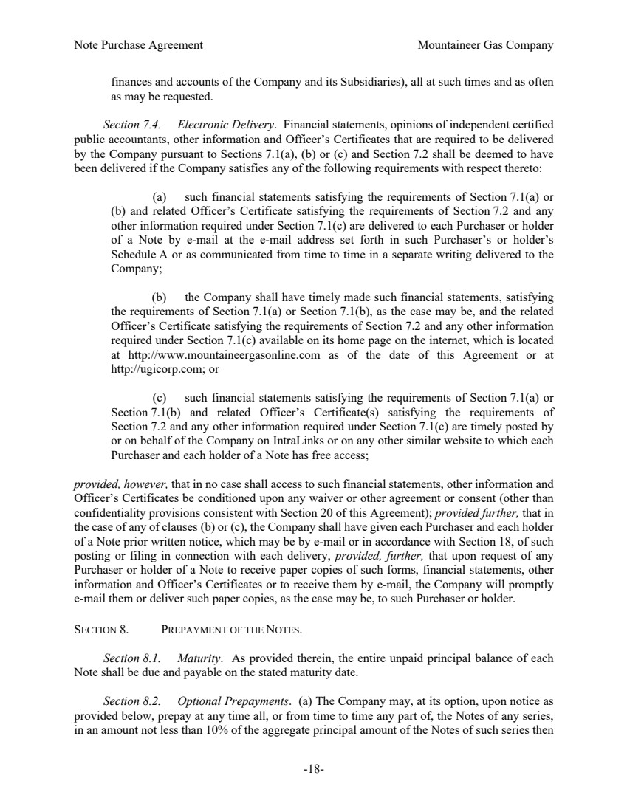 | Note Purchase Agreement Mountaineer Gas Company -18- finances and accounts of the Company and its Subsidiaries), all at such times and as often as may be requested. Section 7.4. Electronic Delivery. Financial statements, opinions of independent certified public accountants, other information and Officer’s Certificates that are required to be delivered by the Company pursuant to Sections 7.1(a), (b) or (c) and Section 7.2 shall be deemed to have been delivered if the Company satisfies any of the following requirements with respect thereto: (a) such financial statements satisfying the requirements of Section 7.1(a) or (b) and related Officer’s Certificate satisfying the requirements of Section 7.2 and any other information required under Section 7.1(c) are delivered to each Purchaser or holder of a Note by e-mail at the e-mail address set forth in such Purchaser’s or holder’s Schedule A or as communicated from time to time in a separate writing delivered to the Company; (b) the Company shall have timely made such financial statements, satisfying the requirements of Section 7.1(a) or Section 7.1(b), as the case may be, and the related Officer’s Certificate satisfying the requirements of Section 7.2 and any other information required under Section 7.1(c) available on its home page on the internet, which is located at http://www.mountaineergasonline.com as of the date of this Agreement or at http://ugicorp.com; or (c) such financial statements satisfying the requirements of Section 7.1(a) or Section 7.1(b) and related Officer’s Certificate(s) satisfying the requirements of Section 7.2 and any other information required under Section 7.1(c) are timely posted by or on behalf of the Company on IntraLinks or on any other similar website to which each Purchaser and each holder of a Note has free access; provided, however, that in no case shall access to such financial statements, other information and Officer’s Certificates be conditioned upon any waiver or other agreement or consent (other than confidentiality provisions consistent with Section 20 of this Agreement); provided further, that in the case of any of clauses (b) or (c), the Company shall have given each Purchaser and each holder of a Note prior written notice, which may be by e-mail or in accordance with Section 18, of such posting or filing in connection with each delivery, provided, further, that upon request of any Purchaser or holder of a Note to receive paper copies of such forms, financial statements, other information and Officer’s Certificates or to receive them by e-mail, the Company will promptly e-mail them or deliver such paper copies, as the case may be, to such Purchaser or holder. SECTION 8. PREPAYMENT OF THE NOTES. Section 8.1. Maturity. As provided therein, the entire unpaid principal balance of each Note shall be due and payable on the stated maturity date. Section 8.2. Optional Prepayments. (a) The Company may, at its option, upon notice as provided below, prepay at any time all, or from time to time any part of, the Notes of any series, in an amount not less than 10% of the aggregate principal amount of the Notes of such series then
 | 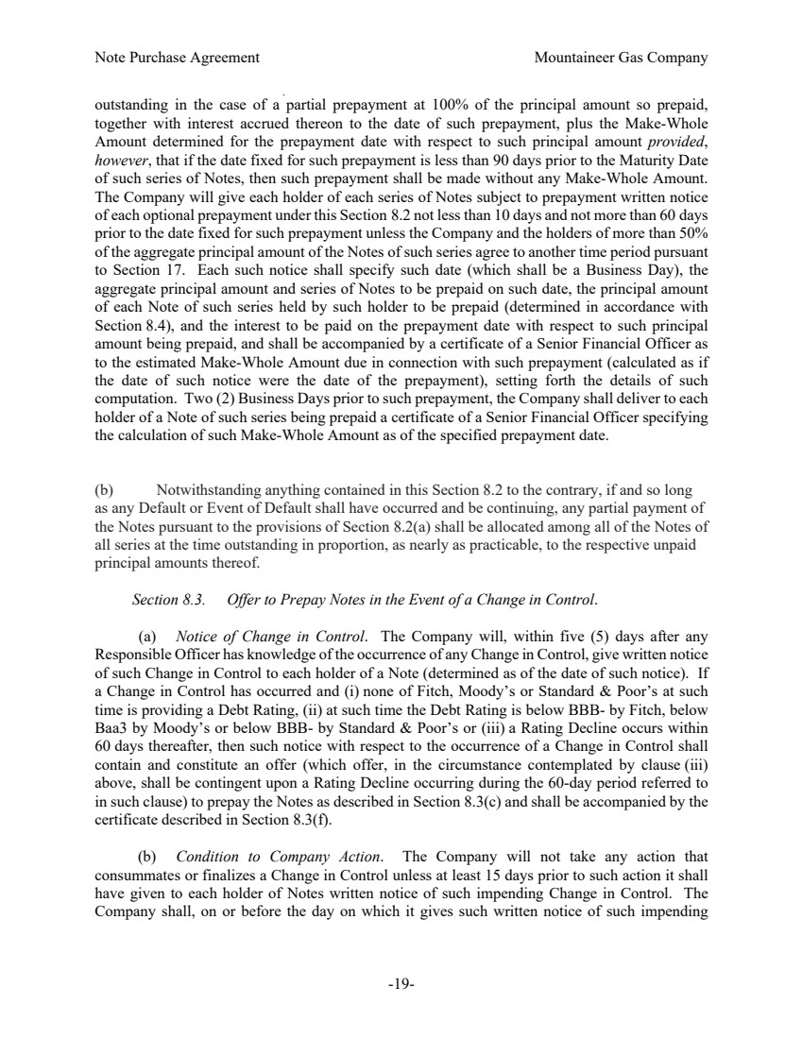 | Note Purchase Agreement Mountaineer Gas Company -19- outstanding in the case of a partial prepayment at 100% of the principal amount so prepaid, together with interest accrued thereon to the date of such prepayment, plus the Make-Whole Amount determined for the prepayment date with respect to such principal amount provided, however, that if the date fixed for such prepayment is less than 90 days prior to the Maturity Date of such series of Notes, then such prepayment shall be made without any Make-Whole Amount. The Company will give each holder of each series of Notes subject to prepayment written notice of each optional prepayment under this Section 8.2 not less than 10 days and not more than 60 days prior to the date fixed for such prepayment unless the Company and the holders of more than 50% of the aggregate principal amount of the Notes of such series agree to another time period pursuant to Section 17. Each such notice shall specify such date (which shall be a Business Day), the aggregate principal amount and series of Notes to be prepaid on such date, the principal amount of each Note of such series held by such holder to be prepaid (determined in accordance with Section 8.4), and the interest to be paid on the prepayment date with respect to such principal amount being prepaid, and shall be accompanied by a certificate of a Senior Financial Officer as to the estimated Make-Whole Amount due in connection with such prepayment (calculated as if the date of such notice were the date of the prepayment), setting forth the details of such computation. Two (2) Business Days prior to such prepayment, the Company shall deliver to each holder of a Note of such series being prepaid a certificate of a Senior Financial Officer specifying the calculation of such Make-Whole Amount as of the specified prepayment date. (b) Notwithstanding anything contained in this Section 8.2 to the contrary, if and so long as any Default or Event of Default shall have occurred and be continuing, any partial payment of the Notes pursuant to the provisions of Section 8.2(a) shall be allocated among all of the Notes of all series at the time outstanding in proportion, as nearly as practicable, to the respective unpaid principal amounts thereof. Section 8.3. Offer to Prepay Notes in the Event of a Change in Control. (a) Notice of Change in Control. The Company will, within five (5) days after any Responsible Officer has knowledge of the occurrence of any Change in Control, give written notice of such Change in Control to each holder of a Note (determined as of the date of such notice). If a Change in Control has occurred and (i) none of Fitch, Moody’s or Standard & Poor’s at such time is providing a Debt Rating, (ii) at such time the Debt Rating is below BBB- by Fitch, below Baa3 by Moody’s or below BBB- by Standard & Poor’s or (iii) a Rating Decline occurs within 60 days thereafter, then such notice with respect to the occurrence of a Change in Control shall contain and constitute an offer (which offer, in the circumstance contemplated by clause (iii) above, shall be contingent upon a Rating Decline occurring during the 60-day period referred to in such clause) to prepay the Notes as described in Section 8.3(c) and shall be accompanied by the certificate described in Section 8.3(f). (b) Condition to Company Action. The Company will not take any action that consummates or finalizes a Change in Control unless at least 15 days prior to such action it shall have given to each holder of Notes written notice of such impending Change in Control. The Company shall, on or before the day on which it gives such written notice of such impending
 | 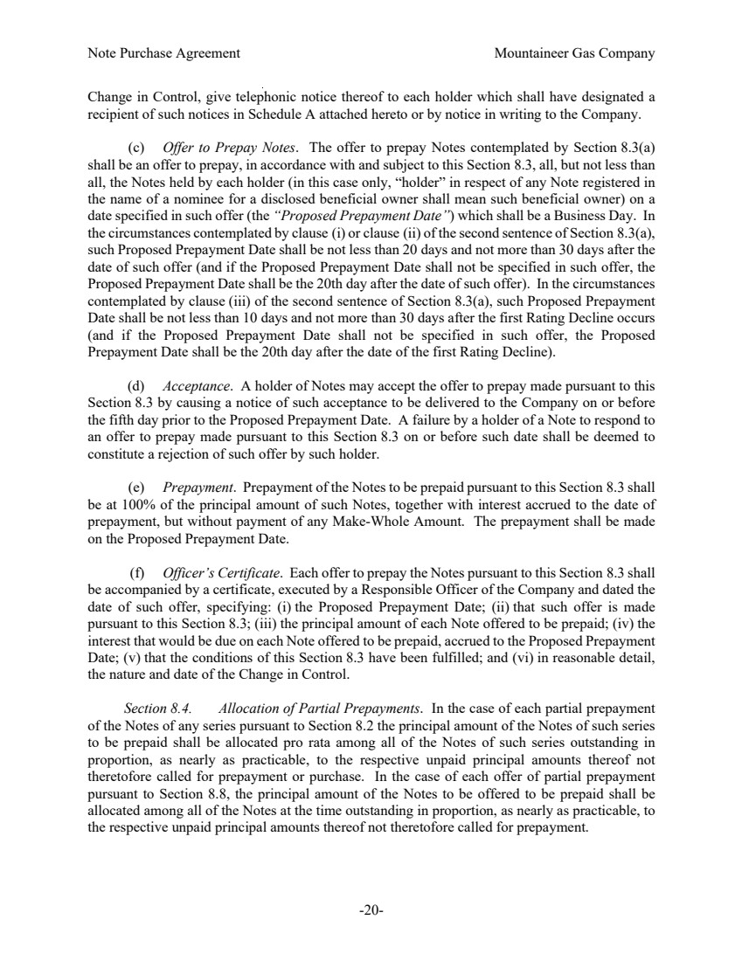 | Note Purchase Agreement Mountaineer Gas Company -20- Change in Control, give telephonic notice thereof to each holder which shall have designated a recipient of such notices in Schedule A attached hereto or by notice in writing to the Company. (c) Offer to Prepay Notes. The offer to prepay Notes contemplated by Section 8.3(a) shall be an offer to prepay, in accordance with and subject to this Section 8.3, all, but not less than all, the Notes held by each holder (in this case only, “holder” in respect of any Note registered in the name of a nominee for a disclosed beneficial owner shall mean such beneficial owner) on a date specified in such offer (the “Proposed Prepayment Date”) which shall be a Business Day. In the circumstances contemplated by clause (i) or clause (ii) of the second sentence of Section 8.3(a), such Proposed Prepayment Date shall be not less than 20 days and not more than 30 days after the date of such offer (and if the Proposed Prepayment Date shall not be specified in such offer, the Proposed Prepayment Date shall be the 20th day after the date of such offer). In the circumstances contemplated by clause (iii) of the second sentence of Section 8.3(a), such Proposed Prepayment Date shall be not less than 10 days and not more than 30 days after the first Rating Decline occurs (and if the Proposed Prepayment Date shall not be specified in such offer, the Proposed Prepayment Date shall be the 20th day after the date of the first Rating Decline). (d) Acceptance. A holder of Notes may accept the offer to prepay made pursuant to this Section 8.3 by causing a notice of such acceptance to be delivered to the Company on or before the fifth day prior to the Proposed Prepayment Date. A failure by a holder of a Note to respond to an offer to prepay made pursuant to this Section 8.3 on or before such date shall be deemed to constitute a rejection of such offer by such holder. (e) Prepayment. Prepayment of the Notes to be prepaid pursuant to this Section 8.3 shall be at 100% of the principal amount of such Notes, together with interest accrued to the date of prepayment, but without payment of any Make-Whole Amount. The prepayment shall be made on the Proposed Prepayment Date. (f) Officer’s Certificate. Each offer to prepay the Notes pursuant to this Section 8.3 shall be accompanied by a certificate, executed by a Responsible Officer of the Company and dated the date of such offer, specifying: (i) the Proposed Prepayment Date; (ii) that such offer is made pursuant to this Section 8.3; (iii) the principal amount of each Note offered to be prepaid; (iv) the interest that would be due on each Note offered to be prepaid, accrued to the Proposed Prepayment Date; (v) that the conditions of this Section 8.3 have been fulfilled; and (vi) in reasonable detail, the nature and date of the Change in Control. Section 8.4. Allocation of Partial Prepayments. In the case of each partial prepayment of the Notes of any series pursuant to Section 8.2 the principal amount of the Notes of such series to be prepaid shall be allocated pro rata among all of the Notes of such series outstanding in proportion, as nearly as practicable, to the respective unpaid principal amounts thereof not theretofore called for prepayment or purchase. In the case of each offer of partial prepayment pursuant to Section 8.8, the principal amount of the Notes to be offered to be prepaid shall be allocated among all of the Notes at the time outstanding in proportion, as nearly as practicable, to the respective unpaid principal amounts thereof not theretofore called for prepayment.
 | 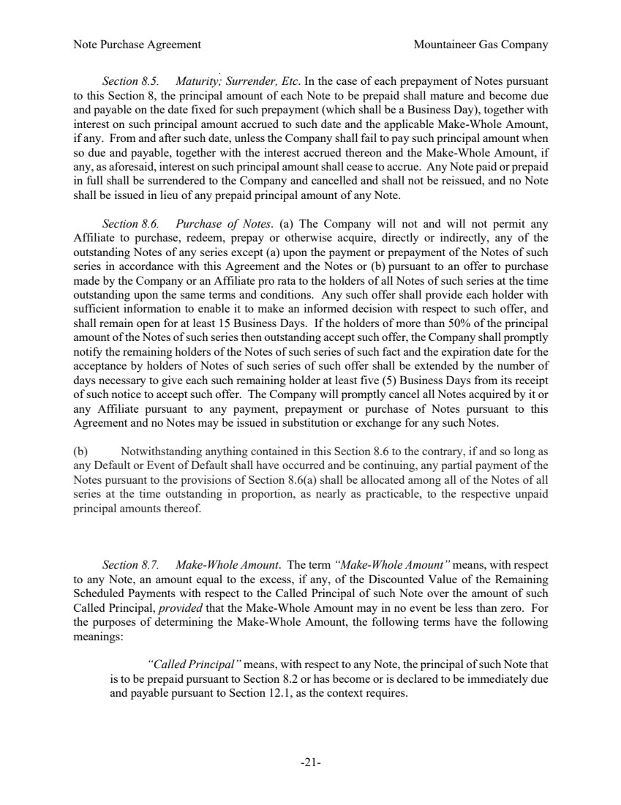 | Note Purchase Agreement Mountaineer Gas Company -21- Section 8.5. Maturity; Surrender, Etc. In the case of each prepayment of Notes pursuant to this Section 8, the principal amount of each Note to be prepaid shall mature and become due and payable on the date fixed for such prepayment (which shall be a Business Day), together with interest on such principal amount accrued to such date and the applicable Make-Whole Amount, if any. From and after such date, unless the Company shall fail to pay such principal amount when so due and payable, together with the interest accrued thereon and the Make-Whole Amount, if any, as aforesaid, interest on such principal amount shall cease to accrue. Any Note paid or prepaid in full shall be surrendered to the Company and cancelled and shall not be reissued, and no Note shall be issued in lieu of any prepaid principal amount of any Note. Section 8.6. Purchase of Notes. (a) The Company will not and will not permit any Affiliate to purchase, redeem, prepay or otherwise acquire, directly or indirectly, any of the outstanding Notes of any series except (a) upon the payment or prepayment of the Notes of such series in accordance with this Agreement and the Notes or (b) pursuant to an offer to purchase made by the Company or an Affiliate pro rata to the holders of all Notes of such series at the time outstanding upon the same terms and conditions. Any such offer shall provide each holder with sufficient information to enable it to make an informed decision with respect to such offer, and shall remain open for at least 15 Business Days. If the holders of more than 50% of the principal amount of the Notes of such series then outstanding accept such offer, the Company shall promptly notify the remaining holders of the Notes of such series of such fact and the expiration date for the acceptance by holders of Notes of such series of such offer shall be extended by the number of days necessary to give each such remaining holder at least five (5) Business Days from its receipt of such notice to accept such offer. The Company will promptly cancel all Notes acquired by it or any Affiliate pursuant to any payment, prepayment or purchase of Notes pursuant to this Agreement and no Notes may be issued in substitution or exchange for any such Notes. (b) Notwithstanding anything contained in this Section 8.6 to the contrary, if and so long as any Default or Event of Default shall have occurred and be continuing, any partial payment of the Notes pursuant to the provisions of Section 8.6(a) shall be allocated among all of the Notes of all series at the time outstanding in proportion, as nearly as practicable, to the respective unpaid principal amounts thereof. Section 8.7. Make-Whole Amount. The term “Make-Whole Amount” means, with respect to any Note, an amount equal to the excess, if any, of the Discounted Value of the Remaining Scheduled Payments with respect to the Called Principal of such Note over the amount of such Called Principal, provided that the Make-Whole Amount may in no event be less than zero. For the purposes of determining the Make-Whole Amount, the following terms have the following meanings: “Called Principal” means, with respect to any Note, the principal of such Note that is to be prepaid pursuant to Section 8.2 or has become or is declared to be immediately due and payable pursuant to Section 12.1, as the context requires.
 | 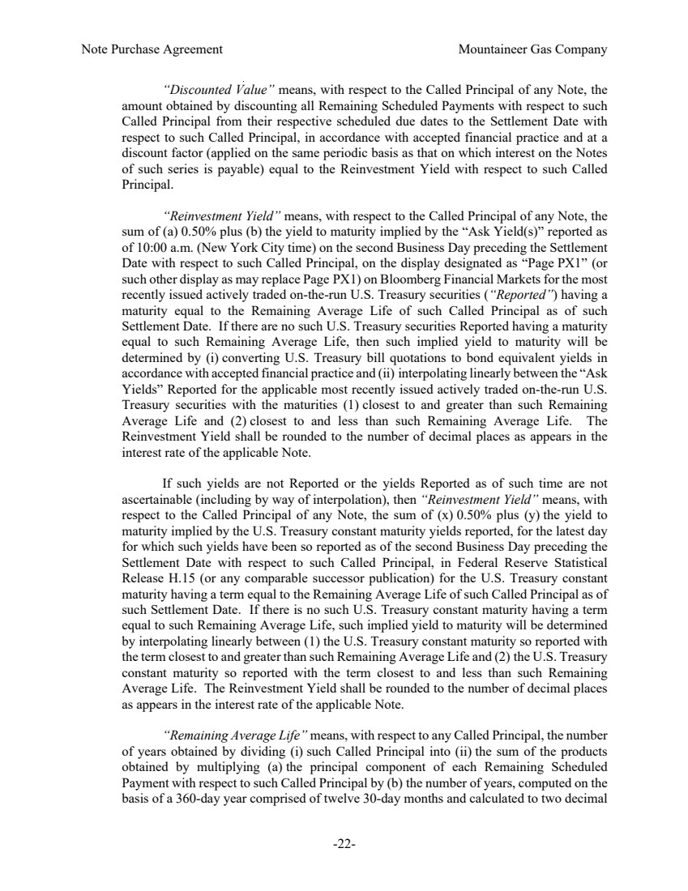 | Note Purchase Agreement Mountaineer Gas Company -22- “Discounted Value” means, with respect to the Called Principal of any Note, the amount obtained by discounting all Remaining Scheduled Payments with respect to such Called Principal from their respective scheduled due dates to the Settlement Date with respect to such Called Principal, in accordance with accepted financial practice and at a discount factor (applied on the same periodic basis as that on which interest on the Notes of such series is payable) equal to the Reinvestment Yield with respect to such Called Principal. “Reinvestment Yield” means, with respect to the Called Principal of any Note, the sum of (a) 0.50% plus (b) the yield to maturity implied by the “Ask Yield(s)” reported as of 10:00 a.m. (New York City time) on the second Business Day preceding the Settlement Date with respect to such Called Principal, on the display designated as “Page PX1” (or such other display as may replace Page PX1) on Bloomberg Financial Markets for the most recently issued actively traded on-the-run U.S. Treasury securities (“Reported”) having a maturity equal to the Remaining Average Life of such Called Principal as of such Settlement Date. If there are no such U.S. Treasury securities Reported having a maturity equal to such Remaining Average Life, then such implied yield to maturity will be determined by (i) converting U.S. Treasury bill quotations to bond equivalent yields in accordance with accepted financial practice and (ii) interpolating linearly between the “Ask Yields” Reported for the applicable most recently issued actively traded on-the-run U.S. Treasury securities with the maturities (1) closest to and greater than such Remaining Average Life and (2) closest to and less than such Remaining Average Life. The Reinvestment Yield shall be rounded to the number of decimal places as appears in the interest rate of the applicable Note. If such yields are not Reported or the yields Reported as of such time are not ascertainable (including by way of interpolation), then “Reinvestment Yield” means, with respect to the Called Principal of any Note, the sum of (x) 0.50% plus (y) the yield to maturity implied by the U.S. Treasury constant maturity yields reported, for the latest day for which such yields have been so reported as of the second Business Day preceding the Settlement Date with respect to such Called Principal, in Federal Reserve Statistical Release H.15 (or any comparable successor publication) for the U.S. Treasury constant maturity having a term equal to the Remaining Average Life of such Called Principal as of such Settlement Date. If there is no such U.S. Treasury constant maturity having a term equal to such Remaining Average Life, such implied yield to maturity will be determined by interpolating linearly between (1) the U.S. Treasury constant maturity so reported with the term closest to and greater than such Remaining Average Life and (2) the U.S. Treasury constant maturity so reported with the term closest to and less than such Remaining Average Life. The Reinvestment Yield shall be rounded to the number of decimal places as appears in the interest rate of the applicable Note. “Remaining Average Life” means, with respect to any Called Principal, the number of years obtained by dividing (i) such Called Principal into (ii) the sum of the products obtained by multiplying (a) the principal component of each Remaining Scheduled Payment with respect to such Called Principal by (b) the number of years, computed on the basis of a 360-day year comprised of twelve 30-day months and calculated to two decimal
 | 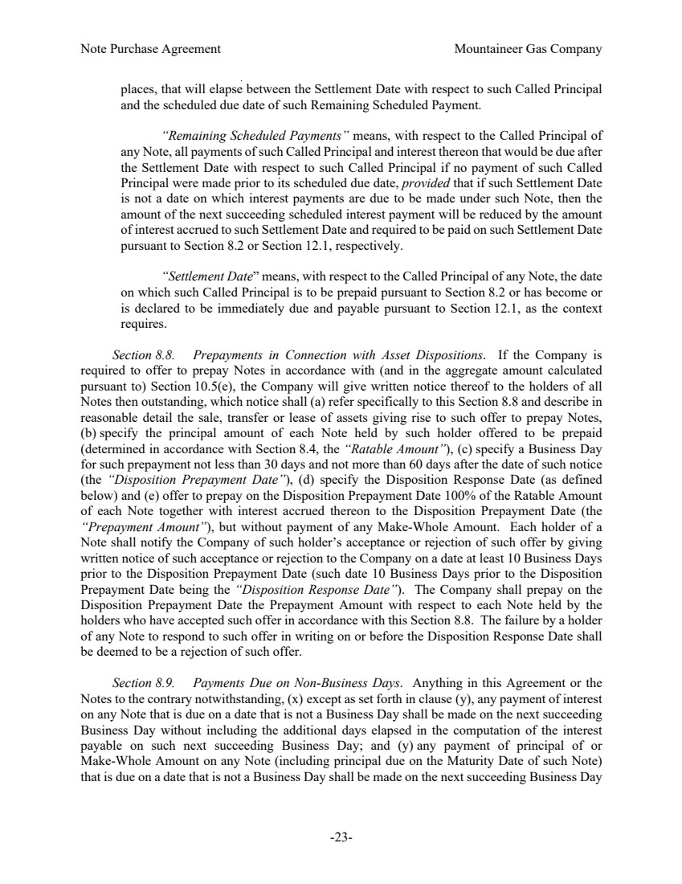 | Note Purchase Agreement Mountaineer Gas Company -23- places, that will elapse between the Settlement Date with respect to such Called Principal and the scheduled due date of such Remaining Scheduled Payment. “Remaining Scheduled Payments” means, with respect to the Called Principal of any Note, all payments of such Called Principal and interest thereon that would be due after the Settlement Date with respect to such Called Principal if no payment of such Called Principal were made prior to its scheduled due date, provided that if such Settlement Date is not a date on which interest payments are due to be made under such Note, then the amount of the next succeeding scheduled interest payment will be reduced by the amount of interest accrued to such Settlement Date and required to be paid on such Settlement Date pursuant to Section 8.2 or Section 12.1, respectively. “Settlement Date” means, with respect to the Called Principal of any Note, the date on which such Called Principal is to be prepaid pursuant to Section 8.2 or has become or is declared to be immediately due and payable pursuant to Section 12.1, as the context requires. Section 8.8. Prepayments in Connection with Asset Dispositions. If the Company is required to offer to prepay Notes in accordance with (and in the aggregate amount calculated pursuant to) Section 10.5(e), the Company will give written notice thereof to the holders of all Notes then outstanding, which notice shall (a) refer specifically to this Section 8.8 and describe in reasonable detail the sale, transfer or lease of assets giving rise to such offer to prepay Notes, (b) specify the principal amount of each Note held by such holder offered to be prepaid (determined in accordance with Section 8.4, the “Ratable Amount”), (c) specify a Business Day for such prepayment not less than 30 days and not more than 60 days after the date of such notice (the “Disposition Prepayment Date”), (d) specify the Disposition Response Date (as defined below) and (e) offer to prepay on the Disposition Prepayment Date 100% of the Ratable Amount of each Note together with interest accrued thereon to the Disposition Prepayment Date (the “Prepayment Amount”), but without payment of any Make-Whole Amount. Each holder of a Note shall notify the Company of such holder’s acceptance or rejection of such offer by giving written notice of such acceptance or rejection to the Company on a date at least 10 Business Days prior to the Disposition Prepayment Date (such date 10 Business Days prior to the Disposition Prepayment Date being the “Disposition Response Date”). The Company shall prepay on the Disposition Prepayment Date the Prepayment Amount with respect to each Note held by the holders who have accepted such offer in accordance with this Section 8.8. The failure by a holder of any Note to respond to such offer in writing on or before the Disposition Response Date shall be deemed to be a rejection of such offer. Section 8.9. Payments Due on Non-Business Days. Anything in this Agreement or the Notes to the contrary notwithstanding, (x) except as set forth in clause (y), any payment of interest on any Note that is due on a date that is not a Business Day shall be made on the next succeeding Business Day without including the additional days elapsed in the computation of the interest payable on such next succeeding Business Day; and (y) any payment of principal of or Make-Whole Amount on any Note (including principal due on the Maturity Date of such Note) that is due on a date that is not a Business Day shall be made on the next succeeding Business Day
 | 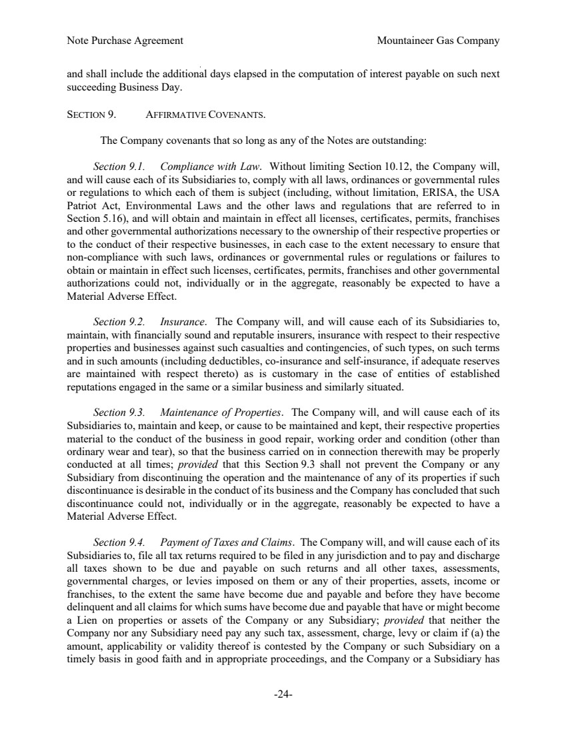 | Note Purchase Agreement Mountaineer Gas Company -24- and shall include the additional days elapsed in the computation of interest payable on such next succeeding Business Day. SECTION 9. AFFIRMATIVE COVENANTS. The Company covenants that so long as any of the Notes are outstanding: Section 9.1. Compliance with Law. Without limiting Section 10.12, the Company will, and will cause each of its Subsidiaries to, comply with all laws, ordinances or governmental rules or regulations to which each of them is subject (including, without limitation, ERISA, the USA Patriot Act, Environmental Laws and the other laws and regulations that are referred to in Section 5.16), and will obtain and maintain in effect all licenses, certificates, permits, franchises and other governmental authorizations necessary to the ownership of their respective properties or to the conduct of their respective businesses, in each case to the extent necessary to ensure that non-compliance with such laws, ordinances or governmental rules or regulations or failures to obtain or maintain in effect such licenses, certificates, permits, franchises and other governmental authorizations could not, individually or in the aggregate, reasonably be expected to have a Material Adverse Effect. Section 9.2. Insurance. The Company will, and will cause each of its Subsidiaries to, maintain, with financially sound and reputable insurers, insurance with respect to their respective properties and businesses against such casualties and contingencies, of such types, on such terms and in such amounts (including deductibles, co-insurance and self-insurance, if adequate reserves are maintained with respect thereto) as is customary in the case of entities of established reputations engaged in the same or a similar business and similarly situated. Section 9.3. Maintenance of Properties. The Company will, and will cause each of its Subsidiaries to, maintain and keep, or cause to be maintained and kept, their respective properties material to the conduct of the business in good repair, working order and condition (other than ordinary wear and tear), so that the business carried on in connection therewith may be properly conducted at all times; provided that this Section 9.3 shall not prevent the Company or any Subsidiary from discontinuing the operation and the maintenance of any of its properties if such discontinuance is desirable in the conduct of its business and the Company has concluded that such discontinuance could not, individually or in the aggregate, reasonably be expected to have a Material Adverse Effect. Section 9.4. Payment of Taxes and Claims. The Company will, and will cause each of its Subsidiaries to, file all tax returns required to be filed in any jurisdiction and to pay and discharge all taxes shown to be due and payable on such returns and all other taxes, assessments, governmental charges, or levies imposed on them or any of their properties, assets, income or franchises, to the extent the same have become due and payable and before they have become delinquent and all claims for which sums have become due and payable that have or might become a Lien on properties or assets of the Company or any Subsidiary; provided that neither the Company nor any Subsidiary need pay any such tax, assessment, charge, levy or claim if (a) the amount, applicability or validity thereof is contested by the Company or such Subsidiary on a timely basis in good faith and in appropriate proceedings, and the Company or a Subsidiary has
 | 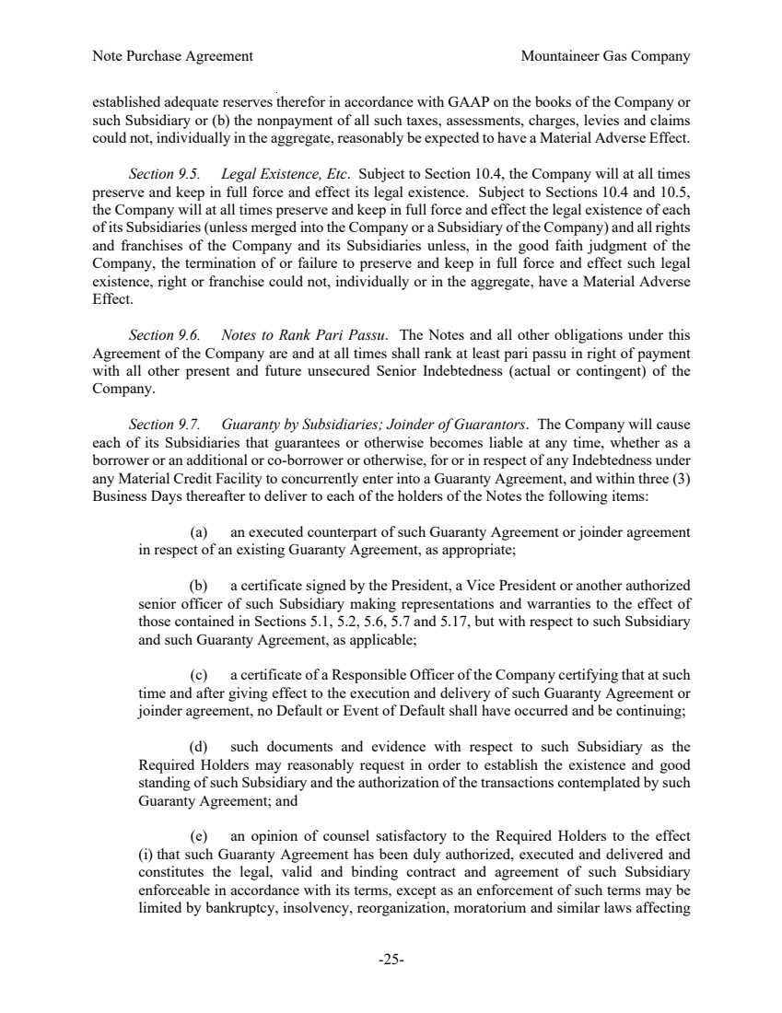 | Note Purchase Agreement Mountaineer Gas Company -25- established adequate reserves therefor in accordance with GAAP on the books of the Company or such Subsidiary or (b) the nonpayment of all such taxes, assessments, charges, levies and claims could not, individually in the aggregate, reasonably be expected to have a Material Adverse Effect. Section 9.5. Legal Existence, Etc. Subject to Section 10.4, the Company will at all times preserve and keep in full force and effect its legal existence. Subject to Sections 10.4 and 10.5, the Company will at all times preserve and keep in full force and effect the legal existence of each of its Subsidiaries (unless merged into the Company or a Subsidiary of the Company) and all rights and franchises of the Company and its Subsidiaries unless, in the good faith judgment of the Company, the termination of or failure to preserve and keep in full force and effect such legal existence, right or franchise could not, individually or in the aggregate, have a Material Adverse Effect. Section 9.6. Notes to Rank Pari Passu. The Notes and all other obligations under this Agreement of the Company are and at all times shall rank at least pari passu in right of payment with all other present and future unsecured Senior Indebtedness (actual or contingent) of the Company. Section 9.7. Guaranty by Subsidiaries; Joinder of Guarantors. The Company will cause each of its Subsidiaries that guarantees or otherwise becomes liable at any time, whether as a borrower or an additional or co-borrower or otherwise, for or in respect of any Indebtedness under any Material Credit Facility to concurrently enter into a Guaranty Agreement, and within three (3) Business Days thereafter to deliver to each of the holders of the Notes the following items: (a) an executed counterpart of such Guaranty Agreement or joinder agreement in respect of an existing Guaranty Agreement, as appropriate; (b) a certificate signed by the President, a Vice President or another authorized senior officer of such Subsidiary making representations and warranties to the effect of those contained in Sections 5.1, 5.2, 5.6, 5.7 and 5.17, but with respect to such Subsidiary and such Guaranty Agreement, as applicable; (c) a certificate of a Responsible Officer of the Company certifying that at such time and after giving effect to the execution and delivery of such Guaranty Agreement or joinder agreement, no Default or Event of Default shall have occurred and be continuing; (d) such documents and evidence with respect to such Subsidiary as the Required Holders may reasonably request in order to establish the existence and good standing of such Subsidiary and the authorization of the transactions contemplated by such Guaranty Agreement; and (e) an opinion of counsel satisfactory to the Required Holders to the effect (i) that such Guaranty Agreement has been duly authorized, executed and delivered and constitutes the legal, valid and binding contract and agreement of such Subsidiary enforceable in accordance with its terms, except as an enforcement of such terms may be limited by bankruptcy, insolvency, reorganization, moratorium and similar laws affecting
 | 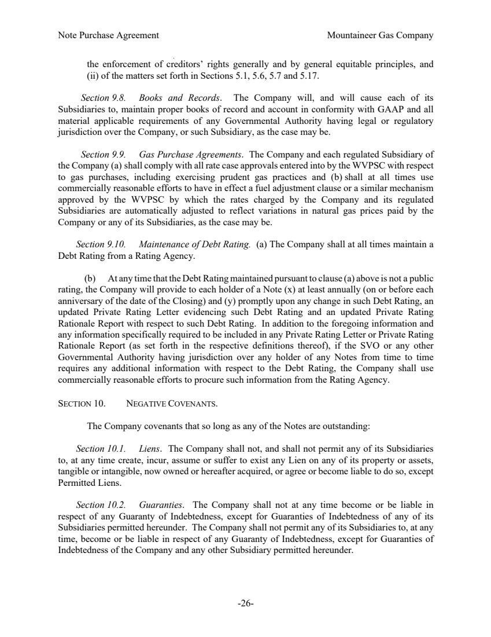 | Note Purchase Agreement Mountaineer Gas Company -26- the enforcement of creditors’ rights generally and by general equitable principles, and (ii) of the matters set forth in Sections 5.1, 5.6, 5.7 and 5.17. Section 9.8. Books and Records. The Company will, and will cause each of its Subsidiaries to, maintain proper books of record and account in conformity with GAAP and all material applicable requirements of any Governmental Authority having legal or regulatory jurisdiction over the Company, or such Subsidiary, as the case may be. Section 9.9. Gas Purchase Agreements. The Company and each regulated Subsidiary of the Company (a) shall comply with all rate case approvals entered into by the WVPSC with respect to gas purchases, including exercising prudent gas practices and (b) shall at all times use commercially reasonable efforts to have in effect a fuel adjustment clause or a similar mechanism approved by the WVPSC by which the rates charged by the Company and its regulated Subsidiaries are automatically adjusted to reflect variations in natural gas prices paid by the Company or any of its Subsidiaries, as the case may be. Section 9.10. Maintenance of Debt Rating. (a) The Company shall at all times maintain a Debt Rating from a Rating Agency. (b) At any time that the Debt Rating maintained pursuant to clause (a) above is not a public rating, the Company will provide to each holder of a Note (x) at least annually (on or before each anniversary of the date of the Closing) and (y) promptly upon any change in such Debt Rating, an updated Private Rating Letter evidencing such Debt Rating and an updated Private Rating Rationale Report with respect to such Debt Rating. In addition to the foregoing information and any information specifically required to be included in any Private Rating Letter or Private Rating Rationale Report (as set forth in the respective definitions thereof), if the SVO or any other Governmental Authority having jurisdiction over any holder of any Notes from time to time requires any additional information with respect to the Debt Rating, the Company shall use commercially reasonable efforts to procure such information from the Rating Agency. SECTION 10. NEGATIVE COVENANTS. The Company covenants that so long as any of the Notes are outstanding: Section 10.1. Liens. The Company shall not, and shall not permit any of its Subsidiaries to, at any time create, incur, assume or suffer to exist any Lien on any of its property or assets, tangible or intangible, now owned or hereafter acquired, or agree or become liable to do so, except Permitted Liens. Section 10.2. Guaranties. The Company shall not at any time become or be liable in respect of any Guaranty of Indebtedness, except for Guaranties of Indebtedness of any of its Subsidiaries permitted hereunder. The Company shall not permit any of its Subsidiaries to, at any time, become or be liable in respect of any Guaranty of Indebtedness, except for Guaranties of Indebtedness of the Company and any other Subsidiary permitted hereunder.
 | 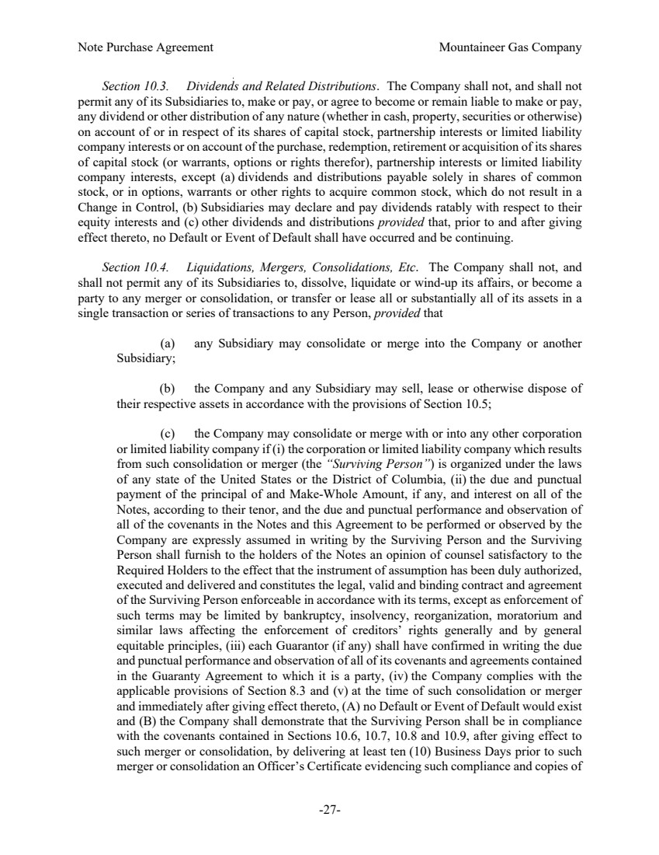 | Note Purchase Agreement Mountaineer Gas Company -27- Section 10.3. Dividends and Related Distributions. The Company shall not, and shall not permit any of its Subsidiaries to, make or pay, or agree to become or remain liable to make or pay, any dividend or other distribution of any nature (whether in cash, property, securities or otherwise) on account of or in respect of its shares of capital stock, partnership interests or limited liability company interests or on account of the purchase, redemption, retirement or acquisition of its shares of capital stock (or warrants, options or rights therefor), partnership interests or limited liability company interests, except (a) dividends and distributions payable solely in shares of common stock, or in options, warrants or other rights to acquire common stock, which do not result in a Change in Control, (b) Subsidiaries may declare and pay dividends ratably with respect to their equity interests and (c) other dividends and distributions provided that, prior to and after giving effect thereto, no Default or Event of Default shall have occurred and be continuing. Section 10.4. Liquidations, Mergers, Consolidations, Etc. The Company shall not, and shall not permit any of its Subsidiaries to, dissolve, liquidate or wind-up its affairs, or become a party to any merger or consolidation, or transfer or lease all or substantially all of its assets in a single transaction or series of transactions to any Person, provided that (a) any Subsidiary may consolidate or merge into the Company or another Subsidiary; (b) the Company and any Subsidiary may sell, lease or otherwise dispose of their respective assets in accordance with the provisions of Section 10.5; (c) the Company may consolidate or merge with or into any other corporation or limited liability company if (i) the corporation or limited liability company which results from such consolidation or merger (the “Surviving Person”) is organized under the laws of any state of the United States or the District of Columbia, (ii) the due and punctual payment of the principal of and Make-Whole Amount, if any, and interest on all of the Notes, according to their tenor, and the due and punctual performance and observation of all of the covenants in the Notes and this Agreement to be performed or observed by the Company are expressly assumed in writing by the Surviving Person and the Surviving Person shall furnish to the holders of the Notes an opinion of counsel satisfactory to the Required Holders to the effect that the instrument of assumption has been duly authorized, executed and delivered and constitutes the legal, valid and binding contract and agreement of the Surviving Person enforceable in accordance with its terms, except as enforcement of such terms may be limited by bankruptcy, insolvency, reorganization, moratorium and similar laws affecting the enforcement of creditors’ rights generally and by general equitable principles, (iii) each Guarantor (if any) shall have confirmed in writing the due and punctual performance and observation of all of its covenants and agreements contained in the Guaranty Agreement to which it is a party, (iv) the Company complies with the applicable provisions of Section 8.3 and (v) at the time of such consolidation or merger and immediately after giving effect thereto, (A) no Default or Event of Default would exist and (B) the Company shall demonstrate that the Surviving Person shall be in compliance with the covenants contained in Sections 10.6, 10.7, 10.8 and 10.9, after giving effect to such merger or consolidation, by delivering at least ten (10) Business Days prior to such merger or consolidation an Officer’s Certificate evidencing such compliance and copies of
 | 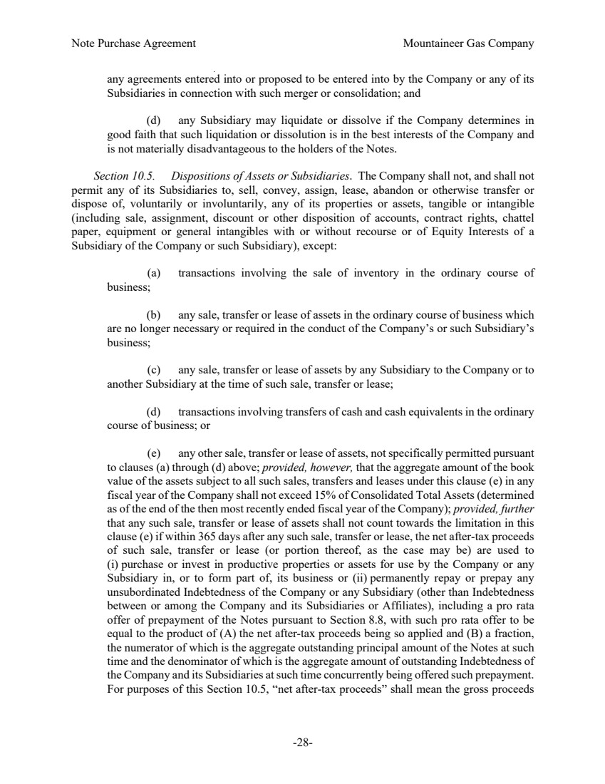 | Note Purchase Agreement Mountaineer Gas Company -28- any agreements entered into or proposed to be entered into by the Company or any of its Subsidiaries in connection with such merger or consolidation; and (d) any Subsidiary may liquidate or dissolve if the Company determines in good faith that such liquidation or dissolution is in the best interests of the Company and is not materially disadvantageous to the holders of the Notes. Section 10.5. Dispositions of Assets or Subsidiaries. The Company shall not, and shall not permit any of its Subsidiaries to, sell, convey, assign, lease, abandon or otherwise transfer or dispose of, voluntarily or involuntarily, any of its properties or assets, tangible or intangible (including sale, assignment, discount or other disposition of accounts, contract rights, chattel paper, equipment or general intangibles with or without recourse or of Equity Interests of a Subsidiary of the Company or such Subsidiary), except: (a) transactions involving the sale of inventory in the ordinary course of business; (b) any sale, transfer or lease of assets in the ordinary course of business which are no longer necessary or required in the conduct of the Company’s or such Subsidiary’s business; (c) any sale, transfer or lease of assets by any Subsidiary to the Company or to another Subsidiary at the time of such sale, transfer or lease; (d) transactions involving transfers of cash and cash equivalents in the ordinary course of business; or (e) any other sale, transfer or lease of assets, not specifically permitted pursuant to clauses (a) through (d) above; provided, however, that the aggregate amount of the book value of the assets subject to all such sales, transfers and leases under this clause (e) in any fiscal year of the Company shall not exceed 15% of Consolidated Total Assets (determined as of the end of the then most recently ended fiscal year of the Company); provided, further that any such sale, transfer or lease of assets shall not count towards the limitation in this clause (e) if within 365 days after any such sale, transfer or lease, the net after-tax proceeds of such sale, transfer or lease (or portion thereof, as the case may be) are used to (i) purchase or invest in productive properties or assets for use by the Company or any Subsidiary in, or to form part of, its business or (ii) permanently repay or prepay any unsubordinated Indebtedness of the Company or any Subsidiary (other than Indebtedness between or among the Company and its Subsidiaries or Affiliates), including a pro rata offer of prepayment of the Notes pursuant to Section 8.8, with such pro rata offer to be equal to the product of (A) the net after-tax proceeds being so applied and (B) a fraction, the numerator of which is the aggregate outstanding principal amount of the Notes at such time and the denominator of which is the aggregate amount of outstanding Indebtedness of the Company and its Subsidiaries at such time concurrently being offered such prepayment. For purposes of this Section 10.5, “net after-tax proceeds” shall mean the gross proceeds
 | 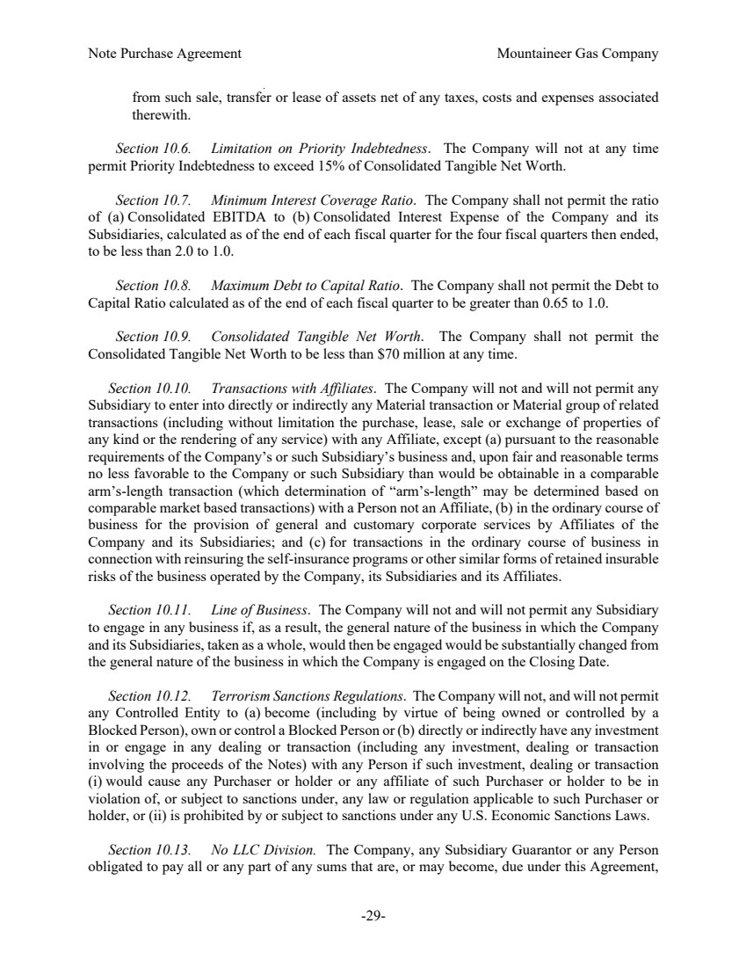 | Note Purchase Agreement Mountaineer Gas Company -29- from such sale, transfer or lease of assets net of any taxes, costs and expenses associated therewith. Section 10.6. Limitation on Priority Indebtedness. The Company will not at any time permit Priority Indebtedness to exceed 15% of Consolidated Tangible Net Worth. Section 10.7. Minimum Interest Coverage Ratio. The Company shall not permit the ratio of (a) Consolidated EBITDA to (b) Consolidated Interest Expense of the Company and its Subsidiaries, calculated as of the end of each fiscal quarter for the four fiscal quarters then ended, to be less than 2.0 to 1.0. Section 10.8. Maximum Debt to Capital Ratio. The Company shall not permit the Debt to Capital Ratio calculated as of the end of each fiscal quarter to be greater than 0.65 to 1.0. Section 10.9. Consolidated Tangible Net Worth. The Company shall not permit the Consolidated Tangible Net Worth to be less than $70 million at any time. Section 10.10. Transactions with Affiliates. The Company will not and will not permit any Subsidiary to enter into directly or indirectly any Material transaction or Material group of related transactions (including without limitation the purchase, lease, sale or exchange of properties of any kind or the rendering of any service) with any Affiliate, except (a) pursuant to the reasonable requirements of the Company’s or such Subsidiary’s business and, upon fair and reasonable terms no less favorable to the Company or such Subsidiary than would be obtainable in a comparable arm’s-length transaction (which determination of “arm’s-length” may be determined based on comparable market based transactions) with a Person not an Affiliate, (b) in the ordinary course of business for the provision of general and customary corporate services by Affiliates of the Company and its Subsidiaries; and (c) for transactions in the ordinary course of business in connection with reinsuring the self-insurance programs or other similar forms of retained insurable risks of the business operated by the Company, its Subsidiaries and its Affiliates. Section 10.11. Line of Business. The Company will not and will not permit any Subsidiary to engage in any business if, as a result, the general nature of the business in which the Company and its Subsidiaries, taken as a whole, would then be engaged would be substantially changed from the general nature of the business in which the Company is engaged on the Closing Date. Section 10.12. Terrorism Sanctions Regulations. The Company will not, and will not permit any Controlled Entity to (a) become (including by virtue of being owned or controlled by a Blocked Person), own or control a Blocked Person or (b) directly or indirectly have any investment in or engage in any dealing or transaction (including any investment, dealing or transaction involving the proceeds of the Notes) with any Person if such investment, dealing or transaction (i) would cause any Purchaser or holder or any affiliate of such Purchaser or holder to be in violation of, or subject to sanctions under, any law or regulation applicable to such Purchaser or holder, or (ii) is prohibited by or subject to sanctions under any U.S. Economic Sanctions Laws. Section 10.13. No LLC Division. The Company, any Subsidiary Guarantor or any Person obligated to pay all or any part of any sums that are, or may become, due under this Agreement,
 | 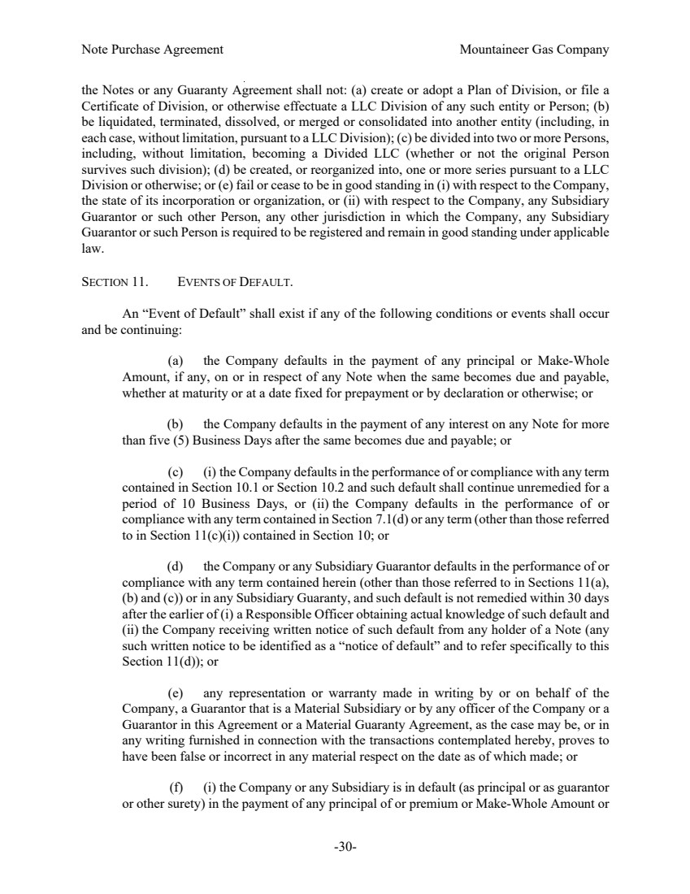 | Note Purchase Agreement Mountaineer Gas Company -30- the Notes or any Guaranty Agreement shall not: (a) create or adopt a Plan of Division, or file a Certificate of Division, or otherwise effectuate a LLC Division of any such entity or Person; (b) be liquidated, terminated, dissolved, or merged or consolidated into another entity (including, in each case, without limitation, pursuant to a LLC Division); (c) be divided into two or more Persons, including, without limitation, becoming a Divided LLC (whether or not the original Person survives such division); (d) be created, or reorganized into, one or more series pursuant to a LLC Division or otherwise; or (e) fail or cease to be in good standing in (i) with respect to the Company, the state of its incorporation or organization, or (ii) with respect to the Company, any Subsidiary Guarantor or such other Person, any other jurisdiction in which the Company, any Subsidiary Guarantor or such Person is required to be registered and remain in good standing under applicable law. SECTION 11. EVENTS OF DEFAULT. An “Event of Default” shall exist if any of the following conditions or events shall occur and be continuing: (a) the Company defaults in the payment of any principal or Make-Whole Amount, if any, on or in respect of any Note when the same becomes due and payable, whether at maturity or at a date fixed for prepayment or by declaration or otherwise; or (b) the Company defaults in the payment of any interest on any Note for more than five (5) Business Days after the same becomes due and payable; or (c) (i) the Company defaults in the performance of or compliance with any term contained in Section 10.1 or Section 10.2 and such default shall continue unremedied for a period of 10 Business Days, or (ii) the Company defaults in the performance of or compliance with any term contained in Section 7.1(d) or any term (other than those referred to in Section 11(c)(i)) contained in Section 10; or (d) the Company or any Subsidiary Guarantor defaults in the performance of or compliance with any term contained herein (other than those referred to in Sections 11(a), (b) and (c)) or in any Subsidiary Guaranty, and such default is not remedied within 30 days after the earlier of (i) a Responsible Officer obtaining actual knowledge of such default and (ii) the Company receiving written notice of such default from any holder of a Note (any such written notice to be identified as a “notice of default” and to refer specifically to this Section 11(d)); or (e) any representation or warranty made in writing by or on behalf of the Company, a Guarantor that is a Material Subsidiary or by any officer of the Company or a Guarantor in this Agreement or a Material Guaranty Agreement, as the case may be, or in any writing furnished in connection with the transactions contemplated hereby, proves to have been false or incorrect in any material respect on the date as of which made; or (f) (i) the Company or any Subsidiary is in default (as principal or as guarantor or other surety) in the payment of any principal of or premium or Make-Whole Amount or
 | 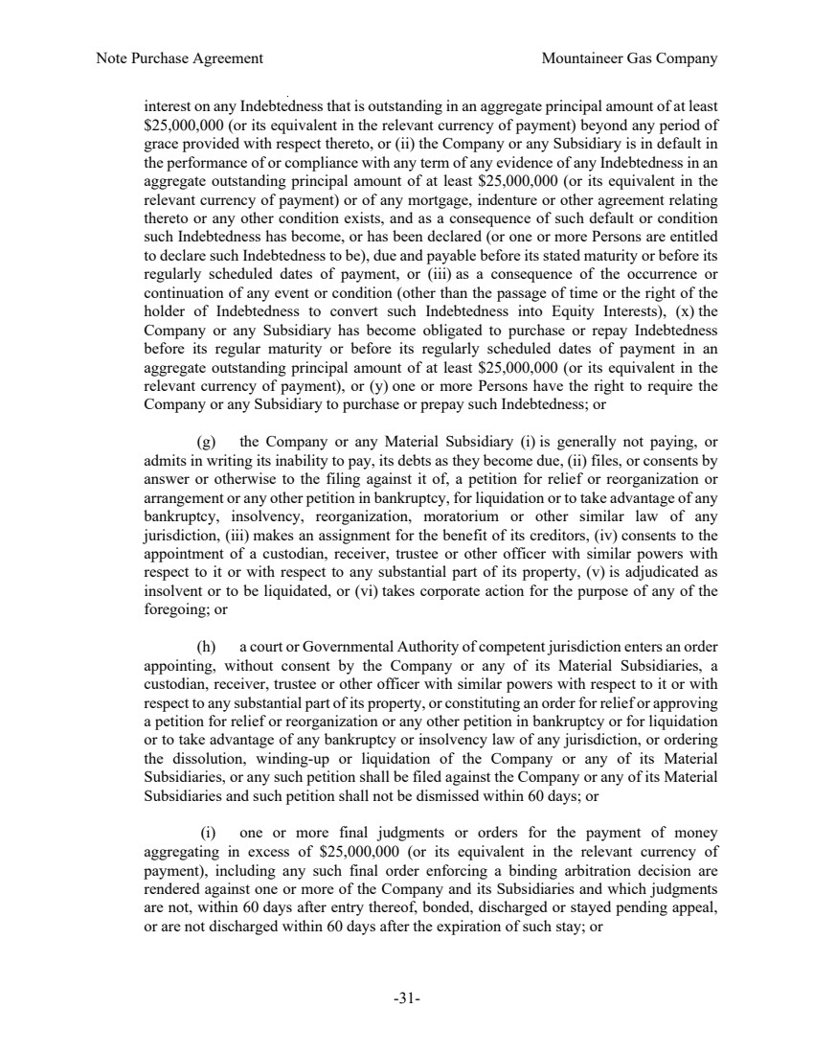 | Note Purchase Agreement Mountaineer Gas Company -31- interest on any Indebtedness that is outstanding in an aggregate principal amount of at least $25,000,000 (or its equivalent in the relevant currency of payment) beyond any period of grace provided with respect thereto, or (ii) the Company or any Subsidiary is in default in the performance of or compliance with any term of any evidence of any Indebtedness in an aggregate outstanding principal amount of at least $25,000,000 (or its equivalent in the relevant currency of payment) or of any mortgage, indenture or other agreement relating thereto or any other condition exists, and as a consequence of such default or condition such Indebtedness has become, or has been declared (or one or more Persons are entitled to declare such Indebtedness to be), due and payable before its stated maturity or before its regularly scheduled dates of payment, or (iii) as a consequence of the occurrence or continuation of any event or condition (other than the passage of time or the right of the holder of Indebtedness to convert such Indebtedness into Equity Interests), (x) the Company or any Subsidiary has become obligated to purchase or repay Indebtedness before its regular maturity or before its regularly scheduled dates of payment in an aggregate outstanding principal amount of at least $25,000,000 (or its equivalent in the relevant currency of payment), or (y) one or more Persons have the right to require the Company or any Subsidiary to purchase or prepay such Indebtedness; or (g) the Company or any Material Subsidiary (i) is generally not paying, or admits in writing its inability to pay, its debts as they become due, (ii) files, or consents by answer or otherwise to the filing against it of, a petition for relief or reorganization or arrangement or any other petition in bankruptcy, for liquidation or to take advantage of any bankruptcy, insolvency, reorganization, moratorium or other similar law of any jurisdiction, (iii) makes an assignment for the benefit of its creditors, (iv) consents to the appointment of a custodian, receiver, trustee or other officer with similar powers with respect to it or with respect to any substantial part of its property, (v) is adjudicated as insolvent or to be liquidated, or (vi) takes corporate action for the purpose of any of the foregoing; or (h) a court or Governmental Authority of competent jurisdiction enters an order appointing, without consent by the Company or any of its Material Subsidiaries, a custodian, receiver, trustee or other officer with similar powers with respect to it or with respect to any substantial part of its property, or constituting an order for relief or approving a petition for relief or reorganization or any other petition in bankruptcy or for liquidation or to take advantage of any bankruptcy or insolvency law of any jurisdiction, or ordering the dissolution, winding-up or liquidation of the Company or any of its Material Subsidiaries, or any such petition shall be filed against the Company or any of its Material Subsidiaries and such petition shall not be dismissed within 60 days; or (i) one or more final judgments or orders for the payment of money aggregating in excess of $25,000,000 (or its equivalent in the relevant currency of payment), including any such final order enforcing a binding arbitration decision are rendered against one or more of the Company and its Subsidiaries and which judgments are not, within 60 days after entry thereof, bonded, discharged or stayed pending appeal, or are not discharged within 60 days after the expiration of such stay; or
 | 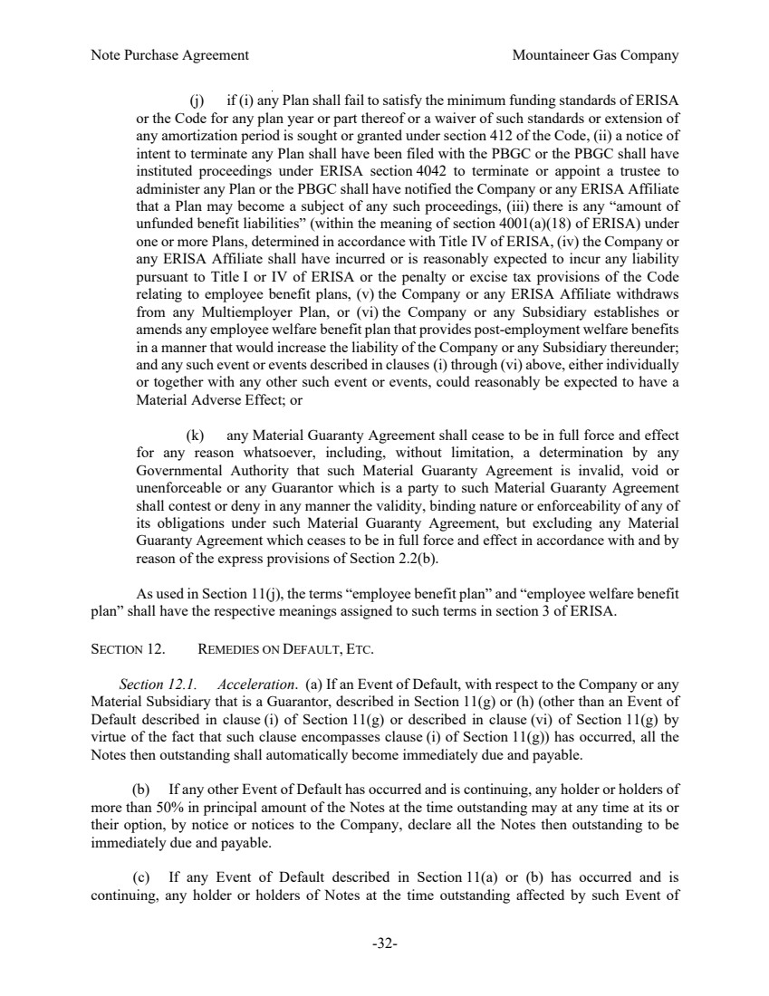 | Note Purchase Agreement Mountaineer Gas Company -32- (j) if (i) any Plan shall fail to satisfy the minimum funding standards of ERISA or the Code for any plan year or part thereof or a waiver of such standards or extension of any amortization period is sought or granted under section 412 of the Code, (ii) a notice of intent to terminate any Plan shall have been filed with the PBGC or the PBGC shall have instituted proceedings under ERISA section 4042 to terminate or appoint a trustee to administer any Plan or the PBGC shall have notified the Company or any ERISA Affiliate that a Plan may become a subject of any such proceedings, (iii) there is any “amount of unfunded benefit liabilities” (within the meaning of section 4001(a)(18) of ERISA) under one or more Plans, determined in accordance with Title IV of ERISA, (iv) the Company or any ERISA Affiliate shall have incurred or is reasonably expected to incur any liability pursuant to Title I or IV of ERISA or the penalty or excise tax provisions of the Code relating to employee benefit plans, (v) the Company or any ERISA Affiliate withdraws from any Multiemployer Plan, or (vi) the Company or any Subsidiary establishes or amends any employee welfare benefit plan that provides post-employment welfare benefits in a manner that would increase the liability of the Company or any Subsidiary thereunder; and any such event or events described in clauses (i) through (vi) above, either individually or together with any other such event or events, could reasonably be expected to have a Material Adverse Effect; or (k) any Material Guaranty Agreement shall cease to be in full force and effect for any reason whatsoever, including, without limitation, a determination by any Governmental Authority that such Material Guaranty Agreement is invalid, void or unenforceable or any Guarantor which is a party to such Material Guaranty Agreement shall contest or deny in any manner the validity, binding nature or enforceability of any of its obligations under such Material Guaranty Agreement, but excluding any Material Guaranty Agreement which ceases to be in full force and effect in accordance with and by reason of the express provisions of Section 2.2(b). As used in Section 11(j), the terms “employee benefit plan” and “employee welfare benefit plan” shall have the respective meanings assigned to such terms in section 3 of ERISA. SECTION 12. REMEDIES ON DEFAULT, ETC. Section 12.1. Acceleration. (a) If an Event of Default, with respect to the Company or any Material Subsidiary that is a Guarantor, described in Section 11(g) or (h) (other than an Event of Default described in clause (i) of Section 11(g) or described in clause (vi) of Section 11(g) by virtue of the fact that such clause encompasses clause (i) of Section 11(g)) has occurred, all the Notes then outstanding shall automatically become immediately due and payable. (b) If any other Event of Default has occurred and is continuing, any holder or holders of more than 50% in principal amount of the Notes at the time outstanding may at any time at its or their option, by notice or notices to the Company, declare all the Notes then outstanding to be immediately due and payable. (c) If any Event of Default described in Section 11(a) or (b) has occurred and is continuing, any holder or holders of Notes at the time outstanding affected by such Event of
 | 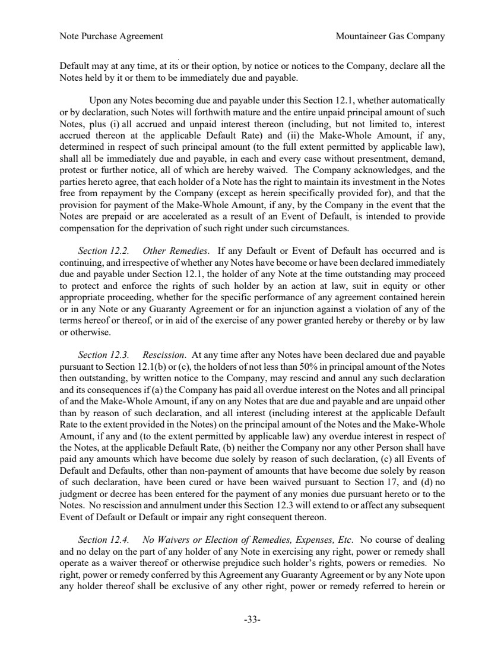 | Note Purchase Agreement Mountaineer Gas Company -33- Default may at any time, at its or their option, by notice or notices to the Company, declare all the Notes held by it or them to be immediately due and payable. Upon any Notes becoming due and payable under this Section 12.1, whether automatically or by declaration, such Notes will forthwith mature and the entire unpaid principal amount of such Notes, plus (i) all accrued and unpaid interest thereon (including, but not limited to, interest accrued thereon at the applicable Default Rate) and (ii) the Make-Whole Amount, if any, determined in respect of such principal amount (to the full extent permitted by applicable law), shall all be immediately due and payable, in each and every case without presentment, demand, protest or further notice, all of which are hereby waived. The Company acknowledges, and the parties hereto agree, that each holder of a Note has the right to maintain its investment in the Notes free from repayment by the Company (except as herein specifically provided for), and that the provision for payment of the Make-Whole Amount, if any, by the Company in the event that the Notes are prepaid or are accelerated as a result of an Event of Default, is intended to provide compensation for the deprivation of such right under such circumstances. Section 12.2. Other Remedies. If any Default or Event of Default has occurred and is continuing, and irrespective of whether any Notes have become or have been declared immediately due and payable under Section 12.1, the holder of any Note at the time outstanding may proceed to protect and enforce the rights of such holder by an action at law, suit in equity or other appropriate proceeding, whether for the specific performance of any agreement contained herein or in any Note or any Guaranty Agreement or for an injunction against a violation of any of the terms hereof or thereof, or in aid of the exercise of any power granted hereby or thereby or by law or otherwise. Section 12.3. Rescission. At any time after any Notes have been declared due and payable pursuant to Section 12.1(b) or (c), the holders of not less than 50% in principal amount of the Notes then outstanding, by written notice to the Company, may rescind and annul any such declaration and its consequences if (a) the Company has paid all overdue interest on the Notes and all principal of and the Make-Whole Amount, if any on any Notes that are due and payable and are unpaid other than by reason of such declaration, and all interest (including interest at the applicable Default Rate to the extent provided in the Notes) on the principal amount of the Notes and the Make-Whole Amount, if any and (to the extent permitted by applicable law) any overdue interest in respect of the Notes, at the applicable Default Rate, (b) neither the Company nor any other Person shall have paid any amounts which have become due solely by reason of such declaration, (c) all Events of Default and Defaults, other than non-payment of amounts that have become due solely by reason of such declaration, have been cured or have been waived pursuant to Section 17, and (d) no judgment or decree has been entered for the payment of any monies due pursuant hereto or to the Notes. No rescission and annulment under this Section 12.3 will extend to or affect any subsequent Event of Default or Default or impair any right consequent thereon. Section 12.4. No Waivers or Election of Remedies, Expenses, Etc. No course of dealing and no delay on the part of any holder of any Note in exercising any right, power or remedy shall operate as a waiver thereof or otherwise prejudice such holder’s rights, powers or remedies. No right, power or remedy conferred by this Agreement any Guaranty Agreement or by any Note upon any holder thereof shall be exclusive of any other right, power or remedy referred to herein or
 | 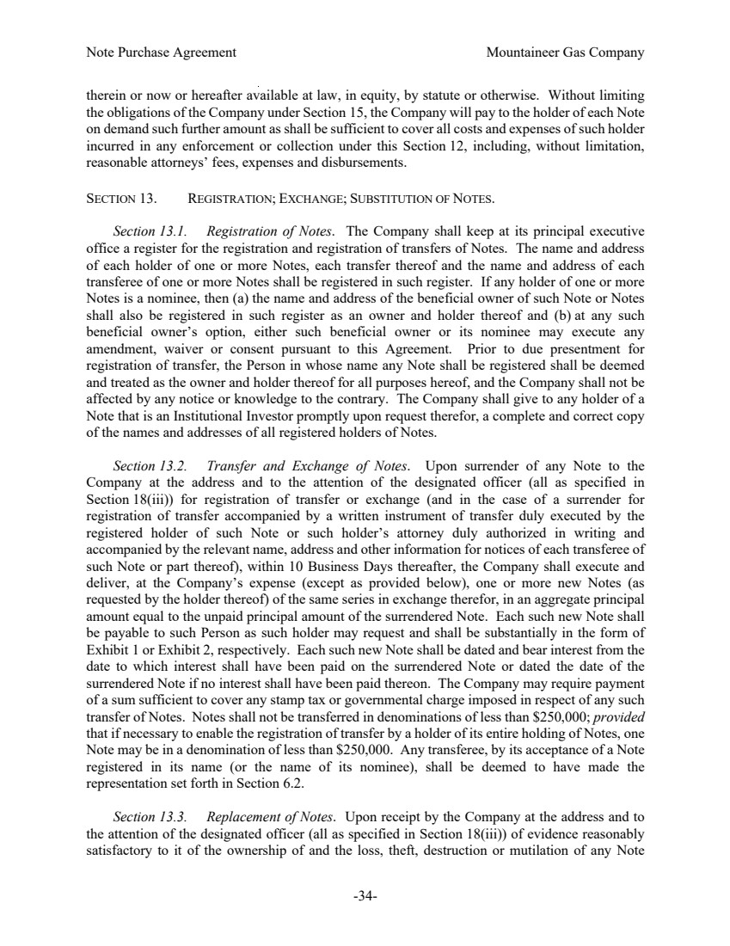 | Note Purchase Agreement Mountaineer Gas Company -34- therein or now or hereafter available at law, in equity, by statute or otherwise. Without limiting the obligations of the Company under Section 15, the Company will pay to the holder of each Note on demand such further amount as shall be sufficient to cover all costs and expenses of such holder incurred in any enforcement or collection under this Section 12, including, without limitation, reasonable attorneys’ fees, expenses and disbursements. SECTION 13. REGISTRATION; EXCHANGE; SUBSTITUTION OF NOTES. Section 13.1. Registration of Notes. The Company shall keep at its principal executive office a register for the registration and registration of transfers of Notes. The name and address of each holder of one or more Notes, each transfer thereof and the name and address of each transferee of one or more Notes shall be registered in such register. If any holder of one or more Notes is a nominee, then (a) the name and address of the beneficial owner of such Note or Notes shall also be registered in such register as an owner and holder thereof and (b) at any such beneficial owner’s option, either such beneficial owner or its nominee may execute any amendment, waiver or consent pursuant to this Agreement. Prior to due presentment for registration of transfer, the Person in whose name any Note shall be registered shall be deemed and treated as the owner and holder thereof for all purposes hereof, and the Company shall not be affected by any notice or knowledge to the contrary. The Company shall give to any holder of a Note that is an Institutional Investor promptly upon request therefor, a complete and correct copy of the names and addresses of all registered holders of Notes. Section 13.2. Transfer and Exchange of Notes. Upon surrender of any Note to the Company at the address and to the attention of the designated officer (all as specified in Section 18(iii)) for registration of transfer or exchange (and in the case of a surrender for registration of transfer accompanied by a written instrument of transfer duly executed by the registered holder of such Note or such holder’s attorney duly authorized in writing and accompanied by the relevant name, address and other information for notices of each transferee of such Note or part thereof), within 10 Business Days thereafter, the Company shall execute and deliver, at the Company’s expense (except as provided below), one or more new Notes (as requested by the holder thereof) of the same series in exchange therefor, in an aggregate principal amount equal to the unpaid principal amount of the surrendered Note. Each such new Note shall be payable to such Person as such holder may request and shall be substantially in the form of Exhibit 1 or Exhibit 2, respectively. Each such new Note shall be dated and bear interest from the date to which interest shall have been paid on the surrendered Note or dated the date of the surrendered Note if no interest shall have been paid thereon. The Company may require payment of a sum sufficient to cover any stamp tax or governmental charge imposed in respect of any such transfer of Notes. Notes shall not be transferred in denominations of less than $250,000; provided that if necessary to enable the registration of transfer by a holder of its entire holding of Notes, one Note may be in a denomination of less than $250,000. Any transferee, by its acceptance of a Note registered in its name (or the name of its nominee), shall be deemed to have made the representation set forth in Section 6.2. Section 13.3. Replacement of Notes. Upon receipt by the Company at the address and to the attention of the designated officer (all as specified in Section 18(iii)) of evidence reasonably satisfactory to it of the ownership of and the loss, theft, destruction or mutilation of any Note
 | 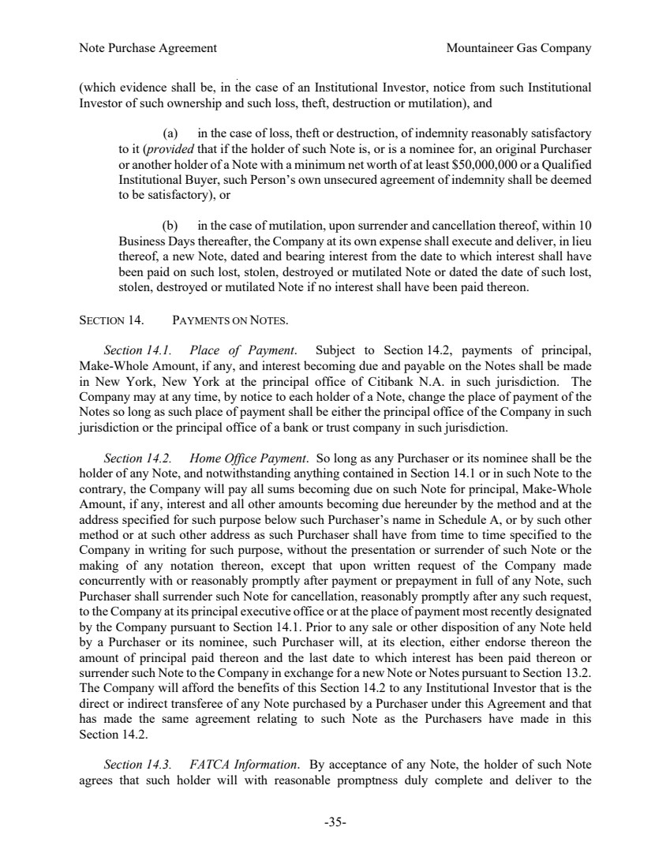 | Note Purchase Agreement Mountaineer Gas Company -35- (which evidence shall be, in the case of an Institutional Investor, notice from such Institutional Investor of such ownership and such loss, theft, destruction or mutilation), and (a) in the case of loss, theft or destruction, of indemnity reasonably satisfactory to it (provided that if the holder of such Note is, or is a nominee for, an original Purchaser or another holder of a Note with a minimum net worth of at least $50,000,000 or a Qualified Institutional Buyer, such Person’s own unsecured agreement of indemnity shall be deemed to be satisfactory), or (b) in the case of mutilation, upon surrender and cancellation thereof, within 10 Business Days thereafter, the Company at its own expense shall execute and deliver, in lieu thereof, a new Note, dated and bearing interest from the date to which interest shall have been paid on such lost, stolen, destroyed or mutilated Note or dated the date of such lost, stolen, destroyed or mutilated Note if no interest shall have been paid thereon. SECTION 14. PAYMENTS ON NOTES. Section 14.1. Place of Payment. Subject to Section 14.2, payments of principal, Make-Whole Amount, if any, and interest becoming due and payable on the Notes shall be made in New York, New York at the principal office of Citibank N.A. in such jurisdiction. The Company may at any time, by notice to each holder of a Note, change the place of payment of the Notes so long as such place of payment shall be either the principal office of the Company in such jurisdiction or the principal office of a bank or trust company in such jurisdiction. Section 14.2. Home Office Payment. So long as any Purchaser or its nominee shall be the holder of any Note, and notwithstanding anything contained in Section 14.1 or in such Note to the contrary, the Company will pay all sums becoming due on such Note for principal, Make-Whole Amount, if any, interest and all other amounts becoming due hereunder by the method and at the address specified for such purpose below such Purchaser’s name in Schedule A, or by such other method or at such other address as such Purchaser shall have from time to time specified to the Company in writing for such purpose, without the presentation or surrender of such Note or the making of any notation thereon, except that upon written request of the Company made concurrently with or reasonably promptly after payment or prepayment in full of any Note, such Purchaser shall surrender such Note for cancellation, reasonably promptly after any such request, to the Company at its principal executive office or at the place of payment most recently designated by the Company pursuant to Section 14.1. Prior to any sale or other disposition of any Note held by a Purchaser or its nominee, such Purchaser will, at its election, either endorse thereon the amount of principal paid thereon and the last date to which interest has been paid thereon or surrender such Note to the Company in exchange for a new Note or Notes pursuant to Section 13.2. The Company will afford the benefits of this Section 14.2 to any Institutional Investor that is the direct or indirect transferee of any Note purchased by a Purchaser under this Agreement and that has made the same agreement relating to such Note as the Purchasers have made in this Section 14.2. Section 14.3. FATCA Information. By acceptance of any Note, the holder of such Note agrees that such holder will with reasonable promptness duly complete and deliver to the
 | 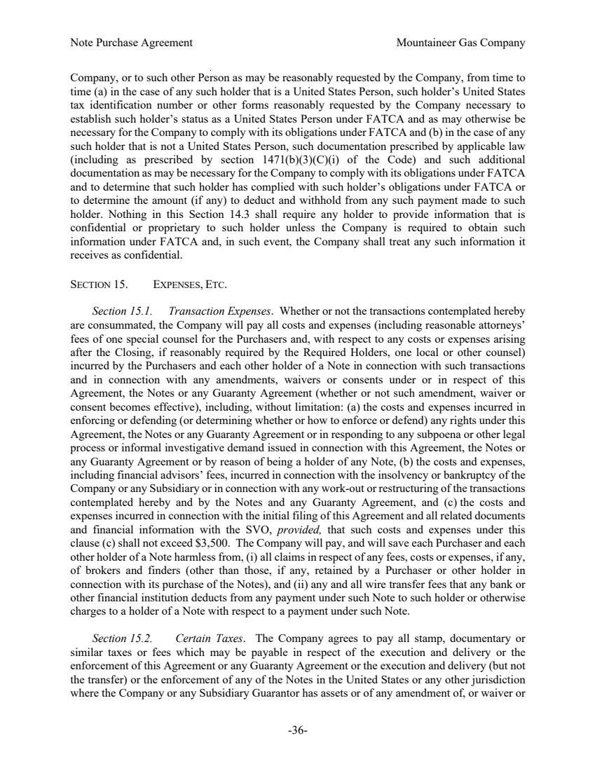 | Note Purchase Agreement Mountaineer Gas Company -36- Company, or to such other Person as may be reasonably requested by the Company, from time to time (a) in the case of any such holder that is a United States Person, such holder’s United States tax identification number or other forms reasonably requested by the Company necessary to establish such holder’s status as a United States Person under FATCA and as may otherwise be necessary for the Company to comply with its obligations under FATCA and (b) in the case of any such holder that is not a United States Person, such documentation prescribed by applicable law (including as prescribed by section 1471(b)(3)(C)(i) of the Code) and such additional documentation as may be necessary for the Company to comply with its obligations under FATCA and to determine that such holder has complied with such holder’s obligations under FATCA or to determine the amount (if any) to deduct and withhold from any such payment made to such holder. Nothing in this Section 14.3 shall require any holder to provide information that is confidential or proprietary to such holder unless the Company is required to obtain such information under FATCA and, in such event, the Company shall treat any such information it receives as confidential. SECTION 15. EXPENSES, ETC. Section 15.1. Transaction Expenses. Whether or not the transactions contemplated hereby are consummated, the Company will pay all costs and expenses (including reasonable attorneys’ fees of one special counsel for the Purchasers and, with respect to any costs or expenses arising after the Closing, if reasonably required by the Required Holders, one local or other counsel) incurred by the Purchasers and each other holder of a Note in connection with such transactions and in connection with any amendments, waivers or consents under or in respect of this Agreement, the Notes or any Guaranty Agreement (whether or not such amendment, waiver or consent becomes effective), including, without limitation: (a) the costs and expenses incurred in enforcing or defending (or determining whether or how to enforce or defend) any rights under this Agreement, the Notes or any Guaranty Agreement or in responding to any subpoena or other legal process or informal investigative demand issued in connection with this Agreement, the Notes or any Guaranty Agreement or by reason of being a holder of any Note, (b) the costs and expenses, including financial advisors’ fees, incurred in connection with the insolvency or bankruptcy of the Company or any Subsidiary or in connection with any work-out or restructuring of the transactions contemplated hereby and by the Notes and any Guaranty Agreement, and (c) the costs and expenses incurred in connection with the initial filing of this Agreement and all related documents and financial information with the SVO, provided, that such costs and expenses under this clause (c) shall not exceed $3,500. The Company will pay, and will save each Purchaser and each other holder of a Note harmless from, (i) all claims in respect of any fees, costs or expenses, if any, of brokers and finders (other than those, if any, retained by a Purchaser or other holder in connection with its purchase of the Notes), and (ii) any and all wire transfer fees that any bank or other financial institution deducts from any payment under such Note to such holder or otherwise charges to a holder of a Note with respect to a payment under such Note. Section 15.2. Certain Taxes. The Company agrees to pay all stamp, documentary or similar taxes or fees which may be payable in respect of the execution and delivery or the enforcement of this Agreement or any Guaranty Agreement or the execution and delivery (but not the transfer) or the enforcement of any of the Notes in the United States or any other jurisdiction where the Company or any Subsidiary Guarantor has assets or of any amendment of, or waiver or
 | 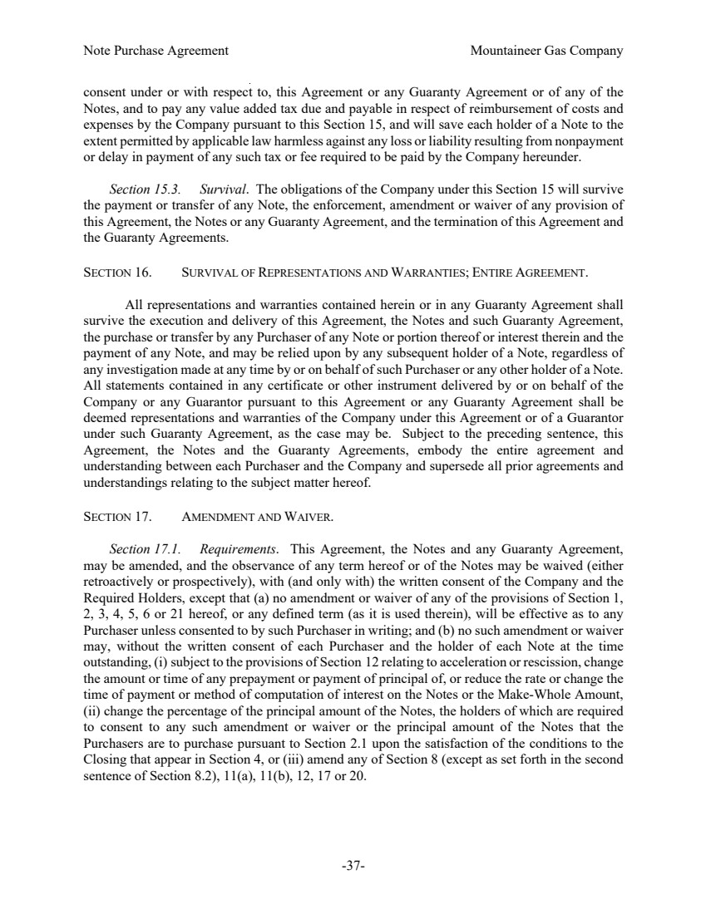 | Note Purchase Agreement Mountaineer Gas Company -37- consent under or with respect to, this Agreement or any Guaranty Agreement or of any of the Notes, and to pay any value added tax due and payable in respect of reimbursement of costs and expenses by the Company pursuant to this Section 15, and will save each holder of a Note to the extent permitted by applicable law harmless against any loss or liability resulting from nonpayment or delay in payment of any such tax or fee required to be paid by the Company hereunder. Section 15.3. Survival. The obligations of the Company under this Section 15 will survive the payment or transfer of any Note, the enforcement, amendment or waiver of any provision of this Agreement, the Notes or any Guaranty Agreement, and the termination of this Agreement and the Guaranty Agreements. SECTION 16. SURVIVAL OF REPRESENTATIONS AND WARRANTIES; ENTIRE AGREEMENT. All representations and warranties contained herein or in any Guaranty Agreement shall survive the execution and delivery of this Agreement, the Notes and such Guaranty Agreement, the purchase or transfer by any Purchaser of any Note or portion thereof or interest therein and the payment of any Note, and may be relied upon by any subsequent holder of a Note, regardless of any investigation made at any time by or on behalf of such Purchaser or any other holder of a Note. All statements contained in any certificate or other instrument delivered by or on behalf of the Company or any Guarantor pursuant to this Agreement or any Guaranty Agreement shall be deemed representations and warranties of the Company under this Agreement or of a Guarantor under such Guaranty Agreement, as the case may be. Subject to the preceding sentence, this Agreement, the Notes and the Guaranty Agreements, embody the entire agreement and understanding between each Purchaser and the Company and supersede all prior agreements and understandings relating to the subject matter hereof. SECTION 17. AMENDMENT AND WAIVER. Section 17.1. Requirements. This Agreement, the Notes and any Guaranty Agreement, may be amended, and the observance of any term hereof or of the Notes may be waived (either retroactively or prospectively), with (and only with) the written consent of the Company and the Required Holders, except that (a) no amendment or waiver of any of the provisions of Section 1, 2, 3, 4, 5, 6 or 21 hereof, or any defined term (as it is used therein), will be effective as to any Purchaser unless consented to by such Purchaser in writing; and (b) no such amendment or waiver may, without the written consent of each Purchaser and the holder of each Note at the time outstanding, (i) subject to the provisions of Section 12 relating to acceleration or rescission, change the amount or time of any prepayment or payment of principal of, or reduce the rate or change the time of payment or method of computation of interest on the Notes or the Make-Whole Amount, (ii) change the percentage of the principal amount of the Notes, the holders of which are required to consent to any such amendment or waiver or the principal amount of the Notes that the Purchasers are to purchase pursuant to Section 2.1 upon the satisfaction of the conditions to the Closing that appear in Section 4, or (iii) amend any of Section 8 (except as set forth in the second sentence of Section 8.2), 11(a), 11(b), 12, 17 or 20.
 | 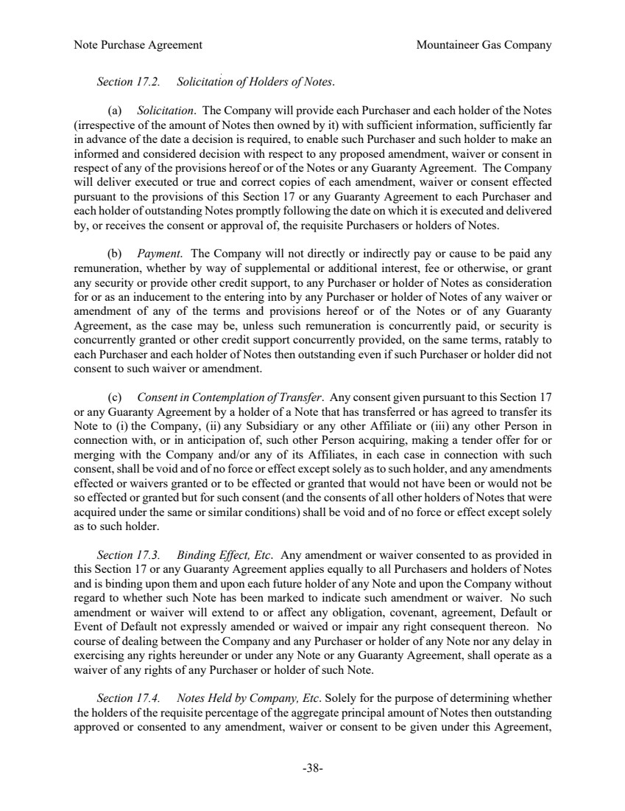 | Note Purchase Agreement Mountaineer Gas Company -38- Section 17.2. Solicitation of Holders of Notes. (a) Solicitation. The Company will provide each Purchaser and each holder of the Notes (irrespective of the amount of Notes then owned by it) with sufficient information, sufficiently far in advance of the date a decision is required, to enable such Purchaser and such holder to make an informed and considered decision with respect to any proposed amendment, waiver or consent in respect of any of the provisions hereof or of the Notes or any Guaranty Agreement. The Company will deliver executed or true and correct copies of each amendment, waiver or consent effected pursuant to the provisions of this Section 17 or any Guaranty Agreement to each Purchaser and each holder of outstanding Notes promptly following the date on which it is executed and delivered by, or receives the consent or approval of, the requisite Purchasers or holders of Notes. (b) Payment. The Company will not directly or indirectly pay or cause to be paid any remuneration, whether by way of supplemental or additional interest, fee or otherwise, or grant any security or provide other credit support, to any Purchaser or holder of Notes as consideration for or as an inducement to the entering into by any Purchaser or holder of Notes of any waiver or amendment of any of the terms and provisions hereof or of the Notes or of any Guaranty Agreement, as the case may be, unless such remuneration is concurrently paid, or security is concurrently granted or other credit support concurrently provided, on the same terms, ratably to each Purchaser and each holder of Notes then outstanding even if such Purchaser or holder did not consent to such waiver or amendment. (c) Consent in Contemplation of Transfer. Any consent given pursuant to this Section 17 or any Guaranty Agreement by a holder of a Note that has transferred or has agreed to transfer its Note to (i) the Company, (ii) any Subsidiary or any other Affiliate or (iii) any other Person in connection with, or in anticipation of, such other Person acquiring, making a tender offer for or merging with the Company and/or any of its Affiliates, in each case in connection with such consent, shall be void and of no force or effect except solely as to such holder, and any amendments effected or waivers granted or to be effected or granted that would not have been or would not be so effected or granted but for such consent (and the consents of all other holders of Notes that were acquired under the same or similar conditions) shall be void and of no force or effect except solely as to such holder. Section 17.3. Binding Effect, Etc. Any amendment or waiver consented to as provided in this Section 17 or any Guaranty Agreement applies equally to all Purchasers and holders of Notes and is binding upon them and upon each future holder of any Note and upon the Company without regard to whether such Note has been marked to indicate such amendment or waiver. No such amendment or waiver will extend to or affect any obligation, covenant, agreement, Default or Event of Default not expressly amended or waived or impair any right consequent thereon. No course of dealing between the Company and any Purchaser or holder of any Note nor any delay in exercising any rights hereunder or under any Note or any Guaranty Agreement, shall operate as a waiver of any rights of any Purchaser or holder of such Note. Section 17.4. Notes Held by Company, Etc. Solely for the purpose of determining whether the holders of the requisite percentage of the aggregate principal amount of Notes then outstanding approved or consented to any amendment, waiver or consent to be given under this Agreement,
 | 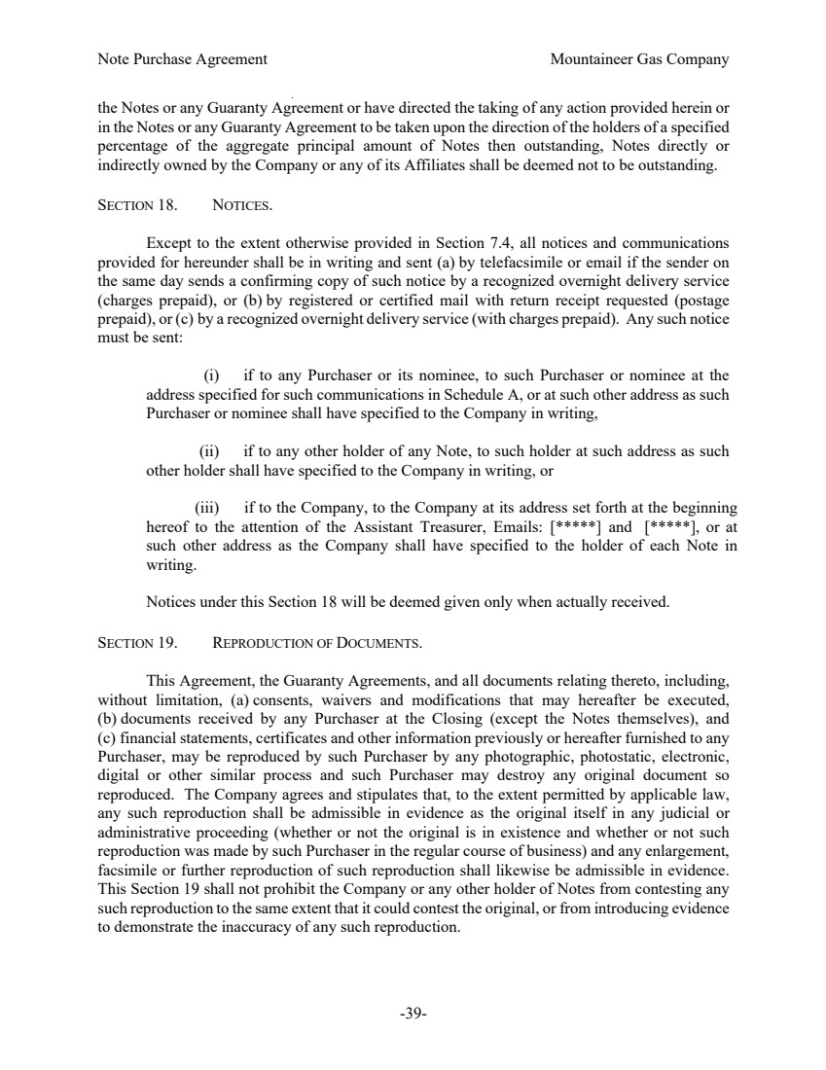 | Note Purchase Agreement Mountaineer Gas Company -39- the Notes or any Guaranty Agreement or have directed the taking of any action provided herein or in the Notes or any Guaranty Agreement to be taken upon the direction of the holders of a specified percentage of the aggregate principal amount of Notes then outstanding, Notes directly or indirectly owned by the Company or any of its Affiliates shall be deemed not to be outstanding. SECTION 18. NOTICES. Except to the extent otherwise provided in Section 7.4, all notices and communications provided for hereunder shall be in writing and sent (a) by telefacsimile or email if the sender on the same day sends a confirming copy of such notice by a recognized overnight delivery service (charges prepaid), or (b) by registered or certified mail with return receipt requested (postage prepaid), or (c) by a recognized overnight delivery service (with charges prepaid). Any such notice must be sent: (i) if to any Purchaser or its nominee, to such Purchaser or nominee at the address specified for such communications in Schedule A, or at such other address as such Purchaser or nominee shall have specified to the Company in writing, (ii) if to any other holder of any Note, to such holder at such address as such other holder shall have specified to the Company in writing, or (iii) if to the Company, to the Company at its address set forth at the beginning hereof to the attention of the Assistant Treasurer, Emails: [*****] and [*****], or at such other address as the Company shall have specified to the holder of each Note in writing. Notices under this Section 18 will be deemed given only when actually received. SECTION 19. REPRODUCTION OF DOCUMENTS. This Agreement, the Guaranty Agreements, and all documents relating thereto, including, without limitation, (a) consents, waivers and modifications that may hereafter be executed, (b) documents received by any Purchaser at the Closing (except the Notes themselves), and (c) financial statements, certificates and other information previously or hereafter furnished to any Purchaser, may be reproduced by such Purchaser by any photographic, photostatic, electronic, digital or other similar process and such Purchaser may destroy any original document so reproduced. The Company agrees and stipulates that, to the extent permitted by applicable law, any such reproduction shall be admissible in evidence as the original itself in any judicial or administrative proceeding (whether or not the original is in existence and whether or not such reproduction was made by such Purchaser in the regular course of business) and any enlargement, facsimile or further reproduction of such reproduction shall likewise be admissible in evidence. This Section 19 shall not prohibit the Company or any other holder of Notes from contesting any such reproduction to the same extent that it could contest the original, or from introducing evidence to demonstrate the inaccuracy of any such reproduction.
 | 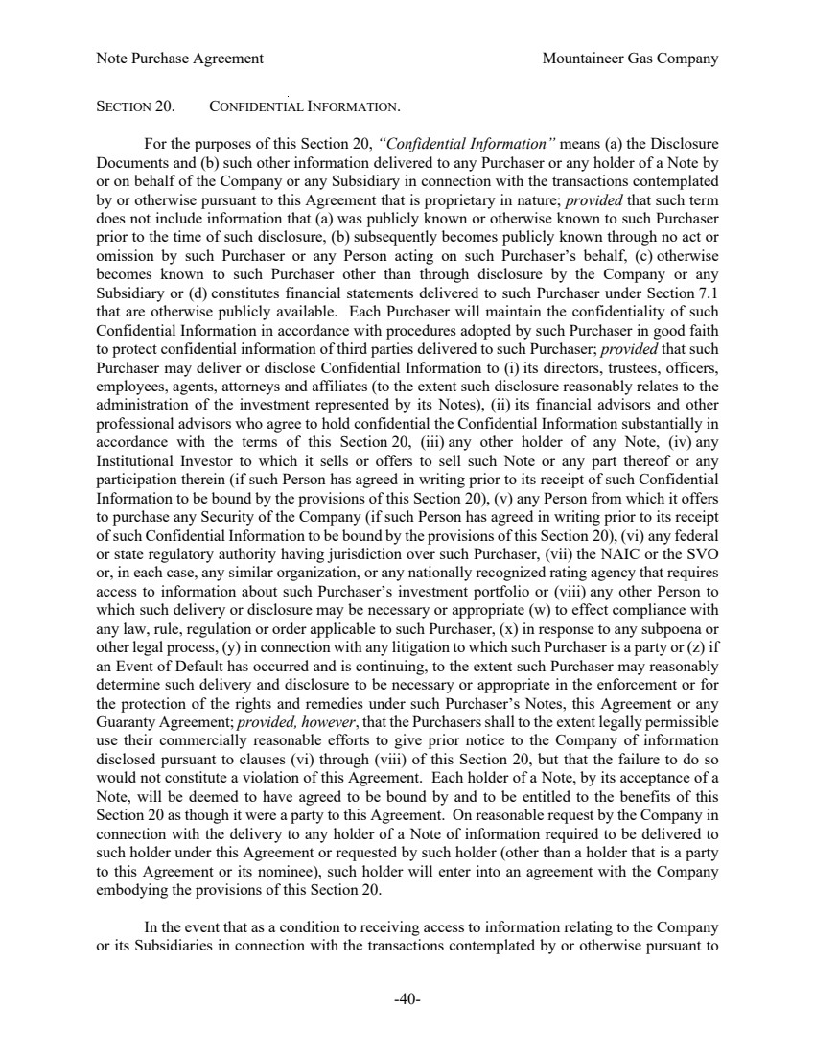 | Note Purchase Agreement Mountaineer Gas Company -40- SECTION 20. CONFIDENTIAL INFORMATION. For the purposes of this Section 20, “Confidential Information” means (a) the Disclosure Documents and (b) such other information delivered to any Purchaser or any holder of a Note by or on behalf of the Company or any Subsidiary in connection with the transactions contemplated by or otherwise pursuant to this Agreement that is proprietary in nature; provided that such term does not include information that (a) was publicly known or otherwise known to such Purchaser prior to the time of such disclosure, (b) subsequently becomes publicly known through no act or omission by such Purchaser or any Person acting on such Purchaser’s behalf, (c) otherwise becomes known to such Purchaser other than through disclosure by the Company or any Subsidiary or (d) constitutes financial statements delivered to such Purchaser under Section 7.1 that are otherwise publicly available. Each Purchaser will maintain the confidentiality of such Confidential Information in accordance with procedures adopted by such Purchaser in good faith to protect confidential information of third parties delivered to such Purchaser; provided that such Purchaser may deliver or disclose Confidential Information to (i) its directors, trustees, officers, employees, agents, attorneys and affiliates (to the extent such disclosure reasonably relates to the administration of the investment represented by its Notes), (ii) its financial advisors and other professional advisors who agree to hold confidential the Confidential Information substantially in accordance with the terms of this Section 20, (iii) any other holder of any Note, (iv) any Institutional Investor to which it sells or offers to sell such Note or any part thereof or any participation therein (if such Person has agreed in writing prior to its receipt of such Confidential Information to be bound by the provisions of this Section 20), (v) any Person from which it offers to purchase any Security of the Company (if such Person has agreed in writing prior to its receipt of such Confidential Information to be bound by the provisions of this Section 20), (vi) any federal or state regulatory authority having jurisdiction over such Purchaser, (vii) the NAIC or the SVO or, in each case, any similar organization, or any nationally recognized rating agency that requires access to information about such Purchaser’s investment portfolio or (viii) any other Person to which such delivery or disclosure may be necessary or appropriate (w) to effect compliance with any law, rule, regulation or order applicable to such Purchaser, (x) in response to any subpoena or other legal process, (y) in connection with any litigation to which such Purchaser is a party or (z) if an Event of Default has occurred and is continuing, to the extent such Purchaser may reasonably determine such delivery and disclosure to be necessary or appropriate in the enforcement or for the protection of the rights and remedies under such Purchaser’s Notes, this Agreement or any Guaranty Agreement; provided, however, that the Purchasers shall to the extent legally permissible use their commercially reasonable efforts to give prior notice to the Company of information disclosed pursuant to clauses (vi) through (viii) of this Section 20, but that the failure to do so would not constitute a violation of this Agreement. Each holder of a Note, by its acceptance of a Note, will be deemed to have agreed to be bound by and to be entitled to the benefits of this Section 20 as though it were a party to this Agreement. On reasonable request by the Company in connection with the delivery to any holder of a Note of information required to be delivered to such holder under this Agreement or requested by such holder (other than a holder that is a party to this Agreement or its nominee), such holder will enter into an agreement with the Company embodying the provisions of this Section 20. In the event that as a condition to receiving access to information relating to the Company or its Subsidiaries in connection with the transactions contemplated by or otherwise pursuant to
 | 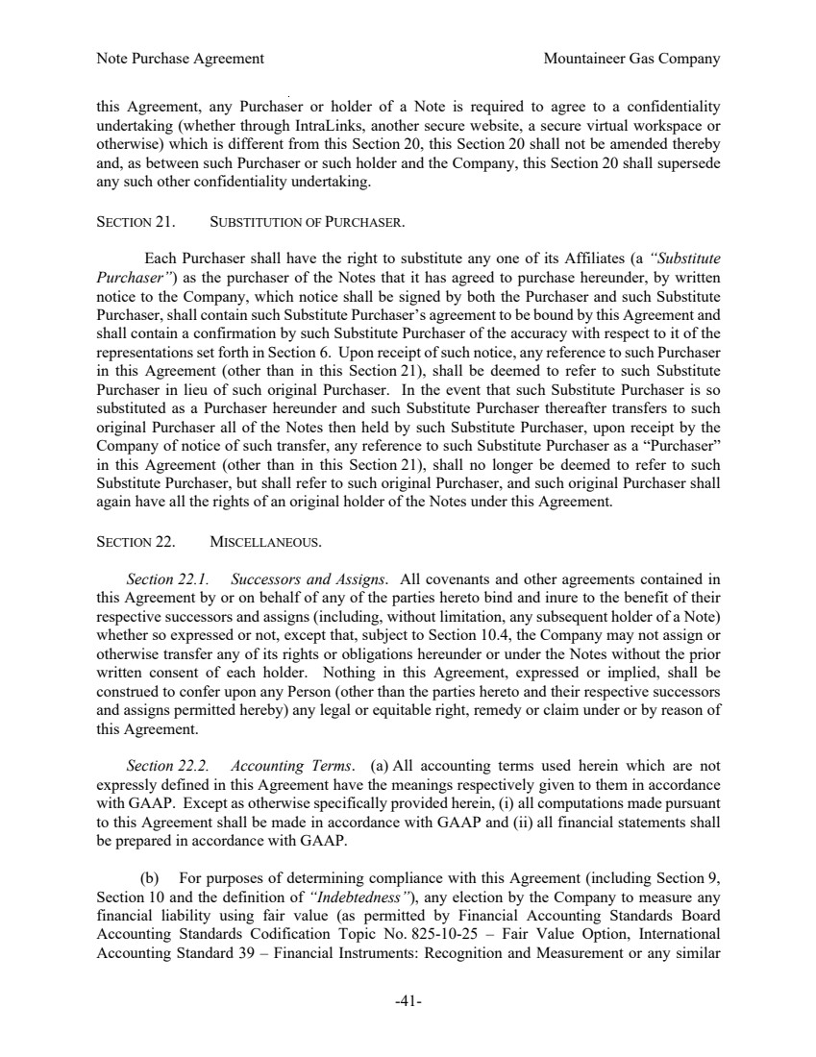 | Note Purchase Agreement Mountaineer Gas Company -41- this Agreement, any Purchaser or holder of a Note is required to agree to a confidentiality undertaking (whether through IntraLinks, another secure website, a secure virtual workspace or otherwise) which is different from this Section 20, this Section 20 shall not be amended thereby and, as between such Purchaser or such holder and the Company, this Section 20 shall supersede any such other confidentiality undertaking. SECTION 21. SUBSTITUTION OF PURCHASER. Each Purchaser shall have the right to substitute any one of its Affiliates (a “Substitute Purchaser”) as the purchaser of the Notes that it has agreed to purchase hereunder, by written notice to the Company, which notice shall be signed by both the Purchaser and such Substitute Purchaser, shall contain such Substitute Purchaser’s agreement to be bound by this Agreement and shall contain a confirmation by such Substitute Purchaser of the accuracy with respect to it of the representations set forth in Section 6. Upon receipt of such notice, any reference to such Purchaser in this Agreement (other than in this Section 21), shall be deemed to refer to such Substitute Purchaser in lieu of such original Purchaser. In the event that such Substitute Purchaser is so substituted as a Purchaser hereunder and such Substitute Purchaser thereafter transfers to such original Purchaser all of the Notes then held by such Substitute Purchaser, upon receipt by the Company of notice of such transfer, any reference to such Substitute Purchaser as a “Purchaser” in this Agreement (other than in this Section 21), shall no longer be deemed to refer to such Substitute Purchaser, but shall refer to such original Purchaser, and such original Purchaser shall again have all the rights of an original holder of the Notes under this Agreement. SECTION 22. MISCELLANEOUS. Section 22.1. Successors and Assigns. All covenants and other agreements contained in this Agreement by or on behalf of any of the parties hereto bind and inure to the benefit of their respective successors and assigns (including, without limitation, any subsequent holder of a Note) whether so expressed or not, except that, subject to Section 10.4, the Company may not assign or otherwise transfer any of its rights or obligations hereunder or under the Notes without the prior written consent of each holder. Nothing in this Agreement, expressed or implied, shall be construed to confer upon any Person (other than the parties hereto and their respective successors and assigns permitted hereby) any legal or equitable right, remedy or claim under or by reason of this Agreement. Section 22.2. Accounting Terms. (a) All accounting terms used herein which are not expressly defined in this Agreement have the meanings respectively given to them in accordance with GAAP. Except as otherwise specifically provided herein, (i) all computations made pursuant to this Agreement shall be made in accordance with GAAP and (ii) all financial statements shall be prepared in accordance with GAAP. (b) For purposes of determining compliance with this Agreement (including Section 9, Section 10 and the definition of “Indebtedness”), any election by the Company to measure any financial liability using fair value (as permitted by Financial Accounting Standards Board Accounting Standards Codification Topic No. 825-10-25 – Fair Value Option, International Accounting Standard 39 – Financial Instruments: Recognition and Measurement or any similar
 | 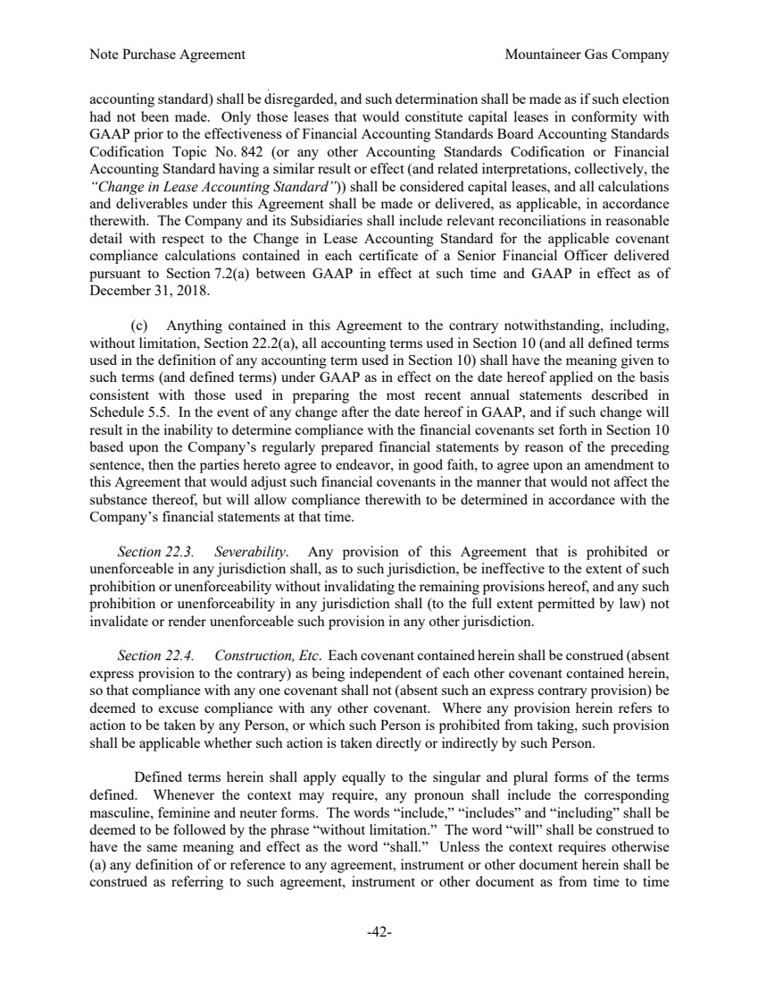 | Note Purchase Agreement Mountaineer Gas Company -42- accounting standard) shall be disregarded, and such determination shall be made as if such election had not been made. Only those leases that would constitute capital leases in conformity with GAAP prior to the effectiveness of Financial Accounting Standards Board Accounting Standards Codification Topic No. 842 (or any other Accounting Standards Codification or Financial Accounting Standard having a similar result or effect (and related interpretations, collectively, the “Change in Lease Accounting Standard”)) shall be considered capital leases, and all calculations and deliverables under this Agreement shall be made or delivered, as applicable, in accordance therewith. The Company and its Subsidiaries shall include relevant reconciliations in reasonable detail with respect to the Change in Lease Accounting Standard for the applicable covenant compliance calculations contained in each certificate of a Senior Financial Officer delivered pursuant to Section 7.2(a) between GAAP in effect at such time and GAAP in effect as of December 31, 2018. (c) Anything contained in this Agreement to the contrary notwithstanding, including, without limitation, Section 22.2(a), all accounting terms used in Section 10 (and all defined terms used in the definition of any accounting term used in Section 10) shall have the meaning given to such terms (and defined terms) under GAAP as in effect on the date hereof applied on the basis consistent with those used in preparing the most recent annual statements described in Schedule 5.5. In the event of any change after the date hereof in GAAP, and if such change will result in the inability to determine compliance with the financial covenants set forth in Section 10 based upon the Company’s regularly prepared financial statements by reason of the preceding sentence, then the parties hereto agree to endeavor, in good faith, to agree upon an amendment to this Agreement that would adjust such financial covenants in the manner that would not affect the substance thereof, but will allow compliance therewith to be determined in accordance with the Company’s financial statements at that time. Section 22.3. Severability. Any provision of this Agreement that is prohibited or unenforceable in any jurisdiction shall, as to such jurisdiction, be ineffective to the extent of such prohibition or unenforceability without invalidating the remaining provisions hereof, and any such prohibition or unenforceability in any jurisdiction shall (to the full extent permitted by law) not invalidate or render unenforceable such provision in any other jurisdiction. Section 22.4. Construction, Etc. Each covenant contained herein shall be construed (absent express provision to the contrary) as being independent of each other covenant contained herein, so that compliance with any one covenant shall not (absent such an express contrary provision) be deemed to excuse compliance with any other covenant. Where any provision herein refers to action to be taken by any Person, or which such Person is prohibited from taking, such provision shall be applicable whether such action is taken directly or indirectly by such Person. Defined terms herein shall apply equally to the singular and plural forms of the terms defined. Whenever the context may require, any pronoun shall include the corresponding masculine, feminine and neuter forms. The words “include,” “includes” and “including” shall be deemed to be followed by the phrase “without limitation.” The word “will” shall be construed to have the same meaning and effect as the word “shall.” Unless the context requires otherwise (a) any definition of or reference to any agreement, instrument or other document herein shall be construed as referring to such agreement, instrument or other document as from time to time
 | 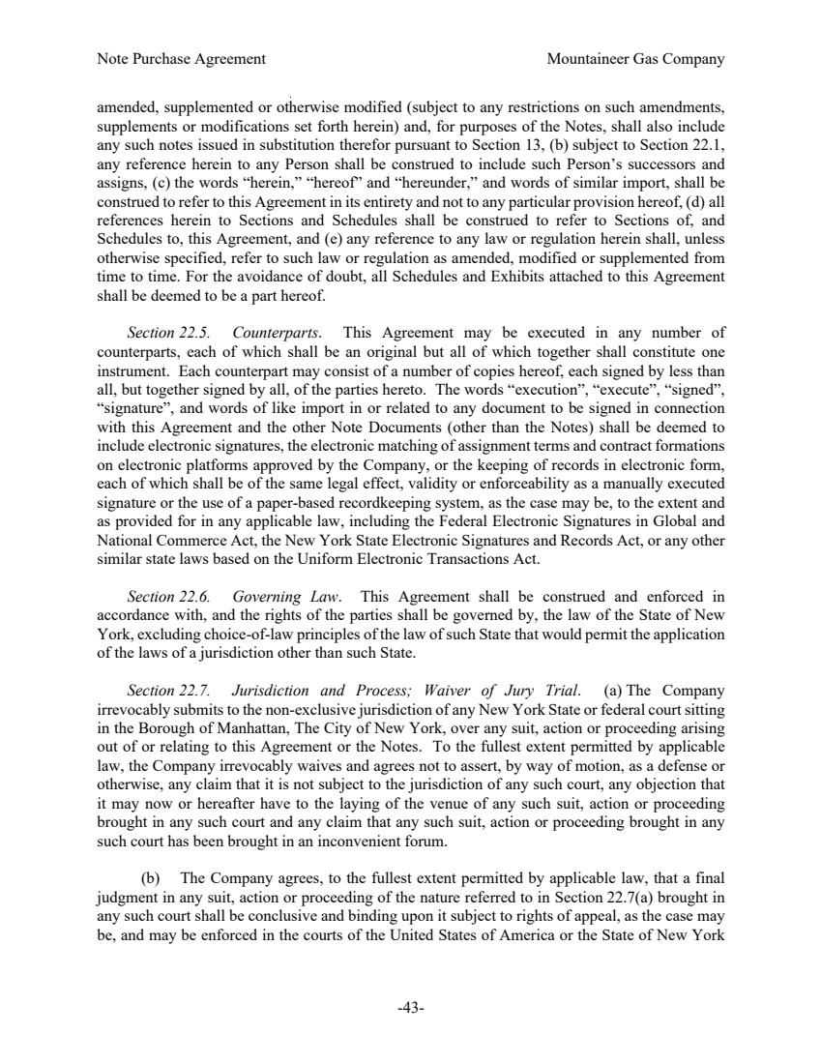 | Note Purchase Agreement Mountaineer Gas Company -43- amended, supplemented or otherwise modified (subject to any restrictions on such amendments, supplements or modifications set forth herein) and, for purposes of the Notes, shall also include any such notes issued in substitution therefor pursuant to Section 13, (b) subject to Section 22.1, any reference herein to any Person shall be construed to include such Person’s successors and assigns, (c) the words “herein,” “hereof” and “hereunder,” and words of similar import, shall be construed to refer to this Agreement in its entirety and not to any particular provision hereof, (d) all references herein to Sections and Schedules shall be construed to refer to Sections of, and Schedules to, this Agreement, and (e) any reference to any law or regulation herein shall, unless otherwise specified, refer to such law or regulation as amended, modified or supplemented from time to time. For the avoidance of doubt, all Schedules and Exhibits attached to this Agreement shall be deemed to be a part hereof. Section 22.5. Counterparts. This Agreement may be executed in any number of counterparts, each of which shall be an original but all of which together shall constitute one instrument. Each counterpart may consist of a number of copies hereof, each signed by less than all, but together signed by all, of the parties hereto. The words “execution”, “execute”, “signed”, “signature”, and words of like import in or related to any document to be signed in connection with this Agreement and the other Note Documents (other than the Notes) shall be deemed to include electronic signatures, the electronic matching of assignment terms and contract formations on electronic platforms approved by the Company, or the keeping of records in electronic form, each of which shall be of the same legal effect, validity or enforceability as a manually executed signature or the use of a paper-based recordkeeping system, as the case may be, to the extent and as provided for in any applicable law, including the Federal Electronic Signatures in Global and National Commerce Act, the New York State Electronic Signatures and Records Act, or any other similar state laws based on the Uniform Electronic Transactions Act. Section 22.6. Governing Law. This Agreement shall be construed and enforced in accordance with, and the rights of the parties shall be governed by, the law of the State of New York, excluding choice-of-law principles of the law of such State that would permit the application of the laws of a jurisdiction other than such State. Section 22.7. Jurisdiction and Process; Waiver of Jury Trial. (a) The Company irrevocably submits to the non-exclusive jurisdiction of any New York State or federal court sitting in the Borough of Manhattan, The City of New York, over any suit, action or proceeding arising out of or relating to this Agreement or the Notes. To the fullest extent permitted by applicable law, the Company irrevocably waives and agrees not to assert, by way of motion, as a defense or otherwise, any claim that it is not subject to the jurisdiction of any such court, any objection that it may now or hereafter have to the laying of the venue of any such suit, action or proceeding brought in any such court and any claim that any such suit, action or proceeding brought in any such court has been brought in an inconvenient forum. (b) The Company agrees, to the fullest extent permitted by applicable law, that a final judgment in any suit, action or proceeding of the nature referred to in Section 22.7(a) brought in any such court shall be conclusive and binding upon it subject to rights of appeal, as the case may be, and may be enforced in the courts of the United States of America or the State of New York
 | 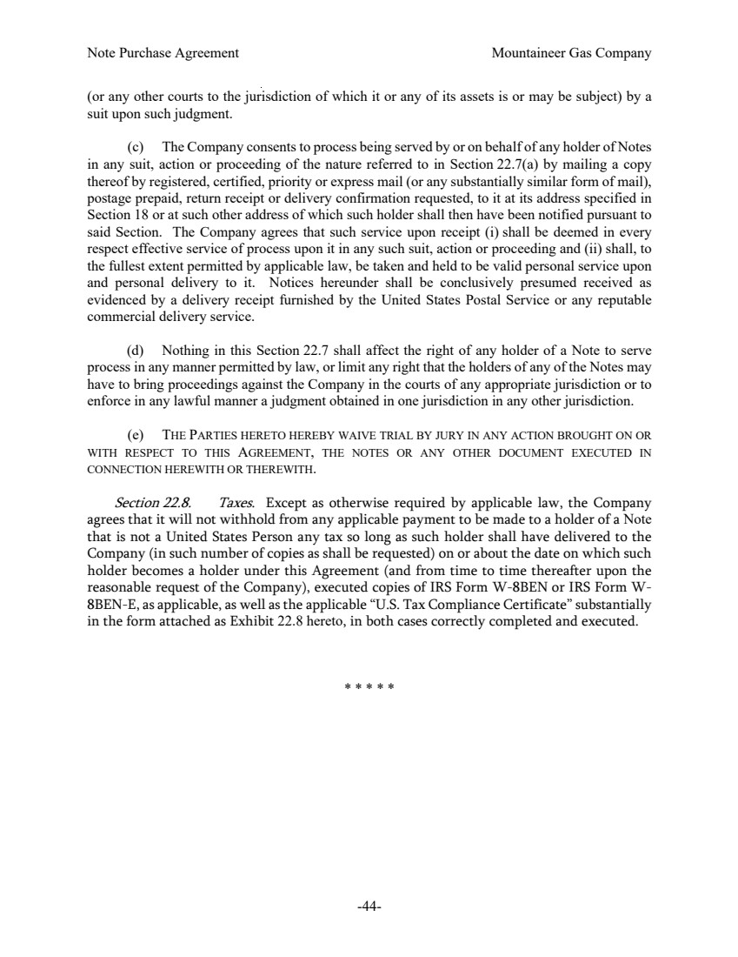 | Note Purchase Agreement Mountaineer Gas Company -44- (or any other courts to the jurisdiction of which it or any of its assets is or may be subject) by a suit upon such judgment. (c) The Company consents to process being served by or on behalf of any holder of Notes in any suit, action or proceeding of the nature referred to in Section 22.7(a) by mailing a copy thereof by registered, certified, priority or express mail (or any substantially similar form of mail), postage prepaid, return receipt or delivery confirmation requested, to it at its address specified in Section 18 or at such other address of which such holder shall then have been notified pursuant to said Section. The Company agrees that such service upon receipt (i) shall be deemed in every respect effective service of process upon it in any such suit, action or proceeding and (ii) shall, to the fullest extent permitted by applicable law, be taken and held to be valid personal service upon and personal delivery to it. Notices hereunder shall be conclusively presumed received as evidenced by a delivery receipt furnished by the United States Postal Service or any reputable commercial delivery service. (d) Nothing in this Section 22.7 shall affect the right of any holder of a Note to serve process in any manner permitted by law, or limit any right that the holders of any of the Notes may have to bring proceedings against the Company in the courts of any appropriate jurisdiction or to enforce in any lawful manner a judgment obtained in one jurisdiction in any other jurisdiction. (e) THE PARTIES HERETO HEREBY WAIVE TRIAL BY JURY IN ANY ACTION BROUGHT ON OR WITH RESPECT TO THIS AGREEMENT, THE NOTES OR ANY OTHER DOCUMENT EXECUTED IN CONNECTION HEREWITH OR THEREWITH. Section 22.8. Taxes. Except as otherwise required by applicable law, the Company agrees that it will not withhold from any applicable payment to be made to a holder of a Note that is not a United States Person any tax so long as such holder shall have delivered to the Company (in such number of copies as shall be requested) on or about the date on which such holder becomes a holder under this Agreement (and from time to time thereafter upon the reasonable request of the Company), executed copies of IRS Form W-8BEN or IRS Form W-8BEN-E, as applicable, as well as the applicable “U.S. Tax Compliance Certificate” substantially in the form attached as Exhibit 22.8 hereto, in both cases correctly completed and executed. * * * * *
 | 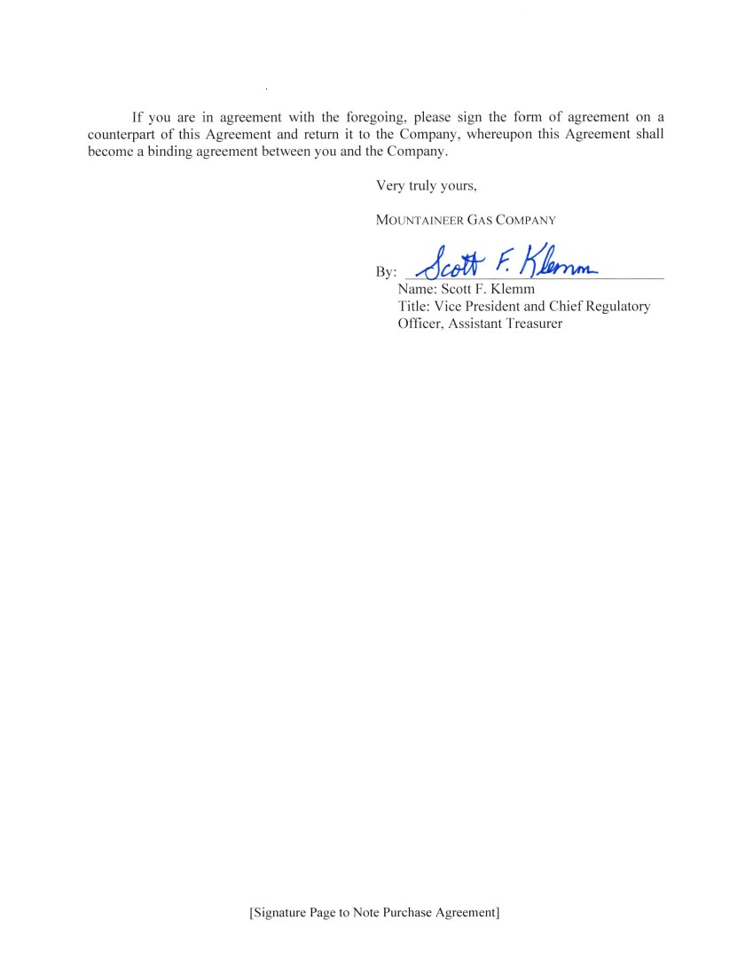 | If you are in agreement with the foregoing, please sign the form of agreement on a counterpart of this Agreement and return it to the Company, whereupon this Agreement shall become a binding agreement between you and the Company. Very truly yours, MouNrarNEER GAS CorrapRNv By J* r K/',* Name: Scott F. Klemm Title: Vice President and Chief Regulatory Officer, Assistant Treasurer ISignature Page to Note Purchase Agreement]
 | 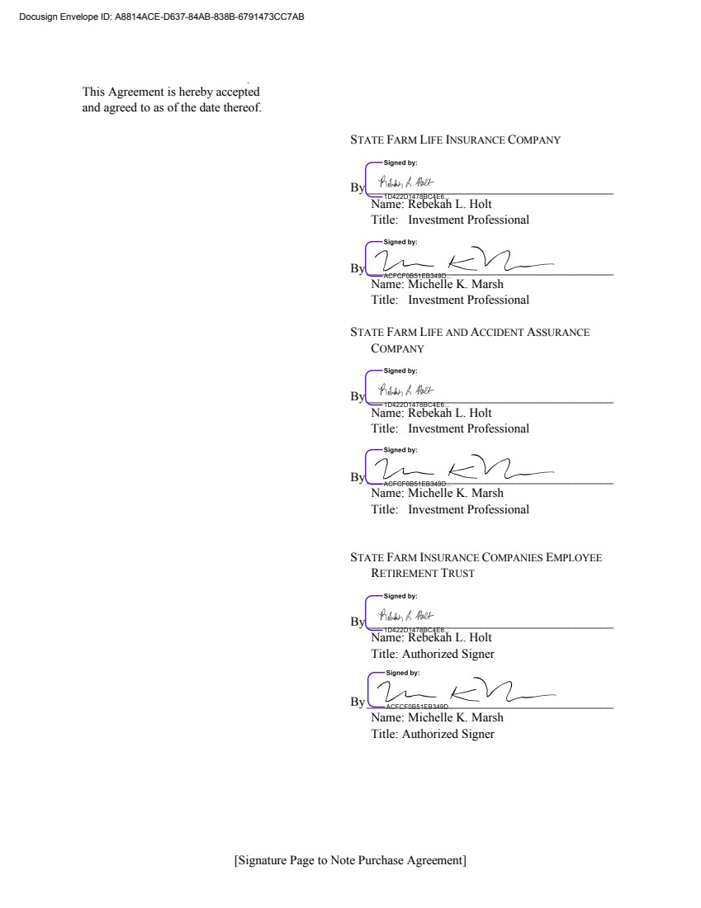 | [Signature Page to Note Purchase Agreement] This Agreement is hereby accepted and agreed to as of the date thereof. STATE FARM LIFE INSURANCE COMPANY By_______________________________________ Name: Rebekah L. Holt Title: Investment Professional By_______________________________________ Name: Michelle K. Marsh Title: Investment Professional STATE FARM LIFE AND ACCIDENT ASSURANCE COMPANY By_______________________________________ Name: Rebekah L. Holt Title: Investment Professional By_______________________________________ Name: Michelle K. Marsh Title: Investment Professional STATE FARM INSURANCE COMPANIES EMPLOYEE RETIREMENT TRUST By_______________________________________ Name: Rebekah L. Holt Title: Authorized Signer By_______________________________________ Name: Michelle K. Marsh Title: Authorized Signer ???????????????????? ????​?? ?-????-????-????-?? ​??? ???
 | 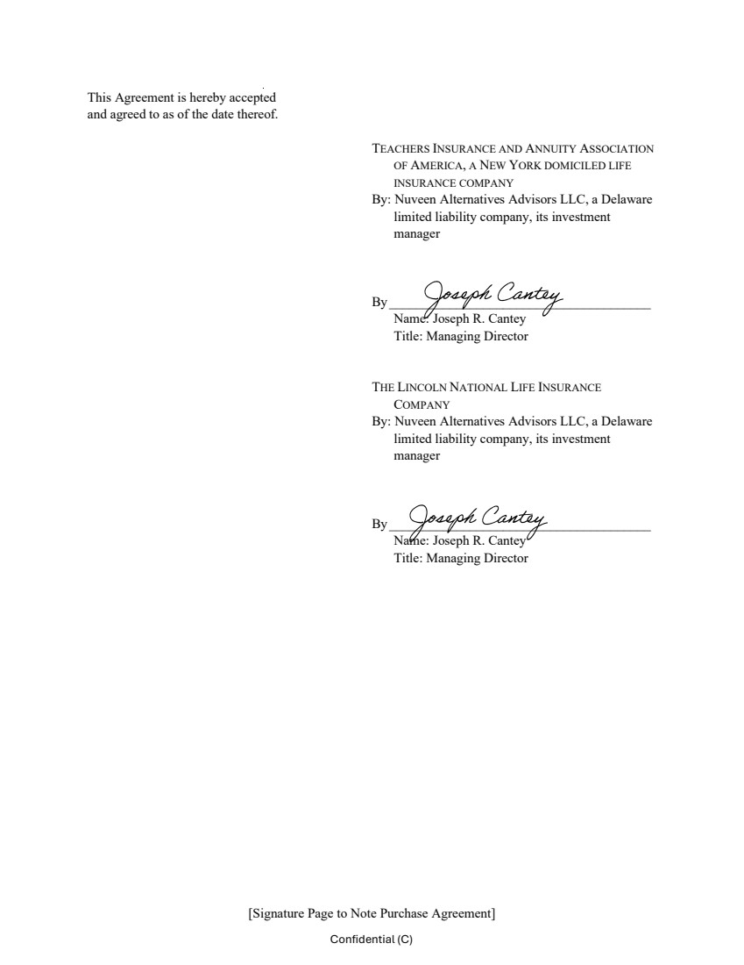 | [Signature Page to Note Purchase Agreement] Confidential (C) This Agreement is hereby accepted and agreed to as of the date thereof. TEACHERS INSURANCE AND ANNUITY ASSOCIATION OF AMERICA, A NEW YORK DOMICILED LIFE INSURANCE COMPANY By: Nuveen Alternatives Advisors LLC, a Delaware limited liability company, its investment manager By _______________________________________ Name: Joseph R. Cantey Title: Managing Director THE LINCOLN NATIONAL LIFE INSURANCE COMPANY By: Nuveen Alternatives Advisors LLC, a Delaware limited liability company, its investment manager By _______________________________________ Name: Joseph R. Cantey Title: Managing Director
 | 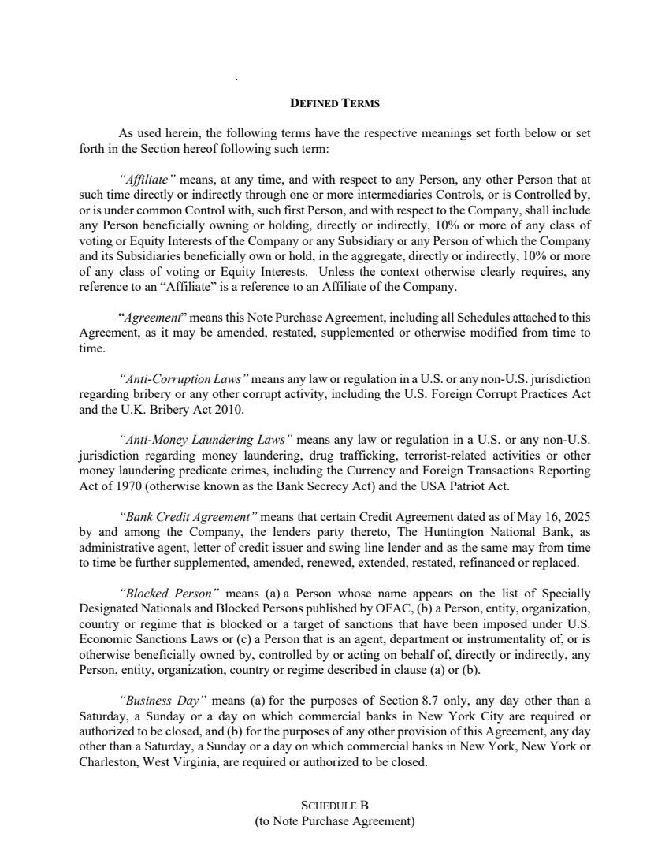 | SCHEDULE B (to Note Purchase Agreement) DEFINED TERMS As used herein, the following terms have the respective meanings set forth below or set forth in the Section hereof following such term: “Affiliate” means, at any time, and with respect to any Person, any other Person that at such time directly or indirectly through one or more intermediaries Controls, or is Controlled by, or is under common Control with, such first Person, and with respect to the Company, shall include any Person beneficially owning or holding, directly or indirectly, 10% or more of any class of voting or Equity Interests of the Company or any Subsidiary or any Person of which the Company and its Subsidiaries beneficially own or hold, in the aggregate, directly or indirectly, 10% or more of any class of voting or Equity Interests. Unless the context otherwise clearly requires, any reference to an “Affiliate” is a reference to an Affiliate of the Company. “Agreement” means this Note Purchase Agreement, including all Schedules attached to this Agreement, as it may be amended, restated, supplemented or otherwise modified from time to time. “Anti-Corruption Laws” means any law or regulation in a U.S. or any non-U.S. jurisdiction regarding bribery or any other corrupt activity, including the U.S. Foreign Corrupt Practices Act and the U.K. Bribery Act 2010. “Anti-Money Laundering Laws” means any law or regulation in a U.S. or any non-U.S. jurisdiction regarding money laundering, drug trafficking, terrorist-related activities or other money laundering predicate crimes, including the Currency and Foreign Transactions Reporting Act of 1970 (otherwise known as the Bank Secrecy Act) and the USA Patriot Act. “Bank Credit Agreement” means that certain Credit Agreement dated as of May 16, 2025 by and among the Company, the lenders party thereto, The Huntington National Bank, as administrative agent, letter of credit issuer and swing line lender and as the same may from time to time be further supplemented, amended, renewed, extended, restated, refinanced or replaced. “Blocked Person” means (a) a Person whose name appears on the list of Specially Designated Nationals and Blocked Persons published by OFAC, (b) a Person, entity, organization, country or regime that is blocked or a target of sanctions that have been imposed under U.S. Economic Sanctions Laws or (c) a Person that is an agent, department or instrumentality of, or is otherwise beneficially owned by, controlled by or acting on behalf of, directly or indirectly, any Person, entity, organization, country or regime described in clause (a) or (b). “Business Day” means (a) for the purposes of Section 8.7 only, any day other than a Saturday, a Sunday or a day on which commercial banks in New York City are required or authorized to be closed, and (b) for the purposes of any other provision of this Agreement, any day other than a Saturday, a Sunday or a day on which commercial banks in New York, New York or Charleston, West Virginia, are required or authorized to be closed.
 | 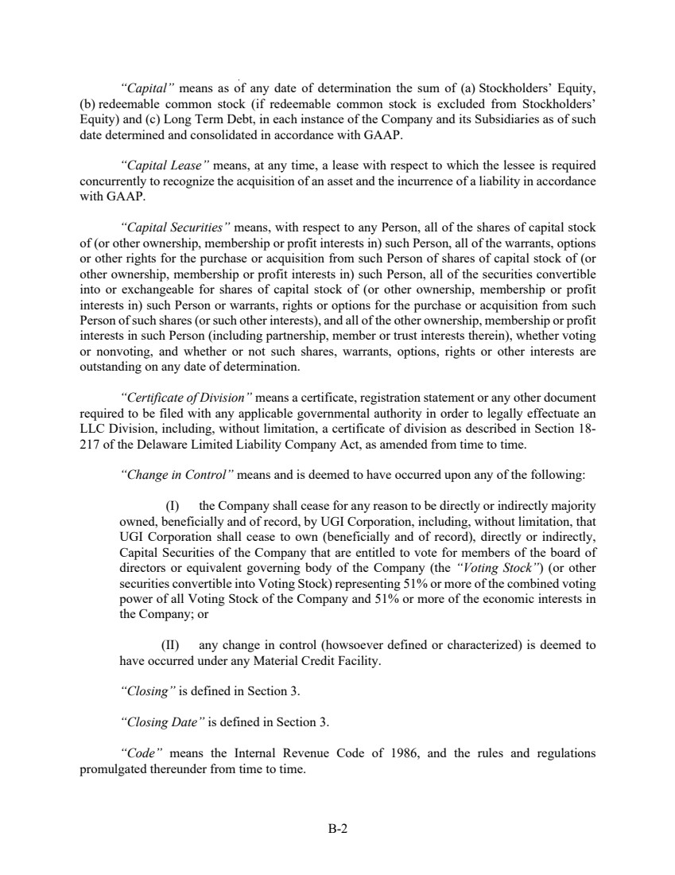 | B-2 “Capital” means as of any date of determination the sum of (a) Stockholders’ Equity, (b) redeemable common stock (if redeemable common stock is excluded from Stockholders’ Equity) and (c) Long Term Debt, in each instance of the Company and its Subsidiaries as of such date determined and consolidated in accordance with GAAP. “Capital Lease” means, at any time, a lease with respect to which the lessee is required concurrently to recognize the acquisition of an asset and the incurrence of a liability in accordance with GAAP. “Capital Securities” means, with respect to any Person, all of the shares of capital stock of (or other ownership, membership or profit interests in) such Person, all of the warrants, options or other rights for the purchase or acquisition from such Person of shares of capital stock of (or other ownership, membership or profit interests in) such Person, all of the securities convertible into or exchangeable for shares of capital stock of (or other ownership, membership or profit interests in) such Person or warrants, rights or options for the purchase or acquisition from such Person of such shares (or such other interests), and all of the other ownership, membership or profit interests in such Person (including partnership, member or trust interests therein), whether voting or nonvoting, and whether or not such shares, warrants, options, rights or other interests are outstanding on any date of determination. “Certificate of Division” means a certificate, registration statement or any other document required to be filed with any applicable governmental authority in order to legally effectuate an LLC Division, including, without limitation, a certificate of division as described in Section 18- 217 of the Delaware Limited Liability Company Act, as amended from time to time. “Change in Control” means and is deemed to have occurred upon any of the following: (I) the Company shall cease for any reason to be directly or indirectly majority owned, beneficially and of record, by UGI Corporation, including, without limitation, that UGI Corporation shall cease to own (beneficially and of record), directly or indirectly, Capital Securities of the Company that are entitled to vote for members of the board of directors or equivalent governing body of the Company (the “Voting Stock”) (or other securities convertible into Voting Stock) representing 51% or more of the combined voting power of all Voting Stock of the Company and 51% or more of the economic interests in the Company; or (II) any change in control (howsoever defined or characterized) is deemed to have occurred under any Material Credit Facility. “Closing” is defined in Section 3. “Closing Date” is defined in Section 3. “Code” means the Internal Revenue Code of 1986, and the rules and regulations promulgated thereunder from time to time.
 | 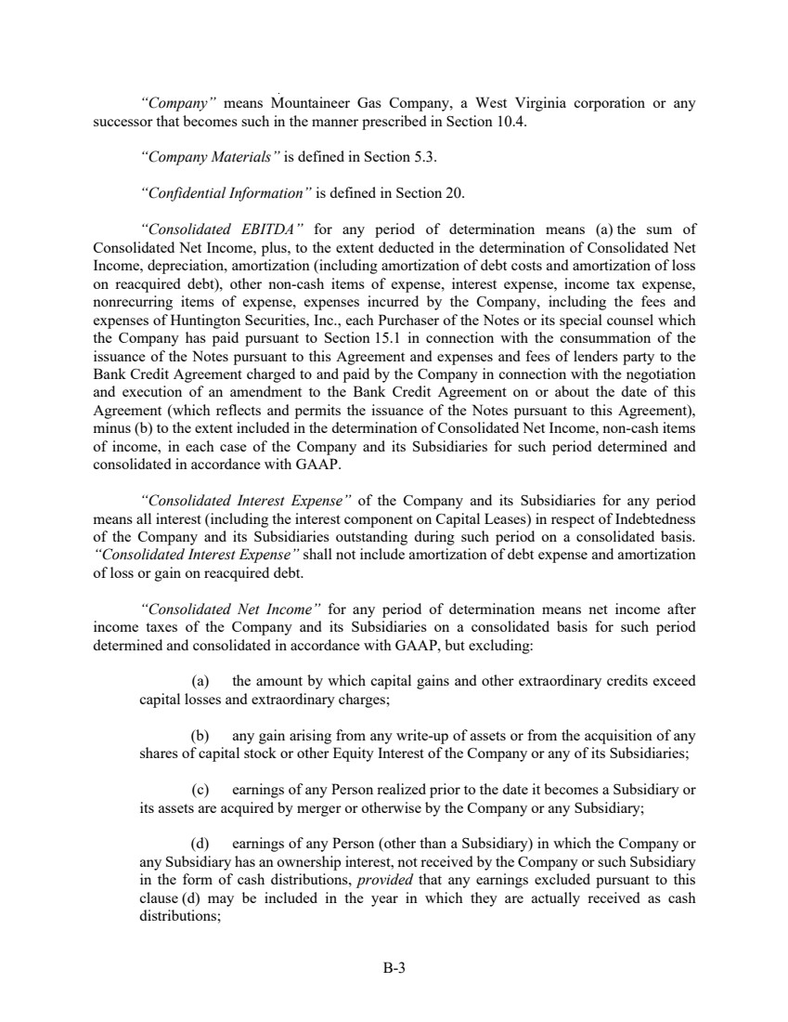 | B-3 “Company” means Mountaineer Gas Company, a West Virginia corporation or any successor that becomes such in the manner prescribed in Section 10.4. “Company Materials” is defined in Section 5.3. “Confidential Information” is defined in Section 20. “Consolidated EBITDA” for any period of determination means (a) the sum of Consolidated Net Income, plus, to the extent deducted in the determination of Consolidated Net Income, depreciation, amortization (including amortization of debt costs and amortization of loss on reacquired debt), other non-cash items of expense, interest expense, income tax expense, nonrecurring items of expense, expenses incurred by the Company, including the fees and expenses of Huntington Securities, Inc., each Purchaser of the Notes or its special counsel which the Company has paid pursuant to Section 15.1 in connection with the consummation of the issuance of the Notes pursuant to this Agreement and expenses and fees of lenders party to the Bank Credit Agreement charged to and paid by the Company in connection with the negotiation and execution of an amendment to the Bank Credit Agreement on or about the date of this Agreement (which reflects and permits the issuance of the Notes pursuant to this Agreement), minus (b) to the extent included in the determination of Consolidated Net Income, non-cash items of income, in each case of the Company and its Subsidiaries for such period determined and consolidated in accordance with GAAP. “Consolidated Interest Expense” of the Company and its Subsidiaries for any period means all interest (including the interest component on Capital Leases) in respect of Indebtedness of the Company and its Subsidiaries outstanding during such period on a consolidated basis. “Consolidated Interest Expense” shall not include amortization of debt expense and amortization of loss or gain on reacquired debt. “Consolidated Net Income” for any period of determination means net income after income taxes of the Company and its Subsidiaries on a consolidated basis for such period determined and consolidated in accordance with GAAP, but excluding: (a) the amount by which capital gains and other extraordinary credits exceed capital losses and extraordinary charges; (b) any gain arising from any write-up of assets or from the acquisition of any shares of capital stock or other Equity Interest of the Company or any of its Subsidiaries; (c) earnings of any Person realized prior to the date it becomes a Subsidiary or its assets are acquired by merger or otherwise by the Company or any Subsidiary; (d) earnings of any Person (other than a Subsidiary) in which the Company or any Subsidiary has an ownership interest, not received by the Company or such Subsidiary in the form of cash distributions, provided that any earnings excluded pursuant to this clause (d) may be included in the year in which they are actually received as cash distributions;
 | 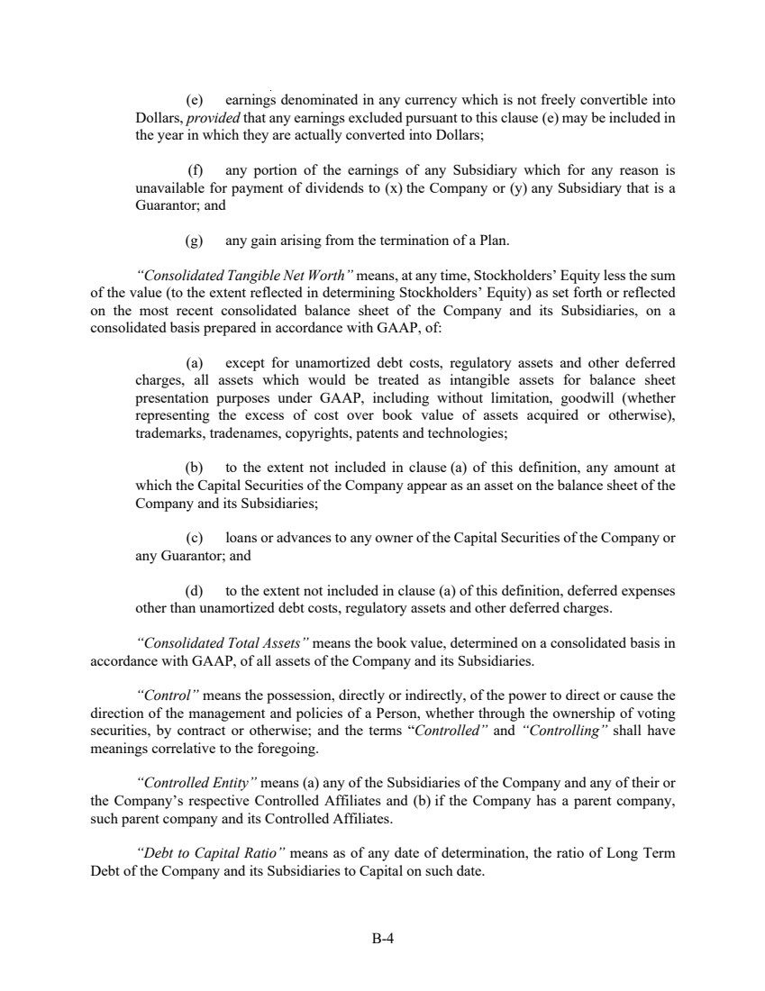 | B-4 (e) earnings denominated in any currency which is not freely convertible into Dollars, provided that any earnings excluded pursuant to this clause (e) may be included in the year in which they are actually converted into Dollars; (f) any portion of the earnings of any Subsidiary which for any reason is unavailable for payment of dividends to (x) the Company or (y) any Subsidiary that is a Guarantor; and (g) any gain arising from the termination of a Plan. “Consolidated Tangible Net Worth” means, at any time, Stockholders’ Equity less the sum of the value (to the extent reflected in determining Stockholders’ Equity) as set forth or reflected on the most recent consolidated balance sheet of the Company and its Subsidiaries, on a consolidated basis prepared in accordance with GAAP, of: (a) except for unamortized debt costs, regulatory assets and other deferred charges, all assets which would be treated as intangible assets for balance sheet presentation purposes under GAAP, including without limitation, goodwill (whether representing the excess of cost over book value of assets acquired or otherwise), trademarks, tradenames, copyrights, patents and technologies; (b) to the extent not included in clause (a) of this definition, any amount at which the Capital Securities of the Company appear as an asset on the balance sheet of the Company and its Subsidiaries; (c) loans or advances to any owner of the Capital Securities of the Company or any Guarantor; and (d) to the extent not included in clause (a) of this definition, deferred expenses other than unamortized debt costs, regulatory assets and other deferred charges. “Consolidated Total Assets” means the book value, determined on a consolidated basis in accordance with GAAP, of all assets of the Company and its Subsidiaries. “Control” means the possession, directly or indirectly, of the power to direct or cause the direction of the management and policies of a Person, whether through the ownership of voting securities, by contract or otherwise; and the terms “Controlled” and “Controlling” shall have meanings correlative to the foregoing. “Controlled Entity” means (a) any of the Subsidiaries of the Company and any of their or the Company’s respective Controlled Affiliates and (b) if the Company has a parent company, such parent company and its Controlled Affiliates. “Debt to Capital Ratio” means as of any date of determination, the ratio of Long Term Debt of the Company and its Subsidiaries to Capital on such date.
 | 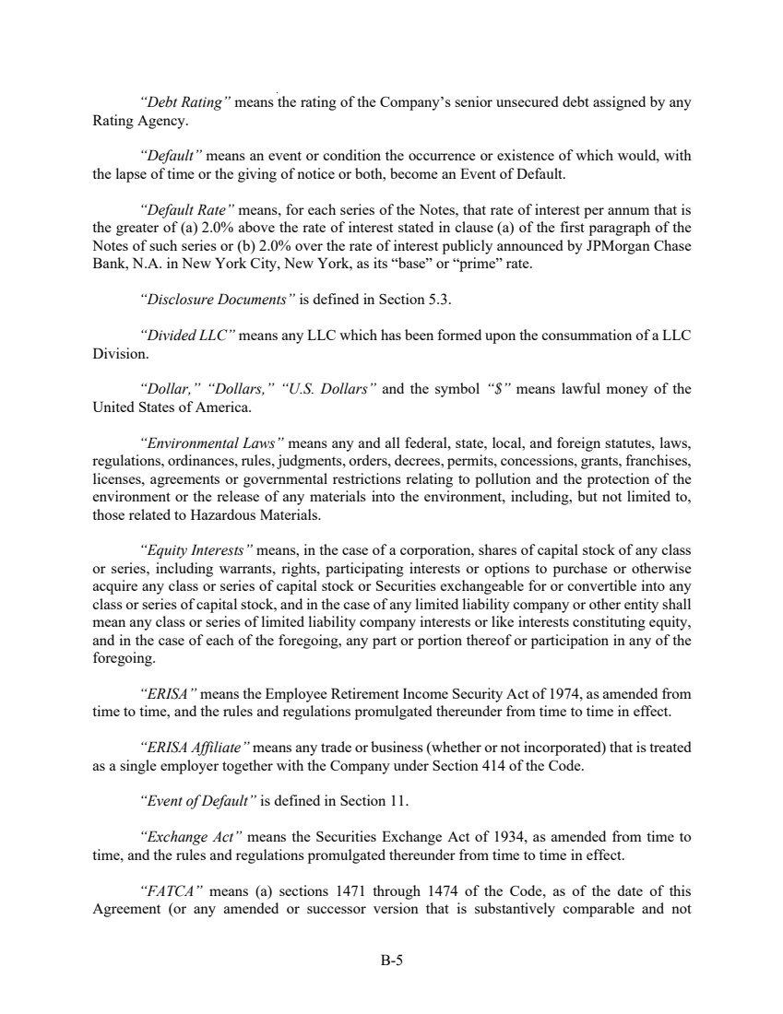 | B-5 “Debt Rating” means the rating of the Company’s senior unsecured debt assigned by any Rating Agency. “Default” means an event or condition the occurrence or existence of which would, with the lapse of time or the giving of notice or both, become an Event of Default. “Default Rate” means, for each series of the Notes, that rate of interest per annum that is the greater of (a) 2.0% above the rate of interest stated in clause (a) of the first paragraph of the Notes of such series or (b) 2.0% over the rate of interest publicly announced by JPMorgan Chase Bank, N.A. in New York City, New York, as its “base” or “prime” rate. “Disclosure Documents” is defined in Section 5.3. “Divided LLC” means any LLC which has been formed upon the consummation of a LLC Division. “Dollar,” “Dollars,” “U.S. Dollars” and the symbol “$” means lawful money of the United States of America. “Environmental Laws” means any and all federal, state, local, and foreign statutes, laws, regulations, ordinances, rules, judgments, orders, decrees, permits, concessions, grants, franchises, licenses, agreements or governmental restrictions relating to pollution and the protection of the environment or the release of any materials into the environment, including, but not limited to, those related to Hazardous Materials. “Equity Interests” means, in the case of a corporation, shares of capital stock of any class or series, including warrants, rights, participating interests or options to purchase or otherwise acquire any class or series of capital stock or Securities exchangeable for or convertible into any class or series of capital stock, and in the case of any limited liability company or other entity shall mean any class or series of limited liability company interests or like interests constituting equity, and in the case of each of the foregoing, any part or portion thereof or participation in any of the foregoing. “ERISA” means the Employee Retirement Income Security Act of 1974, as amended from time to time, and the rules and regulations promulgated thereunder from time to time in effect. “ERISA Affiliate” means any trade or business (whether or not incorporated) that is treated as a single employer together with the Company under Section 414 of the Code. “Event of Default” is defined in Section 11. “Exchange Act” means the Securities Exchange Act of 1934, as amended from time to time, and the rules and regulations promulgated thereunder from time to time in effect. “FATCA” means (a) sections 1471 through 1474 of the Code, as of the date of this Agreement (or any amended or successor version that is substantively comparable and not
 | 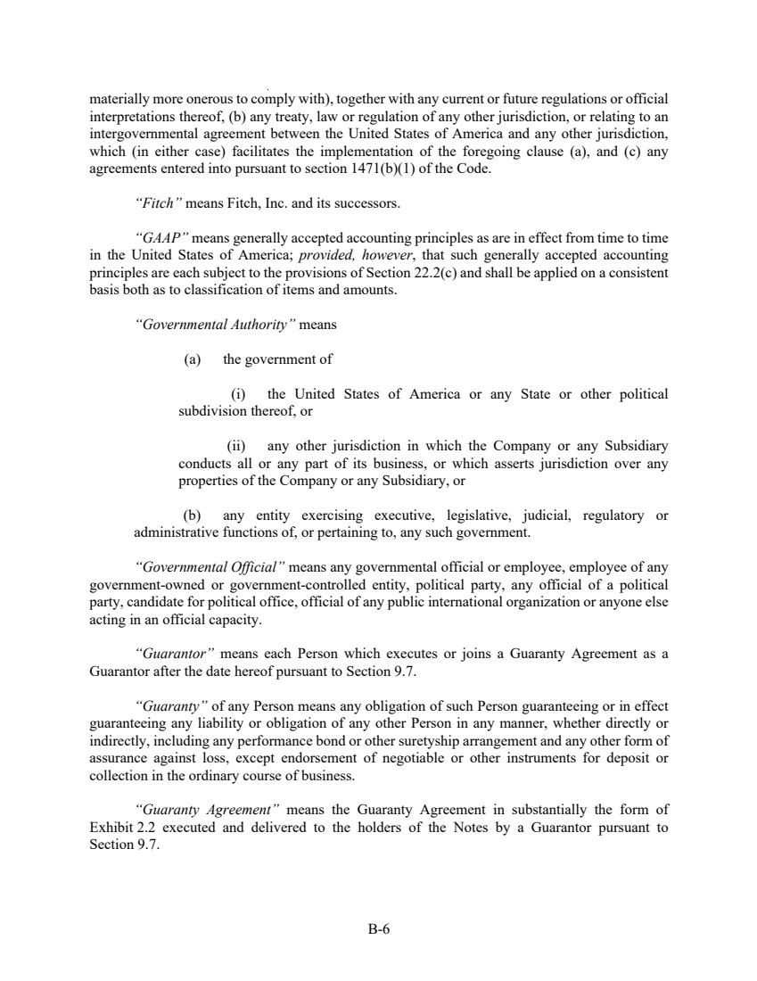 | B-6 materially more onerous to comply with), together with any current or future regulations or official interpretations thereof, (b) any treaty, law or regulation of any other jurisdiction, or relating to an intergovernmental agreement between the United States of America and any other jurisdiction, which (in either case) facilitates the implementation of the foregoing clause (a), and (c) any agreements entered into pursuant to section 1471(b)(1) of the Code. “Fitch” means Fitch, Inc. and its successors. “GAAP” means generally accepted accounting principles as are in effect from time to time in the United States of America; provided, however, that such generally accepted accounting principles are each subject to the provisions of Section 22.2(c) and shall be applied on a consistent basis both as to classification of items and amounts. “Governmental Authority” means (a) the government of (i) the United States of America or any State or other political subdivision thereof, or (ii) any other jurisdiction in which the Company or any Subsidiary conducts all or any part of its business, or which asserts jurisdiction over any properties of the Company or any Subsidiary, or (b) any entity exercising executive, legislative, judicial, regulatory or administrative functions of, or pertaining to, any such government. “Governmental Official” means any governmental official or employee, employee of any government-owned or government-controlled entity, political party, any official of a political party, candidate for political office, official of any public international organization or anyone else acting in an official capacity. “Guarantor” means each Person which executes or joins a Guaranty Agreement as a Guarantor after the date hereof pursuant to Section 9.7. “Guaranty” of any Person means any obligation of such Person guaranteeing or in effect guaranteeing any liability or obligation of any other Person in any manner, whether directly or indirectly, including any performance bond or other suretyship arrangement and any other form of assurance against loss, except endorsement of negotiable or other instruments for deposit or collection in the ordinary course of business. “Guaranty Agreement” means the Guaranty Agreement in substantially the form of Exhibit 2.2 executed and delivered to the holders of the Notes by a Guarantor pursuant to Section 9.7.
 | 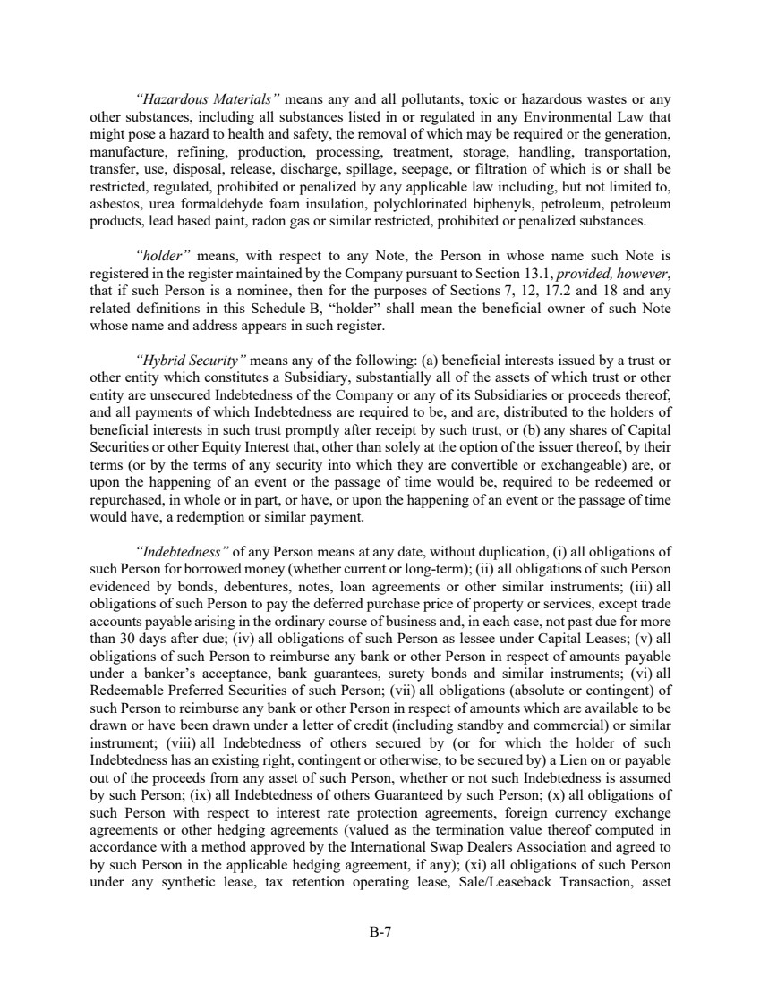 | B-7 “Hazardous Materials” means any and all pollutants, toxic or hazardous wastes or any other substances, including all substances listed in or regulated in any Environmental Law that might pose a hazard to health and safety, the removal of which may be required or the generation, manufacture, refining, production, processing, treatment, storage, handling, transportation, transfer, use, disposal, release, discharge, spillage, seepage, or filtration of which is or shall be restricted, regulated, prohibited or penalized by any applicable law including, but not limited to, asbestos, urea formaldehyde foam insulation, polychlorinated biphenyls, petroleum, petroleum products, lead based paint, radon gas or similar restricted, prohibited or penalized substances. “holder” means, with respect to any Note, the Person in whose name such Note is registered in the register maintained by the Company pursuant to Section 13.1, provided, however, that if such Person is a nominee, then for the purposes of Sections 7, 12, 17.2 and 18 and any related definitions in this Schedule B, “holder” shall mean the beneficial owner of such Note whose name and address appears in such register. “Hybrid Security” means any of the following: (a) beneficial interests issued by a trust or other entity which constitutes a Subsidiary, substantially all of the assets of which trust or other entity are unsecured Indebtedness of the Company or any of its Subsidiaries or proceeds thereof, and all payments of which Indebtedness are required to be, and are, distributed to the holders of beneficial interests in such trust promptly after receipt by such trust, or (b) any shares of Capital Securities or other Equity Interest that, other than solely at the option of the issuer thereof, by their terms (or by the terms of any security into which they are convertible or exchangeable) are, or upon the happening of an event or the passage of time would be, required to be redeemed or repurchased, in whole or in part, or have, or upon the happening of an event or the passage of time would have, a redemption or similar payment. “Indebtedness” of any Person means at any date, without duplication, (i) all obligations of such Person for borrowed money (whether current or long-term); (ii) all obligations of such Person evidenced by bonds, debentures, notes, loan agreements or other similar instruments; (iii) all obligations of such Person to pay the deferred purchase price of property or services, except trade accounts payable arising in the ordinary course of business and, in each case, not past due for more than 30 days after due; (iv) all obligations of such Person as lessee under Capital Leases; (v) all obligations of such Person to reimburse any bank or other Person in respect of amounts payable under a banker’s acceptance, bank guarantees, surety bonds and similar instruments; (vi) all Redeemable Preferred Securities of such Person; (vii) all obligations (absolute or contingent) of such Person to reimburse any bank or other Person in respect of amounts which are available to be drawn or have been drawn under a letter of credit (including standby and commercial) or similar instrument; (viii) all Indebtedness of others secured by (or for which the holder of such Indebtedness has an existing right, contingent or otherwise, to be secured by) a Lien on or payable out of the proceeds from any asset of such Person, whether or not such Indebtedness is assumed by such Person; (ix) all Indebtedness of others Guaranteed by such Person; (x) all obligations of such Person with respect to interest rate protection agreements, foreign currency exchange agreements or other hedging agreements (valued as the termination value thereof computed in accordance with a method approved by the International Swap Dealers Association and agreed to by such Person in the applicable hedging agreement, if any); (xi) all obligations of such Person under any synthetic lease, tax retention operating lease, Sale/Leaseback Transaction, asset
 | 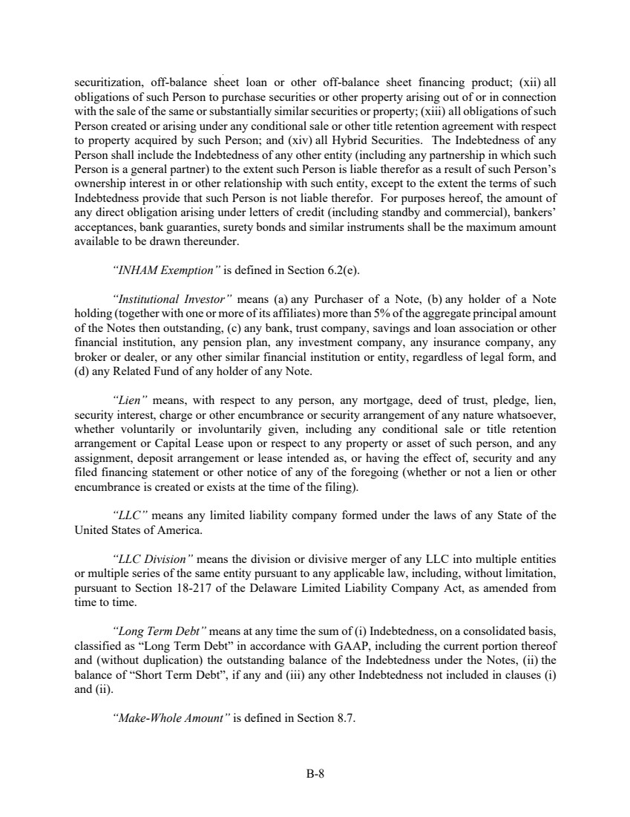 | B-8 securitization, off-balance sheet loan or other off-balance sheet financing product; (xii) all obligations of such Person to purchase securities or other property arising out of or in connection with the sale of the same or substantially similar securities or property; (xiii) all obligations of such Person created or arising under any conditional sale or other title retention agreement with respect to property acquired by such Person; and (xiv) all Hybrid Securities. The Indebtedness of any Person shall include the Indebtedness of any other entity (including any partnership in which such Person is a general partner) to the extent such Person is liable therefor as a result of such Person’s ownership interest in or other relationship with such entity, except to the extent the terms of such Indebtedness provide that such Person is not liable therefor. For purposes hereof, the amount of any direct obligation arising under letters of credit (including standby and commercial), bankers’ acceptances, bank guaranties, surety bonds and similar instruments shall be the maximum amount available to be drawn thereunder. “INHAM Exemption” is defined in Section 6.2(e). “Institutional Investor” means (a) any Purchaser of a Note, (b) any holder of a Note holding (together with one or more of its affiliates) more than 5% of the aggregate principal amount of the Notes then outstanding, (c) any bank, trust company, savings and loan association or other financial institution, any pension plan, any investment company, any insurance company, any broker or dealer, or any other similar financial institution or entity, regardless of legal form, and (d) any Related Fund of any holder of any Note. “Lien” means, with respect to any person, any mortgage, deed of trust, pledge, lien, security interest, charge or other encumbrance or security arrangement of any nature whatsoever, whether voluntarily or involuntarily given, including any conditional sale or title retention arrangement or Capital Lease upon or respect to any property or asset of such person, and any assignment, deposit arrangement or lease intended as, or having the effect of, security and any filed financing statement or other notice of any of the foregoing (whether or not a lien or other encumbrance is created or exists at the time of the filing). “LLC” means any limited liability company formed under the laws of any State of the United States of America. “LLC Division” means the division or divisive merger of any LLC into multiple entities or multiple series of the same entity pursuant to any applicable law, including, without limitation, pursuant to Section 18-217 of the Delaware Limited Liability Company Act, as amended from time to time. “Long Term Debt” means at any time the sum of (i) Indebtedness, on a consolidated basis, classified as “Long Term Debt” in accordance with GAAP, including the current portion thereof and (without duplication) the outstanding balance of the Indebtedness under the Notes, (ii) the balance of “Short Term Debt”, if any and (iii) any other Indebtedness not included in clauses (i) and (ii). “Make-Whole Amount” is defined in Section 8.7.
 | 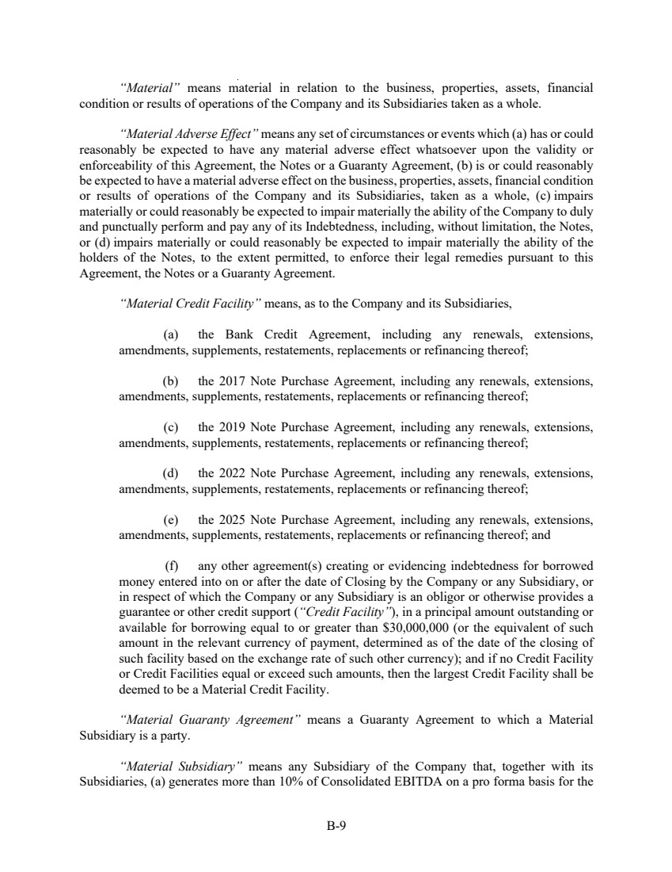 | B-9 “Material” means material in relation to the business, properties, assets, financial condition or results of operations of the Company and its Subsidiaries taken as a whole. “Material Adverse Effect” means any set of circumstances or events which (a) has or could reasonably be expected to have any material adverse effect whatsoever upon the validity or enforceability of this Agreement, the Notes or a Guaranty Agreement, (b) is or could reasonably be expected to have a material adverse effect on the business, properties, assets, financial condition or results of operations of the Company and its Subsidiaries, taken as a whole, (c) impairs materially or could reasonably be expected to impair materially the ability of the Company to duly and punctually perform and pay any of its Indebtedness, including, without limitation, the Notes, or (d) impairs materially or could reasonably be expected to impair materially the ability of the holders of the Notes, to the extent permitted, to enforce their legal remedies pursuant to this Agreement, the Notes or a Guaranty Agreement. “Material Credit Facility” means, as to the Company and its Subsidiaries, (a) the Bank Credit Agreement, including any renewals, extensions, amendments, supplements, restatements, replacements or refinancing thereof; (b) the 2017 Note Purchase Agreement, including any renewals, extensions, amendments, supplements, restatements, replacements or refinancing thereof; (c) the 2019 Note Purchase Agreement, including any renewals, extensions, amendments, supplements, restatements, replacements or refinancing thereof; (d) the 2022 Note Purchase Agreement, including any renewals, extensions, amendments, supplements, restatements, replacements or refinancing thereof; (e) the 2025 Note Purchase Agreement, including any renewals, extensions, amendments, supplements, restatements, replacements or refinancing thereof; and (f) any other agreement(s) creating or evidencing indebtedness for borrowed money entered into on or after the date of Closing by the Company or any Subsidiary, or in respect of which the Company or any Subsidiary is an obligor or otherwise provides a guarantee or other credit support (“Credit Facility”), in a principal amount outstanding or available for borrowing equal to or greater than $30,000,000 (or the equivalent of such amount in the relevant currency of payment, determined as of the date of the closing of such facility based on the exchange rate of such other currency); and if no Credit Facility or Credit Facilities equal or exceed such amounts, then the largest Credit Facility shall be deemed to be a Material Credit Facility. “Material Guaranty Agreement” means a Guaranty Agreement to which a Material Subsidiary is a party. “Material Subsidiary” means any Subsidiary of the Company that, together with its Subsidiaries, (a) generates more than 10% of Consolidated EBITDA on a pro forma basis for the
 | 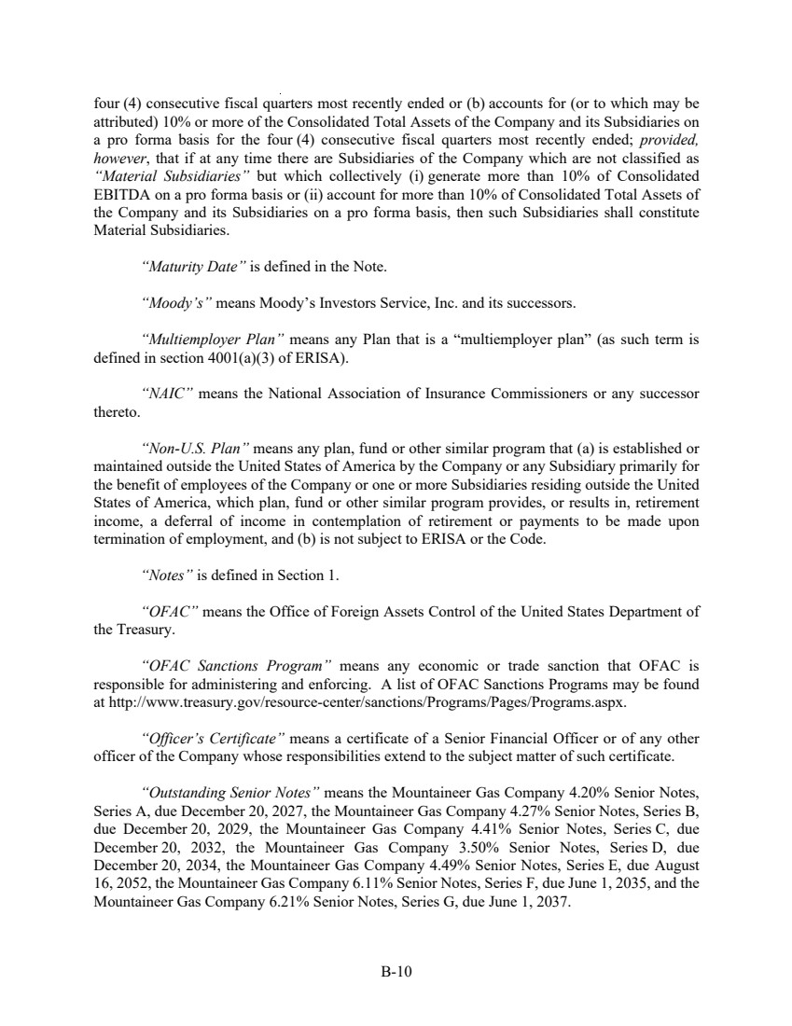 | B-10 four (4) consecutive fiscal quarters most recently ended or (b) accounts for (or to which may be attributed) 10% or more of the Consolidated Total Assets of the Company and its Subsidiaries on a pro forma basis for the four (4) consecutive fiscal quarters most recently ended; provided, however, that if at any time there are Subsidiaries of the Company which are not classified as “Material Subsidiaries” but which collectively (i) generate more than 10% of Consolidated EBITDA on a pro forma basis or (ii) account for more than 10% of Consolidated Total Assets of the Company and its Subsidiaries on a pro forma basis, then such Subsidiaries shall constitute Material Subsidiaries. “Maturity Date” is defined in the Note. “Moody’s” means Moody’s Investors Service, Inc. and its successors. “Multiemployer Plan” means any Plan that is a “multiemployer plan” (as such term is defined in section 4001(a)(3) of ERISA). “NAIC” means the National Association of Insurance Commissioners or any successor thereto. “Non-U.S. Plan” means any plan, fund or other similar program that (a) is established or maintained outside the United States of America by the Company or any Subsidiary primarily for the benefit of employees of the Company or one or more Subsidiaries residing outside the United States of America, which plan, fund or other similar program provides, or results in, retirement income, a deferral of income in contemplation of retirement or payments to be made upon termination of employment, and (b) is not subject to ERISA or the Code. “Notes” is defined in Section 1. “OFAC” means the Office of Foreign Assets Control of the United States Department of the Treasury. “OFAC Sanctions Program” means any economic or trade sanction that OFAC is responsible for administering and enforcing. A list of OFAC Sanctions Programs may be found at http://www.treasury.gov/resource-center/sanctions/Programs/Pages/Programs.aspx. “Officer’s Certificate” means a certificate of a Senior Financial Officer or of any other officer of the Company whose responsibilities extend to the subject matter of such certificate. “Outstanding Senior Notes” means the Mountaineer Gas Company 4.20% Senior Notes, Series A, due December 20, 2027, the Mountaineer Gas Company 4.27% Senior Notes, Series B, due December 20, 2029, the Mountaineer Gas Company 4.41% Senior Notes, Series C, due December 20, 2032, the Mountaineer Gas Company 3.50% Senior Notes, Series D, due December 20, 2034, the Mountaineer Gas Company 4.49% Senior Notes, Series E, due August 16, 2052, the Mountaineer Gas Company 6.11% Senior Notes, Series F, due June 1, 2035, and the Mountaineer Gas Company 6.21% Senior Notes, Series G, due June 1, 2037.
 | 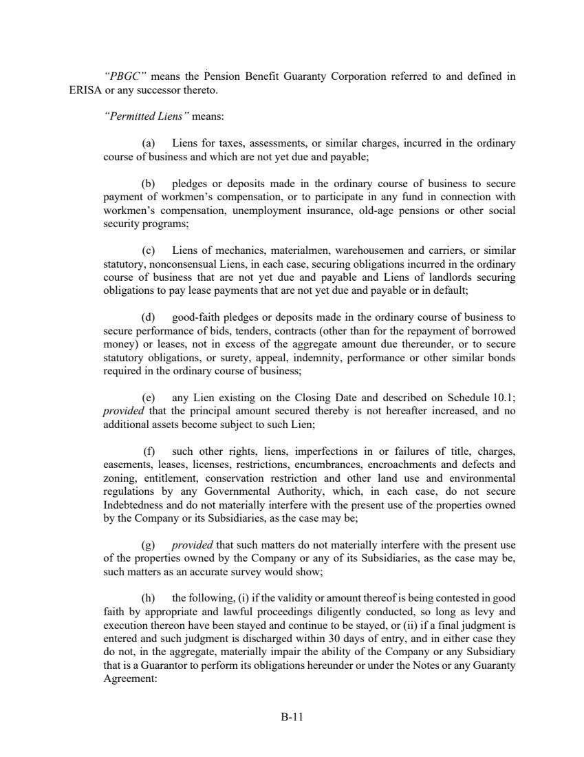 | B-11 “PBGC” means the Pension Benefit Guaranty Corporation referred to and defined in ERISA or any successor thereto. “Permitted Liens” means: (a) Liens for taxes, assessments, or similar charges, incurred in the ordinary course of business and which are not yet due and payable; (b) pledges or deposits made in the ordinary course of business to secure payment of workmen’s compensation, or to participate in any fund in connection with workmen’s compensation, unemployment insurance, old-age pensions or other social security programs; (c) Liens of mechanics, materialmen, warehousemen and carriers, or similar statutory, nonconsensual Liens, in each case, securing obligations incurred in the ordinary course of business that are not yet due and payable and Liens of landlords securing obligations to pay lease payments that are not yet due and payable or in default; (d) good-faith pledges or deposits made in the ordinary course of business to secure performance of bids, tenders, contracts (other than for the repayment of borrowed money) or leases, not in excess of the aggregate amount due thereunder, or to secure statutory obligations, or surety, appeal, indemnity, performance or other similar bonds required in the ordinary course of business; (e) any Lien existing on the Closing Date and described on Schedule 10.1; provided that the principal amount secured thereby is not hereafter increased, and no additional assets become subject to such Lien; (f) such other rights, liens, imperfections in or failures of title, charges, easements, leases, licenses, restrictions, encumbrances, encroachments and defects and zoning, entitlement, conservation restriction and other land use and environmental regulations by any Governmental Authority, which, in each case, do not secure Indebtedness and do not materially interfere with the present use of the properties owned by the Company or its Subsidiaries, as the case may be; (g) provided that such matters do not materially interfere with the present use of the properties owned by the Company or any of its Subsidiaries, as the case may be, such matters as an accurate survey would show; (h) the following, (i) if the validity or amount thereof is being contested in good faith by appropriate and lawful proceedings diligently conducted, so long as levy and execution thereon have been stayed and continue to be stayed, or (ii) if a final judgment is entered and such judgment is discharged within 30 days of entry, and in either case they do not, in the aggregate, materially impair the ability of the Company or any Subsidiary that is a Guarantor to perform its obligations hereunder or under the Notes or any Guaranty Agreement:
 | 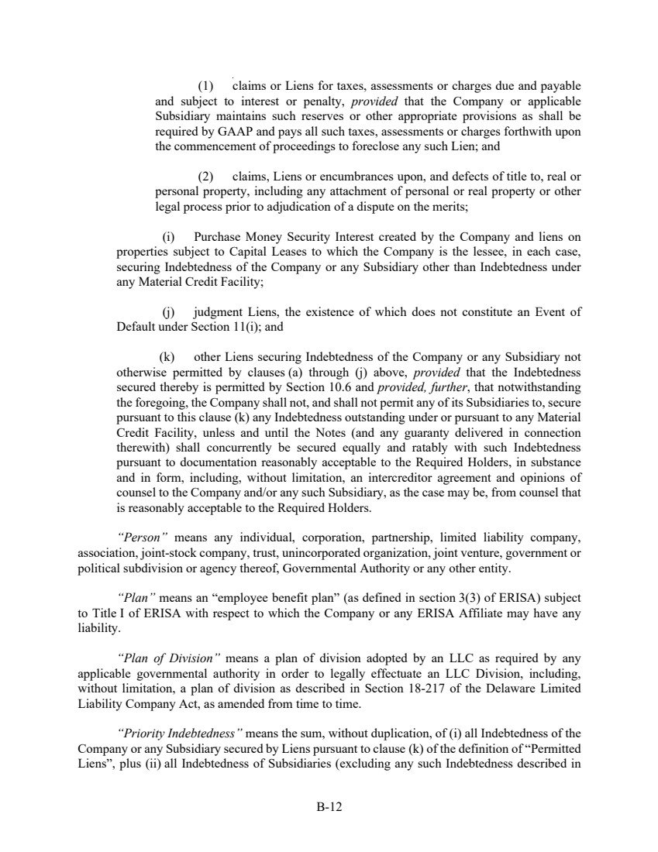 | B-12 (1) claims or Liens for taxes, assessments or charges due and payable and subject to interest or penalty, provided that the Company or applicable Subsidiary maintains such reserves or other appropriate provisions as shall be required by GAAP and pays all such taxes, assessments or charges forthwith upon the commencement of proceedings to foreclose any such Lien; and (2) claims, Liens or encumbrances upon, and defects of title to, real or personal property, including any attachment of personal or real property or other legal process prior to adjudication of a dispute on the merits; (i) Purchase Money Security Interest created by the Company and liens on properties subject to Capital Leases to which the Company is the lessee, in each case, securing Indebtedness of the Company or any Subsidiary other than Indebtedness under any Material Credit Facility; (j) judgment Liens, the existence of which does not constitute an Event of Default under Section 11(i); and (k) other Liens securing Indebtedness of the Company or any Subsidiary not otherwise permitted by clauses (a) through (j) above, provided that the Indebtedness secured thereby is permitted by Section 10.6 and provided, further, that notwithstanding the foregoing, the Company shall not, and shall not permit any of its Subsidiaries to, secure pursuant to this clause (k) any Indebtedness outstanding under or pursuant to any Material Credit Facility, unless and until the Notes (and any guaranty delivered in connection therewith) shall concurrently be secured equally and ratably with such Indebtedness pursuant to documentation reasonably acceptable to the Required Holders, in substance and in form, including, without limitation, an intercreditor agreement and opinions of counsel to the Company and/or any such Subsidiary, as the case may be, from counsel that is reasonably acceptable to the Required Holders. “Person” means any individual, corporation, partnership, limited liability company, association, joint-stock company, trust, unincorporated organization, joint venture, government or political subdivision or agency thereof, Governmental Authority or any other entity. “Plan” means an “employee benefit plan” (as defined in section 3(3) of ERISA) subject to Title I of ERISA with respect to which the Company or any ERISA Affiliate may have any liability. “Plan of Division” means a plan of division adopted by an LLC as required by any applicable governmental authority in order to legally effectuate an LLC Division, including, without limitation, a plan of division as described in Section 18-217 of the Delaware Limited Liability Company Act, as amended from time to time. “Priority Indebtedness” means the sum, without duplication, of (i) all Indebtedness of the Company or any Subsidiary secured by Liens pursuant to clause (k) of the definition of “Permitted Liens”, plus (ii) all Indebtedness of Subsidiaries (excluding any such Indebtedness described in
 | 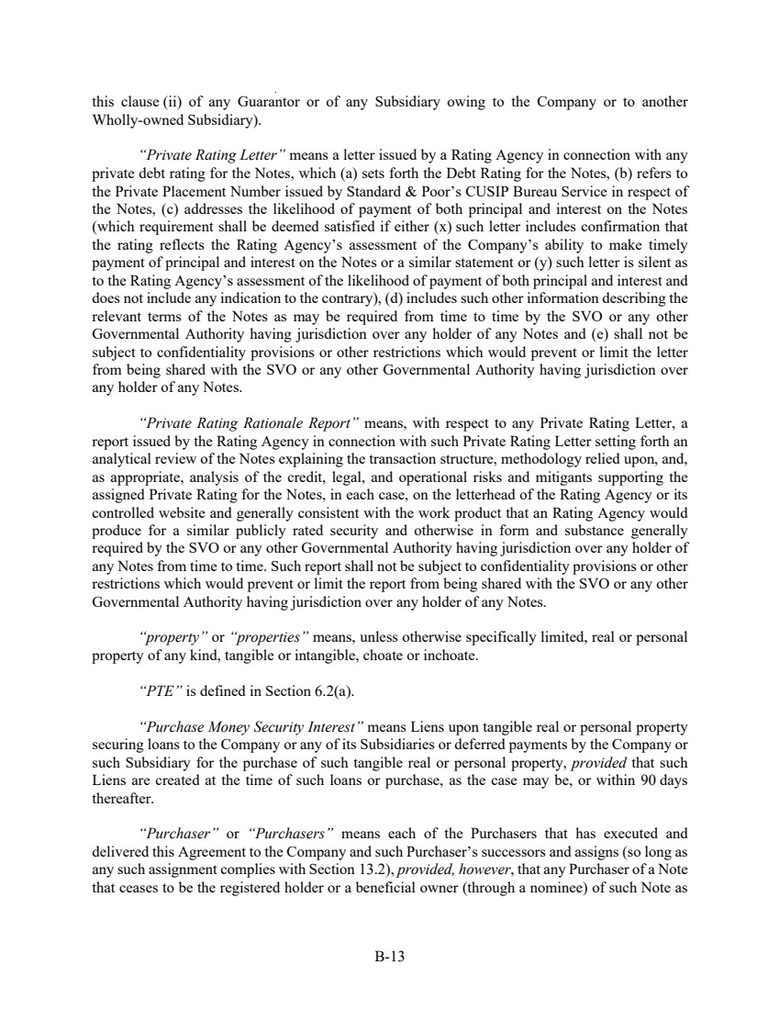 | B-13 this clause (ii) of any Guarantor or of any Subsidiary owing to the Company or to another Wholly-owned Subsidiary). “Private Rating Letter” means a letter issued by a Rating Agency in connection with any private debt rating for the Notes, which (a) sets forth the Debt Rating for the Notes, (b) refers to the Private Placement Number issued by Standard & Poor’s CUSIP Bureau Service in respect of the Notes, (c) addresses the likelihood of payment of both principal and interest on the Notes (which requirement shall be deemed satisfied if either (x) such letter includes confirmation that the rating reflects the Rating Agency’s assessment of the Company’s ability to make timely payment of principal and interest on the Notes or a similar statement or (y) such letter is silent as to the Rating Agency’s assessment of the likelihood of payment of both principal and interest and does not include any indication to the contrary), (d) includes such other information describing the relevant terms of the Notes as may be required from time to time by the SVO or any other Governmental Authority having jurisdiction over any holder of any Notes and (e) shall not be subject to confidentiality provisions or other restrictions which would prevent or limit the letter from being shared with the SVO or any other Governmental Authority having jurisdiction over any holder of any Notes. “Private Rating Rationale Report” means, with respect to any Private Rating Letter, a report issued by the Rating Agency in connection with such Private Rating Letter setting forth an analytical review of the Notes explaining the transaction structure, methodology relied upon, and, as appropriate, analysis of the credit, legal, and operational risks and mitigants supporting the assigned Private Rating for the Notes, in each case, on the letterhead of the Rating Agency or its controlled website and generally consistent with the work product that an Rating Agency would produce for a similar publicly rated security and otherwise in form and substance generally required by the SVO or any other Governmental Authority having jurisdiction over any holder of any Notes from time to time. Such report shall not be subject to confidentiality provisions or other restrictions which would prevent or limit the report from being shared with the SVO or any other Governmental Authority having jurisdiction over any holder of any Notes. “property” or “properties” means, unless otherwise specifically limited, real or personal property of any kind, tangible or intangible, choate or inchoate. “PTE” is defined in Section 6.2(a). “Purchase Money Security Interest” means Liens upon tangible real or personal property securing loans to the Company or any of its Subsidiaries or deferred payments by the Company or such Subsidiary for the purchase of such tangible real or personal property, provided that such Liens are created at the time of such loans or purchase, as the case may be, or within 90 days thereafter. “Purchaser” or “Purchasers” means each of the Purchasers that has executed and delivered this Agreement to the Company and such Purchaser’s successors and assigns (so long as any such assignment complies with Section 13.2), provided, however, that any Purchaser of a Note that ceases to be the registered holder or a beneficial owner (through a nominee) of such Note as
 | 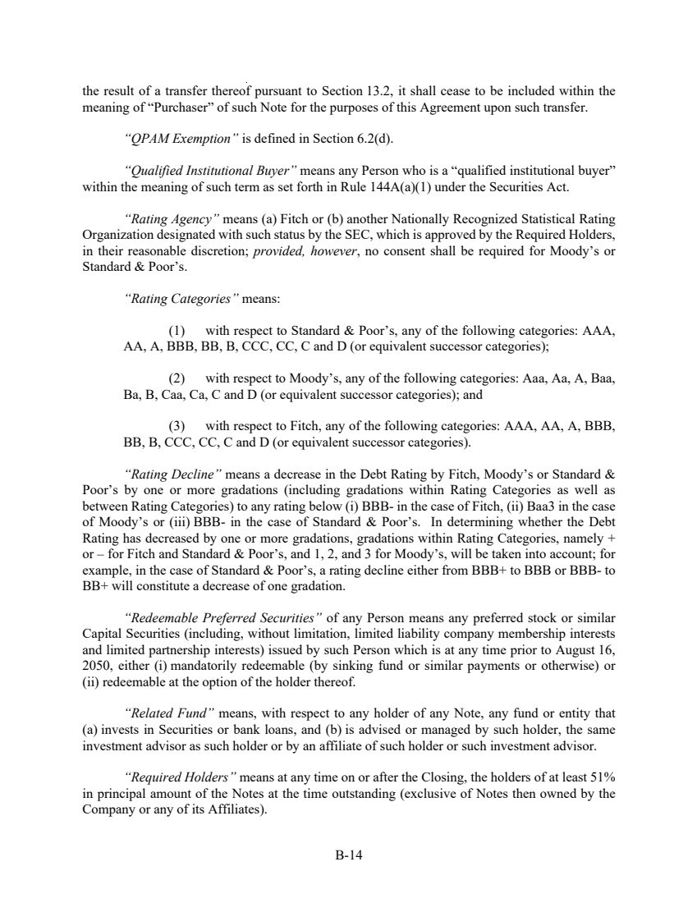 | B-14 the result of a transfer thereof pursuant to Section 13.2, it shall cease to be included within the meaning of “Purchaser” of such Note for the purposes of this Agreement upon such transfer. “QPAM Exemption” is defined in Section 6.2(d). “Qualified Institutional Buyer” means any Person who is a “qualified institutional buyer” within the meaning of such term as set forth in Rule 144A(a)(1) under the Securities Act. “Rating Agency” means (a) Fitch or (b) another Nationally Recognized Statistical Rating Organization designated with such status by the SEC, which is approved by the Required Holders, in their reasonable discretion; provided, however, no consent shall be required for Moody’s or Standard & Poor’s. “Rating Categories” means: (1) with respect to Standard & Poor’s, any of the following categories: AAA, AA, A, BBB, BB, B, CCC, CC, C and D (or equivalent successor categories); (2) with respect to Moody’s, any of the following categories: Aaa, Aa, A, Baa, Ba, B, Caa, Ca, C and D (or equivalent successor categories); and (3) with respect to Fitch, any of the following categories: AAA, AA, A, BBB, BB, B, CCC, CC, C and D (or equivalent successor categories). “Rating Decline” means a decrease in the Debt Rating by Fitch, Moody’s or Standard & Poor’s by one or more gradations (including gradations within Rating Categories as well as between Rating Categories) to any rating below (i) BBB- in the case of Fitch, (ii) Baa3 in the case of Moody’s or (iii) BBB- in the case of Standard & Poor’s. In determining whether the Debt Rating has decreased by one or more gradations, gradations within Rating Categories, namely + or – for Fitch and Standard & Poor’s, and 1, 2, and 3 for Moody’s, will be taken into account; for example, in the case of Standard & Poor’s, a rating decline either from BBB+ to BBB or BBB- to BB+ will constitute a decrease of one gradation. “Redeemable Preferred Securities” of any Person means any preferred stock or similar Capital Securities (including, without limitation, limited liability company membership interests and limited partnership interests) issued by such Person which is at any time prior to August 16, 2050, either (i) mandatorily redeemable (by sinking fund or similar payments or otherwise) or (ii) redeemable at the option of the holder thereof. “Related Fund” means, with respect to any holder of any Note, any fund or entity that (a) invests in Securities or bank loans, and (b) is advised or managed by such holder, the same investment advisor as such holder or by an affiliate of such holder or such investment advisor. “Required Holders” means at any time on or after the Closing, the holders of at least 51% in principal amount of the Notes at the time outstanding (exclusive of Notes then owned by the Company or any of its Affiliates).
 | 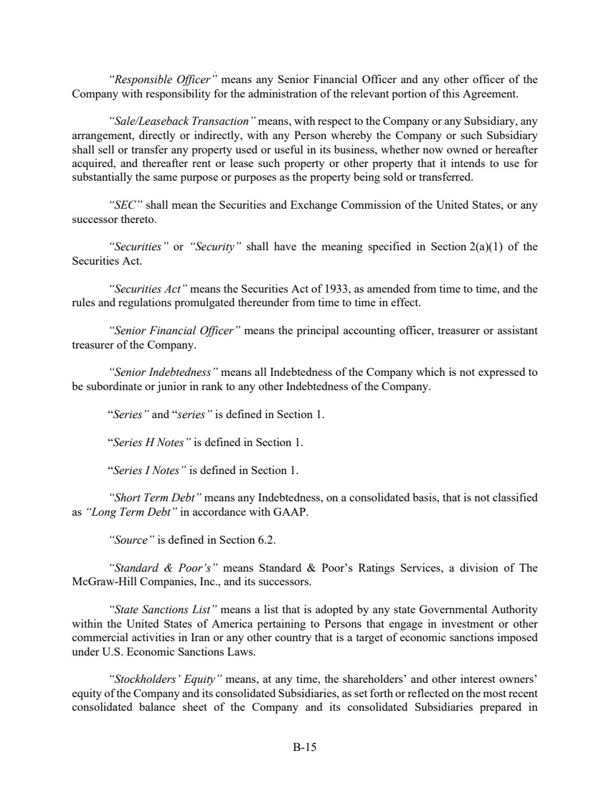 | B-15 “Responsible Officer” means any Senior Financial Officer and any other officer of the Company with responsibility for the administration of the relevant portion of this Agreement. “Sale/Leaseback Transaction” means, with respect to the Company or any Subsidiary, any arrangement, directly or indirectly, with any Person whereby the Company or such Subsidiary shall sell or transfer any property used or useful in its business, whether now owned or hereafter acquired, and thereafter rent or lease such property or other property that it intends to use for substantially the same purpose or purposes as the property being sold or transferred. “SEC” shall mean the Securities and Exchange Commission of the United States, or any successor thereto. “Securities” or “Security” shall have the meaning specified in Section 2(a)(1) of the Securities Act. “Securities Act” means the Securities Act of 1933, as amended from time to time, and the rules and regulations promulgated thereunder from time to time in effect. “Senior Financial Officer” means the principal accounting officer, treasurer or assistant treasurer of the Company. “Senior Indebtedness” means all Indebtedness of the Company which is not expressed to be subordinate or junior in rank to any other Indebtedness of the Company. “Series” and “series” is defined in Section 1. “Series H Notes” is defined in Section 1. “Series I Notes” is defined in Section 1. “Short Term Debt” means any Indebtedness, on a consolidated basis, that is not classified as “Long Term Debt” in accordance with GAAP. “Source” is defined in Section 6.2. “Standard & Poor’s” means Standard & Poor’s Ratings Services, a division of The McGraw-Hill Companies, Inc., and its successors. “State Sanctions List” means a list that is adopted by any state Governmental Authority within the United States of America pertaining to Persons that engage in investment or other commercial activities in Iran or any other country that is a target of economic sanctions imposed under U.S. Economic Sanctions Laws. “Stockholders’ Equity” means, at any time, the shareholders’ and other interest owners’ equity of the Company and its consolidated Subsidiaries, as set forth or reflected on the most recent consolidated balance sheet of the Company and its consolidated Subsidiaries prepared in
 | 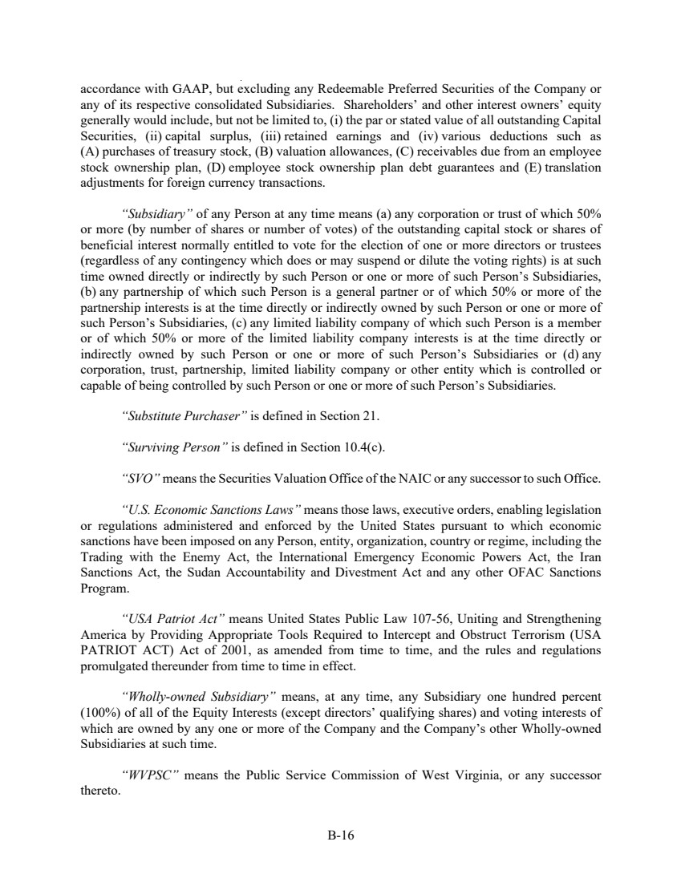 | B-16 accordance with GAAP, but excluding any Redeemable Preferred Securities of the Company or any of its respective consolidated Subsidiaries. Shareholders’ and other interest owners’ equity generally would include, but not be limited to, (i) the par or stated value of all outstanding Capital Securities, (ii) capital surplus, (iii) retained earnings and (iv) various deductions such as (A) purchases of treasury stock, (B) valuation allowances, (C) receivables due from an employee stock ownership plan, (D) employee stock ownership plan debt guarantees and (E) translation adjustments for foreign currency transactions. “Subsidiary” of any Person at any time means (a) any corporation or trust of which 50% or more (by number of shares or number of votes) of the outstanding capital stock or shares of beneficial interest normally entitled to vote for the election of one or more directors or trustees (regardless of any contingency which does or may suspend or dilute the voting rights) is at such time owned directly or indirectly by such Person or one or more of such Person’s Subsidiaries, (b) any partnership of which such Person is a general partner or of which 50% or more of the partnership interests is at the time directly or indirectly owned by such Person or one or more of such Person’s Subsidiaries, (c) any limited liability company of which such Person is a member or of which 50% or more of the limited liability company interests is at the time directly or indirectly owned by such Person or one or more of such Person’s Subsidiaries or (d) any corporation, trust, partnership, limited liability company or other entity which is controlled or capable of being controlled by such Person or one or more of such Person’s Subsidiaries. “Substitute Purchaser” is defined in Section 21. “Surviving Person” is defined in Section 10.4(c). “SVO” means the Securities Valuation Office of the NAIC or any successor to such Office. “U.S. Economic Sanctions Laws” means those laws, executive orders, enabling legislation or regulations administered and enforced by the United States pursuant to which economic sanctions have been imposed on any Person, entity, organization, country or regime, including the Trading with the Enemy Act, the International Emergency Economic Powers Act, the Iran Sanctions Act, the Sudan Accountability and Divestment Act and any other OFAC Sanctions Program. “USA Patriot Act” means United States Public Law 107-56, Uniting and Strengthening America by Providing Appropriate Tools Required to Intercept and Obstruct Terrorism (USA PATRIOT ACT) Act of 2001, as amended from time to time, and the rules and regulations promulgated thereunder from time to time in effect. “Wholly-owned Subsidiary” means, at any time, any Subsidiary one hundred percent (100%) of all of the Equity Interests (except directors’ qualifying shares) and voting interests of which are owned by any one or more of the Company and the Company’s other Wholly-owned Subsidiaries at such time. “WVPSC” means the Public Service Commission of West Virginia, or any successor thereto.
 | 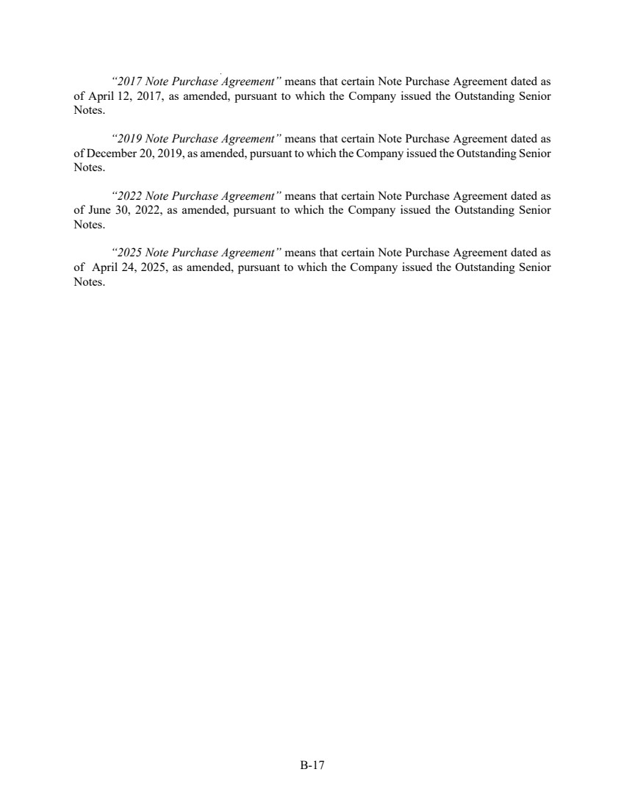 | B-17 “2017 Note Purchase Agreement” means that certain Note Purchase Agreement dated as of April 12, 2017, as amended, pursuant to which the Company issued the Outstanding Senior Notes. “2019 Note Purchase Agreement” means that certain Note Purchase Agreement dated as of December 20, 2019, as amended, pursuant to which the Company issued the Outstanding Senior Notes. “2022 Note Purchase Agreement” means that certain Note Purchase Agreement dated as of June 30, 2022, as amended, pursuant to which the Company issued the Outstanding Senior Notes. “2025 Note Purchase Agreement” means that certain Note Purchase Agreement dated as of April 24, 2025, as amended, pursuant to which the Company issued the Outstanding Senior Notes.

