​
​
​
UNITED STATES
SECURITIES AND EXCHANGE COMMISSION
WASHINGTON, D.C. 20549
FORM 8-K
CURRENT REPORT
Pursuant to Section 13 or 15(d)
of The Securities Exchange Act of 1934
Date of Report (Date of earliest event reported): August 4, 2026
UGI Corporation
(Exact Name of Registrant as Specified in Its Charter)
​ | ​ | ​
Pennsylvania  (State or Other Jurisdiction  of Incorporation) | 1-11071  (Commission  File Number) | 23-2668356  (IRS Employer  Identification No.)
​
500 North Gulph Road, King of Prussia, PA 19406
(Address of Principal Executive Offices) (Zip Code)
Registrant’s Telephone Number, Including Area Code: 610 337-1000
Not Applicable
Former Name or Former Address, if Changed Since Last Report
Check the appropriate box below if the Form 8-K filing is intended to simultaneously satisfy the filing obligation of the registrant under any of the following provisions:
☐ | Written communications pursuant to Rule 425 under the Securities Act (17 CFR 230.425)
☐ | Soliciting material pursuant to Rule 14a-12 under the Exchange Act (17 CFR 240.14a-12)
☐ | Pre-commencement communications pursuant to Rule 14d-2(b) under the Exchange Act (17 CFR 240.14d-2(b))
☐ | Pre-commencement communications pursuant to Rule 13e-4(c) under the Exchange Act (17 CFR 240.13e-4(c))
Securities registered pursuant to Section 12(b) of the Act:

​ | ​ | ​ | ​ | ​
Title of each class | ​ ​ ​ | Trading  Symbol(s) | ​ ​ ​ | Name of each exchange  on which registered
Common Stock, without par value | ​ | UGI | ​ | New York Stock Exchange
​
Indicate by check mark whether the registrant is an emerging growth company as defined in Rule 405 of the Securities Act of 1933 (§230.405 of this chapter) or Rule 12b-2 of the Securities Exchange Act of 1934 (§240.12b-2 of this chapter).
Emerging growth company ☐
If an emerging growth company, indicate by check mark if the registrant has elected not to use the extended transition period for complying with any new or revised financial accounting standards provided pursuant to Section 13(a) of the Exchange Act. ☐
​
​
​
​
​
​
​
​
​
Item 5.02 Departure of Directors or Certain Officers; Election of Directors; Appointment of Certain Officers; Compensatory Arrangements of Certain Officers.
​
On August 4, 2026, the Compensation and Talent Development Committee (the “Committee”) of the Board of Directors of UGI Corporation (the “Company”) approved the UGI Corporation Executive Short-Term Incentive Bonus Plan (the “Bonus Plan”), effective October 1, 2026. The Bonus Plan supersedes and replaces the UGI Corporation Executive Annual Bonus Plan, the AmeriGas Executive Annual Bonus Plan, the UGI Utilities Executive Annual Bonus Plan, and all other executive annual bonus plans and plan summary details for the Company and any of its subsidiaries and affiliates that participate in the Bonus Plan (the “Related Companies”).
The Bonus Plan provides financial incentives, as a percentage of base salary, to certain senior level employees of the Related Companies who are selected by the Committee to participate in the Bonus Plan (each, a “Participant”). In order to receive an annual bonus, Participants must satisfy the Bonus Plan’s requirements, including (i) meeting or exceeding annual Performance Goals (as defined in the Bonus Plan); (ii) service criteria; and, if applicable, (iii) qualifying termination requirements, including upon a Participant’s Retirement or Disability (each as defined in the Bonus Plan), an involuntary termination without Cause (as defined in the Bonus Plan), or upon a Change in Control (as defined in the Bonus Plan). Upon a Participant’s termination without Cause, the treatment of annual bonuses shall be governed by the UGI Corporation Executive Severance Plan. Each of the Company’s officers who are designated by the Company’s Board of Directors as executive officers under Section 16 of the Securities Exchange Act of 1934, as amended (the “Exchange Act”), is a Participant in the Bonus Plan.
The foregoing summary is qualified in its entirety by reference to the Bonus Plan attached hereto as Exhibit 10.1 and incorporated herein by reference.
Item 9.01 Financial Statements and Exhibits.
(d) Exhibits.
​ | ​ | ​
Exhibit Number: |  | Description
10.1 | ​ | UGI Corporation Executive Short-Term Incentive Bonus Plan, effective October 1, 2026.
​ | ​ | ​
104 | ​ | Cover Page Interactive Data File (formatted as inline XBRL).
​
​
​
SIGNATURES
Pursuant to the requirements of the Securities Exchange Act of 1934, the registrant has duly caused this report to be signed on its behalf by the undersigned hereunto duly authorized.
​ | ​ | UGI Corporation
​ | ​ | ​
August 10, 2026 | ​ | By: | /s/ Jessica A. Milner
​ | ​ | Name: | Jessica A. Milner
​ | ​ | Title: | Secretary
​ | ​ | ​
​
​
​

 | 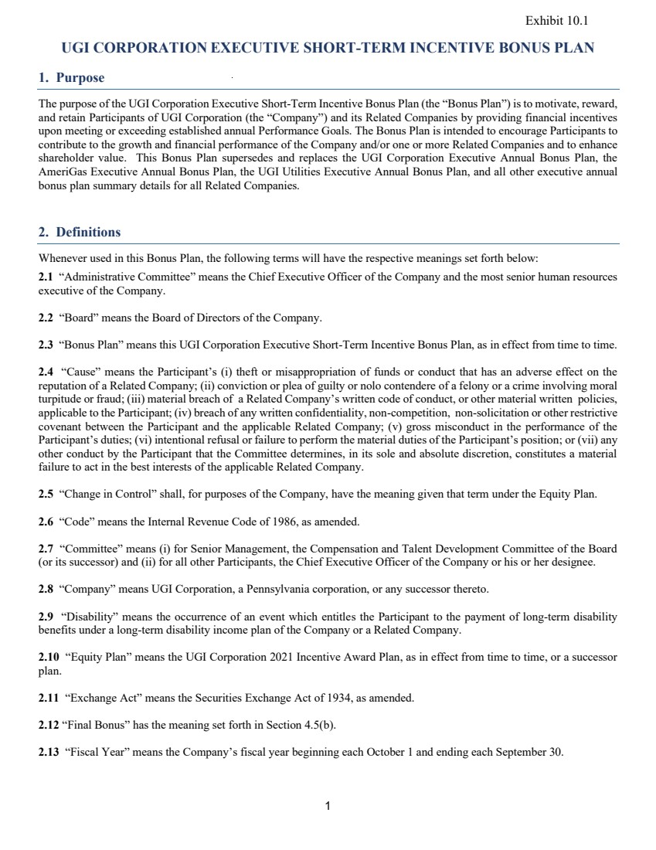 | 1 UGI CORPORATION EXECUTIVE SHORT-TERM INCENTIVE BONUS PLAN 1. Purpose The purpose of the UGI Corporation Executive Short-Term Incentive Bonus Plan (the “Bonus Plan”) is to motivate, reward, and retain Participants of UGI Corporation (the “Company”) and its Related Companies by providing financial incentives upon meeting or exceeding established annual Performance Goals. The Bonus Plan is intended to encourage Participants to contribute to the growth and financial performance of the Company and/or one or more Related Companies and to enhance shareholder value. This Bonus Plan supersedes and replaces the UGI Corporation Executive Annual Bonus Plan, the AmeriGas Executive Annual Bonus Plan, the UGI Utilities Executive Annual Bonus Plan, and all other executive annual bonus plan summary details for all Related Companies. 2. Definitions Whenever used in this Bonus Plan, the following terms will have the respective meanings set forth below: 2.1 “Administrative Committee” means the Chief Executive Officer of the Company and the most senior human resources executive of the Company. 2.2 “Board” means the Board of Directors of the Company. 2.3 “Bonus Plan” means this UGI Corporation Executive Short-Term Incentive Bonus Plan, as in effect from time to time. 2.4 “Cause” means the Participant’s (i) theft or misappropriation of funds or conduct that has an adverse effect on the reputation of a Related Company; (ii) conviction or plea of guilty or nolo contendere of a felony or a crime involving moral turpitude or fraud; (iii) material breach of a Related Company’s written code of conduct, or other material written policies, applicable to the Participant; (iv) breach of any written confidentiality, non-competition, non-solicitation or other restrictive covenant between the Participant and the applicable Related Company; (v) gross misconduct in the performance of the Participant’s duties; (vi) intentional refusal or failure to perform the material duties of the Participant’s position; or (vii) any other conduct by the Participant that the Committee determines, in its sole and absolute discretion, constitutes a material failure to act in the best interests of the applicable Related Company. 2.5 “Change in Control” shall, for purposes of the Company, have the meaning given that term under the Equity Plan. 2.6 “Code” means the Internal Revenue Code of 1986, as amended. 2.7 “Committee” means (i) for Senior Management, the Compensation and Talent Development Committee of the Board (or its successor) and (ii) for all other Participants, the Chief Executive Officer of the Company or his or her designee. 2.8 “Company” means UGI Corporation, a Pennsylvania corporation, or any successor thereto. 2.9 “Disability” means the occurrence of an event which entitles the Participant to the payment of long-term disability benefits under a long-term disability income plan of the Company or a Related Company. 2.10 “Equity Plan” means the UGI Corporation 2021 Incentive Award Plan, as in effect from time to time, or a successor plan. 2.11 “Exchange Act” means the Securities Exchange Act of 1934, as amended. 2.12 “Final Bonus” has the meaning set forth in Section 4.5(b). 2.13 “Fiscal Year” means the Company’s fiscal year beginning each October 1 and ending each September 30. Exhibit 10.1
 | 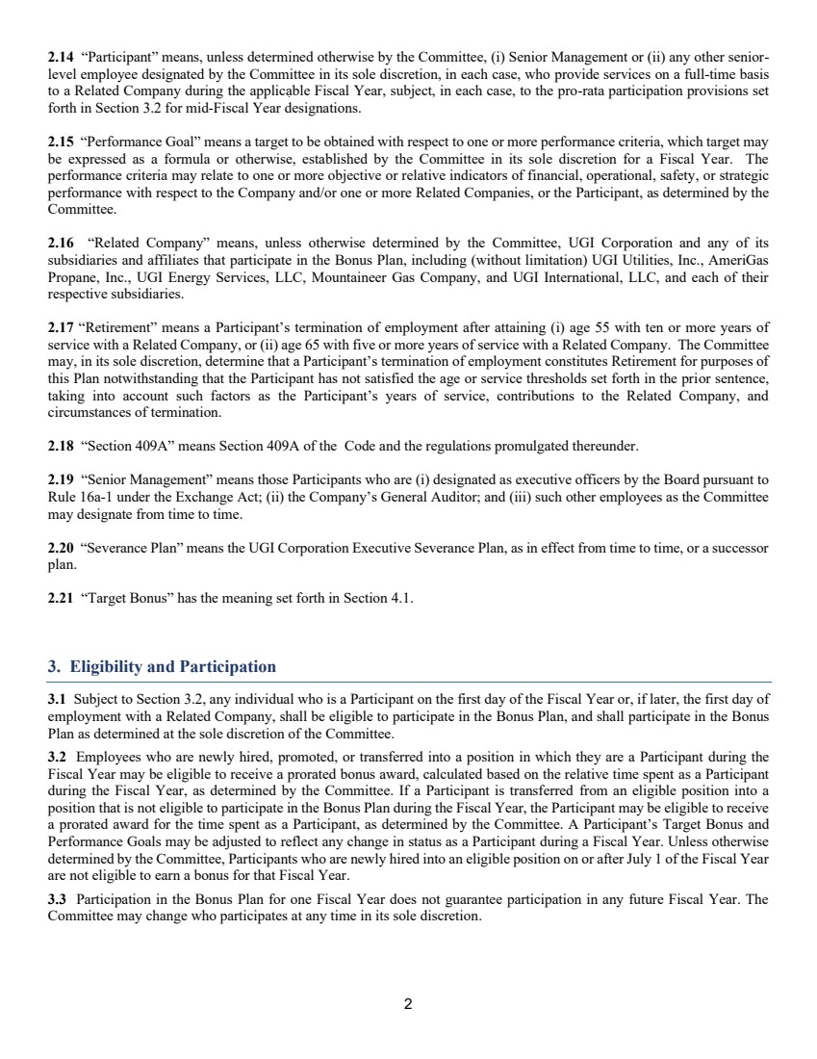 | 2 2.14 “Participant” means, unless determined otherwise by the Committee, (i) Senior Management or (ii) any other senior-level employee designated by the Committee in its sole discretion, in each case, who provide services on a full-time basis to a Related Company during the applicable Fiscal Year, subject, in each case, to the pro-rata participation provisions set forth in Section 3.2 for mid-Fiscal Year designations. 2.15 “Performance Goal” means a target to be obtained with respect to one or more performance criteria, which target may be expressed as a formula or otherwise, established by the Committee in its sole discretion for a Fiscal Year. The performance criteria may relate to one or more objective or relative indicators of financial, operational, safety, or strategic performance with respect to the Company and/or one or more Related Companies, or the Participant, as determined by the Committee. 2.16 “Related Company” means, unless otherwise determined by the Committee, UGI Corporation and any of its subsidiaries and affiliates that participate in the Bonus Plan, including (without limitation) UGI Utilities, Inc., AmeriGas Propane, Inc., UGI Energy Services, LLC, Mountaineer Gas Company, and UGI International, LLC, and each of their respective subsidiaries. 2.17 “Retirement” means a Participant’s termination of employment after attaining (i) age 55 with ten or more years of service with a Related Company, or (ii) age 65 with five or more years of service with a Related Company. The Committee may, in its sole discretion, determine that a Participant’s termination of employment constitutes Retirement for purposes of this Plan notwithstanding that the Participant has not satisfied the age or service thresholds set forth in the prior sentence, taking into account such factors as the Participant’s years of service, contributions to the Related Company, and circumstances of termination. 2.18 “Section 409A” means Section 409A of the Code and the regulations promulgated thereunder. 2.19 “Senior Management” means those Participants who are (i) designated as executive officers by the Board pursuant to Rule 16a-1 under the Exchange Act; (ii) the Company’s General Auditor; and (iii) such other employees as the Committee may designate from time to time. 2.20 “Severance Plan” means the UGI Corporation Executive Severance Plan, as in effect from time to time, or a successor plan. 2.21 “Target Bonus” has the meaning set forth in Section 4.1. 3. Eligibility and Participation 3.1 Subject to Section 3.2, any individual who is a Participant on the first day of the Fiscal Year or, if later, the first day of employment with a Related Company, shall be eligible to participate in the Bonus Plan, and shall participate in the Bonus Plan as determined at the sole discretion of the Committee. 3.2 Employees who are newly hired, promoted, or transferred into a position in which they are a Participant during the Fiscal Year may be eligible to receive a prorated bonus award, calculated based on the relative time spent as a Participant during the Fiscal Year, as determined by the Committee. If a Participant is transferred from an eligible position into a position that is not eligible to participate in the Bonus Plan during the Fiscal Year, the Participant may be eligible to receive a prorated award for the time spent as a Participant, as determined by the Committee. A Participant’s Target Bonus and Performance Goals may be adjusted to reflect any change in status as a Participant during a Fiscal Year. Unless otherwise determined by the Committee, Participants who are newly hired into an eligible position on or after July 1 of the Fiscal Year are not eligible to earn a bonus for that Fiscal Year. 3.3 Participation in the Bonus Plan for one Fiscal Year does not guarantee participation in any future Fiscal Year. The Committee may change who participates at any time in its sole discretion.
 | 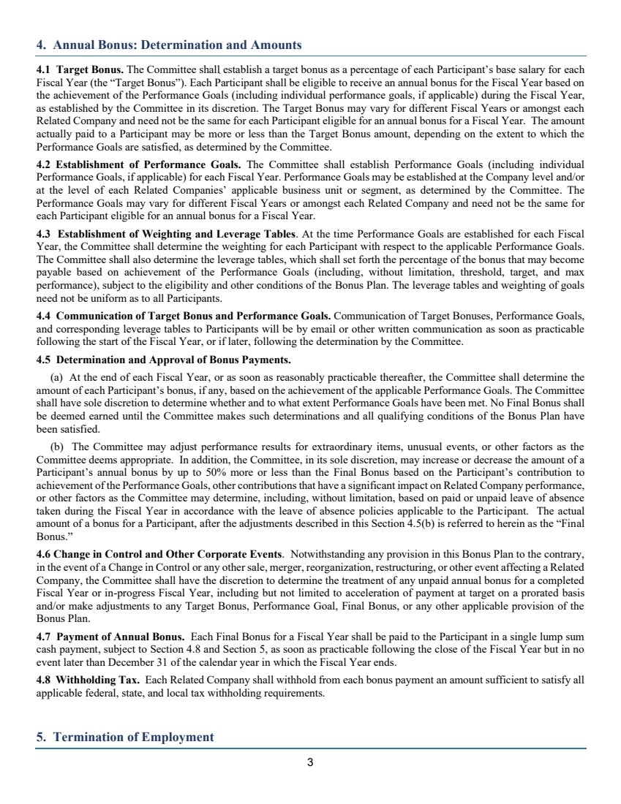 | 3 4. Annual Bonus: Determination and Amounts 4.1 Target Bonus. The Committee shall establish a target bonus as a percentage of each Participant’s base salary for each Fiscal Year (the “Target Bonus”). Each Participant shall be eligible to receive an annual bonus for the Fiscal Year based on the achievement of the Performance Goals (including individual performance goals, if applicable) during the Fiscal Year, as established by the Committee in its discretion. The Target Bonus may vary for different Fiscal Years or amongst each Related Company and need not be the same for each Participant eligible for an annual bonus for a Fiscal Year. The amount actually paid to a Participant may be more or less than the Target Bonus amount, depending on the extent to which the Performance Goals are satisfied, as determined by the Committee. 4.2 Establishment of Performance Goals. The Committee shall establish Performance Goals (including individual Performance Goals, if applicable) for each Fiscal Year. Performance Goals may be established at the Company level and/or at the level of each Related Companies’ applicable business unit or segment, as determined by the Committee. The Performance Goals may vary for different Fiscal Years or amongst each Related Company and need not be the same for each Participant eligible for an annual bonus for a Fiscal Year. 4.3 Establishment of Weighting and Leverage Tables. At the time Performance Goals are established for each Fiscal Year, the Committee shall determine the weighting for each Participant with respect to the applicable Performance Goals. The Committee shall also determine the leverage tables, which shall set forth the percentage of the bonus that may become payable based on achievement of the Performance Goals (including, without limitation, threshold, target, and max performance), subject to the eligibility and other conditions of the Bonus Plan. The leverage tables and weighting of goals need not be uniform as to all Participants. 4.4 Communication of Target Bonus and Performance Goals. Communication of Target Bonuses, Performance Goals, and corresponding leverage tables to Participants will be by email or other written communication as soon as practicable following the start of the Fiscal Year, or if later, following the determination by the Committee. 4.5 Determination and Approval of Bonus Payments. (a) At the end of each Fiscal Year, or as soon as reasonably practicable thereafter, the Committee shall determine the amount of each Participant’s bonus, if any, based on the achievement of the applicable Performance Goals. The Committee shall have sole discretion to determine whether and to what extent Performance Goals have been met. No Final Bonus shall be deemed earned until the Committee makes such determinations and all qualifying conditions of the Bonus Plan have been satisfied. (b) The Committee may adjust performance results for extraordinary items, unusual events, or other factors as the Committee deems appropriate. In addition, the Committee, in its sole discretion, may increase or decrease the amount of a Participant’s annual bonus by up to 50% more or less than the Final Bonus based on the Participant’s contribution to achievement of the Performance Goals, other contributions that have a significant impact on Related Company performance, or other factors as the Committee may determine, including, without limitation, based on paid or unpaid leave of absence taken during the Fiscal Year in accordance with the leave of absence policies applicable to the Participant. The actual amount of a bonus for a Participant, after the adjustments described in this Section 4.5(b) is referred to herein as the “Final Bonus.” 4.6 Change in Control and Other Corporate Events. Notwithstanding any provision in this Bonus Plan to the contrary, in the event of a Change in Control or any other sale, merger, reorganization, restructuring, or other event affecting a Related Company, the Committee shall have the discretion to determine the treatment of any unpaid annual bonus for a completed Fiscal Year or in-progress Fiscal Year, including but not limited to acceleration of payment at target on a prorated basis and/or make adjustments to any Target Bonus, Performance Goal, Final Bonus, or any other applicable provision of the Bonus Plan. 4.7 Payment of Annual Bonus. Each Final Bonus for a Fiscal Year shall be paid to the Participant in a single lump sum cash payment, subject to Section 4.8 and Section 5, as soon as practicable following the close of the Fiscal Year but in no event later than December 31 of the calendar year in which the Fiscal Year ends. 4.8 Withholding Tax. Each Related Company shall withhold from each bonus payment an amount sufficient to satisfy all applicable federal, state, and local tax withholding requirements. 5. Termination of Employment
 | 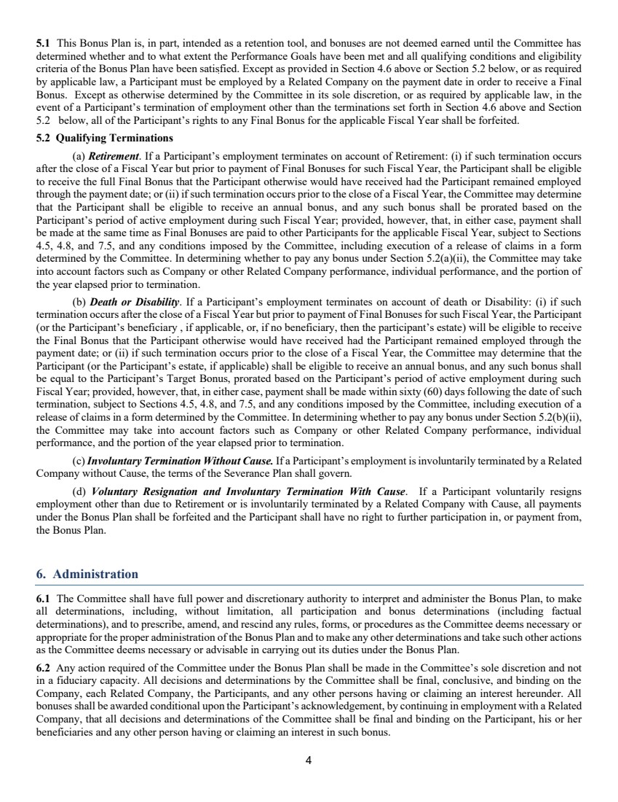 | 4 5.1 This Bonus Plan is, in part, intended as a retention tool, and bonuses are not deemed earned until the Committee has determined whether and to what extent the Performance Goals have been met and all qualifying conditions and eligibility criteria of the Bonus Plan have been satisfied. Except as provided in Section 4.6 above or Section 5.2 below, or as required by applicable law, a Participant must be employed by a Related Company on the payment date in order to receive a Final Bonus. Except as otherwise determined by the Committee in its sole discretion, or as required by applicable law, in the event of a Participant’s termination of employment other than the terminations set forth in Section 4.6 above and Section 5.2 below, all of the Participant’s rights to any Final Bonus for the applicable Fiscal Year shall be forfeited. 5.2 Qualifying Terminations (a) Retirement. If a Participant’s employment terminates on account of Retirement: (i) if such termination occurs after the close of a Fiscal Year but prior to payment of Final Bonuses for such Fiscal Year, the Participant shall be eligible to receive the full Final Bonus that the Participant otherwise would have received had the Participant remained employed through the payment date; or (ii) if such termination occurs prior to the close of a Fiscal Year, the Committee may determine that the Participant shall be eligible to receive an annual bonus, and any such bonus shall be prorated based on the Participant’s period of active employment during such Fiscal Year; provided, however, that, in either case, payment shall be made at the same time as Final Bonuses are paid to other Participants for the applicable Fiscal Year, subject to Sections 4.5, 4.8, and 7.5, and any conditions imposed by the Committee, including execution of a release of claims in a form determined by the Committee. In determining whether to pay any bonus under Section 5.2(a)(ii), the Committee may take into account factors such as Company or other Related Company performance, individual performance, and the portion of the year elapsed prior to termination. (b) Death or Disability. If a Participant’s employment terminates on account of death or Disability: (i) if such termination occurs after the close of a Fiscal Year but prior to payment of Final Bonuses for such Fiscal Year, the Participant (or the Participant’s beneficiary , if applicable, or, if no beneficiary, then the participant’s estate) will be eligible to receive the Final Bonus that the Participant otherwise would have received had the Participant remained employed through the payment date; or (ii) if such termination occurs prior to the close of a Fiscal Year, the Committee may determine that the Participant (or the Participant’s estate, if applicable) shall be eligible to receive an annual bonus, and any such bonus shall be equal to the Participant’s Target Bonus, prorated based on the Participant’s period of active employment during such Fiscal Year; provided, however, that, in either case, payment shall be made within sixty (60) days following the date of such termination, subject to Sections 4.5, 4.8, and 7.5, and any conditions imposed by the Committee, including execution of a release of claims in a form determined by the Committee. In determining whether to pay any bonus under Section 5.2(b)(ii), the Committee may take into account factors such as Company or other Related Company performance, individual performance, and the portion of the year elapsed prior to termination. (c)Involuntary Termination Without Cause. If a Participant’s employment is involuntarily terminated by a Related Company without Cause, the terms of the Severance Plan shall govern. (d) Voluntary Resignation and Involuntary Termination With Cause. If a Participant voluntarily resigns employment other than due to Retirement or is involuntarily terminated by a Related Company with Cause, all payments under the Bonus Plan shall be forfeited and the Participant shall have no right to further participation in, or payment from, the Bonus Plan. 6. Administration 6.1 The Committee shall have full power and discretionary authority to interpret and administer the Bonus Plan, to make all determinations, including, without limitation, all participation and bonus determinations (including factual determinations), and to prescribe, amend, and rescind any rules, forms, or procedures as the Committee deems necessary or appropriate for the proper administration of the Bonus Plan and to make any other determinations and take such other actions as the Committee deems necessary or advisable in carrying out its duties under the Bonus Plan. 6.2 Any action required of the Committee under the Bonus Plan shall be made in the Committee’s sole discretion and not in a fiduciary capacity. All decisions and determinations by the Committee shall be final, conclusive, and binding on the Company, each Related Company, the Participants, and any other persons having or claiming an interest hereunder. All bonuses shall be awarded conditional upon the Participant’s acknowledgement, by continuing in employment with a Related Company, that all decisions and determinations of the Committee shall be final and binding on the Participant, his or her beneficiaries and any other person having or claiming an interest in such bonus.
 | 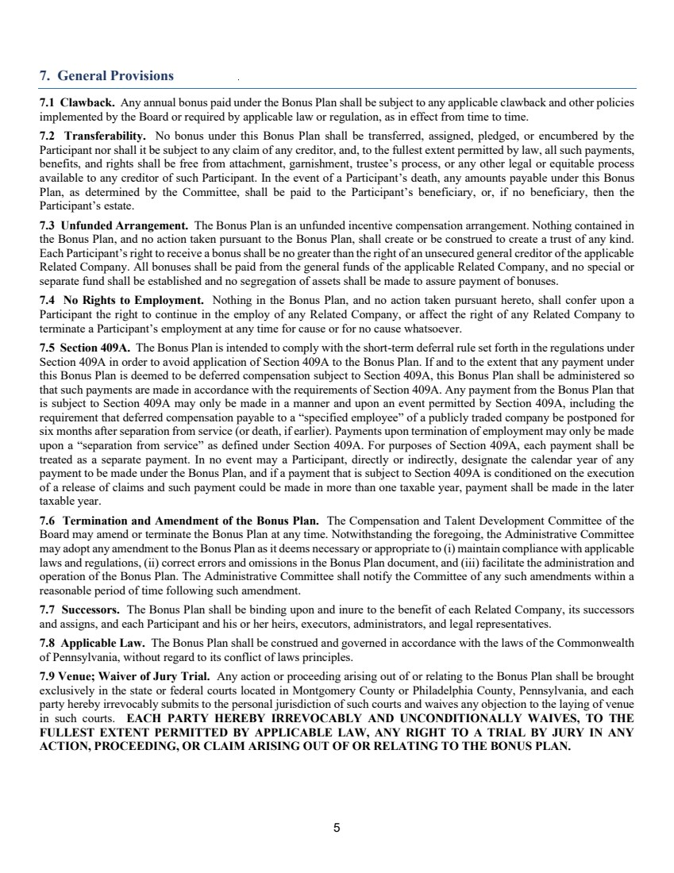 | 5 7. General Provisions 7.1 Clawback. Any annual bonus paid under the Bonus Plan shall be subject to any applicable clawback and other policies implemented by the Board or required by applicable law or regulation, as in effect from time to time. 7.2 Transferability. No bonus under this Bonus Plan shall be transferred, assigned, pledged, or encumbered by the Participant nor shall it be subject to any claim of any creditor, and, to the fullest extent permitted by law, all such payments, benefits, and rights shall be free from attachment, garnishment, trustee’s process, or any other legal or equitable process available to any creditor of such Participant. In the event of a Participant’s death, any amounts payable under this Bonus Plan, as determined by the Committee, shall be paid to the Participant’s beneficiary, or, if no beneficiary, then the Participant’s estate. 7.3 Unfunded Arrangement. The Bonus Plan is an unfunded incentive compensation arrangement. Nothing contained in the Bonus Plan, and no action taken pursuant to the Bonus Plan, shall create or be construed to create a trust of any kind. Each Participant’s right to receive a bonus shall be no greater than the right of an unsecured general creditor of the applicable Related Company. All bonuses shall be paid from the general funds of the applicable Related Company, and no special or separate fund shall be established and no segregation of assets shall be made to assure payment of bonuses. 7.4 No Rights to Employment. Nothing in the Bonus Plan, and no action taken pursuant hereto, shall confer upon a Participant the right to continue in the employ of any Related Company, or affect the right of any Related Company to terminate a Participant’s employment at any time for cause or for no cause whatsoever. 7.5 Section 409A. The Bonus Plan is intended to comply with the short-term deferral rule set forth in the regulations under Section 409A in order to avoid application of Section 409A to the Bonus Plan. If and to the extent that any payment under this Bonus Plan is deemed to be deferred compensation subject to Section 409A, this Bonus Plan shall be administered so that such payments are made in accordance with the requirements of Section 409A. Any payment from the Bonus Plan that is subject to Section 409A may only be made in a manner and upon an event permitted by Section 409A, including the requirement that deferred compensation payable to a “specified employee” of a publicly traded company be postponed for six months after separation from service (or death, if earlier). Payments upon termination of employment may only be made upon a “separation from service” as defined under Section 409A. For purposes of Section 409A, each payment shall be treated as a separate payment. In no event may a Participant, directly or indirectly, designate the calendar year of any payment to be made under the Bonus Plan, and if a payment that is subject to Section 409A is conditioned on the execution of a release of claims and such payment could be made in more than one taxable year, payment shall be made in the later taxable year. 7.6 Termination and Amendment of the Bonus Plan. The Compensation and Talent Development Committee of the Board may amend or terminate the Bonus Plan at any time. Notwithstanding the foregoing, the Administrative Committee may adopt any amendment to the Bonus Plan as it deems necessary or appropriate to (i) maintain compliance with applicable laws and regulations, (ii) correct errors and omissions in the Bonus Plan document, and (iii) facilitate the administration and operation of the Bonus Plan. The Administrative Committee shall notify the Committee of any such amendments within a reasonable period of time following such amendment. 7.7 Successors. The Bonus Plan shall be binding upon and inure to the benefit of each Related Company, its successors and assigns, and each Participant and his or her heirs, executors, administrators, and legal representatives. 7.8 Applicable Law. The Bonus Plan shall be construed and governed in accordance with the laws of the Commonwealth of Pennsylvania, without regard to its conflict of laws principles. 7.9 Venue; Waiver of Jury Trial. Any action or proceeding arising out of or relating to the Bonus Plan shall be brought exclusively in the state or federal courts located in Montgomery County or Philadelphia County, Pennsylvania, and each party hereby irrevocably submits to the personal jurisdiction of such courts and waives any objection to the laying of venue in such courts. EACH PARTY HEREBY IRREVOCABLY AND UNCONDITIONALLY WAIVES, TO THE FULLEST EXTENT PERMITTED BY APPLICABLE LAW, ANY RIGHT TO A TRIAL BY JURY IN ANY ACTION, PROCEEDING, OR CLAIM ARISING OUT OF OR RELATING TO THE BONUS PLAN.

