​
​
​
UNITED STATES
SECURITIES AND EXCHANGE COMMISSION
WASHINGTON, D.C. 20549
FORM 8-K
CURRENT REPORT
Pursuant to Section 13 or 15(d)
of The Securities Exchange Act of 1934
Date of Report (Date of earliest event reported): August 11, 2026
UGI Corporation
(Exact Name of Registrant as Specified in Its Charter)
​ | ​ | ​
Pennsylvania  (State or Other Jurisdiction  of Incorporation) | 1-11071  (Commission  File Number) | 23-2668356  (IRS Employer  Identification No.)
​
500 North Gulph Road, King of Prussia, PA 19406
(Address of Principal Executive Offices) (Zip Code)
Registrant’s Telephone Number, Including Area Code: 610 337-1000
Not Applicable
Former Name or Former Address, if Changed Since Last Report
Check the appropriate box below if the Form 8-K filing is intended to simultaneously satisfy the filing obligation of the registrant under any of the following provisions:
☐ | Written communications pursuant to Rule 425 under the Securities Act (17 CFR 230.425)
☐ | Soliciting material pursuant to Rule 14a-12 under the Exchange Act (17 CFR 240.14a-12)
☐ | Pre-commencement communications pursuant to Rule 14d-2(b) under the Exchange Act (17 CFR 240.14d-2(b))
☐ | Pre-commencement communications pursuant to Rule 13e-4(c) under the Exchange Act (17 CFR 240.13e-4(c))
Securities registered pursuant to Section 12(b) of the Act:

​ | ​ | ​ | ​ | ​
Title of each class | ​ ​ ​ | Trading  Symbol(s) | ​ ​ ​ | Name of each exchange  on which registered
Common Stock, without par value | ​ | UGI | ​ | New York Stock Exchange
​
Indicate by check mark whether the registrant is an emerging growth company as defined in Rule 405 of the Securities Act of 1933 (§230.405 of this chapter) or Rule 12b-2 of the Securities Exchange Act of 1934 (§240.12b-2 of this chapter).
Emerging growth company ☐
If an emerging growth company, indicate by check mark if the registrant has elected not to use the extended transition period for complying with any new or revised financial accounting standards provided pursuant to Section 13(a) of the Exchange Act. ☐
​
​
​
​
​
Item 1.01. Entry into a Material Definitive Agreement.
On August 11, 2026, UGI Utilities, Inc. (“UGI Utilities”), a wholly owned subsidiary of UGI Corporation (the “Company”), entered into a Note Purchase Agreement (the “Utilities Note Purchase Agreement”) with certain persons (the “Utilities Note Purchasers”) relating to the private placement of $125 million aggregate principal amount of 5.45% Senior Notes with a maturity date of August 15, 2031 (the “Notes”). The private placement of the Notes is exempt from registration under the Securities Act of 1933, as amended. Funding of the Notes occurred on August 11, 2026. Interest payments on the Notes will be payable semiannually on August 15th and February 15th of each year. The Notes will be unsecured and unsubordinated obligations of UGI Utilities, ranking pari passu in all respects with UGI Utilities’ existing and future unsecured and unsubordinated indebtedness. If any subsidiary guarantees or otherwise becomes liable for UGI Utilities’ obligations under a primary credit facility, the subsidiary will provide a guaranty of payment of the Notes and compliance with the Utilities Note Purchase Agreement. Proceeds from the Notes will be used primarily to refinance indebtedness and for general corporate purposes. The pricing of the Notes occurred on July 23, 2026.
The Utilities Note Purchase Agreement includes the usual and customary covenants for note purchase agreements of this type, including, among others, covenants relating to the maintenance of existence, payment of taxes when due, compliance with laws, maintenance of properties in good repair, compliance with the Office of Foreign Assets Control of the United States Department of the Treasury, maintenance of insurance, maintenance of books and records, pari passu ranking, merger and consolidation, line of business, antiterrorism sanctions, and change in control. The Utilities Note Purchase Agreement also contains restrictive and financial covenants, specifying, among other things, that the sale of assets is limited to 15% of consolidated total assets as of the end of any period of twelve consecutive months subject to safe harbors for debt prepayment or property reinvestments and specified exclusions, that indebtedness (excluding certain indebtedness of subsidiaries) plus basket liens will not at any time exceed 10% of consolidated total assets, and that the ratio of total debt to total capitalization will not exceed 0.65 to 1.00 as of the end of any fiscal quarter.
The Utilities Note Purchase Agreement also contains customary events of default, including, without limitation, failure to pay principal and make whole amount when due at maturity or otherwise, failure to pay interest within five business days of the due date, failure to satisfy any financial covenant, failure to comply with the non-financial covenants within a 30-day grace period, default beyond the applicable grace period for payments on other borrowings and cross acceleration for acceleration of other borrowings as a result of non-monetary defaults provided that either of such defaults relates to indebtedness in an aggregate principal amount of more than 2% of consolidated total assets, certain events of bankruptcy or insolvency of UGI Utilities and its principal subsidiaries, judgment defaults provided such judgment relates to the payment of money aggregating in excess of 2% of consolidated total assets, and material ERISA defaults.
The Notes are callable by UGI Utilities, (i) at any time at a price equal to 100% of the principal amount thereof, plus the applicable “make-whole” premium and accrued and unpaid interest thereon to the date of prepayment, and (ii) at any time on a date that is less than 30 days prior to the maturity date of the Notes, at 100% of the principal amount thereof, plus accrued and unpaid interest thereon to the date of prepayment, but without the payment of a “make-whole” premium, in each case, so long as there is no Default or Event of Default under the Utilities Note Purchase Agreement. Holders of the Notes have a right to require prepayment of the principal amount of the Notes, together with interest accrued thereon to the date of prepayment, if UGI Utilities ceases to be directly or indirectly majority owned, beneficially and of record, by the Company, including, without limitation, if the Company ceases to own (beneficially and of record), directly or indirectly, voting stock of UGI Utilities (or other securities convertible into such voting stock) representing 51% or more of the combined voting power of all voting stock of UGI Utilities and 51% or more of the economic interests in UGI Utilities.
The foregoing description of the Utilities Note Purchase Agreement does not purport to be complete and is qualified in its entirety by reference to the Utilities Note Purchase Agreement, which is filed as Exhibit 4.1 to this Current Report on Form 8-K and is incorporated herein by reference.
​
​
​
​
Item 2.03. Creation of a Direct Financial Obligation or an Obligation under an Off-Balance Sheet Arrangement of a Registrant.
The information set forth above in Item 1.01 regarding the Utilities Note Purchase Agreement is hereby incorporated into this Item 2.03 by reference. This description is qualified in its entirety by reference to the full text of the Utilities Note Purchase Agreement, which is filed as Exhibit 4.1 to this Current Report on Form 8-K and is incorporated herein by reference.
Item 9.01. Financial Statements and Exhibits.
(d) Exhibits.
​
​ | ​ | ​
Exhibit  Number: | ​ ​ ​ | Description
4.1 | ​ | Note Purchase Agreement, dated August 11, 2026, by and among UGI Utilities, Inc. and the purchasers listed as signatories thereto.
​ | ​ | ​
104 | ​ | Cover Page Interactive Data File (formatted as inline XBRL).
​
​
​
​
SIGNATURES
Pursuant to the requirements of the Securities Exchange Act of 1934, the registrant has duly caused this report to be signed on its behalf by the undersigned hereunto duly authorized.
​ | ​ | UGI Corporation
​ | ​ | ​
August 17, 2026 | ​ | By: | /s/ Jessica A. Milner
​ | ​ | Name: | Jessica A. Milner
​ | ​ | Title: | Secretary
​ | ​ | ​
​
​
​
​

 | 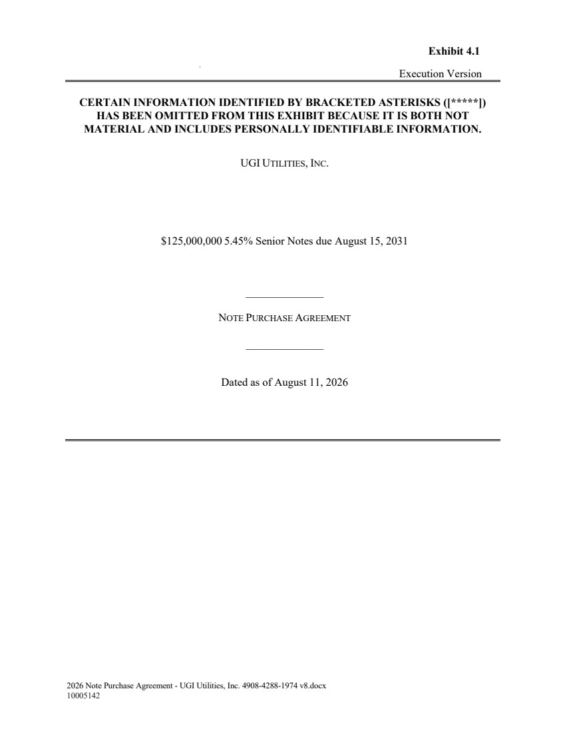 | 2026 Note Purchase Agreement - UGI Utilities, Inc. 4908-4288-1974 v8.docx 10005142 Execution Version UGI UTILITIES, INC. $125,000,000 5.45% Senior Notes due August 15, 2031 ______________ NOTE PURCHASE AGREEMENT ______________ Dated as of August 11, 2026 Exhibit 4.1 CERTAIN INFORMATION IDENTIFIED BY BRACKETED ASTERISKS ([*****]) HAS BEEN OMITTED FROM THIS EXHIBIT BECAUSE IT IS BOTH NOT MATERIAL AND INCLUDES PERSONALLY IDENTIFIABLE INFORMATION.
 | 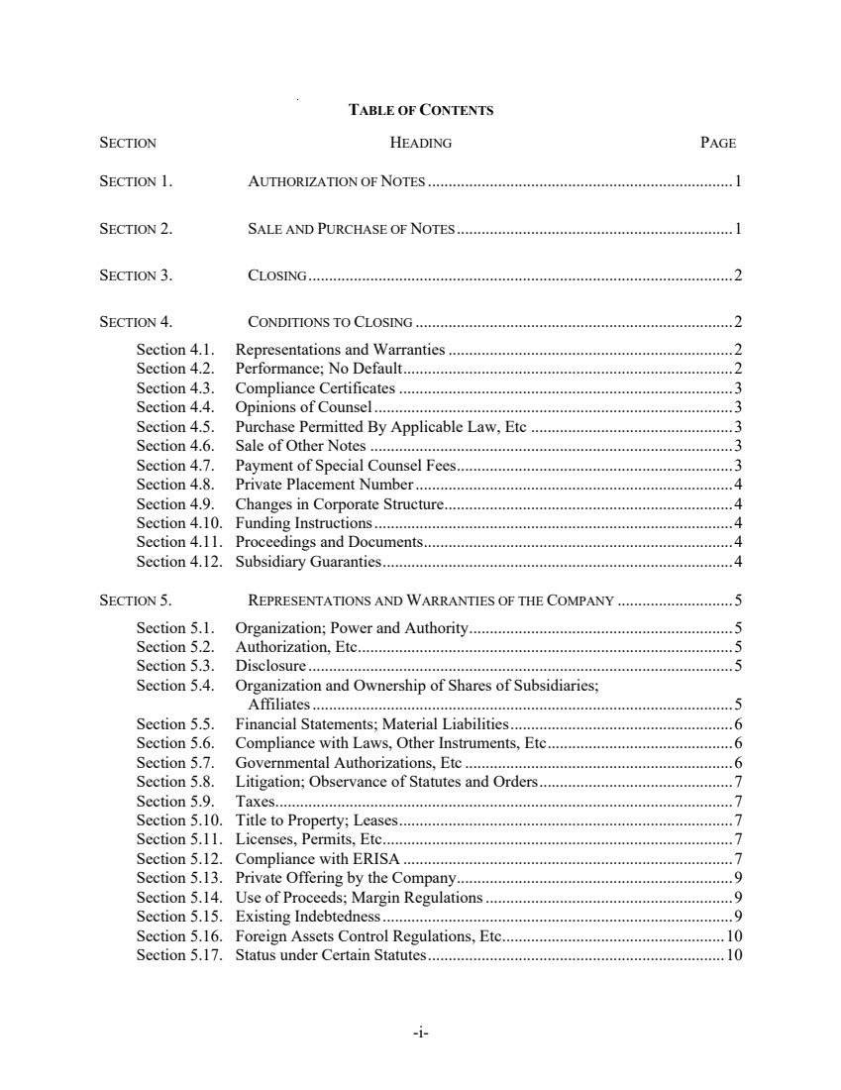 | -i-TABLE OF CONTENTS SECTION HEADING PAGE SECTION 1. AUTHORIZATION OF NOTES ..........................................................................1 SECTION 2. SALE AND PURCHASE OF NOTES...................................................................1 SECTION 3. CLOSING.......................................................................................................2 SECTION 4. CONDITIONS TO CLOSING .............................................................................2 Section 4.1. Representations and Warranties.....................................................................2 Section 4.2. Performance; No Default................................................................................2 Section 4.3. Compliance Certificates .................................................................................3 Section 4.4. Opinions of Counsel.......................................................................................3 Section 4.5. Purchase Permitted By Applicable Law, Etc .................................................3 Section 4.6. Sale of Other Notes ........................................................................................3 Section 4.7. Payment of Special Counsel Fees...................................................................3 Section 4.8. Private Placement Number.............................................................................4 Section 4.9. Changes in Corporate Structure......................................................................4 Section 4.10. Funding Instructions.......................................................................................4 Section 4.11. Proceedings and Documents...........................................................................4 Section 4.12. Subsidiary Guaranties.....................................................................................4 SECTION 5. REPRESENTATIONS AND WARRANTIES OF THE COMPANY ............................5 Section 5.1. Organization; Power and Authority................................................................5 Section 5.2. Authorization, Etc...........................................................................................5 Section 5.3. Disclosure .......................................................................................................5 Section 5.4. Organization and Ownership of Shares of Subsidiaries; Affiliates......................................................................................................5 Section 5.5. Financial Statements; Material Liabilities......................................................6 Section 5.6. Compliance with Laws, Other Instruments, Etc.............................................6 Section 5.7. Governmental Authorizations, Etc .................................................................6 Section 5.8. Litigation; Observance of Statutes and Orders...............................................7 Section 5.9. Taxes...............................................................................................................7 Section 5.10. Title to Property; Leases.................................................................................7 Section 5.11. Licenses, Permits, Etc.....................................................................................7 Section 5.12. Compliance with ERISA ................................................................................7 Section 5.13. Private Offering by the Company...................................................................9 Section 5.14. Use of Proceeds; Margin Regulations............................................................9 Section 5.15. Existing Indebtedness.....................................................................................9 Section 5.16. Foreign Assets Control Regulations, Etc......................................................10 Section 5.17. Status under Certain Statutes........................................................................10
 | 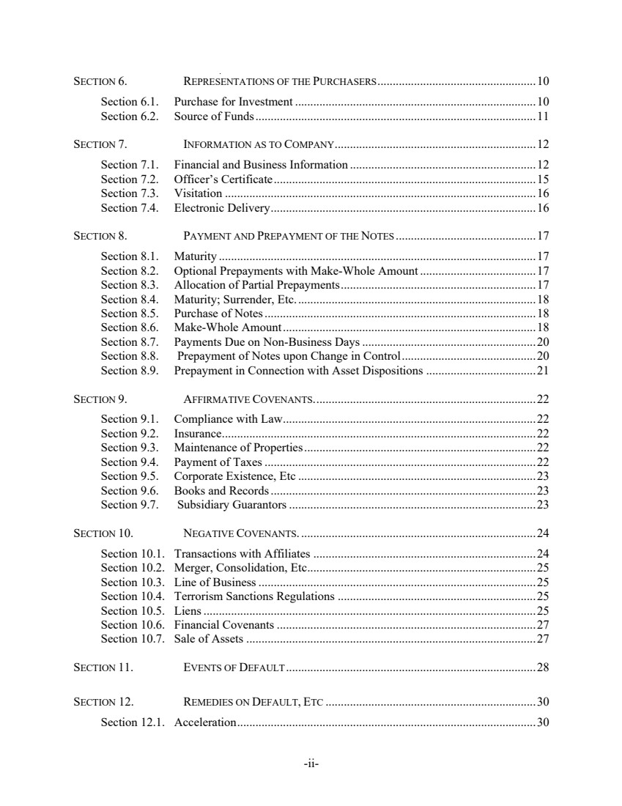 | -ii-SECTION 6. REPRESENTATIONS OF THE PURCHASERS....................................................10 Section 6.1. Purchase for Investment ...............................................................................10 Section 6.2. Source of Funds............................................................................................11 SECTION 7. INFORMATION AS TO COMPANY..................................................................12 Section 7.1. Financial and Business Information .............................................................12 Section 7.2. Officer’s Certificate......................................................................................15 Section 7.3. Visitation ......................................................................................................16 Section 7.4. Electronic Delivery.......................................................................................16 SECTION 8. PAYMENT AND PREPAYMENT OF THE NOTES ..............................................17 Section 8.1. Maturity ........................................................................................................17 Section 8.2. Optional Prepayments with Make-Whole Amount ......................................17 Section 8.3. Allocation of Partial Prepayments................................................................17 Section 8.4. Maturity; Surrender, Etc...............................................................................18 Section 8.5. Purchase of Notes.........................................................................................18 Section 8.6. Make-Whole Amount...................................................................................18 Section 8.7. Payments Due on Non-Business Days.........................................................20 Section 8.8. Prepayment of Notes upon Change in Control............................................20 Section 8.9. Prepayment in Connection with Asset Dispositions ....................................21 SECTION 9. AFFIRMATIVE COVENANTS.........................................................................22 Section 9.1. Compliance with Law...................................................................................22 Section 9.2. Insurance.......................................................................................................22 Section 9.3. Maintenance of Properties............................................................................22 Section 9.4. Payment of Taxes.........................................................................................22 Section 9.5. Corporate Existence, Etc ..............................................................................23 Section 9.6. Books and Records.......................................................................................23 Section 9.7. Subsidiary Guarantors.................................................................................23 SECTION 10. NEGATIVE COVENANTS. .............................................................................24 Section 10.1. Transactions with Affiliates .........................................................................24 Section 10.2. Merger, Consolidation, Etc...........................................................................25 Section 10.3. Line of Business...........................................................................................25 Section 10.4. Terrorism Sanctions Regulations .................................................................25 Section 10.5. Liens.............................................................................................................25 Section 10.6. Financial Covenants .....................................................................................27 Section 10.7. Sale of Assets ...............................................................................................27 SECTION 11. EVENTS OF DEFAULT..................................................................................28 SECTION 12. REMEDIES ON DEFAULT, ETC .....................................................................30 Section 12.1. Acceleration..................................................................................................30
 | 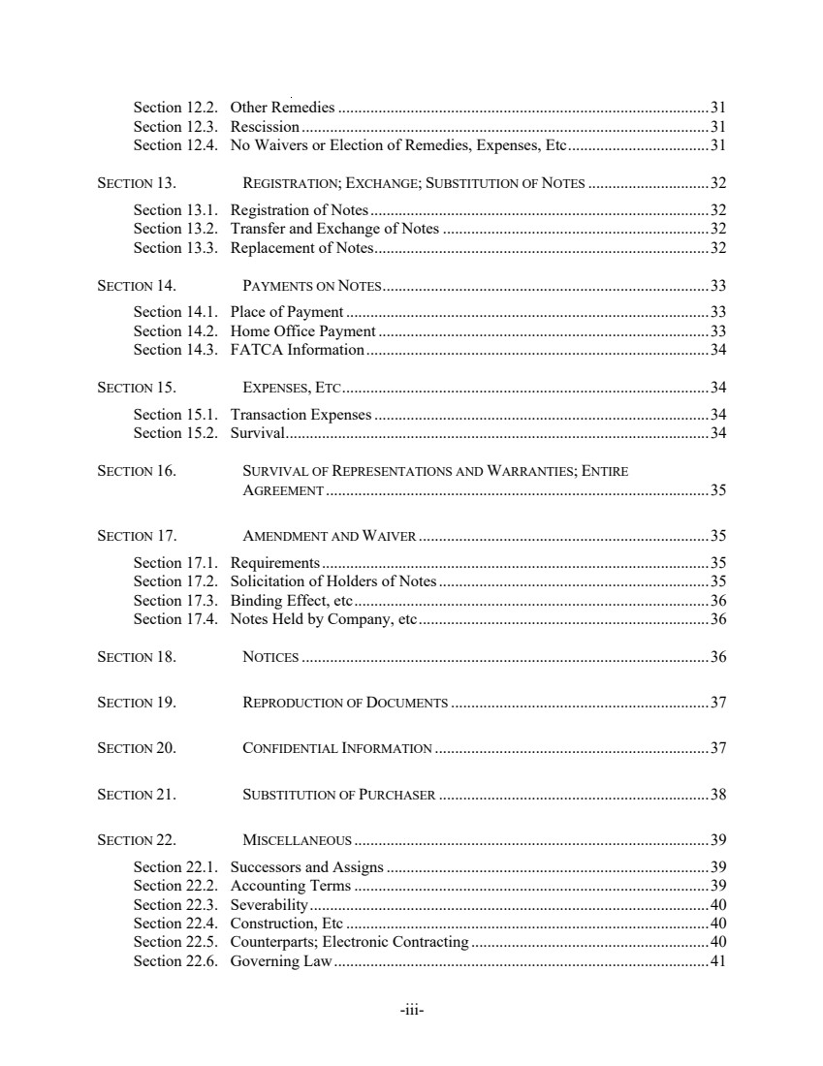 | -iii-Section 12.2. Other Remedies............................................................................................31 Section 12.3. Rescission .....................................................................................................31 Section 12.4. No Waivers or Election of Remedies, Expenses, Etc...................................31 SECTION 13. REGISTRATION; EXCHANGE; SUBSTITUTION OF NOTES ..............................32 Section 13.1. Registration of Notes....................................................................................32 Section 13.2. Transfer and Exchange of Notes ..................................................................32 Section 13.3. Replacement of Notes...................................................................................32 SECTION 14. PAYMENTS ON NOTES.................................................................................33 Section 14.1. Place of Payment ..........................................................................................33 Section 14.2. Home Office Payment ..................................................................................33 Section 14.3. FATCA Information.....................................................................................34 SECTION 15. EXPENSES, ETC...........................................................................................34 Section 15.1. Transaction Expenses...................................................................................34 Section 15.2. Survival.........................................................................................................34 SECTION 16. SURVIVAL OF REPRESENTATIONS AND WARRANTIES; ENTIRE AGREEMENT ...............................................................................................35 SECTION 17. AMENDMENT AND WAIVER ........................................................................35 Section 17.1. Requirements................................................................................................35 Section 17.2. Solicitation of Holders of Notes...................................................................35 Section 17.3. Binding Effect, etc........................................................................................36 Section 17.4. Notes Held by Company, etc........................................................................36 SECTION 18. NOTICES .....................................................................................................36 SECTION 19. REPRODUCTION OF DOCUMENTS ................................................................37 SECTION 20. CONFIDENTIAL INFORMATION ....................................................................37 SECTION 21. SUBSTITUTION OF PURCHASER ...................................................................38 SECTION 22. MISCELLANEOUS ........................................................................................39 Section 22.1. Successors and Assigns................................................................................39 Section 22.2. Accounting Terms........................................................................................39 Section 22.3. Severability...................................................................................................40 Section 22.4. Construction, Etc ..........................................................................................40 Section 22.5. Counterparts; Electronic Contracting ...........................................................40 Section 22.6. Governing Law.............................................................................................41
 | 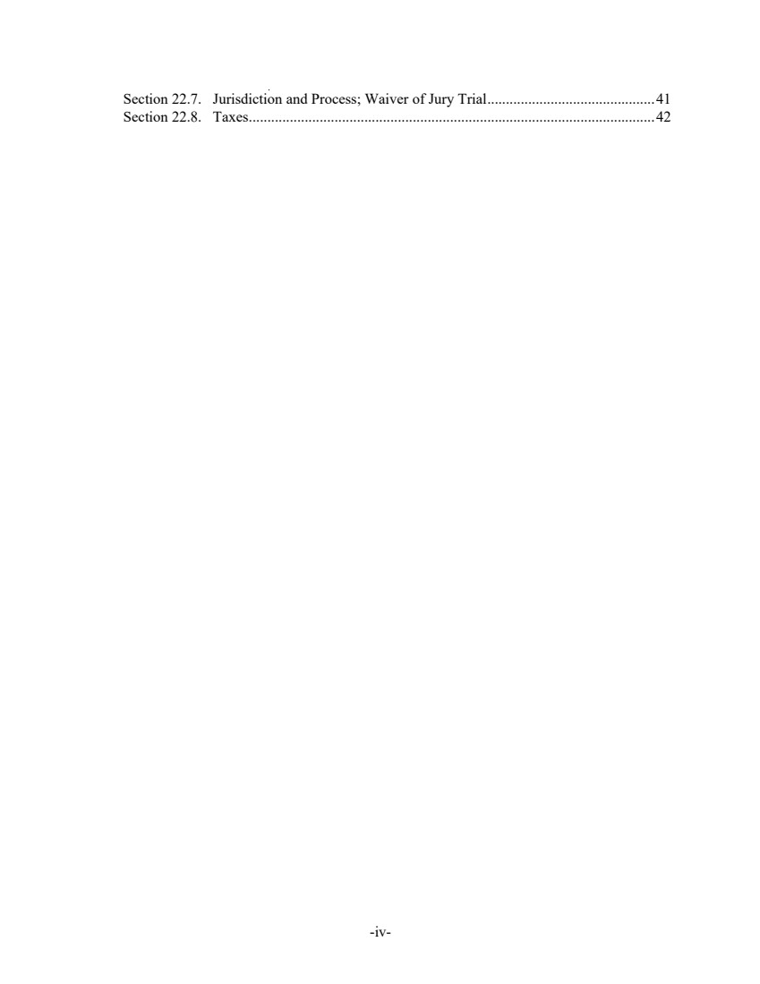 | -iv-Section 22.7. Jurisdiction and Process; Waiver of Jury Trial.............................................41 Section 22.8. Taxes.............................................................................................................42
 | 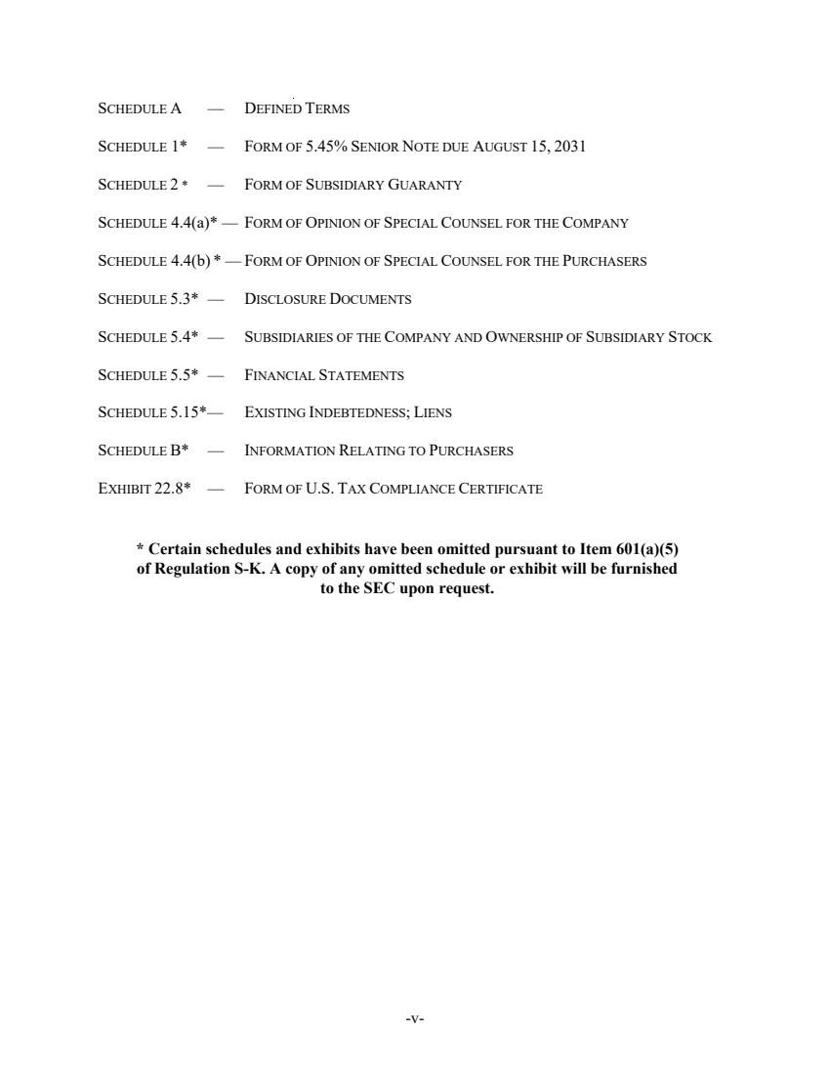 | -v-SCHEDULE A — DEFINED TERMS SCHEDULE 1* — FORM OF 5.45% SENIOR NOTE DUE AUGUST 15, 2031 SCHEDULE 2 * — FORM OF SUBSIDIARY GUARANTY SCHEDULE 4.4(a)* — FORM OF OPINION OF SPECIAL COUNSEL FOR THE COMPANY SCHEDULE 4.4(b) * — FORM OF OPINION OF SPECIAL COUNSEL FOR THE PURCHASERS SCHEDULE 5.3* — DISCLOSURE DOCUMENTS SCHEDULE 5.4* — SUBSIDIARIES OF THE COMPANY AND OWNERSHIP OF SUBSIDIARY STOCK SCHEDULE 5.5* — FINANCIAL STATEMENTS SCHEDULE 5.15*— EXISTING INDEBTEDNESS; LIENS SCHEDULE B* — INFORMATION RELATING TO PURCHASERS EXHIBIT 22.8* — FORM OF U.S. TAX COMPLIANCE CERTIFICATE * Certain schedules and exhibits have been omitted pursuant to Item 601(a)(5) of Regulation S-K. A copy of any omitted schedule or exhibit will be furnished to the SEC upon request.
 | 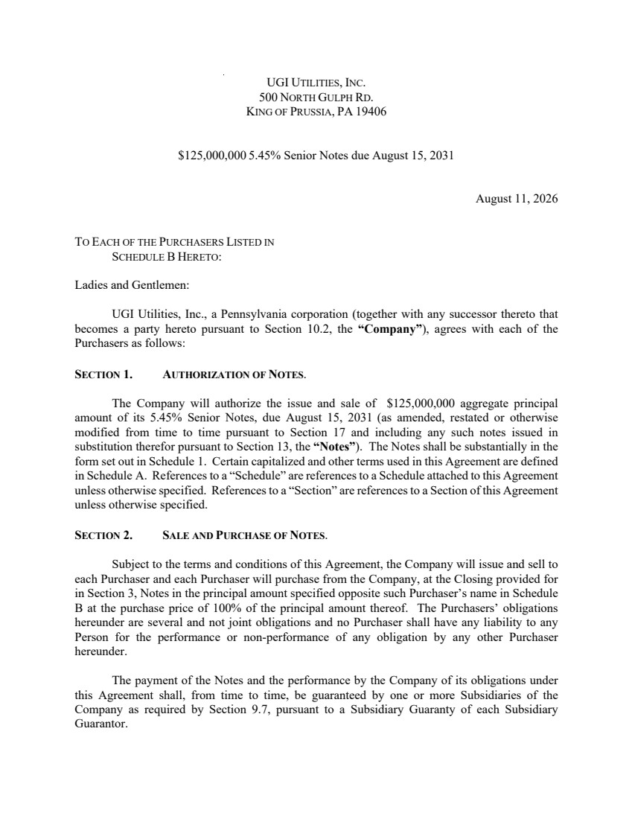 | UGI UTILITIES, INC. 500 NORTH GULPH RD. KING OF PRUSSIA, PA 19406 $125,000,000 5.45% Senior Notes due August 15, 2031 August 11, 2026 TO EACH OF THE PURCHASERS LISTED IN SCHEDULE B HERETO: Ladies and Gentlemen: UGI Utilities, Inc., a Pennsylvania corporation (together with any successor thereto that becomes a party hereto pursuant to Section 10.2, the “Company”), agrees with each of the Purchasers as follows: SECTION 1. AUTHORIZATION OF NOTES. The Company will authorize the issue and sale of $125,000,000 aggregate principal amount of its 5.45% Senior Notes, due August 15, 2031 (as amended, restated or otherwise modified from time to time pursuant to Section 17 and including any such notes issued in substitution therefor pursuant to Section 13, the “Notes”). The Notes shall be substantially in the form set out in Schedule 1. Certain capitalized and other terms used in this Agreement are defined in Schedule A. References to a “Schedule” are references to a Schedule attached to this Agreement unless otherwise specified. References to a “Section” are references to a Section of this Agreement unless otherwise specified. SECTION 2. SALE AND PURCHASE OF NOTES. Subject to the terms and conditions of this Agreement, the Company will issue and sell to each Purchaser and each Purchaser will purchase from the Company, at the Closing provided for in Section 3, Notes in the principal amount specified opposite such Purchaser’s name in Schedule B at the purchase price of 100% of the principal amount thereof. The Purchasers’ obligations hereunder are several and not joint obligations and no Purchaser shall have any liability to any Person for the performance or non-performance of any obligation by any other Purchaser hereunder. The payment of the Notes and the performance by the Company of its obligations under this Agreement shall, from time to time, be guaranteed by one or more Subsidiaries of the Company as required by Section 9.7, pursuant to a Subsidiary Guaranty of each Subsidiary Guarantor.
 | 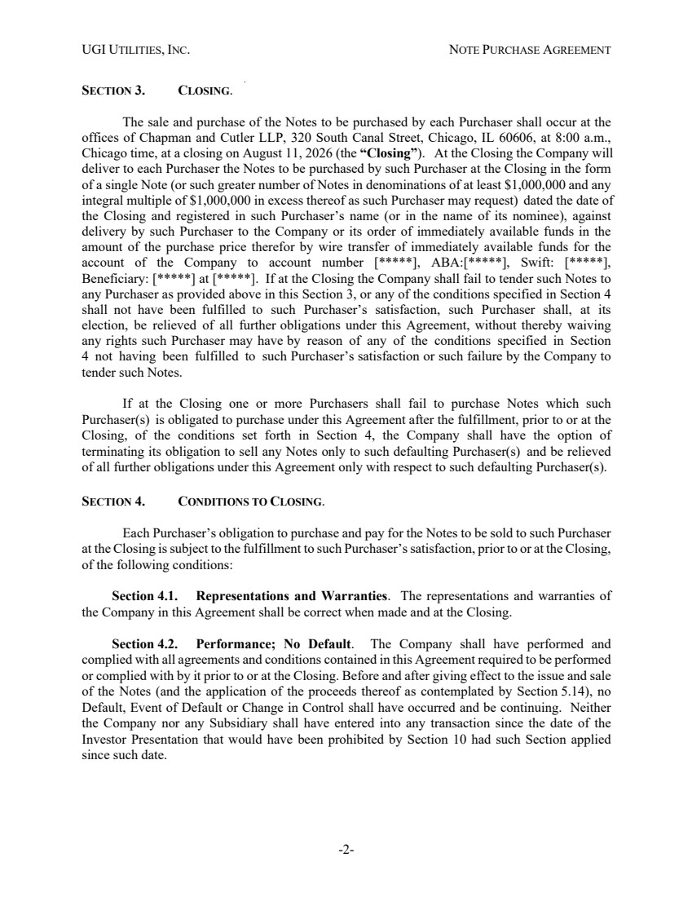 | UGI UTILITIES, INC. NOTE PURCHASE AGREEMENT -2- SECTION 3. CLOSING. The sale and purchase of the Notes to be purchased by each Purchaser shall occur at the offices of Chapman and Cutler LLP, 320 South Canal Street, Chicago, IL 60606, at 8:00 a.m., Chicago time, at a closing on August 11, 2026 (the “Closing”). At the Closing the Company will deliver to each Purchaser the Notes to be purchased by such Purchaser at the Closing in the form of a single Note (or such greater number of Notes in denominations of at least $1,000,000 and any integral multiple of $1,000,000 in excess thereof as such Purchaser may request) dated the date of the Closing and registered in such Purchaser’s name (or in the name of its nominee), against delivery by such Purchaser to the Company or its order of immediately available funds in the amount of the purchase price therefor by wire transfer of immediately available funds for the account of the Company to account number [*****], ABA:[*****], Swift: [*****], Beneficiary: [*****] at [*****]. If at the Closing the Company shall fail to tender such Notes to any Purchaser as provided above in this Section 3, or any of the conditions specified in Section 4 shall not have been fulfilled to such Purchaser’s satisfaction, such Purchaser shall, at its election, be relieved of all further obligations under this Agreement, without thereby waiving any rights such Purchaser may have by reason of any of the conditions specified in Section 4 not having been fulfilled to such Purchaser’s satisfaction or such failure by the Company to tender such Notes. If at the Closing one or more Purchasers shall fail to purchase Notes which such Purchaser(s) is obligated to purchase under this Agreement after the fulfillment, prior to or at the Closing, of the conditions set forth in Section 4, the Company shall have the option of terminating its obligation to sell any Notes only to such defaulting Purchaser(s) and be relieved of all further obligations under this Agreement only with respect to such defaulting Purchaser(s). SECTION 4. CONDITIONS TO CLOSING. Each Purchaser’s obligation to purchase and pay for the Notes to be sold to such Purchaser at the Closing is subject to the fulfillment to such Purchaser’s satisfaction, prior to or at the Closing, of the following conditions: Section 4.1. Representations and Warranties. The representations and warranties of the Company in this Agreement shall be correct when made and at the Closing. Section 4.2. Performance; No Default. The Company shall have performed and complied with all agreements and conditions contained in this Agreement required to be performed or complied with by it prior to or at the Closing. Before and after giving effect to the issue and sale of the Notes (and the application of the proceeds thereof as contemplated by Section 5.14), no Default, Event of Default or Change in Control shall have occurred and be continuing. Neither the Company nor any Subsidiary shall have entered into any transaction since the date of the Investor Presentation that would have been prohibited by Section 10 had such Section applied since such date.
 | 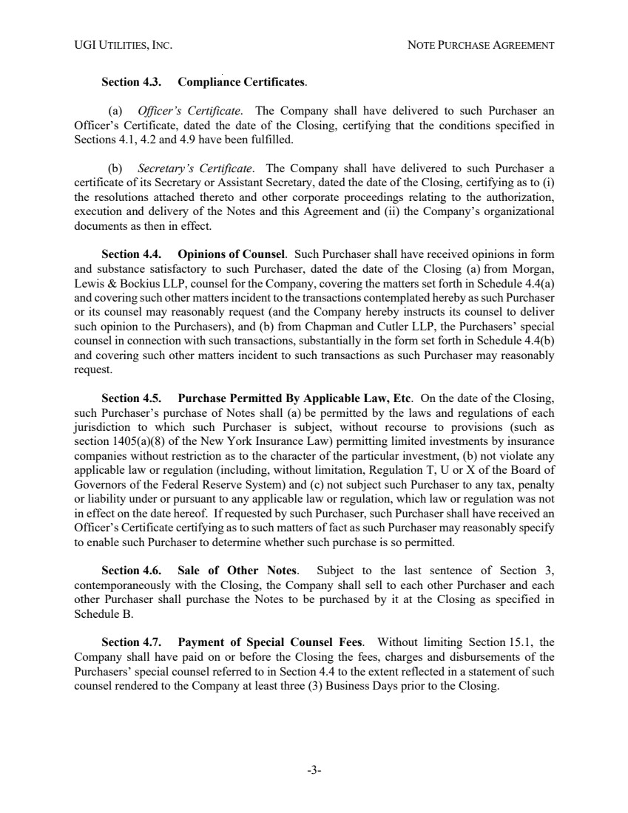 | UGI UTILITIES, INC. NOTE PURCHASE AGREEMENT -3- Section 4.3. Compliance Certificates. (a) Officer’s Certificate. The Company shall have delivered to such Purchaser an Officer’s Certificate, dated the date of the Closing, certifying that the conditions specified in Sections 4.1, 4.2 and 4.9 have been fulfilled. (b) Secretary’s Certificate. The Company shall have delivered to such Purchaser a certificate of its Secretary or Assistant Secretary, dated the date of the Closing, certifying as to (i) the resolutions attached thereto and other corporate proceedings relating to the authorization, execution and delivery of the Notes and this Agreement and (ii) the Company’s organizational documents as then in effect. Section 4.4. Opinions of Counsel. Such Purchaser shall have received opinions in form and substance satisfactory to such Purchaser, dated the date of the Closing (a) from Morgan, Lewis & Bockius LLP, counsel for the Company, covering the matters set forth in Schedule 4.4(a) and covering such other matters incident to the transactions contemplated hereby as such Purchaser or its counsel may reasonably request (and the Company hereby instructs its counsel to deliver such opinion to the Purchasers), and (b) from Chapman and Cutler LLP, the Purchasers’ special counsel in connection with such transactions, substantially in the form set forth in Schedule 4.4(b) and covering such other matters incident to such transactions as such Purchaser may reasonably request. Section 4.5. Purchase Permitted By Applicable Law, Etc. On the date of the Closing, such Purchaser’s purchase of Notes shall (a) be permitted by the laws and regulations of each jurisdiction to which such Purchaser is subject, without recourse to provisions (such as section 1405(a)(8) of the New York Insurance Law) permitting limited investments by insurance companies without restriction as to the character of the particular investment, (b) not violate any applicable law or regulation (including, without limitation, Regulation T, U or X of the Board of Governors of the Federal Reserve System) and (c) not subject such Purchaser to any tax, penalty or liability under or pursuant to any applicable law or regulation, which law or regulation was not in effect on the date hereof. If requested by such Purchaser, such Purchaser shall have received an Officer’s Certificate certifying as to such matters of fact as such Purchaser may reasonably specify to enable such Purchaser to determine whether such purchase is so permitted. Section 4.6. Sale of Other Notes. Subject to the last sentence of Section 3, contemporaneously with the Closing, the Company shall sell to each other Purchaser and each other Purchaser shall purchase the Notes to be purchased by it at the Closing as specified in Schedule B. Section 4.7. Payment of Special Counsel Fees. Without limiting Section 15.1, the Company shall have paid on or before the Closing the fees, charges and disbursements of the Purchasers’ special counsel referred to in Section 4.4 to the extent reflected in a statement of such counsel rendered to the Company at least three (3) Business Days prior to the Closing.
 | 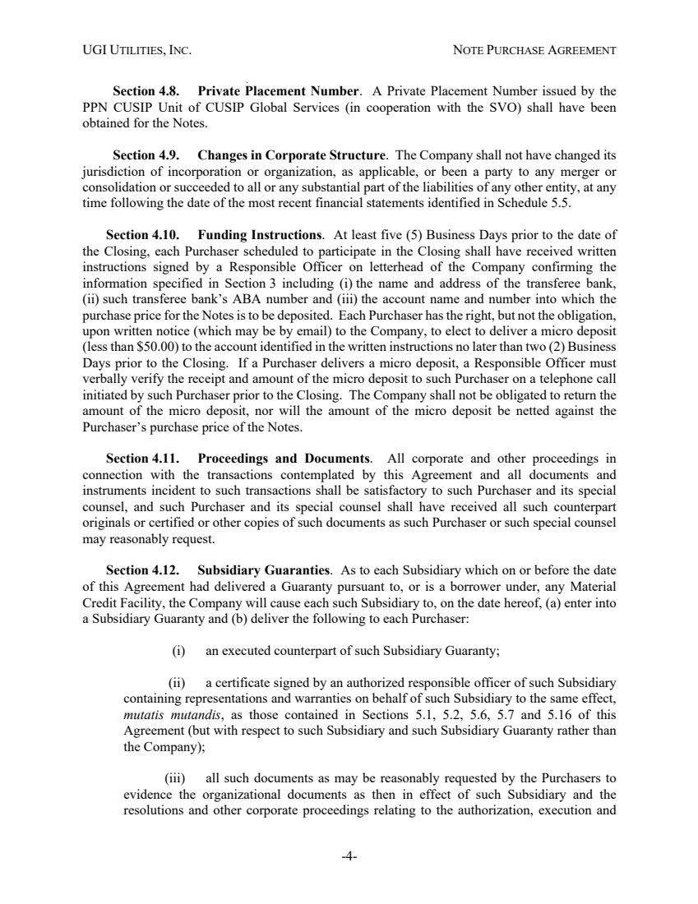 | UGI UTILITIES, INC. NOTE PURCHASE AGREEMENT -4- Section 4.8. Private Placement Number. A Private Placement Number issued by the PPN CUSIP Unit of CUSIP Global Services (in cooperation with the SVO) shall have been obtained for the Notes. Section 4.9. Changes in Corporate Structure. The Company shall not have changed its jurisdiction of incorporation or organization, as applicable, or been a party to any merger or consolidation or succeeded to all or any substantial part of the liabilities of any other entity, at any time following the date of the most recent financial statements identified in Schedule 5.5. Section 4.10. Funding Instructions. At least five (5) Business Days prior to the date of the Closing, each Purchaser scheduled to participate in the Closing shall have received written instructions signed by a Responsible Officer on letterhead of the Company confirming the information specified in Section 3 including (i) the name and address of the transferee bank, (ii) such transferee bank’s ABA number and (iii) the account name and number into which the purchase price for the Notes is to be deposited. Each Purchaser has the right, but not the obligation, upon written notice (which may be by email) to the Company, to elect to deliver a micro deposit (less than $50.00) to the account identified in the written instructions no later than two (2) Business Days prior to the Closing. If a Purchaser delivers a micro deposit, a Responsible Officer must verbally verify the receipt and amount of the micro deposit to such Purchaser on a telephone call initiated by such Purchaser prior to the Closing. The Company shall not be obligated to return the amount of the micro deposit, nor will the amount of the micro deposit be netted against the Purchaser’s purchase price of the Notes. Section 4.11. Proceedings and Documents. All corporate and other proceedings in connection with the transactions contemplated by this Agreement and all documents and instruments incident to such transactions shall be satisfactory to such Purchaser and its special counsel, and such Purchaser and its special counsel shall have received all such counterpart originals or certified or other copies of such documents as such Purchaser or such special counsel may reasonably request. Section 4.12. Subsidiary Guaranties. As to each Subsidiary which on or before the date of this Agreement had delivered a Guaranty pursuant to, or is a borrower under, any Material Credit Facility, the Company will cause each such Subsidiary to, on the date hereof, (a) enter into a Subsidiary Guaranty and (b) deliver the following to each Purchaser: (i) an executed counterpart of such Subsidiary Guaranty; (ii) a certificate signed by an authorized responsible officer of such Subsidiary containing representations and warranties on behalf of such Subsidiary to the same effect, mutatis mutandis, as those contained in Sections 5.1, 5.2, 5.6, 5.7 and 5.16 of this Agreement (but with respect to such Subsidiary and such Subsidiary Guaranty rather than the Company); (iii) all such documents as may be reasonably requested by the Purchasers to evidence the organizational documents as then in effect of such Subsidiary and the resolutions and other corporate proceedings relating to the authorization, execution and
 | 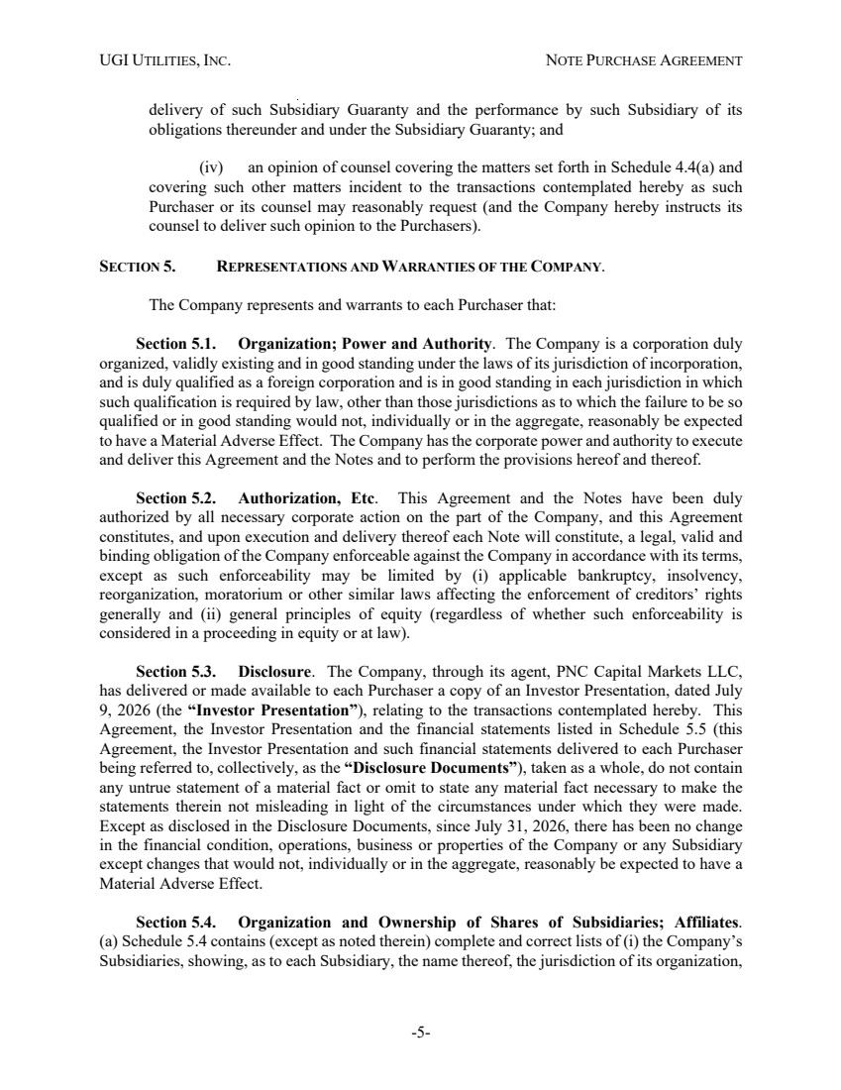 | UGI UTILITIES, INC. NOTE PURCHASE AGREEMENT -5- delivery of such Subsidiary Guaranty and the performance by such Subsidiary of its obligations thereunder and under the Subsidiary Guaranty; and (iv) an opinion of counsel covering the matters set forth in Schedule 4.4(a) and covering such other matters incident to the transactions contemplated hereby as such Purchaser or its counsel may reasonably request (and the Company hereby instructs its counsel to deliver such opinion to the Purchasers). SECTION 5. REPRESENTATIONS AND WARRANTIES OF THE COMPANY. The Company represents and warrants to each Purchaser that: Section 5.1. Organization; Power and Authority. The Company is a corporation duly organized, validly existing and in good standing under the laws of its jurisdiction of incorporation, and is duly qualified as a foreign corporation and is in good standing in each jurisdiction in which such qualification is required by law, other than those jurisdictions as to which the failure to be so qualified or in good standing would not, individually or in the aggregate, reasonably be expected to have a Material Adverse Effect. The Company has the corporate power and authority to execute and deliver this Agreement and the Notes and to perform the provisions hereof and thereof. Section 5.2. Authorization, Etc. This Agreement and the Notes have been duly authorized by all necessary corporate action on the part of the Company, and this Agreement constitutes, and upon execution and delivery thereof each Note will constitute, a legal, valid and binding obligation of the Company enforceable against the Company in accordance with its terms, except as such enforceability may be limited by (i) applicable bankruptcy, insolvency, reorganization, moratorium or other similar laws affecting the enforcement of creditors’ rights generally and (ii) general principles of equity (regardless of whether such enforceability is considered in a proceeding in equity or at law). Section 5.3. Disclosure. The Company, through its agent, PNC Capital Markets LLC, has delivered or made available to each Purchaser a copy of an Investor Presentation, dated July 9, 2026 (the “Investor Presentation”), relating to the transactions contemplated hereby. This Agreement, the Investor Presentation and the financial statements listed in Schedule 5.5 (this Agreement, the Investor Presentation and such financial statements delivered to each Purchaser being referred to, collectively, as the “Disclosure Documents”), taken as a whole, do not contain any untrue statement of a material fact or omit to state any material fact necessary to make the statements therein not misleading in light of the circumstances under which they were made. Except as disclosed in the Disclosure Documents, since July 31, 2026, there has been no change in the financial condition, operations, business or properties of the Company or any Subsidiary except changes that would not, individually or in the aggregate, reasonably be expected to have a Material Adverse Effect. Section 5.4. Organization and Ownership of Shares of Subsidiaries; Affiliates. (a) Schedule 5.4 contains (except as noted therein) complete and correct lists of (i) the Company’s Subsidiaries, showing, as to each Subsidiary, the name thereof, the jurisdiction of its organization,
 | 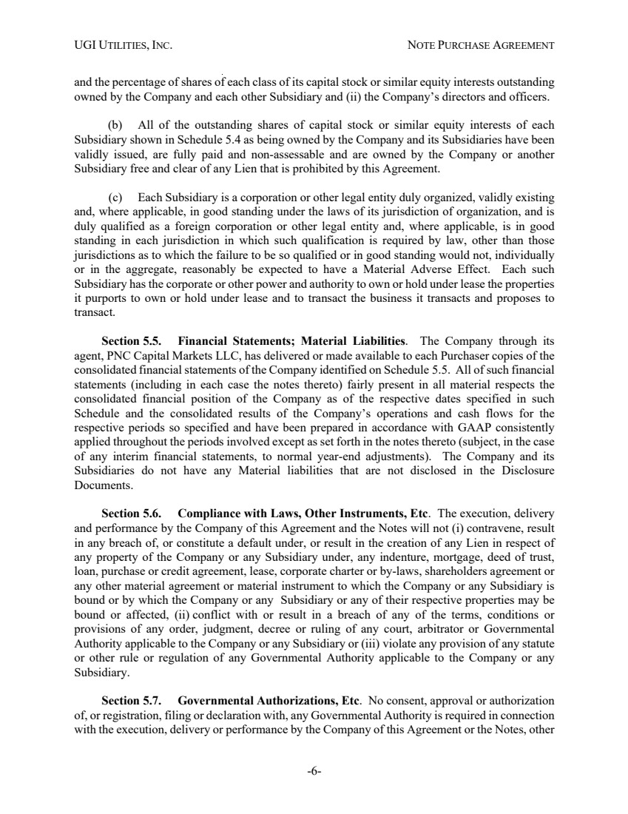 | UGI UTILITIES, INC. NOTE PURCHASE AGREEMENT -6- and the percentage of shares of each class of its capital stock or similar equity interests outstanding owned by the Company and each other Subsidiary and (ii) the Company’s directors and officers. (b) All of the outstanding shares of capital stock or similar equity interests of each Subsidiary shown in Schedule 5.4 as being owned by the Company and its Subsidiaries have been validly issued, are fully paid and non-assessable and are owned by the Company or another Subsidiary free and clear of any Lien that is prohibited by this Agreement. (c) Each Subsidiary is a corporation or other legal entity duly organized, validly existing and, where applicable, in good standing under the laws of its jurisdiction of organization, and is duly qualified as a foreign corporation or other legal entity and, where applicable, is in good standing in each jurisdiction in which such qualification is required by law, other than those jurisdictions as to which the failure to be so qualified or in good standing would not, individually or in the aggregate, reasonably be expected to have a Material Adverse Effect. Each such Subsidiary has the corporate or other power and authority to own or hold under lease the properties it purports to own or hold under lease and to transact the business it transacts and proposes to transact. Section 5.5. Financial Statements; Material Liabilities. The Company through its agent, PNC Capital Markets LLC, has delivered or made available to each Purchaser copies of the consolidated financial statements of the Company identified on Schedule 5.5. All of such financial statements (including in each case the notes thereto) fairly present in all material respects the consolidated financial position of the Company as of the respective dates specified in such Schedule and the consolidated results of the Company’s operations and cash flows for the respective periods so specified and have been prepared in accordance with GAAP consistently applied throughout the periods involved except as set forth in the notes thereto (subject, in the case of any interim financial statements, to normal year-end adjustments). The Company and its Subsidiaries do not have any Material liabilities that are not disclosed in the Disclosure Documents. Section 5.6. Compliance with Laws, Other Instruments, Etc. The execution, delivery and performance by the Company of this Agreement and the Notes will not (i) contravene, result in any breach of, or constitute a default under, or result in the creation of any Lien in respect of any property of the Company or any Subsidiary under, any indenture, mortgage, deed of trust, loan, purchase or credit agreement, lease, corporate charter or by-laws, shareholders agreement or any other material agreement or material instrument to which the Company or any Subsidiary is bound or by which the Company or any Subsidiary or any of their respective properties may be bound or affected, (ii) conflict with or result in a breach of any of the terms, conditions or provisions of any order, judgment, decree or ruling of any court, arbitrator or Governmental Authority applicable to the Company or any Subsidiary or (iii) violate any provision of any statute or other rule or regulation of any Governmental Authority applicable to the Company or any Subsidiary. Section 5.7. Governmental Authorizations, Etc. No consent, approval or authorization of, or registration, filing or declaration with, any Governmental Authority is required in connection with the execution, delivery or performance by the Company of this Agreement or the Notes, other
 | 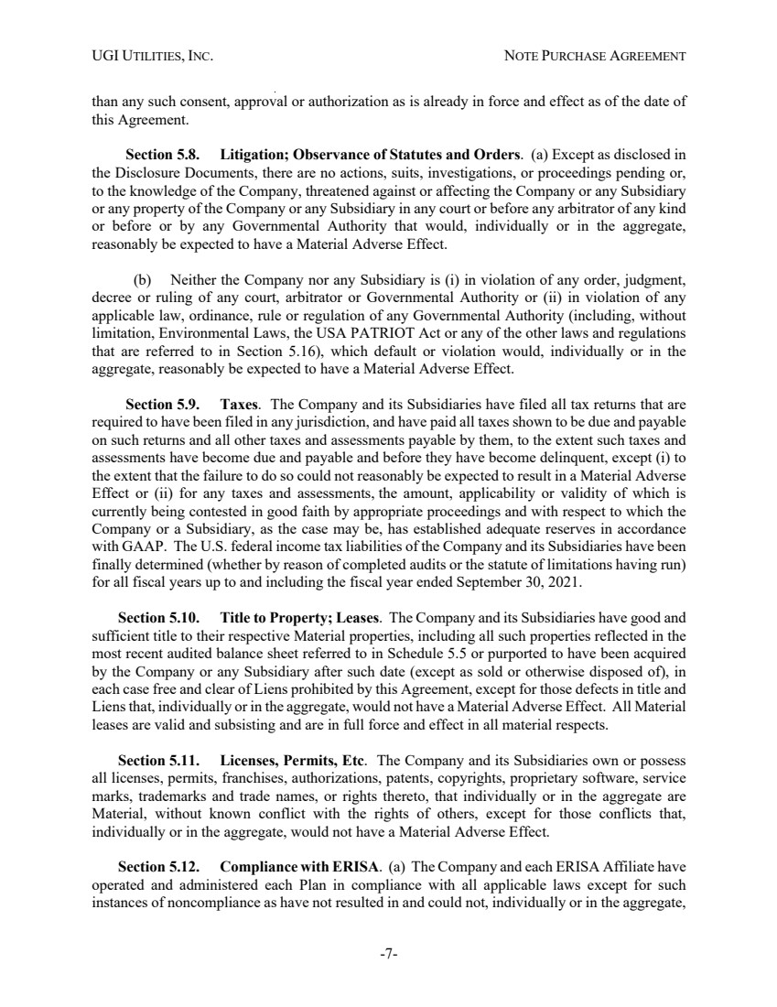 | UGI UTILITIES, INC. NOTE PURCHASE AGREEMENT -7- than any such consent, approval or authorization as is already in force and effect as of the date of this Agreement. Section 5.8. Litigation; Observance of Statutes and Orders. (a) Except as disclosed in the Disclosure Documents, there are no actions, suits, investigations, or proceedings pending or, to the knowledge of the Company, threatened against or affecting the Company or any Subsidiary or any property of the Company or any Subsidiary in any court or before any arbitrator of any kind or before or by any Governmental Authority that would, individually or in the aggregate, reasonably be expected to have a Material Adverse Effect. (b) Neither the Company nor any Subsidiary is (i) in violation of any order, judgment, decree or ruling of any court, arbitrator or Governmental Authority or (ii) in violation of any applicable law, ordinance, rule or regulation of any Governmental Authority (including, without limitation, Environmental Laws, the USA PATRIOT Act or any of the other laws and regulations that are referred to in Section 5.16), which default or violation would, individually or in the aggregate, reasonably be expected to have a Material Adverse Effect. Section 5.9. Taxes. The Company and its Subsidiaries have filed all tax returns that are required to have been filed in any jurisdiction, and have paid all taxes shown to be due and payable on such returns and all other taxes and assessments payable by them, to the extent such taxes and assessments have become due and payable and before they have become delinquent, except (i) to the extent that the failure to do so could not reasonably be expected to result in a Material Adverse Effect or (ii) for any taxes and assessments, the amount, applicability or validity of which is currently being contested in good faith by appropriate proceedings and with respect to which the Company or a Subsidiary, as the case may be, has established adequate reserves in accordance with GAAP. The U.S. federal income tax liabilities of the Company and its Subsidiaries have been finally determined (whether by reason of completed audits or the statute of limitations having run) for all fiscal years up to and including the fiscal year ended September 30, 2021. Section 5.10. Title to Property; Leases. The Company and its Subsidiaries have good and sufficient title to their respective Material properties, including all such properties reflected in the most recent audited balance sheet referred to in Schedule 5.5 or purported to have been acquired by the Company or any Subsidiary after such date (except as sold or otherwise disposed of), in each case free and clear of Liens prohibited by this Agreement, except for those defects in title and Liens that, individually or in the aggregate, would not have a Material Adverse Effect. All Material leases are valid and subsisting and are in full force and effect in all material respects. Section 5.11. Licenses, Permits, Etc. The Company and its Subsidiaries own or possess all licenses, permits, franchises, authorizations, patents, copyrights, proprietary software, service marks, trademarks and trade names, or rights thereto, that individually or in the aggregate are Material, without known conflict with the rights of others, except for those conflicts that, individually or in the aggregate, would not have a Material Adverse Effect. Section 5.12. Compliance with ERISA. (a) The Company and each ERISA Affiliate have operated and administered each Plan in compliance with all applicable laws except for such instances of noncompliance as have not resulted in and could not, individually or in the aggregate,
 | 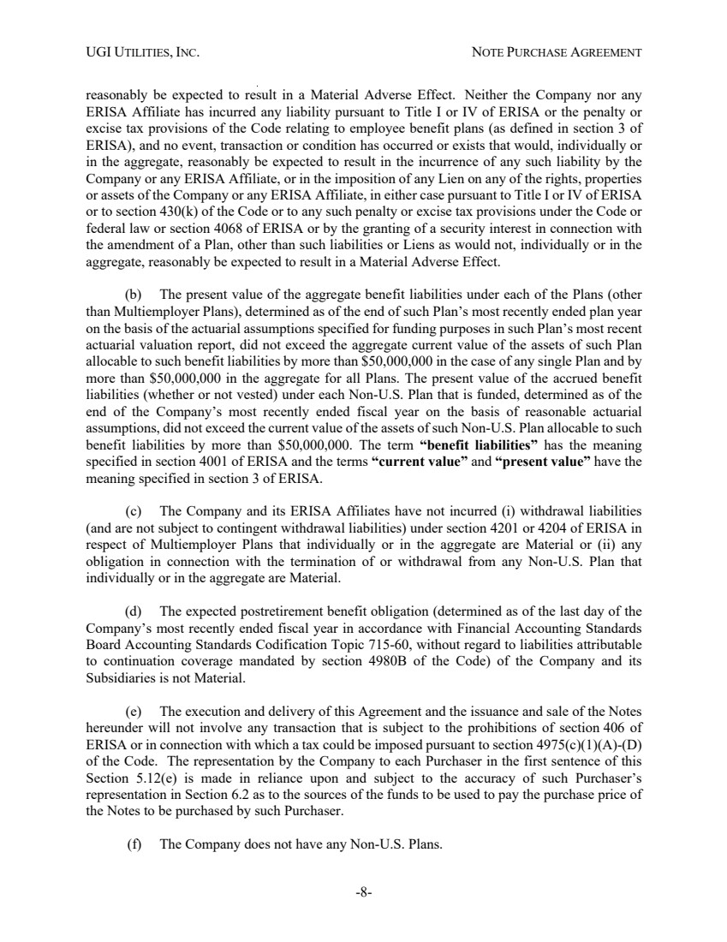 | UGI UTILITIES, INC. NOTE PURCHASE AGREEMENT -8- reasonably be expected to result in a Material Adverse Effect. Neither the Company nor any ERISA Affiliate has incurred any liability pursuant to Title I or IV of ERISA or the penalty or excise tax provisions of the Code relating to employee benefit plans (as defined in section 3 of ERISA), and no event, transaction or condition has occurred or exists that would, individually or in the aggregate, reasonably be expected to result in the incurrence of any such liability by the Company or any ERISA Affiliate, or in the imposition of any Lien on any of the rights, properties or assets of the Company or any ERISA Affiliate, in either case pursuant to Title I or IV of ERISA or to section 430(k) of the Code or to any such penalty or excise tax provisions under the Code or federal law or section 4068 of ERISA or by the granting of a security interest in connection with the amendment of a Plan, other than such liabilities or Liens as would not, individually or in the aggregate, reasonably be expected to result in a Material Adverse Effect. (b) The present value of the aggregate benefit liabilities under each of the Plans (other than Multiemployer Plans), determined as of the end of such Plan’s most recently ended plan year on the basis of the actuarial assumptions specified for funding purposes in such Plan’s most recent actuarial valuation report, did not exceed the aggregate current value of the assets of such Plan allocable to such benefit liabilities by more than $50,000,000 in the case of any single Plan and by more than $50,000,000 in the aggregate for all Plans. The present value of the accrued benefit liabilities (whether or not vested) under each Non-U.S. Plan that is funded, determined as of the end of the Company’s most recently ended fiscal year on the basis of reasonable actuarial assumptions, did not exceed the current value of the assets of such Non-U.S. Plan allocable to such benefit liabilities by more than $50,000,000. The term “benefit liabilities” has the meaning specified in section 4001 of ERISA and the terms “current value” and “present value” have the meaning specified in section 3 of ERISA. (c) The Company and its ERISA Affiliates have not incurred (i) withdrawal liabilities (and are not subject to contingent withdrawal liabilities) under section 4201 or 4204 of ERISA in respect of Multiemployer Plans that individually or in the aggregate are Material or (ii) any obligation in connection with the termination of or withdrawal from any Non-U.S. Plan that individually or in the aggregate are Material. (d) The expected postretirement benefit obligation (determined as of the last day of the Company’s most recently ended fiscal year in accordance with Financial Accounting Standards Board Accounting Standards Codification Topic 715-60, without regard to liabilities attributable to continuation coverage mandated by section 4980B of the Code) of the Company and its Subsidiaries is not Material. (e) The execution and delivery of this Agreement and the issuance and sale of the Notes hereunder will not involve any transaction that is subject to the prohibitions of section 406 of ERISA or in connection with which a tax could be imposed pursuant to section 4975(c)(1)(A)-(D) of the Code. The representation by the Company to each Purchaser in the first sentence of this Section 5.12(e) is made in reliance upon and subject to the accuracy of such Purchaser’s representation in Section 6.2 as to the sources of the funds to be used to pay the purchase price of the Notes to be purchased by such Purchaser. (f) The Company does not have any Non-U.S. Plans.
 | 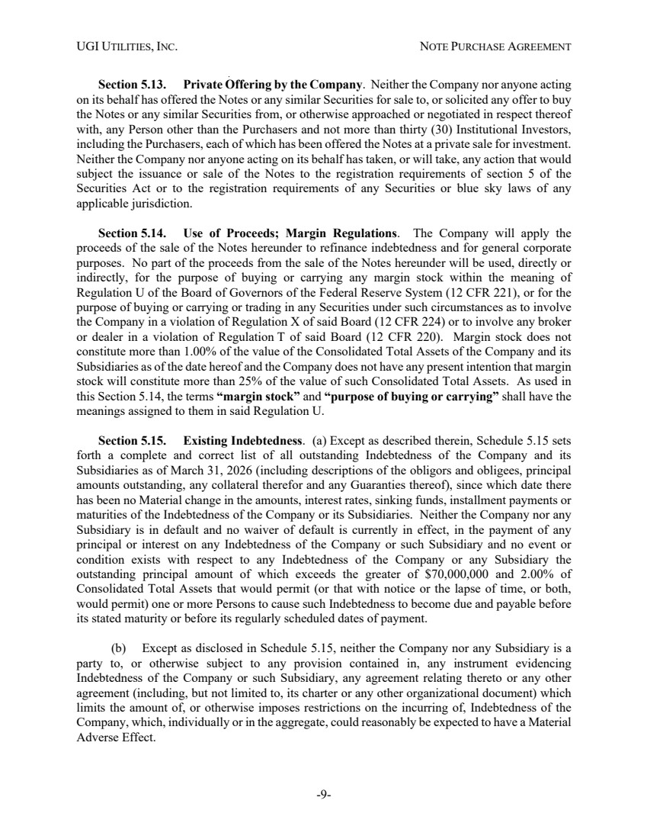 | UGI UTILITIES, INC. NOTE PURCHASE AGREEMENT -9- Section 5.13. Private Offering by the Company. Neither the Company nor anyone acting on its behalf has offered the Notes or any similar Securities for sale to, or solicited any offer to buy the Notes or any similar Securities from, or otherwise approached or negotiated in respect thereof with, any Person other than the Purchasers and not more than thirty (30) Institutional Investors, including the Purchasers, each of which has been offered the Notes at a private sale for investment. Neither the Company nor anyone acting on its behalf has taken, or will take, any action that would subject the issuance or sale of the Notes to the registration requirements of section 5 of the Securities Act or to the registration requirements of any Securities or blue sky laws of any applicable jurisdiction. Section 5.14. Use of Proceeds; Margin Regulations. The Company will apply the proceeds of the sale of the Notes hereunder to refinance indebtedness and for general corporate purposes. No part of the proceeds from the sale of the Notes hereunder will be used, directly or indirectly, for the purpose of buying or carrying any margin stock within the meaning of Regulation U of the Board of Governors of the Federal Reserve System (12 CFR 221), or for the purpose of buying or carrying or trading in any Securities under such circumstances as to involve the Company in a violation of Regulation X of said Board (12 CFR 224) or to involve any broker or dealer in a violation of Regulation T of said Board (12 CFR 220). Margin stock does not constitute more than 1.00% of the value of the Consolidated Total Assets of the Company and its Subsidiaries as of the date hereof and the Company does not have any present intention that margin stock will constitute more than 25% of the value of such Consolidated Total Assets. As used in this Section 5.14, the terms “margin stock” and “purpose of buying or carrying” shall have the meanings assigned to them in said Regulation U. Section 5.15. Existing Indebtedness. (a) Except as described therein, Schedule 5.15 sets forth a complete and correct list of all outstanding Indebtedness of the Company and its Subsidiaries as of March 31, 2026 (including descriptions of the obligors and obligees, principal amounts outstanding, any collateral therefor and any Guaranties thereof), since which date there has been no Material change in the amounts, interest rates, sinking funds, installment payments or maturities of the Indebtedness of the Company or its Subsidiaries. Neither the Company nor any Subsidiary is in default and no waiver of default is currently in effect, in the payment of any principal or interest on any Indebtedness of the Company or such Subsidiary and no event or condition exists with respect to any Indebtedness of the Company or any Subsidiary the outstanding principal amount of which exceeds the greater of $70,000,000 and 2.00% of Consolidated Total Assets that would permit (or that with notice or the lapse of time, or both, would permit) one or more Persons to cause such Indebtedness to become due and payable before its stated maturity or before its regularly scheduled dates of payment. (b) Except as disclosed in Schedule 5.15, neither the Company nor any Subsidiary is a party to, or otherwise subject to any provision contained in, any instrument evidencing Indebtedness of the Company or such Subsidiary, any agreement relating thereto or any other agreement (including, but not limited to, its charter or any other organizational document) which limits the amount of, or otherwise imposes restrictions on the incurring of, Indebtedness of the Company, which, individually or in the aggregate, could reasonably be expected to have a Material Adverse Effect.
 | 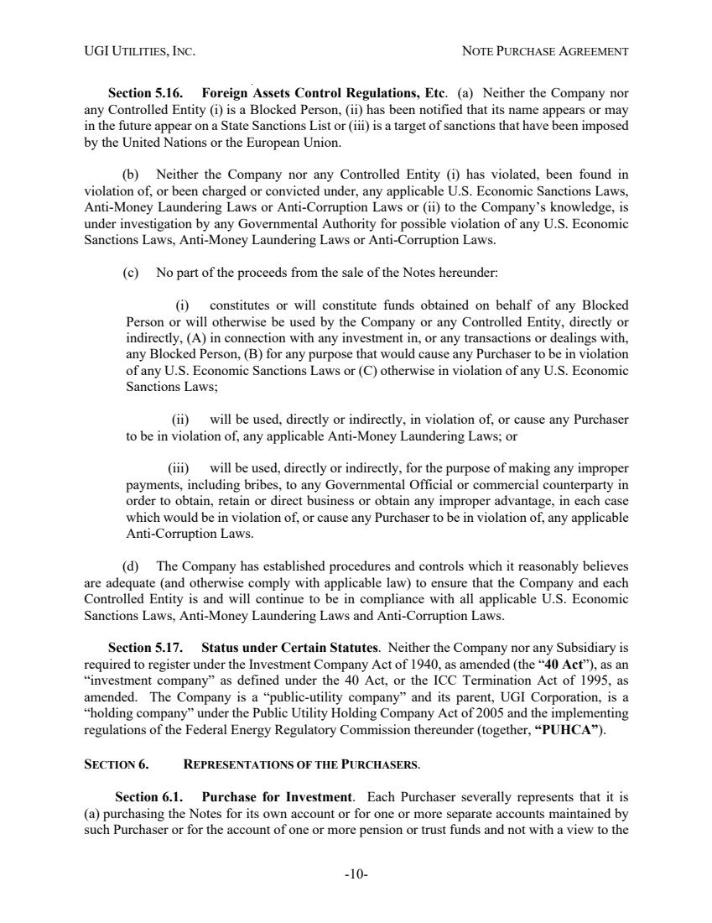 | UGI UTILITIES, INC. NOTE PURCHASE AGREEMENT -10- Section 5.16. Foreign Assets Control Regulations, Etc. (a) Neither the Company nor any Controlled Entity (i) is a Blocked Person, (ii) has been notified that its name appears or may in the future appear on a State Sanctions List or (iii) is a target of sanctions that have been imposed by the United Nations or the European Union. (b) Neither the Company nor any Controlled Entity (i) has violated, been found in violation of, or been charged or convicted under, any applicable U.S. Economic Sanctions Laws, Anti-Money Laundering Laws or Anti-Corruption Laws or (ii) to the Company’s knowledge, is under investigation by any Governmental Authority for possible violation of any U.S. Economic Sanctions Laws, Anti-Money Laundering Laws or Anti-Corruption Laws. (c) No part of the proceeds from the sale of the Notes hereunder: (i) constitutes or will constitute funds obtained on behalf of any Blocked Person or will otherwise be used by the Company or any Controlled Entity, directly or indirectly, (A) in connection with any investment in, or any transactions or dealings with, any Blocked Person, (B) for any purpose that would cause any Purchaser to be in violation of any U.S. Economic Sanctions Laws or (C) otherwise in violation of any U.S. Economic Sanctions Laws; (ii) will be used, directly or indirectly, in violation of, or cause any Purchaser to be in violation of, any applicable Anti-Money Laundering Laws; or (iii) will be used, directly or indirectly, for the purpose of making any improper payments, including bribes, to any Governmental Official or commercial counterparty in order to obtain, retain or direct business or obtain any improper advantage, in each case which would be in violation of, or cause any Purchaser to be in violation of, any applicable Anti-Corruption Laws. (d) The Company has established procedures and controls which it reasonably believes are adequate (and otherwise comply with applicable law) to ensure that the Company and each Controlled Entity is and will continue to be in compliance with all applicable U.S. Economic Sanctions Laws, Anti-Money Laundering Laws and Anti-Corruption Laws. Section 5.17. Status under Certain Statutes. Neither the Company nor any Subsidiary is required to register under the Investment Company Act of 1940, as amended (the “40 Act”), as an “investment company” as defined under the 40 Act, or the ICC Termination Act of 1995, as amended. The Company is a “public-utility company” and its parent, UGI Corporation, is a “holding company” under the Public Utility Holding Company Act of 2005 and the implementing regulations of the Federal Energy Regulatory Commission thereunder (together, “PUHCA”). SECTION 6. REPRESENTATIONS OF THE PURCHASERS. Section 6.1. Purchase for Investment. Each Purchaser severally represents that it is (a) purchasing the Notes for its own account or for one or more separate accounts maintained by such Purchaser or for the account of one or more pension or trust funds and not with a view to the
 | 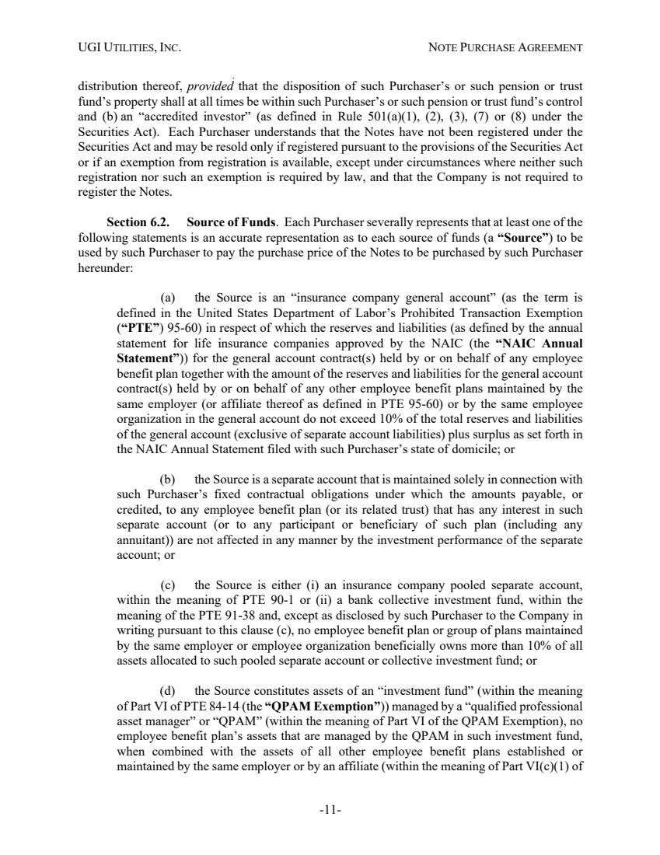 | UGI UTILITIES, INC. NOTE PURCHASE AGREEMENT -11- distribution thereof, provided that the disposition of such Purchaser’s or such pension or trust fund’s property shall at all times be within such Purchaser’s or such pension or trust fund’s control and (b) an “accredited investor” (as defined in Rule 501(a)(1), (2), (3), (7) or (8) under the Securities Act). Each Purchaser understands that the Notes have not been registered under the Securities Act and may be resold only if registered pursuant to the provisions of the Securities Act or if an exemption from registration is available, except under circumstances where neither such registration nor such an exemption is required by law, and that the Company is not required to register the Notes. Section 6.2. Source of Funds. Each Purchaser severally represents that at least one of the following statements is an accurate representation as to each source of funds (a “Source”) to be used by such Purchaser to pay the purchase price of the Notes to be purchased by such Purchaser hereunder: (a) the Source is an “insurance company general account” (as the term is defined in the United States Department of Labor’s Prohibited Transaction Exemption (“PTE”) 95-60) in respect of which the reserves and liabilities (as defined by the annual statement for life insurance companies approved by the NAIC (the “NAIC Annual Statement”)) for the general account contract(s) held by or on behalf of any employee benefit plan together with the amount of the reserves and liabilities for the general account contract(s) held by or on behalf of any other employee benefit plans maintained by the same employer (or affiliate thereof as defined in PTE 95-60) or by the same employee organization in the general account do not exceed 10% of the total reserves and liabilities of the general account (exclusive of separate account liabilities) plus surplus as set forth in the NAIC Annual Statement filed with such Purchaser’s state of domicile; or (b) the Source is a separate account that is maintained solely in connection with such Purchaser’s fixed contractual obligations under which the amounts payable, or credited, to any employee benefit plan (or its related trust) that has any interest in such separate account (or to any participant or beneficiary of such plan (including any annuitant)) are not affected in any manner by the investment performance of the separate account; or (c) the Source is either (i) an insurance company pooled separate account, within the meaning of PTE 90-1 or (ii) a bank collective investment fund, within the meaning of the PTE 91-38 and, except as disclosed by such Purchaser to the Company in writing pursuant to this clause (c), no employee benefit plan or group of plans maintained by the same employer or employee organization beneficially owns more than 10% of all assets allocated to such pooled separate account or collective investment fund; or (d) the Source constitutes assets of an “investment fund” (within the meaning of Part VI of PTE 84-14 (the “QPAM Exemption”)) managed by a “qualified professional asset manager” or “QPAM” (within the meaning of Part VI of the QPAM Exemption), no employee benefit plan’s assets that are managed by the QPAM in such investment fund, when combined with the assets of all other employee benefit plans established or maintained by the same employer or by an affiliate (within the meaning of Part VI(c)(1) of
 | 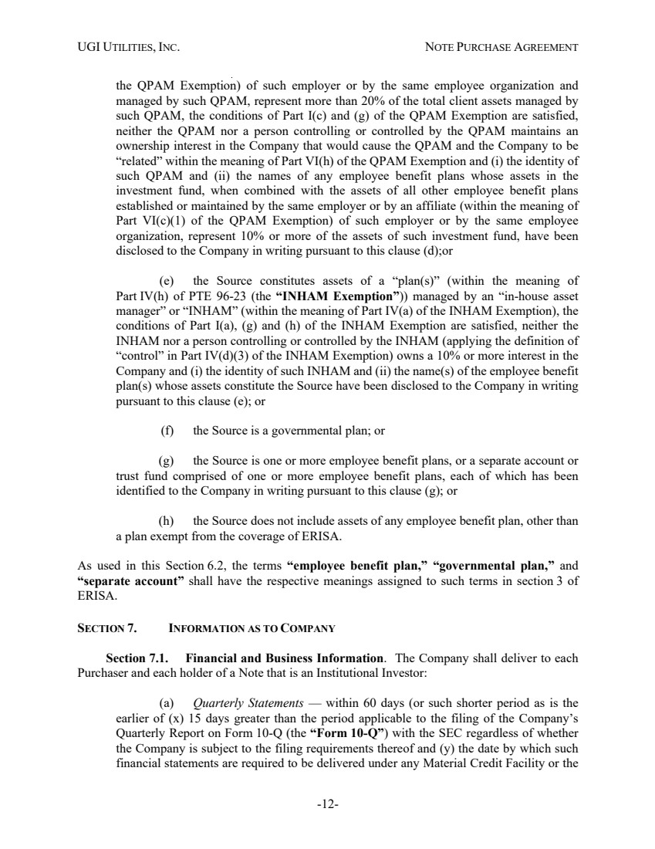 | UGI UTILITIES, INC. NOTE PURCHASE AGREEMENT -12- the QPAM Exemption) of such employer or by the same employee organization and managed by such QPAM, represent more than 20% of the total client assets managed by such QPAM, the conditions of Part I(c) and (g) of the QPAM Exemption are satisfied, neither the QPAM nor a person controlling or controlled by the QPAM maintains an ownership interest in the Company that would cause the QPAM and the Company to be “related” within the meaning of Part VI(h) of the QPAM Exemption and (i) the identity of such QPAM and (ii) the names of any employee benefit plans whose assets in the investment fund, when combined with the assets of all other employee benefit plans established or maintained by the same employer or by an affiliate (within the meaning of Part VI(c)(1) of the QPAM Exemption) of such employer or by the same employee organization, represent 10% or more of the assets of such investment fund, have been disclosed to the Company in writing pursuant to this clause (d);or (e) the Source constitutes assets of a “plan(s)” (within the meaning of Part IV(h) of PTE 96-23 (the “INHAM Exemption”)) managed by an “in-house asset manager” or “INHAM” (within the meaning of Part IV(a) of the INHAM Exemption), the conditions of Part I(a), (g) and (h) of the INHAM Exemption are satisfied, neither the INHAM nor a person controlling or controlled by the INHAM (applying the definition of “control” in Part IV(d)(3) of the INHAM Exemption) owns a 10% or more interest in the Company and (i) the identity of such INHAM and (ii) the name(s) of the employee benefit plan(s) whose assets constitute the Source have been disclosed to the Company in writing pursuant to this clause (e); or (f) the Source is a governmental plan; or (g) the Source is one or more employee benefit plans, or a separate account or trust fund comprised of one or more employee benefit plans, each of which has been identified to the Company in writing pursuant to this clause (g); or (h) the Source does not include assets of any employee benefit plan, other than a plan exempt from the coverage of ERISA. As used in this Section 6.2, the terms “employee benefit plan,” “governmental plan,” and “separate account” shall have the respective meanings assigned to such terms in section 3 of ERISA. SECTION 7. INFORMATION AS TO COMPANY Section 7.1. Financial and Business Information. The Company shall deliver to each Purchaser and each holder of a Note that is an Institutional Investor: (a) Quarterly Statements — within 60 days (or such shorter period as is the earlier of (x) 15 days greater than the period applicable to the filing of the Company’s Quarterly Report on Form 10-Q (the “Form 10-Q”) with the SEC regardless of whether the Company is subject to the filing requirements thereof and (y) the date by which such financial statements are required to be delivered under any Material Credit Facility or the
 | 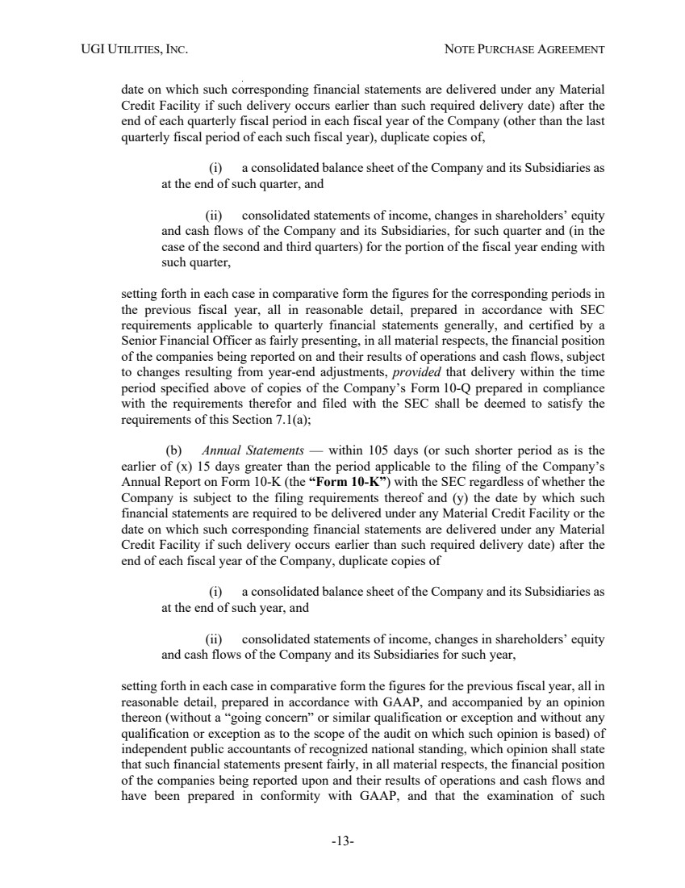 | UGI UTILITIES, INC. NOTE PURCHASE AGREEMENT -13- date on which such corresponding financial statements are delivered under any Material Credit Facility if such delivery occurs earlier than such required delivery date) after the end of each quarterly fiscal period in each fiscal year of the Company (other than the last quarterly fiscal period of each such fiscal year), duplicate copies of, (i) a consolidated balance sheet of the Company and its Subsidiaries as at the end of such quarter, and (ii) consolidated statements of income, changes in shareholders’ equity and cash flows of the Company and its Subsidiaries, for such quarter and (in the case of the second and third quarters) for the portion of the fiscal year ending with such quarter, setting forth in each case in comparative form the figures for the corresponding periods in the previous fiscal year, all in reasonable detail, prepared in accordance with SEC requirements applicable to quarterly financial statements generally, and certified by a Senior Financial Officer as fairly presenting, in all material respects, the financial position of the companies being reported on and their results of operations and cash flows, subject to changes resulting from year-end adjustments, provided that delivery within the time period specified above of copies of the Company’s Form 10-Q prepared in compliance with the requirements therefor and filed with the SEC shall be deemed to satisfy the requirements of this Section 7.1(a); (b) Annual Statements — within 105 days (or such shorter period as is the earlier of (x) 15 days greater than the period applicable to the filing of the Company’s Annual Report on Form 10-K (the “Form 10-K”) with the SEC regardless of whether the Company is subject to the filing requirements thereof and (y) the date by which such financial statements are required to be delivered under any Material Credit Facility or the date on which such corresponding financial statements are delivered under any Material Credit Facility if such delivery occurs earlier than such required delivery date) after the end of each fiscal year of the Company, duplicate copies of (i) a consolidated balance sheet of the Company and its Subsidiaries as at the end of such year, and (ii) consolidated statements of income, changes in shareholders’ equity and cash flows of the Company and its Subsidiaries for such year, setting forth in each case in comparative form the figures for the previous fiscal year, all in reasonable detail, prepared in accordance with GAAP, and accompanied by an opinion thereon (without a “going concern” or similar qualification or exception and without any qualification or exception as to the scope of the audit on which such opinion is based) of independent public accountants of recognized national standing, which opinion shall state that such financial statements present fairly, in all material respects, the financial position of the companies being reported upon and their results of operations and cash flows and have been prepared in conformity with GAAP, and that the examination of such
 | 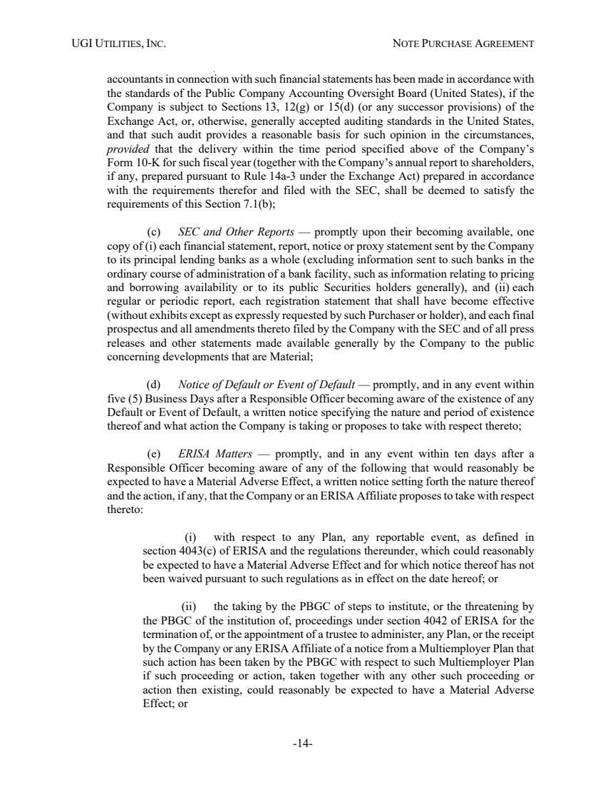 | UGI UTILITIES, INC. NOTE PURCHASE AGREEMENT -14- accountants in connection with such financial statements has been made in accordance with the standards of the Public Company Accounting Oversight Board (United States), if the Company is subject to Sections 13, 12(g) or 15(d) (or any successor provisions) of the Exchange Act, or, otherwise, generally accepted auditing standards in the United States, and that such audit provides a reasonable basis for such opinion in the circumstances, provided that the delivery within the time period specified above of the Company’s Form 10-K for such fiscal year (together with the Company’s annual report to shareholders, if any, prepared pursuant to Rule 14a-3 under the Exchange Act) prepared in accordance with the requirements therefor and filed with the SEC, shall be deemed to satisfy the requirements of this Section 7.1(b); (c) SEC and Other Reports — promptly upon their becoming available, one copy of (i) each financial statement, report, notice or proxy statement sent by the Company to its principal lending banks as a whole (excluding information sent to such banks in the ordinary course of administration of a bank facility, such as information relating to pricing and borrowing availability or to its public Securities holders generally), and (ii) each regular or periodic report, each registration statement that shall have become effective (without exhibits except as expressly requested by such Purchaser or holder), and each final prospectus and all amendments thereto filed by the Company with the SEC and of all press releases and other statements made available generally by the Company to the public concerning developments that are Material; (d) Notice of Default or Event of Default — promptly, and in any event within five (5) Business Days after a Responsible Officer becoming aware of the existence of any Default or Event of Default, a written notice specifying the nature and period of existence thereof and what action the Company is taking or proposes to take with respect thereto; (e) ERISA Matters — promptly, and in any event within ten days after a Responsible Officer becoming aware of any of the following that would reasonably be expected to have a Material Adverse Effect, a written notice setting forth the nature thereof and the action, if any, that the Company or an ERISA Affiliate proposes to take with respect thereto: (i) with respect to any Plan, any reportable event, as defined in section 4043(c) of ERISA and the regulations thereunder, which could reasonably be expected to have a Material Adverse Effect and for which notice thereof has not been waived pursuant to such regulations as in effect on the date hereof; or (ii) the taking by the PBGC of steps to institute, or the threatening by the PBGC of the institution of, proceedings under section 4042 of ERISA for the termination of, or the appointment of a trustee to administer, any Plan, or the receipt by the Company or any ERISA Affiliate of a notice from a Multiemployer Plan that such action has been taken by the PBGC with respect to such Multiemployer Plan if such proceeding or action, taken together with any other such proceeding or action then existing, could reasonably be expected to have a Material Adverse Effect; or
 | 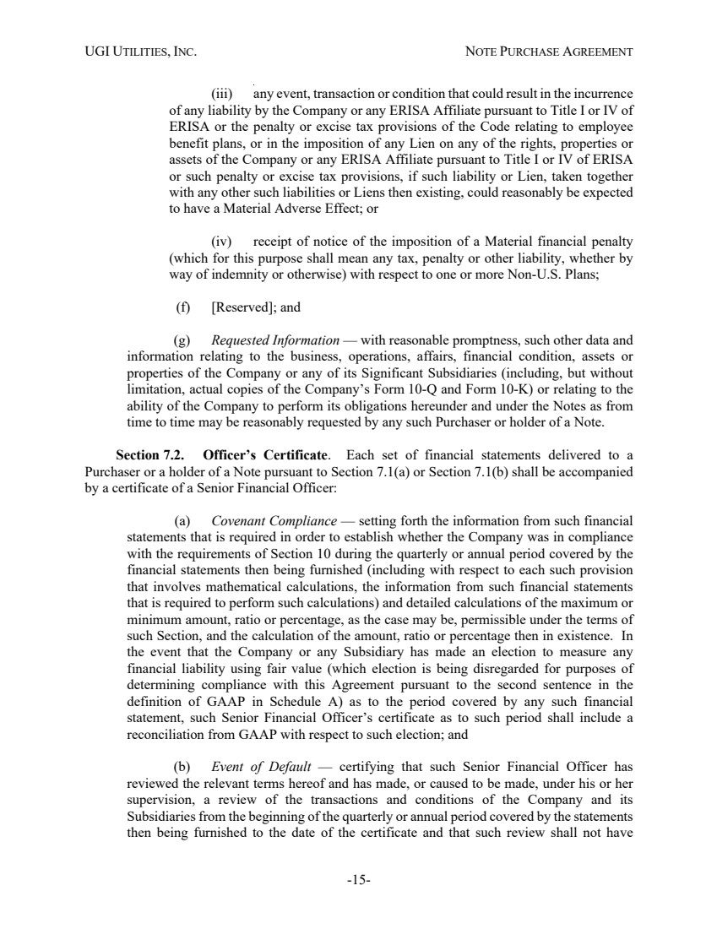 | UGI UTILITIES, INC. NOTE PURCHASE AGREEMENT -15- (iii) any event, transaction or condition that could result in the incurrence of any liability by the Company or any ERISA Affiliate pursuant to Title I or IV of ERISA or the penalty or excise tax provisions of the Code relating to employee benefit plans, or in the imposition of any Lien on any of the rights, properties or assets of the Company or any ERISA Affiliate pursuant to Title I or IV of ERISA or such penalty or excise tax provisions, if such liability or Lien, taken together with any other such liabilities or Liens then existing, could reasonably be expected to have a Material Adverse Effect; or (iv) receipt of notice of the imposition of a Material financial penalty (which for this purpose shall mean any tax, penalty or other liability, whether by way of indemnity or otherwise) with respect to one or more Non-U.S. Plans; (f) [Reserved]; and (g) Requested Information — with reasonable promptness, such other data and information relating to the business, operations, affairs, financial condition, assets or properties of the Company or any of its Significant Subsidiaries (including, but without limitation, actual copies of the Company’s Form 10-Q and Form 10-K) or relating to the ability of the Company to perform its obligations hereunder and under the Notes as from time to time may be reasonably requested by any such Purchaser or holder of a Note. Section 7.2. Officer’s Certificate. Each set of financial statements delivered to a Purchaser or a holder of a Note pursuant to Section 7.1(a) or Section 7.1(b) shall be accompanied by a certificate of a Senior Financial Officer: (a) Covenant Compliance — setting forth the information from such financial statements that is required in order to establish whether the Company was in compliance with the requirements of Section 10 during the quarterly or annual period covered by the financial statements then being furnished (including with respect to each such provision that involves mathematical calculations, the information from such financial statements that is required to perform such calculations) and detailed calculations of the maximum or minimum amount, ratio or percentage, as the case may be, permissible under the terms of such Section, and the calculation of the amount, ratio or percentage then in existence. In the event that the Company or any Subsidiary has made an election to measure any financial liability using fair value (which election is being disregarded for purposes of determining compliance with this Agreement pursuant to the second sentence in the definition of GAAP in Schedule A) as to the period covered by any such financial statement, such Senior Financial Officer’s certificate as to such period shall include a reconciliation from GAAP with respect to such election; and (b) Event of Default — certifying that such Senior Financial Officer has reviewed the relevant terms hereof and has made, or caused to be made, under his or her supervision, a review of the transactions and conditions of the Company and its Subsidiaries from the beginning of the quarterly or annual period covered by the statements then being furnished to the date of the certificate and that such review shall not have
 | 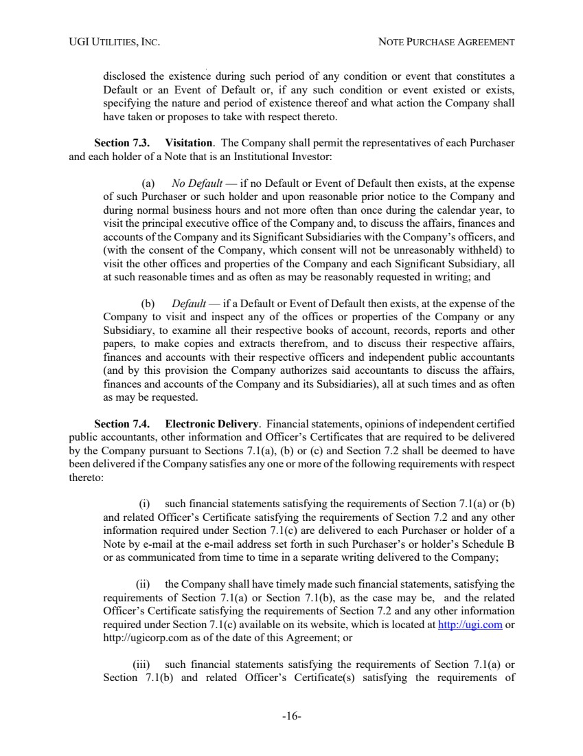 | UGI UTILITIES, INC. NOTE PURCHASE AGREEMENT -16- disclosed the existence during such period of any condition or event that constitutes a Default or an Event of Default or, if any such condition or event existed or exists, specifying the nature and period of existence thereof and what action the Company shall have taken or proposes to take with respect thereto. Section 7.3. Visitation. The Company shall permit the representatives of each Purchaser and each holder of a Note that is an Institutional Investor: (a) No Default — if no Default or Event of Default then exists, at the expense of such Purchaser or such holder and upon reasonable prior notice to the Company and during normal business hours and not more often than once during the calendar year, to visit the principal executive office of the Company and, to discuss the affairs, finances and accounts of the Company and its Significant Subsidiaries with the Company’s officers, and (with the consent of the Company, which consent will not be unreasonably withheld) to visit the other offices and properties of the Company and each Significant Subsidiary, all at such reasonable times and as often as may be reasonably requested in writing; and (b) Default — if a Default or Event of Default then exists, at the expense of the Company to visit and inspect any of the offices or properties of the Company or any Subsidiary, to examine all their respective books of account, records, reports and other papers, to make copies and extracts therefrom, and to discuss their respective affairs, finances and accounts with their respective officers and independent public accountants (and by this provision the Company authorizes said accountants to discuss the affairs, finances and accounts of the Company and its Subsidiaries), all at such times and as often as may be requested. Section 7.4. Electronic Delivery. Financial statements, opinions of independent certified public accountants, other information and Officer’s Certificates that are required to be delivered by the Company pursuant to Sections 7.1(a), (b) or (c) and Section 7.2 shall be deemed to have been delivered if the Company satisfies any one or more of the following requirements with respect thereto: (i) such financial statements satisfying the requirements of Section 7.1(a) or (b) and related Officer’s Certificate satisfying the requirements of Section 7.2 and any other information required under Section 7.1(c) are delivered to each Purchaser or holder of a Note by e-mail at the e-mail address set forth in such Purchaser’s or holder’s Schedule B or as communicated from time to time in a separate writing delivered to the Company; (ii) the Company shall have timely made such financial statements, satisfying the requirements of Section 7.1(a) or Section 7.1(b), as the case may be, and the related Officer’s Certificate satisfying the requirements of Section 7.2 and any other information required under Section 7.1(c) available on its website, which is located at http://ugi.com or http://ugicorp.com as of the date of this Agreement; or (iii) such financial statements satisfying the requirements of Section 7.1(a) or Section 7.1(b) and related Officer’s Certificate(s) satisfying the requirements of
 | 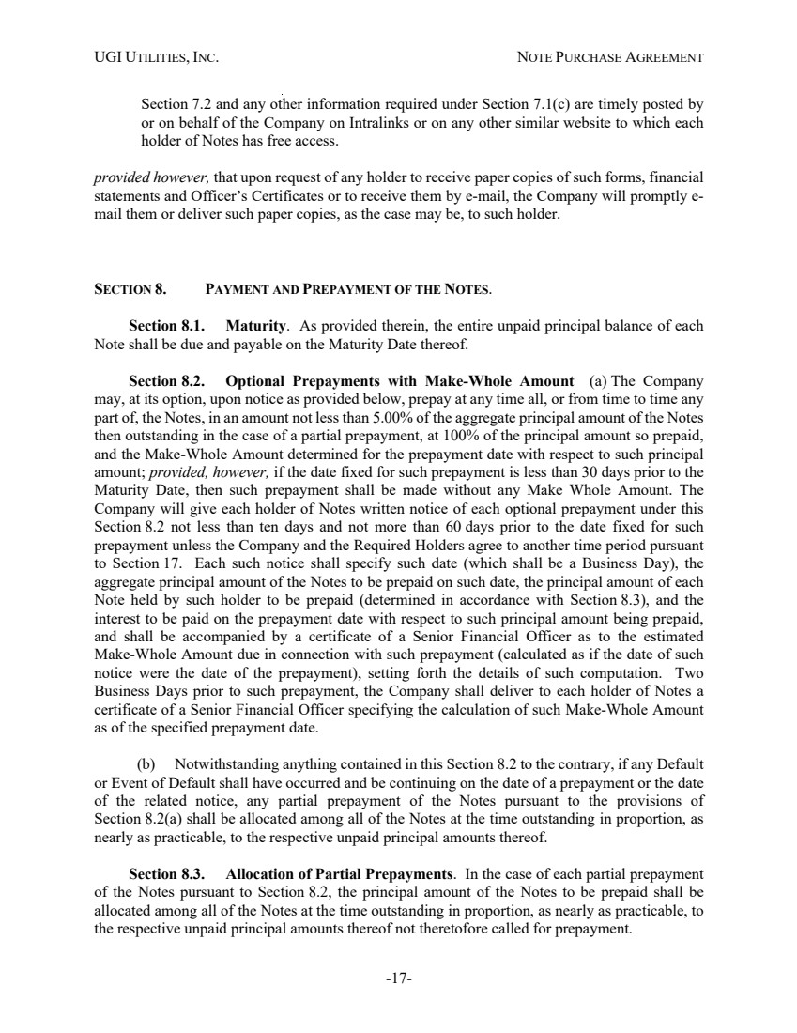 | UGI UTILITIES, INC. NOTE PURCHASE AGREEMENT -17- Section 7.2 and any other information required under Section 7.1(c) are timely posted by or on behalf of the Company on Intralinks or on any other similar website to which each holder of Notes has free access. provided however, that upon request of any holder to receive paper copies of such forms, financial statements and Officer’s Certificates or to receive them by e-mail, the Company will promptly e-mail them or deliver such paper copies, as the case may be, to such holder. SECTION 8. PAYMENT AND PREPAYMENT OF THE NOTES. Section 8.1. Maturity. As provided therein, the entire unpaid principal balance of each Note shall be due and payable on the Maturity Date thereof. Section 8.2. Optional Prepayments with Make-Whole Amount (a) The Company may, at its option, upon notice as provided below, prepay at any time all, or from time to time any part of, the Notes, in an amount not less than 5.00% of the aggregate principal amount of the Notes then outstanding in the case of a partial prepayment, at 100% of the principal amount so prepaid, and the Make-Whole Amount determined for the prepayment date with respect to such principal amount; provided, however, if the date fixed for such prepayment is less than 30 days prior to the Maturity Date, then such prepayment shall be made without any Make Whole Amount. The Company will give each holder of Notes written notice of each optional prepayment under this Section 8.2 not less than ten days and not more than 60 days prior to the date fixed for such prepayment unless the Company and the Required Holders agree to another time period pursuant to Section 17. Each such notice shall specify such date (which shall be a Business Day), the aggregate principal amount of the Notes to be prepaid on such date, the principal amount of each Note held by such holder to be prepaid (determined in accordance with Section 8.3), and the interest to be paid on the prepayment date with respect to such principal amount being prepaid, and shall be accompanied by a certificate of a Senior Financial Officer as to the estimated Make-Whole Amount due in connection with such prepayment (calculated as if the date of such notice were the date of the prepayment), setting forth the details of such computation. Two Business Days prior to such prepayment, the Company shall deliver to each holder of Notes a certificate of a Senior Financial Officer specifying the calculation of such Make-Whole Amount as of the specified prepayment date. (b) Notwithstanding anything contained in this Section 8.2 to the contrary, if any Default or Event of Default shall have occurred and be continuing on the date of a prepayment or the date of the related notice, any partial prepayment of the Notes pursuant to the provisions of Section 8.2(a) shall be allocated among all of the Notes at the time outstanding in proportion, as nearly as practicable, to the respective unpaid principal amounts thereof. Section 8.3. Allocation of Partial Prepayments. In the case of each partial prepayment of the Notes pursuant to Section 8.2, the principal amount of the Notes to be prepaid shall be allocated among all of the Notes at the time outstanding in proportion, as nearly as practicable, to the respective unpaid principal amounts thereof not theretofore called for prepayment.
 | 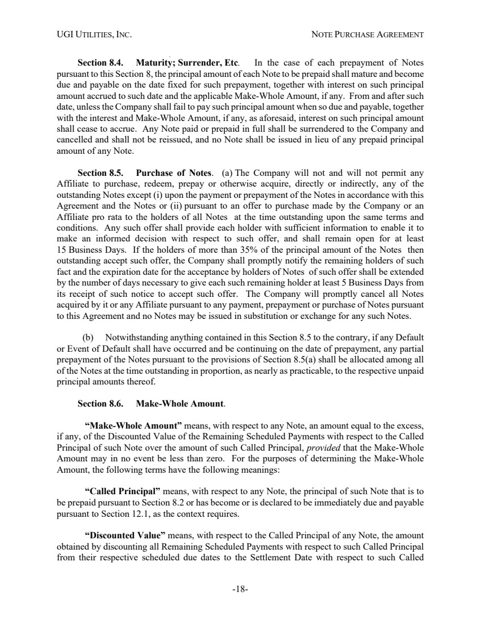 | UGI UTILITIES, INC. NOTE PURCHASE AGREEMENT -18- Section 8.4. Maturity; Surrender, Etc. In the case of each prepayment of Notes pursuant to this Section 8, the principal amount of each Note to be prepaid shall mature and become due and payable on the date fixed for such prepayment, together with interest on such principal amount accrued to such date and the applicable Make-Whole Amount, if any. From and after such date, unless the Company shall fail to pay such principal amount when so due and payable, together with the interest and Make-Whole Amount, if any, as aforesaid, interest on such principal amount shall cease to accrue. Any Note paid or prepaid in full shall be surrendered to the Company and cancelled and shall not be reissued, and no Note shall be issued in lieu of any prepaid principal amount of any Note. Section 8.5. Purchase of Notes. (a) The Company will not and will not permit any Affiliate to purchase, redeem, prepay or otherwise acquire, directly or indirectly, any of the outstanding Notes except (i) upon the payment or prepayment of the Notes in accordance with this Agreement and the Notes or (ii) pursuant to an offer to purchase made by the Company or an Affiliate pro rata to the holders of all Notes at the time outstanding upon the same terms and conditions. Any such offer shall provide each holder with sufficient information to enable it to make an informed decision with respect to such offer, and shall remain open for at least 15 Business Days. If the holders of more than 35% of the principal amount of the Notes then outstanding accept such offer, the Company shall promptly notify the remaining holders of such fact and the expiration date for the acceptance by holders of Notes of such offer shall be extended by the number of days necessary to give each such remaining holder at least 5 Business Days from its receipt of such notice to accept such offer. The Company will promptly cancel all Notes acquired by it or any Affiliate pursuant to any payment, prepayment or purchase of Notes pursuant to this Agreement and no Notes may be issued in substitution or exchange for any such Notes. (b) Notwithstanding anything contained in this Section 8.5 to the contrary, if any Default or Event of Default shall have occurred and be continuing on the date of prepayment, any partial prepayment of the Notes pursuant to the provisions of Section 8.5(a) shall be allocated among all of the Notes at the time outstanding in proportion, as nearly as practicable, to the respective unpaid principal amounts thereof. Section 8.6. Make-Whole Amount. “Make-Whole Amount” means, with respect to any Note, an amount equal to the excess, if any, of the Discounted Value of the Remaining Scheduled Payments with respect to the Called Principal of such Note over the amount of such Called Principal, provided that the Make-Whole Amount may in no event be less than zero. For the purposes of determining the Make-Whole Amount, the following terms have the following meanings: “Called Principal” means, with respect to any Note, the principal of such Note that is to be prepaid pursuant to Section 8.2 or has become or is declared to be immediately due and payable pursuant to Section 12.1, as the context requires. “Discounted Value” means, with respect to the Called Principal of any Note, the amount obtained by discounting all Remaining Scheduled Payments with respect to such Called Principal from their respective scheduled due dates to the Settlement Date with respect to such Called
 | 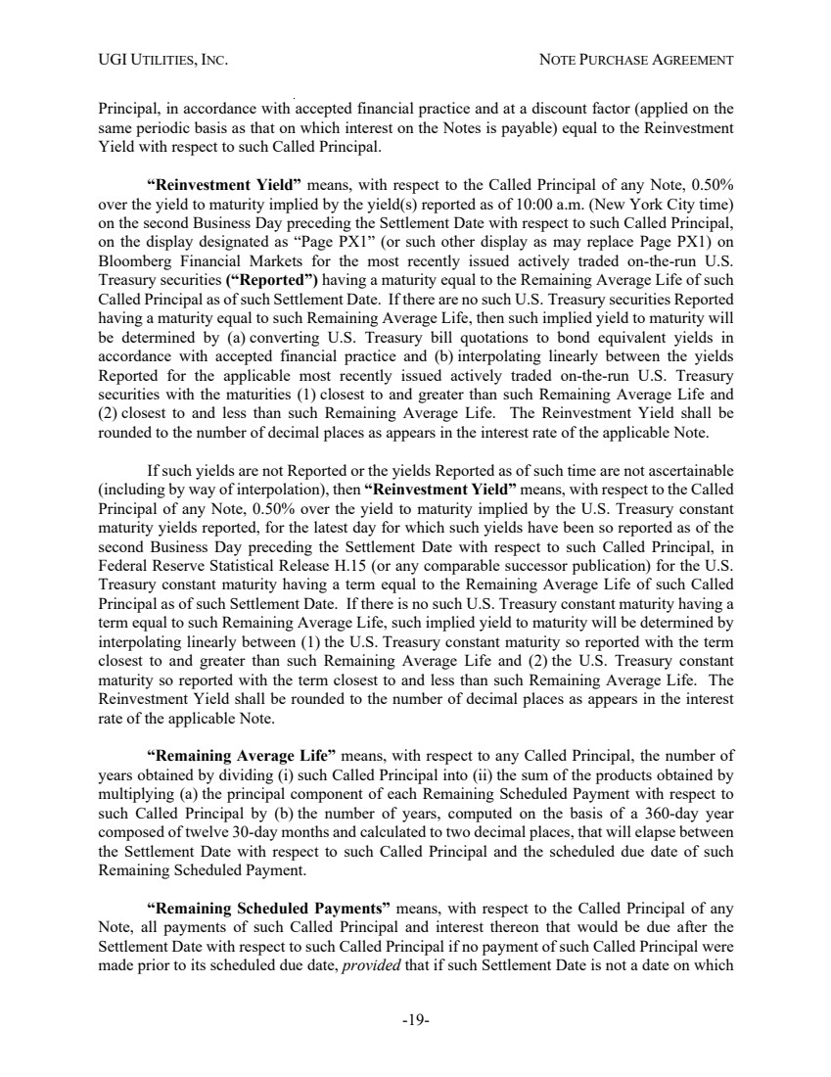 | UGI UTILITIES, INC. NOTE PURCHASE AGREEMENT -19- Principal, in accordance with accepted financial practice and at a discount factor (applied on the same periodic basis as that on which interest on the Notes is payable) equal to the Reinvestment Yield with respect to such Called Principal. “Reinvestment Yield” means, with respect to the Called Principal of any Note, 0.50% over the yield to maturity implied by the yield(s) reported as of 10:00 a.m. (New York City time) on the second Business Day preceding the Settlement Date with respect to such Called Principal, on the display designated as “Page PX1” (or such other display as may replace Page PX1) on Bloomberg Financial Markets for the most recently issued actively traded on-the-run U.S. Treasury securities (“Reported”) having a maturity equal to the Remaining Average Life of such Called Principal as of such Settlement Date. If there are no such U.S. Treasury securities Reported having a maturity equal to such Remaining Average Life, then such implied yield to maturity will be determined by (a) converting U.S. Treasury bill quotations to bond equivalent yields in accordance with accepted financial practice and (b) interpolating linearly between the yields Reported for the applicable most recently issued actively traded on-the-run U.S. Treasury securities with the maturities (1) closest to and greater than such Remaining Average Life and (2) closest to and less than such Remaining Average Life. The Reinvestment Yield shall be rounded to the number of decimal places as appears in the interest rate of the applicable Note. If such yields are not Reported or the yields Reported as of such time are not ascertainable (including by way of interpolation), then “Reinvestment Yield” means, with respect to the Called Principal of any Note, 0.50% over the yield to maturity implied by the U.S. Treasury constant maturity yields reported, for the latest day for which such yields have been so reported as of the second Business Day preceding the Settlement Date with respect to such Called Principal, in Federal Reserve Statistical Release H.15 (or any comparable successor publication) for the U.S. Treasury constant maturity having a term equal to the Remaining Average Life of such Called Principal as of such Settlement Date. If there is no such U.S. Treasury constant maturity having a term equal to such Remaining Average Life, such implied yield to maturity will be determined by interpolating linearly between (1) the U.S. Treasury constant maturity so reported with the term closest to and greater than such Remaining Average Life and (2) the U.S. Treasury constant maturity so reported with the term closest to and less than such Remaining Average Life. The Reinvestment Yield shall be rounded to the number of decimal places as appears in the interest rate of the applicable Note. “Remaining Average Life” means, with respect to any Called Principal, the number of years obtained by dividing (i) such Called Principal into (ii) the sum of the products obtained by multiplying (a) the principal component of each Remaining Scheduled Payment with respect to such Called Principal by (b) the number of years, computed on the basis of a 360-day year composed of twelve 30-day months and calculated to two decimal places, that will elapse between the Settlement Date with respect to such Called Principal and the scheduled due date of such Remaining Scheduled Payment. “Remaining Scheduled Payments” means, with respect to the Called Principal of any Note, all payments of such Called Principal and interest thereon that would be due after the Settlement Date with respect to such Called Principal if no payment of such Called Principal were made prior to its scheduled due date, provided that if such Settlement Date is not a date on which
 | 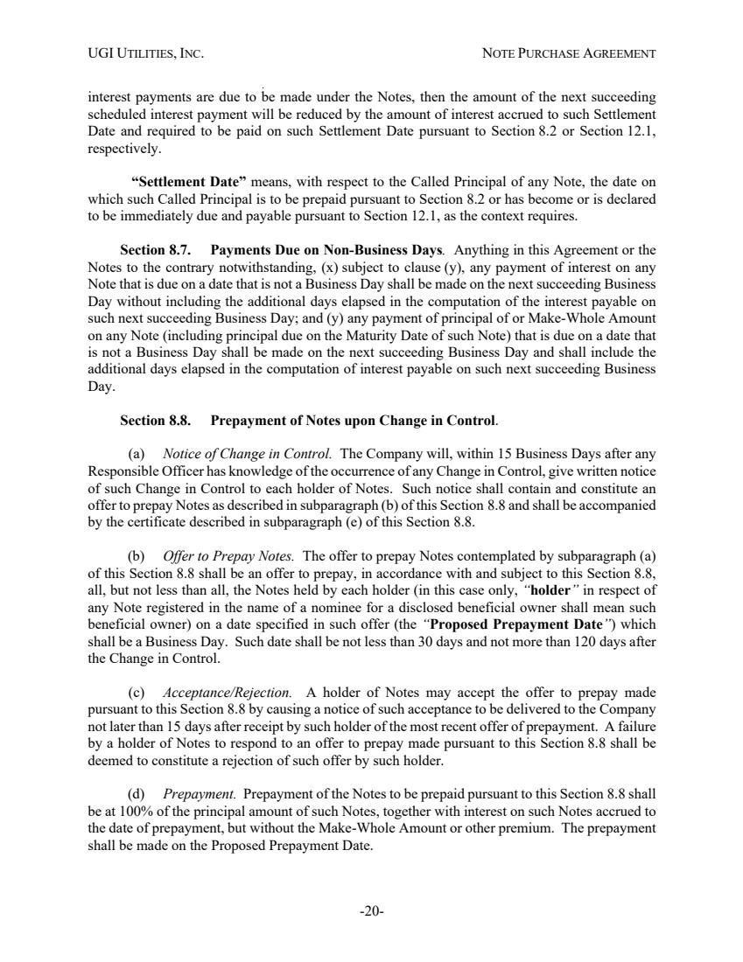 | UGI UTILITIES, INC. NOTE PURCHASE AGREEMENT -20- interest payments are due to be made under the Notes, then the amount of the next succeeding scheduled interest payment will be reduced by the amount of interest accrued to such Settlement Date and required to be paid on such Settlement Date pursuant to Section 8.2 or Section 12.1, respectively. “Settlement Date” means, with respect to the Called Principal of any Note, the date on which such Called Principal is to be prepaid pursuant to Section 8.2 or has become or is declared to be immediately due and payable pursuant to Section 12.1, as the context requires. Section 8.7. Payments Due on Non-Business Days. Anything in this Agreement or the Notes to the contrary notwithstanding, (x) subject to clause (y), any payment of interest on any Note that is due on a date that is not a Business Day shall be made on the next succeeding Business Day without including the additional days elapsed in the computation of the interest payable on such next succeeding Business Day; and (y) any payment of principal of or Make-Whole Amount on any Note (including principal due on the Maturity Date of such Note) that is due on a date that is not a Business Day shall be made on the next succeeding Business Day and shall include the additional days elapsed in the computation of interest payable on such next succeeding Business Day. Section 8.8. Prepayment of Notes upon Change in Control. (a) Notice of Change in Control. The Company will, within 15 Business Days after any Responsible Officer has knowledge of the occurrence of any Change in Control, give written notice of such Change in Control to each holder of Notes. Such notice shall contain and constitute an offer to prepay Notes as described in subparagraph (b) of this Section 8.8 and shall be accompanied by the certificate described in subparagraph (e) of this Section 8.8. (b) Offer to Prepay Notes. The offer to prepay Notes contemplated by subparagraph (a) of this Section 8.8 shall be an offer to prepay, in accordance with and subject to this Section 8.8, all, but not less than all, the Notes held by each holder (in this case only, “holder” in respect of any Note registered in the name of a nominee for a disclosed beneficial owner shall mean such beneficial owner) on a date specified in such offer (the “Proposed Prepayment Date”) which shall be a Business Day. Such date shall be not less than 30 days and not more than 120 days after the Change in Control. (c) Acceptance/Rejection. A holder of Notes may accept the offer to prepay made pursuant to this Section 8.8 by causing a notice of such acceptance to be delivered to the Company not later than 15 days after receipt by such holder of the most recent offer of prepayment. A failure by a holder of Notes to respond to an offer to prepay made pursuant to this Section 8.8 shall be deemed to constitute a rejection of such offer by such holder. (d) Prepayment. Prepayment of the Notes to be prepaid pursuant to this Section 8.8 shall be at 100% of the principal amount of such Notes, together with interest on such Notes accrued to the date of prepayment, but without the Make-Whole Amount or other premium. The prepayment shall be made on the Proposed Prepayment Date.
 | 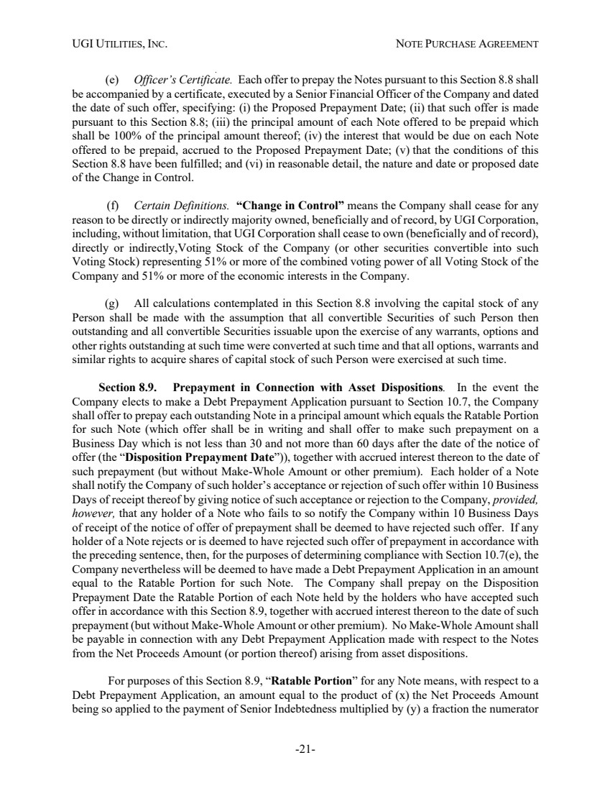 | UGI UTILITIES, INC. NOTE PURCHASE AGREEMENT -21- (e) Officer’s Certificate. Each offer to prepay the Notes pursuant to this Section 8.8 shall be accompanied by a certificate, executed by a Senior Financial Officer of the Company and dated the date of such offer, specifying: (i) the Proposed Prepayment Date; (ii) that such offer is made pursuant to this Section 8.8; (iii) the principal amount of each Note offered to be prepaid which shall be 100% of the principal amount thereof; (iv) the interest that would be due on each Note offered to be prepaid, accrued to the Proposed Prepayment Date; (v) that the conditions of this Section 8.8 have been fulfilled; and (vi) in reasonable detail, the nature and date or proposed date of the Change in Control. (f) Certain Definitions. “Change in Control” means the Company shall cease for any reason to be directly or indirectly majority owned, beneficially and of record, by UGI Corporation, including, without limitation, that UGI Corporation shall cease to own (beneficially and of record), directly or indirectly,Voting Stock of the Company (or other securities convertible into such Voting Stock) representing 51% or more of the combined voting power of all Voting Stock of the Company and 51% or more of the economic interests in the Company. (g) All calculations contemplated in this Section 8.8 involving the capital stock of any Person shall be made with the assumption that all convertible Securities of such Person then outstanding and all convertible Securities issuable upon the exercise of any warrants, options and other rights outstanding at such time were converted at such time and that all options, warrants and similar rights to acquire shares of capital stock of such Person were exercised at such time. Section 8.9. Prepayment in Connection with Asset Dispositions. In the event the Company elects to make a Debt Prepayment Application pursuant to Section 10.7, the Company shall offer to prepay each outstanding Note in a principal amount which equals the Ratable Portion for such Note (which offer shall be in writing and shall offer to make such prepayment on a Business Day which is not less than 30 and not more than 60 days after the date of the notice of offer (the “Disposition Prepayment Date”)), together with accrued interest thereon to the date of such prepayment (but without Make-Whole Amount or other premium). Each holder of a Note shall notify the Company of such holder’s acceptance or rejection of such offer within 10 Business Days of receipt thereof by giving notice of such acceptance or rejection to the Company, provided, however, that any holder of a Note who fails to so notify the Company within 10 Business Days of receipt of the notice of offer of prepayment shall be deemed to have rejected such offer. If any holder of a Note rejects or is deemed to have rejected such offer of prepayment in accordance with the preceding sentence, then, for the purposes of determining compliance with Section 10.7(e), the Company nevertheless will be deemed to have made a Debt Prepayment Application in an amount equal to the Ratable Portion for such Note. The Company shall prepay on the Disposition Prepayment Date the Ratable Portion of each Note held by the holders who have accepted such offer in accordance with this Section 8.9, together with accrued interest thereon to the date of such prepayment (but without Make-Whole Amount or other premium). No Make-Whole Amount shall be payable in connection with any Debt Prepayment Application made with respect to the Notes from the Net Proceeds Amount (or portion thereof) arising from asset dispositions. For purposes of this Section 8.9, “Ratable Portion” for any Note means, with respect to a Debt Prepayment Application, an amount equal to the product of (x) the Net Proceeds Amount being so applied to the payment of Senior Indebtedness multiplied by (y) a fraction the numerator
 | 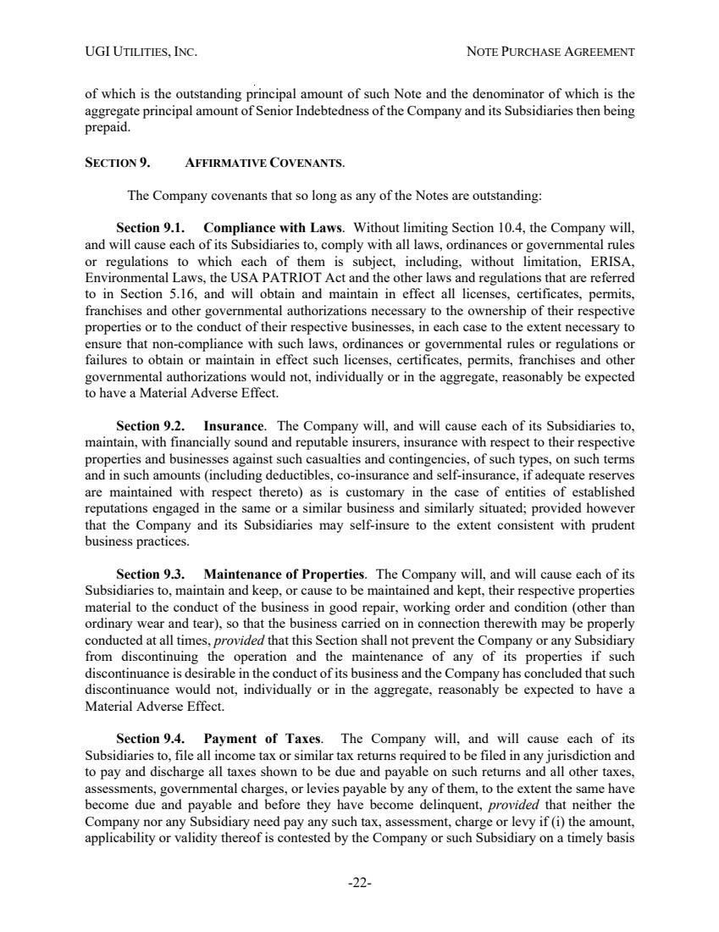 | UGI UTILITIES, INC. NOTE PURCHASE AGREEMENT -22- of which is the outstanding principal amount of such Note and the denominator of which is the aggregate principal amount of Senior Indebtedness of the Company and its Subsidiaries then being prepaid. SECTION 9. AFFIRMATIVE COVENANTS. The Company covenants that so long as any of the Notes are outstanding: Section 9.1. Compliance with Laws. Without limiting Section 10.4, the Company will, and will cause each of its Subsidiaries to, comply with all laws, ordinances or governmental rules or regulations to which each of them is subject, including, without limitation, ERISA, Environmental Laws, the USA PATRIOT Act and the other laws and regulations that are referred to in Section 5.16, and will obtain and maintain in effect all licenses, certificates, permits, franchises and other governmental authorizations necessary to the ownership of their respective properties or to the conduct of their respective businesses, in each case to the extent necessary to ensure that non-compliance with such laws, ordinances or governmental rules or regulations or failures to obtain or maintain in effect such licenses, certificates, permits, franchises and other governmental authorizations would not, individually or in the aggregate, reasonably be expected to have a Material Adverse Effect. Section 9.2. Insurance. The Company will, and will cause each of its Subsidiaries to, maintain, with financially sound and reputable insurers, insurance with respect to their respective properties and businesses against such casualties and contingencies, of such types, on such terms and in such amounts (including deductibles, co-insurance and self-insurance, if adequate reserves are maintained with respect thereto) as is customary in the case of entities of established reputations engaged in the same or a similar business and similarly situated; provided however that the Company and its Subsidiaries may self-insure to the extent consistent with prudent business practices. Section 9.3. Maintenance of Properties. The Company will, and will cause each of its Subsidiaries to, maintain and keep, or cause to be maintained and kept, their respective properties material to the conduct of the business in good repair, working order and condition (other than ordinary wear and tear), so that the business carried on in connection therewith may be properly conducted at all times, provided that this Section shall not prevent the Company or any Subsidiary from discontinuing the operation and the maintenance of any of its properties if such discontinuance is desirable in the conduct of its business and the Company has concluded that such discontinuance would not, individually or in the aggregate, reasonably be expected to have a Material Adverse Effect. Section 9.4. Payment of Taxes. The Company will, and will cause each of its Subsidiaries to, file all income tax or similar tax returns required to be filed in any jurisdiction and to pay and discharge all taxes shown to be due and payable on such returns and all other taxes, assessments, governmental charges, or levies payable by any of them, to the extent the same have become due and payable and before they have become delinquent, provided that neither the Company nor any Subsidiary need pay any such tax, assessment, charge or levy if (i) the amount, applicability or validity thereof is contested by the Company or such Subsidiary on a timely basis
 | 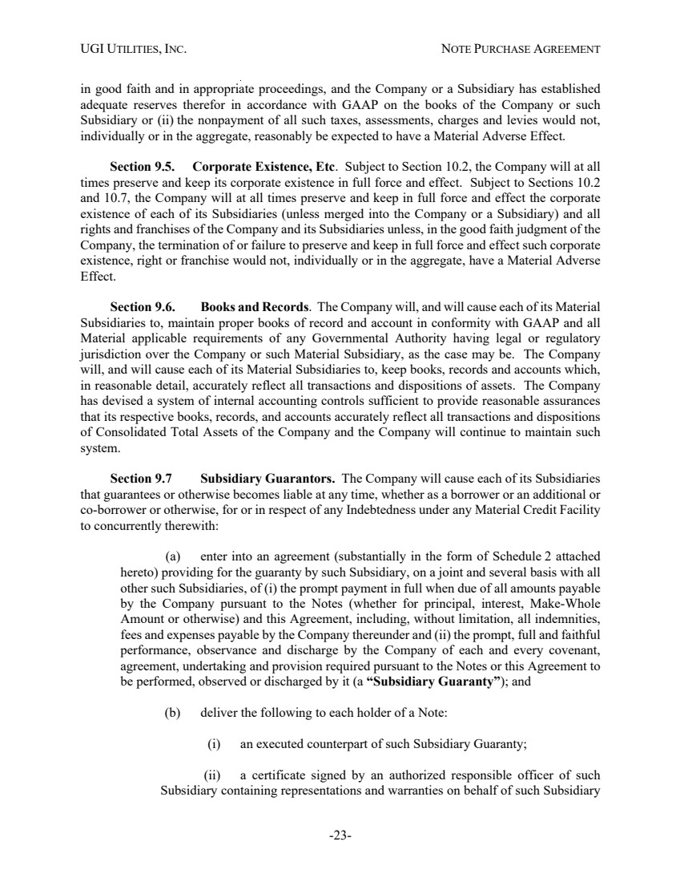 | UGI UTILITIES, INC. NOTE PURCHASE AGREEMENT -23- in good faith and in appropriate proceedings, and the Company or a Subsidiary has established adequate reserves therefor in accordance with GAAP on the books of the Company or such Subsidiary or (ii) the nonpayment of all such taxes, assessments, charges and levies would not, individually or in the aggregate, reasonably be expected to have a Material Adverse Effect. Section 9.5. Corporate Existence, Etc. Subject to Section 10.2, the Company will at all times preserve and keep its corporate existence in full force and effect. Subject to Sections 10.2 and 10.7, the Company will at all times preserve and keep in full force and effect the corporate existence of each of its Subsidiaries (unless merged into the Company or a Subsidiary) and all rights and franchises of the Company and its Subsidiaries unless, in the good faith judgment of the Company, the termination of or failure to preserve and keep in full force and effect such corporate existence, right or franchise would not, individually or in the aggregate, have a Material Adverse Effect. Section 9.6. Books and Records. The Company will, and will cause each of its Material Subsidiaries to, maintain proper books of record and account in conformity with GAAP and all Material applicable requirements of any Governmental Authority having legal or regulatory jurisdiction over the Company or such Material Subsidiary, as the case may be. The Company will, and will cause each of its Material Subsidiaries to, keep books, records and accounts which, in reasonable detail, accurately reflect all transactions and dispositions of assets. The Company has devised a system of internal accounting controls sufficient to provide reasonable assurances that its respective books, records, and accounts accurately reflect all transactions and dispositions of Consolidated Total Assets of the Company and the Company will continue to maintain such system. Section 9.7 Subsidiary Guarantors. The Company will cause each of its Subsidiaries that guarantees or otherwise becomes liable at any time, whether as a borrower or an additional or co-borrower or otherwise, for or in respect of any Indebtedness under any Material Credit Facility to concurrently therewith: (a) enter into an agreement (substantially in the form of Schedule 2 attached hereto) providing for the guaranty by such Subsidiary, on a joint and several basis with all other such Subsidiaries, of (i) the prompt payment in full when due of all amounts payable by the Company pursuant to the Notes (whether for principal, interest, Make-Whole Amount or otherwise) and this Agreement, including, without limitation, all indemnities, fees and expenses payable by the Company thereunder and (ii) the prompt, full and faithful performance, observance and discharge by the Company of each and every covenant, agreement, undertaking and provision required pursuant to the Notes or this Agreement to be performed, observed or discharged by it (a “Subsidiary Guaranty”); and (b) deliver the following to each holder of a Note: (i) an executed counterpart of such Subsidiary Guaranty; (ii) a certificate signed by an authorized responsible officer of such Subsidiary containing representations and warranties on behalf of such Subsidiary
 | 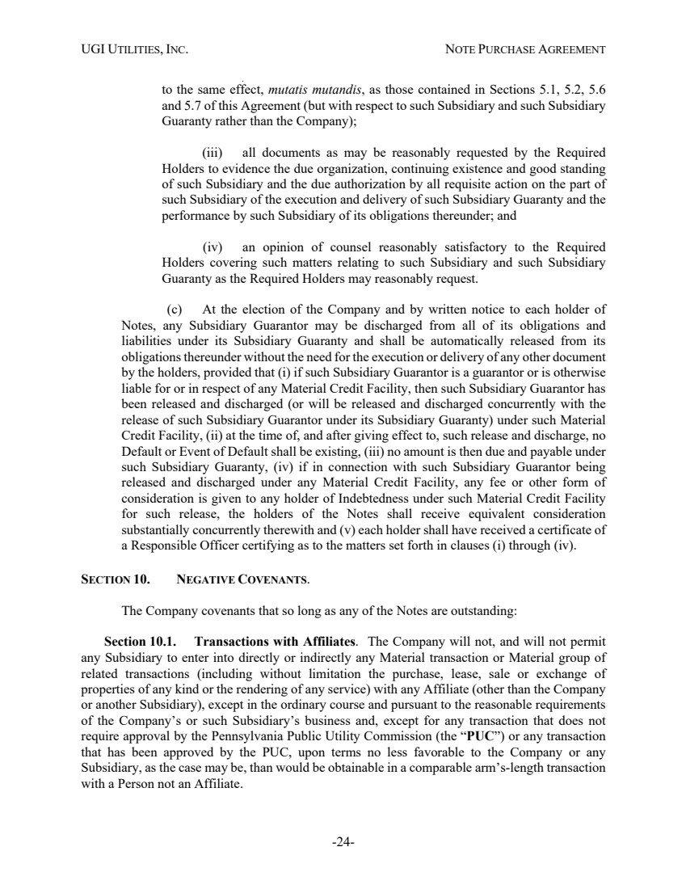 | UGI UTILITIES, INC. NOTE PURCHASE AGREEMENT -24- to the same effect, mutatis mutandis, as those contained in Sections 5.1, 5.2, 5.6 and 5.7 of this Agreement (but with respect to such Subsidiary and such Subsidiary Guaranty rather than the Company); (iii) all documents as may be reasonably requested by the Required Holders to evidence the due organization, continuing existence and good standing of such Subsidiary and the due authorization by all requisite action on the part of such Subsidiary of the execution and delivery of such Subsidiary Guaranty and the performance by such Subsidiary of its obligations thereunder; and (iv) an opinion of counsel reasonably satisfactory to the Required Holders covering such matters relating to such Subsidiary and such Subsidiary Guaranty as the Required Holders may reasonably request. (c) At the election of the Company and by written notice to each holder of Notes, any Subsidiary Guarantor may be discharged from all of its obligations and liabilities under its Subsidiary Guaranty and shall be automatically released from its obligations thereunder without the need for the execution or delivery of any other document by the holders, provided that (i) if such Subsidiary Guarantor is a guarantor or is otherwise liable for or in respect of any Material Credit Facility, then such Subsidiary Guarantor has been released and discharged (or will be released and discharged concurrently with the release of such Subsidiary Guarantor under its Subsidiary Guaranty) under such Material Credit Facility, (ii) at the time of, and after giving effect to, such release and discharge, no Default or Event of Default shall be existing, (iii) no amount is then due and payable under such Subsidiary Guaranty, (iv) if in connection with such Subsidiary Guarantor being released and discharged under any Material Credit Facility, any fee or other form of consideration is given to any holder of Indebtedness under such Material Credit Facility for such release, the holders of the Notes shall receive equivalent consideration substantially concurrently therewith and (v) each holder shall have received a certificate of a Responsible Officer certifying as to the matters set forth in clauses (i) through (iv). SECTION 10. NEGATIVE COVENANTS. The Company covenants that so long as any of the Notes are outstanding: Section 10.1. Transactions with Affiliates. The Company will not, and will not permit any Subsidiary to enter into directly or indirectly any Material transaction or Material group of related transactions (including without limitation the purchase, lease, sale or exchange of properties of any kind or the rendering of any service) with any Affiliate (other than the Company or another Subsidiary), except in the ordinary course and pursuant to the reasonable requirements of the Company’s or such Subsidiary’s business and, except for any transaction that does not require approval by the Pennsylvania Public Utility Commission (the “PUC”) or any transaction that has been approved by the PUC, upon terms no less favorable to the Company or any Subsidiary, as the case may be, than would be obtainable in a comparable arm’s-length transaction with a Person not an Affiliate.
 | 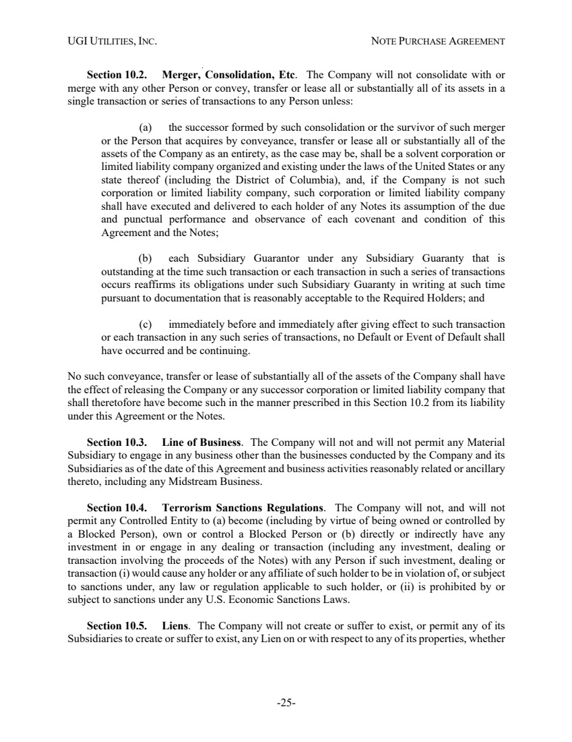 | UGI UTILITIES, INC. NOTE PURCHASE AGREEMENT -25- Section 10.2. Merger, Consolidation, Etc. The Company will not consolidate with or merge with any other Person or convey, transfer or lease all or substantially all of its assets in a single transaction or series of transactions to any Person unless: (a) the successor formed by such consolidation or the survivor of such merger or the Person that acquires by conveyance, transfer or lease all or substantially all of the assets of the Company as an entirety, as the case may be, shall be a solvent corporation or limited liability company organized and existing under the laws of the United States or any state thereof (including the District of Columbia), and, if the Company is not such corporation or limited liability company, such corporation or limited liability company shall have executed and delivered to each holder of any Notes its assumption of the due and punctual performance and observance of each covenant and condition of this Agreement and the Notes; (b) each Subsidiary Guarantor under any Subsidiary Guaranty that is outstanding at the time such transaction or each transaction in such a series of transactions occurs reaffirms its obligations under such Subsidiary Guaranty in writing at such time pursuant to documentation that is reasonably acceptable to the Required Holders; and (c) immediately before and immediately after giving effect to such transaction or each transaction in any such series of transactions, no Default or Event of Default shall have occurred and be continuing. No such conveyance, transfer or lease of substantially all of the assets of the Company shall have the effect of releasing the Company or any successor corporation or limited liability company that shall theretofore have become such in the manner prescribed in this Section 10.2 from its liability under this Agreement or the Notes. Section 10.3. Line of Business. The Company will not and will not permit any Material Subsidiary to engage in any business other than the businesses conducted by the Company and its Subsidiaries as of the date of this Agreement and business activities reasonably related or ancillary thereto, including any Midstream Business. Section 10.4. Terrorism Sanctions Regulations. The Company will not, and will not permit any Controlled Entity to (a) become (including by virtue of being owned or controlled by a Blocked Person), own or control a Blocked Person or (b) directly or indirectly have any investment in or engage in any dealing or transaction (including any investment, dealing or transaction involving the proceeds of the Notes) with any Person if such investment, dealing or transaction (i) would cause any holder or any affiliate of such holder to be in violation of, or subject to sanctions under, any law or regulation applicable to such holder, or (ii) is prohibited by or subject to sanctions under any U.S. Economic Sanctions Laws. Section 10.5. Liens. The Company will not create or suffer to exist, or permit any of its Subsidiaries to create or suffer to exist, any Lien on or with respect to any of its properties, whether
 | 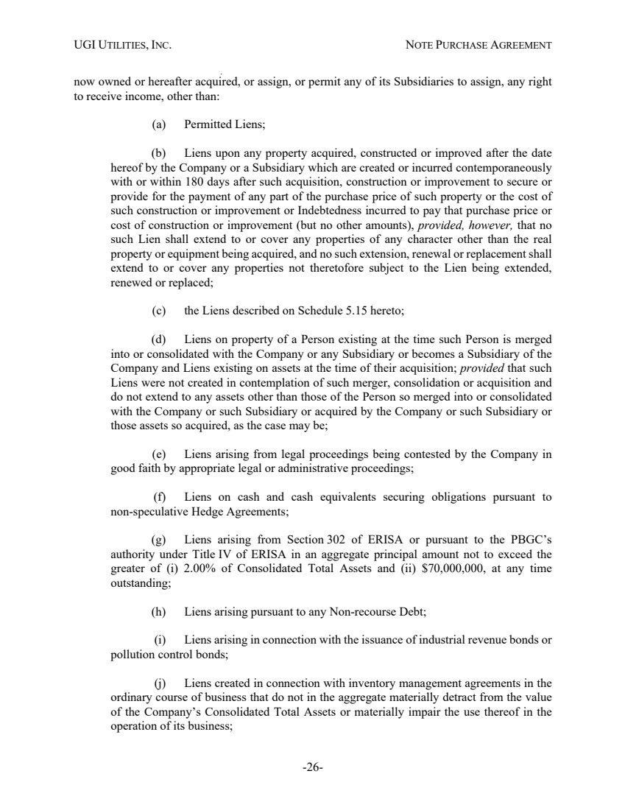 | UGI UTILITIES, INC. NOTE PURCHASE AGREEMENT -26- now owned or hereafter acquired, or assign, or permit any of its Subsidiaries to assign, any right to receive income, other than: (a) Permitted Liens; (b) Liens upon any property acquired, constructed or improved after the date hereof by the Company or a Subsidiary which are created or incurred contemporaneously with or within 180 days after such acquisition, construction or improvement to secure or provide for the payment of any part of the purchase price of such property or the cost of such construction or improvement or Indebtedness incurred to pay that purchase price or cost of construction or improvement (but no other amounts), provided, however, that no such Lien shall extend to or cover any properties of any character other than the real property or equipment being acquired, and no such extension, renewal or replacement shall extend to or cover any properties not theretofore subject to the Lien being extended, renewed or replaced; (c) the Liens described on Schedule 5.15 hereto; (d) Liens on property of a Person existing at the time such Person is merged into or consolidated with the Company or any Subsidiary or becomes a Subsidiary of the Company and Liens existing on assets at the time of their acquisition; provided that such Liens were not created in contemplation of such merger, consolidation or acquisition and do not extend to any assets other than those of the Person so merged into or consolidated with the Company or such Subsidiary or acquired by the Company or such Subsidiary or those assets so acquired, as the case may be; (e) Liens arising from legal proceedings being contested by the Company in good faith by appropriate legal or administrative proceedings; (f) Liens on cash and cash equivalents securing obligations pursuant to non-speculative Hedge Agreements; (g) Liens arising from Section 302 of ERISA or pursuant to the PBGC’s authority under Title IV of ERISA in an aggregate principal amount not to exceed the greater of (i) 2.00% of Consolidated Total Assets and (ii) $70,000,000, at any time outstanding; (h) Liens arising pursuant to any Non-recourse Debt; (i) Liens arising in connection with the issuance of industrial revenue bonds or pollution control bonds; (j) Liens created in connection with inventory management agreements in the ordinary course of business that do not in the aggregate materially detract from the value of the Company’s Consolidated Total Assets or materially impair the use thereof in the operation of its business;
 | 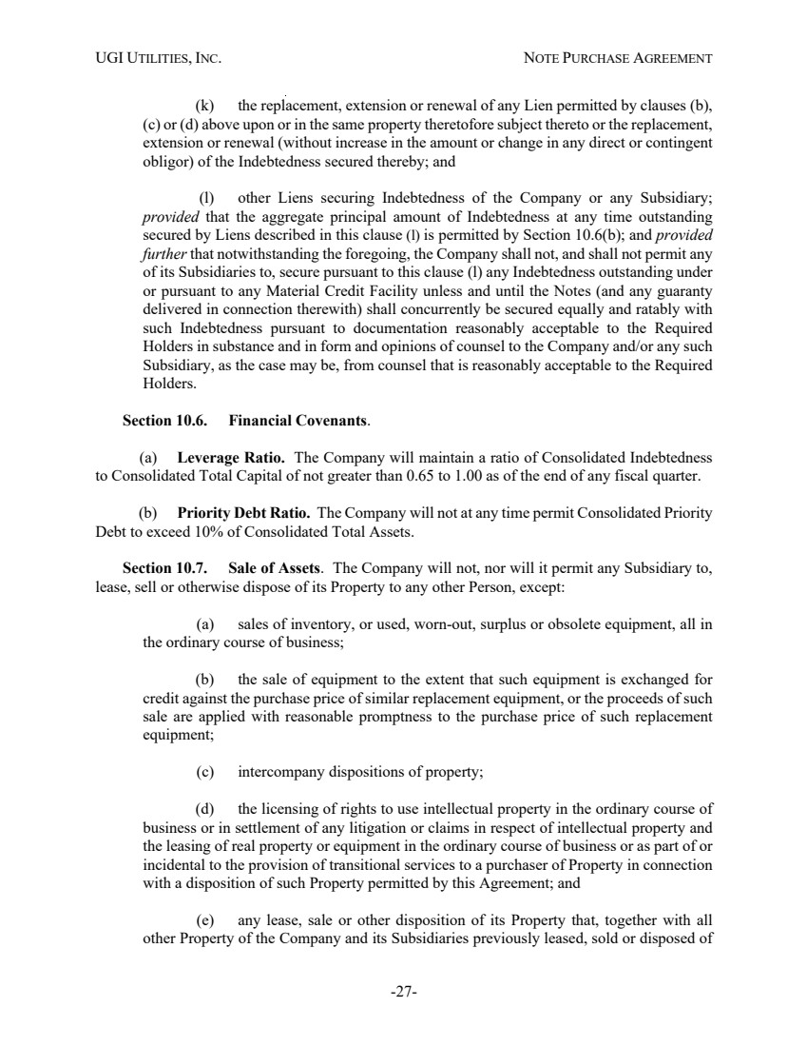 | UGI UTILITIES, INC. NOTE PURCHASE AGREEMENT -27- (k) the replacement, extension or renewal of any Lien permitted by clauses (b), (c) or (d) above upon or in the same property theretofore subject thereto or the replacement, extension or renewal (without increase in the amount or change in any direct or contingent obligor) of the Indebtedness secured thereby; and (l) other Liens securing Indebtedness of the Company or any Subsidiary; provided that the aggregate principal amount of Indebtedness at any time outstanding secured by Liens described in this clause (l) is permitted by Section 10.6(b); and provided further that notwithstanding the foregoing, the Company shall not, and shall not permit any of its Subsidiaries to, secure pursuant to this clause (l) any Indebtedness outstanding under or pursuant to any Material Credit Facility unless and until the Notes (and any guaranty delivered in connection therewith) shall concurrently be secured equally and ratably with such Indebtedness pursuant to documentation reasonably acceptable to the Required Holders in substance and in form and opinions of counsel to the Company and/or any such Subsidiary, as the case may be, from counsel that is reasonably acceptable to the Required Holders. Section 10.6. Financial Covenants. (a) Leverage Ratio. The Company will maintain a ratio of Consolidated Indebtedness to Consolidated Total Capital of not greater than 0.65 to 1.00 as of the end of any fiscal quarter. (b) Priority Debt Ratio. The Company will not at any time permit Consolidated Priority Debt to exceed 10% of Consolidated Total Assets. Section 10.7. Sale of Assets. The Company will not, nor will it permit any Subsidiary to, lease, sell or otherwise dispose of its Property to any other Person, except: (a) sales of inventory, or used, worn-out, surplus or obsolete equipment, all in the ordinary course of business; (b) the sale of equipment to the extent that such equipment is exchanged for credit against the purchase price of similar replacement equipment, or the proceeds of such sale are applied with reasonable promptness to the purchase price of such replacement equipment; (c) intercompany dispositions of property; (d) the licensing of rights to use intellectual property in the ordinary course of business or in settlement of any litigation or claims in respect of intellectual property and the leasing of real property or equipment in the ordinary course of business or as part of or incidental to the provision of transitional services to a purchaser of Property in connection with a disposition of such Property permitted by this Agreement; and (e) any lease, sale or other disposition of its Property that, together with all other Property of the Company and its Subsidiaries previously leased, sold or disposed of
 | 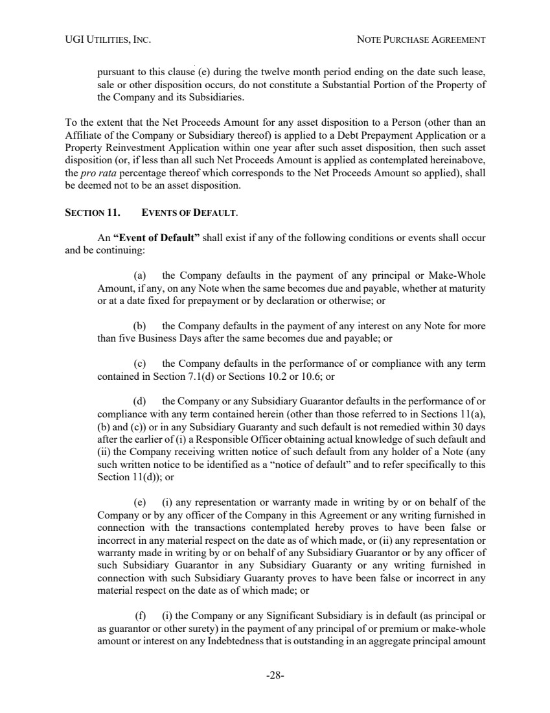 | UGI UTILITIES, INC. NOTE PURCHASE AGREEMENT -28- pursuant to this clause (e) during the twelve month period ending on the date such lease, sale or other disposition occurs, do not constitute a Substantial Portion of the Property of the Company and its Subsidiaries. To the extent that the Net Proceeds Amount for any asset disposition to a Person (other than an Affiliate of the Company or Subsidiary thereof) is applied to a Debt Prepayment Application or a Property Reinvestment Application within one year after such asset disposition, then such asset disposition (or, if less than all such Net Proceeds Amount is applied as contemplated hereinabove, the pro rata percentage thereof which corresponds to the Net Proceeds Amount so applied), shall be deemed not to be an asset disposition. SECTION 11. EVENTS OF DEFAULT. An “Event of Default” shall exist if any of the following conditions or events shall occur and be continuing: (a) the Company defaults in the payment of any principal or Make-Whole Amount, if any, on any Note when the same becomes due and payable, whether at maturity or at a date fixed for prepayment or by declaration or otherwise; or (b) the Company defaults in the payment of any interest on any Note for more than five Business Days after the same becomes due and payable; or (c) the Company defaults in the performance of or compliance with any term contained in Section 7.1(d) or Sections 10.2 or 10.6; or (d) the Company or any Subsidiary Guarantor defaults in the performance of or compliance with any term contained herein (other than those referred to in Sections 11(a), (b) and (c)) or in any Subsidiary Guaranty and such default is not remedied within 30 days after the earlier of (i) a Responsible Officer obtaining actual knowledge of such default and (ii) the Company receiving written notice of such default from any holder of a Note (any such written notice to be identified as a “notice of default” and to refer specifically to this Section 11(d)); or (e) (i) any representation or warranty made in writing by or on behalf of the Company or by any officer of the Company in this Agreement or any writing furnished in connection with the transactions contemplated hereby proves to have been false or incorrect in any material respect on the date as of which made, or (ii) any representation or warranty made in writing by or on behalf of any Subsidiary Guarantor or by any officer of such Subsidiary Guarantor in any Subsidiary Guaranty or any writing furnished in connection with such Subsidiary Guaranty proves to have been false or incorrect in any material respect on the date as of which made; or (f) (i) the Company or any Significant Subsidiary is in default (as principal or as guarantor or other surety) in the payment of any principal of or premium or make-whole amount or interest on any Indebtedness that is outstanding in an aggregate principal amount
 | 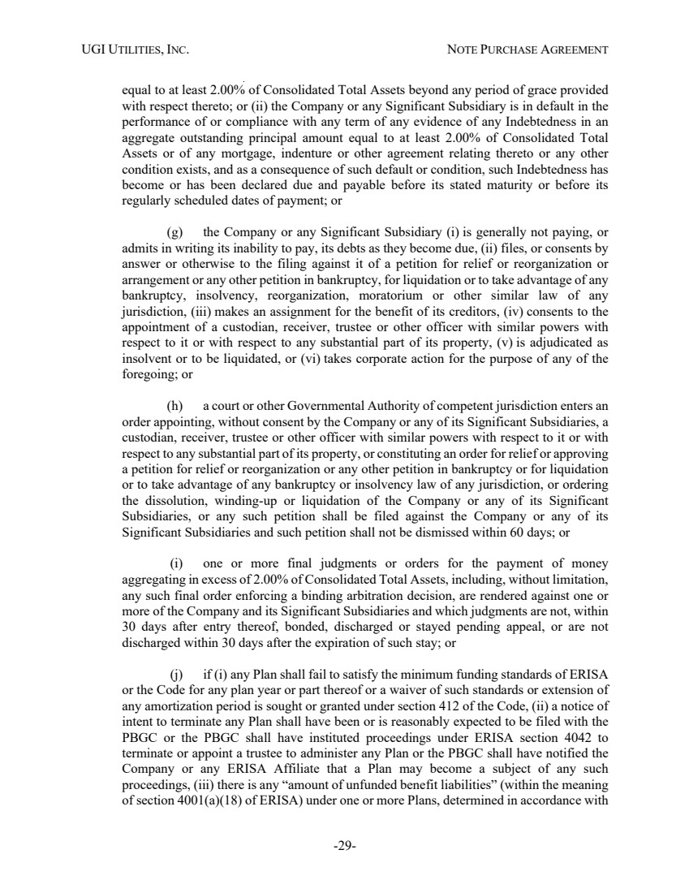 | UGI UTILITIES, INC. NOTE PURCHASE AGREEMENT -29- equal to at least 2.00% of Consolidated Total Assets beyond any period of grace provided with respect thereto; or (ii) the Company or any Significant Subsidiary is in default in the performance of or compliance with any term of any evidence of any Indebtedness in an aggregate outstanding principal amount equal to at least 2.00% of Consolidated Total Assets or of any mortgage, indenture or other agreement relating thereto or any other condition exists, and as a consequence of such default or condition, such Indebtedness has become or has been declared due and payable before its stated maturity or before its regularly scheduled dates of payment; or (g) the Company or any Significant Subsidiary (i) is generally not paying, or admits in writing its inability to pay, its debts as they become due, (ii) files, or consents by answer or otherwise to the filing against it of a petition for relief or reorganization or arrangement or any other petition in bankruptcy, for liquidation or to take advantage of any bankruptcy, insolvency, reorganization, moratorium or other similar law of any jurisdiction, (iii) makes an assignment for the benefit of its creditors, (iv) consents to the appointment of a custodian, receiver, trustee or other officer with similar powers with respect to it or with respect to any substantial part of its property, (v) is adjudicated as insolvent or to be liquidated, or (vi) takes corporate action for the purpose of any of the foregoing; or (h) a court or other Governmental Authority of competent jurisdiction enters an order appointing, without consent by the Company or any of its Significant Subsidiaries, a custodian, receiver, trustee or other officer with similar powers with respect to it or with respect to any substantial part of its property, or constituting an order for relief or approving a petition for relief or reorganization or any other petition in bankruptcy or for liquidation or to take advantage of any bankruptcy or insolvency law of any jurisdiction, or ordering the dissolution, winding-up or liquidation of the Company or any of its Significant Subsidiaries, or any such petition shall be filed against the Company or any of its Significant Subsidiaries and such petition shall not be dismissed within 60 days; or (i) one or more final judgments or orders for the payment of money aggregating in excess of 2.00% of Consolidated Total Assets, including, without limitation, any such final order enforcing a binding arbitration decision, are rendered against one or more of the Company and its Significant Subsidiaries and which judgments are not, within 30 days after entry thereof, bonded, discharged or stayed pending appeal, or are not discharged within 30 days after the expiration of such stay; or (j) if (i) any Plan shall fail to satisfy the minimum funding standards of ERISA or the Code for any plan year or part thereof or a waiver of such standards or extension of any amortization period is sought or granted under section 412 of the Code, (ii) a notice of intent to terminate any Plan shall have been or is reasonably expected to be filed with the PBGC or the PBGC shall have instituted proceedings under ERISA section 4042 to terminate or appoint a trustee to administer any Plan or the PBGC shall have notified the Company or any ERISA Affiliate that a Plan may become a subject of any such proceedings, (iii) there is any “amount of unfunded benefit liabilities” (within the meaning of section 4001(a)(18) of ERISA) under one or more Plans, determined in accordance with
 | 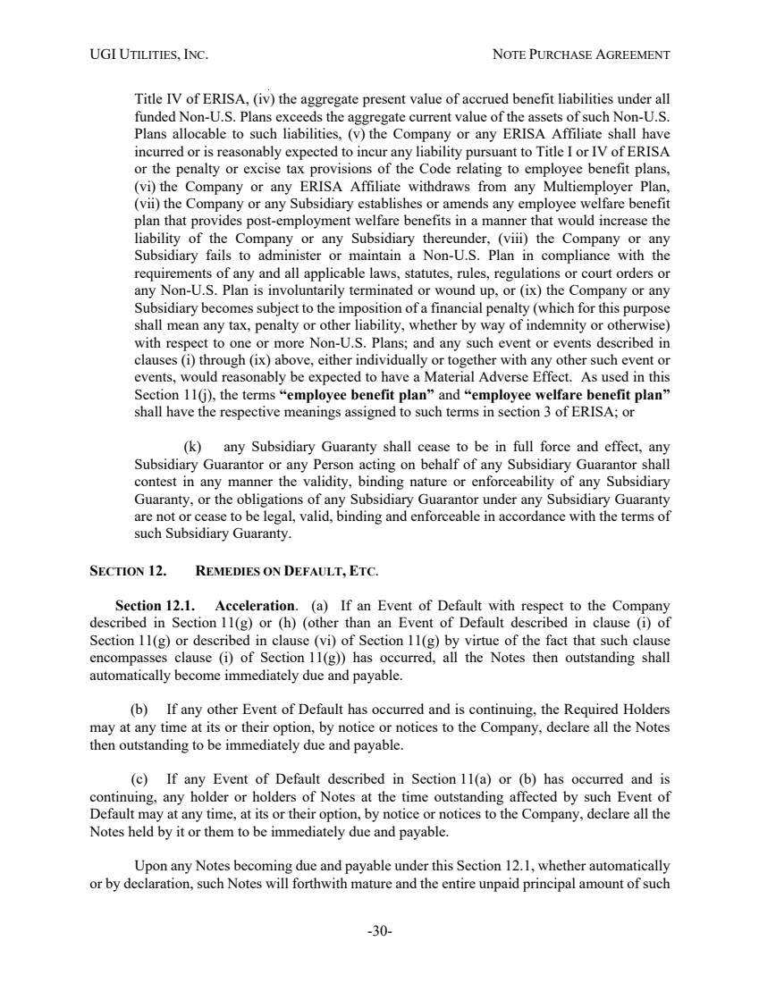 | UGI UTILITIES, INC. NOTE PURCHASE AGREEMENT -30- Title IV of ERISA, (iv) the aggregate present value of accrued benefit liabilities under all funded Non-U.S. Plans exceeds the aggregate current value of the assets of such Non-U.S. Plans allocable to such liabilities, (v) the Company or any ERISA Affiliate shall have incurred or is reasonably expected to incur any liability pursuant to Title I or IV of ERISA or the penalty or excise tax provisions of the Code relating to employee benefit plans, (vi) the Company or any ERISA Affiliate withdraws from any Multiemployer Plan, (vii) the Company or any Subsidiary establishes or amends any employee welfare benefit plan that provides post-employment welfare benefits in a manner that would increase the liability of the Company or any Subsidiary thereunder, (viii) the Company or any Subsidiary fails to administer or maintain a Non-U.S. Plan in compliance with the requirements of any and all applicable laws, statutes, rules, regulations or court orders or any Non-U.S. Plan is involuntarily terminated or wound up, or (ix) the Company or any Subsidiary becomes subject to the imposition of a financial penalty (which for this purpose shall mean any tax, penalty or other liability, whether by way of indemnity or otherwise) with respect to one or more Non-U.S. Plans; and any such event or events described in clauses (i) through (ix) above, either individually or together with any other such event or events, would reasonably be expected to have a Material Adverse Effect. As used in this Section 11(j), the terms “employee benefit plan” and “employee welfare benefit plan” shall have the respective meanings assigned to such terms in section 3 of ERISA; or (k) any Subsidiary Guaranty shall cease to be in full force and effect, any Subsidiary Guarantor or any Person acting on behalf of any Subsidiary Guarantor shall contest in any manner the validity, binding nature or enforceability of any Subsidiary Guaranty, or the obligations of any Subsidiary Guarantor under any Subsidiary Guaranty are not or cease to be legal, valid, binding and enforceable in accordance with the terms of such Subsidiary Guaranty. SECTION 12. REMEDIES ON DEFAULT, ETC. Section 12.1. Acceleration. (a) If an Event of Default with respect to the Company described in Section 11(g) or (h) (other than an Event of Default described in clause (i) of Section 11(g) or described in clause (vi) of Section 11(g) by virtue of the fact that such clause encompasses clause (i) of Section 11(g)) has occurred, all the Notes then outstanding shall automatically become immediately due and payable. (b) If any other Event of Default has occurred and is continuing, the Required Holders may at any time at its or their option, by notice or notices to the Company, declare all the Notes then outstanding to be immediately due and payable. (c) If any Event of Default described in Section 11(a) or (b) has occurred and is continuing, any holder or holders of Notes at the time outstanding affected by such Event of Default may at any time, at its or their option, by notice or notices to the Company, declare all the Notes held by it or them to be immediately due and payable. Upon any Notes becoming due and payable under this Section 12.1, whether automatically or by declaration, such Notes will forthwith mature and the entire unpaid principal amount of such
 | 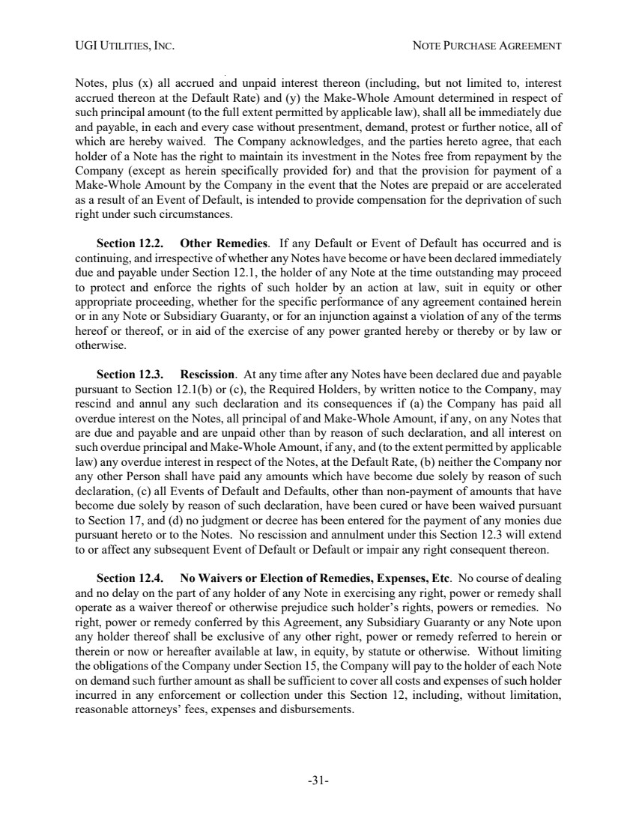 | UGI UTILITIES, INC. NOTE PURCHASE AGREEMENT -31- Notes, plus (x) all accrued and unpaid interest thereon (including, but not limited to, interest accrued thereon at the Default Rate) and (y) the Make-Whole Amount determined in respect of such principal amount (to the full extent permitted by applicable law), shall all be immediately due and payable, in each and every case without presentment, demand, protest or further notice, all of which are hereby waived. The Company acknowledges, and the parties hereto agree, that each holder of a Note has the right to maintain its investment in the Notes free from repayment by the Company (except as herein specifically provided for) and that the provision for payment of a Make-Whole Amount by the Company in the event that the Notes are prepaid or are accelerated as a result of an Event of Default, is intended to provide compensation for the deprivation of such right under such circumstances. Section 12.2. Other Remedies. If any Default or Event of Default has occurred and is continuing, and irrespective of whether any Notes have become or have been declared immediately due and payable under Section 12.1, the holder of any Note at the time outstanding may proceed to protect and enforce the rights of such holder by an action at law, suit in equity or other appropriate proceeding, whether for the specific performance of any agreement contained herein or in any Note or Subsidiary Guaranty, or for an injunction against a violation of any of the terms hereof or thereof, or in aid of the exercise of any power granted hereby or thereby or by law or otherwise. Section 12.3. Rescission. At any time after any Notes have been declared due and payable pursuant to Section 12.1(b) or (c), the Required Holders, by written notice to the Company, may rescind and annul any such declaration and its consequences if (a) the Company has paid all overdue interest on the Notes, all principal of and Make-Whole Amount, if any, on any Notes that are due and payable and are unpaid other than by reason of such declaration, and all interest on such overdue principal and Make-Whole Amount, if any, and (to the extent permitted by applicable law) any overdue interest in respect of the Notes, at the Default Rate, (b) neither the Company nor any other Person shall have paid any amounts which have become due solely by reason of such declaration, (c) all Events of Default and Defaults, other than non-payment of amounts that have become due solely by reason of such declaration, have been cured or have been waived pursuant to Section 17, and (d) no judgment or decree has been entered for the payment of any monies due pursuant hereto or to the Notes. No rescission and annulment under this Section 12.3 will extend to or affect any subsequent Event of Default or Default or impair any right consequent thereon. Section 12.4. No Waivers or Election of Remedies, Expenses, Etc. No course of dealing and no delay on the part of any holder of any Note in exercising any right, power or remedy shall operate as a waiver thereof or otherwise prejudice such holder’s rights, powers or remedies. No right, power or remedy conferred by this Agreement, any Subsidiary Guaranty or any Note upon any holder thereof shall be exclusive of any other right, power or remedy referred to herein or therein or now or hereafter available at law, in equity, by statute or otherwise. Without limiting the obligations of the Company under Section 15, the Company will pay to the holder of each Note on demand such further amount as shall be sufficient to cover all costs and expenses of such holder incurred in any enforcement or collection under this Section 12, including, without limitation, reasonable attorneys’ fees, expenses and disbursements.
 | 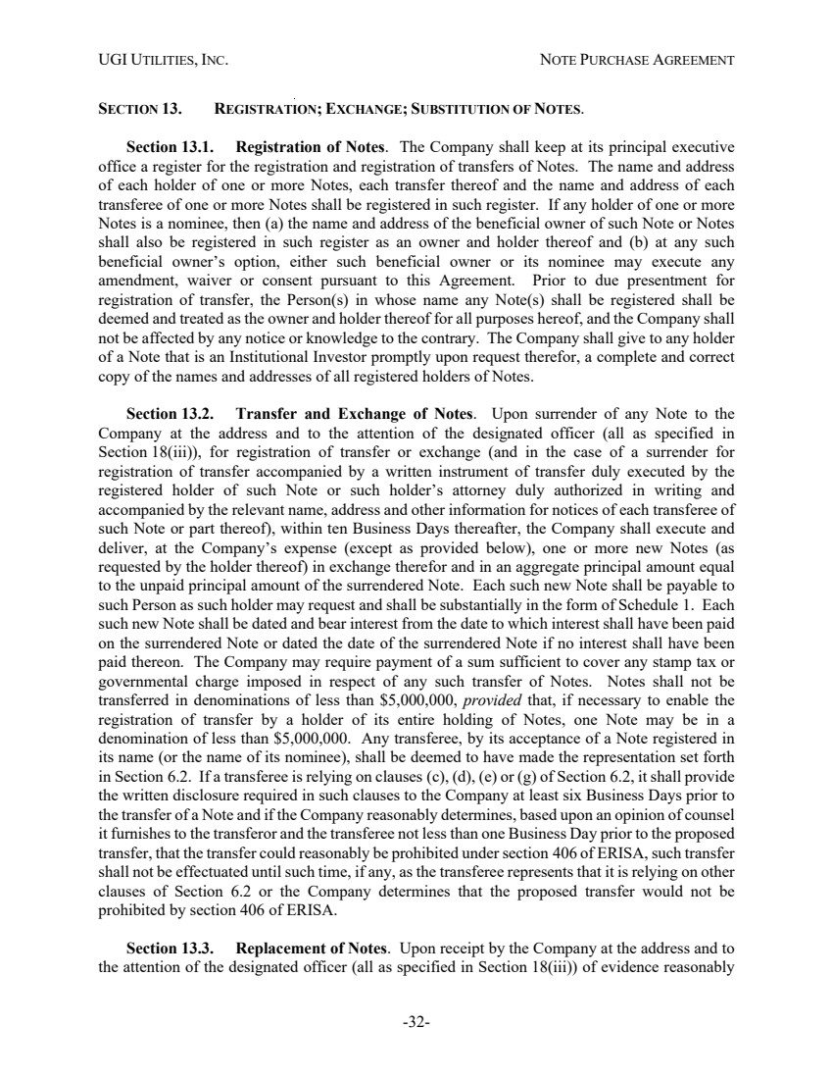 | UGI UTILITIES, INC. NOTE PURCHASE AGREEMENT -32- SECTION 13. REGISTRATION; EXCHANGE; SUBSTITUTION OF NOTES. Section 13.1. Registration of Notes. The Company shall keep at its principal executive office a register for the registration and registration of transfers of Notes. The name and address of each holder of one or more Notes, each transfer thereof and the name and address of each transferee of one or more Notes shall be registered in such register. If any holder of one or more Notes is a nominee, then (a) the name and address of the beneficial owner of such Note or Notes shall also be registered in such register as an owner and holder thereof and (b) at any such beneficial owner’s option, either such beneficial owner or its nominee may execute any amendment, waiver or consent pursuant to this Agreement. Prior to due presentment for registration of transfer, the Person(s) in whose name any Note(s) shall be registered shall be deemed and treated as the owner and holder thereof for all purposes hereof, and the Company shall not be affected by any notice or knowledge to the contrary. The Company shall give to any holder of a Note that is an Institutional Investor promptly upon request therefor, a complete and correct copy of the names and addresses of all registered holders of Notes. Section 13.2. Transfer and Exchange of Notes. Upon surrender of any Note to the Company at the address and to the attention of the designated officer (all as specified in Section 18(iii)), for registration of transfer or exchange (and in the case of a surrender for registration of transfer accompanied by a written instrument of transfer duly executed by the registered holder of such Note or such holder’s attorney duly authorized in writing and accompanied by the relevant name, address and other information for notices of each transferee of such Note or part thereof), within ten Business Days thereafter, the Company shall execute and deliver, at the Company’s expense (except as provided below), one or more new Notes (as requested by the holder thereof) in exchange therefor and in an aggregate principal amount equal to the unpaid principal amount of the surrendered Note. Each such new Note shall be payable to such Person as such holder may request and shall be substantially in the form of Schedule 1. Each such new Note shall be dated and bear interest from the date to which interest shall have been paid on the surrendered Note or dated the date of the surrendered Note if no interest shall have been paid thereon. The Company may require payment of a sum sufficient to cover any stamp tax or governmental charge imposed in respect of any such transfer of Notes. Notes shall not be transferred in denominations of less than $5,000,000, provided that, if necessary to enable the registration of transfer by a holder of its entire holding of Notes, one Note may be in a denomination of less than $5,000,000. Any transferee, by its acceptance of a Note registered in its name (or the name of its nominee), shall be deemed to have made the representation set forth in Section 6.2. If a transferee is relying on clauses (c), (d), (e) or (g) of Section 6.2, it shall provide the written disclosure required in such clauses to the Company at least six Business Days prior to the transfer of a Note and if the Company reasonably determines, based upon an opinion of counsel it furnishes to the transferor and the transferee not less than one Business Day prior to the proposed transfer, that the transfer could reasonably be prohibited under section 406 of ERISA, such transfer shall not be effectuated until such time, if any, as the transferee represents that it is relying on other clauses of Section 6.2 or the Company determines that the proposed transfer would not be prohibited by section 406 of ERISA. Section 13.3. Replacement of Notes. Upon receipt by the Company at the address and to the attention of the designated officer (all as specified in Section 18(iii)) of evidence reasonably
 | 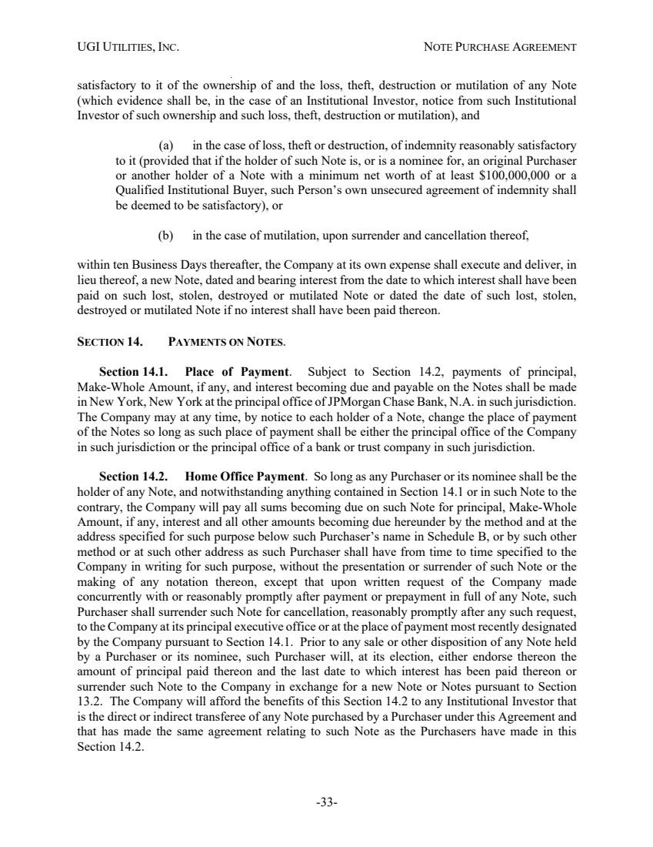 | UGI UTILITIES, INC. NOTE PURCHASE AGREEMENT -33- satisfactory to it of the ownership of and the loss, theft, destruction or mutilation of any Note (which evidence shall be, in the case of an Institutional Investor, notice from such Institutional Investor of such ownership and such loss, theft, destruction or mutilation), and (a) in the case of loss, theft or destruction, of indemnity reasonably satisfactory to it (provided that if the holder of such Note is, or is a nominee for, an original Purchaser or another holder of a Note with a minimum net worth of at least $100,000,000 or a Qualified Institutional Buyer, such Person’s own unsecured agreement of indemnity shall be deemed to be satisfactory), or (b) in the case of mutilation, upon surrender and cancellation thereof, within ten Business Days thereafter, the Company at its own expense shall execute and deliver, in lieu thereof, a new Note, dated and bearing interest from the date to which interest shall have been paid on such lost, stolen, destroyed or mutilated Note or dated the date of such lost, stolen, destroyed or mutilated Note if no interest shall have been paid thereon. SECTION 14. PAYMENTS ON NOTES. Section 14.1. Place of Payment. Subject to Section 14.2, payments of principal, Make-Whole Amount, if any, and interest becoming due and payable on the Notes shall be made in New York, New York at the principal office of JPMorgan Chase Bank, N.A. in such jurisdiction. The Company may at any time, by notice to each holder of a Note, change the place of payment of the Notes so long as such place of payment shall be either the principal office of the Company in such jurisdiction or the principal office of a bank or trust company in such jurisdiction. Section 14.2. Home Office Payment. So long as any Purchaser or its nominee shall be the holder of any Note, and notwithstanding anything contained in Section 14.1 or in such Note to the contrary, the Company will pay all sums becoming due on such Note for principal, Make-Whole Amount, if any, interest and all other amounts becoming due hereunder by the method and at the address specified for such purpose below such Purchaser’s name in Schedule B, or by such other method or at such other address as such Purchaser shall have from time to time specified to the Company in writing for such purpose, without the presentation or surrender of such Note or the making of any notation thereon, except that upon written request of the Company made concurrently with or reasonably promptly after payment or prepayment in full of any Note, such Purchaser shall surrender such Note for cancellation, reasonably promptly after any such request, to the Company at its principal executive office or at the place of payment most recently designated by the Company pursuant to Section 14.1. Prior to any sale or other disposition of any Note held by a Purchaser or its nominee, such Purchaser will, at its election, either endorse thereon the amount of principal paid thereon and the last date to which interest has been paid thereon or surrender such Note to the Company in exchange for a new Note or Notes pursuant to Section 13.2. The Company will afford the benefits of this Section 14.2 to any Institutional Investor that is the direct or indirect transferee of any Note purchased by a Purchaser under this Agreement and that has made the same agreement relating to such Note as the Purchasers have made in this Section 14.2.
 | 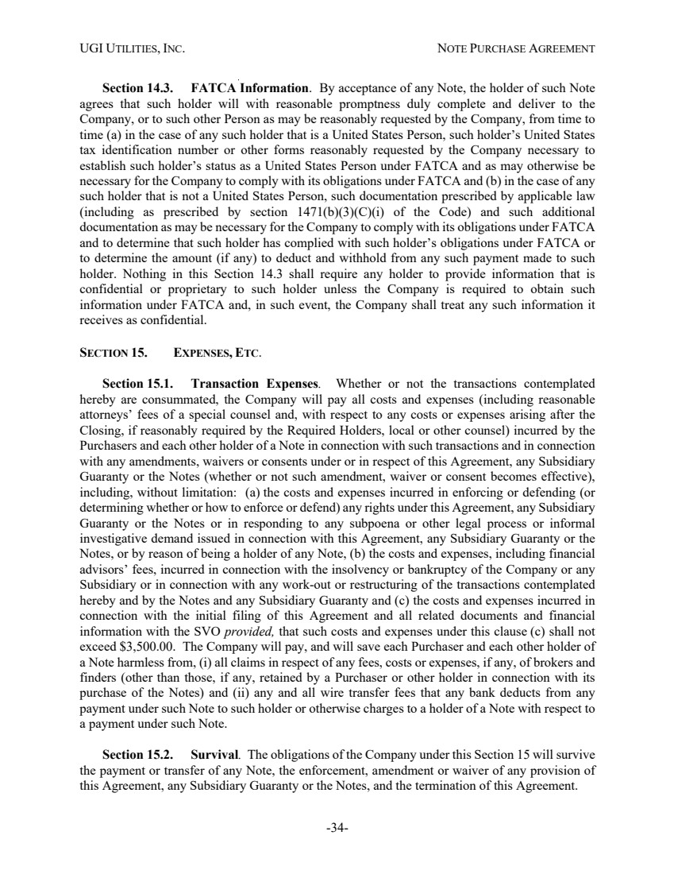 | UGI UTILITIES, INC. NOTE PURCHASE AGREEMENT -34- Section 14.3. FATCA Information. By acceptance of any Note, the holder of such Note agrees that such holder will with reasonable promptness duly complete and deliver to the Company, or to such other Person as may be reasonably requested by the Company, from time to time (a) in the case of any such holder that is a United States Person, such holder’s United States tax identification number or other forms reasonably requested by the Company necessary to establish such holder’s status as a United States Person under FATCA and as may otherwise be necessary for the Company to comply with its obligations under FATCA and (b) in the case of any such holder that is not a United States Person, such documentation prescribed by applicable law (including as prescribed by section 1471(b)(3)(C)(i) of the Code) and such additional documentation as may be necessary for the Company to comply with its obligations under FATCA and to determine that such holder has complied with such holder’s obligations under FATCA or to determine the amount (if any) to deduct and withhold from any such payment made to such holder. Nothing in this Section 14.3 shall require any holder to provide information that is confidential or proprietary to such holder unless the Company is required to obtain such information under FATCA and, in such event, the Company shall treat any such information it receives as confidential. SECTION 15. EXPENSES, ETC. Section 15.1. Transaction Expenses. Whether or not the transactions contemplated hereby are consummated, the Company will pay all costs and expenses (including reasonable attorneys’ fees of a special counsel and, with respect to any costs or expenses arising after the Closing, if reasonably required by the Required Holders, local or other counsel) incurred by the Purchasers and each other holder of a Note in connection with such transactions and in connection with any amendments, waivers or consents under or in respect of this Agreement, any Subsidiary Guaranty or the Notes (whether or not such amendment, waiver or consent becomes effective), including, without limitation: (a) the costs and expenses incurred in enforcing or defending (or determining whether or how to enforce or defend) any rights under this Agreement, any Subsidiary Guaranty or the Notes or in responding to any subpoena or other legal process or informal investigative demand issued in connection with this Agreement, any Subsidiary Guaranty or the Notes, or by reason of being a holder of any Note, (b) the costs and expenses, including financial advisors’ fees, incurred in connection with the insolvency or bankruptcy of the Company or any Subsidiary or in connection with any work-out or restructuring of the transactions contemplated hereby and by the Notes and any Subsidiary Guaranty and (c) the costs and expenses incurred in connection with the initial filing of this Agreement and all related documents and financial information with the SVO provided, that such costs and expenses under this clause (c) shall not exceed $3,500.00. The Company will pay, and will save each Purchaser and each other holder of a Note harmless from, (i) all claims in respect of any fees, costs or expenses, if any, of brokers and finders (other than those, if any, retained by a Purchaser or other holder in connection with its purchase of the Notes) and (ii) any and all wire transfer fees that any bank deducts from any payment under such Note to such holder or otherwise charges to a holder of a Note with respect to a payment under such Note. Section 15.2. Survival. The obligations of the Company under this Section 15 will survive the payment or transfer of any Note, the enforcement, amendment or waiver of any provision of this Agreement, any Subsidiary Guaranty or the Notes, and the termination of this Agreement.
 | 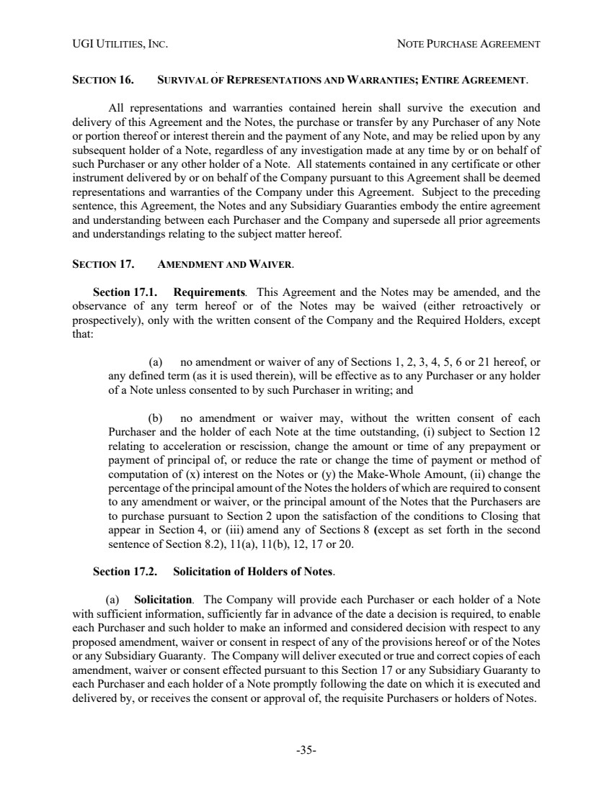 | UGI UTILITIES, INC. NOTE PURCHASE AGREEMENT -35- SECTION 16. SURVIVAL OF REPRESENTATIONS AND WARRANTIES; ENTIRE AGREEMENT. All representations and warranties contained herein shall survive the execution and delivery of this Agreement and the Notes, the purchase or transfer by any Purchaser of any Note or portion thereof or interest therein and the payment of any Note, and may be relied upon by any subsequent holder of a Note, regardless of any investigation made at any time by or on behalf of such Purchaser or any other holder of a Note. All statements contained in any certificate or other instrument delivered by or on behalf of the Company pursuant to this Agreement shall be deemed representations and warranties of the Company under this Agreement. Subject to the preceding sentence, this Agreement, the Notes and any Subsidiary Guaranties embody the entire agreement and understanding between each Purchaser and the Company and supersede all prior agreements and understandings relating to the subject matter hereof. SECTION 17. AMENDMENT AND WAIVER. Section 17.1. Requirements. This Agreement and the Notes may be amended, and the observance of any term hereof or of the Notes may be waived (either retroactively or prospectively), only with the written consent of the Company and the Required Holders, except that: (a) no amendment or waiver of any of Sections 1, 2, 3, 4, 5, 6 or 21 hereof, or any defined term (as it is used therein), will be effective as to any Purchaser or any holder of a Note unless consented to by such Purchaser in writing; and (b) no amendment or waiver may, without the written consent of each Purchaser and the holder of each Note at the time outstanding, (i) subject to Section 12 relating to acceleration or rescission, change the amount or time of any prepayment or payment of principal of, or reduce the rate or change the time of payment or method of computation of (x) interest on the Notes or (y) the Make-Whole Amount, (ii) change the percentage of the principal amount of the Notes the holders of which are required to consent to any amendment or waiver, or the principal amount of the Notes that the Purchasers are to purchase pursuant to Section 2 upon the satisfaction of the conditions to Closing that appear in Section 4, or (iii) amend any of Sections 8 (except as set forth in the second sentence of Section 8.2), 11(a), 11(b), 12, 17 or 20. Section 17.2. Solicitation of Holders of Notes. (a) Solicitation. The Company will provide each Purchaser or each holder of a Note with sufficient information, sufficiently far in advance of the date a decision is required, to enable each Purchaser and such holder to make an informed and considered decision with respect to any proposed amendment, waiver or consent in respect of any of the provisions hereof or of the Notes or any Subsidiary Guaranty. The Company will deliver executed or true and correct copies of each amendment, waiver or consent effected pursuant to this Section 17 or any Subsidiary Guaranty to each Purchaser and each holder of a Note promptly following the date on which it is executed and delivered by, or receives the consent or approval of, the requisite Purchasers or holders of Notes.
 | 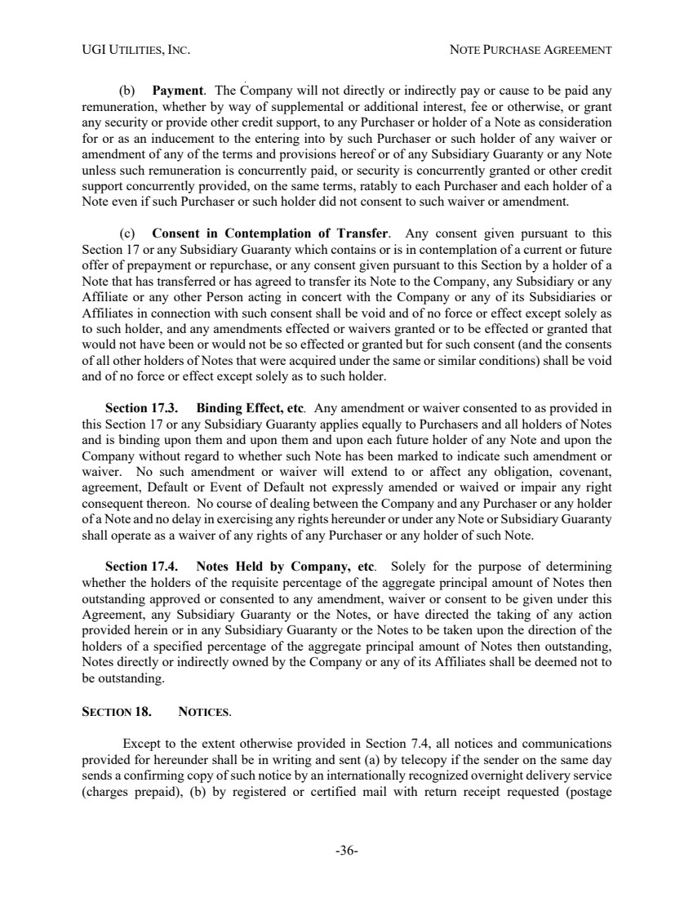 | UGI UTILITIES, INC. NOTE PURCHASE AGREEMENT -36- (b) Payment. The Company will not directly or indirectly pay or cause to be paid any remuneration, whether by way of supplemental or additional interest, fee or otherwise, or grant any security or provide other credit support, to any Purchaser or holder of a Note as consideration for or as an inducement to the entering into by such Purchaser or such holder of any waiver or amendment of any of the terms and provisions hereof or of any Subsidiary Guaranty or any Note unless such remuneration is concurrently paid, or security is concurrently granted or other credit support concurrently provided, on the same terms, ratably to each Purchaser and each holder of a Note even if such Purchaser or such holder did not consent to such waiver or amendment. (c) Consent in Contemplation of Transfer. Any consent given pursuant to this Section 17 or any Subsidiary Guaranty which contains or is in contemplation of a current or future offer of prepayment or repurchase, or any consent given pursuant to this Section by a holder of a Note that has transferred or has agreed to transfer its Note to the Company, any Subsidiary or any Affiliate or any other Person acting in concert with the Company or any of its Subsidiaries or Affiliates in connection with such consent shall be void and of no force or effect except solely as to such holder, and any amendments effected or waivers granted or to be effected or granted that would not have been or would not be so effected or granted but for such consent (and the consents of all other holders of Notes that were acquired under the same or similar conditions) shall be void and of no force or effect except solely as to such holder. Section 17.3. Binding Effect, etc. Any amendment or waiver consented to as provided in this Section 17 or any Subsidiary Guaranty applies equally to Purchasers and all holders of Notes and is binding upon them and upon them and upon each future holder of any Note and upon the Company without regard to whether such Note has been marked to indicate such amendment or waiver. No such amendment or waiver will extend to or affect any obligation, covenant, agreement, Default or Event of Default not expressly amended or waived or impair any right consequent thereon. No course of dealing between the Company and any Purchaser or any holder of a Note and no delay in exercising any rights hereunder or under any Note or Subsidiary Guaranty shall operate as a waiver of any rights of any Purchaser or any holder of such Note. Section 17.4. Notes Held by Company, etc. Solely for the purpose of determining whether the holders of the requisite percentage of the aggregate principal amount of Notes then outstanding approved or consented to any amendment, waiver or consent to be given under this Agreement, any Subsidiary Guaranty or the Notes, or have directed the taking of any action provided herein or in any Subsidiary Guaranty or the Notes to be taken upon the direction of the holders of a specified percentage of the aggregate principal amount of Notes then outstanding, Notes directly or indirectly owned by the Company or any of its Affiliates shall be deemed not to be outstanding. SECTION 18. NOTICES. Except to the extent otherwise provided in Section 7.4, all notices and communications provided for hereunder shall be in writing and sent (a) by telecopy if the sender on the same day sends a confirming copy of such notice by an internationally recognized overnight delivery service (charges prepaid), (b) by registered or certified mail with return receipt requested (postage
 | 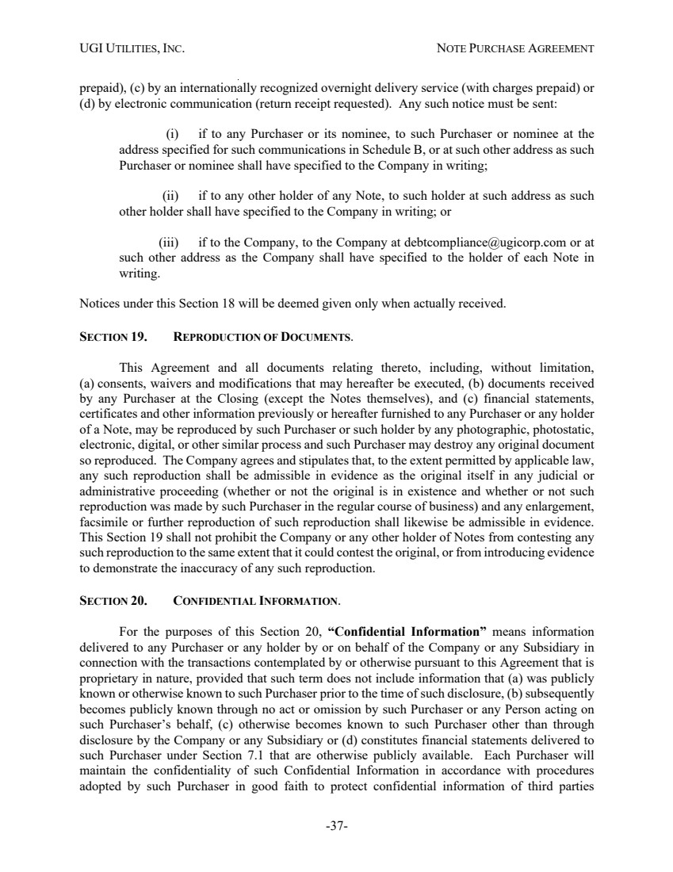 | UGI UTILITIES, INC. NOTE PURCHASE AGREEMENT -37- prepaid), (c) by an internationally recognized overnight delivery service (with charges prepaid) or (d) by electronic communication (return receipt requested). Any such notice must be sent: (i) if to any Purchaser or its nominee, to such Purchaser or nominee at the address specified for such communications in Schedule B, or at such other address as such Purchaser or nominee shall have specified to the Company in writing; (ii) if to any other holder of any Note, to such holder at such address as such other holder shall have specified to the Company in writing; or (iii) if to the Company, to the Company at debtcompliance@ugicorp.com or at such other address as the Company shall have specified to the holder of each Note in writing. Notices under this Section 18 will be deemed given only when actually received. SECTION 19. REPRODUCTION OF DOCUMENTS. This Agreement and all documents relating thereto, including, without limitation, (a) consents, waivers and modifications that may hereafter be executed, (b) documents received by any Purchaser at the Closing (except the Notes themselves), and (c) financial statements, certificates and other information previously or hereafter furnished to any Purchaser or any holder of a Note, may be reproduced by such Purchaser or such holder by any photographic, photostatic, electronic, digital, or other similar process and such Purchaser may destroy any original document so reproduced. The Company agrees and stipulates that, to the extent permitted by applicable law, any such reproduction shall be admissible in evidence as the original itself in any judicial or administrative proceeding (whether or not the original is in existence and whether or not such reproduction was made by such Purchaser in the regular course of business) and any enlargement, facsimile or further reproduction of such reproduction shall likewise be admissible in evidence. This Section 19 shall not prohibit the Company or any other holder of Notes from contesting any such reproduction to the same extent that it could contest the original, or from introducing evidence to demonstrate the inaccuracy of any such reproduction. SECTION 20. CONFIDENTIAL INFORMATION. For the purposes of this Section 20, “Confidential Information” means information delivered to any Purchaser or any holder by or on behalf of the Company or any Subsidiary in connection with the transactions contemplated by or otherwise pursuant to this Agreement that is proprietary in nature, provided that such term does not include information that (a) was publicly known or otherwise known to such Purchaser prior to the time of such disclosure, (b) subsequently becomes publicly known through no act or omission by such Purchaser or any Person acting on such Purchaser’s behalf, (c) otherwise becomes known to such Purchaser other than through disclosure by the Company or any Subsidiary or (d) constitutes financial statements delivered to such Purchaser under Section 7.1 that are otherwise publicly available. Each Purchaser will maintain the confidentiality of such Confidential Information in accordance with procedures adopted by such Purchaser in good faith to protect confidential information of third parties
 | 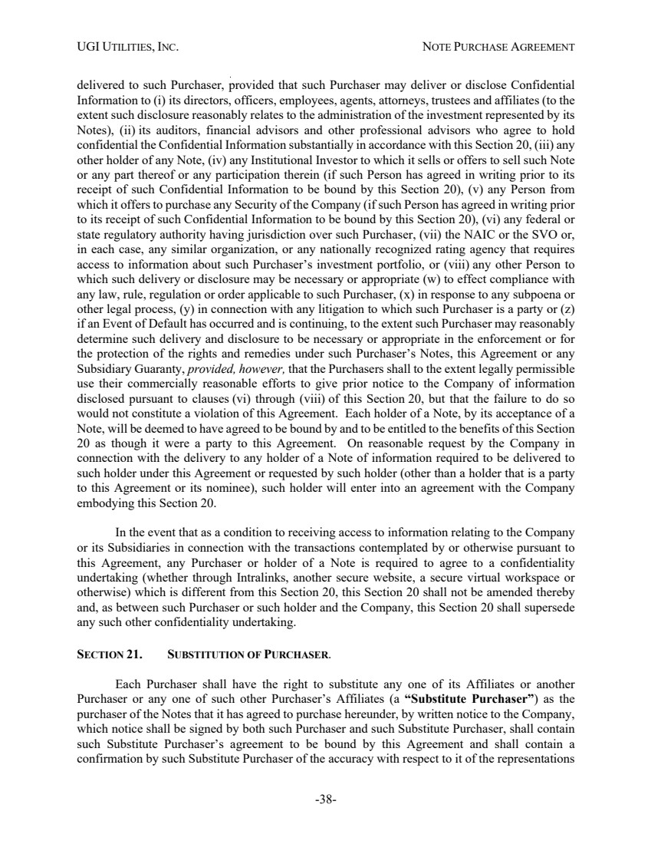 | UGI UTILITIES, INC. NOTE PURCHASE AGREEMENT -38- delivered to such Purchaser, provided that such Purchaser may deliver or disclose Confidential Information to (i) its directors, officers, employees, agents, attorneys, trustees and affiliates (to the extent such disclosure reasonably relates to the administration of the investment represented by its Notes), (ii) its auditors, financial advisors and other professional advisors who agree to hold confidential the Confidential Information substantially in accordance with this Section 20, (iii) any other holder of any Note, (iv) any Institutional Investor to which it sells or offers to sell such Note or any part thereof or any participation therein (if such Person has agreed in writing prior to its receipt of such Confidential Information to be bound by this Section 20), (v) any Person from which it offers to purchase any Security of the Company (if such Person has agreed in writing prior to its receipt of such Confidential Information to be bound by this Section 20), (vi) any federal or state regulatory authority having jurisdiction over such Purchaser, (vii) the NAIC or the SVO or, in each case, any similar organization, or any nationally recognized rating agency that requires access to information about such Purchaser’s investment portfolio, or (viii) any other Person to which such delivery or disclosure may be necessary or appropriate (w) to effect compliance with any law, rule, regulation or order applicable to such Purchaser, (x) in response to any subpoena or other legal process, (y) in connection with any litigation to which such Purchaser is a party or (z) if an Event of Default has occurred and is continuing, to the extent such Purchaser may reasonably determine such delivery and disclosure to be necessary or appropriate in the enforcement or for the protection of the rights and remedies under such Purchaser’s Notes, this Agreement or any Subsidiary Guaranty, provided, however, that the Purchasers shall to the extent legally permissible use their commercially reasonable efforts to give prior notice to the Company of information disclosed pursuant to clauses (vi) through (viii) of this Section 20, but that the failure to do so would not constitute a violation of this Agreement. Each holder of a Note, by its acceptance of a Note, will be deemed to have agreed to be bound by and to be entitled to the benefits of this Section 20 as though it were a party to this Agreement. On reasonable request by the Company in connection with the delivery to any holder of a Note of information required to be delivered to such holder under this Agreement or requested by such holder (other than a holder that is a party to this Agreement or its nominee), such holder will enter into an agreement with the Company embodying this Section 20. In the event that as a condition to receiving access to information relating to the Company or its Subsidiaries in connection with the transactions contemplated by or otherwise pursuant to this Agreement, any Purchaser or holder of a Note is required to agree to a confidentiality undertaking (whether through Intralinks, another secure website, a secure virtual workspace or otherwise) which is different from this Section 20, this Section 20 shall not be amended thereby and, as between such Purchaser or such holder and the Company, this Section 20 shall supersede any such other confidentiality undertaking. SECTION 21. SUBSTITUTION OF PURCHASER. Each Purchaser shall have the right to substitute any one of its Affiliates or another Purchaser or any one of such other Purchaser’s Affiliates (a “Substitute Purchaser”) as the purchaser of the Notes that it has agreed to purchase hereunder, by written notice to the Company, which notice shall be signed by both such Purchaser and such Substitute Purchaser, shall contain such Substitute Purchaser’s agreement to be bound by this Agreement and shall contain a confirmation by such Substitute Purchaser of the accuracy with respect to it of the representations
 | 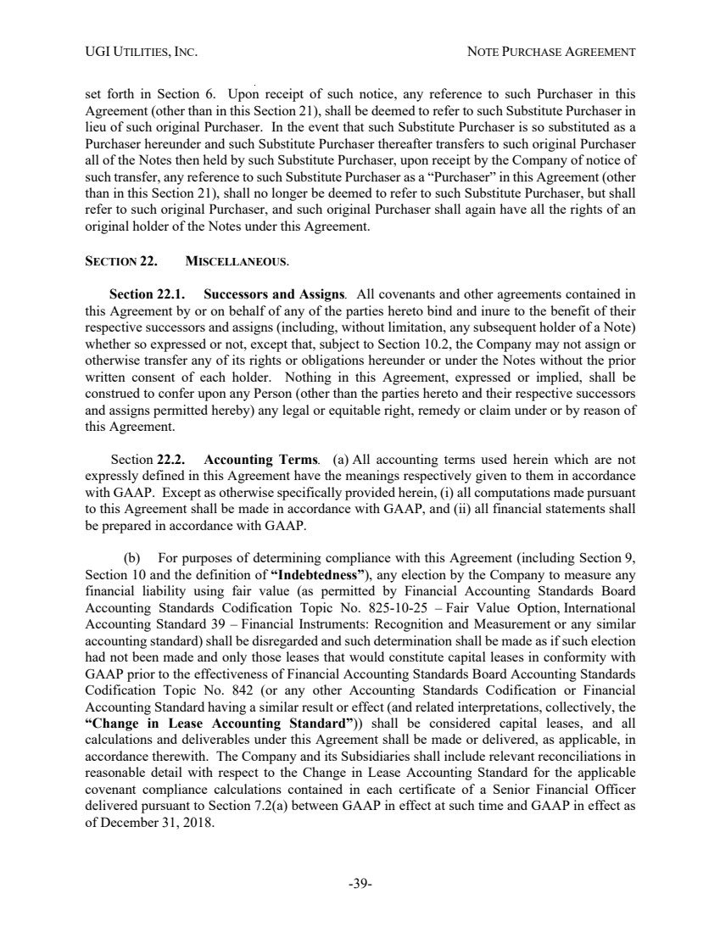 | UGI UTILITIES, INC. NOTE PURCHASE AGREEMENT -39- set forth in Section 6. Upon receipt of such notice, any reference to such Purchaser in this Agreement (other than in this Section 21), shall be deemed to refer to such Substitute Purchaser in lieu of such original Purchaser. In the event that such Substitute Purchaser is so substituted as a Purchaser hereunder and such Substitute Purchaser thereafter transfers to such original Purchaser all of the Notes then held by such Substitute Purchaser, upon receipt by the Company of notice of such transfer, any reference to such Substitute Purchaser as a “Purchaser” in this Agreement (other than in this Section 21), shall no longer be deemed to refer to such Substitute Purchaser, but shall refer to such original Purchaser, and such original Purchaser shall again have all the rights of an original holder of the Notes under this Agreement. SECTION 22. MISCELLANEOUS. Section 22.1. Successors and Assigns. All covenants and other agreements contained in this Agreement by or on behalf of any of the parties hereto bind and inure to the benefit of their respective successors and assigns (including, without limitation, any subsequent holder of a Note) whether so expressed or not, except that, subject to Section 10.2, the Company may not assign or otherwise transfer any of its rights or obligations hereunder or under the Notes without the prior written consent of each holder. Nothing in this Agreement, expressed or implied, shall be construed to confer upon any Person (other than the parties hereto and their respective successors and assigns permitted hereby) any legal or equitable right, remedy or claim under or by reason of this Agreement. Section 22.2. Accounting Terms. (a) All accounting terms used herein which are not expressly defined in this Agreement have the meanings respectively given to them in accordance with GAAP. Except as otherwise specifically provided herein, (i) all computations made pursuant to this Agreement shall be made in accordance with GAAP, and (ii) all financial statements shall be prepared in accordance with GAAP. (b) For purposes of determining compliance with this Agreement (including Section 9, Section 10 and the definition of “Indebtedness”), any election by the Company to measure any financial liability using fair value (as permitted by Financial Accounting Standards Board Accounting Standards Codification Topic No. 825-10-25 – Fair Value Option, International Accounting Standard 39 – Financial Instruments: Recognition and Measurement or any similar accounting standard) shall be disregarded and such determination shall be made as if such election had not been made and only those leases that would constitute capital leases in conformity with GAAP prior to the effectiveness of Financial Accounting Standards Board Accounting Standards Codification Topic No. 842 (or any other Accounting Standards Codification or Financial Accounting Standard having a similar result or effect (and related interpretations, collectively, the “Change in Lease Accounting Standard”)) shall be considered capital leases, and all calculations and deliverables under this Agreement shall be made or delivered, as applicable, in accordance therewith. The Company and its Subsidiaries shall include relevant reconciliations in reasonable detail with respect to the Change in Lease Accounting Standard for the applicable covenant compliance calculations contained in each certificate of a Senior Financial Officer delivered pursuant to Section 7.2(a) between GAAP in effect at such time and GAAP in effect as of December 31, 2018.
 | 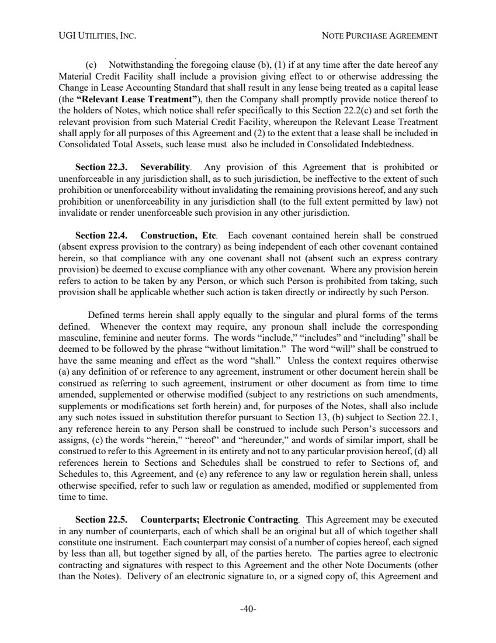 | UGI UTILITIES, INC. NOTE PURCHASE AGREEMENT -40- (c) Notwithstanding the foregoing clause (b), (1) if at any time after the date hereof any Material Credit Facility shall include a provision giving effect to or otherwise addressing the Change in Lease Accounting Standard that shall result in any lease being treated as a capital lease (the “Relevant Lease Treatment”), then the Company shall promptly provide notice thereof to the holders of Notes, which notice shall refer specifically to this Section 22.2(c) and set forth the relevant provision from such Material Credit Facility, whereupon the Relevant Lease Treatment shall apply for all purposes of this Agreement and (2) to the extent that a lease shall be included in Consolidated Total Assets, such lease must also be included in Consolidated Indebtedness. Section 22.3. Severability. Any provision of this Agreement that is prohibited or unenforceable in any jurisdiction shall, as to such jurisdiction, be ineffective to the extent of such prohibition or unenforceability without invalidating the remaining provisions hereof, and any such prohibition or unenforceability in any jurisdiction shall (to the full extent permitted by law) not invalidate or render unenforceable such provision in any other jurisdiction. Section 22.4. Construction, Etc. Each covenant contained herein shall be construed (absent express provision to the contrary) as being independent of each other covenant contained herein, so that compliance with any one covenant shall not (absent such an express contrary provision) be deemed to excuse compliance with any other covenant. Where any provision herein refers to action to be taken by any Person, or which such Person is prohibited from taking, such provision shall be applicable whether such action is taken directly or indirectly by such Person. Defined terms herein shall apply equally to the singular and plural forms of the terms defined. Whenever the context may require, any pronoun shall include the corresponding masculine, feminine and neuter forms. The words “include,” “includes” and “including” shall be deemed to be followed by the phrase “without limitation.” The word “will” shall be construed to have the same meaning and effect as the word “shall.” Unless the context requires otherwise (a) any definition of or reference to any agreement, instrument or other document herein shall be construed as referring to such agreement, instrument or other document as from time to time amended, supplemented or otherwise modified (subject to any restrictions on such amendments, supplements or modifications set forth herein) and, for purposes of the Notes, shall also include any such notes issued in substitution therefor pursuant to Section 13, (b) subject to Section 22.1, any reference herein to any Person shall be construed to include such Person’s successors and assigns, (c) the words “herein,” “hereof” and “hereunder,” and words of similar import, shall be construed to refer to this Agreement in its entirety and not to any particular provision hereof, (d) all references herein to Sections and Schedules shall be construed to refer to Sections of, and Schedules to, this Agreement, and (e) any reference to any law or regulation herein shall, unless otherwise specified, refer to such law or regulation as amended, modified or supplemented from time to time. Section 22.5. Counterparts; Electronic Contracting. This Agreement may be executed in any number of counterparts, each of which shall be an original but all of which together shall constitute one instrument. Each counterpart may consist of a number of copies hereof, each signed by less than all, but together signed by all, of the parties hereto. The parties agree to electronic contracting and signatures with respect to this Agreement and the other Note Documents (other than the Notes). Delivery of an electronic signature to, or a signed copy of, this Agreement and
 | 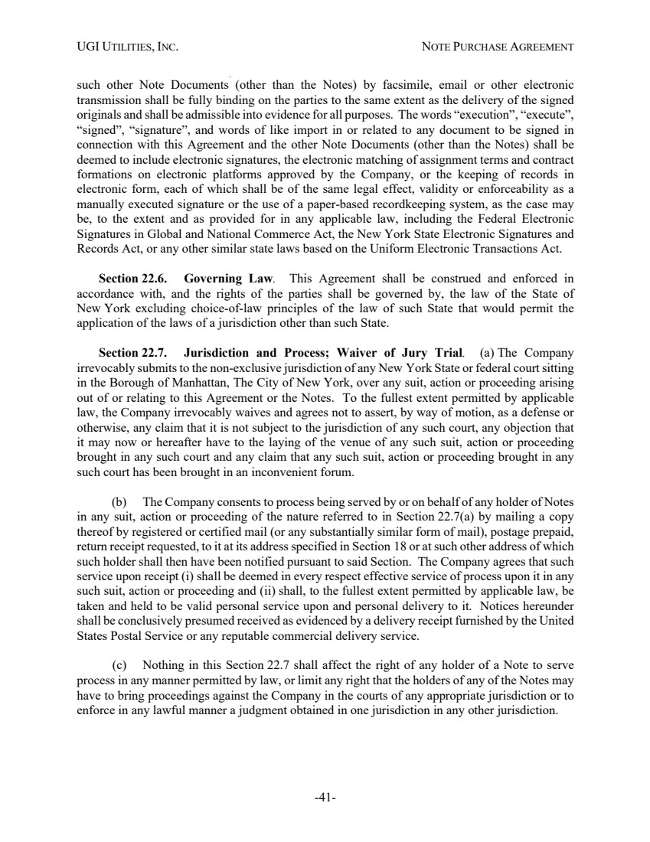 | UGI UTILITIES, INC. NOTE PURCHASE AGREEMENT -41- such other Note Documents (other than the Notes) by facsimile, email or other electronic transmission shall be fully binding on the parties to the same extent as the delivery of the signed originals and shall be admissible into evidence for all purposes. The words “execution”, “execute”, “signed”, “signature”, and words of like import in or related to any document to be signed in connection with this Agreement and the other Note Documents (other than the Notes) shall be deemed to include electronic signatures, the electronic matching of assignment terms and contract formations on electronic platforms approved by the Company, or the keeping of records in electronic form, each of which shall be of the same legal effect, validity or enforceability as a manually executed signature or the use of a paper-based recordkeeping system, as the case may be, to the extent and as provided for in any applicable law, including the Federal Electronic Signatures in Global and National Commerce Act, the New York State Electronic Signatures and Records Act, or any other similar state laws based on the Uniform Electronic Transactions Act. Section 22.6. Governing Law. This Agreement shall be construed and enforced in accordance with, and the rights of the parties shall be governed by, the law of the State of New York excluding choice-of-law principles of the law of such State that would permit the application of the laws of a jurisdiction other than such State. Section 22.7. Jurisdiction and Process; Waiver of Jury Trial. (a) The Company irrevocably submits to the non-exclusive jurisdiction of any New York State or federal court sitting in the Borough of Manhattan, The City of New York, over any suit, action or proceeding arising out of or relating to this Agreement or the Notes. To the fullest extent permitted by applicable law, the Company irrevocably waives and agrees not to assert, by way of motion, as a defense or otherwise, any claim that it is not subject to the jurisdiction of any such court, any objection that it may now or hereafter have to the laying of the venue of any such suit, action or proceeding brought in any such court and any claim that any such suit, action or proceeding brought in any such court has been brought in an inconvenient forum. (b) The Company consents to process being served by or on behalf of any holder of Notes in any suit, action or proceeding of the nature referred to in Section 22.7(a) by mailing a copy thereof by registered or certified mail (or any substantially similar form of mail), postage prepaid, return receipt requested, to it at its address specified in Section 18 or at such other address of which such holder shall then have been notified pursuant to said Section. The Company agrees that such service upon receipt (i) shall be deemed in every respect effective service of process upon it in any such suit, action or proceeding and (ii) shall, to the fullest extent permitted by applicable law, be taken and held to be valid personal service upon and personal delivery to it. Notices hereunder shall be conclusively presumed received as evidenced by a delivery receipt furnished by the United States Postal Service or any reputable commercial delivery service. (c) Nothing in this Section 22.7 shall affect the right of any holder of a Note to serve process in any manner permitted by law, or limit any right that the holders of any of the Notes may have to bring proceedings against the Company in the courts of any appropriate jurisdiction or to enforce in any lawful manner a judgment obtained in one jurisdiction in any other jurisdiction.
 | 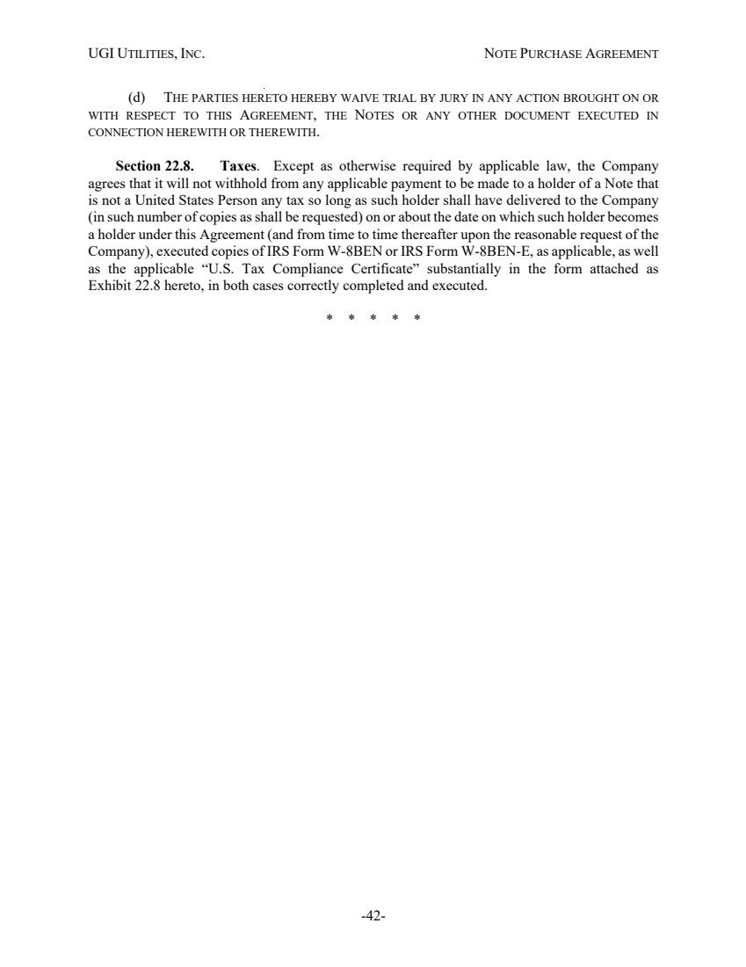 | UGI UTILITIES, INC. NOTE PURCHASE AGREEMENT -42- (d) THE PARTIES HERETO HEREBY WAIVE TRIAL BY JURY IN ANY ACTION BROUGHT ON OR WITH RESPECT TO THIS AGREEMENT, THE NOTES OR ANY OTHER DOCUMENT EXECUTED IN CONNECTION HEREWITH OR THEREWITH. Section 22.8. Taxes. Except as otherwise required by applicable law, the Company agrees that it will not withhold from any applicable payment to be made to a holder of a Note that is not a United States Person any tax so long as such holder shall have delivered to the Company (in such number of copies as shall be requested) on or about the date on which such holder becomes a holder under this Agreement (and from time to time thereafter upon the reasonable request of the Company), executed copies of IRS Form W-8BEN or IRS Form W-8BEN-E, as applicable, as well as the applicable “U.S. Tax Compliance Certificate” substantially in the form attached as Exhibit 22.8 hereto, in both cases correctly completed and executed. * * * * *
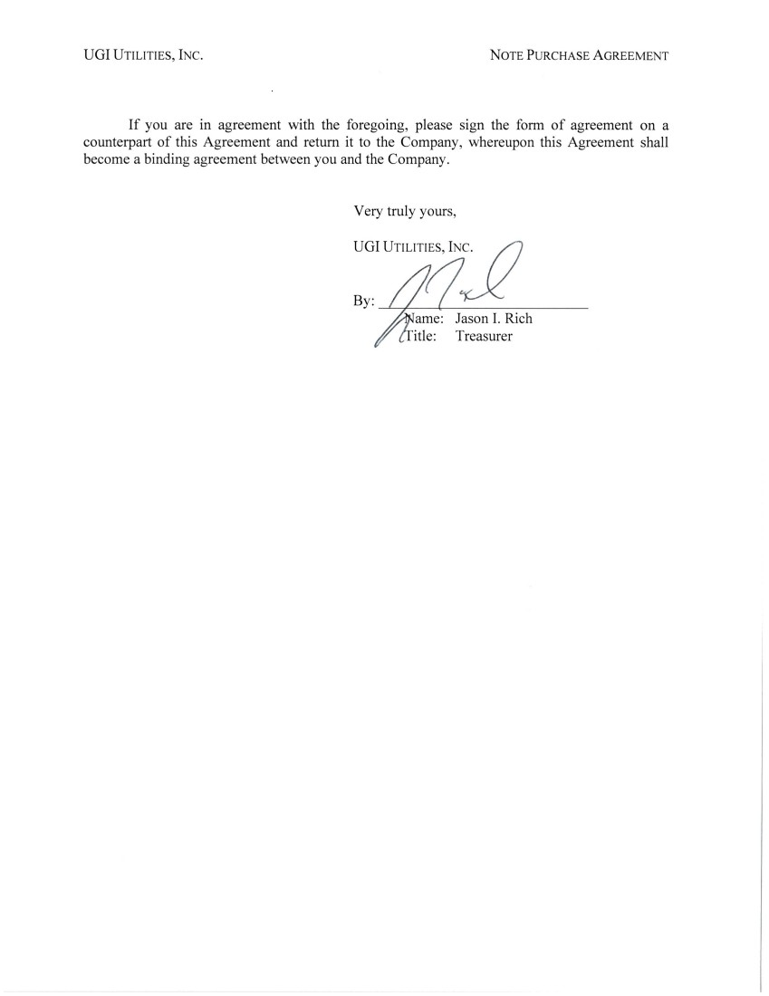
 | 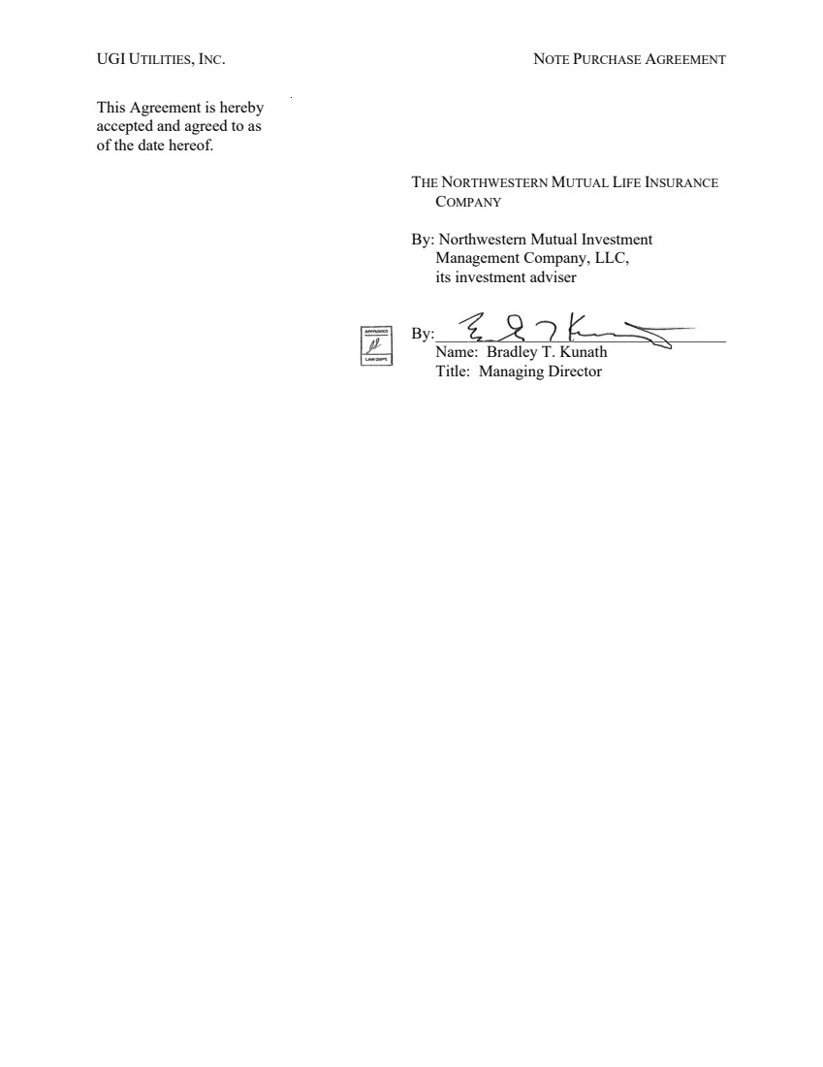 | UGI UTILITIES, INC. NOTE PURCHASE AGREEMENT This Agreement is hereby accepted and agreed to as of the date hereof. THE NORTHWESTERN MUTUAL LIFE INSURANCE COMPANY By: Northwestern Mutual Investment Management Company, LLC, its investment adviser By:____________________________________ Name: Bradley T. Kunath Title: Managing Director
 | 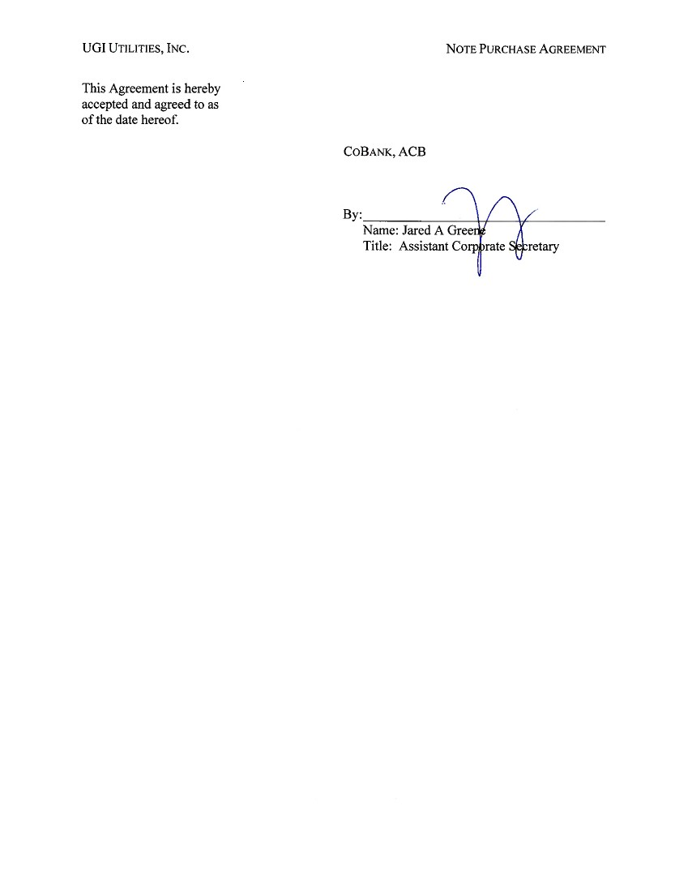 | UGI UTILITIES, INC. NOTE PURCHASE AGREEMENT This Agreement is hereby accepted and agreed to as of the date hereof. COBANK, ACB By: C\ /\/ Name: Jared A Gree Title: Assistant Corpprate Secretary
 | 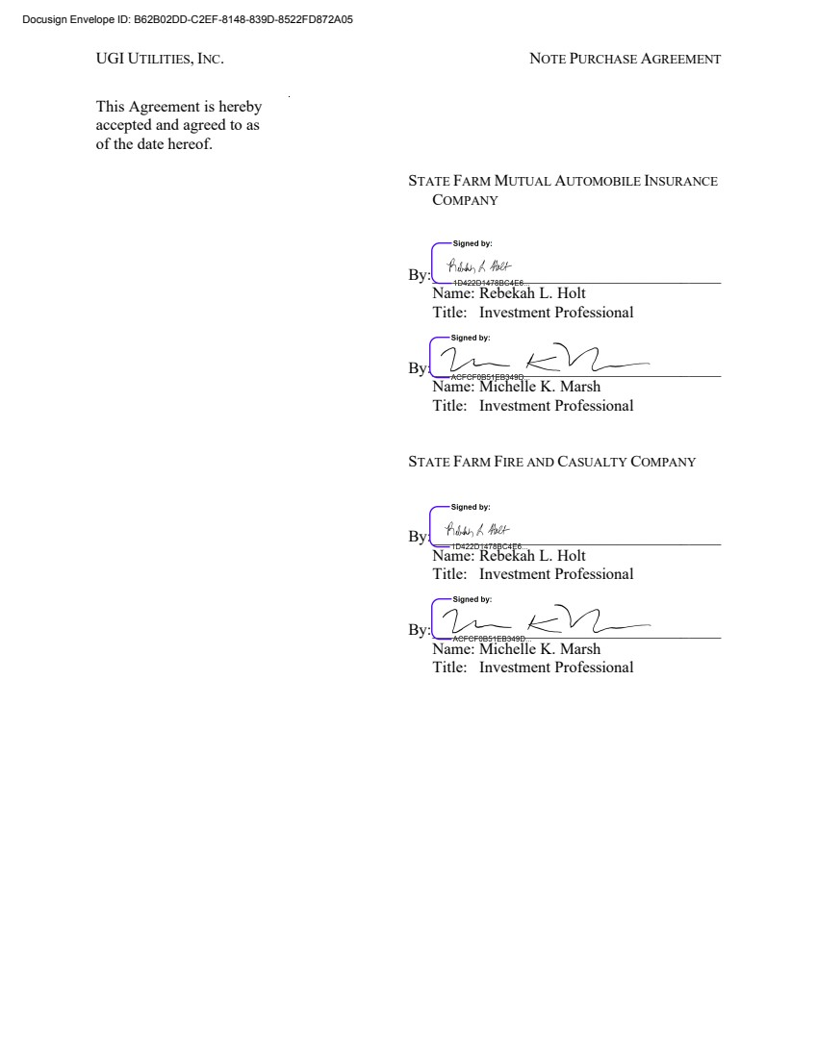 | UGI UTILITIES, INC. NOTE PURCHASE AGREEMENT This Agreement is hereby accepted and agreed to as of the date hereof. STATE FARM MUTUAL AUTOMOBILE INSURANCE COMPANY By:____________________________________ Name: Rebekah L. Holt Title: Investment Professional By:____________________________________ Name: Michelle K. Marsh Title: Investment Professional STATE FARM FIRE AND CASUALTY COMPANY By:____________________________________ Name: Rebekah L. Holt Title: Investment Professional By:____________________________________ Name: Michelle K. Marsh Title: Investment Professional Docusign Envelope ID: B62B02DD-C2EF-8148-839D-8522FD872A05
 | 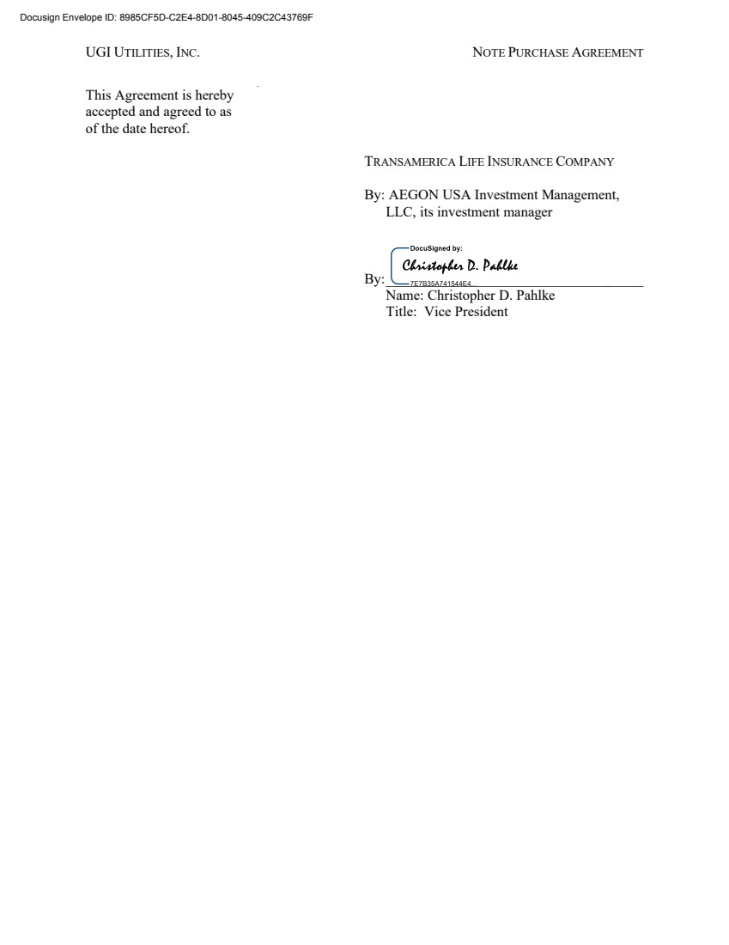 | UGI UTILITIES, INC. NOTE PURCHASE AGREEMENT This Agreement is hereby accepted and agreed to as of the date hereof. TRANSAMERICA LIFE INSURANCE COMPANY By: AEGON USA Investment Management, LLC, its investment manager By:____________________________________ Name: Christopher D. Pahlke Title: Vice President Docusign Envelope ID: 8985CF5D-C2E4-8D01-8045-409C2C43769F
 | 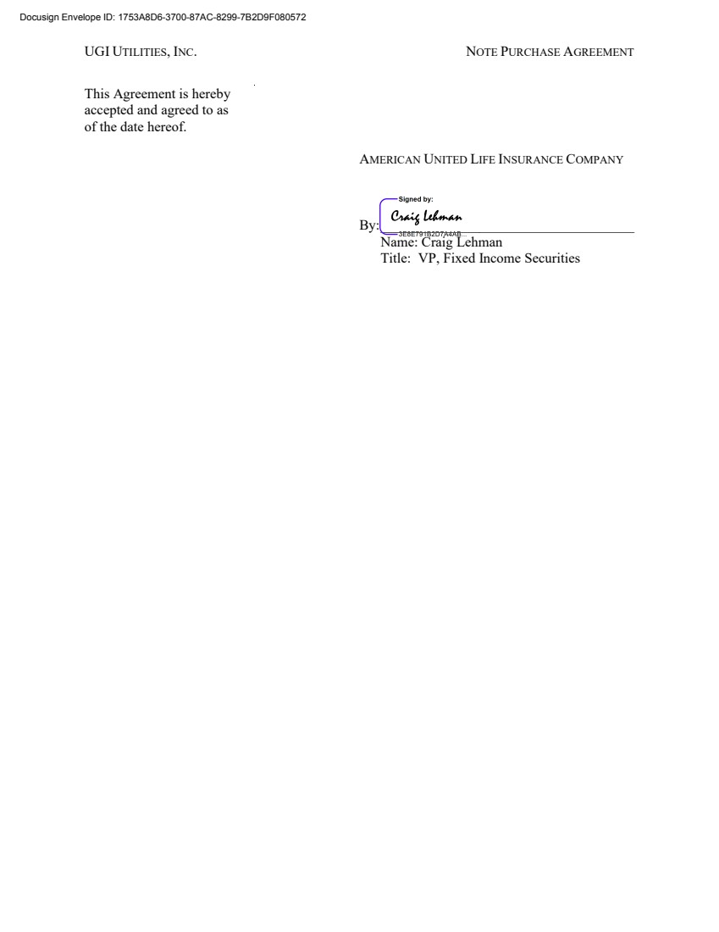 | UGI UTILITIES, INC. NOTE PURCHASE AGREEMENT This Agreement is hereby accepted and agreed to as of the date hereof. AMERICAN UNITED LIFE INSURANCE COMPANY By: ____________________________________ Name: Craig Lehman Title: VP, Fixed Income Securities Docusign Envelope ID: 1753A8D6-3700-87AC-8299-7B2D9F080572
 | 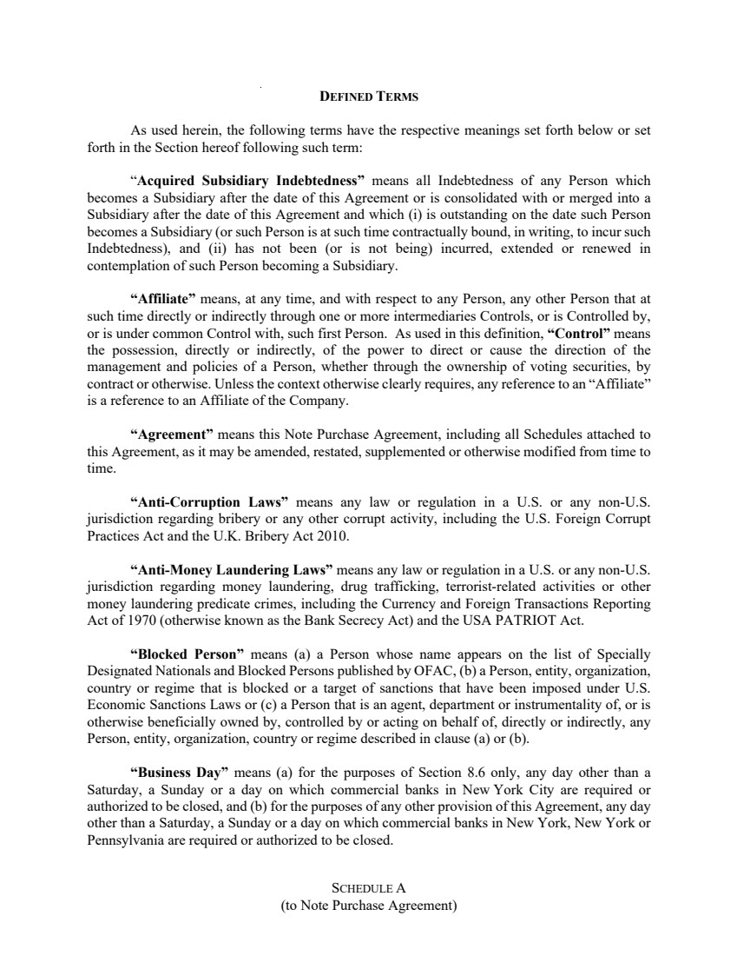 | SCHEDULE A (to Note Purchase Agreement) DEFINED TERMS As used herein, the following terms have the respective meanings set forth below or set forth in the Section hereof following such term: “Acquired Subsidiary Indebtedness” means all Indebtedness of any Person which becomes a Subsidiary after the date of this Agreement or is consolidated with or merged into a Subsidiary after the date of this Agreement and which (i) is outstanding on the date such Person becomes a Subsidiary (or such Person is at such time contractually bound, in writing, to incur such Indebtedness), and (ii) has not been (or is not being) incurred, extended or renewed in contemplation of such Person becoming a Subsidiary. “Affiliate” means, at any time, and with respect to any Person, any other Person that at such time directly or indirectly through one or more intermediaries Controls, or is Controlled by, or is under common Control with, such first Person. As used in this definition, “Control” means the possession, directly or indirectly, of the power to direct or cause the direction of the management and policies of a Person, whether through the ownership of voting securities, by contract or otherwise. Unless the context otherwise clearly requires, any reference to an “Affiliate” is a reference to an Affiliate of the Company. “Agreement” means this Note Purchase Agreement, including all Schedules attached to this Agreement, as it may be amended, restated, supplemented or otherwise modified from time to time. “Anti-Corruption Laws” means any law or regulation in a U.S. or any non-U.S. jurisdiction regarding bribery or any other corrupt activity, including the U.S. Foreign Corrupt Practices Act and the U.K. Bribery Act 2010. “Anti-Money Laundering Laws” means any law or regulation in a U.S. or any non-U.S. jurisdiction regarding money laundering, drug trafficking, terrorist-related activities or other money laundering predicate crimes, including the Currency and Foreign Transactions Reporting Act of 1970 (otherwise known as the Bank Secrecy Act) and the USA PATRIOT Act. “Blocked Person” means (a) a Person whose name appears on the list of Specially Designated Nationals and Blocked Persons published by OFAC, (b) a Person, entity, organization, country or regime that is blocked or a target of sanctions that have been imposed under U.S. Economic Sanctions Laws or (c) a Person that is an agent, department or instrumentality of, or is otherwise beneficially owned by, controlled by or acting on behalf of, directly or indirectly, any Person, entity, organization, country or regime described in clause (a) or (b). “Business Day” means (a) for the purposes of Section 8.6 only, any day other than a Saturday, a Sunday or a day on which commercial banks in New York City are required or authorized to be closed, and (b) for the purposes of any other provision of this Agreement, any day other than a Saturday, a Sunday or a day on which commercial banks in New York, New York or Pennsylvania are required or authorized to be closed.
 | 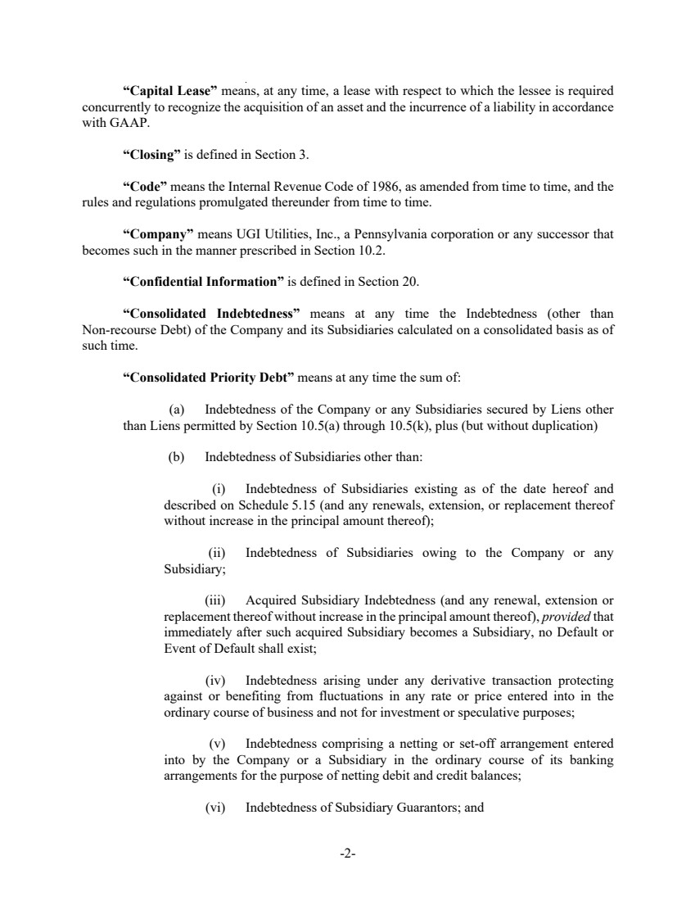 | -2- “Capital Lease” means, at any time, a lease with respect to which the lessee is required concurrently to recognize the acquisition of an asset and the incurrence of a liability in accordance with GAAP. “Closing” is defined in Section 3. “Code” means the Internal Revenue Code of 1986, as amended from time to time, and the rules and regulations promulgated thereunder from time to time. “Company” means UGI Utilities, Inc., a Pennsylvania corporation or any successor that becomes such in the manner prescribed in Section 10.2. “Confidential Information” is defined in Section 20. “Consolidated Indebtedness” means at any time the Indebtedness (other than Non-recourse Debt) of the Company and its Subsidiaries calculated on a consolidated basis as of such time. “Consolidated Priority Debt” means at any time the sum of: (a) Indebtedness of the Company or any Subsidiaries secured by Liens other than Liens permitted by Section 10.5(a) through 10.5(k), plus (but without duplication) (b) Indebtedness of Subsidiaries other than: (i) Indebtedness of Subsidiaries existing as of the date hereof and described on Schedule 5.15 (and any renewals, extension, or replacement thereof without increase in the principal amount thereof); (ii) Indebtedness of Subsidiaries owing to the Company or any Subsidiary; (iii) Acquired Subsidiary Indebtedness (and any renewal, extension or replacement thereof without increase in the principal amount thereof), provided that immediately after such acquired Subsidiary becomes a Subsidiary, no Default or Event of Default shall exist; (iv) Indebtedness arising under any derivative transaction protecting against or benefiting from fluctuations in any rate or price entered into in the ordinary course of business and not for investment or speculative purposes; (v) Indebtedness comprising a netting or set-off arrangement entered into by the Company or a Subsidiary in the ordinary course of its banking arrangements for the purpose of netting debit and credit balances; (vi) Indebtedness of Subsidiary Guarantors; and
 | 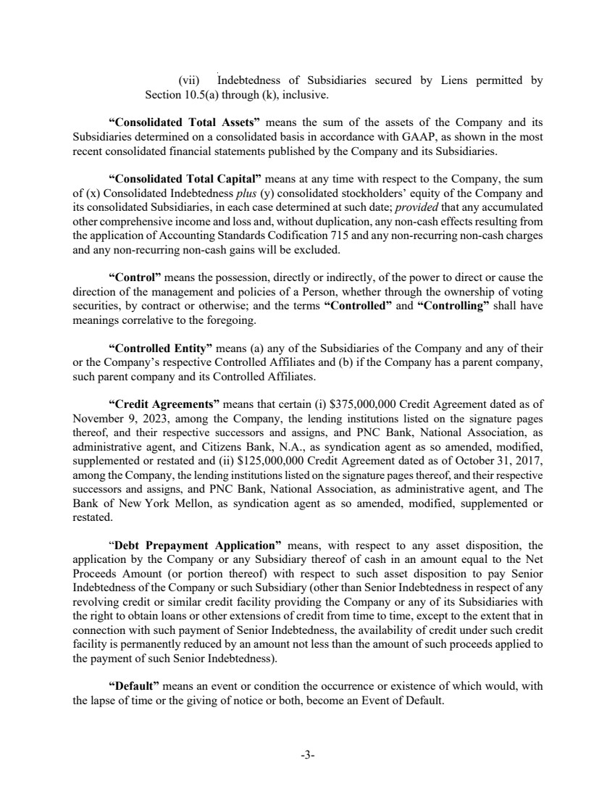 | -3- (vii) Indebtedness of Subsidiaries secured by Liens permitted by Section 10.5(a) through (k), inclusive. “Consolidated Total Assets” means the sum of the assets of the Company and its Subsidiaries determined on a consolidated basis in accordance with GAAP, as shown in the most recent consolidated financial statements published by the Company and its Subsidiaries. “Consolidated Total Capital” means at any time with respect to the Company, the sum of (x) Consolidated Indebtedness plus (y) consolidated stockholders’ equity of the Company and its consolidated Subsidiaries, in each case determined at such date; provided that any accumulated other comprehensive income and loss and, without duplication, any non-cash effects resulting from the application of Accounting Standards Codification 715 and any non-recurring non-cash charges and any non-recurring non-cash gains will be excluded. “Control” means the possession, directly or indirectly, of the power to direct or cause the direction of the management and policies of a Person, whether through the ownership of voting securities, by contract or otherwise; and the terms “Controlled” and “Controlling” shall have meanings correlative to the foregoing. “Controlled Entity” means (a) any of the Subsidiaries of the Company and any of their or the Company’s respective Controlled Affiliates and (b) if the Company has a parent company, such parent company and its Controlled Affiliates. “Credit Agreements” means that certain (i) $375,000,000 Credit Agreement dated as of November 9, 2023, among the Company, the lending institutions listed on the signature pages thereof, and their respective successors and assigns, and PNC Bank, National Association, as administrative agent, and Citizens Bank, N.A., as syndication agent as so amended, modified, supplemented or restated and (ii) $125,000,000 Credit Agreement dated as of October 31, 2017, among the Company, the lending institutions listed on the signature pages thereof, and their respective successors and assigns, and PNC Bank, National Association, as administrative agent, and The Bank of New York Mellon, as syndication agent as so amended, modified, supplemented or restated. “Debt Prepayment Application” means, with respect to any asset disposition, the application by the Company or any Subsidiary thereof of cash in an amount equal to the Net Proceeds Amount (or portion thereof) with respect to such asset disposition to pay Senior Indebtedness of the Company or such Subsidiary (other than Senior Indebtedness in respect of any revolving credit or similar credit facility providing the Company or any of its Subsidiaries with the right to obtain loans or other extensions of credit from time to time, except to the extent that in connection with such payment of Senior Indebtedness, the availability of credit under such credit facility is permanently reduced by an amount not less than the amount of such proceeds applied to the payment of such Senior Indebtedness). “Default” means an event or condition the occurrence or existence of which would, with the lapse of time or the giving of notice or both, become an Event of Default.
 | 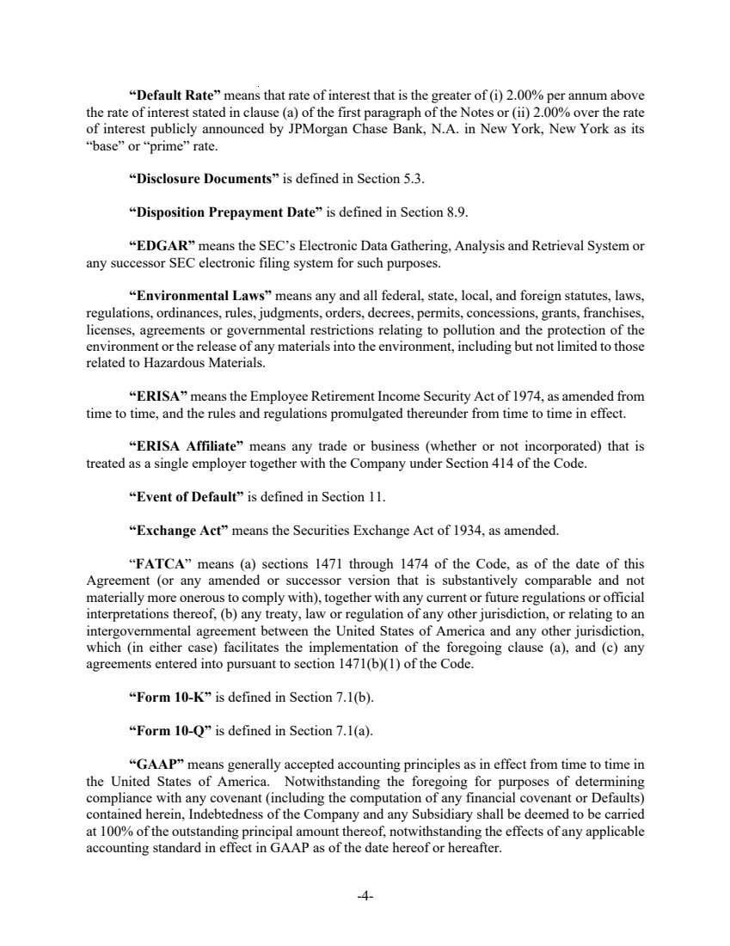 | -4- “Default Rate” means that rate of interest that is the greater of (i) 2.00% per annum above the rate of interest stated in clause (a) of the first paragraph of the Notes or (ii) 2.00% over the rate of interest publicly announced by JPMorgan Chase Bank, N.A. in New York, New York as its “base” or “prime” rate. “Disclosure Documents” is defined in Section 5.3. “Disposition Prepayment Date” is defined in Section 8.9. “EDGAR” means the SEC’s Electronic Data Gathering, Analysis and Retrieval System or any successor SEC electronic filing system for such purposes. “Environmental Laws” means any and all federal, state, local, and foreign statutes, laws, regulations, ordinances, rules, judgments, orders, decrees, permits, concessions, grants, franchises, licenses, agreements or governmental restrictions relating to pollution and the protection of the environment or the release of any materials into the environment, including but not limited to those related to Hazardous Materials. “ERISA” means the Employee Retirement Income Security Act of 1974, as amended from time to time, and the rules and regulations promulgated thereunder from time to time in effect. “ERISA Affiliate” means any trade or business (whether or not incorporated) that is treated as a single employer together with the Company under Section 414 of the Code. “Event of Default” is defined in Section 11. “Exchange Act” means the Securities Exchange Act of 1934, as amended. “FATCA” means (a) sections 1471 through 1474 of the Code, as of the date of this Agreement (or any amended or successor version that is substantively comparable and not materially more onerous to comply with), together with any current or future regulations or official interpretations thereof, (b) any treaty, law or regulation of any other jurisdiction, or relating to an intergovernmental agreement between the United States of America and any other jurisdiction, which (in either case) facilitates the implementation of the foregoing clause (a), and (c) any agreements entered into pursuant to section 1471(b)(1) of the Code. “Form 10-K” is defined in Section 7.1(b). “Form 10-Q” is defined in Section 7.1(a). “GAAP” means generally accepted accounting principles as in effect from time to time in the United States of America. Notwithstanding the foregoing for purposes of determining compliance with any covenant (including the computation of any financial covenant or Defaults) contained herein, Indebtedness of the Company and any Subsidiary shall be deemed to be carried at 100% of the outstanding principal amount thereof, notwithstanding the effects of any applicable accounting standard in effect in GAAP as of the date hereof or hereafter.
 | 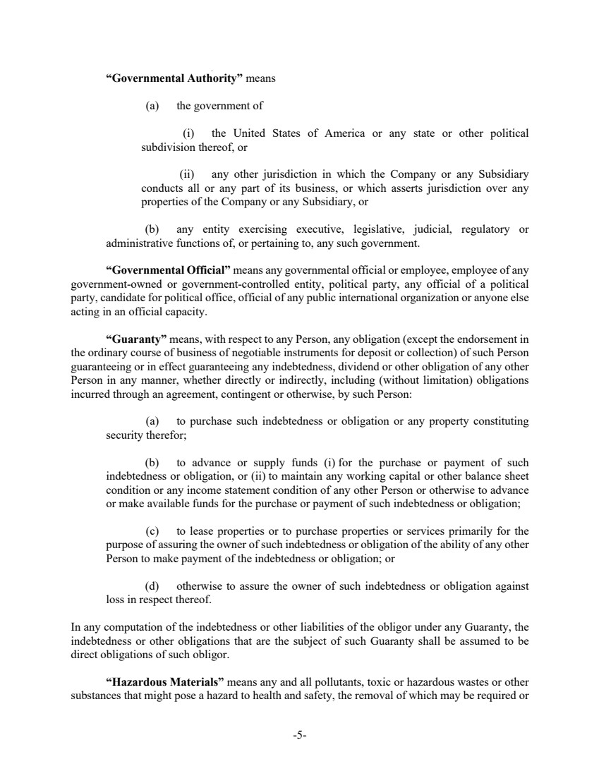 | -5- “Governmental Authority” means (a) the government of (i) the United States of America or any state or other political subdivision thereof, or (ii) any other jurisdiction in which the Company or any Subsidiary conducts all or any part of its business, or which asserts jurisdiction over any properties of the Company or any Subsidiary, or (b) any entity exercising executive, legislative, judicial, regulatory or administrative functions of, or pertaining to, any such government. “Governmental Official” means any governmental official or employee, employee of any government-owned or government-controlled entity, political party, any official of a political party, candidate for political office, official of any public international organization or anyone else acting in an official capacity. “Guaranty” means, with respect to any Person, any obligation (except the endorsement in the ordinary course of business of negotiable instruments for deposit or collection) of such Person guaranteeing or in effect guaranteeing any indebtedness, dividend or other obligation of any other Person in any manner, whether directly or indirectly, including (without limitation) obligations incurred through an agreement, contingent or otherwise, by such Person: (a) to purchase such indebtedness or obligation or any property constituting security therefor; (b) to advance or supply funds (i) for the purchase or payment of such indebtedness or obligation, or (ii) to maintain any working capital or other balance sheet condition or any income statement condition of any other Person or otherwise to advance or make available funds for the purchase or payment of such indebtedness or obligation; (c) to lease properties or to purchase properties or services primarily for the purpose of assuring the owner of such indebtedness or obligation of the ability of any other Person to make payment of the indebtedness or obligation; or (d) otherwise to assure the owner of such indebtedness or obligation against loss in respect thereof. In any computation of the indebtedness or other liabilities of the obligor under any Guaranty, the indebtedness or other obligations that are the subject of such Guaranty shall be assumed to be direct obligations of such obligor. “Hazardous Materials” means any and all pollutants, toxic or hazardous wastes or other substances that might pose a hazard to health and safety, the removal of which may be required or
 | 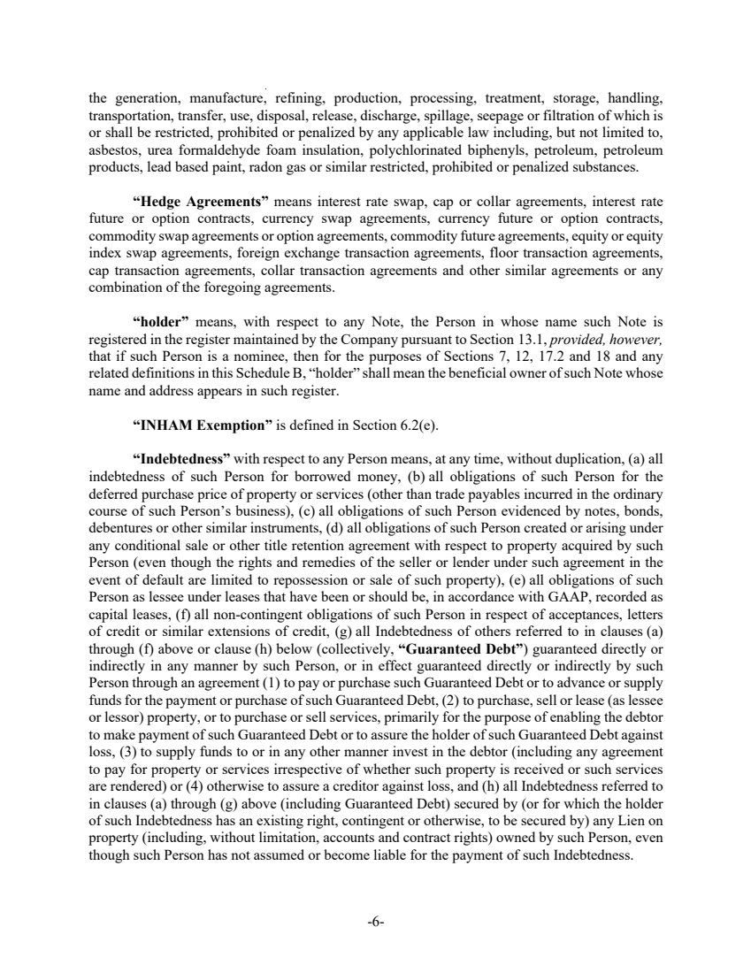 | -6- the generation, manufacture, refining, production, processing, treatment, storage, handling, transportation, transfer, use, disposal, release, discharge, spillage, seepage or filtration of which is or shall be restricted, prohibited or penalized by any applicable law including, but not limited to, asbestos, urea formaldehyde foam insulation, polychlorinated biphenyls, petroleum, petroleum products, lead based paint, radon gas or similar restricted, prohibited or penalized substances. “Hedge Agreements” means interest rate swap, cap or collar agreements, interest rate future or option contracts, currency swap agreements, currency future or option contracts, commodity swap agreements or option agreements, commodity future agreements, equity or equity index swap agreements, foreign exchange transaction agreements, floor transaction agreements, cap transaction agreements, collar transaction agreements and other similar agreements or any combination of the foregoing agreements. “holder” means, with respect to any Note, the Person in whose name such Note is registered in the register maintained by the Company pursuant to Section 13.1, provided, however, that if such Person is a nominee, then for the purposes of Sections 7, 12, 17.2 and 18 and any related definitions in this Schedule B, “holder” shall mean the beneficial owner of such Note whose name and address appears in such register. “INHAM Exemption” is defined in Section 6.2(e). “Indebtedness” with respect to any Person means, at any time, without duplication, (a) all indebtedness of such Person for borrowed money, (b) all obligations of such Person for the deferred purchase price of property or services (other than trade payables incurred in the ordinary course of such Person’s business), (c) all obligations of such Person evidenced by notes, bonds, debentures or other similar instruments, (d) all obligations of such Person created or arising under any conditional sale or other title retention agreement with respect to property acquired by such Person (even though the rights and remedies of the seller or lender under such agreement in the event of default are limited to repossession or sale of such property), (e) all obligations of such Person as lessee under leases that have been or should be, in accordance with GAAP, recorded as capital leases, (f) all non-contingent obligations of such Person in respect of acceptances, letters of credit or similar extensions of credit, (g) all Indebtedness of others referred to in clauses (a) through (f) above or clause (h) below (collectively, “Guaranteed Debt”) guaranteed directly or indirectly in any manner by such Person, or in effect guaranteed directly or indirectly by such Person through an agreement (1) to pay or purchase such Guaranteed Debt or to advance or supply funds for the payment or purchase of such Guaranteed Debt, (2) to purchase, sell or lease (as lessee or lessor) property, or to purchase or sell services, primarily for the purpose of enabling the debtor to make payment of such Guaranteed Debt or to assure the holder of such Guaranteed Debt against loss, (3) to supply funds to or in any other manner invest in the debtor (including any agreement to pay for property or services irrespective of whether such property is received or such services are rendered) or (4) otherwise to assure a creditor against loss, and (h) all Indebtedness referred to in clauses (a) through (g) above (including Guaranteed Debt) secured by (or for which the holder of such Indebtedness has an existing right, contingent or otherwise, to be secured by) any Lien on property (including, without limitation, accounts and contract rights) owned by such Person, even though such Person has not assumed or become liable for the payment of such Indebtedness.
 | 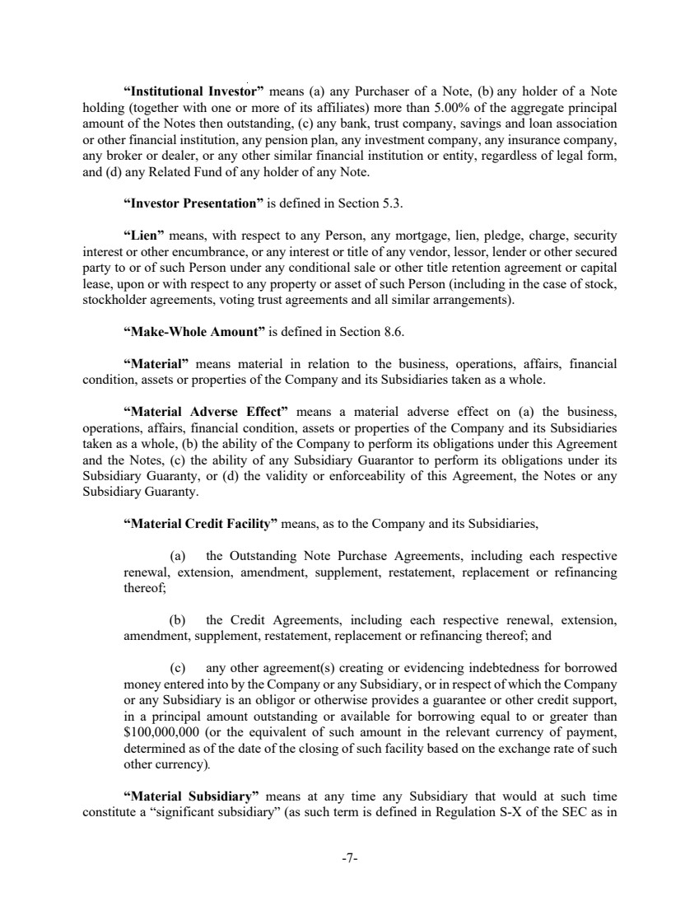 | -7- “Institutional Investor” means (a) any Purchaser of a Note, (b) any holder of a Note holding (together with one or more of its affiliates) more than 5.00% of the aggregate principal amount of the Notes then outstanding, (c) any bank, trust company, savings and loan association or other financial institution, any pension plan, any investment company, any insurance company, any broker or dealer, or any other similar financial institution or entity, regardless of legal form, and (d) any Related Fund of any holder of any Note. “Investor Presentation” is defined in Section 5.3. “Lien” means, with respect to any Person, any mortgage, lien, pledge, charge, security interest or other encumbrance, or any interest or title of any vendor, lessor, lender or other secured party to or of such Person under any conditional sale or other title retention agreement or capital lease, upon or with respect to any property or asset of such Person (including in the case of stock, stockholder agreements, voting trust agreements and all similar arrangements). “Make-Whole Amount” is defined in Section 8.6. “Material” means material in relation to the business, operations, affairs, financial condition, assets or properties of the Company and its Subsidiaries taken as a whole. “Material Adverse Effect” means a material adverse effect on (a) the business, operations, affairs, financial condition, assets or properties of the Company and its Subsidiaries taken as a whole, (b) the ability of the Company to perform its obligations under this Agreement and the Notes, (c) the ability of any Subsidiary Guarantor to perform its obligations under its Subsidiary Guaranty, or (d) the validity or enforceability of this Agreement, the Notes or any Subsidiary Guaranty. “Material Credit Facility” means, as to the Company and its Subsidiaries, (a) the Outstanding Note Purchase Agreements, including each respective renewal, extension, amendment, supplement, restatement, replacement or refinancing thereof; (b) the Credit Agreements, including each respective renewal, extension, amendment, supplement, restatement, replacement or refinancing thereof; and (c) any other agreement(s) creating or evidencing indebtedness for borrowed money entered into by the Company or any Subsidiary, or in respect of which the Company or any Subsidiary is an obligor or otherwise provides a guarantee or other credit support, in a principal amount outstanding or available for borrowing equal to or greater than $100,000,000 (or the equivalent of such amount in the relevant currency of payment, determined as of the date of the closing of such facility based on the exchange rate of such other currency). “Material Subsidiary” means at any time any Subsidiary that would at such time constitute a “significant subsidiary” (as such term is defined in Regulation S-X of the SEC as in
 | 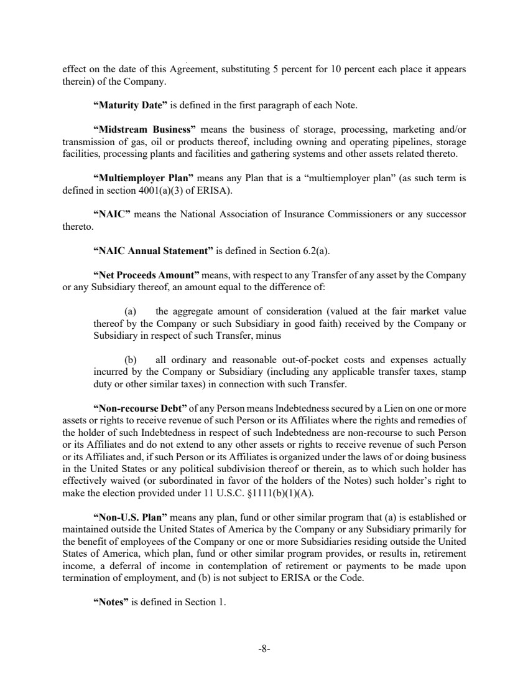 | -8- effect on the date of this Agreement, substituting 5 percent for 10 percent each place it appears therein) of the Company. “Maturity Date” is defined in the first paragraph of each Note. “Midstream Business” means the business of storage, processing, marketing and/or transmission of gas, oil or products thereof, including owning and operating pipelines, storage facilities, processing plants and facilities and gathering systems and other assets related thereto. “Multiemployer Plan” means any Plan that is a “multiemployer plan” (as such term is defined in section 4001(a)(3) of ERISA). “NAIC” means the National Association of Insurance Commissioners or any successor thereto. “NAIC Annual Statement” is defined in Section 6.2(a). “Net Proceeds Amount” means, with respect to any Transfer of any asset by the Company or any Subsidiary thereof, an amount equal to the difference of: (a) the aggregate amount of consideration (valued at the fair market value thereof by the Company or such Subsidiary in good faith) received by the Company or Subsidiary in respect of such Transfer, minus (b) all ordinary and reasonable out-of-pocket costs and expenses actually incurred by the Company or Subsidiary (including any applicable transfer taxes, stamp duty or other similar taxes) in connection with such Transfer. “Non-recourse Debt” of any Person means Indebtedness secured by a Lien on one or more assets or rights to receive revenue of such Person or its Affiliates where the rights and remedies of the holder of such Indebtedness in respect of such Indebtedness are non-recourse to such Person or its Affiliates and do not extend to any other assets or rights to receive revenue of such Person or its Affiliates and, if such Person or its Affiliates is organized under the laws of or doing business in the United States or any political subdivision thereof or therein, as to which such holder has effectively waived (or subordinated in favor of the holders of the Notes) such holder’s right to make the election provided under 11 U.S.C. §1111(b)(1)(A). “Non-U.S. Plan” means any plan, fund or other similar program that (a) is established or maintained outside the United States of America by the Company or any Subsidiary primarily for the benefit of employees of the Company or one or more Subsidiaries residing outside the United States of America, which plan, fund or other similar program provides, or results in, retirement income, a deferral of income in contemplation of retirement or payments to be made upon termination of employment, and (b) is not subject to ERISA or the Code. “Notes” is defined in Section 1.
 | 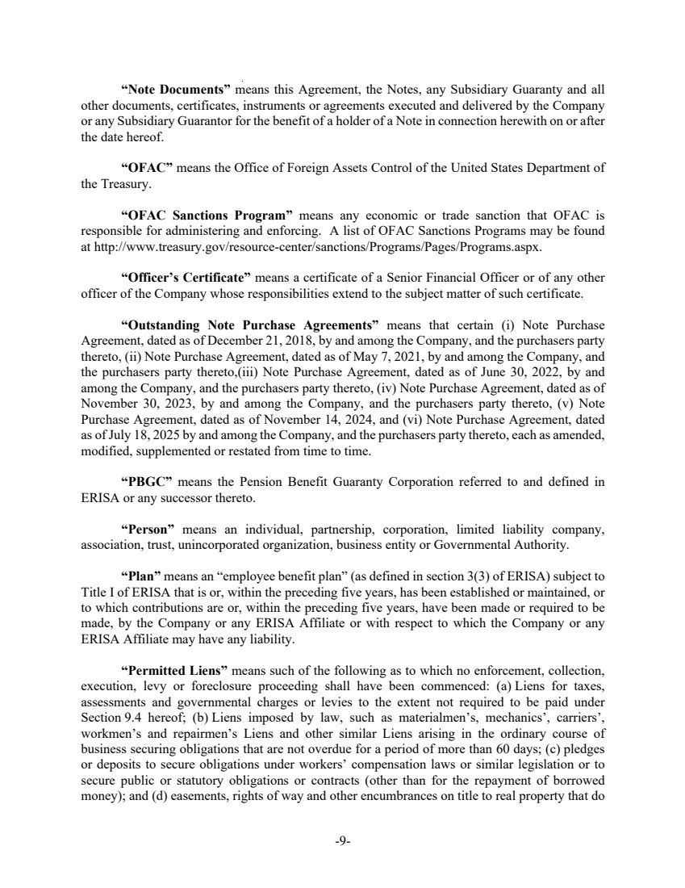 | -9- “Note Documents” means this Agreement, the Notes, any Subsidiary Guaranty and all other documents, certificates, instruments or agreements executed and delivered by the Company or any Subsidiary Guarantor for the benefit of a holder of a Note in connection herewith on or after the date hereof. “OFAC” means the Office of Foreign Assets Control of the United States Department of the Treasury. “OFAC Sanctions Program” means any economic or trade sanction that OFAC is responsible for administering and enforcing. A list of OFAC Sanctions Programs may be found at http://www.treasury.gov/resource-center/sanctions/Programs/Pages/Programs.aspx. “Officer’s Certificate” means a certificate of a Senior Financial Officer or of any other officer of the Company whose responsibilities extend to the subject matter of such certificate. “Outstanding Note Purchase Agreements” means that certain (i) Note Purchase Agreement, dated as of December 21, 2018, by and among the Company, and the purchasers party thereto, (ii) Note Purchase Agreement, dated as of May 7, 2021, by and among the Company, and the purchasers party thereto,(iii) Note Purchase Agreement, dated as of June 30, 2022, by and among the Company, and the purchasers party thereto, (iv) Note Purchase Agreement, dated as of November 30, 2023, by and among the Company, and the purchasers party thereto, (v) Note Purchase Agreement, dated as of November 14, 2024, and (vi) Note Purchase Agreement, dated as of July 18, 2025 by and among the Company, and the purchasers party thereto, each as amended, modified, supplemented or restated from time to time. “PBGC” means the Pension Benefit Guaranty Corporation referred to and defined in ERISA or any successor thereto. “Person” means an individual, partnership, corporation, limited liability company, association, trust, unincorporated organization, business entity or Governmental Authority. “Plan” means an “employee benefit plan” (as defined in section 3(3) of ERISA) subject to Title I of ERISA that is or, within the preceding five years, has been established or maintained, or to which contributions are or, within the preceding five years, have been made or required to be made, by the Company or any ERISA Affiliate or with respect to which the Company or any ERISA Affiliate may have any liability. “Permitted Liens” means such of the following as to which no enforcement, collection, execution, levy or foreclosure proceeding shall have been commenced: (a) Liens for taxes, assessments and governmental charges or levies to the extent not required to be paid under Section 9.4 hereof; (b) Liens imposed by law, such as materialmen’s, mechanics’, carriers’, workmen’s and repairmen’s Liens and other similar Liens arising in the ordinary course of business securing obligations that are not overdue for a period of more than 60 days; (c) pledges or deposits to secure obligations under workers’ compensation laws or similar legislation or to secure public or statutory obligations or contracts (other than for the repayment of borrowed money); and (d) easements, rights of way and other encumbrances on title to real property that do
 | 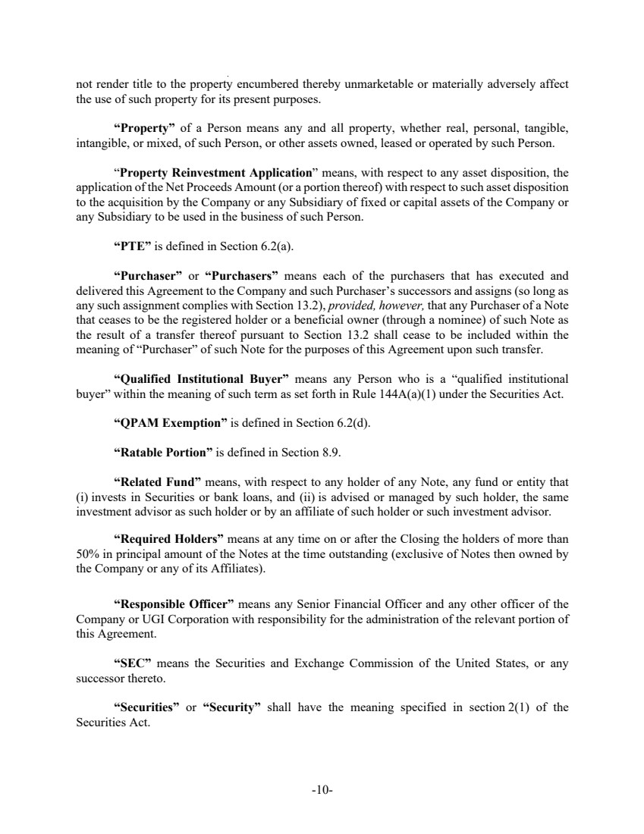 | -10- not render title to the property encumbered thereby unmarketable or materially adversely affect the use of such property for its present purposes. “Property” of a Person means any and all property, whether real, personal, tangible, intangible, or mixed, of such Person, or other assets owned, leased or operated by such Person. “Property Reinvestment Application” means, with respect to any asset disposition, the application of the Net Proceeds Amount (or a portion thereof) with respect to such asset disposition to the acquisition by the Company or any Subsidiary of fixed or capital assets of the Company or any Subsidiary to be used in the business of such Person. “PTE” is defined in Section 6.2(a). “Purchaser” or “Purchasers” means each of the purchasers that has executed and delivered this Agreement to the Company and such Purchaser’s successors and assigns (so long as any such assignment complies with Section 13.2), provided, however, that any Purchaser of a Note that ceases to be the registered holder or a beneficial owner (through a nominee) of such Note as the result of a transfer thereof pursuant to Section 13.2 shall cease to be included within the meaning of “Purchaser” of such Note for the purposes of this Agreement upon such transfer. “Qualified Institutional Buyer” means any Person who is a “qualified institutional buyer” within the meaning of such term as set forth in Rule 144A(a)(1) under the Securities Act. “QPAM Exemption” is defined in Section 6.2(d). “Ratable Portion” is defined in Section 8.9. “Related Fund” means, with respect to any holder of any Note, any fund or entity that (i) invests in Securities or bank loans, and (ii) is advised or managed by such holder, the same investment advisor as such holder or by an affiliate of such holder or such investment advisor. “Required Holders” means at any time on or after the Closing the holders of more than 50% in principal amount of the Notes at the time outstanding (exclusive of Notes then owned by the Company or any of its Affiliates). “Responsible Officer” means any Senior Financial Officer and any other officer of the Company or UGI Corporation with responsibility for the administration of the relevant portion of this Agreement. “SEC” means the Securities and Exchange Commission of the United States, or any successor thereto. “Securities” or “Security” shall have the meaning specified in section 2(1) of the Securities Act.
 | 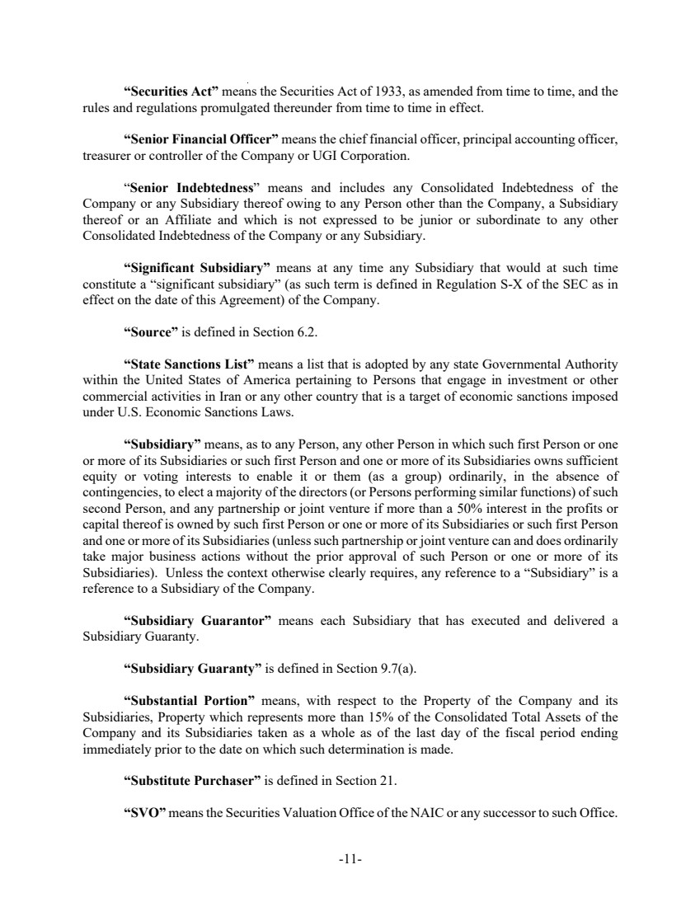 | -11- “Securities Act” means the Securities Act of 1933, as amended from time to time, and the rules and regulations promulgated thereunder from time to time in effect. “Senior Financial Officer” means the chief financial officer, principal accounting officer, treasurer or controller of the Company or UGI Corporation. “Senior Indebtedness” means and includes any Consolidated Indebtedness of the Company or any Subsidiary thereof owing to any Person other than the Company, a Subsidiary thereof or an Affiliate and which is not expressed to be junior or subordinate to any other Consolidated Indebtedness of the Company or any Subsidiary. “Significant Subsidiary” means at any time any Subsidiary that would at such time constitute a “significant subsidiary” (as such term is defined in Regulation S-X of the SEC as in effect on the date of this Agreement) of the Company. “Source” is defined in Section 6.2. “State Sanctions List” means a list that is adopted by any state Governmental Authority within the United States of America pertaining to Persons that engage in investment or other commercial activities in Iran or any other country that is a target of economic sanctions imposed under U.S. Economic Sanctions Laws. “Subsidiary” means, as to any Person, any other Person in which such first Person or one or more of its Subsidiaries or such first Person and one or more of its Subsidiaries owns sufficient equity or voting interests to enable it or them (as a group) ordinarily, in the absence of contingencies, to elect a majority of the directors (or Persons performing similar functions) of such second Person, and any partnership or joint venture if more than a 50% interest in the profits or capital thereof is owned by such first Person or one or more of its Subsidiaries or such first Person and one or more of its Subsidiaries (unless such partnership or joint venture can and does ordinarily take major business actions without the prior approval of such Person or one or more of its Subsidiaries). Unless the context otherwise clearly requires, any reference to a “Subsidiary” is a reference to a Subsidiary of the Company. “Subsidiary Guarantor” means each Subsidiary that has executed and delivered a Subsidiary Guaranty. “Subsidiary Guaranty” is defined in Section 9.7(a). “Substantial Portion” means, with respect to the Property of the Company and its Subsidiaries, Property which represents more than 15% of the Consolidated Total Assets of the Company and its Subsidiaries taken as a whole as of the last day of the fiscal period ending immediately prior to the date on which such determination is made. “Substitute Purchaser” is defined in Section 21. “SVO” means the Securities Valuation Office of the NAIC or any successor to such Office.
 | 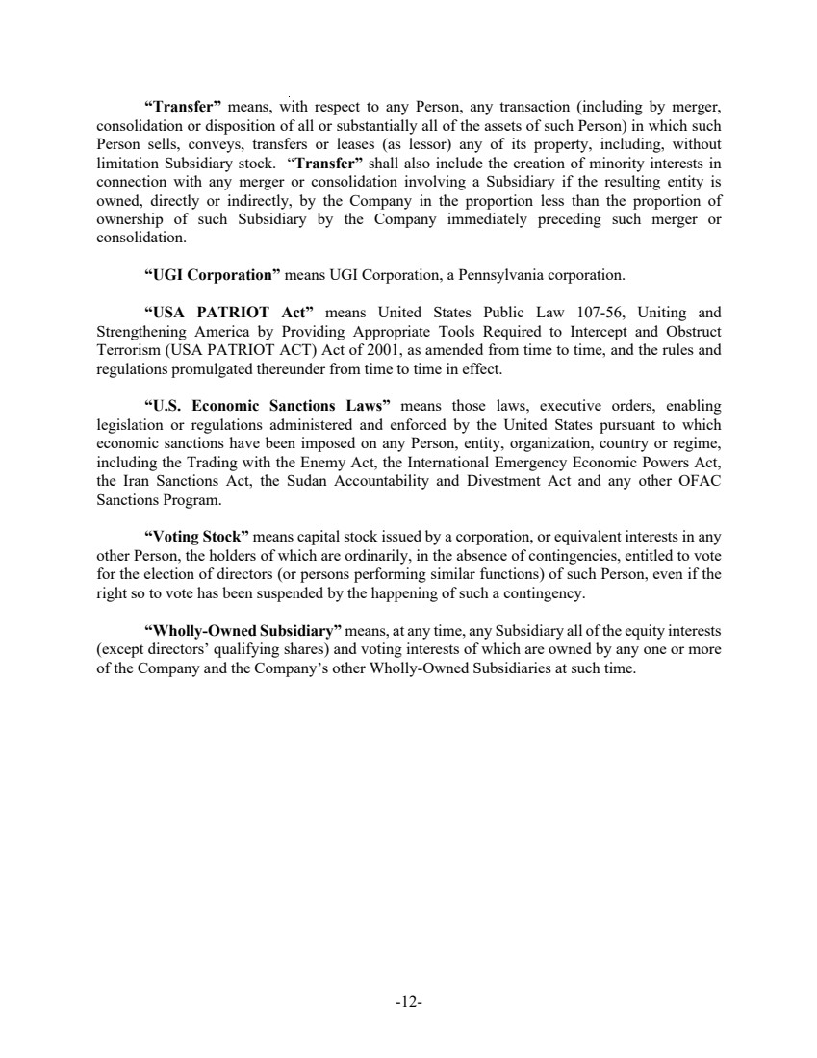 | -12- “Transfer” means, with respect to any Person, any transaction (including by merger, consolidation or disposition of all or substantially all of the assets of such Person) in which such Person sells, conveys, transfers or leases (as lessor) any of its property, including, without limitation Subsidiary stock. “Transfer” shall also include the creation of minority interests in connection with any merger or consolidation involving a Subsidiary if the resulting entity is owned, directly or indirectly, by the Company in the proportion less than the proportion of ownership of such Subsidiary by the Company immediately preceding such merger or consolidation. “UGI Corporation” means UGI Corporation, a Pennsylvania corporation. “USA PATRIOT Act” means United States Public Law 107-56, Uniting and Strengthening America by Providing Appropriate Tools Required to Intercept and Obstruct Terrorism (USA PATRIOT ACT) Act of 2001, as amended from time to time, and the rules and regulations promulgated thereunder from time to time in effect. “U.S. Economic Sanctions Laws” means those laws, executive orders, enabling legislation or regulations administered and enforced by the United States pursuant to which economic sanctions have been imposed on any Person, entity, organization, country or regime, including the Trading with the Enemy Act, the International Emergency Economic Powers Act, the Iran Sanctions Act, the Sudan Accountability and Divestment Act and any other OFAC Sanctions Program. “Voting Stock” means capital stock issued by a corporation, or equivalent interests in any other Person, the holders of which are ordinarily, in the absence of contingencies, entitled to vote for the election of directors (or persons performing similar functions) of such Person, even if the right so to vote has been suspended by the happening of such a contingency. “Wholly-Owned Subsidiary” means, at any time, any Subsidiary all of the equity interests (except directors’ qualifying shares) and voting interests of which are owned by any one or more of the Company and the Company’s other Wholly-Owned Subsidiaries at such time.

